**Team Information**

|  |  |
| --- | --- |
| **Team ID** | **34** |
| **Team Repo on GitHub** | **https://github.com/HUANG-Haolun/COMP3111-GROUP34** |

|  |  |
| --- | --- |
| **Name (Member 1)** | **HUANG Haolun** |
| **GitHub ID** | **HUANG-Haolun** |
| **Email ID** | [**hhuangbl@connect.ust.hk**](mailto:hhuangbl@connect.ust.hk) |
| **Dev Branch** | **feature-input** |
| **Task Assignment** | **input** |

|  |  |
| --- | --- |
| **Name (Member 2)** | **HUANG Baixiang** |
| **GitHub ID** | **Xiaoyuanzi22333** |
| **Email ID** | **bhuangak@connect.ust.hk** |
| **Dev Branch** | **feature-output** |
| **Task Assignment** | **output** |

|  |  |
| --- | --- |
| **Name (Member 3)** | **Ju Jong Hyeon** |
| **GitHub ID** | **JJHyeon25** |
| **Email ID** | **jjuab@connect.ust.hk** |
| **Dev Branch ID** | **feature-process** |
| **Task Assignment** | **process** |

**Submitted by: ______HUANG Haolun_________**

**Date of Submission: ____2022/11/22________________________**

**PART 1: Documentation – Project Management**

* 1. **Team Meeting Minutes**
  2. **Gantt Chart**

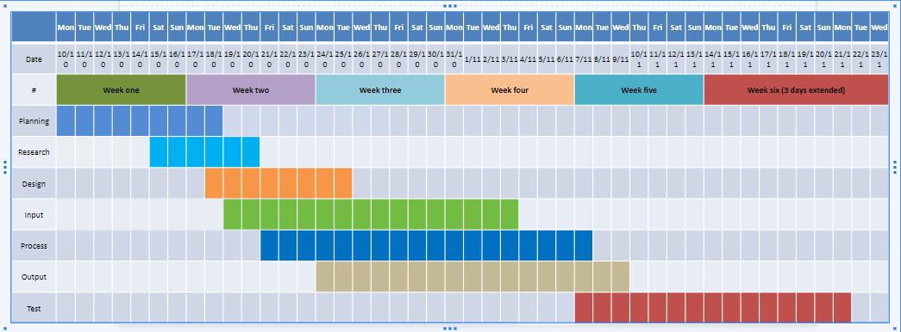

* 1. **Burndown Chart**

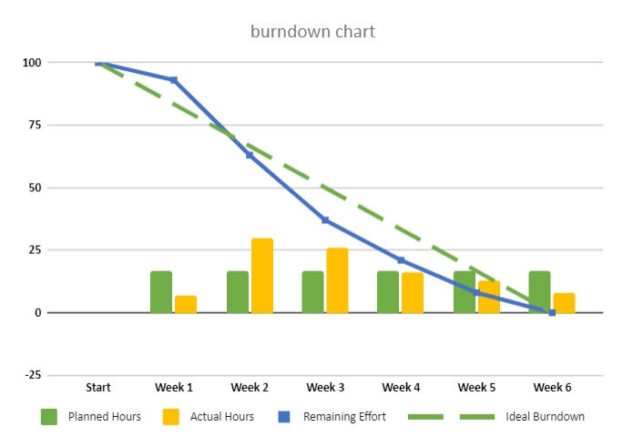

* 1. **Representative Git commit log on GitHub**

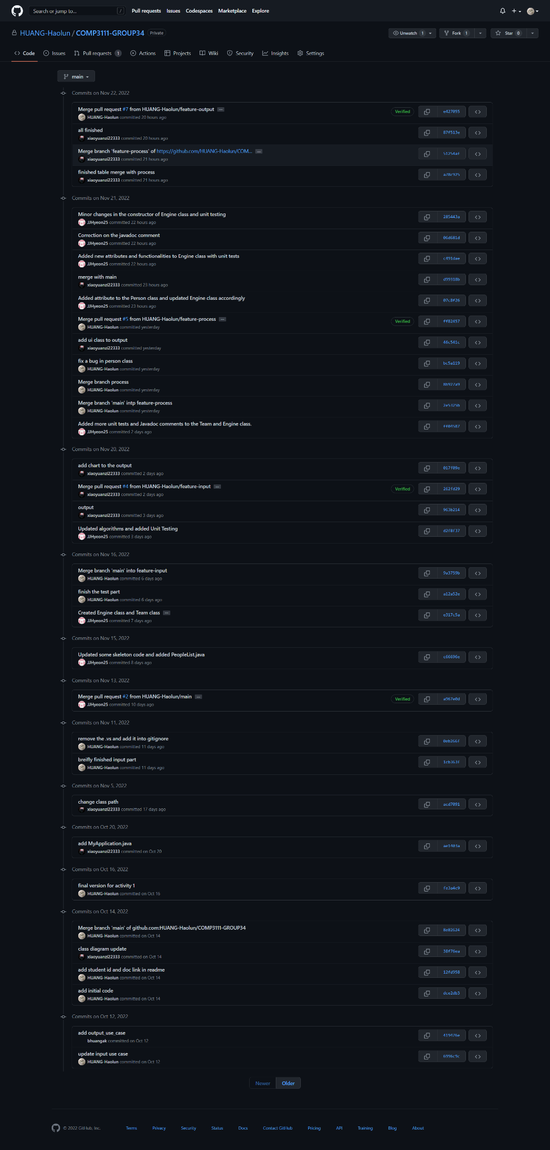

**PART 2: Documentation – Implementation and Testing**

**2.1. Report on the unit testing for the implemented tasks (100% pass)**

**2.2. Report on the coverage test (>65% branch coverage)**

**2.3. Documentation on the implemented tasks using JavaDoc**

**PART 3: Program Execution and Screenshots**

**3.1. Screenshots of the execution of the application showing sample inputs and outputs of your choice (Table-Generating Task:INPUT)**

**3.2. Screenshots of the execution of the application showing sample inputs and outputs of your choice (Chart-Generating Task A1 or B1 or C1)**

**3.3. Presentation of Commendable Features beyond Basic Requirements**