Quiz 1

1. False. Result returned is deterministic due to the int(), it is always x.
2. True. By providing a randomness source, 100, as an argument, random.seed(100) will produce repeatable sequence in every run.
3. True. Brute force solution can produce an optimal solution to 0/1 knapsack problem.
4. True. The length of myList is stochastic.
5. False. In a undirected graph with non-negative weight, the shortest distance between any two nodes can be path other than the edge between the two nodes.

Quiz 2

1. C

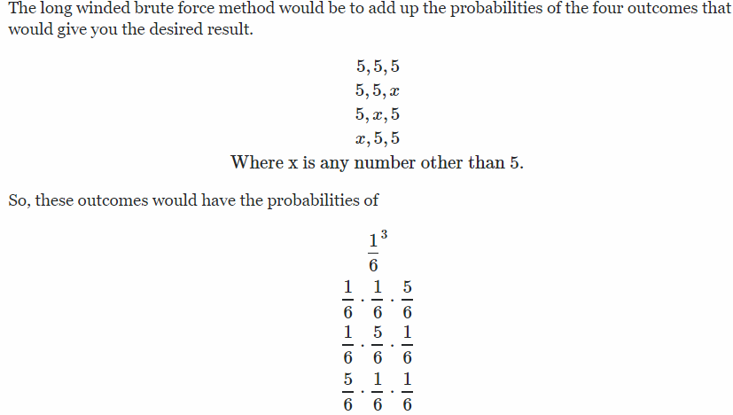

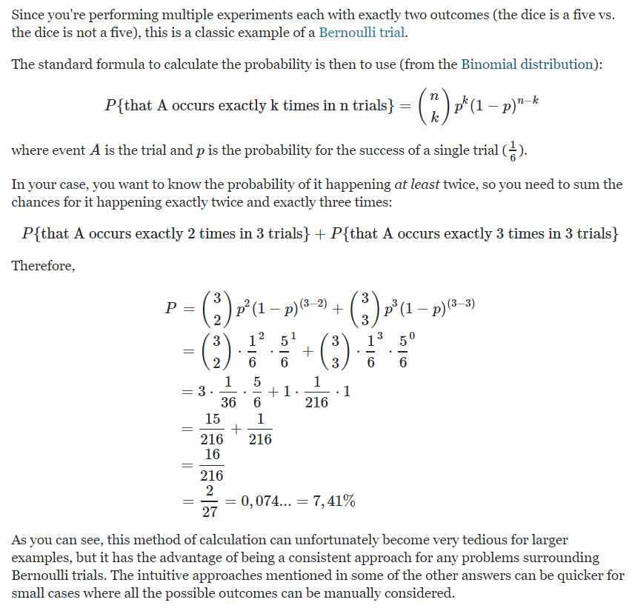

1. A greedy optimization algorithm is typically efficient in time.

1. Breath-first search
2. Both F&G
3. N! = N(N+1)/2 = O(N)