Comparative Analysis of User Revenue Prediction Based on Decision Tree and Random Forest
HUBINXING, G2404098A
IN6227-2023-Assignment-{1}

INTRODUCTION

Many machine learning models can be applied to solve the user income prediction problem. As a tree-based model, the decision tree has the advantages of being simple, easy to understand, highly interpretable, and having shorter training times. Random forests, as an ensemble of decision trees, offer higher robustness and accuracy compared to individual trees. Building on decision trees and random forests, models like Gradient Boosting Trees (GBT), Extra Trees, and Adaptive Boosting have evolved in recent years, and they have been widely applied in real-world scenarios.
Therefore, this paper will apply the basic machine learning model, the decision tree, and the ensemble learning model, the random forest, to predict user income. The goal is to compare the similarities and differences between these two models, laying a foundation for future learning of tree-based ensemble methods.
The article will include the training process of both models, the prediction results, a comparative analysis of the results, and a conclusion. The training process will consist of two steps: data preprocessing and model parameter optimization.

METHODS OR PROCEDURES

data preprocessing
- Cleaning Income Labels
The current income labels are text-based data with values of <=50K and >50K. These need to be converted into binary labels (0 representing <=50K and 1 representing >50K). Additionally, in the adult.test dataset, the income labels contain a period, which is removed to ensure consistency.
- Feature and Label Separation
In both the training and testing sets, the last column represents the income label (the target value to be predicted). Therefore, this column is separated from the feature columns in both datasets.
- Pipeline for Numerical Features
For numerical features, missing values are first imputed using the median to avoid data loss. Although decision trees and random forests do not require data standardization, standardizing the numerical features is performed to improve the generalization of the data, making it suitable for use in a variety of machine learning models.
- Pipeline for Categorical Features
Missing values in categorical features are first imputed using the most frequent category to prevent data loss. Then, one-hot encoding is applied to convert categorical features into a binary format so that they can be processed by the models.
- Handling Class Imbalance with SMOTE
In both the training and testing datasets, about 75% of the data falls into the <=50K category. To prevent the model from being biased towards the majority class during training, the SMOTE (Synthetic Minority Over-sampling Technique) algorithm is used to generate synthetic samples of the minority class, balancing the class distribution.
Model Parameter Optimization
For the decision tree model, grid search combined with five-fold cross-validation is used to fine-tune the model parameters. The tuning focuses on the maximum depth of the tree, the minimum number of samples required to split an internal node, the minimum number of samples required to be at a leaf node, and the maximum number of features considered at each split. When defining the hyperparameter grid, multiple rounds of training and improvement are necessary to ensure that the optimal parameters fall within the selected range.
For the random forest model, since the training process is more resource-intensive, using grid search as in the decision tree model would consume a significant amount of time. Therefore, random search is used instead. The search focuses on the number of trees in the forest, the maximum depth of the trees, the minimum number of samples required to split an internal node, the minimum number of samples required to be at a leaf node, and the maximum number of features considered at each split. Given the longer training time for this model, the number of cross-validation folds is appropriately reduced, and three-fold cross-validation is used.

RESULTS

为了更好的对比两个模型的性能，在模型预测准确率之外，分别计算两个模型的损失率，精确度、召回率、F1值以及绘制ROC曲线进行对比。
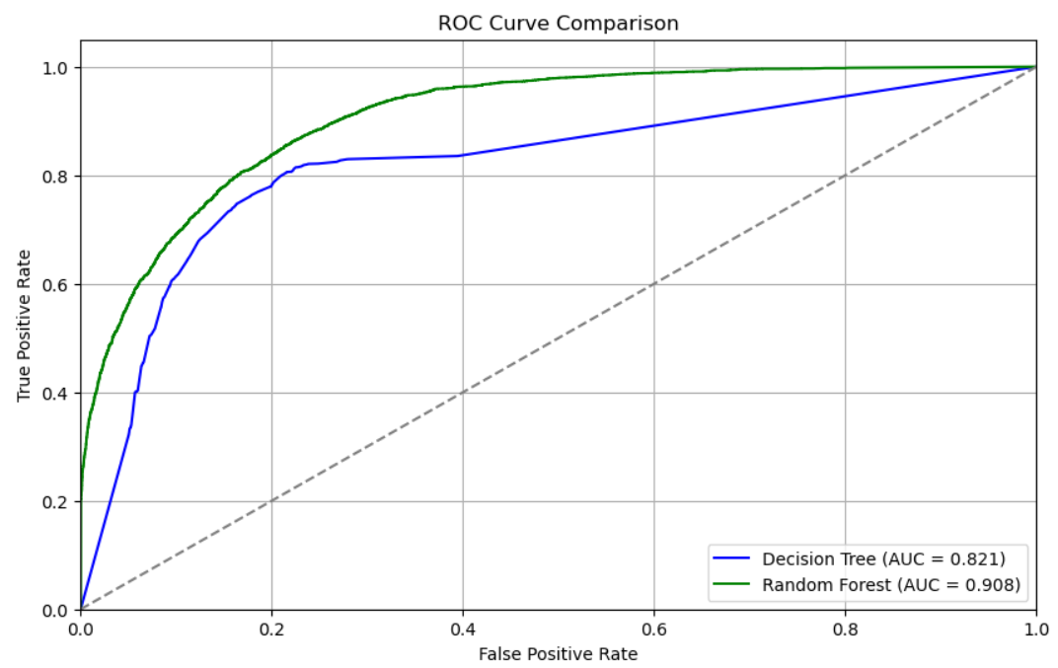
Results are where things can get difficult. If you want to use tables and other approaches go ahead but keep tables within the margins, they do not go after the references but in the text. Moreover, you may use symbols for various statistics. Make sure you are using the correct program to put these in the text.
We strongly encourage authors to carefully review the material posted here to avoid problems with incorrect files or poorly formatted graphics.

DISCUSSION

You want the brilliance of the work to shine and other things like that. So just wrap it up with how great the findings are. Bring it.

CONCLUSION

Although a conclusion may review the main points of the paper, do not replicate the introduction as the conclusion. A conclusion might elaborate on the importance of the work or suggest applications and extensions. Since the conclusion is the last part of the paper read, make it memorable.

REFERENCES

[1] Seeger, M. W., Sellnow, T. and Ulmer, R. R. 2003. Communication and organizational crisis, Westport, CT: Praeger.
[2] Benoit, W. (2018). Crisis and image repair at united airlines: Fly the unfriendly skies. Journal of International Crisis and Risk Communication Research, 1, 11-26. https://doi.org/10.30658/jicrcr.1.1.2

