NATIONAL UNIVERSITY OF SINGAPORE
Institute of Systems Science
Certificate in Intelligent Reasoning Systems
Practice Module

RoadGuard
Road Damage Detection and Maintenance
Scheduling in Jurong
Final Project Report
Submitted by
Hu Erji A0305480L
Yan GuanTing A0305485B
Wu TaoYi A0356972M
AIS08FT · Group 7
21 October 2026

Abstract
RoadGuard integrates road-damage detection, rule-based decisions and maintenance scheduling for four crews in Jurong East and Jurong West. Inspectors upload geolocated images, a local YOLO11s model selects one primary damage observation, and a confidence policy either creates a repair task or requests human review. A genetic algorithm and a Greedy baseline then allocate accepted work from a common NUS-ISS dispatch origin. A shared web application supports inspectors, dispatchers and crew accounts, with persistent task history and revision checks. A dispatcher assistant retrieves reviewed project knowledge and saved-plan evidence, while separate preview and confirmation workflows support persistent crew assignment and task cancellation.
Evaluation combines visual-recognition experiments, twelve routing scenarios and integrated workflow tests. Recognition reliability and independent local validation remain unresolved. Greedy-seeded search improved the scheduling result in all 120 default-budget runs, with scenario-mean objective reductions of 0.73–3.62%. Targeted assistant checks include actual GPT responses, local retrieval and confirmed task-change acceptance; they do not establish broad semantic accuracy. The contribution is an integrated decision process with retained evidence, human correction and constrained crew planning. Operational deployment requires calibrated rules, measured service assumptions and further field evaluation.
Keywords: road damage detection; YOLO; business rules; genetic algorithm; maintenance scheduling.
Contents

Abstract i
1 Introduction 1
1.1 Background and Problem Statement 1
1.2 Related Work and Contribution 1
1.3 Scope and Project Evolution 2
2 Data and Knowledge Preparation 3
3 System Design and Implementation 5
3.1 System Architecture 5
3.2 Decision and Scheduling Semantics 5
3.3 Implementation and User Workspaces 6
3.4 Application of Intelligent Reasoning Techniques 10
3.5 Team Contributions and Development Practice 10
4 Evaluation Methodology 11
5 Results and Discussion 12
5.1 Vision Performance and Error Analysis 12
5.2 Routing Performance 14
5.3 Integrated Workflow Verification 15
6 Conclusions and Future Work 18
6.1 Conclusions and Limitations 18
6.2 Future Work 18
Appendix A Installation and User Guide 19
A.1 Environment and dependencies 19
A.2 Local retrieval and optional GPT configuration 19
A.3 Accounts and data 20
A.4 Start the application 21
A.5 User workflow 21
A.6 Dispatcher evidence questions 22
A.7 Dispatcher route previews and confirmed adjustments 23
A.8 API testing and troubleshooting 23
A.9 Optional Google travel estimates 24
Appendix B Submitted Project Proposal 26
Appendix C Course Functionality Mapping 39

1 Introduction

1.1 Background and Problem Statement
RoadGuard addresses the handoff between road inspection and maintenance scheduling. A photographic observation must be interpreted, reviewed when uncertain, assigned a repair priority and allocated to an available crew. Detection alone does not establish road eligibility, service time or operational urgency.
Singapore’s Land Transport Authority describes manual inspection and reporting as labour-intensive and affected by inspectors’ judgement. Its published account of AI-assisted inspection and GeoFormSG also identifies the effort of transferring location coordinates between applications. This highlights a practical challenge in Singapore's existing road inspection process. However, RoadGuard is developed as an independent prototype and is not integrated with LTA systems.
The project aims to connect inspectors, dispatchers and crews through one traceable workflow. Inspectors submit evidence, dispatchers correct and prioritise observations, and crews consult assigned work and record completion. The intended value is less repeated data handling and clearer allocation decisions. These benefits require later user and operational evaluation; they are not measured financial savings.

1.2 Related Work and Contribution
Arya et al.’s RDD2022 benchmark contains 47,420 images from six countries and four damage families. RoadGuard uses the separately published eight-class RDD2022ES derivative, which offers training material but no evidence of Singapore performance or repair priorities. Redmon et al.’s YOLO work provides the methodological basis for joint box and class prediction; the implemented detector is the later Ultralytics YOLO11, selected through project experiments.
For scheduling, Vidal’s hybrid genetic-search research illustrates the value of evolutionary search and local improvement in capacitated routing. RoadGuard uses a smaller custom GA, not Vidal’s HGS or SWAP* method. A deterministic Greedy baseline supports transparent comparison. The contribution is the combination of learned perception, editable rules, human correction and evaluated crew planning, rather than a new detector architecture or search algorithm. Compared with an inspection-only tool, this connects accepted evidence to repair allocation and completion.

1.3 Scope and Project Evolution
Four crews serve eligible public motor roads in Jurong East and West within frozen URA Master Plan 2025 boundaries, using a simulated NUS-ISS origin. Expressway mainlines and ramps, and private or restricted roads, are excluded. The backend checks geography; road type is user-declared. This is not an actual NUS-ISS maintenance operation.
The workflow covers primary detection, confidence review, rule-based tasks, explicit replanning, comparative schedules and crew completion, plus grounded answers and confirmed adjustments. Table 1 compares the delivered scope with the submitted proposal in Appendix B. Jurong restriction and four crews follow presentation feedback; other changes reflect implementation decisions or evaluation gaps.
Table 1. Changes from the original project plan
Item | Original plan | Current evidence
Area and crews | Singapore example with two crews | Jurong East/West, four crews, NUS-ISS origin
Wide crack priority | Wide, sunken or deep labels mapped to P1 | Wide cracks use P2; sunken/deep labels retain P1
Route refresh | Queue changes automatically trigger recalculation | Changes mark plans stale; dispatcher explicitly recalculates
Travel and map | Google Routes and Maps JavaScript API | Optional Google matrix; default simulation; schematic SVG map
Language assistant | GPT/RAG explanations and confirmed change requests | Chroma/E5 and optional GPT answers; confirmed adjustments; targeted evaluation
Business rules | Proposed rules.yaml and provisional mapping | Versioned JSON policy with 60/120/240-minute durations
User access | Inspector, coordinator and crew workflows | Authenticated roles, own-inspection and fixed-crew enforcement
The configurable 480-minute shift and depot return remain unapproved operational assumptions. GPT/RAG and preview–confirm–replan are implemented; targeted acceptance does not establish the full question-and-change evaluation proposed in Appendix B.

2 Data and Knowledge Preparation
We used version 1 of RDD2022ES dataset and retained its original eight damage classes throughout model development. Images are decoded and annotation coordinates and class IDs checked; missing-label and uncertain orientation groups are quarantined. File hashes and exclusion manifests preserve preparation decisions. The publisher’s conflicting licence statements remain unresolved for prospective commercial reuse.
Originals and mirrors are grouped before splitting, with exact and conservative perceptual similarity checks linking additional related images. Country-stratified allocation uses seed 42 and approximately 70/15/15 proportions. Training includes mirrors; validation and test use originals only. This limits known duplicate leakage but cannot establish independence of adjacent scenes without sequence or location metadata.
Table 2. Prepared visual-data partitions
Partition | Images | Groups | Annotated boxes | Use
Training | 17,916 | 8,939 | 25,314 | Originals and supplied mirrors
Validation | 1,921 | 1,917 | 2,623 | Originals only; model selection
Test | 1,918 | 1,915 | 2,673 | Originals only; historical n10 test
Only the historical YOLO11n 10-epoch baseline has a recorded test-set evaluation. Subsequent model and policy selection reused validation data. These are foreign-source research photographs; synthetic Jurong task coordinates are separate scheduling inputs and do not establish where a photograph was captured.
Versioned business rules encode severity, priority, service minutes and explanations. The source-hashed a-knowledge-v17 package records reviewed scope, label meanings, rules and workflows; it is indexed locally in ChromaDB with multilingual-e5-small embeddings. It was checked against repository content, not approved by engineering experts. Only reviewed static documents are indexed; authorized saved-plan facts are obtained separately. The visual qualifiers “wide”, “sunken” and “deep” are categorical labels, not measurements of width, depth or structural condition.
Table 3. Damage classes and demonstration rules
Class | Severity | Priority | Service minutes
longitudinal crack | low | P3 | 60
longitudinal crack wide | medium | P2 | 120
transverse crack | low | P3 | 60
transverse crack wide | medium | P2 | 120
alligator crack | medium | P2 | 120
alligator crack sunken | high | P1 | 240
pothole | medium | P2 | 120
pothole deep | high | P1 | 240
Confidence governs acceptance, while the selected label determines the rule outcome. A confident incorrect label can therefore create an incorrect task. Service times are project assumptions, not measured construction standards.

3 System Design and Implementation

3.1 System Architecture
A React client uses one FastAPI backend and shared SQLite database. Separate services handle vision, rules, inspections, tasks, crews and planning. YOLO supplies both class and location evidence for review; explicit rules keep policy changes separate from model training. GA addresses the discrete combination of task assignment and visit order, while Greedy provides an interpretable baseline and a dependable initial solution. A dispatcher-only assistant combines local Chroma/E5 retrieval with authorized saved-plan facts. Optional GPT generation selects server-owned evidence IDs; the server restores exact quotations for a guarded answer and derives canonical repair-rule answers from rule evidence. A separate adjustment service validates, confirms and persists changes without letting a generated answer authorize a business action.
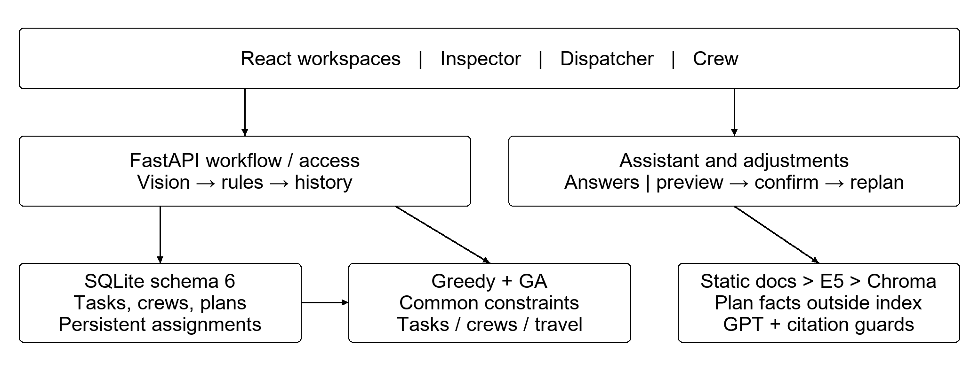
Figure 1. System architecture and principal information flows.
Note. Evidence questions do not mutate business records. Confirmed adjustments persist separately; planning still requires an explicit dispatcher request. Source validation and bounded answer checks do not guarantee every semantic judgement.

3.2 Decision and Scheduling Semantics
The backend checks the local model manifest, weight hash and eight-class schema. Inference filters candidates at confidence 0.20. The primary box is ranked by confidence multiplied by the fourth root of its image-area fraction; this score does not replace raw confidence. A primary confidence of at least 0.60 automatically creates one task, lower confidence requires review, and no detection creates no task. Raw evidence, the rule snapshot and review history are retained. Corrections use the frozen rules, and idempotent requests prevent duplicate tasks.
Both planners read the same active tasks, crew availability, travel matrix and constraints from a consistent revision. Greedy selects the earliest available crew and a feasible task by priority, then travel time. The GA encodes a task permutation and crew-owner vector. Tournament selection, order-preserving crossover, reassignment, swap, reversal, relocation and elitism explore alternatives; evaluation caching avoids duplicate scoring. Online search includes the Greedy solution, whereas unseeded GA is retained for experimental comparison. Both planners also preserve durable task-to-crew constraints, including after a restart or the arrival of new tasks. Unavailable or infeasible constrained work remains explicitly unassigned rather than silently transferring crews.
Candidates minimise the ordered tuple (unassigned P1 count, unassigned P2 count, unassigned P3 count, J), where J = makespan + 0.2 × total travel + 0.5 × workload standard deviation + 0.5 × priority-weighted mean completion time. The final term averages completion times using P1/P2/P3 weights of 3/2/1. Components use minutes; J is a weighted objective, not elapsed time or money. No task deadlines are supplied, so priority-weighted completion is not lateness.
Task or crew changes mark old plans stale. The dispatcher explicitly recalculates, and a superseded input revision is rejected before a new plan is saved. A move preview retains all other assigned tasks and checks travel, service and configured return against the shift. Confirmation stores a durable crew constraint; cancellation retains history and removes active work. Stale or expired proposals, version conflicts, repeated confirmation and role/CSRF checks are handled explicitly. Reassignment immediately removes the previous crew’s task, inspection and completion access; the target crew receives access after a fresh saved GA plan. Completion also checks task version in the same transaction. The database schema is version 6.

3.3 Implementation and User Workspaces
The application supports uploads, inspection details, reviews, tasks, crew availability, route planning, algorithm comparison and a mobile crew workspace. Backend authorization enforces the role restrictions in Table 4 independently of visible navigation. Authentication uses hashed passwords and sessions, with CSRF checks for modifying requests. Route assistant presents English answers before default-collapsed View sources, and four saved-route crew cards with move/cancel previews. Query-v3 returns model identity from non-secret backend configuration without a provider call, gives explicit guidance for clearly unrelated questions, and retains strict evidence validation for repair and saved-route questions. Ambiguous or insufficient evidence remains explicit.
Table 4. Account roles and access restrictions
Role | Permitted workflow | Server-side restriction
Inspector | Upload and inspect own results | No global tasks, reviews or planning
Dispatcher | Review, tasks, crews, planning, comparison, evidence questions and confirmed adjustments | Cannot upload or impersonate a crew workspace
Crew | Read own latest GA route and complete assigned work | Cannot select another crew, replan, adjust tasks or access global lists; reassignment revokes old access
Travel providers supply either simulated geographic-distance estimates or optional Google road-network estimates, with validation and caching. Provider failure returns an error rather than silently changing the source. Routes are shown as schematic segments, not turn-by-turn road geometry. The interface exposes stale plans, source information and unassigned reasons; percentage comparisons require matched context and compatible assigned task sets.
During integration testing, we discovered that loading the vision library unexpectedly replaced the image decoder used for uploads. As a result, malformed images triggered a server error instead of being rejected normally. Retaining the validated decoder reference and adding a regression case resolved the failure. This demonstrates the need to exercise the actual model together with the upload workflow.
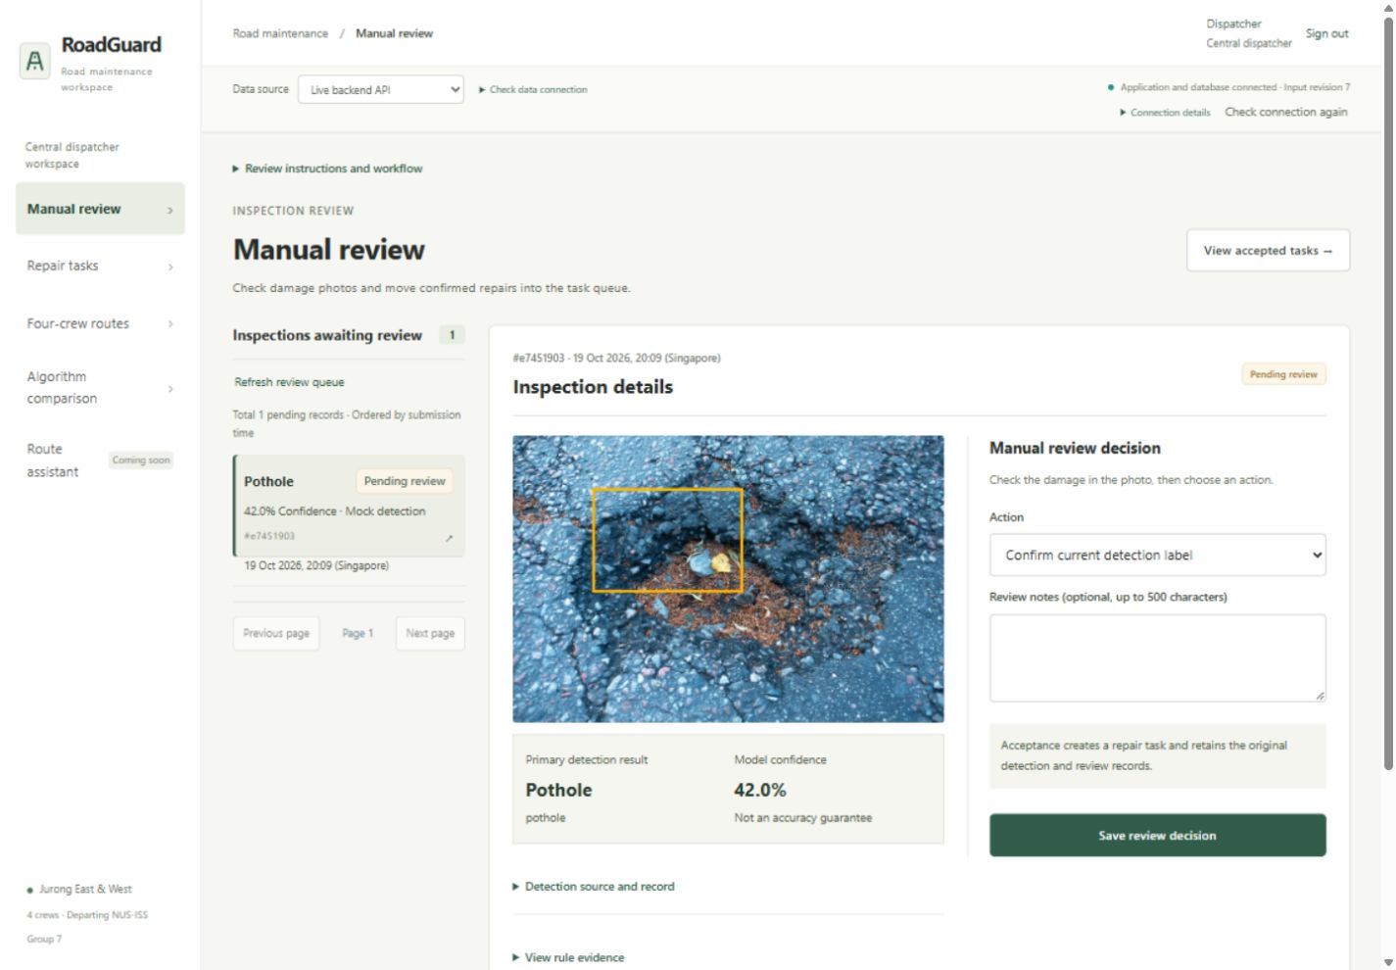
Figure 2. Dispatcher review interface showing a synthetic confidence case.
Note. Recorded on 19 October 2026. The 42% result is a controlled review case rather than a model-accuracy measurement.
On mobile, crew accounts retain sign-out and their fixed crew identity, view the current route and confirm task completion. URL changes cannot grant another crew’s access. Recorded 360/390-pixel browser checks found no whole-page horizontal overflow.
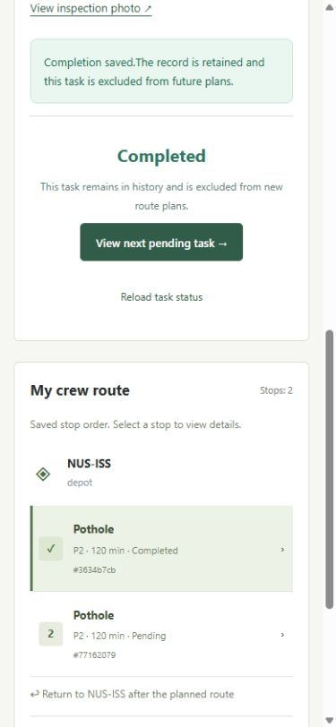
Figure 3. Mobile crew workspace showing task completion and route entries.
Note. Recorded on 19 October 2026. Completion is checked against the current crew assignment and task version.

3.4 Application of Intelligent Reasoning Techniques
Learned visual perception supplies uncertain evidence; explicit rules determine the permitted business response; constrained search allocates accepted work. Retrieval and optional language generation explain reviewed knowledge and saved-plan facts, with server-owned citations and bounded validation. Confirmed business adjustments remain a separate guarded workflow. These complementary methods form the reasoning chain described in Sections 3.1 and 3.2. Appendix C maps delivered functions to MR, RS and CGS, with evidence, verification references and limitations.

3.5 Team Contributions and Development Practice
Table 5. Team responsibilities and completed contributions
Member | Primary area | Completed contribution
Hu Erji  A0305480L | Vision and shared workflow | Data and model experiments; business rules and shared backend; model release; integration, authentication and later interface refinement.
Yan GuanTing  A0305485B | Routing and optimisation | Four-crew Greedy and GA planning; crew and plan persistence; Google matrix provider; routing experiments and ablation.
Wu TaoYi  A0356972M | Frontend and assistant | Frontend foundation and workflow pages; map and comparison integration; retrieval and confirmed-change assistant. Shared integration adds vector grounding and persistent task adjustments.
Responsibilities were confirmed by the coordinator and corroborated by repository history; squash commits make raw commit counts unsuitable as measures of individual contribution.

4 Evaluation Methodology
Evaluation separates recognition quality, scheduling quality and workflow correctness. The paired YOLO11n/YOLO11s experiments used COCO-pretrained initialisation, 30 epochs, 640-pixel inputs, batch 32, AdamW and seed 42. Subsequent YOLO11s fine-tuning used 40 additional epochs, 832-pixel inputs and batch 16. Multiple settings changed together, so the resulting gains cannot be attributed to one parameter.
Precision is TP/(TP+FP), Recall is TP/(TP+FN), and F1 is their harmonic mean. Box evaluation requires the correct eight-class label and one-to-one IoU ≥0.5 matching. These micro counts differ from native class-averaged PR operating points and mAP. Single-subject evaluation instead requires the correct primary image label without a box-overlap condition; a wrong label counts as both FP and FN.
The 1,230 zero/one-annotation images were split deterministically by source group into 853 calibration and 377 confirmation cases; 691 multi-object images were considered separately. Eighty policies were compared on calibration only. Both subsets came from previously used validation data, so confirmation is not an independent test. Macro F1 averages all eight classes, assigning zero to undefined class ratios, including the unsupported wide-transverse class in confirmation.
For the routing experiments, we combined three task counts (10, 15 and 20), two travel-time sources (simulated and Google), and two shift constraints (480 minutes and unlimited), resulting in 12 four-crew scenarios. Each contains Greedy once, pure and Greedy-seeded GA with seeds 1–10, and 20 reference-budget runs with seeds 101–120: 492 runs in total. Default GA uses population 60, at most 300 generations, patience 80, crossover 0.9, mutation 0.3, tournament size 3 and two elites. Reference runs use population 150, at most 1,000 generations and patience 300, alternating pure and seeded initialisation. Inputs and the evaluator are identical within each scenario.

5 Results and Discussion

5.1 Vision Performance and Error Analysis
The paired 30-epoch comparison selected YOLO11s for higher validation mAP50–95, but at confidence 0.25 it gained 107 correct matches and added 220 false positives relative to YOLO11n. Matched warm CPU timing on 40 images, repeated three times, gave median/P95 latency of 53.27/63.59 ms for n30 and 81.87/91.85 ms for s30. These timings include image preparation and inference, excluding cold loading, HTTP, database and task processing.
Table 6. Validation detection results on the same 1,921 images
Model / size / confidence | mAP50 | mAP50–95 | P (%) | R (%)
n10 / 640 / 0.25 | 34.28 | 16.93 | 52.48 | 41.17
n30 / 640 / 0.25 | 37.27 | 19.16 | 50.76 | 47.12
s30 / 640 / 0.25 | 38.77 | 20.23 | 48.62 | 51.20
Balanced / 832 / 0.25 | 40.16 | 20.27 | 50.52 | 52.00
Note. mAP values are percentages from native validation. P/R use eight-class, one-to-one IoU ≥0.5 matching on 2,623 boxes. The n10 run is contextual; n30 and s30 form the matched architecture comparison.
Balanced fine-tuning made modest gains. Original-plus-horizontal-flip inference subsequently reached 53.02%/53.26% box P/R, but CPU median/P95 rose from 85.19/99.00 to 142.64/160.94 ms. This composite recipe was not deployed. The released single-v1 model uses the balanced weights and original-only 832-pixel inference with area-quarter primary selection.
Table 7. Primary image-type results on the 377-image confirmation subset
Policy | TP | FP | FN | P (%) | R (%) | Macro F1 (%)
Confidence baseline, threshold 0.25 | 98 | 62 | 73 | 61.25 | 57.31 | 42.64
Selected area-quarter, threshold 0.20 | 106 | 66 | 65 | 61.63 | 61.99 | 46.15
Note. Offline hash-verified GPU exports; 171 positive and 206 empty-annotation images. Localisation is not required. Macro F1 averages eight classes, with zero for the unsupported class. These are reused-validation results, not a new CPU-service or Jurong field test.
Selected image-type Precision/Recall were 61.63%/61.99%, versus 61.25%/57.31% for confidence-only selection. The selected policy produced eight more correctly typed images and four more false positives. Correct-type localisation at IoU 0.5 was lower, at 50.58%/50.88%. Results over all 1,230 eligible images were 65.68%/65.23%, but include calibration and cannot replace confirmation. Neither target of Precision and Recall above 70% was met.
The approximately 60% result reflects both classification errors and missed or spurious detections. Of 171 annotated positive images, 106 received the correct type, 31 received a wrong type and 34 produced no detection. Another 35 of 206 empty-annotation images produced a prediction. Thus the selected policy has 106 TP, 66 FP and 65 FN. Counting only damage presence gives 79.65% Precision and 80.12% Recall on the same images, but this easier diagnostic does not satisfy eight-class recognition. Box displacement cannot explain the image-type gap because overlap is not required by this metric.
Table 8. Class support and selected image-type performance
Source class | Support | P (%) | R (%)
longitudinal crack | 250 | 73.25 | 71.20
longitudinal crack wide | 25 | 39.39 | 52.00
transverse crack | 74 | 66.67 | 62.16
transverse crack wide | 5 | 75.00 | 60.00
alligator crack | 159 | 75.51 | 69.81
alligator crack sunken | 19 | 43.75 | 36.84
pothole | 41 | 34.62 | 43.90
pothole deep | 8 | 23.08 | 37.50
Note. These class results use all 1,230 eligible validation images, including calibration. Support counts annotated positive images, not boxes or independent capture scenes.
Class support and confusion suggest where further work is needed. In the full eligible set, longitudinal cracks have 250 positives but deep potholes only eight; confirmation contains no wide-transverse positive. In the separate full-validation box audit, 146 of 190 wrong-class matched pairs confused subtypes within a damage family. Small annotated regions also had lower recall: 45.4% below 1% of image area versus 75.0% at or above 20%. These findings support targeted subtype and scale analysis; they do not establish that all errors are caused by data quantity or incorrect annotation. No annotation defect was confirmed in that audit.
A known pothole photograph was still labelled alligator crack at approximately 0.253 confidence and required human correction. The comparisons show that greater capacity and permissive filtering alone do not establish reliable recognition: ranking and thresholds trade false positives against misses. Moderately distant phone imagery presents an additional, unmeasured transfer risk; it is not a demonstrated cause of these validation errors.
The separate 0.60 gate has no measured accepted-task precision guarantee. Section 6.2 therefore prioritises independent local data and evaluation of acceptance precision, review workload and missed errors, retaining all eight labels.

5.2 Routing Performance
BKS is the best lexicographic result among 41 runs per scenario, not a proven optimum. Objective gaps require matching unassigned P1/P2/P3 counts; inferior coverage is counted separately. Identical priority counts can still represent different tasks, so objective gains are not automatically workload-matched travel savings.
Greedy-seeded GA improved all 120 default-budget runs, with scenario-mean objective reductions of 0.73–3.62%. Mean BKS gaps were 0.23–1.82%, versus Greedy’s 1.17–5.10%. Runtime averaged 104.6–361.9 ms; Greedy took less than one millisecond. Seeding and elitism mechanically prevent regression against the included baseline; improvement magnitude and the pure-GA comparison provide the substantive evidence.
Table 9. Greedy and pure GA on complete 20-task scenarios
Matrix / tasks / shift | Travel G / GA | Makespan G / GA | Priority completion G / GA | Objective J G / GA
Simulated / 20 / Unlimited | 227.8 / 242.6 | 722.1 / 721.1 | 438.9 / 402.2 | 1001.0 / 983.6
Google / 20 / Unlimited | 282.9 / 270.3 | 736.6 / 725.9 | 441.6 / 409.8 | 1030.4 / 997.7
Note. Entries show Greedy / pure-GA mean over seeds 1–10. All tasks are assigned; values are minutes except weighted objective J. Improved J need not reduce every component, as simulated travel illustrates.
Table 10. Representative mean objective gaps to the best-known solution
Matrix / shift / tasks | Greedy gap | Pure gap | Pure inferior coverage | Seeded gap
Simulated / 480 / 10 | 1.17 | 0.68 | 0/10 | 0.43
Simulated / 480 / 15 | 1.49 | 0.49 | 0/10 | 0.23
Simulated / 480 / 20 | 4.29 | 0.73 | 0/10 | 1.07
Simulated / Unlimited / 20 | 4.27 | 2.46 | 0/10 | 0.50
Google / 480 / 15 | 2.19 | 0.85 | 5/10 | 0.23
Google / 480 / 20 | 3.53 | 0.90 | 0/10 | 0.93
Google / Unlimited / 20 | 5.10 | 1.77 | 0/10 | 1.82
Note. Gaps are percentages over ten seeds; Google/480/15 pure GA uses five compatible-coverage runs, retaining five failures. Rows include capacity stress and worse seeded gaps. Full records: SystemCode/experiments/routing/results/.
Under Google/480/15, pure-GA seeds 2, 4, 5, 7 and 10 assigned 12 tasks versus Greedy’s 13. Some remaining capacity was concentrated in one crew, but no additional task could be inserted directly. Improving the solution would therefore require reassigning tasks across crews. Seeding recovered 13 assignments in all ten runs. However, seeded mean gaps exceeded pure GA in three 20-task scenarios: seeding provides a dependable starting point, not universal superiority.
Fifteen tasks require 1,920 service minutes, exhausting four shifts before travel. Simulation leaves three unassigned; Google permits one additional P3 assignment. At 20 tasks, both matrices leave eight unassigned and no P1 omitted. Seeded GA reduces simulated travel from 194.9 to 187.1 minutes and Google makespan from 477.1 to 473.0, although task identities may differ. Unlimited shifts assign all 15/20 tasks but exceed 480 minutes; 10-task cases fit the limit.
Google experiments used historical traffic-unaware estimates; browser acceptance used simulation. API wait and algorithm runtime were recorded separately. These are conditional gains on constructed tasks, not measured field productivity.

5.3 Integrated Workflow Verification
The 18 October integration record contains 20 acceptance groups and 201 HTTP requests through the frontend proxy. It covers real-model upload, human correction, invalid-image handling, idempotency, task completion, disabled crews and stale plans. In the constructed 20-task case, both planners assigned 12 and reported eight shift-limit exclusions without omitting P1 work.
Table 11. Recorded release checks and workflow boundaries
Evidence or case | Recorded result | Interpretation
HTTP integration | 20 groups / 201 requests | Main workflow through frontend proxy
Authenticated release d48b877 | 973 backend passed / 1 skipped; 152 frontend; 49 CI guardrails | Regression and remote CI evidence
0.60 / 0.5999; no detection | Auto task / review; no active task | Controlled branch checks, not model calibration
Duplicate, stale or conflicting write | Replay or version conflict | No duplicate task or stale plan acceptance
Unavailable crew or invalid role | Explicit unassigned reason or access rejection | Tasks retained; cross-role/crew restrictions
21 October assistant and task adjustments | Four direct cases / no provider calls; two actual grounded GPT calls; separate HTTP/browser records | Targeted grounding and durable confirmed-change acceptance; scopes overlap and are not a combined test total
21 October release PR 36, merged as b8d0fdea | GitHub CI: 1,255 backend passed / 1 skipped; 179 frontend passed; lint, type checks and build passed. Local infrastructure guardrails: 49 passed. | GitHub run 39569241424 checked head 155d3183. Base CI omits optional vision dependencies; the YOLO test is skipped. Counts are distinct dated evidence, not additive to earlier suites.
The release records in Table 11 have different dates and scopes and are not an overall quality score. Historical 18 October counts remain separate from later assistant and adjustment acceptance; overlapping suites must not be summed. Table 12 reconciles evaluation with the original objectives. Injected detections and synthetic routes verify controlled branches, not model accuracy, engineering validity or user productivity.
On 21 October, intent-routing-20261021.json records four local direct-answer cases with zero provider calls and two actual gpt-4.1-mini grounded calls. The deep-pothole response retained the demonstration P1/240-minute rule; the saved-plan response matched 98.8 travel and 165.0 service minutes. These calls used the then-current a-knowledge-v16 package; later hash normalization and the a-knowledge-v17 documentation refresh do not retroactively re-execute them. Local E5 retrieval, provider-double validation and synthetic route tests are separate evidence categories.
The task-adjustment acceptance record adds isolated authenticated HTTP/browser checks of all four route cards, move/cancel previews, explicit confirmation and recalculation, persistent assignment constraints and crew-access changes. Constructed routes exercise shift infeasibility while retaining other tasks. These bounded records do not demonstrate that every proposed ten-question and ten-change case was executed, nor universal answer correctness.
Table 12. Evaluation coverage against the original project objectives
Planned area | Delivered evidence and remaining gap
Image recognition | Validation experiments and historical n10 test; no independent local test of the final model.
Confidence gate | Boundary, no-detection and replay tests; accepted-case precision and review-rate study remain incomplete.
Priority rules | Eight labels tested through automatic and corrected-review paths; frozen policies checked, but service assumptions remain unvalidated.
Route planning | Four-crew 10/15/20-task experiments and explicit replanning; no deadline-based lateness evaluation.
GPT/RAG | Grounded repair/saved-plan answers, direct intent routing and confirmed adjustments have targeted actual-provider, local retrieval and controlled HTTP/browser evidence. The full proposed ten-question and ten-change suite is not established; broad semantic and user evaluation remain outstanding.
Whole system | Dated desktop/HTTP acceptance and separate mobile checks; no measured user-productivity outcome.

6 Conclusions and Future Work

6.1 Conclusions and Limitations
RoadGuard integrates perception, rules, evolutionary scheduling, grounded explanations and confirmed persistent adjustments. Human correction, citations and revision checks preserve traceability. Recognition gains, seeded schedules, the pure-GA failure and bounded assistant acceptance demonstrate its value and limits.
Reused validation, one training seed, sparse subtypes, one task family and one Google snapshot limit generalisation. Service durations, shift/return policies and objective weights remain assumptions. Optimality, statistical significance and operational savings are unproven; independent local validation remains essential. Targeted checks establish neither universal semantic correctness nor the complete assistant suite; no broad user study exists.

6.2 Future Work
Review subtype labels, missed potholes and disputed negatives, retaining verified corrections. Add rare classes and hard negatives: patches, wet surfaces, shadows, gravel and manholes. Collect moderate-distance phone photographs with road context, all-object annotations and an identified primary subject.
Freeze an independently labelled local acceptance set grouped by location, defect and adjacent frames. Compare sampling, context-preserving augmentation and class calibration using training/calibration data only. Vary model size or resolution individually, with repeated seeds, latency checks and recovery checkpoints. Separately report eight-class P/R, class misses, localisation, automatic-acceptance precision and review rate. Precision and recall remain below 70%; improvements cannot guarantee these targets.
Routing needs verified access, measured service durations, varied travel periods, independent tasks and bounded/exact small-instance comparisons. Coordinated relocation could address insertion failure. GPT/RAG and confirmed adjustments need broader answer-quality, citation, multilingual-ambiguity and recovery evaluation, systematically covering the original questions and changes.
Acknowledgements. The group thanks the NUS-ISS teaching team for feedback on scope and crew allocation.

Appendix A Installation and User Guide
This guide covers local installation, the inspection-to-completion workflow and dispatcher assistant. The final report reproduces this complete guide in Appendix A. Local acceptance used Windows, Python 3.12.14 and Node 22.23.3. Independent installation on a clean machine has not been validated.

A.1 Environment and dependencies
Use Python 3.12 for the full application: the pinned numpy==2.5.2 requires Python >=3.12. Base CI uses Python 3.11 without installing the optional vision dependency set, so its success is not evidence that vision runs on 3.11. Use Node 22.x >=22.12 and npm >=10.
Clone the private repository with authorised access. The approved YOLO checkpoint is included in SystemCode/backend/roadguard/model/; Dataset is not required for inference. From the repository root, create a new environment on first use:
py -3.12 -m venv .venv
.\.venv\Scripts\python.exe -m pip install -r SystemCode/backend/requirements-ci.txt
.\.venv\Scripts\python.exe -m pip install -r SystemCode/model/requirements-vision.txt
If an existing .venv uses another Python version, create a separate Python 3.12 environment and substitute its path in all commands. Do not recreate an environment while it is in use. CPU inference is supported by the recorded local acceptance; GPU training has separate CUDA requirements.

A.2 Local retrieval and optional GPT configuration
Install the full backend requirements and prepare the reviewed local knowledge index before using evidence questions. Run these commands from the repository root after creating the Python 3.12 environment:
.\.venv\Scripts\python.exe -m pip install -r SystemCode/backend/requirements.txt
$env:PYTHONPATH = 'SystemCode/backend'
.\.venv\Scripts\python.exe -m roadguard.assistant.index_knowledge --download-model
First setup downloads approximately 487 MB of pinned multilingual-e5-small model/tokenizer files and verifies their hashes. The encoder uses ONNX Runtime on CPU; it does not call an embedding API or change the YOLO model. Subsequent setup reuses verified files. After pulling a reviewed knowledge update, rebuild the current index with .\.venv\Scripts\python.exe -m roadguard.assistant.index_knowledge and restart the backend. HTTP requests never download models or rebuild indexes. The current package is a-knowledge-v17; Chroma collections are versioned against the manifest, encoder and chunking policy.
The default Chroma path is SystemCode/backend/data/rag/chroma/; embedding files are under SystemCode/backend/data/rag/models/multilingual-e5-small/. Both are ignored local runtime storage. Server-side overrides are ROADGUARD_CHROMA_PATH and ROADGUARD_EMBEDDING_PATH. Dataset, uploads, account records and business databases are not indexed. Retrieval uses cosine similarity, whose score is not answer correctness. See the vector retrieval guide (../SystemCode/backend/roadguard/assistant/VECTOR_RETRIEVAL.md).
GPT generation is disabled by default. To enable it, set these variables privately in the backend terminal before startup:
$env:ROADGUARD_ASSISTANT_ENABLED = 'true'
$env:ROADGUARD_ASSISTANT_MODEL = 'gpt-4.1-mini'
$privateKey = Read-Host 'OpenAI API key' -AsSecureString
$env:OPENAI_API_KEY = [System.Net.NetworkCredential]::new('', $privateKey).Password
Remove-Variable privateKey
gpt-4.1-mini is the model used in the recorded targeted acceptance; select only a model available to your account. The enabled flag accepts exactly lowercase true or false; uppercase True is invalid. Restart the backend after changing environment settings. Never place the key in frontend code, Git or the report. The status endpoint reports non-secret configuration and usage, not credential validity. Optional limits are ROADGUARD_ASSISTANT_MAX_OUTPUT_TOKENS (default 1200, range 256–2000) and ROADGUARD_ASSISTANT_MAX_CALLS (default 20 per process, range 1–200). Attempted calls, including failures, consume the local budget; it resets on restart and is not an account-wide spending cap. Real provider requests may incur charges. There are no automatic retries or model fallbacks.

A.3 Accounts and data
No default accounts or shared passwords are shipped. Provision accounts in the same database used by the server; each command privately prompts for a 12–256-character password:
$env:PYTHONPATH = 'SystemCode/backend'
.\.venv\Scripts\python.exe -m roadguard.auth.manage create inspector --role inspector
.\.venv\Scripts\python.exe -m roadguard.auth.manage create dispatcher --role dispatcher
.\.venv\Scripts\python.exe -m roadguard.auth.manage create crew02 --role crew --crew crew-02
Provision distinct usernames for crew-01, crew-03 and crew-04 when needed. Crew identity is fixed by the account. Accounts and passwords are local database records, not shared through Git. The default database is SystemCode/backend/data/roadguard.sqlite3; back it up with its adjacent uploads directory. If ROADGUARD_DB_PATH is customised, use the same value when provisioning accounts and starting the server. See account roles (../Miscellaneous/ACCOUNT_ROLES.md).

A.4 Start the application
Backend, from the repository root:
$env:ROADGUARD_TRAVEL_MATRIX_PROVIDER = 'simulated'
.\.venv\Scripts\python.exe -m uvicorn roadguard.main:app --app-dir SystemCode/backend --host 127.0.0.1 --port 8000
In a second terminal, from the repository root:
cd SystemCode/frontend
npm ci
$env:ROADGUARD_API_TARGET = 'http://127.0.0.1:8000'
npm run dev
Open http://127.0.0.1:5173 and sign in. API documentation is at http://127.0.0.1:8000/docs; the public health endpoint is /api/v1/health. Health checks application/database access only, and the model loads lazily on real inference. Stop the appropriate terminal with Ctrl+C. Do not start duplicate servers on occupied ports.

A.5 User workflow
1. Sign in as an inspector. Upload a JPEG or PNG within 8 MiB and 20 megapixels, choose real inference or an explicit synthetic scenario, enter Jurong coordinates and declare road type. Coordinates such as 1.3405, 103.706 are synthetic unless verified as the photo's location.
2. Inspect the result. Upload returns inspection_id, status, one detection or null, and task_id. Real primary raw confidence >=0.60 creates one task; lower confidence requires review, and no detection creates no task. Raw evidence and frozen rules remain available in inspection details.
3. Sign in as the dispatcher. Confirm, correct or reject pending inspections; corrections use stored rules. Accepted tasks contain the demonstration priority and service duration. Completed/cancelled records retain history and leave the active planning snapshot.
4. Check crew availability and explicitly recalculate. Both planners use the same snapshot and matrix. Inspect unassigned reasons and the same-round comparison. Changes make existing plans stale; they do not trigger automatic recalculation.
5. Sign in as the crew assigned by the latest saved GA plan. View and complete that crew's tasks; the server checks current assignment and task version. Completion changes planning inputs, and dispatch must explicitly replan.
The frontend map shows schematic stop order, not turn-by-turn navigation. See the frontend guide (../SystemCode/frontend/README.md).

A.6 Dispatcher evidence questions
Sign in as a dispatcher and open Route assistant. Ask about a supported repair rule or project operation, or select an explicit saved plan for route questions. Saved-plan answers use authorized persisted facts rather than browser-supplied totals. English and bounded Chinese question aliases are supported; generated answers and the interface are English.
Read the answer first. Sources are closed by default; expand View sources to inspect exact quotations, citation IDs, package/version hashes and saved-plan provenance. The query-v3 grounded_summary mode uses local Chroma/E5 retrieval and one optional GPT call. GPT chooses server-owned evidence IDs; the server restores exact quotations and required context. Canonical repair answers are rendered from the matching rule rows, preserving demonstration qualifiers. Number, priority, identifier, label, source and plan checks reject unsupported output. These bounded checks do not establish universal semantic correctness.
A standalone question such as “What model are you?” returns the configured model name using server_configuration, without GPT, retrieval or saved-plan reads. It remains usable when generation is disabled or the key is missing. It identifies configuration, not proof of provider execution or the separate YOLO detector. Clearly unrelated questions return scope_guidance with RoadGuard examples. These direct modes have no citations or knowledge-package metadata and consume no model-call budget. Ambiguous or mixed domain questions retain the evidence flow; insufficient evidence and validation failures remain explicit.
Queries do not change tasks, crew availability or routes. A model answer never authorizes a business action.

A.7 Dispatcher route previews and confirmed adjustments
Open Crew adjustments in Route assistant and load a saved plan ID or the latest GA plan. Four crew cards show stop order, travel, service, required return travel, total work, remaining shift and persistent assignment badges. Use a current plan for changes. Crew availability changes remain a separate preview and confirmation workflow.
To move a task, select an assigned active task and a different available crew, then preview. Inspect before/after routes and acknowledge the preview before confirming. The server retains all other assigned work and checks travel plus service plus configured depot return against the shift limit (480 minutes in the routing demo). Unknown travel, infeasible work, stale input/configuration or expired previews are rejected without mutation. A rejected move never silently drops another task.
Confirmation stores a durable task-to-crew constraint; it does not save a new route automatically. Choose Recalculate saved task change and reload the latest GA plan. Both Greedy and GA retain the constraint after restart and when new tasks are added. Stop order may change. Unavailable or infeasible constrained tasks are reported as unassigned instead of silently changing crews. The shift and return policies remain configurable demonstration assumptions.
To cancel work, choose Cancel active task, preview and explicitly confirm. Assigned and unassigned active tasks can be cancelled. Cancellation retains task/history records and removes the task from active planning; explicitly recalculate to replace stale routes. Completed and cancelled tasks cannot be reopened. Discard task preview closes only an unconfirmed proposal and does not cancel a task. Use recent records or the change ID to recover after interruption; refresh before retrying a version conflict. Confirm/replan retries are bounded and idempotent.
Reassignment immediately removes the previous crew's task/inspection read and completion access. The target crew waits for an explicit saved GA recalculation. An affected old route is omitted with a stale/recalculation explanation. Crew and inspector accounts cannot perform dispatcher adjustment operations. These checks apply in the backend as well as the interface.

A.8 API testing and troubleshooting
In Swagger, call POST /api/v1/auth/login with a provisioned account. Keep the same host name for session cookies, and send the returned csrf_token as X-CSRF-Token for authenticated modifying requests. Upload uses multipart image and metadata, with a new Idempotency-Key for each new submission. Retry a lost response with identical content and the same key.
Table A1. Common issues
Issue | Action
Dependency installation rejects NumPy | Check the environment interpreter is Python 3.12; base CI's 3.11 does not include vision
Connection refused | Start the backend and match the frontend proxy target
401/403 | Check sign-in, account role, session host and CSRF token
Database locked | End outstanding viewer transactions; do not delete the database
Real inference unavailable | Install vision requirements, verify the bundled weight/manifest and restart after a failed load
Stale plan or 409 | Refresh current state and explicitly replan or retry with the current record version
Unassigned tasks | Read the reasons, including unavailable crews or shift limits
Embedding model unavailable or index missing/stale | Install full backend requirements, verify configured paths, run the explicit index command and restart; HTTP requests do not repair indexes
Invalid assistant configuration | Use lowercase true/false, a valid model name and documented limit ranges, then restart
GPT unavailable, quota or provider error | Check private server configuration, account access and local attempted-call budget; model identity remains available; do not repeatedly retry unknown outcomes
Insufficient evidence or rejected answer | Narrow the question or select a current saved plan; inspect the explicit error, without bypassing citation validation
Task preview expired or 409 | Refresh task/plan/configuration and create a new preview before confirmation
Move exceeds shift or travel is unknown | Inspect travel/service/return totals and availability; choose a feasible crew; other tasks are retained
Constrained task unassigned | Inspect the locked crew and reason; later recalculation preserves the constraint rather than silently transferring work
Crew access lost after reassignment | Dispatcher explicitly recalculates; the target crew then refreshes its latest saved GA route
Google provider error | Check server credentials/service access; errors do not silently become simulation

A.9 Optional Google travel estimates
Set these variables in the backend terminal, then restart and explicitly recalculate:
$env:ROADGUARD_TRAVEL_MATRIX_PROVIDER = 'google_routes'
$env:ROADGUARD_GOOGLE_MAPS_API_KEY = '<your private key>'
Usage may incur charges. Keep the key private and out of frontend source. The current provider uses traffic-unaware estimates; the map remains schematic. Old plans retain their original source. Recorded browser acceptance used simulation, not a new real-Google call. See the routing guide (../SystemCode/backend/roadguard/routing/README.md).
Retained operating details. The pinned vision requirements include PyTorch, torchvision and Ultralytics. In the crew workflow, the example crew02 account can act only for Crew 02 and may be idle; use the crew assigned in the latest saved GA plan. On an upload, inspect the detail page for provenance and stored rule information. A changed upload payload requires a new submission and Idempotency-Key; GET requests do not require CSRF.
Example real-upload metadata, supplied with the multipart image:
{"mode":"real","latitude":1.3405,"longitude":103.706,
"road_type":"public_motor_road"}

Appendix B Submitted Project Proposal
The final submitted proposal is reproduced in full below, including its original contents, diagrams and pagination. It records the planned two-crew system, rather than completed functionality. Section 1.3 documents scope changes, and Section 5.3 compares the planned evaluation with delivered evidence. The report footer provides continuous page numbering.
Submitted proposal - source page 1 of 13

Submitted proposal - source page 2 of 13
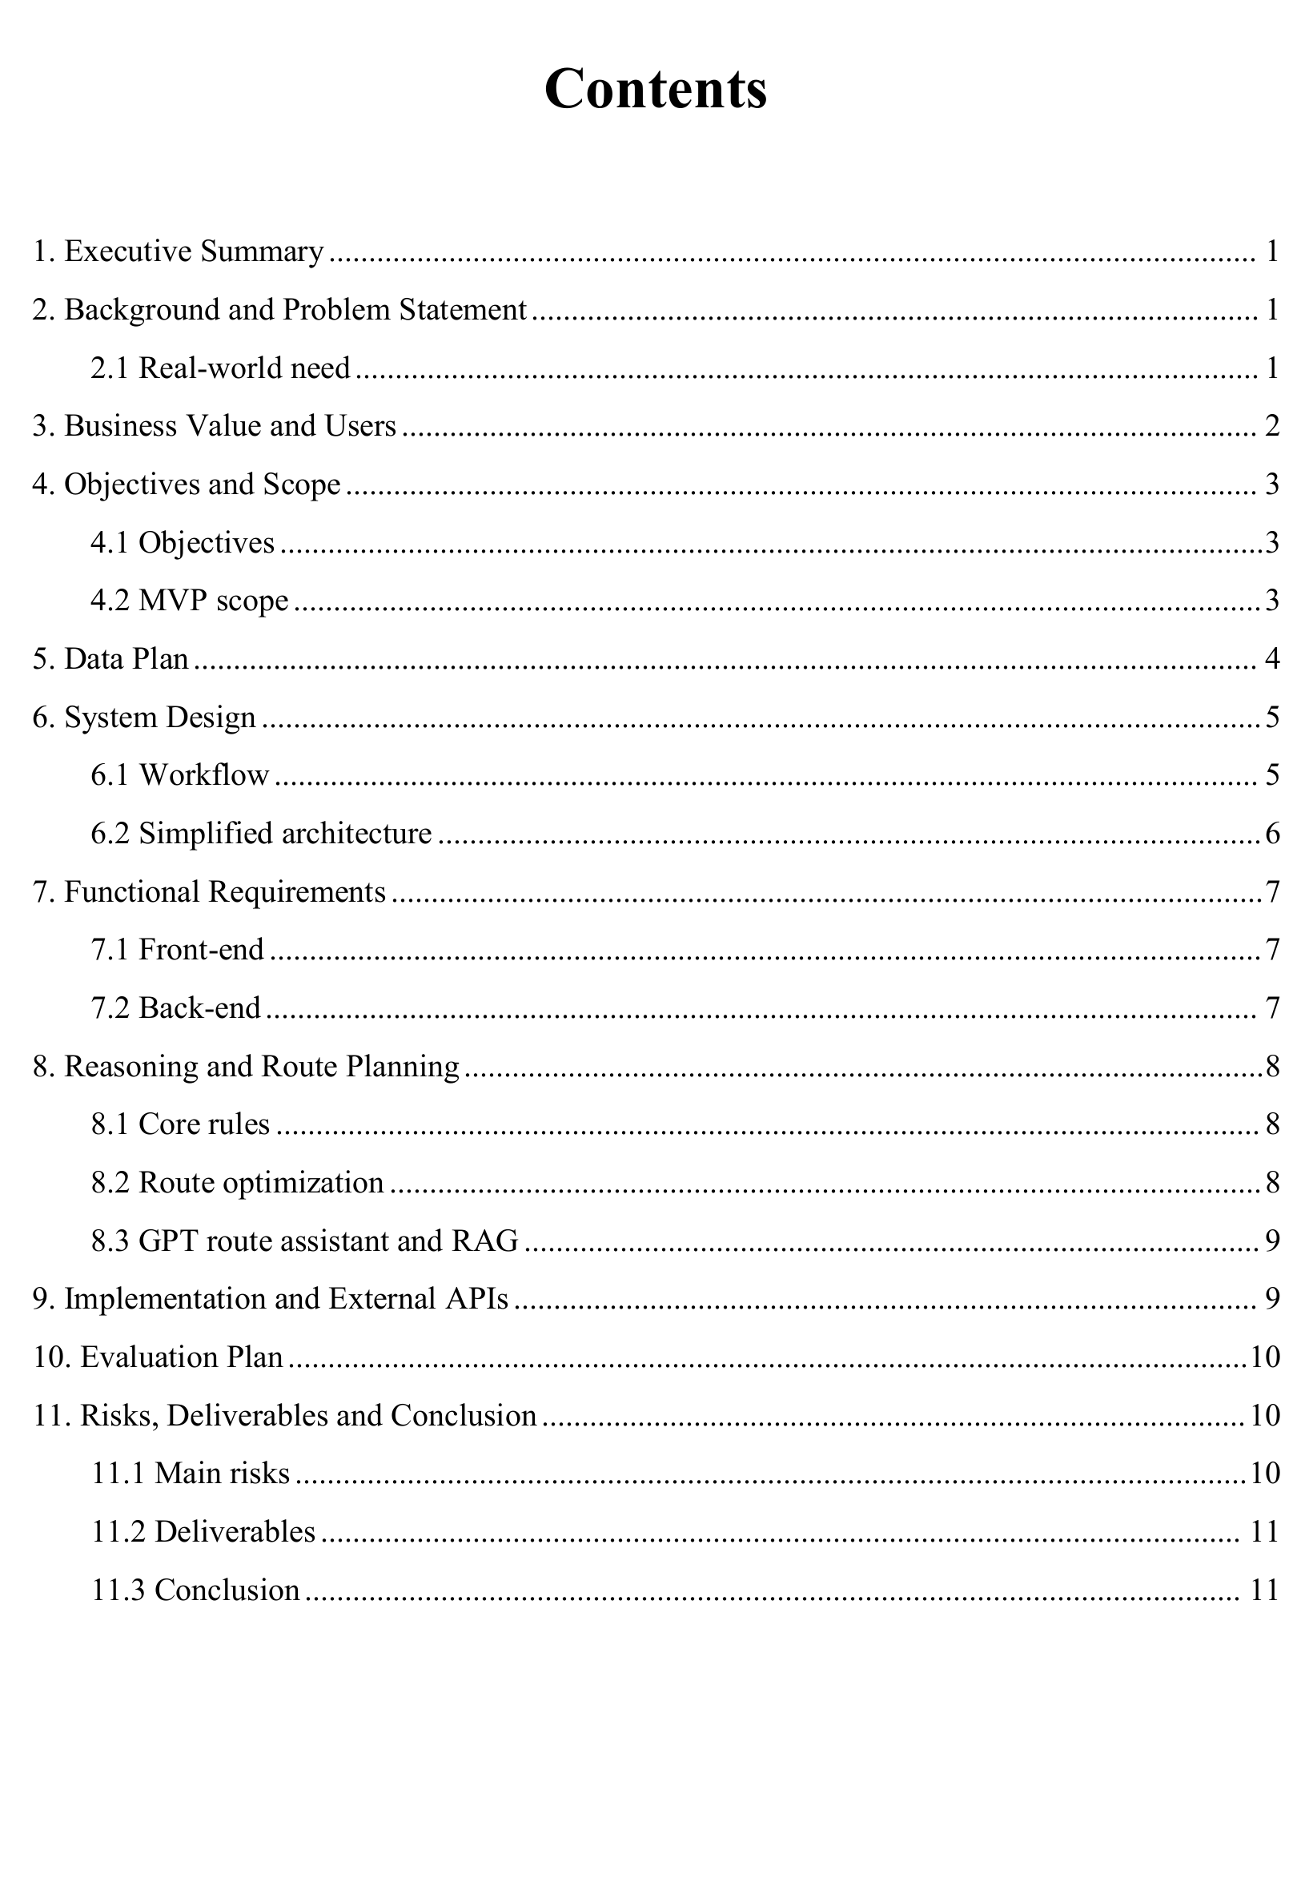
Submitted proposal - source page 3 of 13
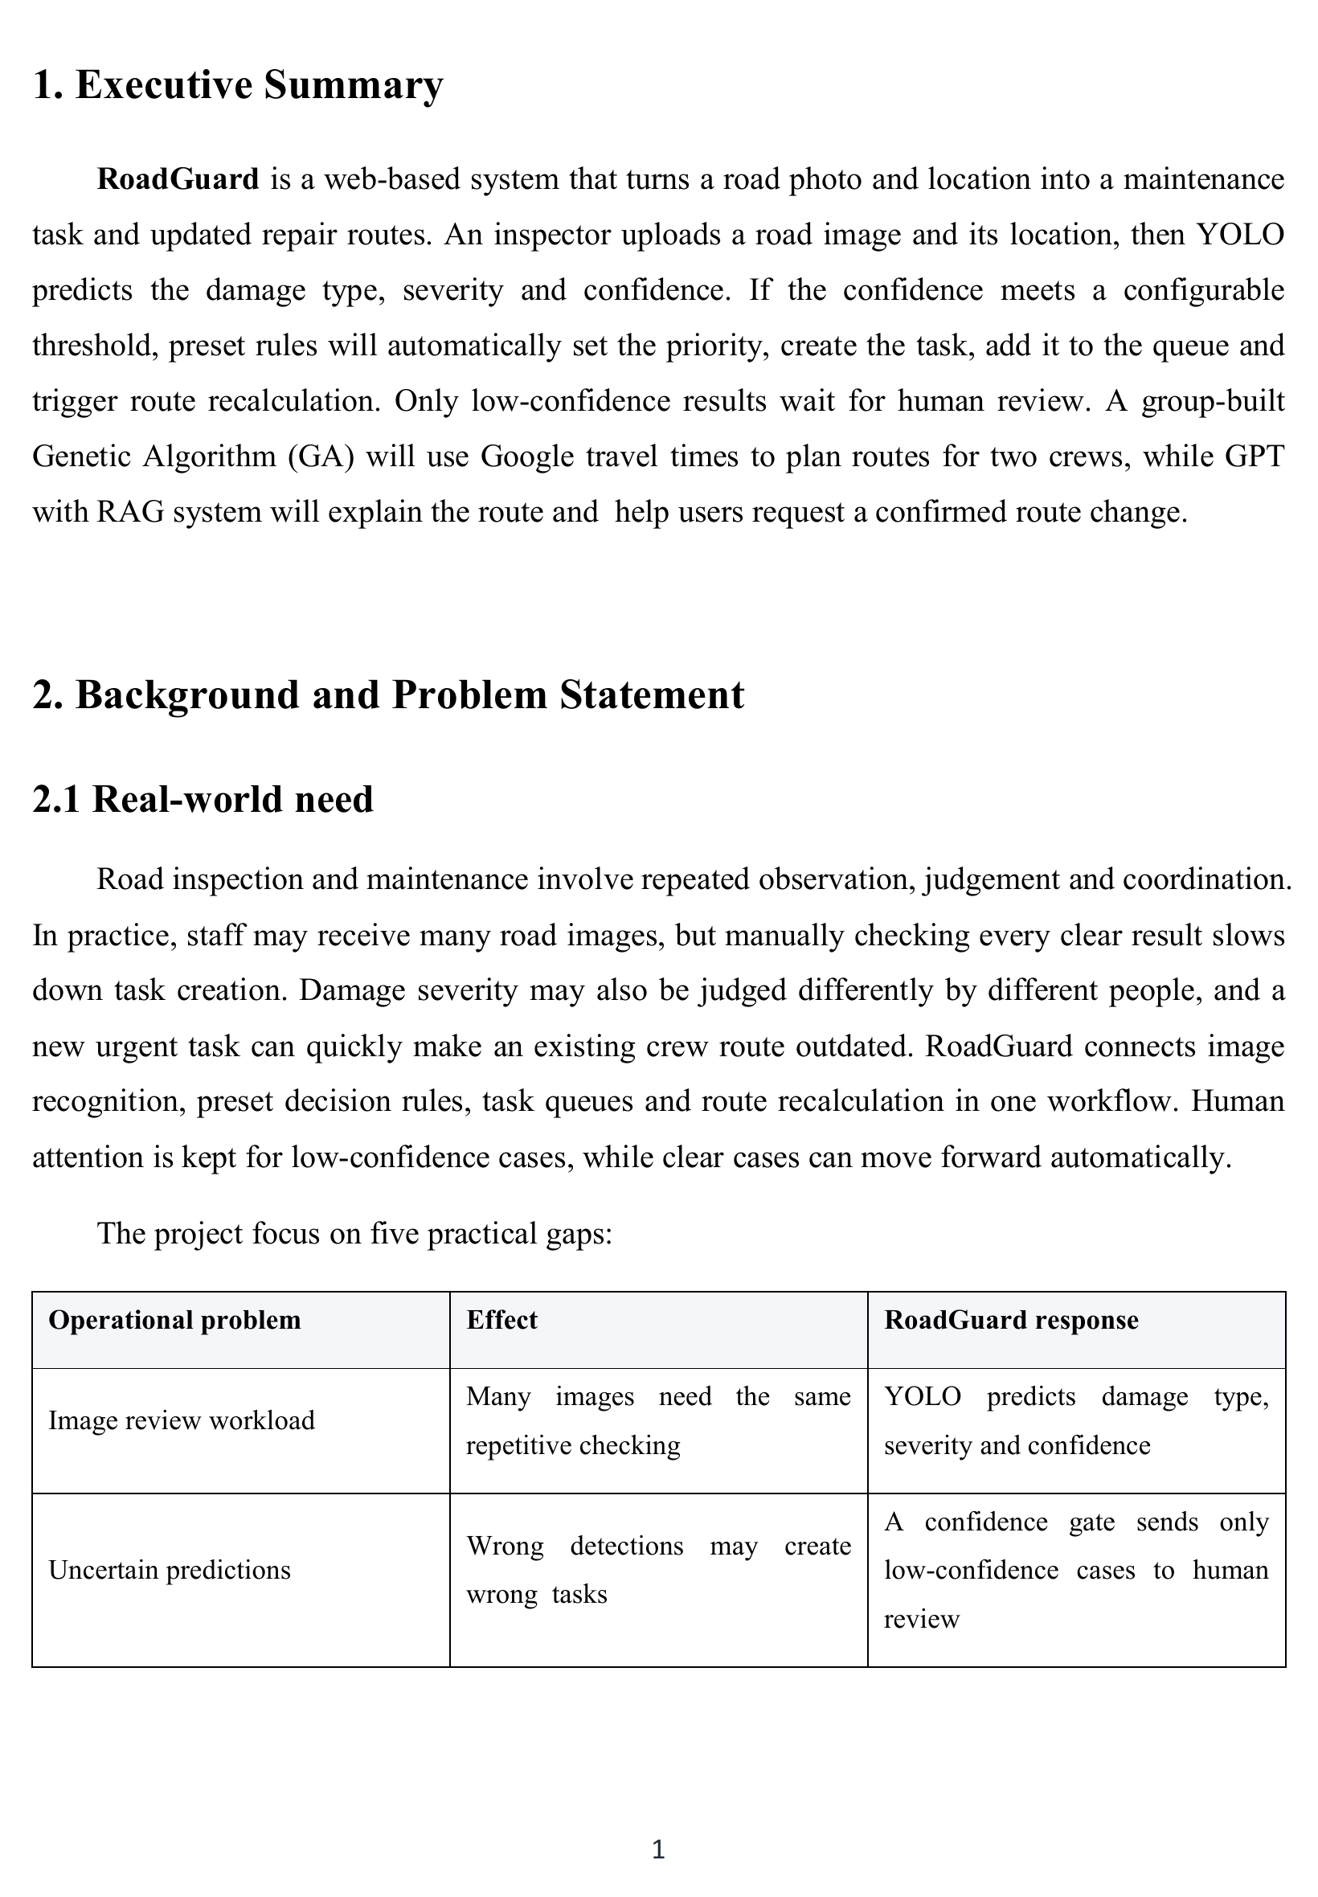
Submitted proposal - source page 4 of 13
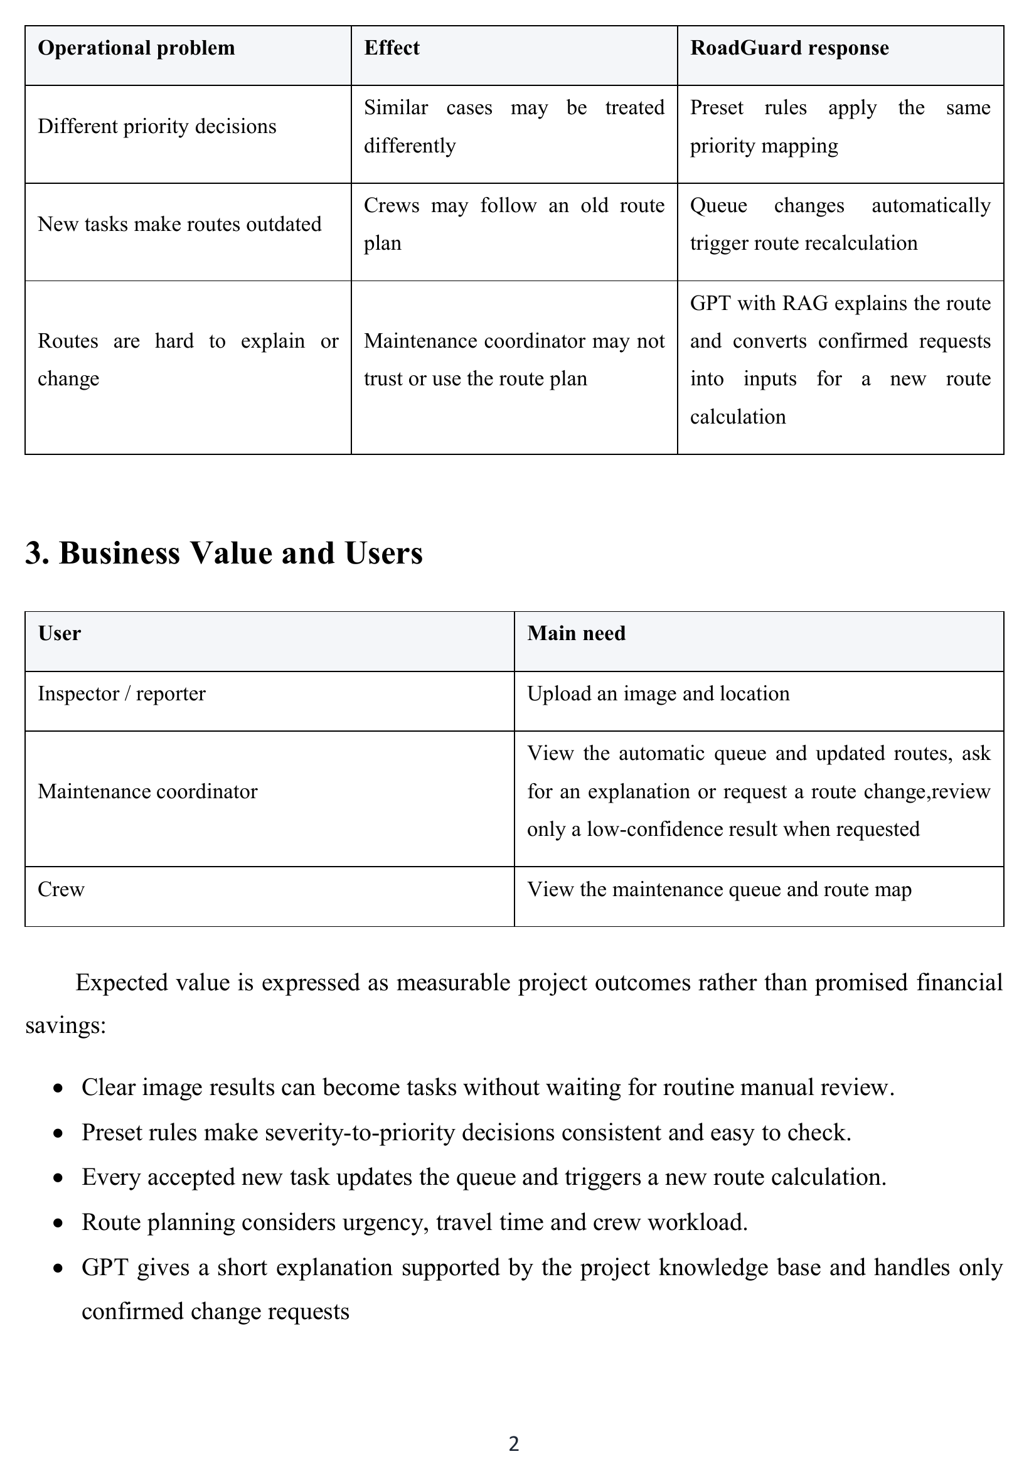
Submitted proposal - source page 5 of 13
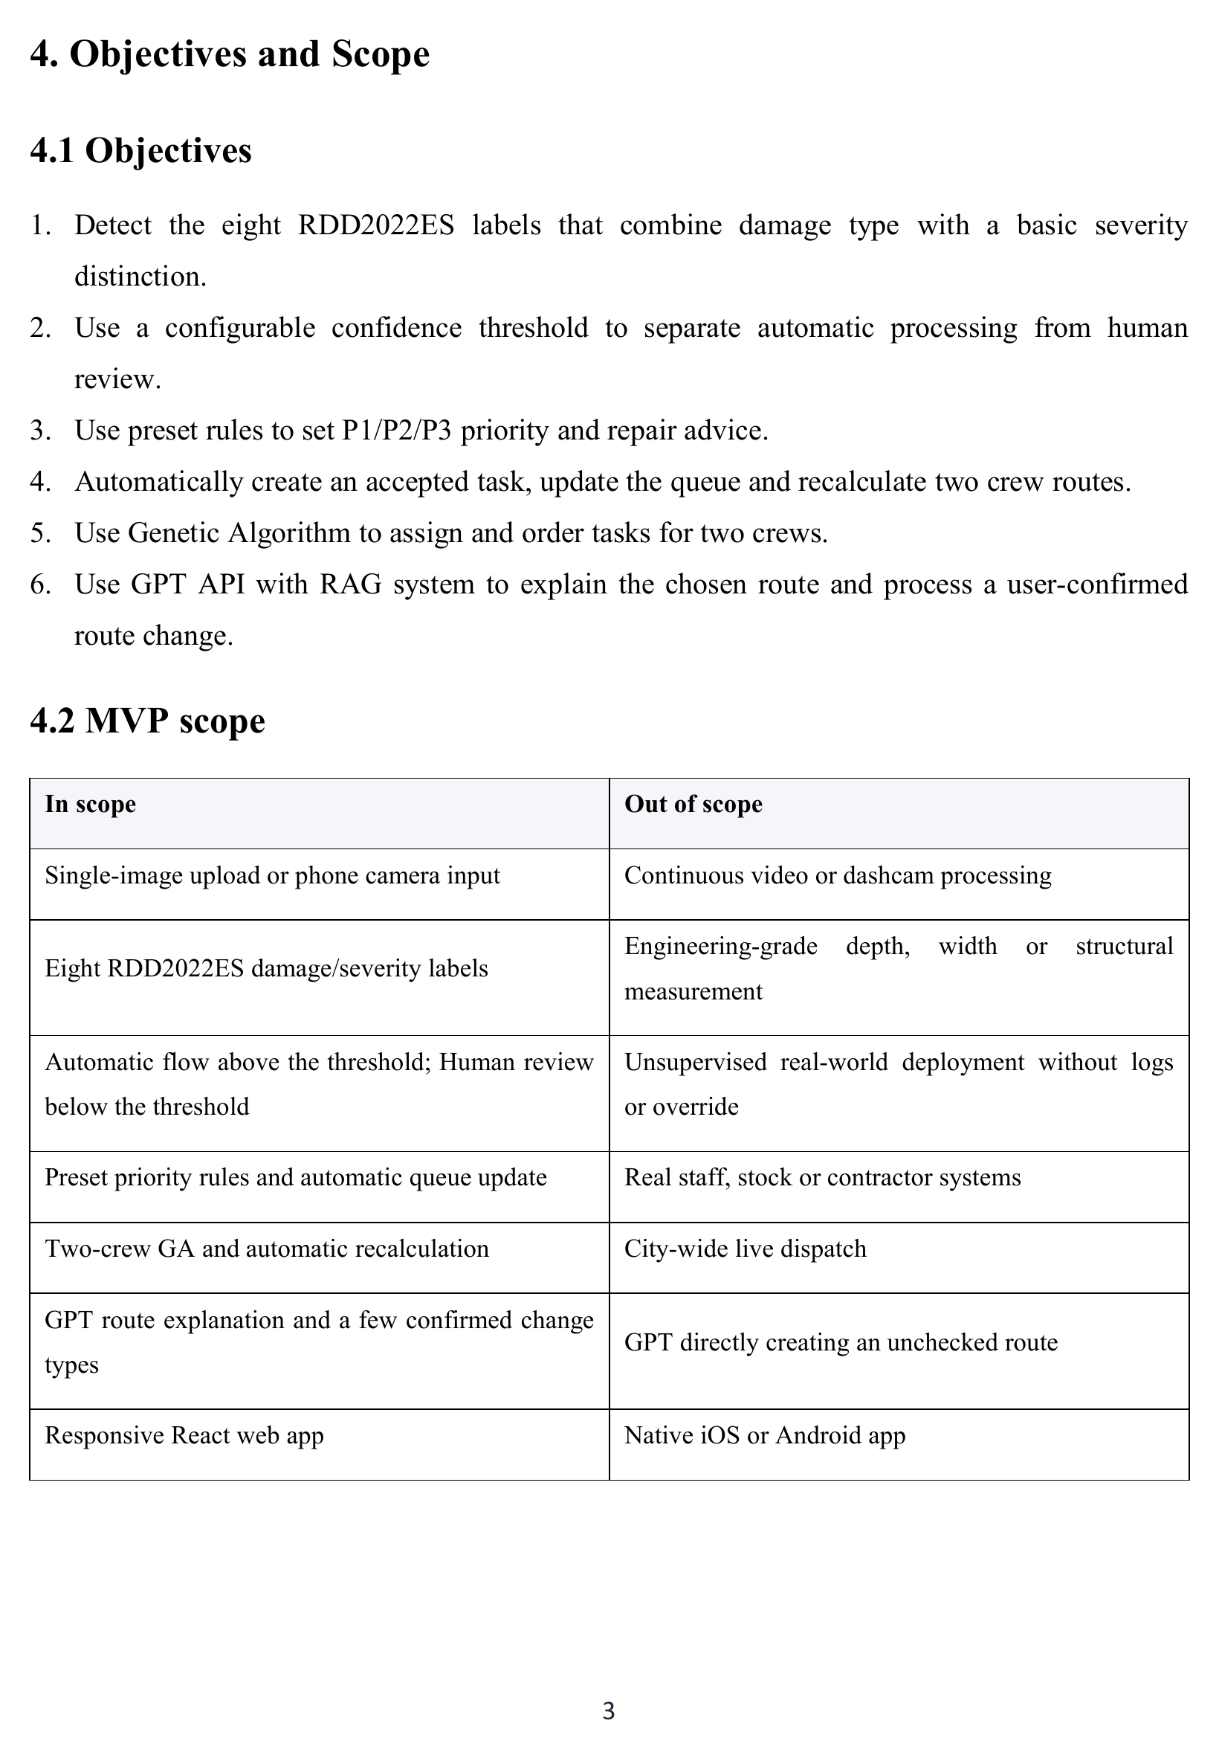
Submitted proposal - source page 6 of 13
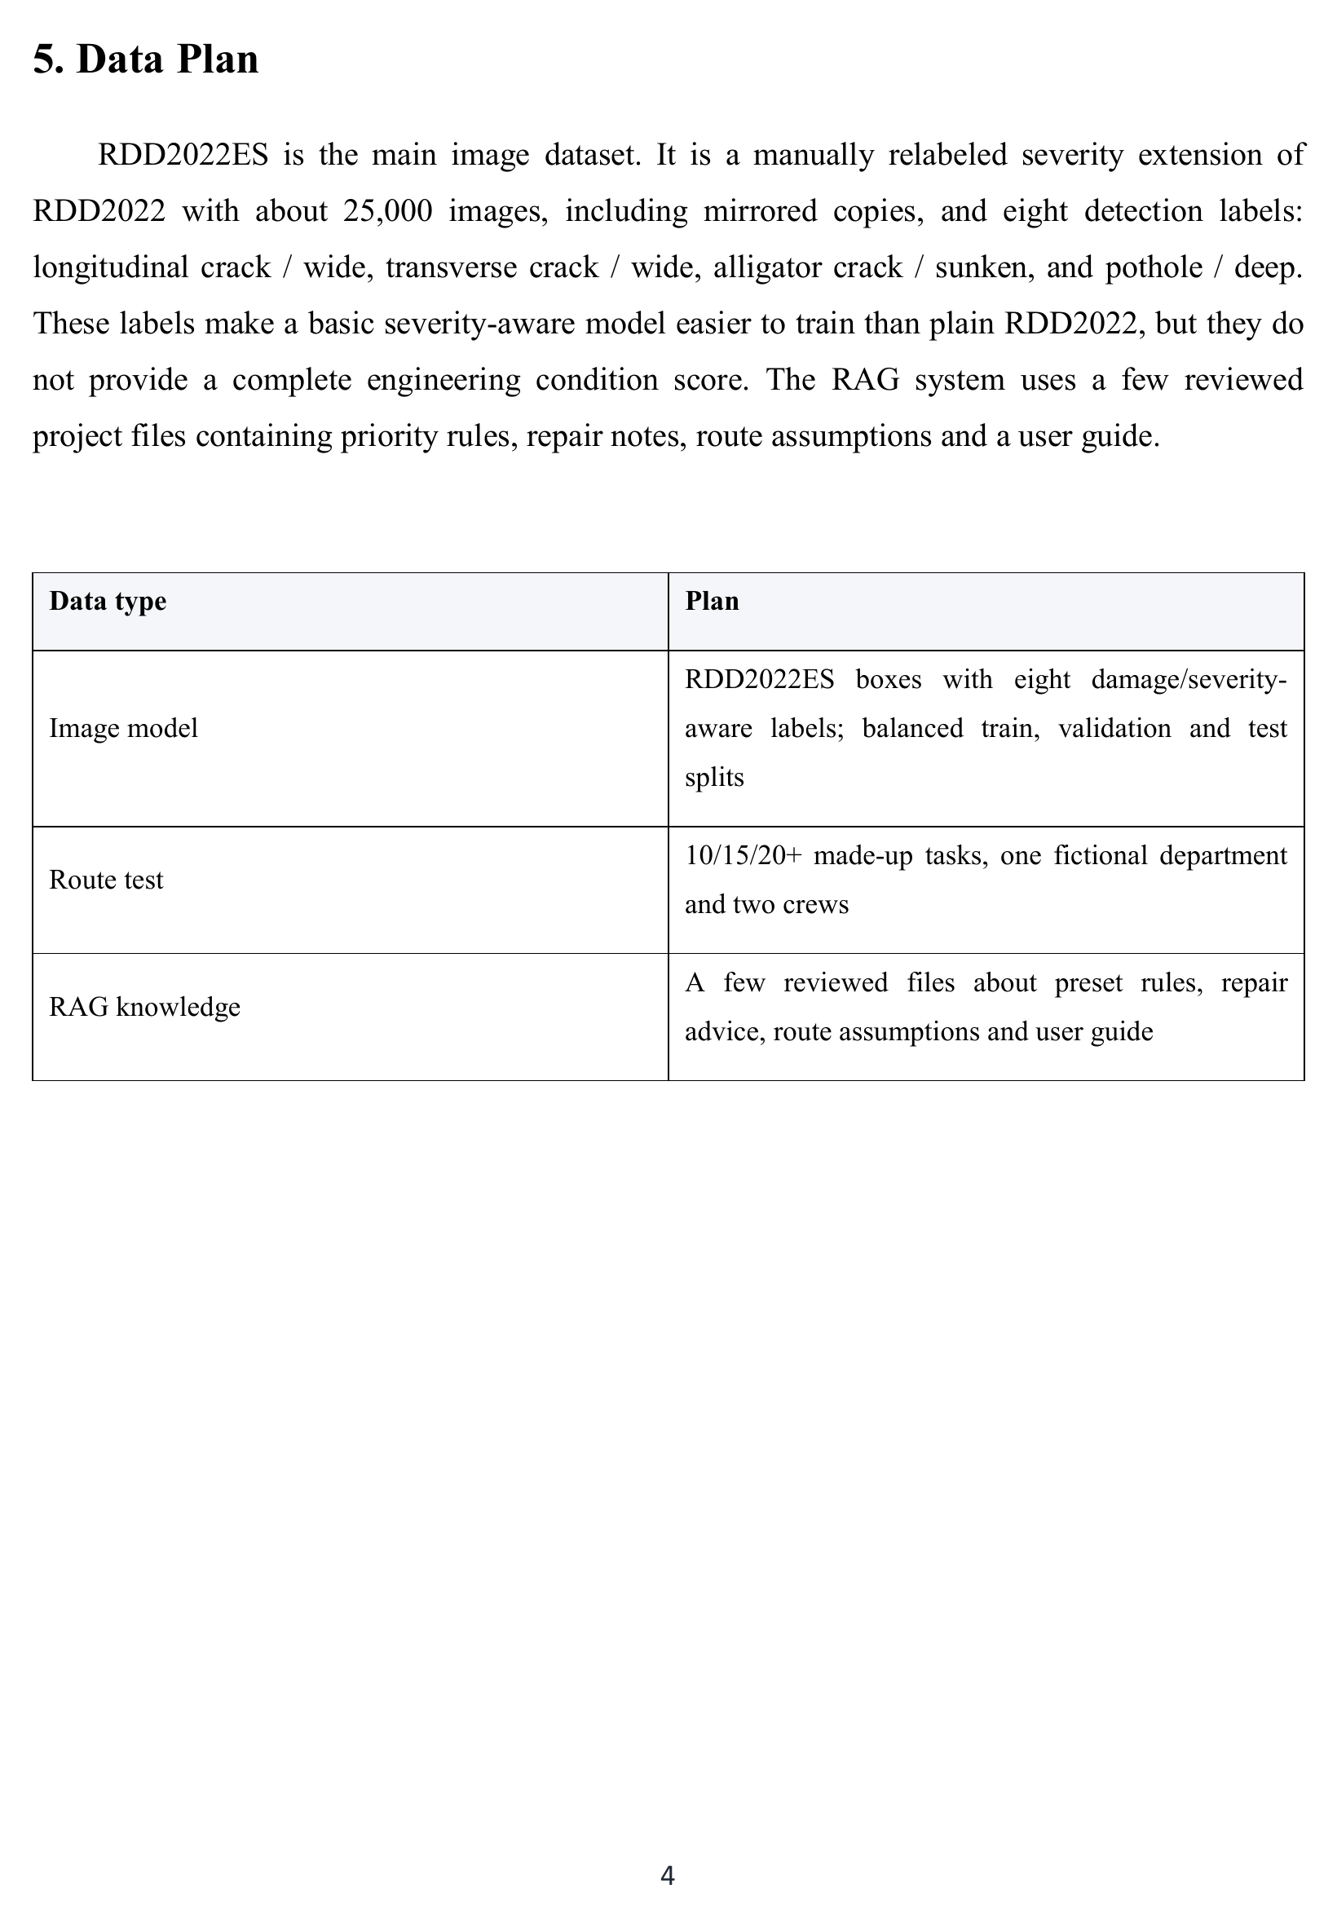
Submitted proposal - source page 7 of 13
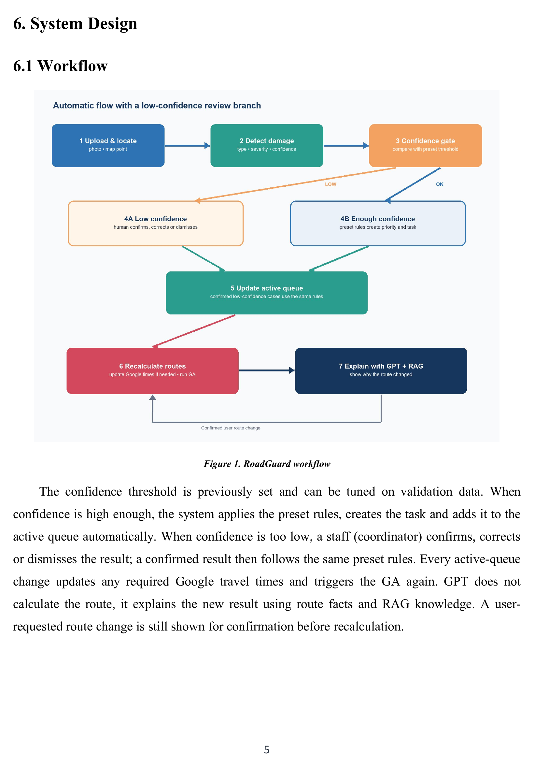
Submitted proposal - source page 8 of 13
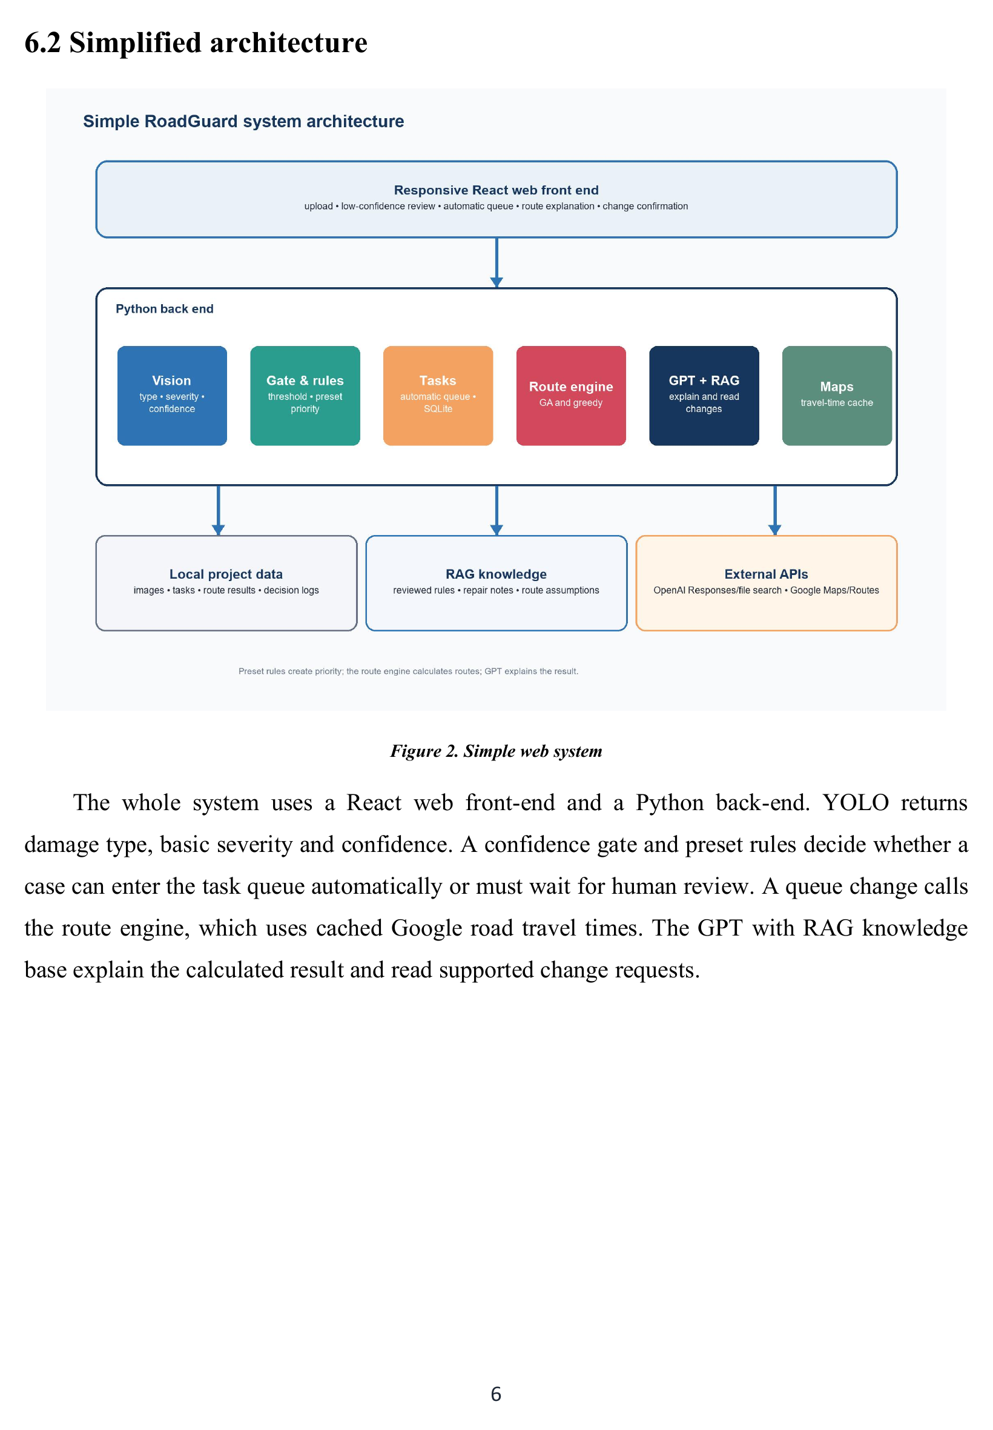
Submitted proposal - source page 9 of 13
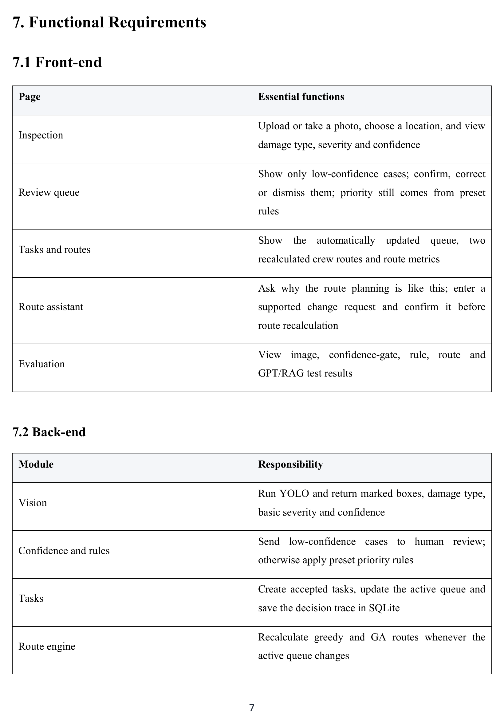
Submitted proposal - source page 10 of 13
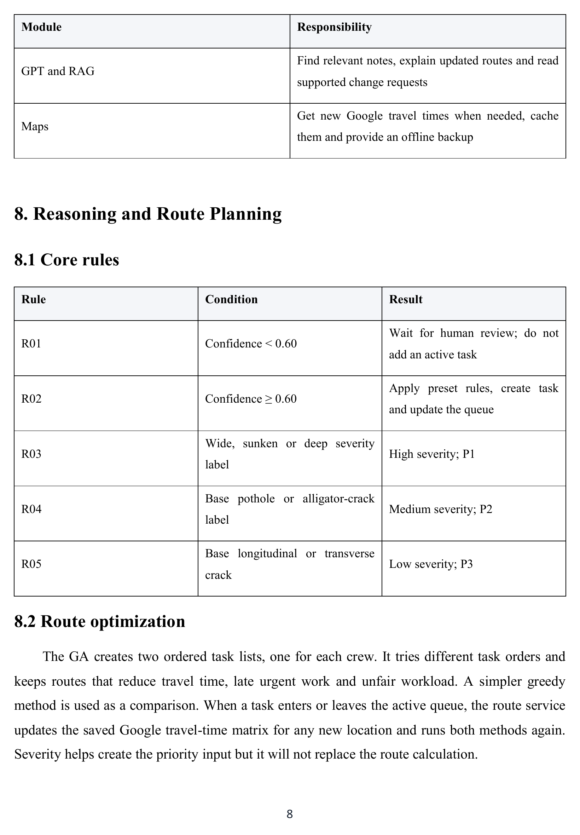
Submitted proposal - source page 11 of 13
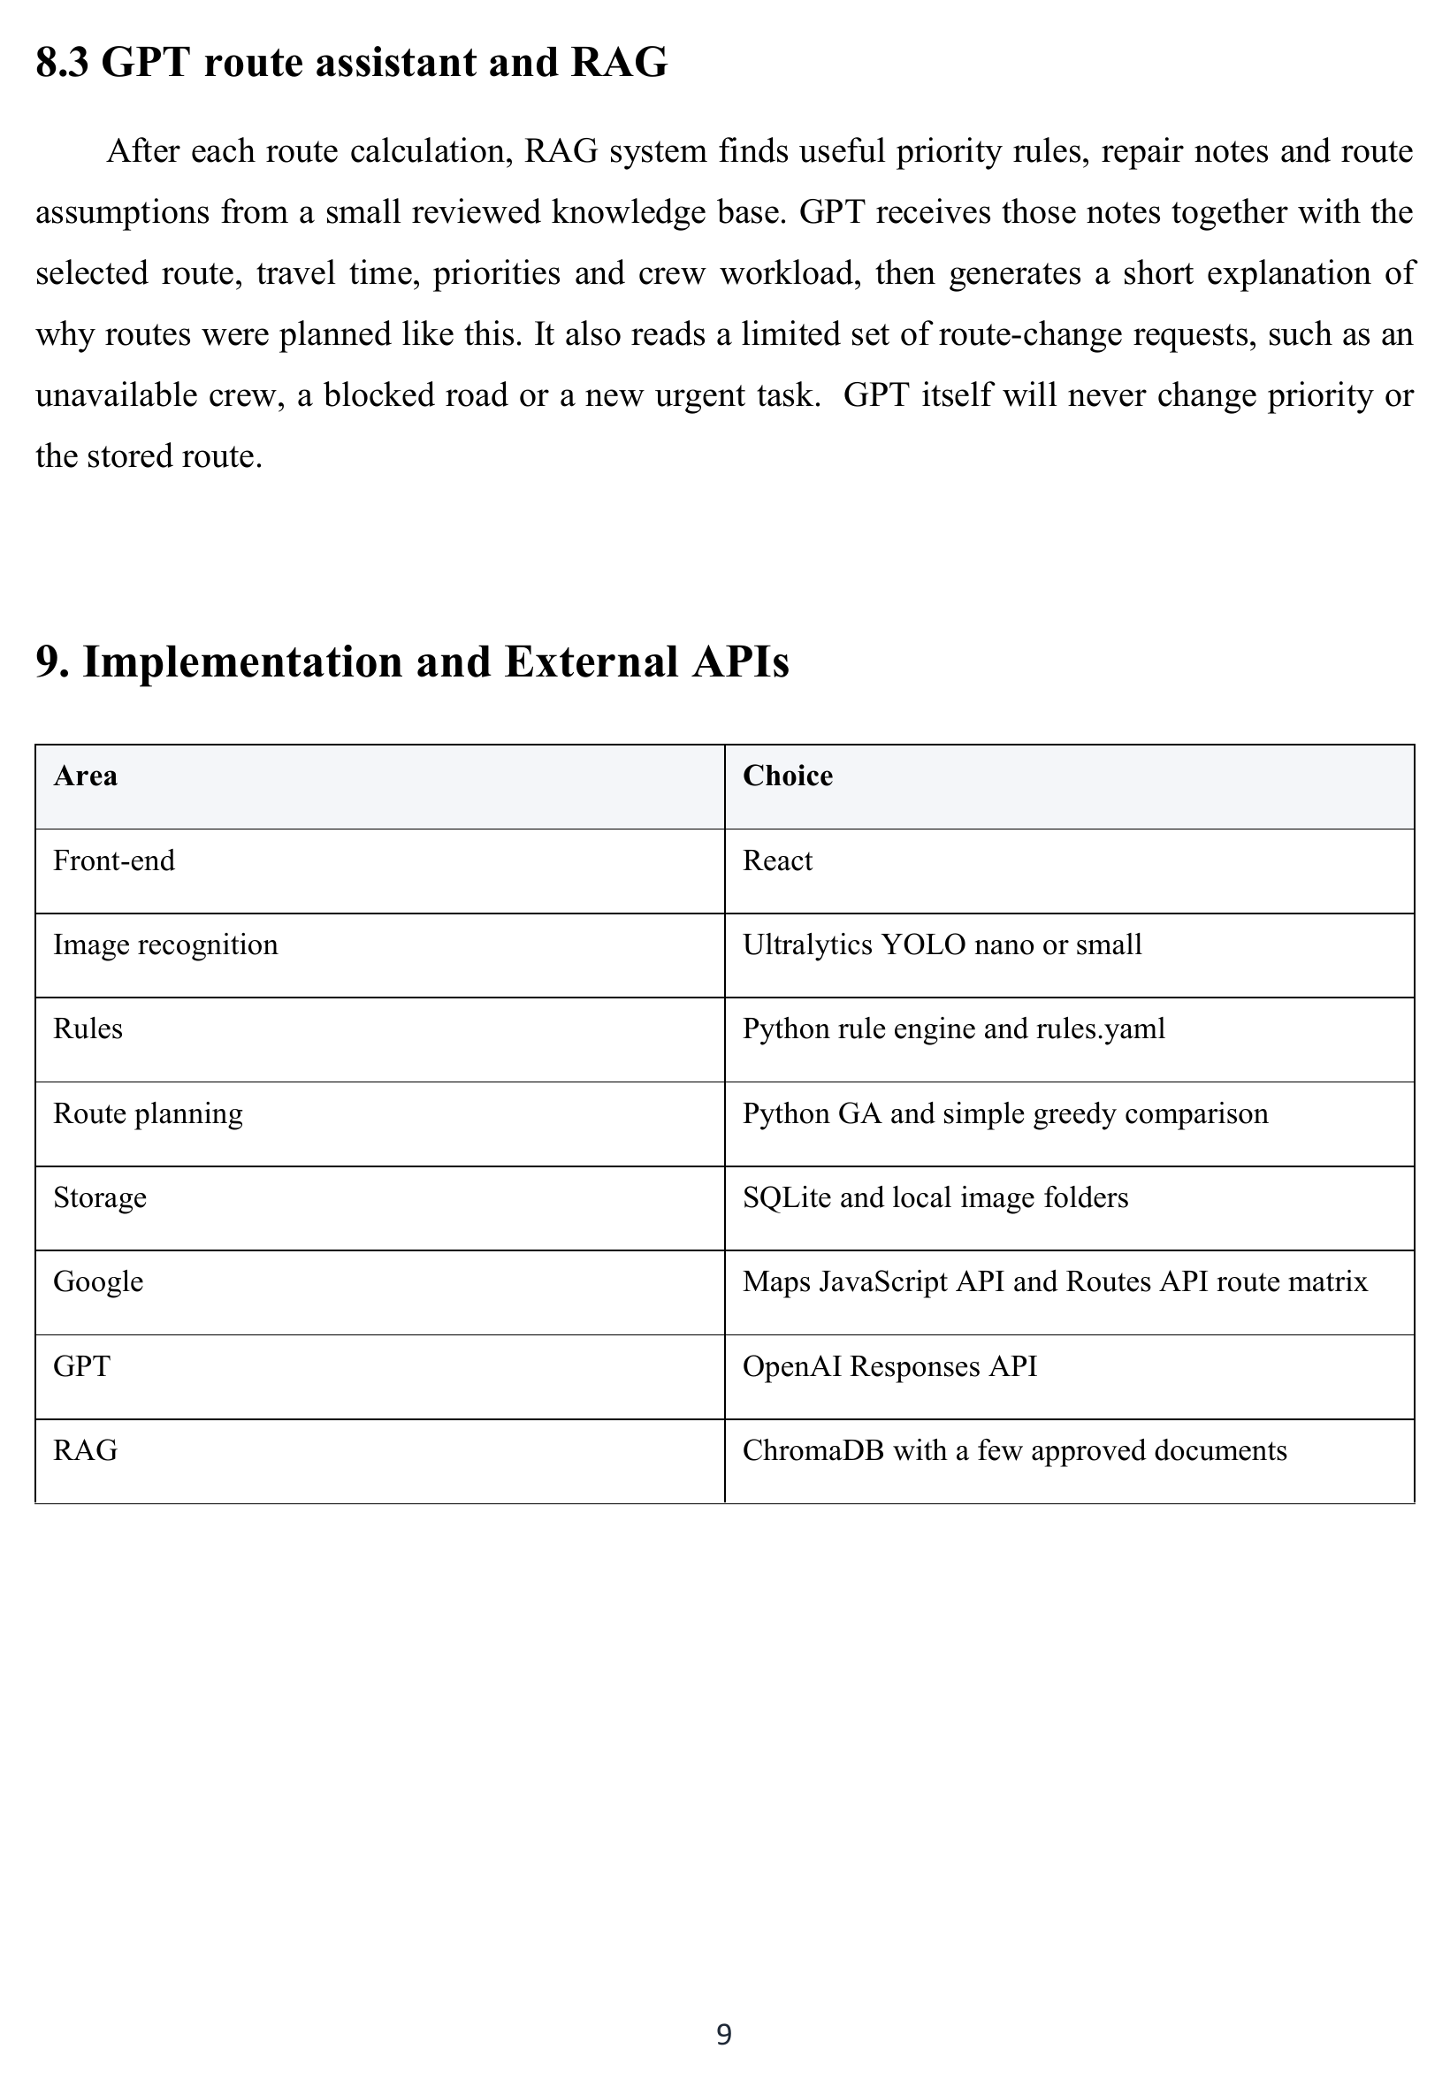
Submitted proposal - source page 12 of 13
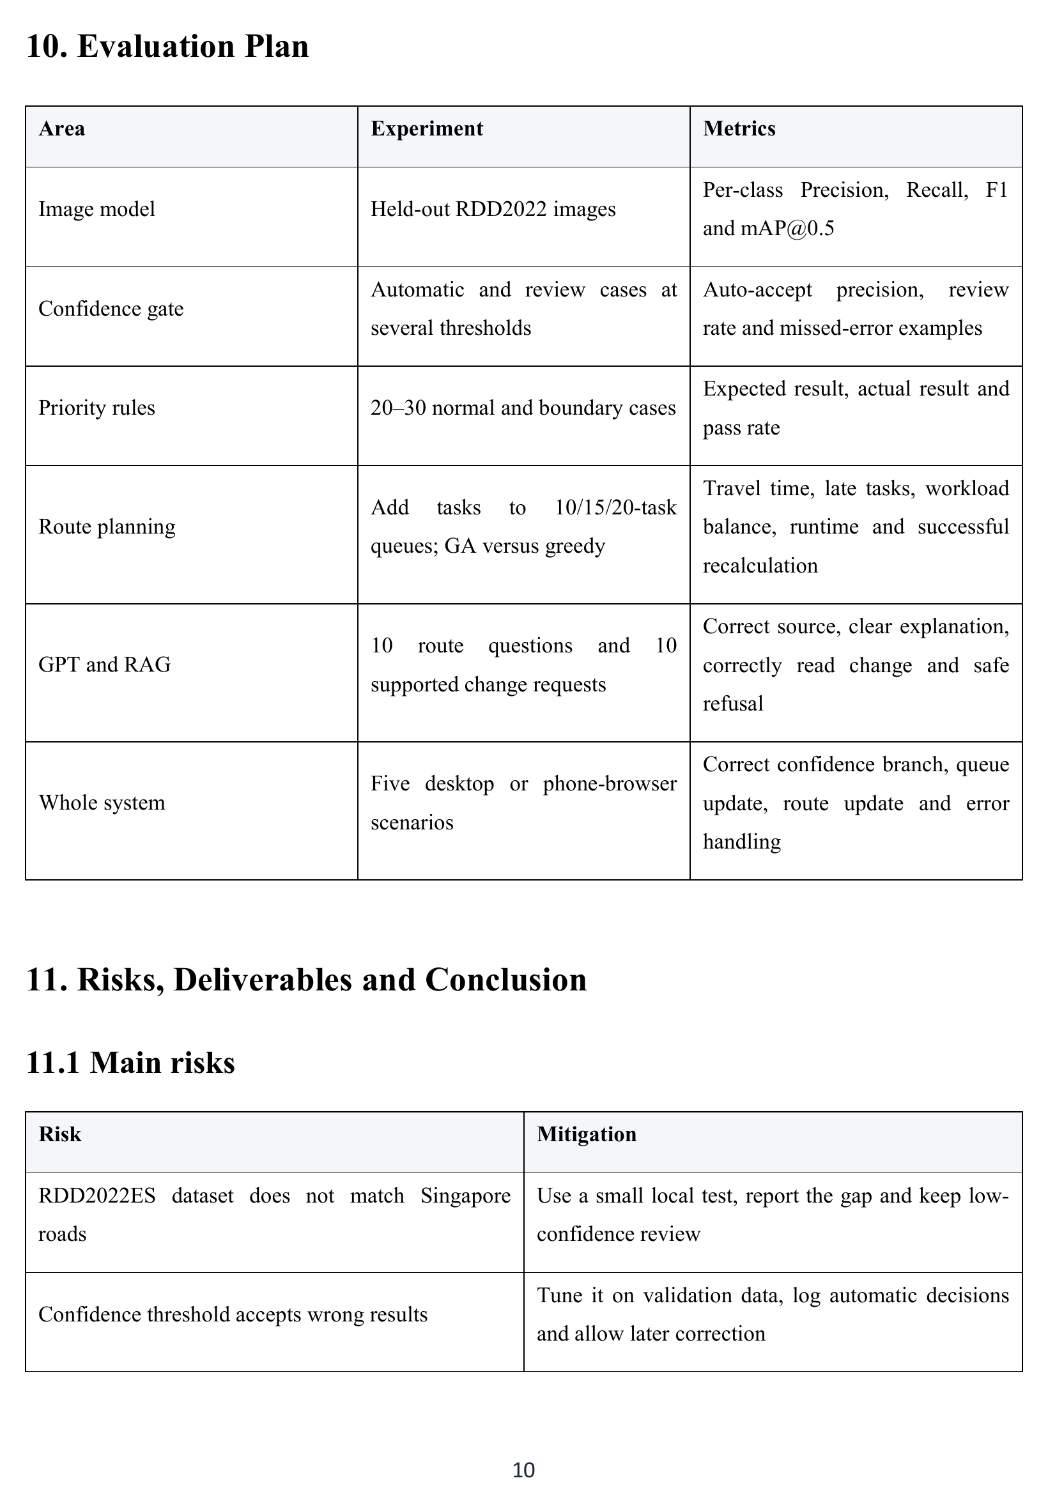
Submitted proposal - source page 13 of 13
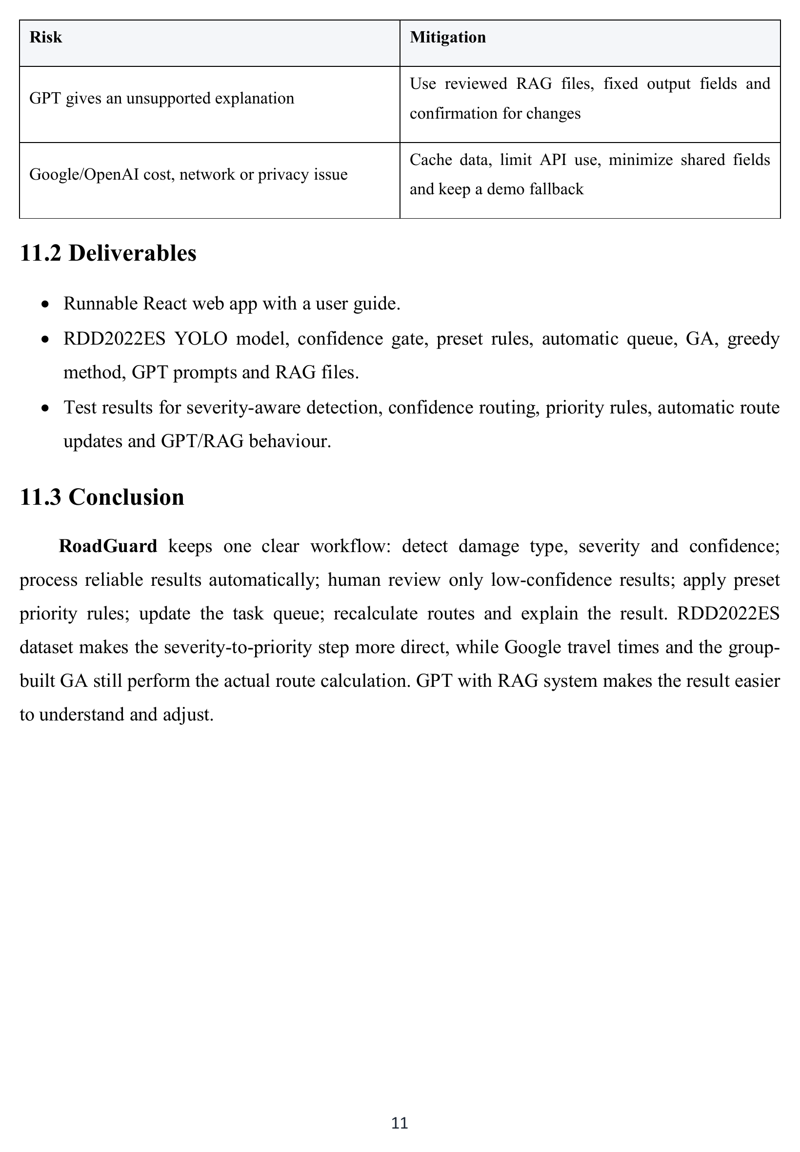

Appendix C Course Functionality Mapping
Table C1 maps implemented functions to the MR, RS and CGS course content and the three applicable technique groups in the practice briefing. It indexes the design and evaluation in the main report without repeating experimental results.
Table C1. Course content applied in the delivered system
Course and technique | Applied function | Implementation evidence | Verification and limits
MR  Decision automation | Confidence routing, repair rules and human correction create tasks. Separately confirmed adjustments govern reassignment and cancellation. | Versioned policies, stored rule snapshots and decision traces; preview validation, durable crew constraints and explicit replanning. | Sections 2, 3.2 and 5.3: boundary, correction, replay and controlled adjustment checks. Service durations remain assumptions.
RS  Evolutionary resource optimisation | Four-crew task assignment and visit ordering. Priority-first coverage precedes a weighted completion, travel and workload objective. | Group-built GA: encoding, selection, crossover, mutation and elitism. GA and Greedy share the evaluator, task snapshot and matrix. | Sections 3.2, 4 and 5.2: 10/15/20 tasks, multiple seeds, seeding ablation and unassigned-task failure analysis. Optimality is not established.
CGS  Learned perception and grounded explanation | YOLO11s predicts eight classes and boxes; primary selection supplies evidence to rules. Retrieval and optional GPT explain reviewed knowledge and authorized saved plans. | Grouped data, supervised training and local inference; static Chroma/E5 index, query-v3 exact citations and server-derived rule answers. Plan facts remain outside the index. | Sections 2–5: recognition metrics and failure audit; distinct actual GPT, local retrieval and controlled cases. Independent local vision validation and broad answer evaluation remain outstanding.
Coverage boundary. Storage, authorization and interface display support these three technique groups. Targeted GPT/RAG acceptance establishes neither universal semantic accuracy nor the complete proposed evaluation.

