PROJECT #2 - Canadian Pension Plans:

Analysis:

- Many R Squared values are nearly 1, indicating strong model performance.
- Mean Squared Errors for some categories (such as Pensionable Earnings and Contributory Earnings) are extremely small, signifying very precise predictions.
- The Mean Absolute Error for Self-Employed Contribution is relatively higher, indicating slightly less accurate predictions for this category compared to others.

DASHBOARD 1:

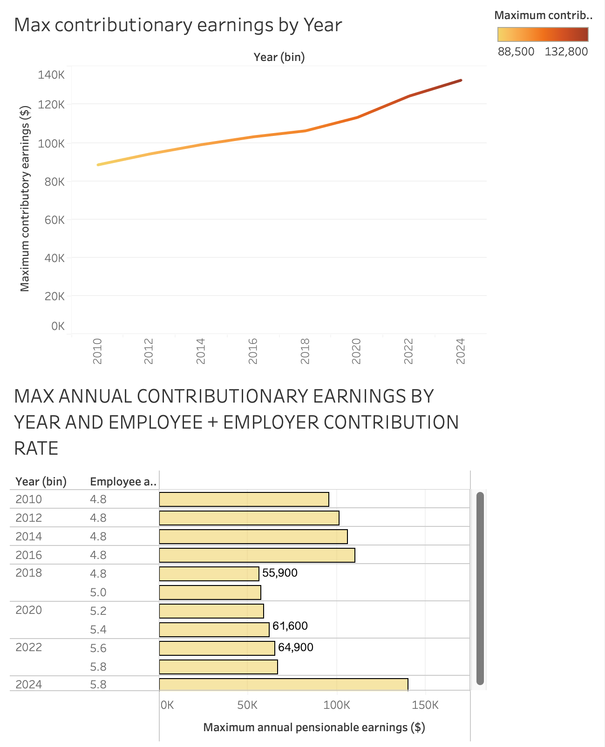

Maximum Contribution Earnings By Year:

- Steady positive correlation
- Never decreases

Maximum Annual Contribution Earnings by Year and Employee + Employer Contribution rate (Bins):

- The Employee + Employer rate stays the same as the early years progress up until 2019.
- The maximum annual pensionable earnings increase when the rates stay at 4.8, it is when they drop down to $55,900, the rate steadily increases as does the contribution earnings.

DASHBOARD 2:

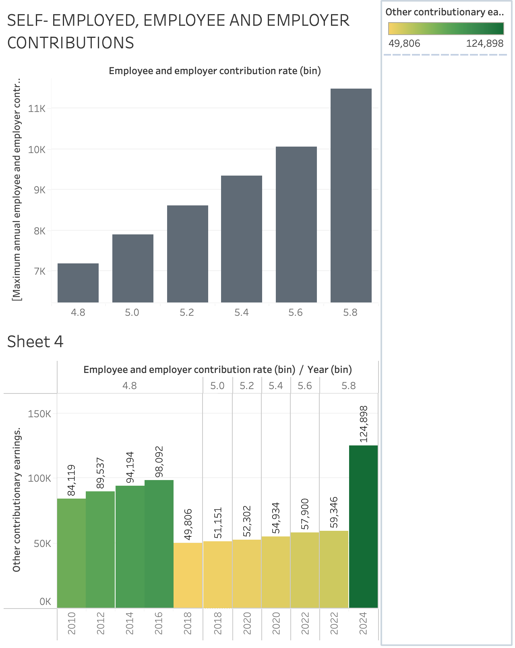

Self-Employed, Employee and Employer contributions:

- Steadily increases as the employee and employer contribution rate increases as well, suggesting that as the rate goes up, there is an increase in contribution.

Other Contribution Earnings by Employee and Employer (bins) + Year (bins)

- Similar and exact result / analysis of the contribution rates visualisation.

