Summarizing the content:

1. Summaries the main points in this module. You may include references to the learning objectives.
2. Optimization Problems
3. Linear Programming
4. Gaussian Elimination
5. Simplex Algorithm
6. How is this useful?

linear programming, mathematical modeling technique in which a linear function is maximized or minimized when subjected to various constraints. This technique has been useful for guiding quantitative decisions in business planning, in industrial engineering, and—to a lesser extent—in the social and physical sciences.

1. How do you plan to use this information?

Linear programming (LP), also called linear optimization, is a method to achieve the best outcome (such as maximum profit or lowest cost) in a mathematical model whose requirements are represented by linear relationships. Linear programming is a special case of mathematical programming (also known as mathematical optimization).

More formally, linear programming is a technique for the optimization of a linear objective function, subject to linear equality and linear inequality constraints. Its feasible region is a convex polytope, which is a set defined as the intersection of finitely many half spaces, each of which is defined by a linear inequality. Its objective function is a real-valued affine (linear) function defined on this polyhedron. A linear programming algorithm finds a point in the polytope where this function has the smallest (or largest) value if such a point exists.

1. Provide summary of your reading list — external resources, websites, book chapters, code libraries, etc.
2. <https://en.wikipedia.org/wiki/Linear_programming>
3. <https://en.wikipedia.org/wiki/Optimization_problem>
4. <https://www.britannica.com/science/linear-programming-mathematics>
5. <https://byjus.com/maths/gauss-elimination-method/>

**Reflecting on the content:**

1. What is the most important thing you learnt in this module?

To efficiently solve a linear program with the simplex algorithm, we would like to convert our

problem into a form where:

* Non-negative constraints are the only inequality constraints.
* All other constraints are equalities.

Solution:

* We should convert our problem into standard form and then convert that standard form into a slack form.
* This will be followed by the application of Simplex

1. How does this relate to what you already know?

In numerical analysis and linear algebra, lower–upper (LU) decomposition or factorization factors a matrix as the product of a lower triangular matrix and an upper triangular matrix (see matrix decomposition). The product sometimes includes a permutation matrix as well. LU decomposition can be viewed as the matrix form of Gaussian elimination. Computers usually solve square systems of linear equations using LU decomposition, and it is also a key step when inverting a matrix or computing the determinant of a matrix. The LU decomposition was introduced by the Polish mathematician Tadeusz Banachiewicz in 1938.[1]

1. Have a look at associated ipynb and reflect on the code given to you for graphical solution of LP.

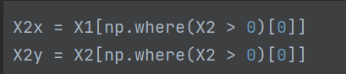

Find the elements in x1 and x2 that are greater than 0.

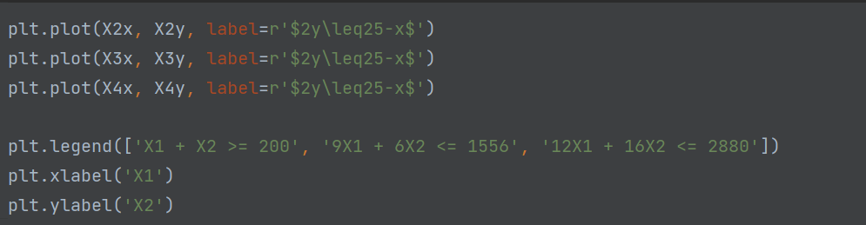

Draw a picture:

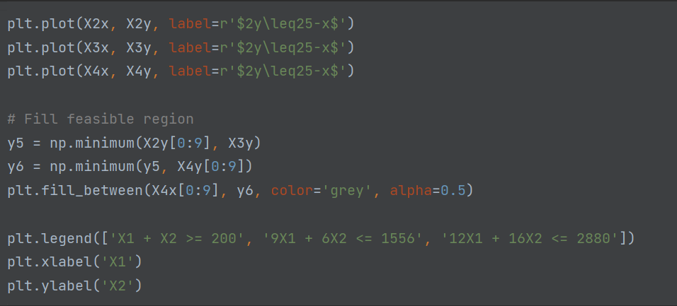

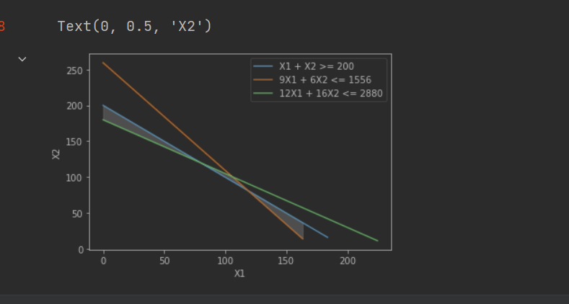

Paint the covered area as shaded.

Find the maximum value of 350X1 + 300X2:

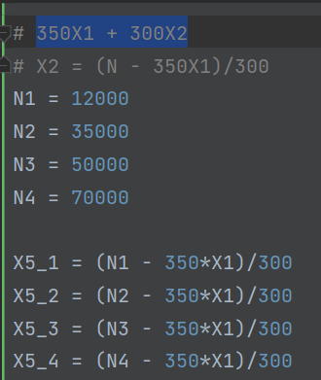

Activity2: Solve the following LP problem graphically using the level curves in this week's lab notebook:

The code and results are shown below. From the screenshots of the code and results, the linear programming problem is Infeasability.

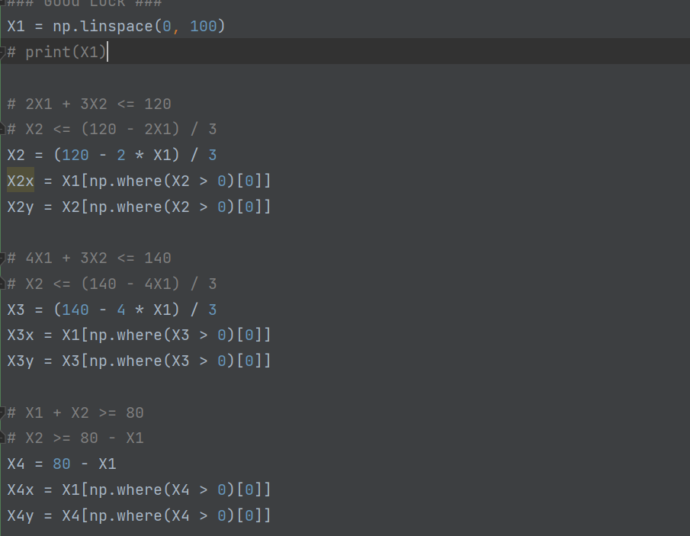

Activity3: Convert the following linear program into Standard Form:

Maximize: $-2X_{1}-7X_{2}+X_{3}$

Subject to: ${-X}_{1}+X_{3}≤-7$

$$X_{1}-X_{3}≤7$$

$$-X_{1}-X_{2}≤-24$$

$$X_{1},X_{2},X_{3}≥0$$

Activity4: Convert the following linear program into Slack Form:

Maximize: $-2X_{1}+6X_{3}$

Subject to: ${7-X}_{1}-X_{2}+X_{3}=X_{4}$

$${3X}_{1}-X_{2}-8=X_{5}$$

$$-X_{1}+{2X}_{2}+2X_{3}=X_{6}$$

$$X_{1},X_{2},X_{3},X_{4},X_{5},X_{6}≥0$$

Activity5: Based on what you learned in the previous section, show that the following linear program in infeasible:

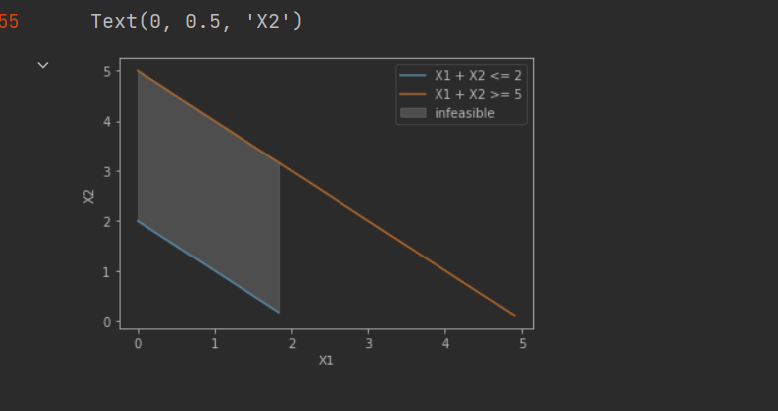

Activity6: Solve the following set of linear equations using forward substitution:

$$\left(\begin{matrix}1 & 0 & 0 \\ 4 & 1 & 0 \\ -5 & 5 & 1\end{matrix}\right)\left(\begin{matrix}x_{1} \\ \begin{matrix}x_{2} \\ x_{3}\end{matrix}\end{matrix}\right)=\left(\begin{matrix}3 \\ 14 \\ -7\end{matrix}\right)$$

$$Ly=b$$

$$\left(\begin{matrix}x_{1} \\ \begin{matrix}x_{2} \\ x_{3}\end{matrix}\end{matrix}\right)=\left(\begin{matrix}3 \\ 2 \\ -2\end{matrix}\right)$$

Activity7: Find an LU Decomposition of the following matrix:

$$\left(\begin{matrix}4 & -5 & 6 \\ 8 & -6 & 7 \\ 12 & -7 & 12\end{matrix}\right)=LU=\left(\begin{matrix}1 & 0 & 0 \\ 2 & 1 & 0 \\ 3 & 2 & 1\end{matrix}\right)×\left(\begin{matrix}4 & -5 & 6 \\ 0 & 4 & -5 \\ 0 & 0 & 4\end{matrix}\right)$$

Activity8: Solve the following linear program using Simplex:

Maximize: $18X_{1}+12.5X_{2}$

Subject to:

$${20-X}_{1}-X_{2}=X_{3}$$

$$12-X_{1}=X_{4}$$

$$16-X_{2}=X_{5}$$

$$X_{1},X_{2},X_{3},X_{4},X_{5}≥0$$

We now stop since no more non-basic variables appear in the objective with a positive coefficient. Our solution is (12, 8, 0, 0, 8) and has a value of 316. Going back to the standard form we started with, we just disregard the values of $X_{3}$ through $X_{5}$ and have the solution that $X_{1}$ = 12 and $X_{2}=8$. We can check that this is both feasible and has the objective achieve 316.