Convolution Matrices for Signal Processing Applications in MATLAB

This M-book requires the Signal Processing Toolbox, version 3.0.

BASIC IDEA - TRANSFER FUNCTION

There are several discrete linear system, a.k.a. digital filter, representations used by the Signal Processing Toolbox. The most commonly used is the transfer function representation, consisting of the ratio of two polynomials
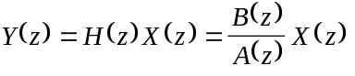

where

and X(z) and Y(z) are the Z-transforms of the input and output sequences x(n) and y(n) respectively:

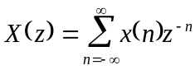
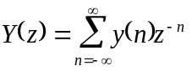
In MATLAB the filter H(z) is represented by vectors containing the polynomial coefficients of B(z) and A(z).

Here is an example filter in the transfer function form

[b,a] = butter(5,.5)

b =
0.0528 0.2639 0.5279 0.5279 0.2639 0.0528
a =
1.0000 -0.0000 0.6334 -0.0000 0.0557 -0.0000

b contains the numerator coefficients, a contains the denominator coefficients.

The filter's Z-transform can be computed around the unit circle 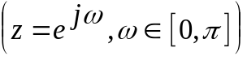 with the freqz function
[H,w] = freqz(b,a);
plot(w,abs(H))
ylabel('Magnitude')
xlabel('Frequency (radians)')
title('Lowpass Filter Response')

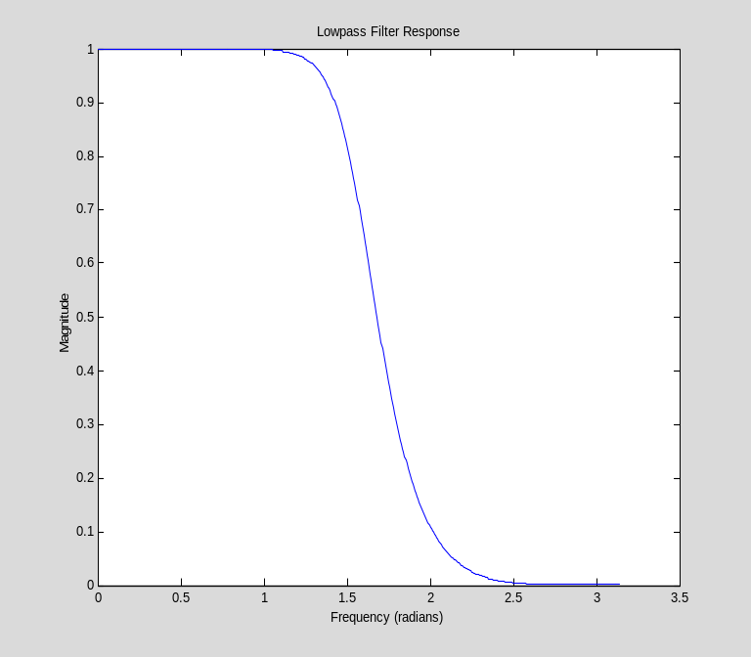

CONVOLUTION MATRIX

The transfer function form is general for linear, time-invariant operators on the space of complex discrete sequences. An alternative general representation for any linear system (time-invariant or not) is an infinite dimensional matrix (a "convolution matrix").

However, infinity is not practical for implementation in MATLAB. Can a finite truncation of this matrix be useful?

IN MATLAB

Representing a system with a finite convolution matrix is ideally suited to MATLAB. Consider a system matrix C, which maps Cm to Cn (the m dimensional space of complex vectors to the n dimensional). Thus C is n-by-m. Given length n input vector x and length m output vector y, the input-output relationship of the system is
y = C*x

Let's compute the impulse response of our filter

h = impz(b,a)

h =
0.0528
0.2639
0.4944
0.3607
-0.0522
-0.1904
0.0055
0.1005
-0.0006
-0.0531
0.0001
0.0280
-0.0000
-0.0148
0.0000
0.0078
-0.0000
-0.0041
0.0000
0.0022
-0.0000
-0.0011
0.0000
0.0006
-0.0000
-0.0003
0.0000
0.0002
-0.0000
-0.0001
0.0000

The rows of the convolution matrix for such a time-invariant system are time shifts of the time-reversed impulse response (if the system were time varying, or adaptive, the rows would all be different in general).

The convmtx function will generate a matrix from an impulse response which, when multiplied by a signal vector, returns the convolution of the signal with the impulse response.

help convmtx

CONVMTX Convolution matrix.
CONVMTX(C,N) returns the convolution matrix for vector C.
If C is a column vector and X is a column vector of length N,
then CONVMTX(C,N)*X is the same as CONV(C,X).
If R is a row vector and X is a row vector of length N,
then X*CONVMTX(R,N) is the same as CONV(R,X).
See also CONV..

C = convmtx(h,10);

Now, take an example signal and see the equivalence of applying the convolution matrix to applying the filter in transfer function form.

format short
C1 = C(1:10,:) % keep only first ten rows (truncates output)
x = randn(10,1); % a random signal
format long e
y = filter(b,a,x)
y1 = C1*x

C1 =
Columns 1 through 7
0.0528 0 0 0 0 0 0
0.2639 0.0528 0 0 0 0 0
0.4944 0.2639 0.0528 0 0 0 0
0.3607 0.4944 0.2639 0.0528 0 0 0
-0.0522 0.3607 0.4944 0.2639 0.0528 0 0
-0.1904 -0.0522 0.3607 0.4944 0.2639 0.0528 0
0.0055 -0.1904 -0.0522 0.3607 0.4944 0.2639 0.0528
0.1005 0.0055 -0.1904 -0.0522 0.3607 0.4944 0.2639
-0.0006 0.1005 0.0055 -0.1904 -0.0522 0.3607 0.4944
-0.0531 -0.0006 0.1005 0.0055 -0.1904 -0.0522 0.3607
Columns 8 through 10
0 0 0
0 0 0
0 0 0
0 0 0
0 0 0
0 0 0
0 0 0
0.0528 0 0
0.2639 0.0528 0
0.4944 0.2639 0.0528
y =
-6.327476116625931e-003
-3.508401686198939e-002
-5.088287847879567e-002
2.113359923355307e-002
5.758050004475002e-002
-1.556115559503205e-001
-4.212745748596921e-001
-2.825565027954645e-001
2.945023636337310e-001
6.022916921622209e-001
y1 =
-6.327476116625931e-003
-3.508401686198939e-002
-5.088287847879567e-002
2.113359923355305e-002
5.758050004475004e-002
-1.556115559503206e-001
-4.212745748596921e-001
-2.825565027954644e-001
2.945023636337310e-001
6.022916921622210e-001

APPLICATION - DECONVOLUTION

Deconvolution is the operation of reconstructing the input to a system, given a description of the system and the output.
H

x(n)
y(n)

Given y(n) and H, find x(n).

An example of this problem is: given the average weekly temperatures throughout the week, can we find the daily temperatures?

For now let's consider the filter b,a we defined up above. As an example input, let's input a square pulse to the filter

n = 30; % length of input signal
t = (0:n-1)'; % index vector
x = (t>5)&(t<15); % a pulse at t = 6,7,8,... 14
y = filter(h,1,x);
clf, plot(t,x,t,y)

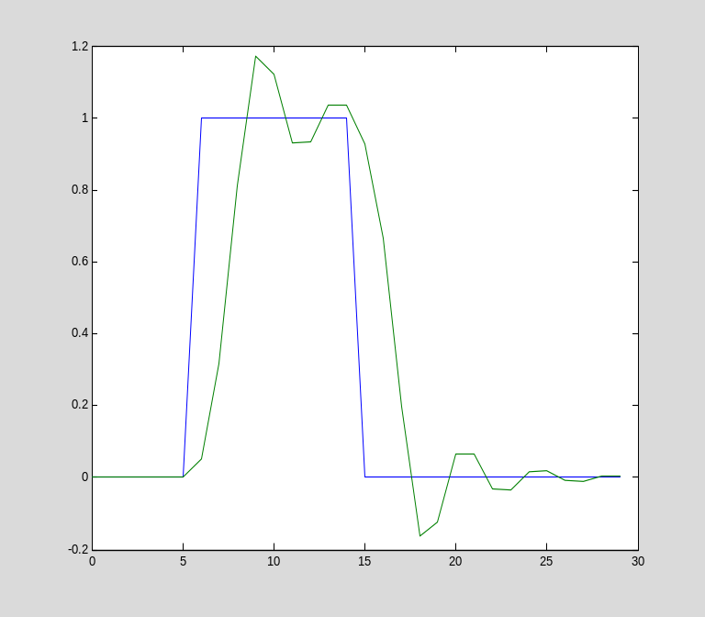

Notice that y is a 'smoothed' version of x.

For a length n signal, this filter's convolution matrix is

C = convmtx(h,n);
C = C(1:n,:); % keep only first n rows (truncates output)

A simple solution is to invert the matrix to recover the input x from the output y. We use \ to get the least squares, or pseudo inverse, solution.

x1 = C\y;
plot(t,x,t,x1)

(This is equivalent to x1 = pinv(C)*y; )

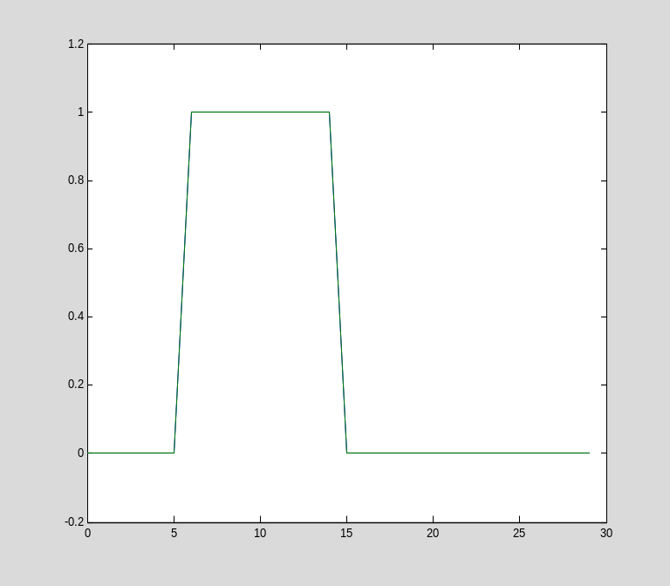

The input has been recovered EXACTLY now (provided the convolution matrix may be inverted).

DECONVOLUTION WITH ADDITIVE NOISE

Now consider the case where there is some noise added to the output of the system prior to the measurements.

+
H

x(n)
y(n)

r(n)

Now the inversion process suffers from 'noise gain'. For example, add some white noise to the output prior to inverting:

r = randn(n,1)/100;
x2 = pinv(C)*(y+r);
plot(t,x,t,x2)

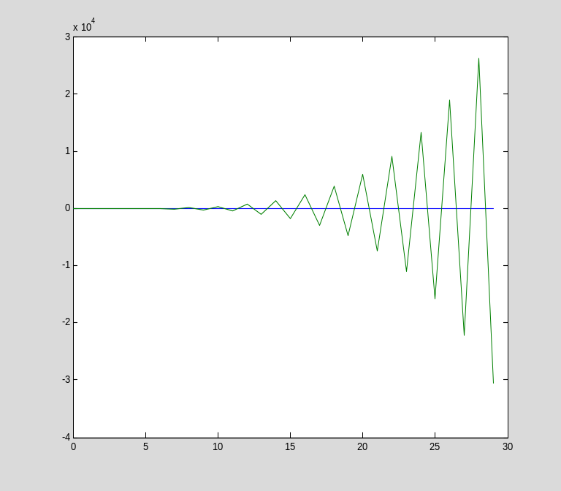

The deconvolved input has gone berserk! Why is this? We only added a bit of noise. The reason is because some of the singular values of our matrix are very very small:

s = svd(C);
clf, plot(s)

When we invert the output y+r, we multiply its coordinates in the basis of the singular vectors of C by the inverse of the singular values.

clf, plot(1./s)

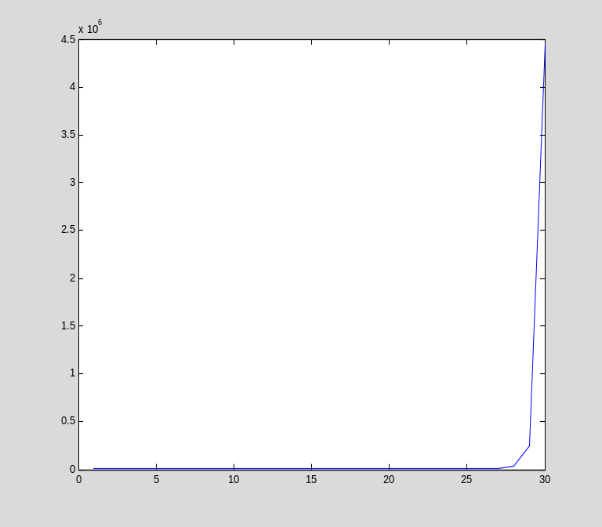

The last 5 or so singular values, when inverted, lead to a HUGE gain in the signal components in the span of those last singular vectors.

TRADING OFF NOISE GAIN FOR RESOLUTION

What can we do about noise gain? We can truncate the inversion to exclude the last singular values that are tiny.

This can be done in the pinv function by passing a tolerance. The pseudo inverse will treat all singular values less than the tolerance as zero.

x2 = pinv(C,s(n-5))*(y+r);
plot(t,x,t,x2)

Here we've truncated the last five singular vectors. We still see a lot of ringing, but the edges of the pulse are very exact.

x2 = pinv(C,s(n-10))*(y+r);
plot(t,x,t,x2)

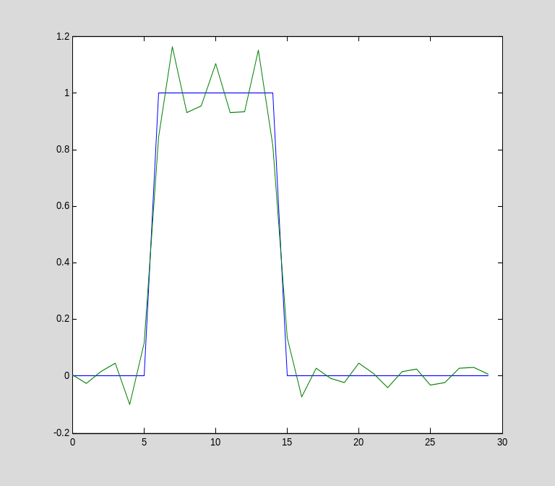

Taking away the last 10 singular vectors, the input pulse is very closely recovered. The ringing is reduced, and the edges of the pulse are easy to distinguish.

x2 = pinv(C,s(5))*(y+r);
plot(t,x,t,x2)

This time, taking away all but 5 singular values, we see very little noise effects but the pulse is smeared. We have lost resolution but have also reduced noise gain.

TRY ME

Try this out with other filters, signal lengths, signals, and number of singular values retained.

