Trịnh Duy Hưng 191 3652

http://www.zun.vn/tai-lieu/he-dieu-hanh-ky-thuat-phan-trang-42393/

Câu 1:

Assume that a task is divided into four equal-sized segments and that the system builds an eight-entry page descriptor table for each segment.

Thus, the system has a combination of segmentation and paging. Assume also that the page size is 2 Kbytes.

1.What is the maximum size of each segment?

2.What is the maximum logical address space for the task?

3.Assume that an element in physical location 00021ABC is accessed by this task.

What is the format of the logical address that the task generates for it?

What is the maximum physical address space for the system?

1. 1 trang = 2 KB

1 segment = 8 trang

=> 1 segment = 16 KB.

1. Task = 4 segments

=> task = 4 * 16 = 64 KB.

1. 2 KB = 2 ^ 11 bytes.

=> offset = 11 bits.

Page table for each segment has 8 entries => 3 bits.

=> Số thự tự cho segment = 2 bits

Địa chỉ dài 32 bit mà off set chiếm 11 bit vậy frame có 21 bit

Frame Off set

0000 0000 0000 0010 0001 1 | 010 1011 1100

Câu 2:

Giả sử:

|  |  |  |  |  |  |  |  |
| --- | --- | --- | --- | --- | --- | --- | --- |
| Segment tables | |  | Page A | |  | Page B | |
| 0 | Page A |  | 0 | A000 |  | 0 | B000 |
| 1 | Page B |  | 1 | A001 |  | 1 | B001 |
| 2 | … |  | 2 | A002 |  | 2 | B002 |
| … |  |  | 3 | A003 |  | 3 | B003 |
|  |  |  | … |  |  | … |  |

Segment Page Offset

1. 0 000 0000

=> page A, off set 0

=> 0x A000 000

1. 2 002 2002

=> không có page nào tại index 2

=> bad virtual address

1. 1 001 5555

=> page B, off-set 1

=> 0x B001 5555

Câu 8.9

Internal fragmentation xảy ra khi vùng nhớ cấp cho process lớn hơn process.

External fragmentation xảy ra khi các vủng nhớ trống bị bỏ lãi riêng lẻ gộp lại đủ cung cấp cho process tiếp theo.

Partitions

|  |  |  |  |  |  |
| --- | --- | --- | --- | --- | --- |
| 300 | 600 | 350 | 200 | 750 | 125 |

Processes

|  |
| --- |
| 115 |
| 500 |
| 358 |
| 200 |
| 375 |

First fit. Allocate the first hole that is big enough.

|  |  |  |  |  |  |
| --- | --- | --- | --- | --- | --- |
| 300 | 600 | 350 | 200 | 750 | 125 |

115

|  |  |  |  |  |  |
| --- | --- | --- | --- | --- | --- |
| 185 | 600 | 350 | 200 | 750 | 125 |

500

|  |  |  |  |  |  |
| --- | --- | --- | --- | --- | --- |
| 185 | 100 | 350 | 200 | 750 | 125 |

358

|  |  |  |  |  |  |
| --- | --- | --- | --- | --- | --- |
| 185 | 100 | 350 | 200 | 392 | 125 |

200

|  |  |  |  |  |  |
| --- | --- | --- | --- | --- | --- |
| 185 | 100 | 150 | 200 | 392 | 125 |

375

|  |  |  |  |  |  |
| --- | --- | --- | --- | --- | --- |
| 185 | 100 | 150 | 200 | 17 | 125 |

Best fit. Allocate the smallest hole that is big enough

|  |  |  |  |  |  |
| --- | --- | --- | --- | --- | --- |
| 300 | 600 | 350 | 200 | 750 | 125 |

115

|  |  |  |  |  |  |
| --- | --- | --- | --- | --- | --- |
| 300 | 600 | 350 | 200 | 750 | 10 |

500

|  |  |  |  |  |  |
| --- | --- | --- | --- | --- | --- |
| 300 | 100 | 350 | 200 | 750 | 10 |

358

|  |  |  |  |  |  |
| --- | --- | --- | --- | --- | --- |
| 300 | 100 | 350 | 200 | 392 | 10 |

200

|  |  |  |  |  |  |
| --- | --- | --- | --- | --- | --- |
| 300 | 100 | 350 | 0 | 392 | 10 |

Free 375

|  |  |  |  |  |  |
| --- | --- | --- | --- | --- | --- |
| 300 | 100 | 350 | 0 | 17 | 10 |

-------------------------------------------------------------------------------------------------------

Worst fit. Allocate the largest hole

|  |  |  |  |  |  |
| --- | --- | --- | --- | --- | --- |
| 300 | 600 | 350 | 200 | 750 | 125 |

115

|  |  |  |  |  |  |
| --- | --- | --- | --- | --- | --- |
| 300 | 600 | 350 | 200 | 635 | 125 |

500

|  |  |  |  |  |  |
| --- | --- | --- | --- | --- | --- |
| 300 | 600 | 350 | 200 | 135 | 125 |

358

|  |  |  |  |  |  |
| --- | --- | --- | --- | --- | --- |
| 300 | 242 | 350 | 200 | 135 | 125 |

200

|  |  |  |  |  |  |
| --- | --- | --- | --- | --- | --- |
| 300 | 242 | 150 | 200 | 135 | 125 |

350 KB process must wait…………………..

|  |  |  |  |  |  |
| --- | --- | --- | --- | --- | --- |
| 300 | 242 | 150 | 200 | 135 | 125 |

Giải thuật best-fit là giải thuật tốt nhất vì nó để lại nhiều lỗ trống free holes nhất.

Bonus:

Best-fit mất O(n) trong khi First-fit luôn luôn là O(1).

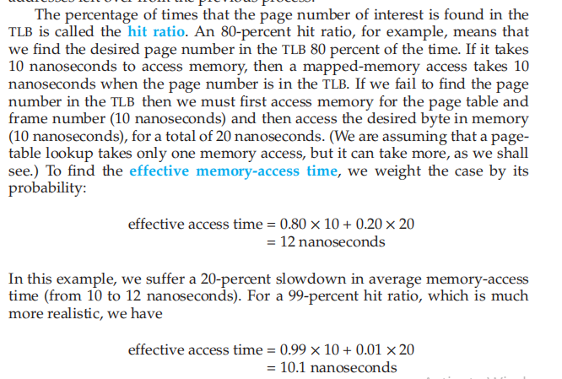

0.9 * 200 + 0.1*400 = 220 ns

=> B