Bài 1:

1. FCFS 0 8 12 13

Turn-around time:

P1 = 8 - 0.0 = 8

P2 = 12 - 0.4 = 11.6

P3 = 13 - 1.0 = 12

=> (8 + 11.6 + 12) / 3= 10.533 (s)

1. SJF 0 8 9 13

Turn-around time

P1 = 8 - 0.0 = 8

P2 = 13 - 0.4 = 12.6

P3 = 9 - 1.0 = 8

=> (8 + 12.6 + 8) / 3 = 9.533 (s)

1. Future-knowledge 0 1(P3 arrived) 2 6 14

Turn-around time

P1 = 14 - 0 = 14

P2 = 6 - 0.4 = 5.6

P3 = 2 - 1.0 = 1

=> (14 + 5.6 + 1) / 3 = 6.866 (s).

Ref: https://gateoverflow.in/103660/future-knowledge-scheduling

Bài 2:

1. FCFS

0 8 14 15 24 27

P1 P2 P3 P4 P5

AVG_waiting_time = (0 + 8 + 14 + 15 + 24) / 5 = 12.2 (s)

AVG_turn-around_time = [(8-0) + (14 - 0) + (15 - 0) + (24 - 0) + (27 - 0)] / 5

= 17.6 (s)

1. SJF
2. 1 4 10 18 27

P3 P5 P2 P1 P4

AVG_waiting_time = (10 + 4 + 0 + 18 + 1) / 5 = 6.6 (s)

AVG_turn-around_time = [(18-0) + (10 - 0) + (1 - 0) + (27 - 0) + (4 - 0)] / 5

= 12 (s)

1. Non-preemptive priority

Ref: https://www.javatpoint.com/os-non-preemptive-priority-scheduling

1. 6 7 16 19 27

P2 P3 P4 P5 P1

AVG_waiting_time = (19 + 0 + 6 + 7 + 16) / 5 = 9.6 (s)

AVG_turn-around_time = [(27-0) + (6 - 0) + (7 - 0) + (16 - 0) + (19 - 0)] / 5

= 15 (s)

1. Round Robin

Quantum = 1

3

|  |  |  |  |  |  |  |  |  |  |
| --- | --- | --- | --- | --- | --- | --- | --- | --- | --- |
| P1 | P2 | P3 | P4 | P5 | P1 | P2 | P4 | P5 | P1 |

13

|  |  |  |  |  |  |  |  |  |  |
| --- | --- | --- | --- | --- | --- | --- | --- | --- | --- |
| P2 | P4 | P5 | P1 | P2 | P4 | P1 | P2 | P4 | P1 |

21 25 27

|  |  |  |  |  |  |  |  |  |  |
| --- | --- | --- | --- | --- | --- | --- | --- | --- | --- |
| P2 | P4 | P1 | P4 | P1 | P4 | P4 |  |  |  |

AVG_waiting_time = [(25 - 8) + (21 - 6) + (3 - 3) + (27 - 9) + (13 - 3)] / 5

= 12 (s)

AVG_turn-around_time = [(25-0) + (21 - 0) + (3 - 0) + (27 - 0) + (13 - 0)] / 5

= 17.8 (s)

Ref: https://www.gatevidyalay.com/round-robin-round-robin-scheduling-examples/

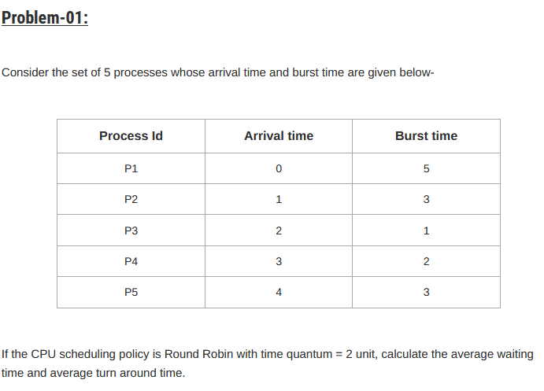

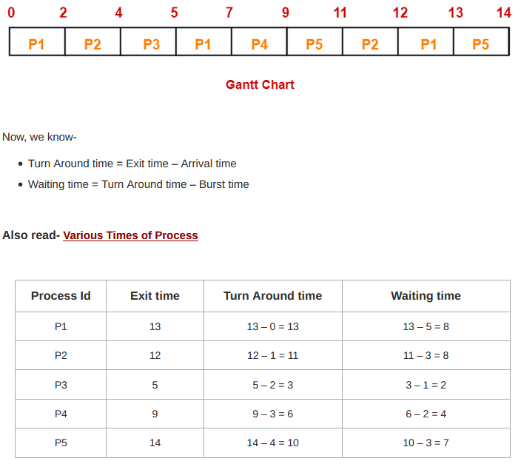

Đề:

