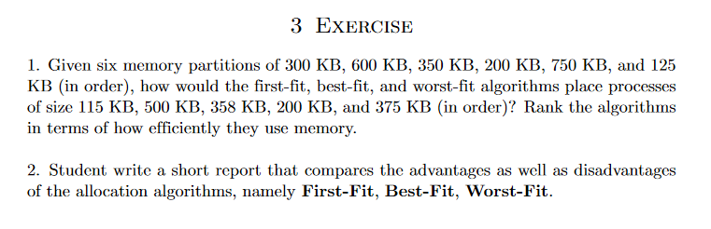

Câu 1:

Partitions

|  |  |  |  |  |  |
| --- | --- | --- | --- | --- | --- |
| 300 | 600 | 350 | 200 | 750 | 125 |

Processes

|  |
| --- |
| 115 |
| 500 |
| 358 |
| 200 |
| 375 |

First fit. Allocate the first hole that is big enough.

|  |  |  |  |  |  |
| --- | --- | --- | --- | --- | --- |
| 300 | 600 | 350 | 200 | 750 | 125 |

115

|  |  |  |  |  |  |
| --- | --- | --- | --- | --- | --- |
| 185 | 600 | 350 | 200 | 750 | 125 |

500

|  |  |  |  |  |  |
| --- | --- | --- | --- | --- | --- |
| 185 | 100 | 350 | 200 | 750 | 125 |

358

|  |  |  |  |  |  |
| --- | --- | --- | --- | --- | --- |
| 185 | 100 | 350 | 200 | 392 | 125 |

200

|  |  |  |  |  |  |
| --- | --- | --- | --- | --- | --- |
| 185 | 100 | 150 | 200 | 392 | 125 |

375

|  |  |  |  |  |  |
| --- | --- | --- | --- | --- | --- |
| 185 | 100 | 150 | 200 | 17 | 125 |

Best fit. Allocate the smallest hole that is big enough

|  |  |  |  |  |  |
| --- | --- | --- | --- | --- | --- |
| 300 | 600 | 350 | 200 | 750 | 125 |

115

|  |  |  |  |  |  |
| --- | --- | --- | --- | --- | --- |
| 300 | 600 | 350 | 200 | 750 | 10 |

500

|  |  |  |  |  |  |
| --- | --- | --- | --- | --- | --- |
| 300 | 100 | 350 | 200 | 750 | 10 |

358

|  |  |  |  |  |  |
| --- | --- | --- | --- | --- | --- |
| 300 | 100 | 350 | 200 | 392 | 10 |

200

|  |  |  |  |  |  |
| --- | --- | --- | --- | --- | --- |
| 300 | 100 | 350 | 0 | 392 | 10 |

Free 375

|  |  |  |  |  |  |
| --- | --- | --- | --- | --- | --- |
| 300 | 100 | 350 | 0 | 17 | 10 |

-------------------------------------------------------------------------------------------------------

Worst fit. Allocate the largest hole

|  |  |  |  |  |  |
| --- | --- | --- | --- | --- | --- |
| 300 | 600 | 350 | 200 | 750 | 125 |

115

|  |  |  |  |  |  |
| --- | --- | --- | --- | --- | --- |
| 300 | 600 | 350 | 200 | 635 | 125 |

500

|  |  |  |  |  |  |
| --- | --- | --- | --- | --- | --- |
| 300 | 600 | 350 | 200 | 135 | 125 |

358

|  |  |  |  |  |  |
| --- | --- | --- | --- | --- | --- |
| 300 | 242 | 350 | 200 | 135 | 125 |

200

|  |  |  |  |  |  |
| --- | --- | --- | --- | --- | --- |
| 300 | 242 | 150 | 200 | 135 | 125 |

350 KB process must wait…………………..

|  |  |  |  |  |  |
| --- | --- | --- | --- | --- | --- |
| 300 | 242 | 150 | 200 | 135 | 125 |

Giải thuật best-fit là giải thuật tốt nhất vì nó để lại nhiều lỗ trống free holes nhất.

Bonus:

Best-fit mất O(n) trong khi First-fit luôn luôn là O(1).

Xếp hạng:

Best fit

First fit

Worst fit ( vì worst fit ko thể sắp xếp tất cả process vào)

Câu 2:

|  |  |
| --- | --- |
| First-fit | |
| Ưu điểm  Thực thi rất nhanh | Nhược điểm  Lãng phí rất nhiều bộ nhớ  (vì nó luôn chọn partition đủ lớn đầu tiên mặc cho nó lớn cỡ nào đi chăng nữa) |
| Best-fit | |
| Ưu điểm  Tối ưu hóa bộ nhớ, tiết kiệm bộ nhớ một cách tối đa, hiệu quả | Nhược điểm  Thực thi rất chậm (phải kiểm tra rất nhiều) |
| Worst-fit | |
| Ưu điểm  Vì giải thuật chọn partition lớn nhất nên sẽ để lại phân mảnh nội (internal partition) khá nhiều và lớn, có thể đủ để cấp phát cho các process khác | Nhược điểm  Thực thi chậm, tốn thời gian |