Remapping issues
The remapping suggestions reported in this document are derived from the updates performed in IntAct databases, many rules can be adjust depending on the usage of PSI CV and on the data types stored by PSI users. In all the tables below you will find on the left side the old terms and on the right side the corresponding terms in PSI-2.5 release. For each remapping table we report some pseudo code to update those obsoletes terms in a IntAct database once the new terms are loaded in the database. We also suggest the freezing of curation while the obsolete remapping is performed.

CV Participant Role splitting :
The PSI-1 CV participant role is split in two CVs experimental role listing the interaction directionalities that depend on the methods (bait prey) and the biological role reporting the interaction direction that are formally independent from the methods (enzyme, target). This because each participant can be related to different experiments, and thus has multiple experimental roles. Consider using the terms “unspecified” and “neutral component” when respectively the Biological Role and the Experimental role are not applicable or use any combination of terms.

Participant role PSI-1 |  | Biological role PSI-2.5 |  | Experimental role PSI-2.5
Bait | MI:0496 |  |  | Bait | MI:0496
Prey | MI:0498 |  |  | Prey | MI:0498
neutral component | MI:0497 |  |  | neutral component | MI:0497
Self | MI:0503 | Self | MI:0503 | Self | MI:0503
Enzyme | MI:0501 | enzyme | MI:0501
enzyme target | MI:0502 | enzyme target | MI:0502
Unspecified | MI:0499 | unspecified | MI:0499

Radiolabelled move from participant detection method to feature type:
The term “radiolabelled” MI:0517 was child of “predetermined” under participant detection method and is now part of the feature type CV for each participant. In this way one can specified which interacting molecule is radiolabelled. We suggest the automatic remapping of the instances that have radiolabelled MI:0517 as participant detection method to predetermined MI:0396. Then the assignment of the CV feature type ‘radiolabelled’ to the preys of the interactions. In the case where an interaction has “neutral component” manual re-curation is required to determine to which participant the term “radio labelled” should be added.

Pseudo code:
SELECT participant RELATED TO an experiment with CV participant detection ==’radiolabelled’ MI:0517;
FOR all selected participant;
-IF participant where CV experimental role ==’PREY’ MI:0498 and CV feature type == ‘tagged protein’ MI:0507 exist;
--UPDATE the feature of the prey to CV feature type == ‘radiolabelled’ MI:0517
-ELSE IF a participant where CV experimental role ==’PREY’ and where there is NOT CV feature type == “tagged protein” (MI:0507) exit;
-CREATE to the prey MI:0498 CV feature type == radiolabelled’ MI:0517
-ELSE put flag for manual curation (when there is no bait-prey pair)
FOR all experiment with CV participant detection == radiolabelled MI:0517;
-UPDATE the experiment CV participant detection to predetermined MI:0396
REMOVE the CV participant detection instance ’radiolabelled’
SELECT CV with short label ‘radiolabelled’ check that the only instance is on CV feature type

Re-mapping of Interaction detection method obsolete terms:
Co-purification: ‘copurification’ and ‘other biochemical technologies’ are obsolete terms in PSI2.5, both can be automatically remapped to ‘biochemical’. On manual re-curation the entries annotated with ‘copurification’ can also be assigned to various biochemical method listed below.

CV Interaction detection PSI-1 |  | Interaction detection PSI-2.5
other biochemical technologies | MI:0079 | Biochemical | MI:0401
Copurification | MI:0025 | Biochemical | MI:0401
Further possible reassignment by re curation | Chromatography | MI:0091
 |  | affinity chromatography technologies | MI:0004
 |  | coip: coimmunoprecipitation | MI:0019
 |  | pull down | MI:0096
 |  | molecular sieving | MI:0071
 |  | ion exchange chromatography | MI:0226
 |  | reverse phase chromatography | MI:0227
 |  | comigration in non denaturing gel electrophoresis | MI:0404
 |  | cosedimentation | MI:0027

SELECT experiments where CV Interaction detection == ‘other biochemical technologies’ (MI:0079) exist;
FOR each selected experiment ;
-UPDATE experiment CV Interaction detection to ‘biochemical’ (MI:0401)

Same for copurification and tri hybrid, but flag experiments for manual recuration to solve remapping ambiguity.

Co-localisation: co-localisation in PSI-1 is an interaction detection method whereas it becomes a new interaction type in PSI-2.5. Thus all interaction entries annotated as being detected by co-localisation or one of it child term must be updated in the following manner:
- interaction detection and participant detection updated in a specific manner depending on the co-localisation technique.
- interaction type ‘aggregation’ MI:0191 becomes ‘co-localisation’ MI:0403

Interaction detection PSI-1 |  | Interaction detection PSI-2.5 |  | Participant detection PSI-2.5 |  | Interaction type PSI-2.5
colocalization/visualisation technologies | MI:0023 | Imaging techniques | MI:0428 | predetermined participant | MI:0396 | colocalization | MI:0403
Colocalization by fluorescent probes cloning | MI:0021 | No update | MI:0021 | No update |  | colocalization | MI:0403
Colocalization by immunostaining | MI:0022 | Imaging techniques | MI:0428 | immunostaining | MI:0422 | colocalization | MI:0403
Note that the term ‘colocalization by electron microscopy’ MI:0020 (renamed transmission electron microscopy MI:0020 in PSI-2.5) although was child of co-localization in PSI-1 is considered to have such high resolution that they are still able to support a “physical interaction”. Moreover FRET and BRET that was also children of co-localisation in PSI-1 have been displaced in the ontology tree as children of fluorescent technologies so data linked to such terms does not need any update.

SELECT experiments where CV Interaction Detection == ‘colocalization/visualisation technologies’ (MI:0023) exist ;
FOR each selected experiment ;
-UPDATE experiment CV Interaction Detection to ‘imaging techniques’ (MI:0428)
-UPDATE experiment CV participant detection to ‘predetermined’(MI:0396)
-SELECT all the interactions RELATED TO each experiment:
--FOR each selected interaction ;
---UPDATE interaction CV Interaction Type ==colocalization (MI:0403)

Same for Colocalization by immunostaining MI:0022
WARNING THE CASE FOR MI:0021 IS DIFFERENT :
SELECT interactions RELATED to experiment where CV Interaction Detection == ‘Colocalization by fluorescent probes cloning’ (MI:0021) exist ;
FOR each selected interaction :
-UPDATE interactions CV Interaction Type ==colocalization (MI:0403)

Tagged proteins:
In PSI-1 the tag were represented as child of pull-down and Co-Ip methods. Thus in PSI-2.5 these children are obsolete and need to be replaced by their parent term together with the addition of the CV feature type describing their flag. For update :
- move the listed terms up to their parent term in the CV interaction detection
- add a term from the CV feature type describing the flag of the BAIT interactor according to the following table

Interaction detection PSI-1 |  | Interaction detection PSI-2.5.5 |  | CV feature type of the BAIT
flag tag coip | MI:0050 | Anti tag coimmunoprecipitation | MI:0007 | FLAG-tagged | MI:0518
ha tag coip | MI:0060 | Anti tag coimmunoprecipitation | MI:0007 | HA-tagged | MI:0520
his tag coip | MI:0062 | Anti tag coimmunoprecipitation | MI:0007 | His-Tagged | MI:0521
myc tag coip | MI:0075 | Anti tag coimmunoprecipitation | MI:0007 | Myc-tagged | MI:0522
tap tag coip | MI:00109 | Anti tag coimmunoprecipitation | MI:0007 | TAP-tagged | MI:0524
pull down children
gst pull down | MI:0059 | Pull down | MI:0096 | GST-tagged | MI:0519
his pull down | MI:0061 | Pull down | MI:0096 | His-Tagged | MI:0521
SELECT all participant RELATED TO experiment where CV Interaction detection == ‘Anti tag coimmunoprecipitation’ (MI:0007) ;
FOR each selected participant ;
-IF participant where CV experimental role == ‘bait’ (MI:0496), AND HAS NOT CV feature type == ‘flag tagged’ (MI:0518);
--CREATE to the bait new CV feature type ‘flag tagged’ (MI:0518);
-ELSE IF participant CV feature type ==’neutral component’ MI:0497;
--put flag for manual curation
-UPDATE experiments CV Interaction Detection to ‘Anti tag coimmunoprecipitation’ MI:0007;

Remapping of obsolete terms in interaction type:
The main term ‘aggregation’ that was used to populate this CV in PSI-1 becomes obsolete in PSI-2.5. Above we already mentioned how to map the entries that need to be updated to “co-localisation” interaction type. The aggregation term can generically be updated to “physical interaction” MI:0218. However we suggest assigning the more specific term “direct interaction” MI:0407 depending on the method associated to an entry. Moreover the interaction type ‘covalent interaction’,’ non covalent interaction’ and ‘disaggregation’ that transiently populated this CV are also deprecated now. Finally following discussion at the Siena PSI meeting, we moved to obsolete “ubiquitin binding” MI:0443 to be remapped to “ubiquitination reaction” MI:0220 or to “physical interaction” or “covalent interaction”. We reasoned that the term “ubiquitination reaction” is there to represent cases where an enzyme ubiquitinated its target whereas while describing interactions of ubiquitin as participant there is no need of a specific term and any interaction type can the used.

Interaction detection PSI-1 |  | Interaction type PSI-1 |  | Interaction type PSI-2.5 |  | Comments
When a binary interaction is detected with the following set of methods the ‘direct interactions’ term can be assigned
x-ray crystallography | MI:0114 | aggregation | MI:0191 | direct interaction | MI:0407 | If binary interactions
surface plasmon resonance | MI:0107 | aggregation | MI:0191 | direct interaction | MI:0407 | If binary interactions
nuclear magnetic resonance | MI:0077 | aggregation | MI:0191 | direct interaction | MI:0407 | If binary interactions
pepide array | MI:0081 | aggregation | MI:0191 | direct interaction | MI:0407 | If binary interactions
protein array | MI:0089 | aggregation | MI:0191 | direct interaction | MI:0407 | If binary interactions
phage display | MI:0084 | aggregation | MI:0191 | direct interaction | MI:0407 | If binary interactions
cross-linking with a bifunctional reagent | MI:0031 | aggregation | MI:0191 | direct interaction | MI:0407 | If binary interactions
yeast display | MI:0115 | aggregation | MI:0191 | direct interaction | MI:0407 | If binary interactions
bacterial display | MI:0009 | aggregation | MI:0191 | direct interaction | MI:0407 | If binary interactions
fret | MI:0055 | aggregation | MI:0191 | direct interaction | MI:0407 | If binary interactions
bret | MI:0012 | aggregation | MI:0191 | direct interaction | MI:0407 | If binary interactions
scintillation proximity assay | MI:0099 | aggregation | MI:0191 | direct interaction | MI:0407 | If binary interactions
All other methods |  | aggregation | MI:0191 | physical interaction | MI:0218

DEFINE list_direct_methods=[list of MI in the left column];
FOR all interactions where CV Interaction Type == ‘aggregation’ MI:0191;
-IF interactions has COUNT participant == 2 AND are RELATED TO experiment where CV interaction detection BELONG to list_direct_method exist ;
--UPDATE interaction CV interaction type to ‘direct interaction’ MI:0407
-ELSE (when count participant >2 or CV interaction detection DOES NOT BELONG to list_direct_method exist ;
--UPDATE interaction CV interaction type to ‘physical interaction’ MI:0218

Interaction type PSI-1 |  | Interaction type PSI-2.5
covalent interaction | MI:0196 | covalent binding | MI:0195
non covalent interaction | MI:0215 | physical interaction | MI:0218
disaggregation | MI:0205 | No remapping
ubiquitin binding | MI:0443 | ‘ubiquitination reaction’ or any other interaction type | MI:0220 | Consider to do it manually

SELECT interaction where CV interaction type == ‘non covalent interaction’MI:0196;
FOR each selected interaction:
-UPDATE selected interactions CV interaction type to ‘covalent binding’ MI:0195

Same for MI:0215 and MI:0205.

Once all this is done do not forget to handle (remove or flag) the obsolete terms in a way that they are no more used for further annotation.

Overview table of CVs remapping:

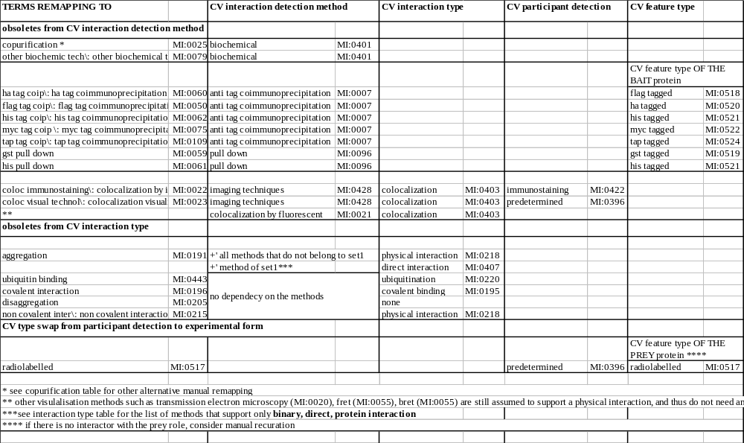

Updated 27-09-05 after Geneva PSI meeting by Luisa considering the merging of the CV experimental form into experimental feature type.

