mzML: Mass Spectrometry Markup Language

Status of This Document

This document presents the completed 1.0 specification for the mzML (Mass Spectrometry Markup Language) data format developed by the HUPO Proteomics Standards Initiative. Distribution is unlimited.

Version of This Document

The current version of this document is: Version 1.0.0.0; June 1, 2008.

The version of this document matches the schema version with one trailing decimal point and integer to denote specification documentation updates that do not correspond to a schema update. Thus the version numbers correspond to:
majorVersion.minorVersion.maintenanceVersion.documentationOnlyUpdateVersion.
Every new release of the specification document will be available in the PSI code repository.

Change Log since 1.0.0.0
- 2008-06-01: 1.0.0.0 – INITIAL RELEASE
- 2008-06-12: 1.0.0.1 – Updated embedded figures, which had incorrect version number. No change to format; documentation update only.

Abstract

The Human Proteome Organisation (HUPO) Proteomics Standards Initiative (PSI) defines community standards for data representation in proteomics to facilitate data comparison, exchange and verification. The Mass Spectrometry Working Group (PSI-MS WG) develops standards for describing the results of a mass spectrometric analysis. This document presents information to the mass spectrometry community about the modelling in XML of the experimental results obtained by mass spectrometric analysis of biomolecular compounds. This XML format is based on the previous two formats mzData (Julian, Binz et al. 2005) and mzXML (Pedrioli, Eng et al. 2004), and when it is completed and accepted, obsoletes the two previous formats, and should be used in place of them. This document should be read in conjunction with a kit of auxiliary files, including the example instance documents, controlled vocabulary file, and xsd files. All files related to this proposal are available for download at http://psidev.info/index.php?q=node/257.

Contents

Abstract 1
1. Introduction 3
1.1 Background 3
1.2 Previous formats 4
1.3 Design Philosophy 5
2. Implementation of the Format 6
2.1 Concepts and Terminology 6
2.2 Relationship to Other Specifications 6
2.2.1 The PSI Mass Spectrometry Controlled Vocabulary (CV) 7
2.3 Resolved Design Issues 7
2.3.1 Count attributes 8
2.3.2 Numerical value and datetimestamp encoding 8
2.3.3 The new CV term problem 8
2.4 Other supporting materials 9
2.5 Open Issues 10
2.6 Comments on Specific Use Cases 10
2.6.1 Selected Reaction Monitoring (SRM) 10
3. Model in XML Schema 11
3.1 Element <mzML> 12
3.2 Element <cvList> 14
3.3 Element <fileDescription> 14
3.4 Element <referenceableParamGroupList> 15
3.5 Element <sampleList> 16
3.6 Element <instrumentConfigurationList> 16
3.7 Element <softwareList> 17
3.8 Element <dataProcessingList> 17
3.9 Element <acquisitionSettingsList> 18
3.10 Element <run> 18
3.11 Element <cv> 20
3.12 Element <fileContent> 21
3.13 Element <sourceFileList> 21
3.14 Element <contact> 22
3.15 Element <referenceableParamGroup> 22
3.16 Element <sample> 23
3.17 Element <instrumentConfiguration> 24
3.18 Element <software> 24
3.19 Element <dataProcessing> 25
3.20 Element <acquisitionSettings> 25
3.21 Element <referenceableParamGroupRef> 26
3.22 Element <cvParam> 26
3.23 Element <userParam> 27
3.24 Element <sourceFileRefList> 27
3.25 Element <spectrumList> 28
3.26 Element <chromatogramList> 29
3.27 Element <sourceFile> 29
3.28 Element <componentList> 30
3.29 Element <softwareRef> 30
3.30 Element <softwareParam> 31
3.31 Element <processingMethod> 31
3.32 Element <targetList> 32
3.33 Element <sourceFileRef> 32
3.34 Element <spectrum> 32
3.35 Element <chromatogram> 34
3.36 Element <source> 35
3.37 Element <analyzer> 36
3.38 Element <detector> 37
3.39 Element <target> 38
3.40 Element <spectrumDescription> 39
3.41 Element <binaryDataArrayList> 40
3.42 Element <acquisitionList> 40
3.43 Element <precursorList> 41
3.44 Element <scan> 42
3.45 Element <binaryDataArray> 43
3.46 Element <acquisition> 45
3.47 Element <precursor> 46
3.48 Element <scanWindowList> 47
3.49 Element <binary> 47
3.50 Element <isolationWindow> 47
3.51 Element <selectedIonList> 48
3.52 Element <activation> 48
3.53 Element <scanWindow> 49
3.54 Element <selectedIon> 49
4. Conclusions 49
5. Authors and Contributors 50
6. References 51
7. Intellectual Property Statement 52
8. Appendix A: The mzML indexing wrapper schema 52
8.1 Element <indexedmzML> 52
8.2 Element <mzML> 53
8.3 Element <indexList> 53
8.4 Element <indexListOffset> 53
8.5 Element <fileChecksum> 53
8.6 Element <index> 53
8.7 Element <offset> 54
Copyright Notice 54

Introduction

Background

Mass spectrometry is a popular method to analyse bio-molecules by measuring the intact mass-to-charge ratios of their in-situ generated ionised forms or the mass-to-charge ratios of in-situ-generated fragments of these ions. The resulting mass spectra are used for a variety of purposes, among which is the identification, characterization, and absolute or relative quantification of the analysed molecules. The processing steps to achieve these goals typically involve semi-automatic computational analysis of the recorded mass spectra and sometimes also of the associated metadata (e.g., elution characteristics if the instrument is coupled to a chromatography system). The result of the processing can be assigned a score, rank or confidence measure.

Differences inherent in the use of a variety of instruments, different experimental conditions under which analyses are performed, and potential automatic data preprocessing steps by the instrument software can influence the actual measurements and therefore the results after processing. Additionally, most instruments output their acquired data in a very specific and often proprietary format. These proprietary formats are then typically transformed into so-called peak lists to be analysed by identification and characterisation software. Data reduction such as peak centroiding and deisotoping is often performed during this transformation from proprietary formats to peak lists. In addition, these peak list file formats lack information about the precursor MS signals and about the associated metadata (i.e., instrument settings and description, acquisition mode, etc) compared to the files they were derived from. The peak lists are then used as inputs for subsequent analysis. The many different and often proprietary formats make integration or comparison of mass spectrometer output data difficult or impossible, and the use of the heavily processed and data-poor peak lists is often suboptimal.

This document addresses this problem with the presentation of the mzML XML format, which is designed to hold the data output of a mass spectrometer as well as a systematic description of the conditions under which this data was acquired and transformed. The following target objectives can be defined for the format:

- The discovery of relevant results, so that, for example, data sets in a database or public repository that use a particular technique or combination of techniques can be identified and studied by experimentalists during experiment design or data analysis.
- The sharing of best practice, whereby, for example, approaches that have been successful at analysing low abundance analytes can be captured alongside the results produced.
- The evaluation of results, whereby, for example, the number and quality of the spectra recorded from a sample can be assessed in the light of the experimental conditions.
- The sharing of data sets, so that, for example, public repositories can import or export data, multi-site projects can share results to support integrated analysis, or meta-analyses can be performed by third parties from previously published data.
- The most comprehensive support of the instruments output, so that data can be captured in profile mode, centroid mode, and other relevant forms of biomolecular mass spectrometry data representation

The primary focus of the model is to support long-term archiving and sharing, rather than day-to-day laboratory management, although the model is extensible to support context-specific details.

The description of mass spectrometry data output and its experimental context requires that models include: (i) the actual data acquired, to a sufficient precision, as well as its associated metadata; and (ii) an adequate description of the instrument characteristics, its configuration and possible preprocessing steps applied. This document details both these parts, as they are required to support the tasks T1 to T5 above.

This document defines a specification and is not a tutorial. As such, the presentation of technical details is deliberately direct. The role of the text is to describe the schema model and justify design decisions made. This document does not provide comprehensive examples of the schema in use. Example documents are provided separately and should be examined in conjunction with this document. It is anticipated that tutorial material will be developed in the future to aid implementation. Although the present specification document describes constraints and guidelines related to the content of an mzML document as well as the availability of tools helping to read and write mzML, it does not describe any implementation constraints or specifications such as coding language or operating system for software that will generate and/or read mzML data.

Previous formats

During 2003 – 2005, two data formats to store mass spectrometer output in an open, vendor-neutral, XML format were developed. The mzData format [mzData] was developed by the PSI, primarily as a data exchange and archive format. The mzXML format [mzXML] was developed at the Institute for Systems Biology (ISB), primarily in order to streamline data processing software. Both formats are used extensively but it has been noted that having two formats for essentially the same information causes unnecessary confusion in the community and adds complexity to software developers as often both formats must be supported. Therefore the designers of mzData and mzXML, including representatives of instrument vendors, analysis software developers and end users, have joined under the auspices of the PSI and jointly developed a single format intended to replace the previous two. This new format is named mzML and is described in this document.

The main difference between the two original formats, aside from the primary intent described above, is the design philosophy of flexibility. The mzData format was designed to be quite flexible via the extensive use of a controlled vocabulary. It was hoped that the actual xsd schema could remain stable for many years while the accompanying controlled vocabulary could be frequently updated to support new technologies, instruments, and methods of acquiring data.

On the other hand, mzXML was designed with a very strict schema with most auxiliary information described in enumerated attributes. This simplified software implementations as there was only one way to present various attributes and the validity of the documents could be easily checked with industry-standard XML validators.

The main challenge in uniting these two formats was therefore resolving the opposing philosophies rather than fundamental technical issues. The result is a format that contains the best aspects of the two original formats so that it may be widely adopted and will resolve the current problem of two formats.

Design Philosophy

Since the development of mzML brought together many different philosophies, the primary mzML designers agreed on the following design principles that would guide its development:

- Keep the format simple. Many elaborate extensions were proposed but most were rejected in favour of a simple implementation.
- Minimize alternate ways of encoding the same information. Such flexibility, while sometimes touted as a benefit for some products, is bad for data formats.
- Build in some flexibility for encoding new important information but keep the format stable. There is a strong desire from companies that develop software for their customers to keep the data format stable over long periods of time with updates to an auxiliary file.
- Support the features of mzData and mzXML but not a lot more in version 1.0. Only support for SRM data was added (which is also supported in the latest mzXML 3.1 and thus not really new).
- Finish version 1.0 of the format soon with the resources available. It was felt that the greatest community benefit would be to resolve the mzData/mzXML duality rather than expend limited resources on new features.

There was great temptation to add support for many new kinds of data and representation possibilities. There are many enhancements that have been suggested, but the small group of volunteers that have actively developed this format have opted to focus on the primary goal set before us: develop a single format that the vendors and current software can easily support and thereby obsolete mzData and mzXML. The enhancements not considered compatible with this goal will be entertained for mzML 2.0

One of the aspects of mzXML that enabled its very swift adoption was a ready set of open source tools that implemented the format. With these tools many users were able to begin using the format immediately without coding their own software. Therefore, to insure that mzML is a format that will be adopted quickly and implemented uniformly, the format is presented with several tools that write, read, and validate the format. At submission to the PSI document process, the following software will implement mzML:

- Two or more converters that convert from vendor formats to mzML.
- The popular RAMP parser library that currently supports mzData and mzXML.
- An mzML semantic validator that checks for correct implementation of files.

The mzData format was a far more flexible format than mzXML. The support of new technologies could be added to mzData files by adding new controlled vocabulary terms, while mzXML often required a full schema revision. This is evidenced by mzData still being at version 1.05 while mzXML is currently at version 3.1. However, mzData did suffer from a problem of inconsistently used vocabulary terms and there appeared several different dialects of mzData, encoding the same information in subtly different ways. This was not usually a problem for human inspection of the file, but caused difficulty writing and maintaining reader software.

This problem was been solved (it is hoped) for mzML by releasing a semantic validator with the data format. This semantic validator enforces many rules as to how controlled vocabulary terms are used, not only making sure that the terms are in the CV, but also that the correct terms are used in the correct location in the document and the required terms are present the correct number of times. This allows greater flexibility in the schema, but enforces order in how the CV terms are used. This will require the discipline of using the semantic validator, not just an XML validator. The result is that new technologies or information can be accommodated with adjustments to the controlled vocabulary and validator, not to the schema. Opinions differ on whether this is a benefit or a curse.

The remainder of this document is structured as follows. Section 2.1 describes a number of concepts and information about the implementation of mzML, including aspects of terminology, design issues, the controlled vocabulary, etc. The schema model itself is presented in XML schema (XSD) notation in Section 3; some conclusions are presented in Section 5.

Implementation of the Format

Concepts and Terminology

This document assumes familiarity with one data modelling notation, namely XML Schema (www.w3.org/XML/Schema). Models are described using XML schema.

The keywords “MUST,” “MUST NOT,” “REQUIRED,” “SHALL,” “SHALL NOT,” “SHOULD,” “SHOULD NOT,” “RECOMMENDED,” “MAY,” and “OPTIONAL” are to be interpreted as described in RFC-2119 (Bradner 1997).

Relationship to Other Specifications

The specification described in this document is not being developed in isolation; indeed, it is designed to be complementary to, and thus used in conjunction with, several existing and emerging models. Related specifications include the following:

- MIAPE MS (http://www.psidev.info/index.php?q=node/91) The “Minimum Information About a Proteomics Experiment: Mass Spectrometry” module document identifies the minimum information required to report the use of a mass spectrometer in a proteomics experiment. The mzML format has been designed to encode the requirements specified in MIAPE MS. However, mzML does not enforce MIAPE compliance itself; mzML documents may be valid and useful without being fully MIAPE compliant. The mzML validator has settings to validate at either the basic mzML level or at a MIAPE MS compliant level, depending on the needs of the user.
- sepCV (http://obo.sourceforge.net/cgi-bin/detail.cgi?sep). At various defined positions within GelML, terms must be provided from a controlled vocabulary or ontology. sepCV is a controlled vocabulary designed specifically by PSI and the Metabolomics Standards Initiative to provide a lexicon for protein separation techniques. sepCV will support the annotation of GelML with an agreed standard terminology.
- spML (http://www.psidev.info/index.php?q=node/90). spML (sample processing Markup Language) is the proposed PSI standard for describing general protein separation and sample processing other than gel electrophoresis. GelML is being developed separately from spML because there is a well defined community associated with gel electrophoresis. As both GelML and spML build on FuGE (Functional Genomics Experiment) (Jones, Miller et al. 2007) and use FuGE to describe the relationships between steps in a proteomics workflow, they will be designed to be straightforward to use together where appropriate. This document does not assume familiarity with spML.
- GelInfoML (http://www.psidev.info/index.php?q=node/38). The GelInfoML specification is being developed by PSI as a model for analysis of images resulting from gel electrophoresis. There are a number of software packages, both commercial and freely available, that analyse gel images to quantify the abundance of protein within a particular gel spot or to compare the abundance of a protein spot between different images. The GelInfoML format is being developed separately from GelML because the kind of information represented in the two formats is different and the images resulting from gel electrophoresis can be analysed multiple times without repeating the experiment.
- analysisXML (http://www.psidev.info/index.php?q=node/85). The analysisXML specification is being developed by PSI as a standard to capture the output of search engines that assign mass spectra to protein or peptide sequences. It is FuGE-based and will provide a UML model as well as an XML schema. It is anticipated that mzML will serve as an important ‘input’ to the model defined by analysisXML. This document does not assume familiarity with analysisXML or FuGE.

The PSI Mass Spectrometry Controlled Vocabulary (CV)

A comprehensive collection of terms have been defined (mostly extracted from vocabulary and definitions in chapter 12 of the IUPAC nomenclature book) and structured in an mzML-friendly way, hopefully facilitating the browsing of the terms. Almost all first-level branch terms (the direct children of the root term) have a homonymous XML element in mzML. Their children, the second-level terms, are relevant topics or categories which need CV support for their description. The leaf nodes under their respective parent categories should be used in a cvParam under the appropriate XML element in mzML schema.

Some terms describe attributes that must be coupled with a numerical value attribute in the CvParam element (e.g. dwell time MS:1000039) and optionally a unit for that value (e.g. second MS:1000502). The terms that require a value are denoted by having a “datatype” key-value pair in the CV itself; the use of the ‘object attribute’ (MS:1000547) term to denote this is now deprecated. Similarly, terms that need to be qualified with units are denoted by have a “needs_units” key in the CV itself.

Although the structure of the CV and the mzML schema are related, the details of which terms are allowed/recommended in a given schema section is reported in the mapping file. The mapping file is a list of associations between a cvParam element in a specific schema location (described with an Xpath) and the branches of the CV terms expected in that location. This file is read and interpreted by the validator, checking that the data annotation is consistent. The mapping file needs to be checked and eventually updated when the CV terms or structure are changed.

As recommended by the PSI CV guidelines, psi-ms.obo should be dynamically maintained via the psidev-ms-vocab mailing lists that allow any user to request new terms in agreement with the community involved. Once a consensus is reached among the community the new terms are added within few days. If there is no obvious consensus, the CV coordinators committee should vote and make a decision. A new psi-ms.obo should then be released by updating the file on the CVS server without changing the name of the file (this would alter the propagation of the file to the OBO website and to other ontology services that rely on file stable URI). For this reason an internal version number with two decimals (x.y.z) should be increased:
- x should be increased when a first level term are renamed added deleted or rearranged in the structure. Such rearrangement is suppose to be rare and is very likely to have repercussion on the mapping.
- y should be increased when any other term except the first level one is altered.
- z should be increased when there is no term addition or deletion but just editing on the definitions or other minor changes.

The following ontologies or controlled vocabularies specified below may also be suitable or required in certain instances:

- Unit Ontology (http://www.obofoundry.org/cgi-bin/detail.cgi?id=unit)
- ChEBI (http://www.ebi.ac.uk/chebi/)
- OBI (Ontology of Biological Investigations - http://obi.sourceforge.net/) (formerly called FuGO)

Resolved Design Issues

There were several issues regarding the design of the format that were not clear cut, and a design choice was made that was not completely agreeable to everyone. So that these issues do not keep coming up, we document here the issues and why the decision that is implemented was made.

Count attributes

It was decided that all list elements would have a count attribute. The reason is that parsers implemented in languages where memory allocation or array sizing is important, it is a nice performance enhancement to have a count attribute indicating how many elements there are in the list. Although it was felt that this is an easy target for creating inconsistent files (i.e. writing out a count=”5” attribute followed by 6 items in the list), this was deemed to be rare and in the vast majority of cases the value can be relied on. The code would need to adapt to cases where the count was incorrect, but this is no more difficult than not knowing the value ahead of time. Validators of mzML should check that the counts are correct when validating file.

Numerical value and datetimestamp encoding

All numerical values shall appear in the XML schema datatype specification (http://www.w3.org/TR/xmlschema-2/). The number 1/10 must always appear as 0.10 and never as 0,10. A preceeding + before a number (+5.0) is prohibited.

Datetimestamps must also be encoded as in the XML specification such as 2007-06-27T15:23:45.00035.

All id attributes follow the XML schema datatype xs:ID (http://www.w3.org/TR/xmlschema-2/#ID), which means that no two id attributes may be the same within a document, and id attributes must be purely alphanumerical strings with at least one letter. Thus they may not contain spaces or underscores, and id attributes may not be a plain number.

The new CV term problem

It was decided that all annotations on the data that should come from a list of allowed values using the <cvParam> element. All information encoded as element attributes are never controlled vocabulary terms. Thus, as an example to describe spectrum type, the cvParam element must be provided to specify a term below MS:1000559 “spectrum type”, such as:

<cvParam cvLabel="MS" accession="MS:1000580" name="MSn spectrum" value=""/>

Note that both accession and the term name are provided. Parsers should focus on the accession number as this should never change, even if the term name is adjusted in the controlled vocabulary later. Note that there is no value. The mere presence of the term is the annotation.

The problem comes when there is a new term to be added. Let’s assume that it becomes necessary to add a new spectrum type “SRM spectrum”. Vendor X would like to start writing mzML with this spectrum type. What should happen and what could also happen?

In an ideal world, Vendor X would contact the PSI-MS WG controlled vocabulary coordinators list and request a new child term of “spectrum type”. A CV coordinator would verify that this is a new concept, not simply a synonym of an existing concept, add the term to the CV and release a new version of the psi-ms.obo file at the same location. Vendor X would obtain the accession number and could begin writing out valid mzML. The semantic validator would (and already does) automatically download the new .obo file and validate that the new mzML is semantically valid using the new term.

If the file is then distributed to arbitrary site Y, local software will suddenly encounter this new term:

<cvParam cvLabel="MS" accession="MS:1000583" name="SRM spectrum" value=""/>

and there is a possibility of failure. The first problem that may occur is that reader software may try to understand what the spectrum type is, but it will not find a spectrum type that it understands. Therefore it can only conclude that either no spectrum type was provided, or one of the terms it doesn’t recognize is a spectrum type but it won’t know which one. If the software could connect to the Internet, and could automatically download the latest .obo file, and look to see if this term was in the file, and then determine what parent the above term had, and understand that the parent is “spectrum type”, then the software could conclude that the above cv term is a spectrum type, but a new one that it doesn’t not know how to handle yet. Such a string of logic is not terribly difficult but it is not trivial and is objectionable to some.

Worse yet, Vendor X could have been lazy and not even contacted the PSI-WG CV coordinator and just started publishing mzML with (“option A”):

<cvParam cvLabel="MS" accession="MS:9999999" name="SRM spectrum" value=""/>

There is no way to resolve this. No reader could possibly know how to handle this. It should be avoided at all cost. Although it should be noted that until the proper accession number is furnished, such an approach will at least initially be used. In any case, processing software may still not know how to properly handle SRM spectra, but it should already be able to confidently understand what the spectrum type is and admit it cannot handle it.

In order to make it easier for software developers, several possible solutions were considered at length, notably one known as “option C”:

<cvParam cvLabel="MS" categoryAccession=”MS:1000035” categoryName=”spectrum type” accession="MS:1000583" name="SRM spectrum" value=""/>

In this case, both the accession and name of both the parent/category and the child/leaf term is explicitly provided. This could help the reader software to know exactly that the spectrum type is “SRM spectrum” without complex logic and proceed with processing based on that.

In this alternative, both the category and the leaf terms are explicitly provided. Reader software could easily determine what the spectrum type is without complex logic even in the face of a MS:9999999 accession shown above. The downside of option C is that files are more verbose than otherwise and that there is the possibility of conflicting, incorrect stated category and left nodes. A final argument against this is that such a scheme was tried with MAGE-ML (MicroArray Gene Expression Markup Language) version 1, and it caused massive confusion. An alternate contention is that the massive confusion resulted from nesting of terms rather than the flat attribute structure proposed here.

After much discussion, it was decided to stick with the original implementation (option A). There were too many arguments against option C, and the main author of the ProteoWizard reference implementation saw no need for option C. Thus, the final specification proceeds with option A.

Other supporting materials

This document cannot be fully judged on its own. It is important to study the accompanying sample instance documents, controlled vocabulary, schema files, and the software that implements this pre-release version of mzML. In fact, the content of section 3 in this document (as well as the on-line HTML documentation) is completely autogenerated from these files and not maintained by hand.

All these files and programs are available at:
http://psidev.info/index.php?q=node/257

They are:

Filename | Description
README.txt | Summary file for the mzML evaluation kit
mzML1.0.0.html | HTML documentation of the model
mzML1.0.0.xsd | Main mzML XML schema definition file
mzML1.0.0_idx.xsd | Wrapper schema for indexing an mzML file for random access
psi-ms.obo | PSI-MS controlled vocabulary in OBO format
specialNotes.txt | A set of special notes associated with individual elements
ms-mapping.txt | XML-encoded rules for where certain cvParams MAY/MUST appear in the document.
tiny.pwiz.mzML | Tiny hand-crafted two spectrum MS1 + MS2 LCQ example
tiny2_SRM.mzML1.0.0.xml | Tiny hand-crafted example of SRM data
tiny4_LTQ-FT.mzML1.0.0.xml | Tiny hand-crafted example of describing hybrid instrument
1min.mzML | Example output of ReAdW Thermo -> mzML converter
2min.mzML | Example output of wolf Waters -> mzML converter
validateMzML.pl | Small Perl program to use Xerces to perform crude (not semantic) validation of an mzML file
mzMLContentHandler.pm | Reader class used by validateMzML.pl
mzML_1.0.0_validator.zip | Java implementation of a full semantic validator for mzML

Additional material is referenced with hyperlinks at the same URL.

Open Issues

All open issues were resolved by the end of the mzML 1.0.0.0 design phase. This may be an appropriate section to describe issues that arise after the 1.0 release that are considered sufficiently disruptive that they require a new major or minor release number. Such disruptive changes to the schema are expected to be rare. It is hoped that it will be several years before the next major revision.

We note that usage of resource description framework (RDF) was considered and rejected for mzML 1.0. It remains a possibility that mzML 2.0 will be based on RDF.

Comments on Specific Use Cases

Many special use cases for mzML were considered during its development. Most of these use cases have a corresponding example file that exercise the relevant part of the schema and provide a reference implementation example. Authors of mzML writing software are encouraged to examine the examples that accompany this format release before implementing the writer. Further, such authors are encouraged to use the validator before releasing any new writer code and working with the PSI Mass Spectrometry Working Group to resolve and issues. In the subsections below, we comment on a few of the notable use cases that were considered.

Selected Reaction Monitoring (SRM)

Selected reaction monitoring (SRM) is the major new technology that is supported by mzML that was not supported by both previous formats. We note that SRM is often referred to as multiple reaction monitoring (MRM), but that term is an obsolete synonym of SRM according to IUPAC.

There was considerable discussion on how to encode SRM experiments. There seem to be two major contenders: encoding them as tiny MS/MS-like spectra; or encoding them directly as complete chromatograms.

The decision was made that each SRM scan is to be encoded as a mini MS/MS-like spectra with a precursor corresponding to the Q1 m/z and a small spectrum encoding one or more Q3 m/z values that correspond to the Q1 m/z. We note that these mini scans may be a single (centroided) value per Q3 m/z, or the mini scans may be profile mode scans surrounding the Q3 m/z. For example, it is entirely permissible to monitor two Q3 m/z values for a single Q1 m/z, and encode profile mode scans for both Q3 regions in a single spectrum.

The mzML specification also supports the <chromatogram> element which is very similar to the <spectrum> element. It is capable of containing a full description of and the data for a chromatogram. The chromatogram may be simply be a total ion current (TIC) chromatogram of an ordinary MS1 or MS/MS run, or a chromatogram corresponding to a Q1,Q3 pair in a SRM run.

It has been resolved that all SRM runs must be encoded as mini MS/MS-like spectra using the <spectrum> element. Optionally, the same information may also be encoded using the <chromatogram> elements as a speed-enhancing feature. At present, it has been decided that SRM output may not be encoded only in the <chromatogram> form. The goal is to avoid having two different ways of encoding the same data. Readers can always count on the mini MS/MS-like spectra and may only optionally support the <chromatogram> constructs. This is merely a policy decision, not one dictated by the schema.

Model in XML Schema

The mzML model is described in XML schema below.

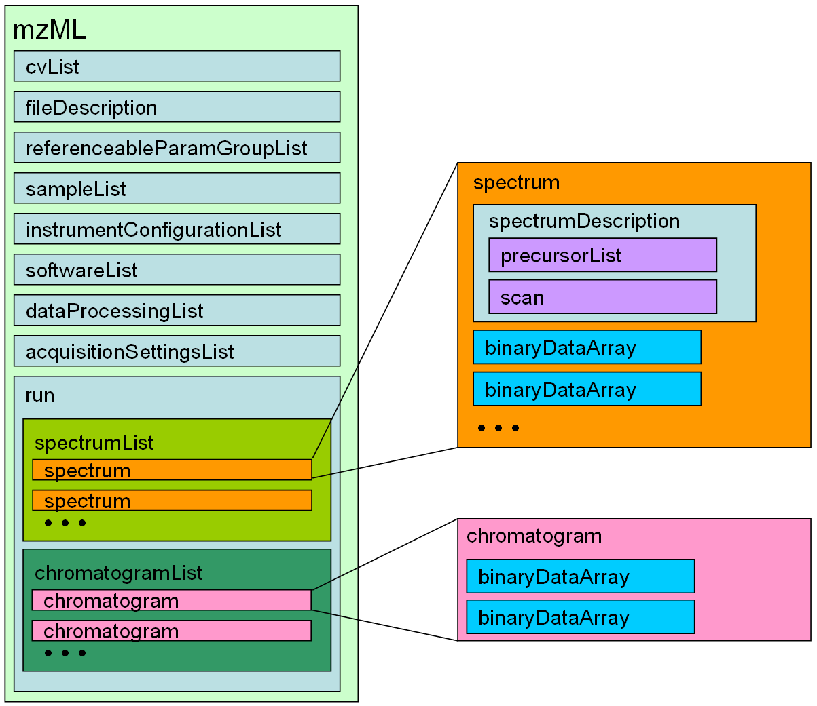
Figure 1: High level overview of the XML elements for mzML. Each box represents an XML element, nested within other elements as shown.

Element <mzML>
Definition: | This is the root element for the Proteomics Standards Initiative (PSI) mzML schema, which is intended to capture the use of a mass spectrometer, the data generated, and the initial processing of that data (to the level of the peak list).
Attributes:
  Attribute Name | Data Type | Use | Definition
  accession | xs:string | optional | An optional accession number for the mzML document.
  id | xs:string | optional | An optional id for the mzML document. It is recommended to use LSIDs when possible.
  version | xs:string | required | The version of this mzML document.
Subelements:
  Subelement Name | minOccurs | maxOccurs | Definition
  cvList | 1 | 1 | Container for one or more controlled vocabulary definitions.
  fileDescription | 1 | 1 | Information pertaining to the entire mzML file (i.e. not specific to any part of the data set) is stored here.
  referenceableParamGroupList | 0 | 1 | Container for a list of referenceableParamGroups
  sampleList | 0 | 1 | List and descriptions of samples.
  instrumentConfigurationList | 1 | 1 | List and descriptions of instrument configurations.
  softwareList | 1 | 1 | List and descriptions of software used to acquire and/or process the data in this mzML file.
  dataProcessingList | 1 | 1 | List and descriptions of data processing applied to this data.
  acquisitionSettingsList | 0 | 1 | List with the descriptions of the acquisition settings applied prior to the start of data acquisition.
  run | 1 | 1 | A run in mzML should correspond to a single, consecutive and coherent set of scans on an instrument.
Graphical Context: | 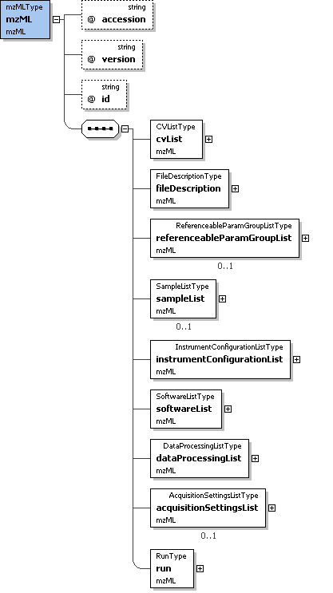
Example Context: | <mzML xmlns="http://psi.hupo.org/schema_revision/mzML_1.0.0" xmlns:xsi="http://www.w3.org/2001/XMLSchema-instance" xsi:schemaLocation="http://psi.hupo.org/schema_revision/mzML_1.0.0 mzML1.0.0.xsd" id="urn:lsid:psidev.info:mzML.instanceDocuments.tiny.pwiz" version="1.0">  <cvList count="2">  <cv id="MS" fullName="Proteomics Standards Initiative Mass Spectrometry Ontology" version="2.0.2" URI="http://psidev.sourceforge.net/ms/xml/mzdata/psi-ms.2.0.2.obo"/>  <cv id="UO" fullName="Unit Ontology" version="unknown" URI="http://obo.cvs.sourceforge.net/obo/obo/ontology/phenotype/unit.obo"/>  </cvList>  ...  </mzML>
Notes and Constraints: | The <mzML> element and all content below may occur by itself in an XML document, but is also designed to be wrapped in the mzML indexing schema in order to facilitate random access within the file with appropriate reader software.

Element <cvList>
Definition: | Container for one or more controlled vocabulary definitions.
Attributes:
  Attribute Name | Data Type | Use | Definition
  count | xs:nonNegativeInteger | required | The number of CV definitionsin this mzML file.
Subelements:
  Subelement Name | minOccurs | maxOccurs | Definition
  cv | 1 | unbounded | Information about an ontology or CV source and a short 'lookup' tag to refer to.
Graphical Context: | 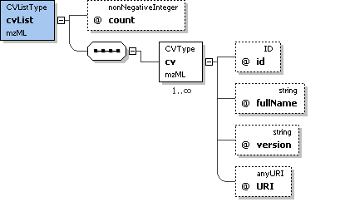
Example Context: | <cvList count="2">  <cv id="MS" fullName="Proteomics Standards Initiative Mass Spectrometry Ontology" version="2.0.2" URI="http://psidev.sourceforge.net/ms/xml/mzdata/psi-ms.2.0.2.obo"/>  <cv id="UO" fullName="Unit Ontology" version="unknown" URI="http://obo.cvs.sourceforge.net/obo/obo/ontology/phenotype/unit.obo"/>  </cvList>
Notes and Constraints: | One of the <cv> elements in this list MUST be the PSI MS controlled vocabulary. All <cvParam> elements in the document MUST refer to one of the <cv> elements in this list.

Element <fileDescription>
Definition: | Information pertaining to the entire mzML file (i.e. not specific to any part of the data set) is stored here.
Attributes: | none
Subelements:
  Subelement Name | minOccurs | maxOccurs | Definition
  fileContent | 1 | 1 | This summarizes the different types of spectra that can be expected in the file. This is expected to aid processing software in skipping files that do not contain appropriate spectrum types for it.
  sourceFileList | 0 | 1 | List and descriptions of the source files this mzML document was generated or derived from
  contact | 0 | unbounded | Structure allowing the use of a controlled (cvParam) or uncontrolled vocabulary (userParam), or a reference to a predefined set of these in this mzML file (paramGroupRef).
Graphical Context: | 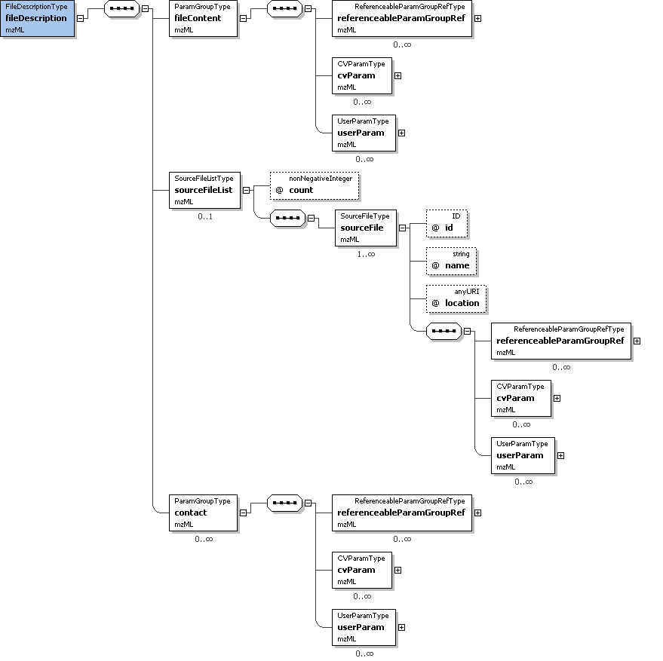
Example Context: | <fileDescription>  <fileContent>  <cvParam cvRef="MS" accession="MS:1000580" name="MSn spectrum" value=""/>  </fileContent>  <sourceFileList count="2">  ...  </fileDescription>

Element <referenceableParamGroupList>
Definition: | Container for a list of referenceableParamGroups
Attributes:
  Attribute Name | Data Type | Use | Definition
  count | xs:nonNegativeInteger | required | The number of ParamGroups defined in this mzML file.
Subelements:
  Subelement Name | minOccurs | maxOccurs | Definition
  referenceableParamGroup | 1 | unbounded | A collection of CVParam and UserParam elements that can be referenced from elsewhere in this mzML document by using the 'paramGroupRef' element in that location to reference the 'id' attribute value of this element.
Graphical Context: | 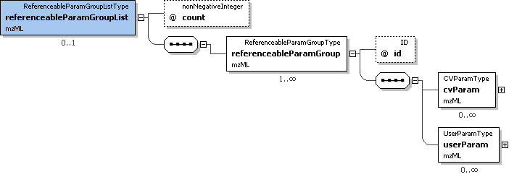
Example Context: | <referenceableParamGroupList count="2">  <referenceableParamGroup id="CommonMS1SpectrumParams">  <cvParam cvRef="MS" accession="MS:1000130" name="positive scan" value=""/>  <cvParam cvRef="MS" accession="MS:1000498" name="full scan" value=""/>  </referenceableParamGroup>  ...  </referenceableParamGroupList>

Element <sampleList>
Definition: | List and descriptions of samples.
Attributes:
  Attribute Name | Data Type | Use | Definition
  count | xs:nonNegativeInteger | required | The number of Samples defined in this mzML file.
Subelements:
  Subelement Name | minOccurs | maxOccurs | Definition
  sample | 1 | unbounded | Expansible description of the sample used to generate the dataset, named in sampleName.
Graphical Context: | 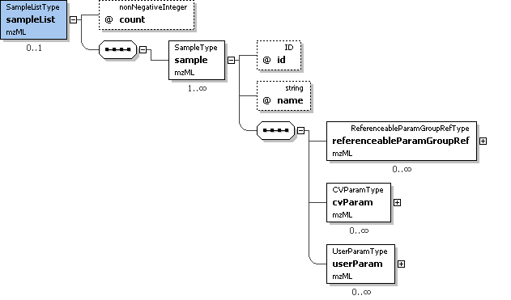
Example Context: | <sampleList count="1">  <sample id="sample1" name="Sample1">  </sample>  </sampleList>

Element <instrumentConfigurationList>
Definition: | List and descriptions of instrument configurations.
Attributes:
  Attribute Name | Data Type | Use | Definition
  count | xs:nonNegativeInteger | required | The number of instrument configurations present in this list.
Subelements:
  Subelement Name | minOccurs | maxOccurs | Definition
  instrumentConfiguration | 1 | unbounded | Description of a particular hardware configuration of a mass spectrometer. Each configuration MUST have one (and only one) of the three different components used for an analysis. For hybrid instruments, such as an LTQ-FT, there MUST be one configuration for each permutation of the components that is used in the document. For software configuration, use a ReferenceableParamGroup element.
Example Context: | <instrumentConfigurationList count="1">  <instrumentConfiguration id="LCQDeca">  <cvParam cvRef="MS" accession="MS:1000554" name="LCQ Deca" value=""/>  <cvParam cvRef="MS" accession="MS:1000529" name="instrument serial number" value="23433"/>  <componentList count="3">  ...  </instrumentConfigurationList>

Element <softwareList>
Definition: | List and descriptions of software used to acquire and/or process the data in this mzML file.
Attributes:
  Attribute Name | Data Type | Use | Definition
  count | xs:nonNegativeInteger | required | The number of softwares defined in this mzML file.
Subelements:
  Subelement Name | minOccurs | maxOccurs | Definition
  software | 1 | unbounded | A piece of software.
Graphical Context: | 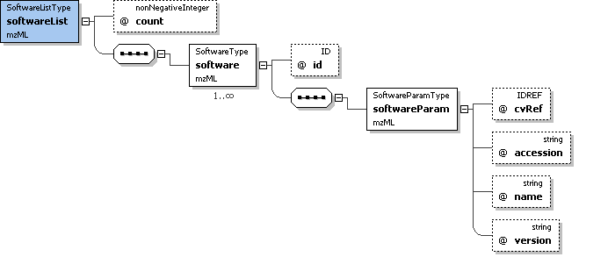
Example Context: | <softwareList count="3">  <software id="Bioworks">  <softwareParam cvRef="MS" accession="MS:1000533" name="Bioworks" version="3.3.1 sp1"/>  </software>  <software id="pwiz">  ...  </softwareList>

Element <dataProcessingList>
Definition: | List and descriptions of data processing applied to this data.
Attributes:
  Attribute Name | Data Type | Use | Definition
  count | xs:nonNegativeInteger | required | The number of DataProcessingTypes in this mzML file.
Subelements:
  Subelement Name | minOccurs | maxOccurs | Definition
  dataProcessing | 1 | unbounded | Description of the way in which a particular software was used.
Graphical Context: | 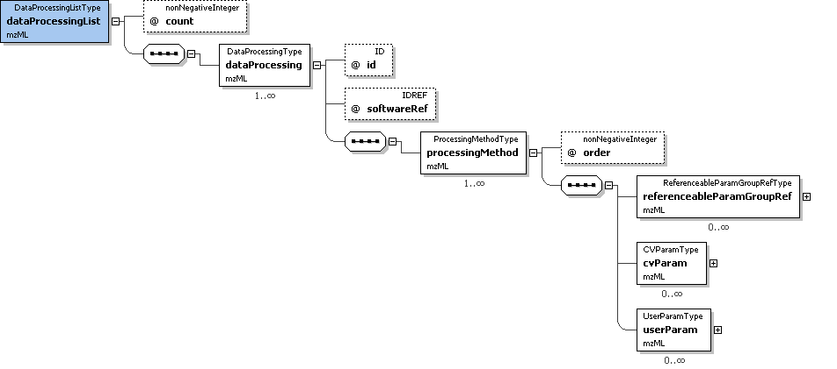
Example Context: | <dataProcessingList count="2">  <dataProcessing id="XcaliburProcessing" softwareRef="Xcalibur">  <processingMethod order="1">  <cvParam cvRef="MS" accession="MS:1000033" name="deisotoping" value="false"/>  <cvParam cvRef="MS" accession="MS:1000034" name="charge deconvolution" value="false"/>  ...  </dataProcessingList>

Element <acquisitionSettingsList>
Definition: | List with the descriptions of the acquisition settings applied prior to the start of data acquisition.
Attributes:
  Attribute Name | Data Type | Use | Definition
  count | xs:nonNegativeInteger | required | The number of AcquisitionType elements in this list.
Subelements:
  Subelement Name | minOccurs | maxOccurs | Definition
  acquisitionSettings | 1 | unbounded | Description of the acquisition settings of the instrument prior to the start of the run.
Graphical Context: | 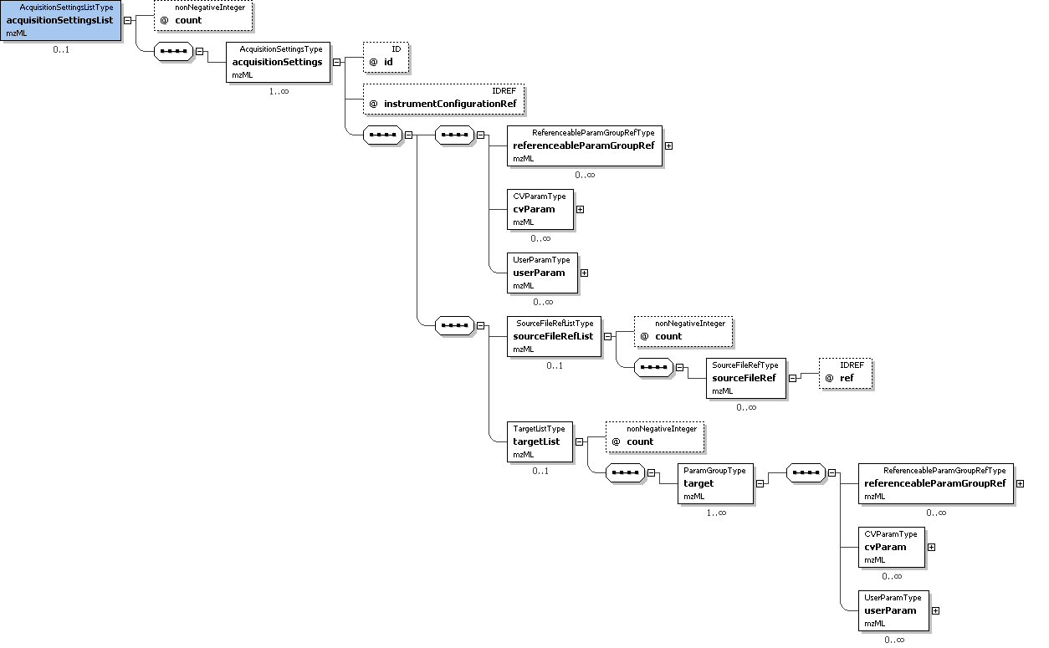
Example Context: | <acquisitionSettingsList count="1">  <acquisitionSettings id="as1" instrumentConfigurationRef="LCQDeca">  <sourceFileRefList count="1">  <sourceFileRef ref="sf_parameters"/>  </sourceFileRefList>  ...  </acquisitionSettingsList>

Element <run>
Definition: | A run in mzML should correspond to a single, consecutive and coherent set of scans on an instrument.
Attributes:
  Attribute Name | Data Type | Use | Definition
  defaultInstrumentConfigurationRef | xs:IDREF | required | This attribute MUST reference the 'id' of the default instrument configuration. If a scan does not reference an instrument configuration, it implicitly refers to this configuration.
  id | xs:ID | required | A unique identifier for this run.
  sampleRef | xs:IDREF | optional | This attribute MUST reference the 'id' of the appropriate sample.
  startTimeStamp | xs:dateTime | optional | The optional start timestamp of the run, in UT.
Subelements:
  Subelement Name | minOccurs | maxOccurs | Definition
  referenceableParamGroupRef | 0 | unbounded | A reference to a previously defined ParamGroup, which is a reusable container of one or more cvParams.
  cvParam | 0 | unbounded | This element holds additional data or annotation. Only controlled values are allowed here.
  userParam | 0 | unbounded | Uncontrolled user parameters (essentially allowing free text). Before using these, one should verify whether there is an appropriate CV term available, and if so, use the CV term instead
  sourceFileRefList | 0 | 1 | Container for a list of source file references.
  spectrumList | 1 | 1 | All mass spectra and the acquisitions underlying them are described and attached here. Subsidiary data arrays are also both described and attached here.
  chromatogramList | 0 | 1 | All chromatograms for thsi run.
Graphical Context: | 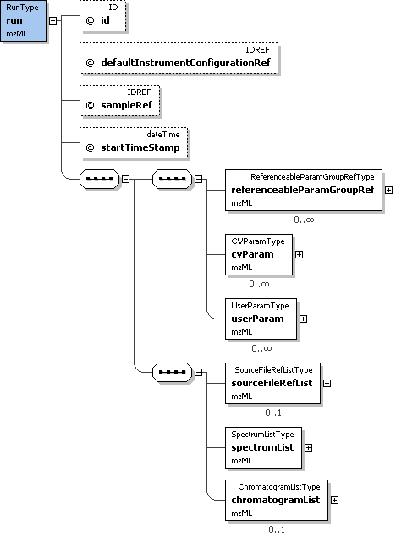
Example Context: | <run id="Exp01" defaultInstrumentConfigurationRef="LCQDeca" sampleRef="sample1" startTimeStamp="2007-06-27T15:23:45.00035">  <sourceFileRefList count="1">  <sourceFileRef ref="sf1"/>  </sourceFileRefList>  <spectrumList count="3">  ...  </run>

Element <cv>
Definition: | Information about an ontology or CV source and a short 'lookup' tag to refer to.
Attributes:
  Attribute Name | Data Type | Use | Definition
  URI | xs:anyURI | required | The URI for the resource.
  fullName | xs:string | required | The usual name for the resource (e.g. The PSI-MS Controlled Vocabulary).
  id | xs:ID | required | The short label to be used as a reference tag with which to refer to this particular Controlled Vocabulary source description (e.g., from the cvLabel attribute, in CVParamType elements).
  version | xs:string | optional | The version of the CV from which the referred-to terms are drawn.
Subelements: | none
Example Context: | <cv id="MS" fullName="Proteomics Standards Initiative Mass Spectrometry Ontology" version="2.0.2" URI="http://psidev.sourceforge.net/ms/xml/mzdata/psi-ms.2.0.2.obo"/>

Element <fileContent>
Definition: | This summarizes the different types of spectra that can be expected in the file. This is expected to aid processing software in skipping files that do not contain appropriate spectrum types for it.
Attributes: | none
Subelements:
  Subelement Name | minOccurs | maxOccurs | Definition
  referenceableParamGroupRef | 0 | unbounded | A reference to a previously defined ParamGroup, which is a reusable container of one or more cvParams.
  cvParam | 0 | unbounded | This element holds additional data or annotation. Only controlled values are allowed here.
  userParam | 0 | unbounded | Uncontrolled user parameters (essentially allowing free text). Before using these, one should verify whether there is an appropriate CV term available, and if so, use the CV term instead
Example Context: | <fileContent>  <cvParam cvRef="MS" accession="MS:1000580" name="MSn spectrum" value=""/>  </fileContent>
cvParam Mapping Rules: | MUST supply a *child* term of MS:1000524 (data file content) one or more times  e.g.: MS:1000235 (total ion current chromatogram)  e.g.: MS:1000579 (MS1 spectrum)  e.g.: MS:1000580 (MSn spectrum)  e.g.: MS:1000581 (CRM spectrum)  e.g.: MS:1000582 (SIM spectrum)  e.g.: MS:1000583 (SRM spectrum)  e.g.: MS:1000620 (PDA spectrum)  e.g.: MS:1000627 (selected ion current chromatogram)  e.g.: MS:1000628 (basepeak chromatogram)
Example cvParams: | <cvParam cvRef="MS" accession="MS:1000580" name="MSn spectrum" value=""/>

Element <sourceFileList>
Definition: | List and descriptions of the source files this mzML document was generated or derived from
Attributes:
  Attribute Name | Data Type | Use | Definition
  count | xs:nonNegativeInteger | required | Number of source files used in generating the instance document.
Subelements:
  Subelement Name | minOccurs | maxOccurs | Definition
  sourceFile | 1 | unbounded | Description of the source file, including location and type.
Example Context: | <sourceFileList count="2">  <sourceFile id="sf1" name="tiny1.RAW" location="file:///F:/data/Exp01">  <cvParam cvRef="MS" accession="MS:1000563" name="Xcalibur RAW file" value=""/>  <cvParam cvRef="MS" accession="MS:1000569" name="SHA-1" value="71be39fb2700ab2f3c8b2234b91274968b6899b1"/>  </sourceFile>  ...  </sourceFileList>

Element <contact>
Definition: | Structure allowing the use of a controlled (cvParam) or uncontrolled vocabulary (userParam), or a reference to a predefined set of these in this mzML file (paramGroupRef).
Attributes: | none
Subelements:
  Subelement Name | minOccurs | maxOccurs | Definition
  referenceableParamGroupRef | 0 | unbounded | A reference to a previously defined ParamGroup, which is a reusable container of one or more cvParams.
  cvParam | 0 | unbounded | This element holds additional data or annotation. Only controlled values are allowed here.
  userParam | 0 | unbounded | Uncontrolled user parameters (essentially allowing free text). Before using these, one should verify whether there is an appropriate CV term available, and if so, use the CV term instead
Example Context: | <contact>  <cvParam cvRef="MS" accession="MS:1000586" name="contact name" value="William Pennington"/>  <cvParam cvRef="MS" accession="MS:1000587" name="contact address" value="Higglesworth University, 12 Higglesworth Avenue, 12045, HI, USA"/>  <cvParam cvRef="MS" accession="MS:1000588" name="contact URL" value="http://www.higglesworth.edu/"/>  <cvParam cvRef="MS" accession="MS:1000589" name="contact email" value="wpennington@higglesworth.edu"/>  ...  </contact>
cvParam Mapping Rules: | MUST supply a *child* term of MS:1000585 (contact person attribute) one or more times  e.g.: MS:1000586 (contact name)  e.g.: MS:1000587 (contact address)  e.g.: MS:1000588 (contact URL)  e.g.: MS:1000589 (contact email)  e.g.: MS:1000590 (contact organization)
Example cvParams: | <cvParam cvRef="MS" accession="MS:1000586" name="contact name" value="William Pennington"/>  <cvParam cvRef="MS" accession="MS:1000587" name="contact address" value="Higglesworth University, 12 Higglesworth Avenue, 12045, HI, USA"/>  <cvParam cvRef="MS" accession="MS:1000588" name="contact URL" value="http://www.higglesworth.edu/"/>  <cvParam cvRef="MS" accession="MS:1000589" name="contact email" value="wpennington@higglesworth.edu"/>

Element <referenceableParamGroup>
Definition: | A collection of CVParam and UserParam elements that can be referenced from elsewhere in this mzML document by using the 'paramGroupRef' element in that location to reference the 'id' attribute value of this element.
Attributes:
  Attribute Name | Data Type | Use | Definition
  id | xs:ID | required | The identifier with which to reference this ReferenceableParamGroup.
Subelements:
  Subelement Name | minOccurs | maxOccurs | Definition
  cvParam | 0 | unbounded | This element holds additional data or annotation. Only controlled values are allowed here.
  userParam | 0 | unbounded | Uncontrolled user parameters (essentially allowing free text). Before using these, one should verify whether there is an appropriate CV term available, and if so, use the CV term instead
Example Context: | <referenceableParamGroup id="CommonMS1SpectrumParams">  <cvParam cvRef="MS" accession="MS:1000130" name="positive scan" value=""/>  <cvParam cvRef="MS" accession="MS:1000498" name="full scan" value=""/>  </referenceableParamGroup>
Example cvParams: | <cvParam cvRef="MS" accession="MS:1000130" name="positive scan" value=""/>  <cvParam cvRef="MS" accession="MS:1000498" name="full scan" value=""/>

Element <sample>
Definition: | Expansible description of the sample used to generate the dataset, named in sampleName.
Attributes:
  Attribute Name | Data Type | Use | Definition
  id | xs:ID | required | A unique identifier across the samples with which to reference this sample description.
  name | xs:string | optional | An optional name for the sample description, mostly intended as a quick mnemonic.
Subelements:
  Subelement Name | minOccurs | maxOccurs | Definition
  referenceableParamGroupRef | 0 | unbounded | A reference to a previously defined ParamGroup, which is a reusable container of one or more cvParams.
  cvParam | 0 | unbounded | This element holds additional data or annotation. Only controlled values are allowed here.
  userParam | 0 | unbounded | Uncontrolled user parameters (essentially allowing free text). Before using these, one should verify whether there is an appropriate CV term available, and if so, use the CV term instead
Example Context: | <sample id="sample1" name="Sample1">  </sample>
cvParam Mapping Rules: | MAY supply a *child* term of GO:0005575 (cellular_component) one or more times  MAY supply a *child* term of BTO:0000000 (brenda source tissue ontology) one or more times  MAY supply a *child* term of PATO:0001241 (quality of an object) one or more times  MAY supply a *child* term of MS:1000548 (sample attribute) one or more times  e.g.: MS:1000001 (sample number)  e.g.: MS:1000004 (sample mass)  e.g.: MS:1000005 (sample volume)  e.g.: MS:1000006 (sample concentration)  e.g.: MS:1000053 (sample batch)

Element <instrumentConfiguration>
Definition: | Description of a particular hardware configuration of a mass spectrometer. Each configuration MUST have one (and only one) of the three different components used for an analysis. For hybrid instruments, such as an LTQ-FT, there MUST be one configuration for each permutation of the components that is used in the document. For software configuration, use a ReferenceableParamGroup element.
Attributes:
  Attribute Name | Data Type | Use | Definition
  id | xs:ID | required | An identifier for this instrument configuration.
Subelements:
  Subelement Name | minOccurs | maxOccurs | Definition
  referenceableParamGroupRef | 0 | unbounded | A reference to a previously defined ParamGroup, which is a reusable container of one or more cvParams.
  cvParam | 0 | unbounded | This element holds additional data or annotation. Only controlled values are allowed here.
  userParam | 0 | unbounded | Uncontrolled user parameters (essentially allowing free text). Before using these, one should verify whether there is an appropriate CV term available, and if so, use the CV term instead
  componentList | 1 | 1 | List with the different components used in the mass spectrometer. At least one source, one mass analyzer and one detector need to be specified.
  softwareRef | 0 | 1 | Reference to a previously defined software element
Example Context: | <instrumentConfiguration id="LCQDeca">  <cvParam cvRef="MS" accession="MS:1000554" name="LCQ Deca" value=""/>  <cvParam cvRef="MS" accession="MS:1000529" name="instrument serial number" value="23433"/>  <componentList count="3">  <source order="1">  ...  </instrumentConfiguration>
Example cvParams: | <cvParam cvRef="MS" accession="MS:1000554" name="LCQ Deca" value=""/>  <cvParam cvRef="MS" accession="MS:1000529" name="instrument serial number" value="23433"/>

Element <software>
Definition: | A piece of software.
Attributes:
  Attribute Name | Data Type | Use | Definition
  id | xs:ID | required | An identifier for this software that is unique across all SoftwareTypes.
Subelements:
  Subelement Name | minOccurs | maxOccurs | Definition
  softwareParam | 1 | 1 | A description of the software, based on CV information and a software version.
Example Context: | <software id="Bioworks">  <softwareParam cvRef="MS" accession="MS:1000533" name="Bioworks" version="3.3.1 sp1"/>  </software>

Element <dataProcessing>
Definition: | Description of the way in which a particular software was used.
Attributes:
  Attribute Name | Data Type | Use | Definition
  id | xs:ID | required | A unique identifier for this data processing that is unique across all DataProcessingTypes.
  softwareRef | xs:IDREF | required | This attribute MUST reference the 'id' of the appropriate SoftwareType.
Subelements:
  Subelement Name | minOccurs | maxOccurs | Definition
  processingMethod | 1 | unbounded | Description of the default peak processing method. This element describes the base method used in the generation of a particular mzML file. Variable methods should be described in the appropriate acquisition section - if no acquisition-specific details are found, then this information serves as the default.
Example Context: | <dataProcessing id="XcaliburProcessing" softwareRef="Xcalibur">  <processingMethod order="1">  <cvParam cvRef="MS" accession="MS:1000033" name="deisotoping" value="false"/>  <cvParam cvRef="MS" accession="MS:1000034" name="charge deconvolution" value="false"/>  <cvParam cvRef="MS" accession="MS:1000035" name="peak picking" value="true"/>  ...  </dataProcessing>

Element <acquisitionSettings>
Definition: | Description of the acquisition settings of the instrument prior to the start of the run.
Attributes:
  Attribute Name | Data Type | Use | Definition
  id | xs:ID | required | A unique identifier for this acquisition setting.
  instrumentConfigurationRef | xs:IDREF | required | This attribute MUST reference the 'id' of the appropriate instrument configuration.
Subelements:
  Subelement Name | minOccurs | maxOccurs | Definition
  referenceableParamGroupRef | 0 | unbounded | A reference to a previously defined ParamGroup, which is a reusable container of one or more cvParams.
  cvParam | 0 | unbounded | This element holds additional data or annotation. Only controlled values are allowed here.
  userParam | 0 | unbounded | Uncontrolled user parameters (essentially allowing free text). Before using these, one should verify whether there is an appropriate CV term available, and if so, use the CV term instead
  sourceFileRefList | 0 | 1 | Container for a list of source file references.
  targetList | 0 | 1 | Target list (or 'inclusion list') configured prior to the run.
Example Context: | <acquisitionSettings id="as1" instrumentConfigurationRef="LCQDeca">  <sourceFileRefList count="1">  <sourceFileRef ref="sf_parameters"/>  </sourceFileRefList>  <targetList count="2">  ...  </acquisitionSettings>

Element <referenceableParamGroupRef>
Definition: | A reference to a previously defined ParamGroup, which is a reusable container of one or more cvParams.
Attributes:
  Attribute Name | Data Type | Use | Definition
  ref | xs:IDREF | required | Reference to the id attribute in a referenceableParamGroup.
Subelements: | none
Example Context: | <referenceableParamGroupRef ref="CommonMS1SpectrumParams"/>
Example cvParams: | <cvParam cvRef="MS" accession="MS:1000016" name="scan time" value="5.8905" unitCvRef="MS" unitAccession="MS:1000038" unitName="minute"/>  <cvParam cvRef="MS" accession="MS:1000512" name="filter string" value="+ c NSI Full ms [ 400.00-1800.00]"/>  <cvParam cvRef="MS" accession="MS:1000616" name="preset scan configuration" value="3"/>

Element <cvParam>
Definition: | This element holds additional data or annotation. Only controlled values are allowed here.
Attributes:
  Attribute Name | Data Type | Use | Definition
  accession | xs:string | required | The accession number of the referred-to term in the named resource (e.g.: MS:000012).
  cvRef | xs:IDREF | required | A reference to the CV 'id' attribute as defined in the cvList in this mzML file.
  name | xs:string | required | The actual name for the parameter, from the referred-to controlled vocabulary. This should be the preferred name associated with the specified accession number.
  unitAccession | xs:string | optional | An optional CV accession number for the unit term associated with the value, if any (e.g., 'UO:0000266' for 'electron volt').
  unitCvRef | xs:IDREF | optional | If a unit term is referenced, this attribute MUST refer to the CV 'id' attribute defined in the cvList in this mzML file.
  unitName | xs:string | optional | An optional CV name for the unit accession number, if any (e.g., 'electron volt' for 'UO:0000266' ).
  value | xs:string | optional | The value for the parameter; may be absent if not appropriate, or a numeric or symbolic value, or may itself be CV (legal values for a parameter should be enumerated and defined in the ontology).
Subelements: | none
Example Context: | <cvParam cvRef="MS" accession="MS:1000580" name="MSn spectrum" value=""/>

Element <userParam>
Definition: | Uncontrolled user parameters (essentially allowing free text). Before using these, one should verify whether there is an appropriate CV term available, and if so, use the CV term instead
Attributes:
  Attribute Name | Data Type | Use | Definition
  name | xs:string | required | The name for the parameter.
  type | xs:string | optional | The datatype of the parameter, where appropriate (e.g.: xsd:float).
  unitAccession | xs:string | optional | An optional CV accession number for the unit term associated with the value, if any (e.g., 'UO:0000266' for 'electron volt').
  unitCvRef | xs:IDREF | optional | If a unit term is referenced, this attribute MUST refer to the CV 'id' attribute defined in the cvList in this mzML file.
  unitName | xs:string | optional | An optional CV name for the unit accession number, if any (e.g., 'electron volt' for 'UO:0000266' ).
  value | xs:string | optional | The value for the parameter, where appropriate.
Subelements: | none
Example Context: | <userParam name="example" value="spectrum with no data (no BinaryDataArrayList)"/>

Element <sourceFileRefList>
Definition: | Container for a list of source file references.
Attributes:
  Attribute Name | Data Type | Use | Definition
  count | xs:nonNegativeInteger | required | This number of source files referenced in this list.
Subelements:
  Subelement Name | minOccurs | maxOccurs | Definition
  sourceFileRef | 0 | unbounded | Reference to a previously defined sourceFile.
Graphical Context: | 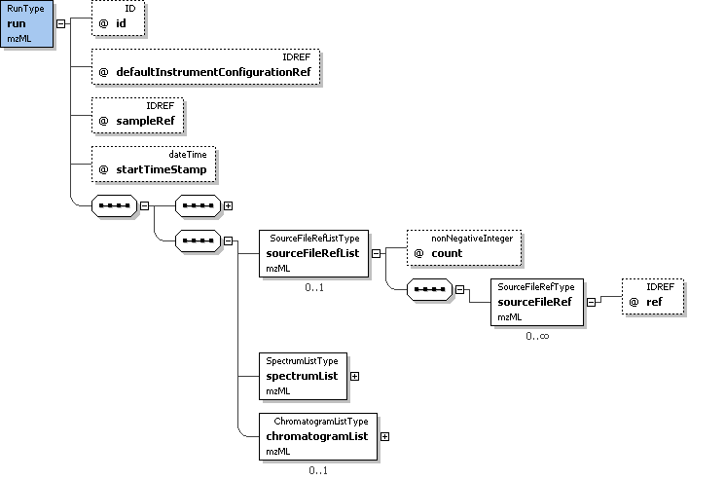
Example Context: | <sourceFileRefList count="1">  <sourceFileRef ref="sf_parameters"/>  </sourceFileRefList>

Element <spectrumList>
Definition: | All mass spectra and the acquisitions underlying them are described and attached here. Subsidiary data arrays are also both described and attached here.
Attributes:
  Attribute Name | Data Type | Use | Definition
  count | xs:nonNegativeInteger | required | The number of spectra defined in this mzML file.
Subelements:
  Subelement Name | minOccurs | maxOccurs | Definition
  spectrum | 0 | unbounded | The structure that captures the generation of a peak list (including the underlying acquisitions)
Graphical Context: | 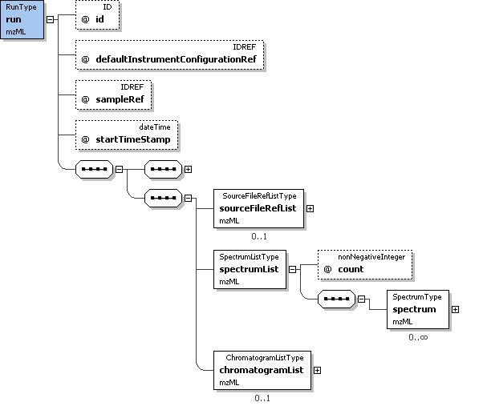
Example Context: | <spectrumList count="3">  <spectrum index="0" id="S19" nativeID="19" defaultArrayLength="15">  <cvParam cvRef="MS" accession="MS:1000580" name="MSn spectrum" value=""/>  <cvParam cvRef="MS" accession="MS:1000511" name="ms level" value="1"/>  <spectrumDescription>  ...  </spectrumList>

Element <chromatogramList>
Definition: | All chromatograms for thsi run.
Attributes:
  Attribute Name | Data Type | Use | Definition
  count | xs:nonNegativeInteger | required | The number of chromatograms defined in this mzML file.
Subelements:
  Subelement Name | minOccurs | maxOccurs | Definition
  chromatogram | 1 | unbounded | A single chromatogram.
Graphical Context: | 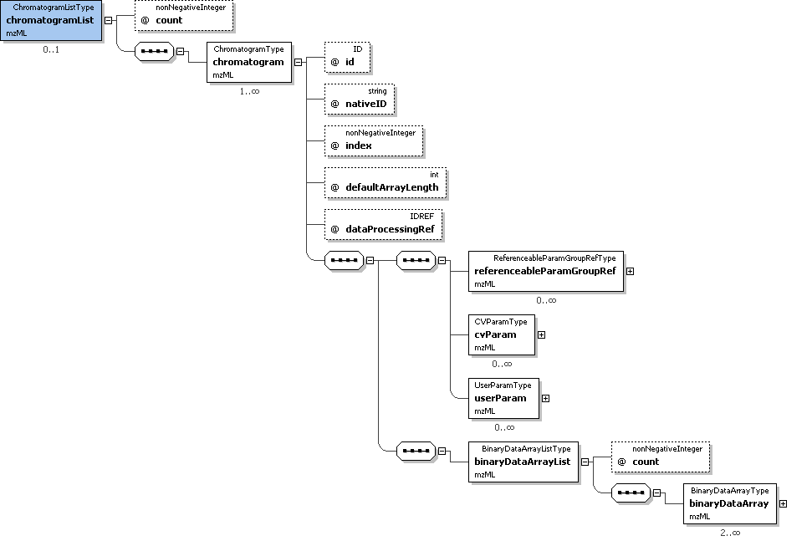
Example Context: | <chromatogramList count="2">  <chromatogram index="0" id="tic" nativeID="tic native" defaultArrayLength="15" dataProcessingRef="XcaliburProcessing">  <cvParam cvRef="MS" accession="MS:1000235" name="total ion current chromatogram" value=""/>  <binaryDataArrayList count="2">  <binaryDataArray encodedLength="160" dataProcessingRef="pwizconversion">  ...  </chromatogramList>

Element <sourceFile>
Definition: | Description of the source file, including location and type.
Attributes:
  Attribute Name | Data Type | Use | Definition
  id | xs:ID | required | An identifier for this file.
  location | xs:anyURI | required | URI-formatted location where the file was retrieved.
  name | xs:string | required | Name of the source file, without reference to location (either URI or local path).
Subelements:
  Subelement Name | minOccurs | maxOccurs | Definition
  referenceableParamGroupRef | 0 | unbounded | A reference to a previously defined ParamGroup, which is a reusable container of one or more cvParams.
  cvParam | 0 | unbounded | This element holds additional data or annotation. Only controlled values are allowed here.
  userParam | 0 | unbounded | Uncontrolled user parameters (essentially allowing free text). Before using these, one should verify whether there is an appropriate CV term available, and if so, use the CV term instead
Example Context: | <sourceFile id="sf1" name="tiny1.RAW" location="file:///F:/data/Exp01">  <cvParam cvRef="MS" accession="MS:1000563" name="Xcalibur RAW file" value=""/>  <cvParam cvRef="MS" accession="MS:1000569" name="SHA-1" value="71be39fb2700ab2f3c8b2234b91274968b6899b1"/>  </sourceFile>
cvParam Mapping Rules: | MUST supply a *child* term of MS:1000561 (data file checksum type) one or more times  e.g.: MS:1000568 (MD5)  e.g.: MS:1000569 (SHA-1)  MUST supply a *child* term of MS:1000560 (source file type) one or more times  e.g.: MS:1000526 (MassLynx raw format)  e.g.: MS:1000562 (wiff file)  e.g.: MS:1000563 (Xcalibur RAW file)  e.g.: MS:1000564 (mzData file)  e.g.: MS:1000565 (pkl file)  e.g.: MS:1000566 (mzXML file)  e.g.: MS:1000567 (yep file)  e.g.: MS:1000584 (mzML file)  e.g.: MS:1000613 (dta file)  e.g.: MS:1000614 (ProteinLynx Global Server mass spectrum XML file)
Example cvParams: | <cvParam cvRef="MS" accession="MS:1000563" name="Xcalibur RAW file" value=""/>  <cvParam cvRef="MS" accession="MS:1000569" name="SHA-1" value="71be39fb2700ab2f3c8b2234b91274968b6899b1"/>

Element <componentList>
Definition: | List with the different components used in the mass spectrometer. At least one source, one mass analyzer and one detector need to be specified.
Attributes:
  Attribute Name | Data Type | Use | Definition
  count | xs:nonNegativeInteger | required | The number of components in this list.
Subelements:
  Subelement Name | minOccurs | maxOccurs | Definition
  source | 1 | 1 | A source component.
  analyzer | 1 | 1 | A mass analyzer (or mass filter) component.
  detector | 1 | 1 | A detector component.
Example Context: | <componentList count="3">  <source order="1">  <cvParam cvRef="MS" accession="MS:1000398" name="nanoelectrospray" value=""/>  </source>  <analyzer order="2">  ...  </componentList>

Element <softwareRef>
Definition: | Reference to a previously defined software element
Attributes:
  Attribute Name | Data Type | Use | Definition
  ref | xs:IDREF | required | This attribute MUST be used to reference the 'id' attribute of a software element.
Subelements: | none
Example Context: | <softwareRef ref="Xcalibur"/>

Element <softwareParam>
Definition: | A description of the software, based on CV information and a software version.
Attributes:
  Attribute Name | Data Type | Use | Definition
  accession | xs:string | required | The accession number for this CV term.
  cvRef | xs:IDREF | required | A reference to the CV 'id' attribute as defined in the cvList in this mzML file.
  name | xs:string | required | The preferred name in the CV for the accession number of this CV term.
  version | xs:string | required | The software version.
Subelements: | none
Example Context: | <softwareParam cvRef="MS" accession="MS:1000533" name="Bioworks" version="3.3.1 sp1"/>

Element <processingMethod>
Definition: | Description of the default peak processing method. This element describes the base method used in the generation of a particular mzML file. Variable methods should be described in the appropriate acquisition section - if no acquisition-specific details are found, then this information serves as the default.
Attributes:
  Attribute Name | Data Type | Use | Definition
  order | xs:nonNegativeInteger | required | This attributes allows a series of consecutive steps to be placed in the correct order.
Subelements:
  Subelement Name | minOccurs | maxOccurs | Definition
  referenceableParamGroupRef | 0 | unbounded | A reference to a previously defined ParamGroup, which is a reusable container of one or more cvParams.
  cvParam | 0 | unbounded | This element holds additional data or annotation. Only controlled values are allowed here.
  userParam | 0 | unbounded | Uncontrolled user parameters (essentially allowing free text). Before using these, one should verify whether there is an appropriate CV term available, and if so, use the CV term instead
Example Context: | <processingMethod order="1">  <cvParam cvRef="MS" accession="MS:1000033" name="deisotoping" value="false"/>  <cvParam cvRef="MS" accession="MS:1000034" name="charge deconvolution" value="false"/>  <cvParam cvRef="MS" accession="MS:1000035" name="peak picking" value="true"/>  </processingMethod>  ...  </processingMethod>
cvParam Mapping Rules: | MUST supply a *child* term of MS:1000543 (data processing action) one or more times  e.g.: MS:1000033 (deisotoping)  e.g.: MS:1000034 (charge deconvolution)  e.g.: MS:1000035 (peak picking)  e.g.: MS:1000592 (smoothing)  e.g.: MS:1000593 (baseline reduction)  e.g.: MS:1000594 (low intensity data point removal)  MUST supply a *child* term of MS:1000530 (file format conversion) one or more times  e.g.: MS:1000544 (Conversion to mzML)  e.g.: MS:1000545 (Conversion to mzXML)  e.g.: MS:1000546 (Conversion to mzData)
Example cvParams: | <cvParam cvRef="MS" accession="MS:1000033" name="deisotoping" value="false"/>  <cvParam cvRef="MS" accession="MS:1000034" name="charge deconvolution" value="false"/>  <cvParam cvRef="MS" accession="MS:1000035" name="peak picking" value="true"/>  <cvParam cvRef="MS" accession="MS:1000544" name="Conversion to mzML" value=""/>

Element <targetList>
Definition: | Target list (or 'inclusion list') configured prior to the run.
Attributes:
  Attribute Name | Data Type | Use | Definition
  count | xs:nonNegativeInteger | required | The number of TargetType elements in this list.
Subelements:
  Subelement Name | minOccurs | maxOccurs | Definition
  target | 1 | unbounded | Structure allowing the use of a controlled (cvParam) or uncontrolled vocabulary (userParam), or a reference to a predefined set of these in this mzML file (paramGroupRef).
Example Context: | <targetList count="2">  <target>  <cvParam cvRef="MS" accession="MS:1000040" name="m/z" value="1000"/>  </target>  <target>  ...  </targetList>

Element <sourceFileRef>
Definition: | Reference to a previously defined sourceFile.
Attributes:
  Attribute Name | Data Type | Use | Definition
  ref | xs:IDREF | required | This attribute MUST reference the 'id' of the appropriate sourceFile.
Subelements: | none
Example Context: | <sourceFileRef ref="sf_parameters"/>

Element <spectrum>
Definition: | The structure that captures the generation of a peak list (including the underlying acquisitions)
Attributes:
  Attribute Name | Data Type | Use | Definition
  dataProcessingRef | xs:IDREF | optional | This attribute can optionally reference the 'id' of the appropriate dataProcessing.
  defaultArrayLength | xs:int | required | Default length of binary data arrays contained in this element.
  id | xs:ID | required | A unique identifier for this spectrum. It should be expected that external files may use this identifier together with the mzML filename or accession to reference a particular spectrum.
  index | xs:nonNegativeInteger | required | The zero-based, consecutive index of the spectrum in the SpectrumList.
  nativeID | xs:string | required | The native identifier for the spectrum, used by the acquisition software.
  sourceFileRef | xs:IDREF | optional | This attribute can optionally reference the 'id' of the appropriate sourceFile.
  spotID | xs:string | optional | The identifier for the spot from which this spectrum was derived, if a MALDI or similar run.
Subelements:
  Subelement Name | minOccurs | maxOccurs | Definition
  referenceableParamGroupRef | 0 | unbounded | A reference to a previously defined ParamGroup, which is a reusable container of one or more cvParams.
  cvParam | 0 | unbounded | This element holds additional data or annotation. Only controlled values are allowed here.
  userParam | 0 | unbounded | Uncontrolled user parameters (essentially allowing free text). Before using these, one should verify whether there is an appropriate CV term available, and if so, use the CV term instead
  spectrumDescription | 1 | 1 | Description of the parameters for the mass spectrometer for a given acquisition (or list of acquisitions).
  binaryDataArrayList | 0 | 1 | List of binary data arrays.
Graphical Context: | 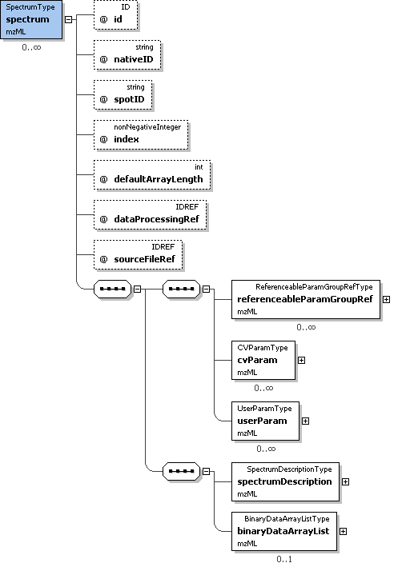
Example Context: | <spectrum index="0" id="S19" nativeID="19" defaultArrayLength="15">  <cvParam cvRef="MS" accession="MS:1000580" name="MSn spectrum" value=""/>  <cvParam cvRef="MS" accession="MS:1000511" name="ms level" value="1"/>  <spectrumDescription>  <cvParam cvRef="MS" accession="MS:1000127" name="centroid mass spectrum" value=""/>  ...  </spectrum>
cvParam Mapping Rules: | MUST supply a *child* term of MS:1000559 (spectrum type) only once  e.g.: MS:1000579 (MS1 spectrum)  e.g.: MS:1000580 (MSn spectrum)  e.g.: MS:1000581 (CRM spectrum)  e.g.: MS:1000582 (SIM spectrum)  e.g.: MS:1000583 (SRM spectrum)  e.g.: MS:1000620 (PDA spectrum)  e.g.: MS:1000627 (selected ion current chromatogram)
Example cvParams: | <cvParam cvRef="MS" accession="MS:1000580" name="MSn spectrum" value=""/>  <cvParam cvRef="MS" accession="MS:1000511" name="ms level" value="1"/>
Notes and Constraints: | id's MUST be unique within a file. They may be LSIDs or simply the scan number. scanNumbers MUST be unique within a file and MUST be monotonically increasing throughout the file, although not necessarily sequentially. If a scan yields no peaks, it should still be reported, but with a defaultArrayLength of 0 and no <binaryDataArrayList> element.

Element <chromatogram>
Definition: | A single chromatogram.
Attributes:
  Attribute Name | Data Type | Use | Definition
  dataProcessingRef | xs:IDREF | optional | This attribute can optionally reference the 'id' of the appropriate dataProcessing.
  defaultArrayLength | xs:int | required | Default length of binary data arrays contained in this element.
  id | xs:ID | required | A unique identifier for this chromatogram.
  index | xs:nonNegativeInteger | required | The zero-based index for this chromatogram in the chromatogram list.
  nativeID | xs:string | required | The native identifier for the spectrum, used by the acquisition software.
Subelements:
  Subelement Name | minOccurs | maxOccurs | Definition
  referenceableParamGroupRef | 0 | unbounded | A reference to a previously defined ParamGroup, which is a reusable container of one or more cvParams.
  cvParam | 0 | unbounded | This element holds additional data or annotation. Only controlled values are allowed here.
  userParam | 0 | unbounded | Uncontrolled user parameters (essentially allowing free text). Before using these, one should verify whether there is an appropriate CV term available, and if so, use the CV term instead
  binaryDataArrayList | 1 | 1 | List of binary data arrays.
Example Context: | <chromatogram index="0" id="tic" nativeID="tic native" defaultArrayLength="15" dataProcessingRef="XcaliburProcessing">  <cvParam cvRef="MS" accession="MS:1000235" name="total ion current chromatogram" value=""/>  <binaryDataArrayList count="2">  <binaryDataArray encodedLength="160" dataProcessingRef="pwizconversion">  <cvParam cvRef="MS" accession="MS:1000523" name="64-bit float" value=""/>  ...  </chromatogram>
Example cvParams: | <cvParam cvRef="MS" accession="MS:1000235" name="total ion current chromatogram" value=""/>

Element <source>
Definition: | A source component.
Attributes:
  Attribute Name | Data Type | Use | Definition
  order | xs:int | required | This attribute MUST be used to indicate the order in which the components are encountered from source to detector (e.g., in a Q-TOF, the quadrupole would have the lower order number, and the TOF the higher number of the two).
Subelements:
  Subelement Name | minOccurs | maxOccurs | Definition
  referenceableParamGroupRef | 0 | unbounded | A reference to a previously defined ParamGroup, which is a reusable container of one or more cvParams.
  cvParam | 0 | unbounded | This element holds additional data or annotation. Only controlled values are allowed here.
  userParam | 0 | unbounded | Uncontrolled user parameters (essentially allowing free text). Before using these, one should verify whether there is an appropriate CV term available, and if so, use the CV term instead
Example Context: | <source order="1">  <cvParam cvRef="MS" accession="MS:1000398" name="nanoelectrospray" value=""/>  </source>
cvParam Mapping Rules: | MUST supply a *child* term of MS:1000482 (source attribute) one or more times  e.g.: MS:1000392 (ionization efficiency)  e.g.: MS:1000486 (source potential)  e.g.: MS:1000552 (maldi spot identifier)  MUST supply a *child* term of MS:1000008 (ionization type) one or more times  e.g.: MS:1000070 (atmospheric pressure chemical ionization)  e.g.: MS:1000071 (chemical ionization)  e.g.: MS:1000074 (fast atom bombardment ionization)  e.g.: MS:1000075 (matrix-assisted laser desorption ionization)  e.g.: MS:1000227 (multiphoton ionization)  e.g.: MS:1000239 (atmospheric pressure matrix-assisted laser desorption ionization)  e.g.: MS:1000255 (flowing afterglow)  e.g.: MS:1000257 (field desorption)  e.g.: MS:1000258 (field ionization)  e.g.: MS:1000259 (glow discharge ionization)  et al.  MUST supply a *child* term of MS:1000007 (inlet type) one or more times  e.g.: MS:1000055 (continuous flow fast atom bombardment)  e.g.: MS:1000056 (direct inlet)  e.g.: MS:1000058 (flow injection analysis)  e.g.: MS:1000059 (inductively coupled plasma)  e.g.: MS:1000060 (infusion)  e.g.: MS:1000061 (jet separator)  e.g.: MS:1000062 (membrane separator)  e.g.: MS:1000063 (moving belt)  e.g.: MS:1000064 (moving wire)  e.g.: MS:1000065 (open split)  et al.
Example cvParams: | <cvParam cvRef="MS" accession="MS:1000398" name="nanoelectrospray" value=""/>

Element <analyzer>
Definition: | A mass analyzer (or mass filter) component.
Attributes:
  Attribute Name | Data Type | Use | Definition
  order | xs:int | required | This attribute MUST be used to indicate the order in which the components are encountered from source to detector (e.g., in a Q-TOF, the quadrupole would have the lower order number, and the TOF the higher number of the two).
Subelements:
  Subelement Name | minOccurs | maxOccurs | Definition
  referenceableParamGroupRef | 0 | unbounded | A reference to a previously defined ParamGroup, which is a reusable container of one or more cvParams.
  cvParam | 0 | unbounded | This element holds additional data or annotation. Only controlled values are allowed here.
  userParam | 0 | unbounded | Uncontrolled user parameters (essentially allowing free text). Before using these, one should verify whether there is an appropriate CV term available, and if so, use the CV term instead
Example Context: | <analyzer order="2">  <cvParam cvRef="MS" accession="MS:1000082" name="quadrupole ion trap" value=""/>  </analyzer>
cvParam Mapping Rules: | MUST supply a *child* term of MS:1000012 (resolution measurement method) one or more times  e.g.: MS:1000085 (baseline)  e.g.: MS:1000086 (full width at half-maximum)  e.g.: MS:1000087 (ten percent valley)  MUST supply a *child* term of MS:1000480 (mass analyzer attribute) one or more times  e.g.: MS:1000014 (accuracy)  e.g.: MS:1000022 (TOF Total Path Length)  e.g.: MS:1000024 (final MS exponent)  e.g.: MS:1000025 (magnetic field strength)  e.g.: MS:1000105 (reflectron off)  e.g.: MS:1000106 (reflectron on)  MUST supply a *child* term of MS:1000443 (mass analyzer type) one or more times  e.g.: MS:1000078 (axial ejection linear ion trap)  e.g.: MS:1000079 (fourier transform ion cyclotron resonance mass spectrometer)  e.g.: MS:1000080 (magnetic sector)  e.g.: MS:1000081 (quadrupole)  e.g.: MS:1000082 (quadrupole ion trap)  e.g.: MS:1000083 (radial ejection linear ion trap)  e.g.: MS:1000084 (time-of-flight)  e.g.: MS:1000254 (electrostatic energy analyzer)  e.g.: MS:1000284 (stored waveform inverse fourier transform)  e.g.: MS:1000288 (cyclotron)  et al.
Example cvParams: | <cvParam cvRef="MS" accession="MS:1000082" name="quadrupole ion trap" value=""/>

Element <detector>
Definition: | A detector component.
Attributes:
  Attribute Name | Data Type | Use | Definition
  order | xs:int | required | This attribute MUST be used to indicate the order in which the components are encountered from source to detector (e.g., in a Q-TOF, the quadrupole would have the lower order number, and the TOF the higher number of the two).
Subelements:
  Subelement Name | minOccurs | maxOccurs | Definition
  referenceableParamGroupRef | 0 | unbounded | A reference to a previously defined ParamGroup, which is a reusable container of one or more cvParams.
  cvParam | 0 | unbounded | This element holds additional data or annotation. Only controlled values are allowed here.
  userParam | 0 | unbounded | Uncontrolled user parameters (essentially allowing free text). Before using these, one should verify whether there is an appropriate CV term available, and if so, use the CV term instead
Example Context: | <detector order="3">  <cvParam cvRef="MS" accession="MS:1000253" name="electron multiplier" value=""/>  </detector>
cvParam Mapping Rules: | MUST supply a *child* term of MS:1000026 (detector type) only once  e.g.: MS:1000107 (channeltron)  e.g.: MS:1000108 (conversion dynode electron multiplier)  e.g.: MS:1000109 (conversion dynode photomultiplier)  e.g.: MS:1000110 (daly detector)  e.g.: MS:1000111 (electron multiplier tube)  e.g.: MS:1000112 (faraday cup)  e.g.: MS:1000113 (focal plane array)  e.g.: MS:1000114 (microchannel plate detector)  e.g.: MS:1000115 (multi-collector)  e.g.: MS:1000116 (photomultiplier)  et al.  MUST supply a *child* term of MS:1000481 (detector attribute) only once  e.g.: MS:1000028 (detector resolution)  e.g.: MS:1000029 (sampling frequency)  MUST supply a *child* term of MS:1000027 (detector acquisition mode) only once  e.g.: MS:1000117 (analog-digital converter)  e.g.: MS:1000118 (pulse counting)  e.g.: MS:1000119 (time-digital converter)  e.g.: MS:1000120 (transient recorder)
Example cvParams: | <cvParam cvRef="MS" accession="MS:1000253" name="electron multiplier" value=""/>

Element <target>
Definition: | Structure allowing the use of a controlled (cvParam) or uncontrolled vocabulary (userParam), or a reference to a predefined set of these in this mzML file (paramGroupRef).
Attributes: | none
Subelements:
  Subelement Name | minOccurs | maxOccurs | Definition
  referenceableParamGroupRef | 0 | unbounded | A reference to a previously defined ParamGroup, which is a reusable container of one or more cvParams.
  cvParam | 0 | unbounded | This element holds additional data or annotation. Only controlled values are allowed here.
  userParam | 0 | unbounded | Uncontrolled user parameters (essentially allowing free text). Before using these, one should verify whether there is an appropriate CV term available, and if so, use the CV term instead
Example Context: | <target>  <cvParam cvRef="MS" accession="MS:1000040" name="m/z" value="1000"/>  </target>
Example cvParams: | <cvParam cvRef="MS" accession="MS:1000040" name="m/z" value="1000"/>

Element <spectrumDescription>
Definition: | Description of the parameters for the mass spectrometer for a given acquisition (or list of acquisitions).
Attributes: | none
Subelements:
  Subelement Name | minOccurs | maxOccurs | Definition
  referenceableParamGroupRef | 0 | unbounded | A reference to a previously defined ParamGroup, which is a reusable container of one or more cvParams.
  cvParam | 0 | unbounded | This element holds additional data or annotation. Only controlled values are allowed here.
  userParam | 0 | unbounded | Uncontrolled user parameters (essentially allowing free text). Before using these, one should verify whether there is an appropriate CV term available, and if so, use the CV term instead
  acquisitionList | 0 | 1 | List and descriptions of acquisitions .
  precursorList | 0 | 1 | List and descriptions of precursors to the spectrum currently being described.
  scan | 0 | 1 | The instrument's 'run time' parameters; common to the whole of this spectrum.
Graphical Context: | 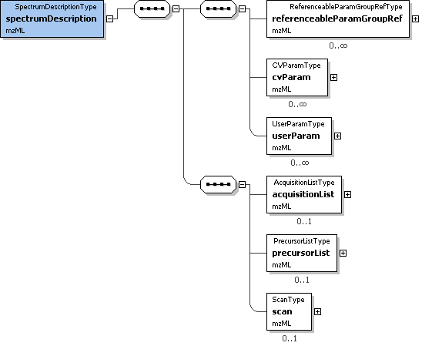
Example Context: | <spectrumDescription>  <cvParam cvRef="MS" accession="MS:1000127" name="centroid mass spectrum" value=""/>  <cvParam cvRef="MS" accession="MS:1000528" name="lowest m/z value" value="400.39"/>  <cvParam cvRef="MS" accession="MS:1000527" name="highest m/z value" value="1795.56"/>  <cvParam cvRef="MS" accession="MS:1000504" name="base peak m/z" value="445.347"/>  ...  </spectrumDescription>
cvParam Mapping Rules: | MUST supply a *child* term of MS:1000525 (spectrum representation) only once  e.g.: MS:1000127 (centroid mass spectrum)  e.g.: MS:1000128 (profile mass spectrum)  MUST supply a *child* term of MS:1000499 (spectrum attribute) one or more times  e.g.: MS:1000285 (total ion current)  e.g.: MS:1000504 (base peak m/z)  e.g.: MS:1000505 (base peak intensity)  e.g.: MS:1000527 (highest m/z value)  e.g.: MS:1000528 (lowest m/z value)  e.g.: MS:1000618 (highest wavelength value)  e.g.: MS:1000619 (lowest wavelength value)
Example cvParams: | <cvParam cvRef="MS" accession="MS:1000127" name="centroid mass spectrum" value=""/>  <cvParam cvRef="MS" accession="MS:1000528" name="lowest m/z value" value="400.39"/>  <cvParam cvRef="MS" accession="MS:1000527" name="highest m/z value" value="1795.56"/>  <cvParam cvRef="MS" accession="MS:1000504" name="base peak m/z" value="445.347"/>  <cvParam cvRef="MS" accession="MS:1000505" name="base peak intensity" value="120053"/>  <cvParam cvRef="MS" accession="MS:1000285" name="total ion current" value="16675500"/>

Element <binaryDataArrayList>
Definition: | List of binary data arrays.
Attributes:
  Attribute Name | Data Type | Use | Definition
  count | xs:nonNegativeInteger | required | The number of binary data arrays defined in this list.
Subelements:
  Subelement Name | minOccurs | maxOccurs | Definition
  binaryDataArray | 2 | unbounded | The structure into which encoded binary data goes. Byte ordering is always little endian (Intel style). Computers using a different endian style MUST convert to/from little endian when writing/reading mzML
Example Context: | <binaryDataArrayList count="2">  <binaryDataArray encodedLength="160" dataProcessingRef="XcaliburProcessing">  <cvParam cvRef="MS" accession="MS:1000523" name="64-bit float" value=""/>  <cvParam cvRef="MS" accession="MS:1000576" name="no compression" value=""/>  <cvParam cvRef="MS" accession="MS:1000514" name="m/z array" value=""/>  ...  </binaryDataArrayList>

Element <acquisitionList>
Definition: | List and descriptions of acquisitions .
Attributes:
  Attribute Name | Data Type | Use | Definition
  count | xs:nonNegativeInteger | required | the number of acquisitions defined in this mzML file.
Subelements:
  Subelement Name | minOccurs | maxOccurs | Definition
  referenceableParamGroupRef | 0 | unbounded | A reference to a previously defined ParamGroup, which is a reusable container of one or more cvParams.
  cvParam | 0 | unbounded | This element holds additional data or annotation. Only controlled values are allowed here.
  userParam | 0 | unbounded | Uncontrolled user parameters (essentially allowing free text). Before using these, one should verify whether there is an appropriate CV term available, and if so, use the CV term instead
  acquisition | 1 | unbounded | Scan or acquisition from original raw file used to create this peak list, as specified in sourceFile.
Graphical Context: | 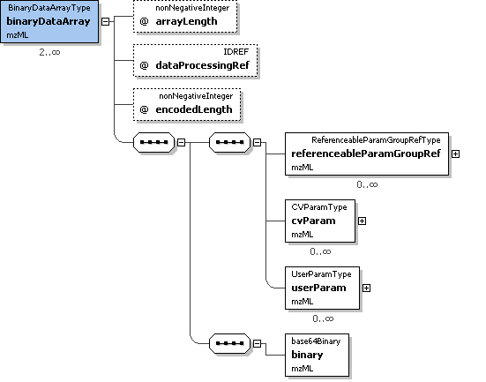
Example Context:
cvParam Mapping Rules: | MUST supply a *child* term of MS:1000570 (spectra combination) one or more times  e.g.: MS:1000571 (sum of spectra)  e.g.: MS:1000573 (median of spectra)  e.g.: MS:1000575 (mean of spectra)

Element <precursorList>
Definition: | List and descriptions of precursors to the spectrum currently being described.
Attributes:
  Attribute Name | Data Type | Use | Definition
  count | xs:nonNegativeInteger | required | The number of precursors in this list.
Subelements:
  Subelement Name | minOccurs | maxOccurs | Definition
  precursor | 1 | unbounded | The method of precursor ion selection and activation
Graphical Context: | 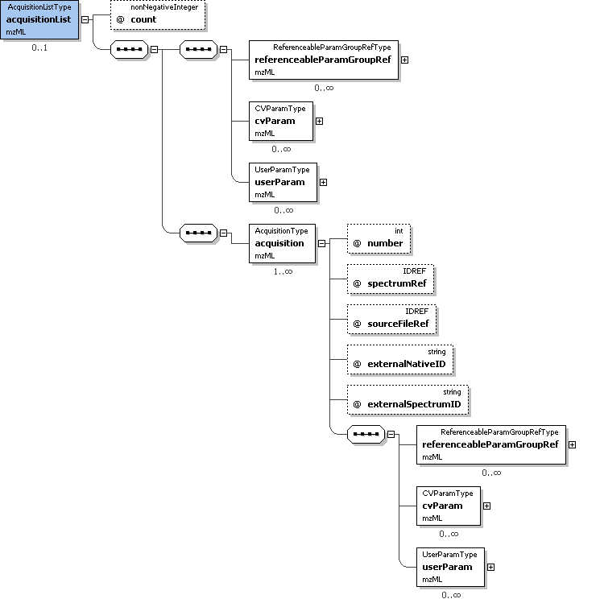
Example Context: | <precursorList count="1">  <precursor spectrumRef="S19">  <selectedIonList count="1">  <selectedIon>  <cvParam cvRef="MS" accession="MS:1000040" name="m/z" value="445.34"/>  ...  </precursorList>

Element <scan>
Definition: | The instrument's 'run time' parameters; common to the whole of this spectrum.
Attributes:
  Attribute Name | Data Type | Use | Definition
  instrumentConfigurationRef | xs:IDREF | optional | This attribute MUST reference the 'id' attribute of the appropriate instrument configuration.
Subelements:
  Subelement Name | minOccurs | maxOccurs | Definition
  referenceableParamGroupRef | 0 | unbounded | A reference to a previously defined ParamGroup, which is a reusable container of one or more cvParams.
  cvParam | 0 | unbounded | This element holds additional data or annotation. Only controlled values are allowed here.
  userParam | 0 | unbounded | Uncontrolled user parameters (essentially allowing free text). Before using these, one should verify whether there is an appropriate CV term available, and if so, use the CV term instead
  scanWindowList | 1 | 1 | Container for a list of select windows.
Graphical Context: | 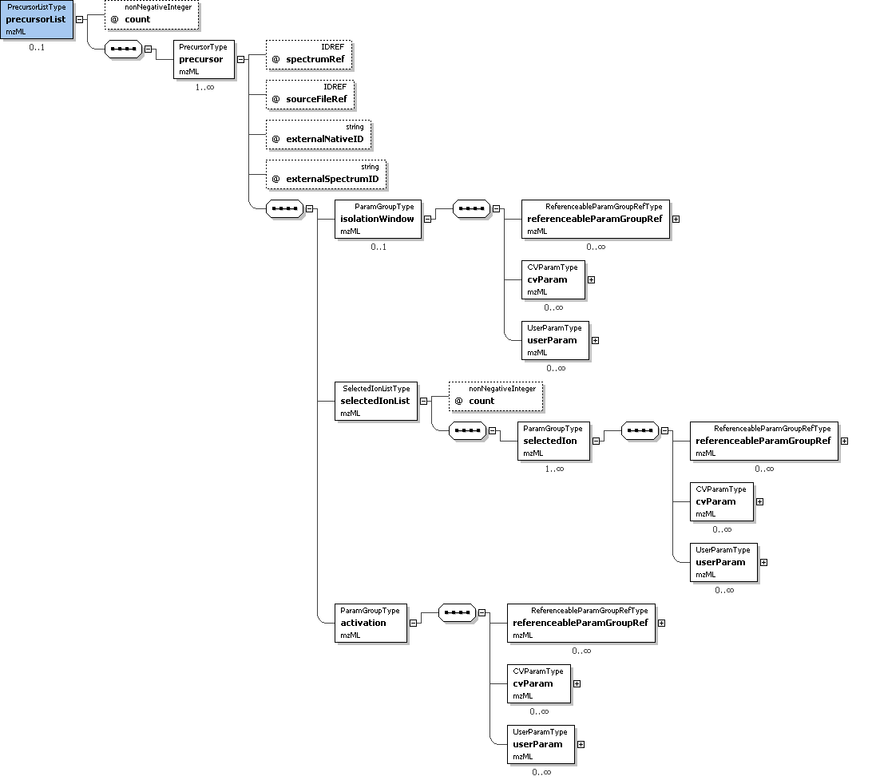
Example Context: | <scan instrumentConfigurationRef="LCQDeca">  <referenceableParamGroupRef ref="CommonMS1SpectrumParams"/>  <cvParam cvRef="MS" accession="MS:1000016" name="scan time" value="5.8905" unitCvRef="MS" unitAccession="MS:1000038" unitName="minute"/>  <cvParam cvRef="MS" accession="MS:1000512" name="filter string" value="+ c NSI Full ms [ 400.00-1800.00]"/>  <cvParam cvRef="MS" accession="MS:1000616" name="preset scan configuration" value="3"/>  ...  </scan>
cvParam Mapping Rules: | MUST supply a *child* term of MS:1000465 (scan polarity) only once  e.g.: MS:1000129 (negative scan)  e.g.: MS:1000130 (positive scan)  MUST supply a *child* term of MS:1000503 (scan attribute) one or more times  e.g.: MS:1000011 (mass resolution)  e.g.: MS:1000015 (scan rate)  e.g.: MS:1000016 (scan time)  e.g.: MS:1000023 (isolation width)  e.g.: MS:1000511 (ms level)  e.g.: MS:1000512 (filter string)  e.g.: MS:1000616 (preset scan configuration)  MUST supply a *child* term of MS:1000018 (scan direction) only once  e.g.: MS:1000092 (decreasing m/z scan)  e.g.: MS:1000093 (increasing m/z scan)  MUST supply a *child* term of MS:1000019 (scan law) only once  e.g.: MS:1000094 (exponential)  e.g.: MS:1000095 (linear)  e.g.: MS:1000096 (quadratic)  MUST supply a *child* term of MS:1000020 (scanning method) only once  e.g.: MS:1000100 (precursor ion scan)  e.g.: MS:1000101 (product ion scan)  e.g.: MS:1000205 (selected ion monitoring)  e.g.: MS:1000206 (selected reaction monitoring)  e.g.: MS:1000244 (consecutive reaction monitoring)  e.g.: MS:1000323 (constant neutral loss scan)  e.g.: MS:1000324 (constant neutral gain scan)  e.g.: MS:1000497 (zoom scan)  e.g.: MS:1000498 (full scan)

Element <binaryDataArray>
Definition: | The structure into which encoded binary data goes. Byte ordering is always little endian (Intel style). Computers using a different endian style MUST convert to/from little endian when writing/reading mzML
Attributes:
  Attribute Name | Data Type | Use | Definition
  arrayLength | xs:nonNegativeInteger | optional | This optional attribute may override the 'defaultArrayLength' defined in SpectrumType. The two default arrays (m/z and intensity) should NEVER use this override option, and should therefore adhere to the 'defaultArrayLength' defined in SpectrumType. Parsing software can thus safely choose to ignore arrays of lengths different from the one defined in the 'defaultArrayLength' SpectrumType element.
  dataProcessingRef | xs:IDREF | optional | This optional attribute may reference the 'id' attribute of the appropriate dataProcessing.
  encodedLength | xs:nonNegativeInteger | required | The encoded length of the binary data array.
Subelements:
  Subelement Name | minOccurs | maxOccurs | Definition
  referenceableParamGroupRef | 0 | unbounded | A reference to a previously defined ParamGroup, which is a reusable container of one or more cvParams.
  cvParam | 0 | unbounded | This element holds additional data or annotation. Only controlled values are allowed here.
  userParam | 0 | unbounded | Uncontrolled user parameters (essentially allowing free text). Before using these, one should verify whether there is an appropriate CV term available, and if so, use the CV term instead
  binary | 1 | 1 | The actual base64 encoded binary data.
Graphical Context: | 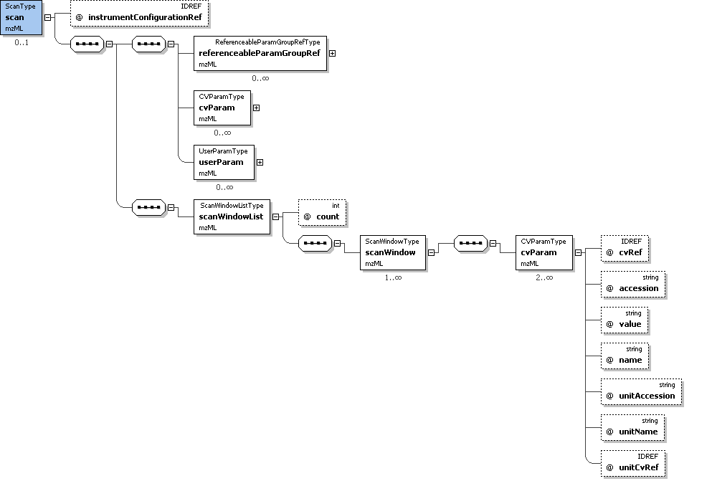
Example Context: | <binaryDataArray encodedLength="160" dataProcessingRef="XcaliburProcessing">  <cvParam cvRef="MS" accession="MS:1000523" name="64-bit float" value=""/>  <cvParam cvRef="MS" accession="MS:1000576" name="no compression" value=""/>  <cvParam cvRef="MS" accession="MS:1000514" name="m/z array" value=""/>  <binary>AAAAAAAAAAAAAAAAAADwPwAAAAAAAABAAAAAAAAACEAAAAAAAA...</binary>  ...  </binaryDataArray>
cvParam Mapping Rules: | MUST supply a *child* term of MS:1000572 (binary data compression type) only once  e.g.: MS:1000574 (zlib compression)  e.g.: MS:1000576 (no compression)  MUST supply a *child* term of MS:1000513 (binary data array) only once  e.g.: MS:1000514 (m/z array)  e.g.: MS:1000515 (intensity array)  e.g.: MS:1000516 (charge array)  e.g.: MS:1000517 (signal to noise array)  e.g.: MS:1000595 (time array)  e.g.: MS:1000617 (wavelength array)  MUST supply a *child* term of MS:1000518 (binary data type) only once  e.g.: MS:1000519 (32-bit integer)  e.g.: MS:1000520 (16-bit float)  e.g.: MS:1000521 (32-bit float)  e.g.: MS:1000522 (64-bit integer)  e.g.: MS:1000523 (64-bit float)
Example cvParams: | <cvParam cvRef="MS" accession="MS:1000523" name="64-bit float" value=""/>  <cvParam cvRef="MS" accession="MS:1000576" name="no compression" value=""/>  <cvParam cvRef="MS" accession="MS:1000514" name="m/z array" value=""/>  <cvParam cvRef="MS" accession="MS:1000515" name="intensity array" value=""/>  <cvParam cvRef="MS" accession="MS:1000595" name="time array" value=""/>
Notes and Constraints: | The arrayLength attribute need only be specified if it is different from the defaultArrayLength specified in the <spectrum> element.

Element <acquisition>
Definition: | Scan or acquisition from original raw file used to create this peak list, as specified in sourceFile.
Attributes:
  Attribute Name | Data Type | Use | Definition
  externalNativeID | xs:string | optional | For acquisitions that are external to this document which can be referenced by nativeID, this string MUST correspond to the 'nativeID' attribute of a spectrum in the external document indicated by 'sourceFileRef'.
  externalSpectrumID | xs:string | optional | For acquisitions that are external to this document which cannot be referenced by nativeID, this string MUST correspond to the 'id' attribute of a spectrum in the external document indicated by 'sourceFileRef'.
  number | xs:int | required | A number for this acquisition.
  sourceFileRef | xs:IDREF | optional | For acquisitions that are external to this document, this attribute MUST reference the 'id' attribute of a sourceFile representing that external document.
  spectrumRef | xs:IDREF | optional | For acquisitions that are local to this document, this attribute MUST reference the 'id' attribute of the appropriate spectrum.
Subelements:
  Subelement Name | minOccurs | maxOccurs | Definition
  referenceableParamGroupRef | 0 | unbounded | A reference to a previously defined ParamGroup, which is a reusable container of one or more cvParams.
  cvParam | 0 | unbounded | This element holds additional data or annotation. Only controlled values are allowed here.
  userParam | 0 | unbounded | Uncontrolled user parameters (essentially allowing free text). Before using these, one should verify whether there is an appropriate CV term available, and if so, use the CV term instead
Example Context:
cvParam Mapping Rules: | MAY supply a *child* term of MS:1000503 (scan attribute) one or more times  e.g.: MS:1000011 (mass resolution)  e.g.: MS:1000015 (scan rate)  e.g.: MS:1000016 (scan time)  e.g.: MS:1000023 (isolation width)  e.g.: MS:1000511 (ms level)  e.g.: MS:1000512 (filter string)  e.g.: MS:1000616 (preset scan configuration)

Element <precursor>
Definition: | The method of precursor ion selection and activation
Attributes:
  Attribute Name | Data Type | Use | Definition
  externalNativeID | xs:string | optional | For precursor spectra that are external to this document which can be referenced by nativeID, this string MUST correspond to the 'nativeID' attribute of a spectrum in the external document indicated by 'sourceFileRef'.
  externalSpectrumID | xs:string | optional | For precursor spectra that are external to this document which cannot be referenced by nativeID, this string MUST correspond to the 'id' attribute of a spectrum in the external document indicated by 'sourceFileRef'.
  sourceFileRef | xs:IDREF | optional | For precursor spectra that are external to this document, this attribute MUST reference the 'id' attribute of a sourceFile representing that external document.
  spectrumRef | xs:IDREF | optional | Reference to the id attribute of the spectrum from which the precursor was selected.
Subelements:
  Subelement Name | minOccurs | maxOccurs | Definition
  isolationWindow | 0 | 1 | This element captures the isolation (or 'selection') window configured to isolate one or more precursors.
  selectedIonList | 1 | 1 | This list of precursor ions that were selected.
  activation | 1 | 1 | The type and energy level used for activation.
Example Context: | <precursor spectrumRef="S19">  <selectedIonList count="1">  <selectedIon>  <cvParam cvRef="MS" accession="MS:1000040" name="m/z" value="445.34"/>  <cvParam cvRef="MS" accession="MS:1000042" name="intensity" value="120053"/>  ...  </precursor>

Element <scanWindowList>
Definition: | Container for a list of select windows.
Attributes:
  Attribute Name | Data Type | Use | Definition
  count | xs:int | required | The number of selection windows defined in this list.
Subelements:
  Subelement Name | minOccurs | maxOccurs | Definition
  scanWindow | 1 | unbounded | Definition of a selection window.
Example Context: | <scanWindowList count="1">  <scanWindow>  <cvParam cvRef="MS" accession="MS:1000501" name="scan m/z lower limit" value="400"/>  <cvParam cvRef="MS" accession="MS:1000500" name="scan m/z upper limit" value="1800"/>  </scanWindow>  ...  </scanWindowList>

Element <binary>
Definition: | The actual base64 encoded binary data.
Attributes: | none
Subelements: | none
Example Context:

Element <isolationWindow>
Definition: | This element captures the isolation (or 'selection') window configured to isolate one or more precursors.
Attributes: | none
Subelements:
  Subelement Name | minOccurs | maxOccurs | Definition
  referenceableParamGroupRef | 0 | unbounded | A reference to a previously defined ParamGroup, which is a reusable container of one or more cvParams.
  cvParam | 0 | unbounded | This element holds additional data or annotation. Only controlled values are allowed here.
  userParam | 0 | unbounded | Uncontrolled user parameters (essentially allowing free text). Before using these, one should verify whether there is an appropriate CV term available, and if so, use the CV term instead
Example Context:

Element <selectedIonList>
Definition: | This list of precursor ions that were selected.
Attributes:
  Attribute Name | Data Type | Use | Definition
  count | xs:nonNegativeInteger | required | The number of selected precursor ions defined in this list.
Subelements:
  Subelement Name | minOccurs | maxOccurs | Definition
  selectedIon | 1 | unbounded | Structure allowing the use of a controlled (cvParam) or uncontrolled vocabulary (userParam), or a reference to a predefined set of these in this mzML file (paramGroupRef).
Example Context: | <selectedIonList count="1">  <selectedIon>  <cvParam cvRef="MS" accession="MS:1000040" name="m/z" value="445.34"/>  <cvParam cvRef="MS" accession="MS:1000042" name="intensity" value="120053"/>  <cvParam cvRef="MS" accession="MS:1000041" name="charge state" value="2"/>  ...  </selectedIonList>

Element <activation>
Definition: | The type and energy level used for activation.
Attributes: | none
Subelements:
  Subelement Name | minOccurs | maxOccurs | Definition
  referenceableParamGroupRef | 0 | unbounded | A reference to a previously defined ParamGroup, which is a reusable container of one or more cvParams.
  cvParam | 0 | unbounded | This element holds additional data or annotation. Only controlled values are allowed here.
  userParam | 0 | unbounded | Uncontrolled user parameters (essentially allowing free text). Before using these, one should verify whether there is an appropriate CV term available, and if so, use the CV term instead
Example Context: | <activation>  <cvParam cvRef="MS" accession="MS:1000133" name="collision-induced dissociation" value=""/>  <cvParam cvRef="MS" accession="MS:1000045" name="collision energy" value="35" unitCvRef="MS" unitAccession="MS:1000137" unitName="electron volt"/>  </activation>
cvParam Mapping Rules: | MUST supply a *child* term of MS:1000456 (precursor activation) one or more times  e.g.: MS:1000045 (collision energy)  e.g.: MS:1000133 (collision-induced dissociation)  e.g.: MS:1000134 (plasma desorption)  e.g.: MS:1000135 (post-source decay)  e.g.: MS:1000136 (surface-induced dissociation)  e.g.: MS:1000242 (blackbody infrared radiative dissociation)  e.g.: MS:1000245 (charge stripping)  e.g.: MS:1000246 (delayed extraction)  e.g.: MS:1000250 (electron capture dissociation)  e.g.: MS:1000262 (infrared multiphoton dissociation)  et al.
Example cvParams: | <cvParam cvRef="MS" accession="MS:1000133" name="collision-induced dissociation" value=""/>  <cvParam cvRef="MS" accession="MS:1000045" name="collision energy" value="35" unitCvRef="MS" unitAccession="MS:1000137" unitName="electron volt"/>

Element <scanWindow>
Definition: | Definition of a selection window.
Attributes: | none
Subelements:
  Subelement Name | minOccurs | maxOccurs | Definition
  cvParam | 2 | unbounded | This element holds additional data or annotation. Only controlled values are allowed here.
Example Context: | <scanWindow>  <cvParam cvRef="MS" accession="MS:1000501" name="scan m/z lower limit" value="400"/>  <cvParam cvRef="MS" accession="MS:1000500" name="scan m/z upper limit" value="1800"/>  </scanWindow>
Example cvParams: | <cvParam cvRef="MS" accession="MS:1000501" name="scan m/z lower limit" value="400"/>  <cvParam cvRef="MS" accession="MS:1000500" name="scan m/z upper limit" value="1800"/>

Element <selectedIon>
Definition: | Structure allowing the use of a controlled (cvParam) or uncontrolled vocabulary (userParam), or a reference to a predefined set of these in this mzML file (paramGroupRef).
Attributes: | none
Subelements:
  Subelement Name | minOccurs | maxOccurs | Definition
  referenceableParamGroupRef | 0 | unbounded | A reference to a previously defined ParamGroup, which is a reusable container of one or more cvParams.
  cvParam | 0 | unbounded | This element holds additional data or annotation. Only controlled values are allowed here.
  userParam | 0 | unbounded | Uncontrolled user parameters (essentially allowing free text). Before using these, one should verify whether there is an appropriate CV term available, and if so, use the CV term instead
Example Context: | <selectedIon>  <cvParam cvRef="MS" accession="MS:1000040" name="m/z" value="445.34"/>  <cvParam cvRef="MS" accession="MS:1000042" name="intensity" value="120053"/>  <cvParam cvRef="MS" accession="MS:1000041" name="charge state" value="2"/>  </selectedIon>  ...  </selectedIon>
Example cvParams: | <cvParam cvRef="MS" accession="MS:1000040" name="m/z" value="445.34"/>  <cvParam cvRef="MS" accession="MS:1000042" name="intensity" value="120053"/>  <cvParam cvRef="MS" accession="MS:1000041" name="charge state" value="2"/>

Conclusions

This document contains the specifications for using the mzML format to represent mass spectrometry results, metadata and associated context. This specification, in conjunction with the XML Schema and the Reference Manual constitute a proposal for a standard from the Proteomics Standards Initiative. These artefacts are currently undergoing the PSI document process standardization process, which will result in a standard officially sanctioned by PSI.

Authors and Contributors

Eric Deutsch
Institute for Systems Biology,
1441 N 34th St,
Seattle WA 98103-8904
United States of America
edeutsch@systemsbiology.org

Lennart Martens
EMBL Outstation,
The European Bioinformatics Institute,
Wellcome Trust Genome Campus,
Cambridge CB10 1SD
United Kingdom
lennart.martens@ebi.ac.uk

Luisa Montecchi-Palazzi
EMBL Outstation,
The European Bioinformatics Institute,
Wellcome Trust Genome Campus,
Cambridge CB10 1SD
United Kingdom
luisa@ebi.ac.uk

Pierre-Alain Binz
Swiss Institute of Bioinformatics
Proteome Informatics Group
1, Rue Michel Servet
CH-1211 Geneve 4
Switzerland
Pierre-Alain.Binz@isb-sib.ch

Darren Kessner
Cedars-Sinai Medical Center
8700 Beverly Blvd.
Los Angeles, CA 90048
darren.kessner@cshs.org

Puneet Souda
Pasarow Mass Spectrometry Laboratory
Box 42, NPI-Semel Institute
UCLA
760 Westwood Plaza
Los Angeles, California, 90024-1759
United States of America

The following people contributed to the model development, controlled vocabulary development, gave feedback or tested mzML:
- Matthew Chambers, Vanderbilt University
- Karl Clauser, Broad Institute
- Mike Coleman, Stowers Institute
- David Creasy, Matrix Science Ltd.
- Eva Duchoslav, MDS Sciex
- Jimmy Eng, University of Washington
- Jayson Falkner, University of Michigan
- David Horn, Agilent Technologies
- Phil Jones, European Bioinformatics Institute
- Henning Hermjakob, European Bioinformatics Institute
- Randy Julian, Indigo Biosystems
- Kent Laursen, Indigo Biosystems
- Jari Häkkinen Lund University
- Frederik Levander, Lund University
- Ruth McNally, ESRC CESAGen
- Luis Mendoza, Institute for Systems Biology
- Patrick Pedrioli, Swiss Institute of Technology
- Angel Pizarro, University of Pittsburgh
- Brian Pratt, Insilicos, LLC
- Erik Nilsson Insilicos, LLC
- Sean Seymour, Applied Biosystems
- Jim Shofstahl, Thermo Fisher
- Howard Read, Waters
- Jim Langridge, Waters
- David Shteynberg, Institute for Systems Biology
- Joshua Tasman, Institute for Systems Biology
- Luis Mendoza, Institute for Systems Biology
- Chris Taylor, European Bioinformatics Institute
- Trish Whetzel, University of Pennsylvania
- Lars Nilse (Manchester)
- Benito Cañas (Madrid)
- Lola Gutierrez (Madrid)
- Alberto Medina (Madrid)
- Ron Beavis (UBC)
- Norman Paton (Manchester)
- Ruedi Aebersold (ETHZ)
- Marc Sturm (U Tuebingen)
- Parag Mallick (CSHS)
- Rune Philosof
- David Sparkman (U Pacific)
- Wilfred Tang (ABI)
- Marius Kallhardt (Bruker)

References

Intellectual Property Statement

The PSI takes no position regarding the validity or scope of any intellectual property or other rights that might be claimed to pertain to the implementation or use of the technology described in this document or the extent to which any license under such rights might or might not be available; neither does it represent that it has made any effort to identify any such rights. Copies of claims of rights made available for publication and any assurances of licenses to be made available, or the result of an attempt made to obtain a general license or permission for the use of such proprietary rights by implementers or users of this specification can be obtained from the PSI Chair.

The PSI invites any interested party to bring to its attention any copyrights, patents or patent applications, or other proprietary rights which may cover technology that may be required to practice this recommendation. Please address the information to the PSI Chair (see contacts information at PSI website).

Appendix A: The mzML indexing wrapper schema

One of the features of mzXML (Pedrioli et al. 1994) was a byte-offset index that allowed random access to arbitrary spectra within the file. This was extremely useful for user interfaces that needed to rapidly access one or a few spectra without parsing through huge files. Most vendor binary formats have this feature as well.

This feature was retained for mzML in that we provide a reference implementation for indexing as a wrapper schema for an mzML document. Therefore, mzML documents themselves do not have an index. But an mzML file can contain <indexedmzML> as the top element, contain an mzML document, followed by the index. Reader software should be prepared to gracefully handle a .mzML file that has and index or not, although it need never actually use the index.

Below is the documentation for the wrapper index schema.

Element <indexedmzML>
Definition: | Container element for mzML which allows the addition of an index.
Attributes: | none
Subelements:
  Subelement Name | minOccurs | maxOccurs | Definition
  mzML | 1 | 1 | -
  indexList | 1 | 1 | List of indices.
  indexListOffset | 1 | 1 | File pointer offset (in bytes) of the 'indexList' element.
  fileChecksum | 1 | 1 | SHA-1 checksum from beginning of file to end of 'fileChecksum' open tag.
Example Context: | <indexedmzML xmlns="http://psi.hupo.org/schema_revision/mzML_1.0.0" xmlns:xsi="http://www.w3.org/2001/XMLSchema-instance" xsi:schemaLocation="http://psi.hupo.org/schema_revision/mzML_1.0.0 mzML1.0.0_idx.xsd">  <mzML xmlns="http://psi.hupo.org/schema_revision/mzML_1.0.0" xmlns:xsi="http://www.w3.org/2001/XMLSchema-instance" xsi:schemaLocation="http://psi.hupo.org/schema_revision/mzML_1.0.0 mzML1.0.0.xsd" id="urn:lsid:psidev.info:mzML.instanceDocuments.tiny.pwiz" version="1.0">  <cvList count="2">  <cv id="MS" fullName="Proteomics Standards Initiative Mass Spectrometry Ontology" version="2.0.2" URI="http://psidev.sourceforge.net/ms/xml/mzdata/psi-ms.2.0.2.obo"/>  <cv id="UO" fullName="Unit Ontology" version="unknown" URI="http://obo.cvs.sourceforge.net/obo/obo/ontology/phenotype/unit.obo"/>  ...  </indexedmzML>

Element <mzML>
This element is defined in another xsd document.

Element <indexList>
Definition: | List of indices.
Attributes:
  Attribute Name | Data Type | Use | Definition
  count | xs:nonNegativeInteger | required | Number of indices in this list.
Subelements:
  Subelement Name | minOccurs | maxOccurs | Definition
  index | 1 | unbounded | Index element containing one or more offsets for random data access for the entity described in the 'name' attribute.
Example Context: | <indexList count="2">  <index name="spectrum">  <offset idRef="S19" nativeID="19">5630</offset>  <offset idRef="S20" nativeID="20">8633</offset>  <offset idRef="S21" nativeID="21">12444</offset>  ...  </indexList>

Element <indexListOffset>
Definition: | File pointer offset (in bytes) of the 'indexList' element.
Attributes: | none
Subelements: | none
Example Context: | <indexListOffset>15808</indexListOffset>

Element <fileChecksum>
Definition: | SHA-1 checksum from beginning of file to end of 'fileChecksum' open tag.
Attributes: | none
Subelements: | none
Example Context: | <fileChecksum>4cacca258c881ef6264adc30d1fc5c4887c20f3e</fileChecksum>

Element <index>
Definition: | Index element containing one or more offsets for random data access for the entity described in the 'name' attribute.
Attributes:
  Attribute Name | Data Type | Use | Definition
  name | xs:string | required | The name of the entity the index entries are pointing to.
Subelements:
  Subelement Name | minOccurs | maxOccurs | Definition
  offset | 1 | unbounded | File pointer offset (in bytes) of the element identified by the 'id' attribute.
Example Context: | <index name="spectrum">  <offset idRef="S19" nativeID="19">5630</offset>  <offset idRef="S20" nativeID="20">8633</offset>  <offset idRef="S21" nativeID="21">12444</offset>  </index>  ...  </index>

Element <offset>
Definition: | File pointer offset (in bytes) of the element identified by the 'id' attribute.
Attributes:
  Attribute Name | Data Type | Use | Definition
  idRef | xs:IDREF | required | Reference to the 'id' attribute of the indexed element.
  nativeID | xs:string | required | The native identifier for the spectrum, used by the acquisition software.
  spotID | xs:string | optional | The identifier for the spot from which this spectrum was derived, if a MALDI or similar run.
Subelements: | none
Example Context: | <offset idRef="S19" nativeID="19">5630</offset>

Copyright Notice

Copyright (C) Proteomics Standards Initiative (2007). All Rights Reserved.

This document and translations of it may be copied and furnished to others, and derivative works that comment on or otherwise explain it or assist in its implementation may be prepared, copied, published and distributed, in whole or in part, without restriction of any kind, provided that the above copyright notice and this paragraph are included on all such copies and derivative works. However, this document itself may not be modified in any way, such as by removing the copyright notice or references to the PSI or other organizations, except as needed for the purpose of developing Proteomics Recommendations in which case the procedures for copyrights defined in the PSI Document process must be followed, or as required to translate it into languages other than English.

The limited permissions granted above are perpetual and will not be revoked by the PSI or its successors or assigns.

This document and the information contained herein is provided on an "AS IS" basis and THE PROTEOMICS STANDARDS INITIATIVE DISCLAIMS ALL WARRANTIES, EXPRESS OR IMPLIED, INCLUDING BUT NOT LIMITED TO ANY WARRANTY THAT THE USE OF THE INFORMATION HEREIN WILL NOT INFRINGE ANY RIGHTS OR ANY IMPLIED WARRANTIES OF MERCHANTABILITY OR FITNESS FOR A PARTICULAR PURPOSE."

