mzQuantML: exchange format for quantitation values associated with peptides, proteins and small molecules from mass spectra

Status of This Document

This document presents a draft specification for the mzQuantML data format developed by the HUPO Proteomics Standards Initiative. Distribution is unlimited.

Version of This Document
The current version of this document is: version 1.0.0 release candidate 2, November 2011

Abstract
The Human Proteome Organisation (HUPO) Proteomics Standards Initiative (PSI) defines community standards for data representation in proteomics to facilitate data comparison, exchange and verification. The Proteomics Informatics Working Group is developing standards for describing the results of identification and quantitation processes for proteins, peptides and protein modifications from mass spectrometry. This document defines an XML schema that can be used to describe the outputs of quantitation software for proteomics. Limited support is also provided for capturing quantitation values about small molecule generated from mass spectrometry.

Contents
Abstract 1
1. Introduction 3
1.1 Background 3
1.2 Document Structure 4
2. Use Cases for mzQuantML 4
3. Concepts and Terminology 5
4. Relationship to Other Specifications 5
4.1 Important concepts from FuGE 6
4.2 The PSI Mass Spectrometry Controlled Vocabulary (CV) 6
4.3 Validation of controlled vocabulary terms 6
5. Resolved Design and scope issues 7
5.1.1 Handling updates to the controlled vocabulary 7
5.1.2 Use of mzQuantML for analysis pipelines 7
5.2 Encoding zeroes, nulls, infinity and calculation errors 7
5.3 Comments on Specific Use Cases 8
5.3.1 MS1 label-free intensity 8
5.3.2 MS1 label-based 9
5.3.3 MS2 spectral counting 10
5.3.4 MS2 tag-based 10
5.4 Other supporting materials 11
5.5 Open Issues 11
5.5.1 Support for metabolomics 11
6. Model in XML Schema 11
6.1 Element <MzQuantML> 12
6.2 Element <Affiliation> 15
6.3 Element <AnalysisSummary> 15
6.4 Element <Assay> 16
6.5 Element <AssayList> 16
6.6 Element <AssayQuantLayer> 17
6.7 Element <Assay_refs> 18
6.8 Element <AuditCollection> 18
6.9 Element <BibliographicReference> 19
6.10 Element <Column> 20
6.11 Element <ColumnDefinition> 20
6.12 Element <ColumnIndex> 21
6.13 Element <ContactRole> 21
6.14 Element <Cv> 21
6.15 Element <CvList> 22
6.16 Element <cvParam> 22
6.17 Element <DatabaseName> 22
6.18 Element <DataMatrix> 23
6.19 Element <DataProcessing> 24
6.20 Element <DataProcessingList> 24
6.21 Element <DataType> 25
6.22 Element <DBIdentificationRef> 29
6.23 Element <ExternalFormatDocumentation> 30
6.24 Element <Feature> 30
6.25 Element <FeatureList> 31
6.26 Element <FeatureQuantLayer> 33
6.27 Element <Feature_refs> 33
6.28 Element <FileFormat> 33
6.29 Element <GlobalQuantLayer> 34
6.30 Element <IdentificationFile> 34
6.31 Element <IdentificationFiles> 35
6.32 Element <IdentificationFile_Refs> 35
6.33 Element <IdentificationRef> 35
6.34 Element <InputFiles> 36
6.35 Element <InputObject_refs> 38
6.36 Element <Label> 38
6.37 Element <Masstrace> 38
6.38 Element <Modification> 39
6.39 Element <MS2AssayQuantLayer> 39
6.40 Element <MS2RatioQuantLayer> 40
6.41 Element <MS2StudyVariableQuantLayer> 40
6.42 Element <Organization> 41
6.43 Element <OutputObject_refs> 41
6.44 Element <Parent> 42
6.45 Element <PeptideConsensus> 42
6.46 Element <PeptideConsensusList> 43
6.47 Element <PeptideConsensus_refs> 46
6.48 Element <PeptideSequence> 46
6.49 Element <Person> 46
6.50 Element <ProcessingMethod> 47
6.51 Element <Protein> 48
6.52 Element <ProteinGroup> 49
6.53 Element <ProteinGroupList> 49
6.54 Element <ProteinList> 52
6.55 Element <Protein_refs> 54
6.56 Element <Provider> 54
6.57 Element <Ratio> 55
6.58 Element <RatioCalculation> 55
6.59 Element <RatioList> 56
6.60 Element <RatioQuantLayer> 56
6.61 Element <RawFile> 57
6.62 Element <RawFilesGroup> 58
6.63 Element <RawFilesGroup_refs> 58
6.64 Element <Role> 59
6.65 Element <Row> 59
6.66 Element <SearchDatabase> 59
6.67 Element <SmallMolecule> 60
6.68 Element <SmallMoleculeList> 61
6.69 Element <Software> 64
6.70 Element <SoftwareList> 64
6.71 Element <SourceFile> 65
6.72 Element <StudyVariable> 65
6.73 Element <StudyVariableList> 66
6.74 Element <StudyVariableQuantLayer> 67
6.75 Element <userParam> 68
7. Specific Comments on schema 68
7.1 File extension and compression 68
7.2 Referencing elements within the document 68
7.3 Unknown modifications 68
8. Conclusions 69
9. Authors and Contributors 69
10. References 69
11. Intellectual Property Statement 69
Copyright Notice 70

Introduction

Background
This document addresses the systematic description of quantifying molecules by mass spectrometry. A large number of different software packages are available that produce output in a variety of different formats. It is intended that mzQuantML will provide a single common format for software to represent, import or export quantitation values derived from mass spectrometry. These values typically report on peptides or proteins in the context of proteomics investigations but it is noted that similar structures are required in metabolomics, and, as such, structures have been developed that can capture small molecules descriptions and quantitative values.

The format was originally developed under the name AnalysisXML as a format for several types of computational analyses performed over mass spectra in the proteomics context. It has been decided to split development into two formats: mzIdentML for peptide and protein identification (described in a separate document) and mzQuantML (described here), covering quantitative proteomic data derived from MS.

mzQuantML has been developed with a view to supporting the following general tasks (more specific use cases are provided in Section 2):

- The discovery of relevant results, so that, for example, data sets in a database that use a particular technique or combination of techniques can be identified and studied by experimentalists during experiment design or data analysis.
- The sharing of best practice, so that, for example, analyses that have been particularly successful at quantifying a certain group of peptides/proteins can be interpreted by consumers of the data.
- The evaluation of results, so that, for example, sufficient information is provided about how a particular analysis was performed to allow the results to be critically evaluated.
- The sharing of data sets, so that, for example, public repositories can import or export data, or multi-site projects can share results to support integrated analysis.
- The creation of a format for input to analysis software, for example, allowing software to be designed that provides statistical significance on top of protein quantitation values.
- An internal format for pipeline analysis software, for example, allowing analysis software to store intermediate results from different stages of a quantitation pipeline, prior to the final results being assembled in a single mzQuantML file.

The description of the analysis of proteomics mass spectra requires that parts of the schema describe: (i) the identity and configuration of software used to perform the analysis and the protocol used to apply this software to the analysis; (ii) the identity of molecules; and (iii) the way in which these relate to other techniques to form a proteomics workflow. Most of this document is concerned with (i) and (ii) – the identification of the key features of different techniques that are required to support the tasks T1 to T5 above. Models of type (iii) are created by developments in the context of the Functional Genomics Experimental Object Model (FuGE), which defines model components of relevance to a wide range of experimental techniques. Several components from FuGE are re-used in the development of mzQuantML.

This document presents a specification, not a tutorial. As such, the presentation of technical details is deliberately direct. The role of the text is to describe the model and justify design decisions made. The document does not discuss how the models should be used in practice, consider tool support for data capture or storage, or provide comprehensive examples of the models in use. It is anticipated that tutorial material will be developed when the specification is stable.

Document Structure
The remainder of this document is structured as follows. Section 2 lists use cases mzQuantML is designed to support. Section 3 describes the terminology used. Section 4 describes how the specification presented in Section 6 relates to other specifications, both those that it extends and those that it is intended to complement. Section 5 discusses the reasoning behind several design decisions taken. Section 6 contains the documentation for the XML schema which is generated automatically and several parts of the schema are documented in more detail in Section . Conclusions are presented in Section 8.

Use Cases for mzQuantML
The development of mzQuantML is driven by some general principles, specific use cases and the goal of supporting specific techniques, as listed below. These were discussed and agreed at the development meeting in Tübingen in July 2011.

General principles, the format SHOULD support:

- Journal requirement for the reporting of quantitative proteomic data from mass spectrometry.
- Reporting according to MIAPE MSI (and the emerging MIAPE Quant document).
- Submission of quantitative data to public databases.
- Data exchange between software tools, where data are defined as values about features (defined here as regions on MS1 mass spectra that report on a single peptide or small molecule), feature matches across different spectra or withing spectra, peptides, proteins and protein groups.
- Import of data into statistical processing tools.
- The ability to reprocess or recreate the analysis workflow using the same parameters, assuming no manual steps have taken place.

Use cases, the format SHOULD capture:

- Final abundance values (relative or absolute) for peptides, proteins and protein groups where protein inference cannot be performed in an unambiguous manner.
- Quantitation values about peptide/protein modifications, such as post-translational modifications.
- Abundance values at the level of a single run (called an assay in this context) and logical groupings of runs (called study variables in this context), which the user, for example, wishes to report relative values for.
- The evidence trail for how final abundance values were calculated, such as the features used for quantifying peptides and proteins.
- Relationships between features either on different regions of the same spectrum or on different spectra that report on the same peptide or small molecule. These are particularly required for relative quantitation approaches.
- Details about pre-fractionation sufficient to describe the combination of multiple input data files (e.g. raw files) into a single assay where this has been performed.

The format SHOULD support the following specific techniques used in proteomics (see section 5.3 for examples of their encoding):
- MS1 label-free intensity
- MS1 label-based e.g. SILAC and metabolic labelling such as ¹⁵N
- MS2 tag-based e.g. iTRAQ / TMT
- MS2 spectral counting

We expect that the format MAY also be able to cover the following techniques adequately, although these have not been tested in great detail at this stage, and we encourage further input from users of these techniques:

- Quantitation by selected reaction monitoring (SRM)
- Absolute quantitation based on averaging the intensities of features e.g. Waters Hi3 technique
- Small molecule quantitation (in metabolomics)
- MS2 intensity-based approaches
- MS2 label-based approaches

Concepts and Terminology
This document assumes familiarity with XML Schema notation (www.w3.org/XML/Schema). The key words “MUST,” “MUST NOT,” “REQUIRED,” “SHALL,” “SHALL NOT,” “SHOULD,” “SHOULD NOT,” “RECOMMENDED,” “MAY,” and “OPTIONAL” are to be interpreted as described in RFC-2119 [RFC2119].

Relationship to Other Specifications
The specification described in this document is not being developed in isolation; indeed, it is designed to be complementary to, and thus used in conjunction with, several existing and emerging models. Related specifications include the following:

- MIAPE MSI (http://www.psidev.info/miape/msi/). The Minimum Information About a Proteomics Experiment: Mass spectrometry Informatics document defines a checklist of information that should be reported about such a study. It is expected that mzQuantML will be used to support MIAPE:MSI compliant submissions to public repositories. Note: the MIAPE MSI document is undergoing a split into two new modules covering identification and quantification separately; mapping documents will be developed for mzQuantML when these specifications are finalised.
- FuGE (http://fuge.sourceforge.net). FuGE is a data model in UML, and an associated XML rendering, that represents various high-level concepts that are characteristic of functional genomics, such as investigations and protocols. FuGE has been developed by representatives of several standards bodies, with a view to making the representation of functional genomic data sets more consistent, and as such more easily shared and compared. The FuGE specifications are available from [Jones 07].
- mzML (http://www.psidev.info/index.php?q=node/80). mzML is the PSI standard for capturing mass spectra / peak lists resulting from mass spectrometry in proteomics. It is RECOMMENDED that mzQuantML should be used in conjunction with mzML, although it will be possible to use mzQuantML with other formats of mass spectra. This document does not assume familiarity with mzML.
- mzIdentML (http://www.psidev.info/index.php?q=node/454). mzIdentML is the PSI standard for peptide and protein identifications. It is RECOMMENDED that mzQuantML should be used in conjunction with mzIdentML, although it will be possible to use mzQuantML without a separate document storing identification evidence data.

Important concepts from FuGE
mzQuantML makes use of several components from FuGE to allow the format to be more easily integrated with other FuGE-based formats. However, FuGE is a large, flexible specification that can cover a variety of concepts not required for mzQuantML. In this release, various concepts from FuGE have been directly incorporated into the schema. Additional knowledge of FuGE is thus not required beyond this specification document.

The PSI Mass Spectrometry Controlled Vocabulary (CV)
The PSI-MS controlled vocabulary is intended to provide terms for annotation of mzML and mzQuantML files. The CV has been generated by collection of terms from software vendors and academic groups working in the area of mass spectrometry and proteome informatics. Some terms describe attributes that must be coupled with a numerical value attribute in the <cvParam> element (e.g. MS:1001191 “p-value”) and optionally a unit for that value (e.g. MS:1001117, “theoretical mass”, units = dalton). The terms that require a value are denoted by having a “datatype” key-value pair in the CV itself: MS:1001172 "mascot:expectation value" value-type:xsd:double. Terms that need to be qualified with units are denoted by have a “has_units” key in the CV itself (relationship: has_units: UO:0000221 ! dalton). The details of which terms are allowed or required in a given schema section is reported in the mapping file (Section 4.3).

As recommended by the PSI CV guidelines, psi-ms.obo should be dynamically maintained via the psidev-ms-vocab@lists.sourceforge.net mailing list that allows any user to request new terms (via the form http://www.psidev.info/index.php?q=node/440 ) in agreement with the community involved. Once a consensus is reached among the community the new terms are added within a few business days. If there is no obvious consensus, the CV coordinators committee should vote and make a decision. A new psi-ms.obo should then be released by updating the file on the CVS server without changing the name of the file (this would alter the propagation of the file to the OBO website and to other ontology services that rely on file stable URI). For this reason an internal version number with two decimals (x.y.z) should be increased:
- x should be increased when a first level term is renamed, added, deleted or rearranged in the structure. Such rearrangement will be rare and is very likely to have repercussion on the mapping.
- y should be increased when any other term except the first level one is altered.
- z should be increased when there is no term addition or deletion but just editing on the definitions or other minor changes.

The following ontologies or controlled vocabularies specified below may also be suitable or required in certain instances:
- Unit Ontology (http://www.obofoundry.org/cgi-bin/detail.cgi?id=unit)
- ChEBI (http://www.ebi.ac.uk/chebi/)
- OBI (Ontology of Biological Investigations - http://obi.sourceforge.net/)
- PSI Protein modifications workgroup - http://psidev.sourceforge.net/mod/data/PSI-MOD.obo
- Unimod modifications database - http://www.unimod.org/obo/unimod.obo

Validation of controlled vocabulary terms
The correct usage of controlled vocabulary terms within mzQuantML is governed by the use of a mapping file which defines each XML location (XPath) where a <cvParam> instance can be used, and the allowed terms from the PSI-MS, or other, controlled vocabularies. The mapping file is read and interpreted by validation software, checking that the data annotation is consistent. The mapping file needs to be checked and updated when the structure of CV is changed, and in some instances when new terms are added to the CV. The draft specifications for the mapping file can be found here: http://www.psidev.info/files/validator/PSI-Mapping.doc. XML paths are associated with CV terms along with a requirement level (MAY, SHOULD or MUST) defining what should be reported by validation software if one of the mapped terms is not provided in an instance document. Example validation software based on the mapping file will be implemented in the PSI validator www.psidev.info/validator in due course.

Resolved Design and scope issues
There were several issues regarding the design of the format that were not clear cut, and a design choice was made that was not completely agreeable to everyone. So that these issues do not keep coming up, we document the issues here and why the decision that is implemented was made.

Handling updates to the controlled vocabulary
There is a difficult issue with respect to how software should encode CV terms, such that changes to core can be accommodated. This issue is discussed at length in the mzML specification document [Martens11], and mzQuantML follows the same convention. In brief, when a new term is required, the file producers must contact the CV working group (via the form http://www.psidev.info/index.php?q=node/440 ) and request the new term. It is anticipated that problems may arise if a consumer of the file encounters a new CV term and they are not working from the latest version of the CV file. It has been decided that rather than aim for a workaround to this issue, it can be expected that data file consumers must ensure that the OBO file is up-to-date.

Use of mzQuantML for analysis pipelines
The primary use case driving the development of mzQuantML is to allow reporting of quantitation values and to allow data to be shared between different tools. It is clear that the proteome bioinformatics community would benefit from a format that can be used internally for capturing the associations between features, peptides and proteins. As such, there is limited support for using mzQuantML for software pipelines, for example by allowing multiple <PeptideConsensusList> elements, which can be mapped as inputs and outputs of a software pipeline using <DataProcessingList>. A mandatory Boolean attribute is provided on <PeptideConsensusList> called finalResult, which allows a consumer of the data file to know which list of peptide results is considered the final result, for example for loading into a database where intermediate results are not required.

Encoding zeroes, nulls, infinity and calculation errors
In various parts of the schema, most notably in <DataMatrix> within QuantLayers, numerical values must be provided specified. In data analysis, it is possible that different types of value arise: null values where an entity has not been measured, a zero value where the entity has been measured but has zero value, infinity values for example in ratios where the denominator is zero, or calculation errors resulting in the common “not a number” (NaN type). In some cases, there is ambiguity with respect to these cases: e.g. in spectral counting if no peptide-spectrum matches are observed for a given protein, it is open for debate as to whether its abundance is zero or null.

In the XML Schema specifications under the xsd:double type, there is a clear mapping for some of these concepts but not all. As such, rows within a <DataMatrix> can contain a list of a union data type between xsd:double and the token “null” to allow nulls to be adequately captured. The encodings are summarized in Table 1.

Value type | mzQuantML encoding | Notes
Zero | 0.0 | For intensity-based approaches, where a feature has been measured but there is no intensity, the “0.0” value MUST be given.
infinity | INF | If ratios are included and the denominator is zero, the “INF” value MUST be given.
Null | null | If an entity has not been measured, for example in an <AssayQuantLayer> where a certain peptide was found for some but not all assays, the “null” value MUST be given. A zero value is not appropriate since, in this example, the peptide may have been ionised but was not measured in one or more assays. Programming language bindings for mzQuantML MUST handle this explicitly, since “null” is technically encoded in mzQuantML as an xsd:token, and automated data type bindings will fail.
Result of calculation error | NaN | If a calculation error has occurred that does not result in a true null, INF or zero value, the value “NaN” must be given.
Table 1 The RECOMMENDED methods for encoding zero values, "not a number" (NaN), nulls and infinity values in mzQuantML.

Comments on Specific Use Cases
Many special use cases for mzQuantML were considered during its development. Each of these use cases has a corresponding example file that exercises the relevant part of the schema and provides a reference implementation example (see supporting documentation). Authors of software that create mzQuantML are encouraged to examine the examples that accompany this format release before implementing the writer. Further, such authors are encouraged to use the validator before releasing any new writer code and working with the PSI PI Working Group to resolve any issues. In the subsections below, we comment on a few of the notable use cases that were considered.

MS1 label-free intensity
There are several different methods used by software for MS1 label-free quantitation. In this document, two methods are considered that give rise to different encodings in mzQuantML instances.

Method 1. Certain software packages (such as Progenesis LC-MS), appear to align parallel runs in the retention time axis, and then quantify the identical feature region in all runs, even if there is no intensity in that region (thus giving a zero value). As such, the data can be represented in a regular fashion with a <PeptideConsensus> element containing exactly one feature for each assay. If the same peptide occurs in a different charge state or with a different modification, this is modelled by a different <PeptideConsensus> element. No attempt is made in the <PeptideConsensusList> to model the summed abundance of different features within the same assay that report on the same peptide.

Method 2. Certain software packages (such as MaxQuant in label-free mode), report all the features that can be mapped to a single peptide sequence (both with different modifications and with different charge states) as one entity. This is modelled in mzQuantML by a single <PeptideConsensus> element that references all the features that can be matched to the same peptide sequence. The charge attribute on <PeptideConsensus> allows more than one value to model this case and the <Modification> sub-element can have a qualifier added to demonstrate the features on which the Modification has been found.

In both cases, the associated QuantLayers (e.g. <AssayQuantLayer>) SHOULD be used to report the data types that are exported by the software without any attempt to re-calculate values i.e. a row in the data matrix can contain the values in each assay either for a single peptide charge state (Method 1) or a peptide summed over different charge states/modifications (method 2), but not both. Example files are provided from export of the same MS data analysed with both Progenesis LC-MS and MaxQuant to illustrate the difference (http://code.google.com/p/mzquantml/source/browse/#svn/trunk/examples/version1.0-rc1/CPTAC).
QuantLayers SHOULD be provided on the <PeptideConsensusList> and the <ProteinGroupList> or <ProteinList>. QuantLayers MAY be provided on the <FeatureList> for reporting additional data types about the features calculated prior to the feature matching process.

MS1 label-based
In MS1 label-based approaches two (or more) samples are mixed and analysed once by MS. In many approaches, pairs of features separated by a predictable mass shift are identified that report the relative abundance of the same peptide, from which a ratio can be calculated. To illustrate how mzQuantML encodes such an approach, the following text describes the encoding of a SILAC approach with a +8 shift for Lys and +10 shift for Arg, analysed in 3 replicates runs.

See example file:
http://code.google.com/p/mzquantml/source/browse/trunk/examples/version1.0-rc1/mzQuantML_draft_SILAC_peptides.mzq

For each replicate, there SHOULD be two <Assay> elements, each of which MUST refer to the same raw file(s) in <RawFileGroup>. One of the <Assay> elements MUST contain details of the modification used to differentiate the peptide, such as the mass shift for the heavy lys/arg.

If the data exporter wishes to communicate the full evidence trail, the primary results from analysis of each <RawFileGroup> SHOULD be represented as a <FeatureList>. The <FeatureList> MAY contain data types about these features, including their raw intensity value. The next stage of the analysis is the finding of pairs of features that report on the same peptide (one of which has the expected mass shift). The result of this analysis for the three replicates SHOULD be captured by one or more <PeptideConsensusList> elements.

The exporter MAY encode results matched across replicate runs in one single <PeptideConsensusList> or maintain separate lists for each replicate run, however, it is REQUIRED that there is exactly one <PeptideConsensusList> with finalResult = “true”, if the file may be imported to a public database. Within each <PeptideConsensusList>, there SHOULD be QuantLayers that report the abundance of peptides as calculated for individual assays or study variables as appropriate, and the exporter MAY encode these using a <RatioQuantLayer>. As with other approaches, if the identity of a peptide is unknown, the <PeptideConsensus> element MUST NOT have the <PeptideSequence> sub-element, but quantitative values MAY still be provided in the associated QuantLayers.

The schema only allows one <ProteinGroupList> and/or one <ProteinList> and as such, if the exporter wishes to communicate values about proteins, the instance MUST contain one <ProteinGroupList> and/or one <ProteinList>, including the relevant QuantLayers for assays or study variables.

MS2 spectral counting
MS2 spectral counting approaches use the number of peptide-spectrum matches assigned to a given protein to estimate the protein abundance in the sample, following a variety of different normalisation schemes. As such, there is no requirement to model the intensity of MS1 features or provide QuantLayers on the <PeptideConsensusList>. A <PeptideConsensusList> MAY be provided to report the peptide sequences identified, although if accompanying mzIdentML files exist, it is not REQUIRED. QuantLayers SHOULD only be provided on the <ProteinGroupList> and/or <ProteinList> to capture the abundance of proteins within assays or study variables.
See example file:
http://code.google.com/p/mzquantml/source/browse/trunk/examples/version1.0-rc1/mzQuantML_draft_spectralCount_MPC.mzq

MS2 tag-based
In MS2 tag-based approaches multiple samples are initially prepared in parallel and each set of peptides is modified by a chemical tag (such as an isobaric tag used in iTRAQ) by which it can be differentiated in MS2. The samples are mixed and analysed once by MS/MS, using the relative intensities of the tags when measured in MS2 to calculate the relative intensities of the tagged peptide in each of the source samples.

In this example, the use of iTRAQ with tags 114, 115, 116 and 117 Daltons in three replicates is described. The primary results from analysis of each <RawFileGroup> SHOULD be represented as a <FeatureList>, as such producing three lists, one for each replicate. Each <FeatureList> SHOULD contain at least one quant layer, of type <MS2AssayQuantLayer> or <MS2RatioQuantLayer> (where the ratios captured describe all assays e.g. 117/114, 116/114, 115/114) depending on what the data exporter wishes to communicate. The exporter MAY also include an <MS2StudyVariableQuantLayer>. It is REQUIRED that each <Assay> element describes the iTRAQ tag contained, and as such, in an <MS2AssayQuantLayer> or <MS2RatioQuantLayer> a data consumer could work out the correspondence between an intensity value given for an assay (or ratio of assays) and the source intensity (or ratio of intensity) of the tag in the MS2 spectrum.

See example file:
http://code.google.com/p/mzquantml/source/browse/trunk/examples/version1.0-rc1/mzQuantML_draft_LCMS_iTRAQ.mzq

The concept of a <Feature> in mzQuantML describes a region on an MS1 spectrum/spectra and as such elements of <Feature> SHOULD be created to capture only the M/Z and charge of the parent ion from which the iTRAQ intensities are calculated. It is noted that in some cases, the retention time of the MS1 features are not known in iTRAQ yet the RT attribute is mandatory on <Feature>. In this case, the “null” value should be used, as discussed in section 5.2.

The exporter MAY encode results matched across replicate runs in one single <PeptideConsensusList> or maintain separate lists for each replicate run, however, it is REQUIRED that there is exactly one <PeptideConsensusList> with finalResult = “true”, if the file may be imported to a public database. Within each <PeptideConsensusList>, there SHOULD be QuantLayers that report the abundance of peptides as calculated for individual assays or study variables as appropriate, and the exporter MAY encode these using a <RatioQuantLayer>. As with other approaches, if the identity of a peptide is unknown, the <PeptideConsensus> element MUST NOT have the <PeptideSequence> sub-element, but quantitative values MAY still be provided in the associated QuantLayers.

Other supporting materials
The following example instance documents are available and between them cover all the techniques and use cases supported.

All example files can be downloaded manually from:
http://code.google.com/p/mzquantml/source/browse/#svn%2Ftrunk%2Fexamples
http://code.google.com/p/mzquantml/source/browse/#svn%2Ftrunk%2Fexamples%2Fversion1.0-rc1%2FABRF
http://code.google.com/p/mzquantml/source/browse/#svn%2Ftrunk%2Fexamples%2Fversion1.0-rc1%2FCPTAC

Open Issues

Support for metabolomics
During the development process for mzQuantML, it has been noted that while this is primarily developed as a format for representing peptide and protein quantitative values, similar structures are required for representing small molecules for metabolomic studies. As such, an extension has been created to the schema that attempts to model small molecules, although it should be noted that at this stage, this has not been tested to the same extent as other parts of the model. The decision was taken to leave it in, thus allowing groups working in this field to test a release version of the format, although no guarantee is made that this structure is yet optimal. We encourage further input from researchers working in the small molecule field.

Model in XML Schema

An overview of the schema is presented in Figure 1. The following documentation is automatically generated from the XML Schema.

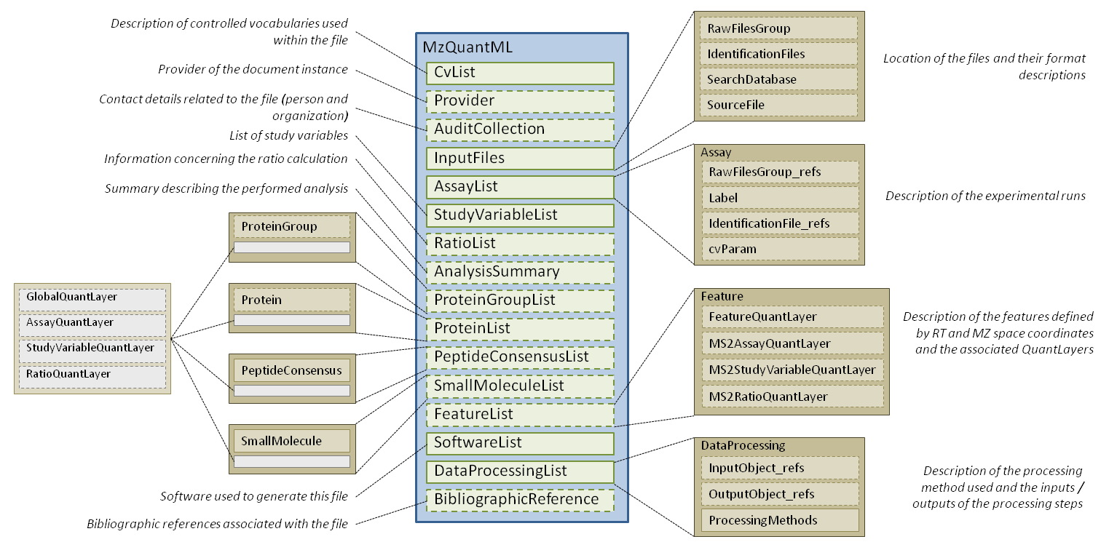
Figure 1 A diagrammatic overview of the mzQuantML schema.

Element <MzQuantML>
Definition: | Root element of the instance document.
Type: | MzQuantMLType
Attributes:
  Attribute Name | Data Type | Use | Definition
  creationDate | xsd:dateTime | optional | The date on which the file was produced.
  version | versionRegex | required | The version of the schema this instance document refers to, in the format x.y.z. Changes to z should not affect prevent instance documents from validating.
Subelements:
  Subelement Name | minOccurs | maxOccurs | Definition
  CvList | 1 | 1 | The list of controlled vocabularies used in the file.
  Provider | 0 | 1 | The provider of the document in terms of the Contact and the software the produced the document instance.
  AuditCollection | 0 | 1 | The complete set of Contacts (people and organisations) for this file.
  InputFiles | 1 | 1 | All the raw files, identification files and databases used in the quantitation
  AssayList | 1 | 1 | The list of assays represented by the file, where each assay captures the concept of one experimental run - this can be one or more raw files.
  StudyVariableList | 1 | 1 | The list of experimental conditions used to group results.
  RatioList | 0 | 1 | The definition of ratios of study variables or assays, referenced elsewhere in the document.
  AnalysisSummary | 0 | 1 | Summary information about the analysis in terms of the type of analysis, any global scores or metrics and global thresholds used.
  ProteinGroupList | 0 | 1 | The list of all groups of proteins with conflicting evidence for which quantitation values are being reported along with quantitative values about those protein groups. If quantitation is done on individual proteins only, ProteinGroupsList should not be included.
  ProteinList | 0 | 1 | The list of all individual proteins (i.e. ungrouped) for which quantitation values are being reported. If quantitation is done on protein groups, the constituent proteins should be listed here with no QuantLayers.
  PeptideConsensusList | 0 | unbounded | The list of all peptides objects for which quantitation values are reported.
  SmallMoleculeList | 0 | 1 | List of small molecules and associated data values.
  FeatureList | 0 | unbounded | All the features identified on a single raw file or raw file group.
  SoftwareList | 1 | 1 | List and descriptions of software used to acquire and/or process the data in this file.
  DataProcessingList | 1 | 1 | List and descriptions of data processing applied to this data.
  BibliographicReference | 0 | unbounded | Any bibliographic references associated with the file.
Graphical Context: | 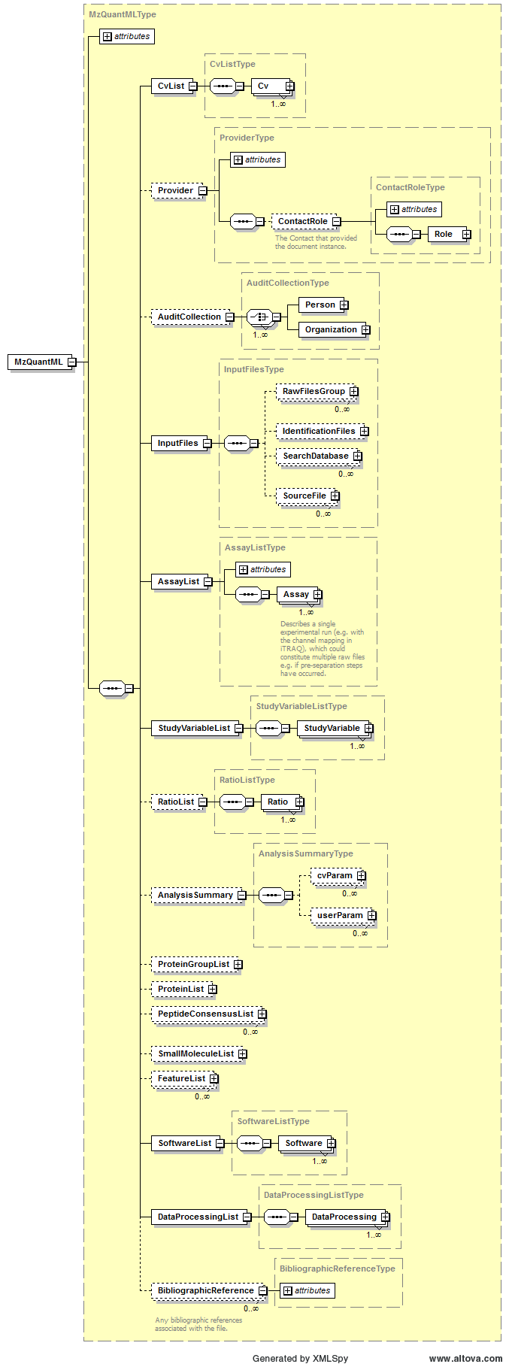
Example Context: | <MzQuantML xmlns:xsi="http://www.w3.org/2001/XMLSchema-instance" xsi:schemaLocation="http://psidev.info/psi/pi/mzQuantML/1.0.0-rc1 ../../schema/mzQuantML_1_0_0-rc.xsd" xmlns="http://psidev.info/psi/pi/mzQuantML/1.0.0-rc1" creationDate="2011-08-25T09:41:00" version="1.0.0">  <CvList>  <Cv id="PSI-MS" fullName="Proteomics Standards Initiative Mass Spectrometry Vocabularies" uri="http://psidev.cvs.sourceforge.net/viewvc/*checkout*/psidev/psi/psi-ms/mzML/controlledVocabulary/psi-ms.obo" version="2.25.0"/>  <Cv id="UO" fullName="Unit Ontology" uri="http://obo.cvs.sourceforge.net/*checkout*/obo/obo/ontology/phenotype/unit.obo"/>  <Cv id="UNIMOD" fullName="unimod modifications ontology" uri="http://www.unimod.org/obo/unimod.obo"/>  </CvList>  <InputFiles>  ...  </MzQuantML>

Element <Affiliation>
Definition: | The organization a person belongs to.
Type: | AffiliationType
Attributes:
  Attribute Name | Data Type | Use | Definition
  organization_ref | xsd:IDREF | required | A reference to the organization this contact belongs to.
Subelements: | none
Example Context: | <Affiliation organization_ref="ULiv"/>

Element <AnalysisSummary>
Definition: | Summary information about the analysis in terms of the type of analysis, any global scores or metrics and global thresholds used.
Type: | AnalysisSummaryType
Attributes: | none
Subelements:
  Subelement Name | minOccurs | maxOccurs | Definition
  cvParam | 0 | unbounded | A single entry from an ontology or a controlled vocabulary.
  userParam | 0 | unbounded | A single user-defined parameter.
Example Context: | <AnalysisSummary>  <cvParam cvRef="PSI-MS" accession="MS:1001834" name="LC-MS label-free"/>  <cvParam cvRef="PSI-MS" accession="" name="Number of proteins quantified" value="1345"/>  <!-- Global params and values go in here -->  </AnalysisSummary>
cvParam Mapping Rules: | Path /MzQuantML/AnalysisSummary  SHOULD supply a *child* term of MS:1001833 (quantitation analysis summary) only once  e.g.: MS:1001834 (LC-MS label-free)  e.g.: MS:1001835 (SILAC)  e.g.: MS:1001836 (spectral counting)  e.g.: MS:1001837 (iTraq)  e.g.: MS:1001838 (SRM)  e.g.: MS:1001839 (metabolic labeling 14N / 15N)
Example cvParams: | <cvParam cvRef="PSI-MS" accession="MS:1001834" name="LC-MS label-free"/>  <cvParam accession="MS:1001836" name="spectral counting" cvRef="PSI-MS"/>

Element <Assay>
Definition: | Describes a single experimental run (e.g. with the channel mapping in iTRAQ), which could constitute multiple raw files e.g. if pre-separation steps have occurred.
Type: | AssayType
Attributes:
  Attribute Name | Data Type | Use | Definition
  id | xsd:ID | required | The unique identifier for the object within the file.
  name | xsd:string | optional | Human readable name for the assay.
Subelements:
  Subelement Name | minOccurs | maxOccurs | Definition
  RawFilesGroup_refs | 0 | 1 | The raw file or group of raw files that constitute this assay.
  Label | 0 | 1 | A specification of labels or tags used to define the assay within the raw file, such as heavy labelling or iTRAQ tag mass.
  IdentificationFile_Refs | 0 | 1 | One or more identification files used within this assay.
  cvParam | 0 | 1 | A single entry from an ontology or a controlled vocabulary.
Example Context: | <Assay id="assay_MUT1">  <RawFilesGroup_refs>TECHREPRAW1</RawFilesGroup_refs>  <Label>  <Modification>  <cvParam accession="UNIMOD:994" name="Label:15N(1)" cvRef="UNIMOD"/> <!-- not really from ammonium sulfate -->  <!-- cvParam accession="MS:1001XXXX" name="metabolic labelling: heavy N (mainly 15N)" cvRef="PSI-MS"/ -->  <!-- cvParam accession="MS:1001XXXX" name="incorporation rate" cvRef="PSI_MS" value="98" unitAccession="" unitCvRef="" unitName="percent"/ -->  ...  </Assay>

Element <AssayList>
Definition: | The list of assays represented by the file, where each assay captures the concept of one experimental run - this can be one or more raw files.
Type: | AssayListType
Attributes:
  Attribute Name | Data Type | Use | Definition
  id | xsd:ID | required | The unique identifier for the object within the file.
Subelements:
  Subelement Name | minOccurs | maxOccurs | Definition
  Assay | 1 | unbounded | Describes a single experimental run (e.g. with the channel mapping in iTRAQ), which could constitute multiple raw files e.g. if pre-separation steps have occurred.
Graphical Context: | 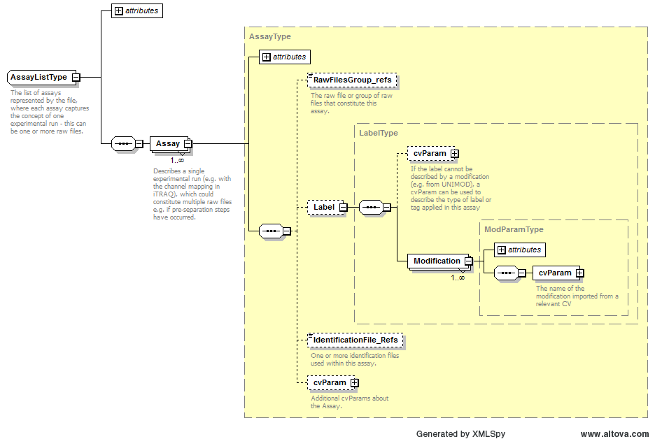
Example Context: | <AssayList id="AssayList1">  <Assay id="assay_WT1">  <RawFilesGroup_refs>TECHREPRAW1</RawFilesGroup_refs>  <Label>  <Modification>  <cvParam accession="MS: 1001839 " name="metabolic labeling 14N / 15N" cvRef="PSI-MS"/>  </Modification>  ...  </AssayList>

Element <AssayQuantLayer>
Definition: | Quant layer for reporting data values about small molecules related to different assays i.e. the column index MUST refer to Assays defined in the file.
Type: | QuantLayerType
Attributes:
  Attribute Name | Data Type | Use | Definition
  id | xsd:ID | required | The unique identifier for the object within the file.
Subelements:
  Subelement Name | minOccurs | maxOccurs | Definition
  DataType | 1 | 1 | Type of data in the column e.g. cvParam = "Intensity|RawAbundance|NormalisedAbundance"
  ColumnIndex | 1 | 1 | Space separated unique identifiers for each column of data, MUST refer to an object in the file i.e. StudyVariable, Assay or Ratio, depending on the context where the QuantLayer resides.
  DataMatrix | 1 | 1 | A matrix of data stored in rows and columns, as defined in the parent QuantLayer.
Example Context: | <AssayQuantLayer id="Pep_AQL1">  <DataType>  <cvParam accession="MS:1001891" cvRef="PSI-MS" name="Progenesis:peptide normalised abundance"/>  </DataType>  <ColumnIndex>ass_0 ass_1 ass_2 ass_3 ass_4 ass_5 ass_6 ass_7 ass_8 ass_9 ass_10 ass_11</ColumnIndex>  <DataMatrix>  <Row object_ref="pep_DPAATSVAAAR">3161.02521217519 8732.65991461099 2588.46808957802 14288.9792489127 11192.9770255351 8666.07647496668 19699.3749172761 14134.829999829 22859.8557143593 36386.9533446536 21335.6607380767 15582.1222036878</Row>  ...  </AssayQuantLayer>

Element <Assay_refs>
Definition: | Reference to the assay that is part of this study variable
Type: | xsd:IDREFS
Attributes: | none
Subelements: | none
Example Context: | <Assay_refs>ass_11 ass_9 ass_5 ass_4 ass_1 ass_0 ass_3 ass_2 ass_7 ass_10 ass_8 ass_6</Assay_refs>

Element <AuditCollection>
Definition: | The complete set of Contacts (people and organisations) for this file.
Type: | AuditCollectionType
Attributes: | none
Subelements:
  Subelement Name | minOccurs | maxOccurs | Definition
  Person | 1 | 1 | A person's name and contact details. Any additional information such as the address, contact email etc. should be supplied using CV parameters or user parameters.
  Organization | 1 | 1 | Organizations are entities like companies, universities, government agencies. Any additional information such as the address, email etc. should be supplied either as CV parameters or as user parameters.
Graphical Context: | 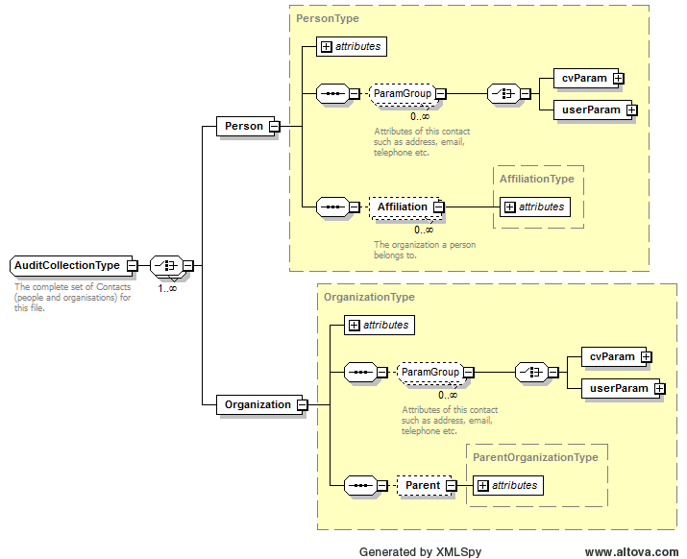
Example Context: | <AuditCollection>  <Person id="person1" firstName="Andy" lastName="Jones">  <Affiliation organization_ref="ULiv"/>  </Person>  <Organization id="ULiv" name="University of Liverpool"></Organization>  </AuditCollection>

Element <BibliographicReference>
Definition: | Any bibliographic references associated with the file.
Type: | BibliographicReferenceType
Attributes:
  Attribute Name | Data Type | Use | Definition
  authors | xsd:string | optional | The names of the authors of the reference.
  doi | xsd:string | optional | The DOI of the referenced publication.
  editor | xsd:string | optional | The editor(s) of the reference.
  id | xsd:ID | required | An identifier is an unambiguous string that is unique within the scope (i.e. a document, a set of related documents, or a repository) of its use.
  issue | xsd:string | optional | The issue name or number.
  name | xsd:string | optional | The potentially ambiguous common identifier, such as a human-readable name for the instance.
  pages | xsd:string | optional | The page numbers.
  publication | xsd:string | optional | The name of the journal, book etc.
  publisher | xsd:string | optional | The publisher of the publication.
  title | xsd:string | optional | The title of the BibliographicReference.
  volume | xsd:string | optional | The volume name or number.
  year | xsd:int | optional | The year of publication.
Subelements: | none
Example Context:

Element <Column>
Definition: | -
Type: | ColumnType
Attributes:
  Attribute Name | Data Type | Use | Definition
  index | xsd:int | required | The column position within the data matrix - incrementing positive integers starting from zero.
Subelements:
  Subelement Name | minOccurs | maxOccurs | Definition
  DataType | 1 | 1 | Type of data in the column e.g. cvParam = "Intensity|RawAbundance|NormalisedAbundance"
Example Context: | <Column index="0">  <DataType>  <cvParam cvRef="PSI-MS" accession="MS:1001903" name="MaxQuant:feature intensity"/>  </DataType>  </Column>

Element <ColumnDefinition>
Definition: | Definition of the data types in each column
Type: | ColumnDefinitionType
Attributes: | none
Subelements:
  Subelement Name | minOccurs | maxOccurs | Definition
  Column | 1 | unbounded | -
Example Context: | <ColumnDefinition>  <Column index="0">  <DataType>  <cvParam cvRef="PSI-MS" accession="MS:1001903" name="MaxQuant:feature intensity"/>  </DataType>  </Column>  <Column index="1">  ...  </ColumnDefinition>

Element <ColumnIndex>
Definition: | Space separated unique identifiers for each column of data, MUST refer to an object in the file i.e. StudyVariable, Assay or Ratio, depending on the context where the QuantLayer resides.
Type: | xsd:IDREFS
Attributes: | none
Subelements: | none
Example Context: | <ColumnIndex>ass_0 ass_1 ass_2 ass_3 ass_4 ass_5 ass_6 ass_7 ass_8 ass_9 ass_10 ass_11</ColumnIndex>

Element <ContactRole>
Definition: | The Contact that provided the document instance.
Type: | ContactRoleType
Attributes:
  Attribute Name | Data Type | Use | Definition
  contact_ref | xsd:IDREF | required | When a ContactRole is used, it specifies which Contact the role is associated with.
Subelements:
  Subelement Name | minOccurs | maxOccurs | Definition
  Role | 1 | 1 | The roles (lab equipment sales, contractor, etc.) the Contact fills.
Example Context: | <ContactRole contact_ref="person1">  <Role>  <cvParam accession="MS:1001271" name="researcher" cvRef="PSI-MS"/>  </Role>  </ContactRole>

Element <Cv>
Definition: | A source controlled vocabulary from which cvParams will be obtained.
Type: | CvType
Attributes:
  Attribute Name | Data Type | Use | Definition
  fullName | xsd:string | required | The full name of the CV.
  id | xsd:ID | required | The unique identifier of this cv within the document to be referenced by cvParam elements.
  uri | xsd:anyURI | required | The URI of the source CV.
  version | xsd:string | optional | The version of the CV.
Subelements: | none
Example Context: | <Cv id="PSI-MS" fullName="Proteomics Standards Initiative Mass Spectrometry Vocabularies"  uri="http://psidev.cvs.sourceforge.net/viewvc/*checkout*/psidev/psi/psi-ms/mzML/controlledVocabulary/psi-ms.obo"  version="2.25.0"/>  <Cv id="UO" fullName="Unit Ontology"  uri="http://obo.cvs.sourceforge.net/*checkout*/obo/obo/ontology/phenotype/unit.obo"/>  <Cv id="PSI-MOD" fullName="Proteomics Standards Initiative Protein Modifications Vocabularies"  uri="http://psidev.cvs.sourceforge.net/psidev/psi/mod/data/PSI-MOD.obo" version="1.2"/>  ...  </Cv>

Element <CvList>
Definition: | The list of controlled vocabularies used in the file.
Type: | CvListType
Attributes: | none
Subelements:
  Subelement Name | minOccurs | maxOccurs | Definition
  Cv | 1 | unbounded | A source controlled vocabulary from which cvParams will be obtained.
Example Context: | <CvList>  <Cv id="PSI-MS" fullName="Proteomics Standards Initiative Mass Spectrometry Vocabularies"  uri="http://psidev.cvs.sourceforge.net/viewvc/*checkout*/psidev/psi/psi-ms/mzML/controlledVocabulary/psi-ms.obo"  version="2.25.0"/>  <Cv id="UO" fullName="Unit Ontology"  uri="http://obo.cvs.sourceforge.net/*checkout*/obo/obo/ontology/phenotype/unit.obo"/>  <Cv id="UNIMOD" fullName="the unimod modifications ontology" uri="http://www.unimod.org/obo/unimod.obo" version="2011-97-14T12:49"/>  ...  </CvList>

Element <cvParam>
Definition: | A single entry from an ontology or a controlled vocabulary.
Type: | CVParamType
Attributes:
  Attribute Name | Data Type | Use | Definition
  accession | xsd:string | required | The accession or ID number of this CV term in the source CV.
  cvRef | xsd:IDREF | required | A reference to the cv element from which this term originates.
  name | xsd:string | required | The name of the parameter.
  unitAccession | xsd:string | optional | An accession number identifying the unit within the OBO foundry Unit CV.
  unitCvRef | xsd:string | optional | If a unit term is referenced, this attribute MUST refer to the CV 'id' attribute defined in the cvList in this file.
  unitName | xsd:string | optional | The name of the unit.
  value | xsd:string | optional | The user-entered value of the parameter.
Subelements: | none
Example Context: | <cvParam accession="MS:1001451" name="decoy DB generation algorithm" cvRef="PSI-MS" value="DecoyDatabaseBuilder, part of the PeakQuant suite (http://www.medizinisches-proteom-center.de/software)"/>

Element <DatabaseName>
Definition: | The database name may be given as a cvParam if it maps exactly to one of the release databases listed in the CV, otherwise a userParam should be used.
Type: | ParamType
Attributes: | none
Subelements:
  Subelement Name | minOccurs | maxOccurs | Definition
  cvParam | 1 | 1 | A single entry from an ontology or a controlled vocabulary.
  userParam | 1 | 1 | A single user-defined parameter.
Example Context: | <DatabaseName>  <cvParam accession="MS:1001104" name="database SwissProt" cvRef="PSI-MS"/>  </DatabaseName>
Example cvParams: | <cvParam accession="MS:1001104" name="database SwissProt" cvRef="PSI-MS"/>  <cvParam accession="MS:1001348" name="FASTA format" cvRef="PSI-MS"/>  <cvParam accession="MS:1001252" name="DB source EBI" cvRef="PSI-MS"/>  <cvParam accession="MS:1001073" name="database type amino acid" cvRef="PSI-MS"/>  <cvParam accession="MS:1001197" name="DB composition target+decoy" cvRef="PSI-MS"/>  <cvParam accession="MS:1001283" name="decoy DB accession regexp" cvRef="PSI-MS" value="^>sp\|s"/>  <cvParam accession="MS:1001297" name="decoy DB from SwissProt" cvRef="PSI-MS"/>  <cvParam accession="MS:1001451" name="decoy DB generation algorithm" cvRef="PSI-MS" value="DecoyDatabaseBuilder, part of the PeakQuant suite (http://www.medizinisches-proteom-center.de/software)"/>  <cvParam accession="MS:1001452" name="decoy DB type shuffle" cvRef="PSI-MS"/>
Example userParams: | <userParam name="mydb.fasta"/>

Element <DataMatrix>
Definition: | A matrix of data stored in rows and columns, as defined in the parent QuantLayer.
Type: | DataMatrixType
Attributes: | none
Subelements:
  Subelement Name | minOccurs | maxOccurs | Definition
  Row | 1 | unbounded | One row of data in a data matrix.
Example Context: | <DataMatrix>  <Row object_ref="pep_DPAATSVAAAR">1357.89246285271 6027.45609707793 1741.70262715384 6194.87655067928 8333.50667321295 5937.2447807612 7200.0533013123 14134.829999829 14498.0061799543 28988.8427024606 36096.4010942969 20293.0428086563</Row>  <Row object_ref="pep_LNRLPAASLGDMVMATVK">1272.97230458237 1398.15757132 1795.83761898216 797.992610455104 1379.44022073789 1659.26873785354 7304.41222866978 16309.2232028826 10937.7287416136 24509.5099529422 34991.4653383882 32567.4708019348</Row>  <Row object_ref="pep_TAIEGSYIDKK">72452.2677668397 69734.8825781993 80177.1913710753 81154.3637259221 82137.0294072145 80895.5590685227 43460.4217327538 100426.167638257 74198.1871253271 82773.3468025117 109723.878908722 54773.8687570152</Row>  <Row object_ref="pep_TAIEGSYIDKK">120724.815931817 113736.195217795 142350.828686848 142103.566729689 143633.248250829 126809.059195862 77014.0071906478 158193.199569401 119522.171836153 128115.134401478 166367.317550587 113690.554966242</Row>  <Row object_ref="pep_FEEWIVPILDK">1315.62623939079 1129.23778936761 1553.93712134212 1043.49849692042 1264.4106417043 1441.22789522785 2977.89029527127 5829.3788229697 67.838983706369 6483.96783045624 7254.87332171345 7371.80497799216</Row>  <Row object_ref="pep_DIGGSSSTTDFTNEIINK">8258.55778814703 9417.84099366744 9807.64061767701 6184.4424020303 7030.85926818683 7603.50402199203 7074.37638824084 20258.5329245341 2250.51943994531 13239.0440723375 25325.7548907753 16743.3758108523</Row>  ...  </DataMatrix>

Element <DataProcessing>
Definition: | Description of the way in which a particular software package was used to analyse data and for example produce different quant layers or lists in the file.
Type: | DataProcessingType
Attributes:
  Attribute Name | Data Type | Use | Definition
  id | xsd:ID | required | The unique identifier for the object within the file.
  software_Ref | xsd:IDREF | required | This attribute MUST reference the 'id' of the appropriate SoftwareType.
Subelements:
  Subelement Name | minOccurs | maxOccurs | Definition
  InputObject_refs | 0 | 1 | References to raw file groups, FeatureList, PeptideConsensusList, ProteinList or ProteinGroupList or QuantLayers that were inputs to the data processing step.
  OutputObject_refs | 0 | 1 | References to raw file groups, FeatureList, PeptideConsensusList, ProteinList or ProteinGroupList or QuantLayers that were the outputs of the data processing step.
  ProcessingMethod | 1 | unbounded | Description of one step within the data processing pipeline.
Example Context: | <DataProcessing id="pep_quantification" software_Ref="FindPairs">  <ProcessingMethod order="0" >  <userParam name="Params for this step to go in here, e.g. which tolerance is used for merging" value=""/>  </ProcessingMethod>  <ProcessingMethod order="1" >  ...  </DataProcessing>

Element <DataProcessingList>
Definition: | List and descriptions of data processing applied to this data.
Type: | DataProcessingListType
Attributes: | none
Subelements:
  Subelement Name | minOccurs | maxOccurs | Definition
  DataProcessing | 1 | unbounded | Description of the way in which a particular software package was used to analyse data and for example produce different quant layers or lists in the file.
Graphical Context: | 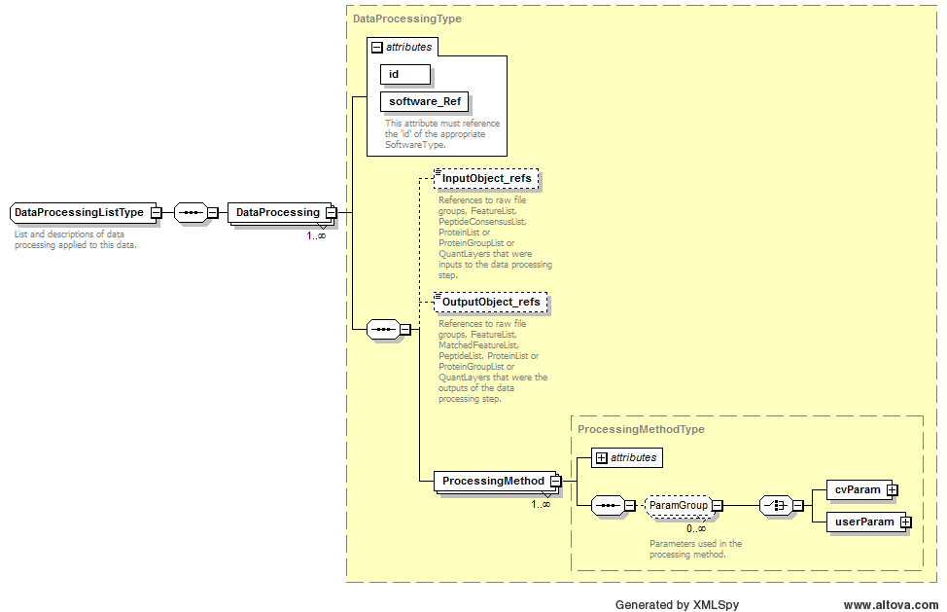
Example Context: | <DataProcessingList>  <DataProcessing id="pep_quantification" software_Ref="FindPairs">  <ProcessingMethod order="0" >  <userParam name="Params for this step to go in here, e.g. which tolerance is used for merging" value=""/>  </ProcessingMethod>  <ProcessingMethod order="1" >  ...  </DataProcessingList>

Element <DataType>
Definition: | Type of data in the column e.g. cvParam = "Intensity|RawAbundance|NormalisedAbundance"
Type: | cvParamRefType
Attributes: | none
Subelements:
  Subelement Name | minOccurs | maxOccurs | Definition
  cvParam | 1 | 1 | A single entry from an ontology or a controlled vocabulary.
Example Context: | <DataType>  <cvParam cvRef="PSI-MS" accession="MS:1001891" name="Progenesis:peptide normalised abundance"/>  </DataType>
cvParam Mapping Rules: | Path /MzQuantML/ProteinGroupList/RatioQuantLayer/DataType  MUST supply a *child* term of MS:1001805 (quantification datatype) only once  e.g.: MS:1001130 (peptide raw area)  e.g.: MS:1001131 (error on peptide area)  e.g.: MS:1001132 (peptide ratio)  e.g.: MS:1001133 (error on peptide ratio)  e.g.: MS:1001134 (protein ratio)  e.g.: MS:1001135 (error on protein ratio)  e.g.: MS:1001136 (p-value (protein diff from 1 randomly))  e.g.: MS:1001137 (absolute quantity)  e.g.: MS:1001138 (error on absolute quantity)  e.g.: MS:1001141 (intensity of precursor ion)  et al.  Path /MzQuantML/SmallMoleculeList/GlobalQuantLayer/DataType  MUST supply a *child* term of MS:1001805 (quantification datatype) only once  e.g.: MS:1001130 (peptide raw area)  e.g.: MS:1001131 (error on peptide area)  e.g.: MS:1001132 (peptide ratio)  e.g.: MS:1001133 (error on peptide ratio)  e.g.: MS:1001134 (protein ratio)  e.g.: MS:1001135 (error on protein ratio)  e.g.: MS:1001136 (p-value (protein diff from 1 randomly))  e.g.: MS:1001137 (absolute quantity)  e.g.: MS:1001138 (error on absolute quantity)  e.g.: MS:1001141 (intensity of precursor ion)  et al.  Path /MzQuantML/ProteinGroupList/AssayQuantLayer/DataType  MUST supply a *child* term of MS:1001805 (quantification datatype) only once  e.g.: MS:1001130 (peptide raw area)  e.g.: MS:1001131 (error on peptide area)  e.g.: MS:1001132 (peptide ratio)  e.g.: MS:1001133 (error on peptide ratio)  e.g.: MS:1001134 (protein ratio)  e.g.: MS:1001135 (error on protein ratio)  e.g.: MS:1001136 (p-value (protein diff from 1 randomly))  e.g.: MS:1001137 (absolute quantity)  e.g.: MS:1001138 (error on absolute quantity)  e.g.: MS:1001141 (intensity of precursor ion)  et al.  Path /MzQuantML/FeatureList/FeatureQuantLayer/ColumnIndex/Column/DataType  MUST supply a *child* term of MS:1001805 (quantification datatype) only once  e.g.: MS:1001130 (peptide raw area)  e.g.: MS:1001131 (error on peptide area)  e.g.: MS:1001132 (peptide ratio)  e.g.: MS:1001133 (error on peptide ratio)  e.g.: MS:1001134 (protein ratio)  e.g.: MS:1001135 (error on protein ratio)  e.g.: MS:1001136 (p-value (protein diff from 1 randomly))  e.g.: MS:1001137 (absolute quantity)  e.g.: MS:1001138 (error on absolute quantity)  e.g.: MS:1001141 (intensity of precursor ion)  et al.  Path /MzQuantML/FeatureList/MS2AssayQuantLayer/DataType  MUST supply a *child* term of MS:1001805 (quantification datatype) only once  e.g.: MS:1001130 (peptide raw area)  e.g.: MS:1001131 (error on peptide area)  e.g.: MS:1001132 (peptide ratio)  e.g.: MS:1001133 (error on peptide ratio)  e.g.: MS:1001134 (protein ratio)  e.g.: MS:1001135 (error on protein ratio)  e.g.: MS:1001136 (p-value (protein diff from 1 randomly))  e.g.: MS:1001137 (absolute quantity)  e.g.: MS:1001138 (error on absolute quantity)  e.g.: MS:1001141 (intensity of precursor ion)  et al.  Path /MzQuantML/PeptideConsensusList/AssayQuantLayer/DataType  MUST supply a *child* term of MS:1001805 (quantification datatype) only once  e.g.: MS:1001130 (peptide raw area)  e.g.: MS:1001131 (error on peptide area)  e.g.: MS:1001132 (peptide ratio)  e.g.: MS:1001133 (error on peptide ratio)  e.g.: MS:1001134 (protein ratio)  e.g.: MS:1001135 (error on protein ratio)  e.g.: MS:1001136 (p-value (protein diff from 1 randomly))  e.g.: MS:1001137 (absolute quantity)  e.g.: MS:1001138 (error on absolute quantity)  e.g.: MS:1001141 (intensity of precursor ion)  et al.  Path /MzQuantML/SmallMoleculeList/StudyVariableQuantLayer/DataType  MUST supply a *child* term of MS:1001805 (quantification datatype) only once  e.g.: MS:1001130 (peptide raw area)  e.g.: MS:1001131 (error on peptide area)  e.g.: MS:1001132 (peptide ratio)  e.g.: MS:1001133 (error on peptide ratio)  e.g.: MS:1001134 (protein ratio)  e.g.: MS:1001135 (error on protein ratio)  e.g.: MS:1001136 (p-value (protein diff from 1 randomly))  e.g.: MS:1001137 (absolute quantity)  e.g.: MS:1001138 (error on absolute quantity)  e.g.: MS:1001141 (intensity of precursor ion)  et al.  Path /MzQuantML/ProteinList/RatioQuantLayer/DataType  MUST supply a *child* term of MS:1001805 (quantification datatype) only once  e.g.: MS:1001130 (peptide raw area)  e.g.: MS:1001131 (error on peptide area)  e.g.: MS:1001132 (peptide ratio)  e.g.: MS:1001133 (error on peptide ratio)  e.g.: MS:1001134 (protein ratio)  e.g.: MS:1001135 (error on protein ratio)  e.g.: MS:1001136 (p-value (protein diff from 1 randomly))  e.g.: MS:1001137 (absolute quantity)  e.g.: MS:1001138 (error on absolute quantity)  e.g.: MS:1001141 (intensity of precursor ion)  et al.  Path /MzQuantML/PeptideConsensusList/GlobalQuantLayer/DataType  MUST supply a *child* term of MS:1001805 (quantification datatype) only once  e.g.: MS:1001130 (peptide raw area)  e.g.: MS:1001131 (error on peptide area)  e.g.: MS:1001132 (peptide ratio)  e.g.: MS:1001133 (error on peptide ratio)  e.g.: MS:1001134 (protein ratio)  e.g.: MS:1001135 (error on protein ratio)  e.g.: MS:1001136 (p-value (protein diff from 1 randomly))  e.g.: MS:1001137 (absolute quantity)  e.g.: MS:1001138 (error on absolute quantity)  e.g.: MS:1001141 (intensity of precursor ion)  et al.  Path /MzQuantML/FeatureList/MS2StudyVariableQuantLayer/DataType  MUST supply a *child* term of MS:1001805 (quantification datatype) only once  e.g.: MS:1001130 (peptide raw area)  e.g.: MS:1001131 (error on peptide area)  e.g.: MS:1001132 (peptide ratio)  e.g.: MS:1001133 (error on peptide ratio)  e.g.: MS:1001134 (protein ratio)  e.g.: MS:1001135 (error on protein ratio)  e.g.: MS:1001136 (p-value (protein diff from 1 randomly))  e.g.: MS:1001137 (absolute quantity)  e.g.: MS:1001138 (error on absolute quantity)  e.g.: MS:1001141 (intensity of precursor ion)  et al.  Path /MzQuantML/PeptideConsensusList/RatioQuantLayer/DataType  MUST supply a *child* term of MS:1001805 (quantification datatype) only once  e.g.: MS:1001130 (peptide raw area)  e.g.: MS:1001131 (error on peptide area)  e.g.: MS:1001132 (peptide ratio)  e.g.: MS:1001133 (error on peptide ratio)  e.g.: MS:1001134 (protein ratio)  e.g.: MS:1001135 (error on protein ratio)  e.g.: MS:1001136 (p-value (protein diff from 1 randomly))  e.g.: MS:1001137 (absolute quantity)  e.g.: MS:1001138 (error on absolute quantity)  e.g.: MS:1001141 (intensity of precursor ion)  et al.  Path /MzQuantML/ProteinGroupList/GlobalQuantLayer/ColumnIndex/Column/DataType  MUST supply a *child* term of MS:1001805 (quantification datatype) only once  e.g.: MS:1001130 (peptide raw area)  e.g.: MS:1001131 (error on peptide area)  e.g.: MS:1001132 (peptide ratio)  e.g.: MS:1001133 (error on peptide ratio)  e.g.: MS:1001134 (protein ratio)  e.g.: MS:1001135 (error on protein ratio)  e.g.: MS:1001136 (p-value (protein diff from 1 randomly))  e.g.: MS:1001137 (absolute quantity)  e.g.: MS:1001138 (error on absolute quantity)  e.g.: MS:1001141 (intensity of precursor ion)  et al.  Path /MzQuantML/ProteinList/GlobalQuantLayer/ColumnIndex/Column/DataType  MUST supply a *child* term of MS:1001805 (quantification datatype) only once  e.g.: MS:1001130 (peptide raw area)  e.g.: MS:1001131 (error on peptide area)  e.g.: MS:1001132 (peptide ratio)  e.g.: MS:1001133 (error on peptide ratio)  e.g.: MS:1001134 (protein ratio)  e.g.: MS:1001135 (error on protein ratio)  e.g.: MS:1001136 (p-value (protein diff from 1 randomly))  e.g.: MS:1001137 (absolute quantity)  e.g.: MS:1001138 (error on absolute quantity)  e.g.: MS:1001141 (intensity of precursor ion)  et al.  Path /MzQuantML/ProteinGroupList/StudyVariableQuantLayer/DataType  MUST supply a *child* term of MS:1001805 (quantification datatype) only once  e.g.: MS:1001130 (peptide raw area)  e.g.: MS:1001131 (error on peptide area)  e.g.: MS:1001132 (peptide ratio)  e.g.: MS:1001133 (error on peptide ratio)  e.g.: MS:1001134 (protein ratio)  e.g.: MS:1001135 (error on protein ratio)  e.g.: MS:1001136 (p-value (protein diff from 1 randomly))  e.g.: MS:1001137 (absolute quantity)  e.g.: MS:1001138 (error on absolute quantity)  e.g.: MS:1001141 (intensity of precursor ion)  et al.  Path /MzQuantML/ProteinList/StudyVariableQuantLayer/DataType  MUST supply a *child* term of MS:1001805 (quantification datatype) only once  e.g.: MS:1001130 (peptide raw area)  e.g.: MS:1001131 (error on peptide area)  e.g.: MS:1001132 (peptide ratio)  e.g.: MS:1001133 (error on peptide ratio)  e.g.: MS:1001134 (protein ratio)  e.g.: MS:1001135 (error on protein ratio)  e.g.: MS:1001136 (p-value (protein diff from 1 randomly))  e.g.: MS:1001137 (absolute quantity)  e.g.: MS:1001138 (error on absolute quantity)  e.g.: MS:1001141 (intensity of precursor ion)  et al.  Path /MzQuantML/SmallMoleculeList/AssayQuantLayer/DataType  MUST supply a *child* term of MS:1001805 (quantification datatype) only once  e.g.: MS:1001130 (peptide raw area)  e.g.: MS:1001131 (error on peptide area)  e.g.: MS:1001132 (peptide ratio)  e.g.: MS:1001133 (error on peptide ratio)  e.g.: MS:1001134 (protein ratio)  e.g.: MS:1001135 (error on protein ratio)  e.g.: MS:1001136 (p-value (protein diff from 1 randomly))  e.g.: MS:1001137 (absolute quantity)  e.g.: MS:1001138 (error on absolute quantity)  e.g.: MS:1001141 (intensity of precursor ion)  et al.  Path /MzQuantML/ProteinList/AssayQuantLayer/DataType  MUST supply a *child* term of MS:1001805 (quantification datatype) only once  e.g.: MS:1001130 (peptide raw area)  e.g.: MS:1001131 (error on peptide area)  e.g.: MS:1001132 (peptide ratio)  e.g.: MS:1001133 (error on peptide ratio)  e.g.: MS:1001134 (protein ratio)  e.g.: MS:1001135 (error on protein ratio)  e.g.: MS:1001136 (p-value (protein diff from 1 randomly))  e.g.: MS:1001137 (absolute quantity)  e.g.: MS:1001138 (error on absolute quantity)  e.g.: MS:1001141 (intensity of precursor ion)  et al.  Path /MzQuantML/PeptideConsensusList/StudyVariableQuantLayer/DataType  MUST supply a *child* term of MS:1001805 (quantification datatype) only once  e.g.: MS:1001130 (peptide raw area)  e.g.: MS:1001131 (error on peptide area)  e.g.: MS:1001132 (peptide ratio)  e.g.: MS:1001133 (error on peptide ratio)  e.g.: MS:1001134 (protein ratio)  e.g.: MS:1001135 (error on protein ratio)  e.g.: MS:1001136 (p-value (protein diff from 1 randomly))  e.g.: MS:1001137 (absolute quantity)  e.g.: MS:1001138 (error on absolute quantity)  e.g.: MS:1001141 (intensity of precursor ion)  et al.  Path /MzQuantML/FeatureList/MS2RatioQuantLayer/DataType  MUST supply a *child* term of MS:1001805 (quantification datatype) only once  e.g.: MS:1001130 (peptide raw area)  e.g.: MS:1001131 (error on peptide area)  e.g.: MS:1001132 (peptide ratio)  e.g.: MS:1001133 (error on peptide ratio)  e.g.: MS:1001134 (protein ratio)  e.g.: MS:1001135 (error on protein ratio)  e.g.: MS:1001136 (p-value (protein diff from 1 randomly))  e.g.: MS:1001137 (absolute quantity)  e.g.: MS:1001138 (error on absolute quantity)  e.g.: MS:1001141 (intensity of precursor ion)  et al.  Path /MzQuantML/SmallMoleculeList/RatioQuantLayer/DataType  MUST supply a *child* term of MS:1001805 (quantification datatype) only once  e.g.: MS:1001130 (peptide raw area)  e.g.: MS:1001131 (error on peptide area)  e.g.: MS:1001132 (peptide ratio)  e.g.: MS:1001133 (error on peptide ratio)  e.g.: MS:1001134 (protein ratio)  e.g.: MS:1001135 (error on protein ratio)  e.g.: MS:1001136 (p-value (protein diff from 1 randomly))  e.g.: MS:1001137 (absolute quantity)  e.g.: MS:1001138 (error on absolute quantity)  e.g.: MS:1001141 (intensity of precursor ion)  et al.
Example cvParams: | <cvParam accession="MS:1001906" cvRef="PSI-MS" name="APEX value"/>  <cvParam accession="MS:1001905" cvRef="PSI-MS" name="emPAI value"/>  <cvParam accession="MS:1001897" cvRef="PSI-MS" name="MaxQuant:peptide counts (unique)"/>  <cvParam accession="MS:1001903" cvRef="PSI-MS" name="MaxQuant:feature intensity"/>  <cvParam accession="MS:1001193" cvRef="PSI-MS" name="confidence score"/>  <cvParam accession="MS:1001854" cvRef="PSI-MS" name="ANOVA p-value"/>  <cvParam accession="MS:1001853" cvRef="PSI-MS" name="max fold change"/>  <cvParam accession="MS:1001890" cvRef="PSI-MS" name="Progenesis:protein normalised abundance"/>  <cvParam accession="MS:1001892" cvRef="PSI-MS" name="Progenesis:protein raw abundance"/>  <cvParam accession="MS:1001891" cvRef="PSI-MS" name="Progenesis:peptide normalised abundance"/>  <cvParam accession="MS:1001893" cvRef="PSI-MS" name="Progenesis:peptide raw abundance"/>  <cvParam accession="MS:1001842" cvRef="PSI-MS" name="peptide PSM count"/>  <cvParam accession="MS:1001132" name="peptide ratio" cvRef="PSI-MS" />  <cvParam accession="MS:1001843" name="peak intensity" cvRef="PSI-MS" />  <cvParam accession="MS:1001845" name="peak area" cvRef="PSI-MS" />  <cvParam cvRef="PSI-MS" accession="MS:1001902" name="MaxQuant:LFQ intensity"/>  <cvParam cvRef="PSI-MS" accession="MS:1000011" name="mass resolution"/>  <cvParam cvRef="PSI-MS" accession="MS:1001901" name="MaxQuant:PEP"/>  <cvParam cvRef="PSI-MS" accession="MS:1001153" name="search engine specific score"/>  <cvParam cvRef="PSI-MS" accession="MS:1001134" name="protein ratio"/>  <cvParam accession="MS:1001851" name="protein value: sum of peptide values" cvRef="PSI-MS"/>  <cvParam accession="MS:1001852" name="normalized protein value" cvRef="PSI-MS"/>  <cvParam accession="MS:1001860" name="mean of peptide ratios" cvRef="PSI-MS"/>  <cvParam accession="MS:1001848" name="simple ratio of two value" cvRef="PSI-MS"/>

Element <DBIdentificationRef>
Definition: | External database references for the small molecule identification
Type: | DBIdentificationRefType
Attributes:
  Attribute Name | Data Type | Use | Definition
  SearchDatabase_ref | xsd:IDREF | required | Reference to the SearchDatabase object in this file from which this identification was made.
  id_ref | xsd:string | required | Reference to the unique identifier of this object in the referenced external file.
Subelements: | none
Example Context: | <DBIdentificationRef id_ref="C000017" SearchDatabase_ref="KEGG"/>

Element <ExternalFormatDocumentation>
Definition: | A URI to access documentation and tools to interpret the external format of the ExternalData instance. For example, XML Schema or static libraries (APIs) to access binary formats.
Type: | xsd:anyURI
Attributes: | none
Subelements: | none
Example Context:

Element <Feature>
Definition: | A region on an MS1 mass spectrum, defined by the RT, MZ and optionally a mass trace. Quantitative values about features can be added in the associated QuantLayers.
Type: | FeatureType
Attributes:
  Attribute Name | Data Type | Use | Definition
  MZ | xsd:double | required | The centre point of the feature on the mass over charge axis in daltons over charge.
  RT | doubleOrNullType | required | The centre point of the feature on the retention time axis in minutes.
  charge | xsd:integer | optional | The assumed charge of the feature, used to calculate the M/Z value.
  id | xsd:ID | required | unique identifier for the feature.
Subelements:
  Subelement Name | minOccurs | maxOccurs | Definition
  Masstrace | 0 | 1 | The coordinates defining the feature in RT and MZ space, given as boundary points or a series of rectangles, as encoded by the MassTraceEncoding cvParam on the FeatureList.
  cvParam | 0 | unbounded | A single entry from an ontology or a controlled vocabulary.
  userParam | 0 | unbounded | A single user-defined parameter.
Example Context: | <Feature id="feature_H1_2" charge="2" MZ="420.172" RT="26.8"/> <!-- example handcrafted, this should be the 15N version mass of feature_L1 -->
cvParam Mapping Rules: | Path /MzQuantML/FeatureList/Feature  MUST supply a *child* term of MS:1001828 (Feature attribute) one or more times  e.g.: MS:1001829 (SRM transition ID)

Element <FeatureList>
Definition: | All the features identified on a single raw file or raw file group.
Type: | FeatureListType
Attributes:
  Attribute Name | Data Type | Use | Definition
  RawFileGroup_ref | xsd:IDREF | required | Refernece to the raw file or group of raw files from which this feature list was generated.
  id | xsd:ID | required | The unique identifier for the object within the file.
Subelements:
  Subelement Name | minOccurs | maxOccurs | Definition
  Feature | 1 | unbounded | A region on an MS1 mass spectrum, defined by the RT, MZ and optionally a mass trace. Quantitative values about features can be added in the associated QuantLayers.
  FeatureQuantLayer | 0 | unbounded | All the data values about features in one raw file or raw file group, such as feature raw intensity, feature RT window size etc.
  MS2AssayQuantLayer | 0 | unbounded | Quant layer for reporting data values about MS2 features (e.g. iTRAQ) related to different assays i.e. the column index MUST refer to Assays defined in the file.
  MS2StudyVariableQuantLayer | 0 | unbounded | Quant layer for reporting data values about MS2 features (e.g. iTRAQ) related to different study variables i.e. the column index MUST refer to StudyVariables defined in the file.
  MS2RatioQuantLayer | 0 | unbounded | Quant layer for reporting data values about MS2 features (e.g. iTRAQ) related to different ratios i.e. the column index MUST refer to Ratio elements defined in the file.
  cvParam | 0 | unbounded | Attributes of this contact such as address, email, telephone etc.
  userParam | 0 | unbounded | Attributes of this contact such as address, email, telephone etc.
Graphical Context: | 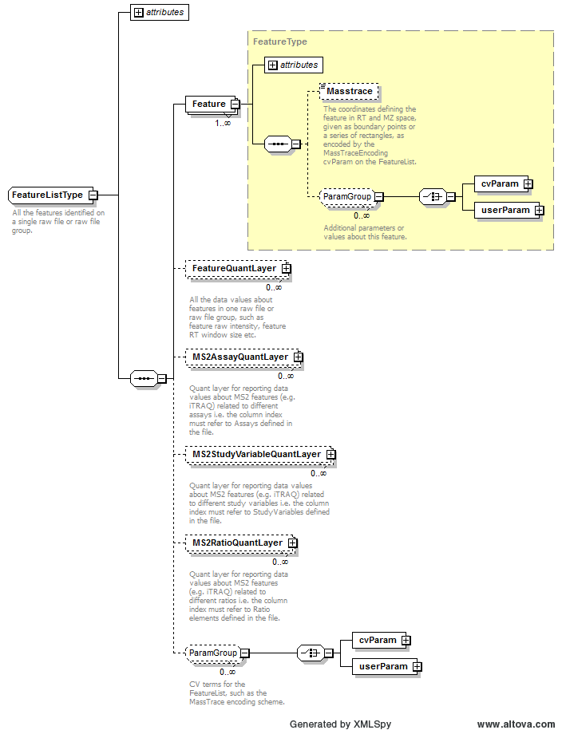
Example Context: | <FeatureList id="Flist11" RawFileGroup_ref="rg_11">  <Feature charge="1" MZ="609.32444284323" RT="59.1377166666667" id="ft_11"/>  <Feature charge="1" MZ="389.119791439754" RT="38.8912666666667" id="ft_23"/>  <Feature charge="2" MZ="505.758929078171" RT="70.4705333333333" id="ft_35"/>  <Feature charge="2" MZ="438.252590112894" RT="45.6422666666667" id="ft_47"/>  <Feature charge="2" MZ="1926.86026020622" RT="140.810666666667" id="ft_59"/>  <Feature charge="3" MZ="432.229525226725" RT="45.6422666666667" id="ft_71"/>  ...  </FeatureList>
cvParam Mapping Rules: | Path /MzQuantML/FeatureList  MUST supply a *child* term of MS:1001825 (FeatureList attribute) one or more times  e.g.: MS:1001826 (mass trace reporting: rectangles)  e.g.: MS:1001827 (mass trace reporting: polygons)

Element <FeatureQuantLayer>
Definition: | All the data values about features in one raw file or raw file group, such as feature raw intensity, feature RT window size etc.
Type: | GlobalQuantLayerType
Attributes:
  Attribute Name | Data Type | Use | Definition
  id | xsd:ID | required | The unique identifier for the object within the file.
Subelements:
  Subelement Name | minOccurs | maxOccurs | Definition
  ColumnDefinition | 1 | 1 | Definition of the data types in each column
  DataMatrix | 1 | 1 | A matrix of data stored in rows and columns, as defined in the parent QuantLayer.
Example Context: | <FeatureQuantLayer id="FQL1">  <ColumnDefinition>  <Column index="0">  <DataType>  <cvParam cvRef="PSI-MS" accession="MS:1001903" name="MaxQuant:feature intensity"/>  </DataType>  </Column>  ...  </FeatureQuantLayer>

Element <Feature_refs>
Definition: | If the Peptide entity is intended as a summary of both modified and unmodified instances of the peptide, then the Feature_refs element MUST be completed to document those peptides only that are modified. If this element is excluded, it is assumed that all features have the modification.
Type: | xsd:IDREFS
Attributes: | none
Subelements: | none
Example Context: | <Feature_refs>ft_60773 ft_60772 ft_60775 ft_60774 ft_60777 ft_60776 ft_60779 ft_60778 ft_60771 ft_60770 ft_60769 ft_60786 ft_60785 ft_60784 ft_60783 ft_60789 ft_60788 ft_60787 ft_60782 ft_60781 ft_60780 ft_60768 ft_60767 ft_60766 ft_60765 ft_60764 ft_60763 ft_60762 ft_60761 ft_60790 ft_60791 ft_60792 ft_60793 ft_60798 ft_60799 ft_60794 ft_60795 ft_60796 ft_60797 ft_60817 ft_60818 ft_60819 ft_60813 ft_60814 ft_60815 ft_60816 ft_60821 ft_60820 ft_60823 ft_60822 ft_60808 ft_60809 ft_60806 ft_60807 ft_60804 ft_60805 ft_60802 ft_60803 ft_60812 ft_60811 ft_60810 ft_60801 ft_60800 ft_60858 ft_60857 ft_60859 ft_60864 ft_60865 ft_60866 ft_60867 ft_60860 ft_60861 ft_60862 ft_60863 ft_60849 ft_60848 ft_60847 ft_60846 ft_60855 ft_60856 ft_60853 ft_60854 ft_60851 ft_60852 ft_60850 ft_60836 ft_60835 ft_60838 ft_60837 ft_60839 ft_60840 ft_60841 ft_60842 ft_60843 ft_60844 ft_60845 ft_60827 ft_60826 ft_60825 ft_60824 ft_60829 ft_60828 ft_60830 ft_60833 ft_60834 ft_60831 ft_60832 ft_60879 ft_60880 ft_60881 ft_60882 ft_60883 ft_60884 ft_60885 ft_60869 ft_60868 ft_60870 ft_60877 ft_60878 ft_60875 ft_60876 ft_60873 ft_60874 ft_60871 ft_60872</Feature_refs>
Example cvParams: | <cvParam cvRef="PSI-MS" accession="MS:1001467" name="taxonomy: NCBI TaxID" value="1456"/>

Element <FileFormat>
Definition: | The format of the ExternalData file, for example "tiff" for image files.
Type: | FileFormatType
Attributes: | none
Subelements:
  Subelement Name | minOccurs | maxOccurs | Definition
  cvParam | 1 | 1 | A single entry from an ontology or a controlled vocabulary.
Example Context:

Element <GlobalQuantLayer>
Definition: | Global values corresponding to the small moleculee such as the total intensity of peptide in all assays, Anova in a quantitative peptidome experiment etc.
Type: | GlobalQuantLayerType
Attributes:
  Attribute Name | Data Type | Use | Definition
  id | xsd:ID | required | The unique identifier for the object within the file.
Subelements:
  Subelement Name | minOccurs | maxOccurs | Definition
  ColumnDefinition | 1 | 1 | Definition of the data types in each column
  DataMatrix | 1 | 1 | A matrix of data stored in rows and columns, as defined in the parent QuantLayer.
Example Context: | <GlobalQuantLayer id="Protein_Global_QL">  <ColumnDefinition>  <Column index="0">  <DataType>  <cvParam accession="MS:1001193" cvRef="PSI-MS" name="confidence score"/>  </DataType>  </Column>  ...  </GlobalQuantLayer>

Element <IdentificationFile>
Definition: | A single identification file associated with this analysis.
Type: | IdentificationFileType
Attributes:
  Attribute Name | Data Type | Use | Definition
  id | xsd:ID | required | An identifier is an unambiguous string that is unique within the scope (i.e. a document, a set of related documents, or a repository) of its use.
  location | xsd:anyURI | required | The location of the data file.
  name | xsd:string | optional | The potentially ambiguous common identifier, such as a human-readable name for the instance.
Subelements:
  Subelement Name | minOccurs | maxOccurs | Definition
  ExternalFormatDocumentation | 0 | 1 | A URI to access documentation and tools to interpret the external format of the ExternalData instance. For example, XML Schema or static libraries (APIs) to access binary formats.
  FileFormat | 0 | 1 | The format of the ExternalData file, for example "tiff" for image files.
Example Context: | <IdentificationFile id="IF_healthy1" location="C:\ms\mzIdent\healthy1.mzid"/>

Element <IdentificationFiles>
Definition: | All identification files associated with this quantitation analysis to be referenced elsewhere.
Type: | IdentificationFilesType
Attributes: | none
Subelements:
  Subelement Name | minOccurs | maxOccurs | Definition
  IdentificationFile | 1 | unbounded | A single identification file associated with this analysis.
Example Context: | <IdentificationFiles>  <IdentificationFile id="IF_healthy1" location="C:\ms\mzIdent\healthy1.mzid"/>  <IdentificationFile id="IF_healthy3" location="C:\ms\mzIdent\healthy3.mzid"/>  <IdentificationFile id="IF_disease2" location="C:\ms\mzIdent\disease2.mzid"/>  <IdentificationFile id="IF_disease4" location="C:\ms\mzIdent\disease4.mzid"/>  </IdentificationFiles>

Element <IdentificationFile_Refs>
Definition: | One or more identification files used within this assay.
Type: | xsd:IDREFS
Attributes: | none
Subelements: | none
Example Context: | <IdentificationFile_Refs>IF_healthy1</IdentificationFile_Refs>

Element <IdentificationRef>
Definition: | Reference for the identification evidence for peptides from the referenced external file and unique identifier e.g. a link to an mzIdentML file and ID for the SpectrumIdentificationItem.
Type: | IdentificationRefType
Attributes:
  Attribute Name | Data Type | Use | Definition
  IdentificationFile_ref | xsd:IDREF | required | Reference to the IdentificationFile object in this file.
  id_ref | xsd:string | required | Reference to the unique identifier of this object in the referenced external file.
Subelements: | none
Example Context: | <IdentificationRef IdentificationFile_ref="IF_healthy1" id_ref="id1" />

Element <InputFiles>
Definition: | All the raw files, identification files and databases used in the quantitation
Type: | InputFilesType
Attributes: | none
Subelements:
  Subelement Name | minOccurs | maxOccurs | Definition
  RawFilesGroup | 0 | unbounded | The raw file or collection of raw files that together form one unit of analysis. This is mandatory unless raw files were not used for quantitation e.g. spectral counting. Multiple raw files should only be provided within a group if they have been used for sample pre-fractionation which are later summed together.
  IdentificationFiles | 0 | 1 | All identification files associated with this quantitation analysis to be referenced elsewhere.
  SearchDatabase | 0 | unbounded | A database used for searching mass spectra. Examples include a set of amino acid sequence entries, or annotated spectra libraries.
  SourceFile | 0 | unbounded | A file from which this MzQuantML instance was created, including potentially MzQuantML files for earlier stages in a workflow.
Graphical Context: | 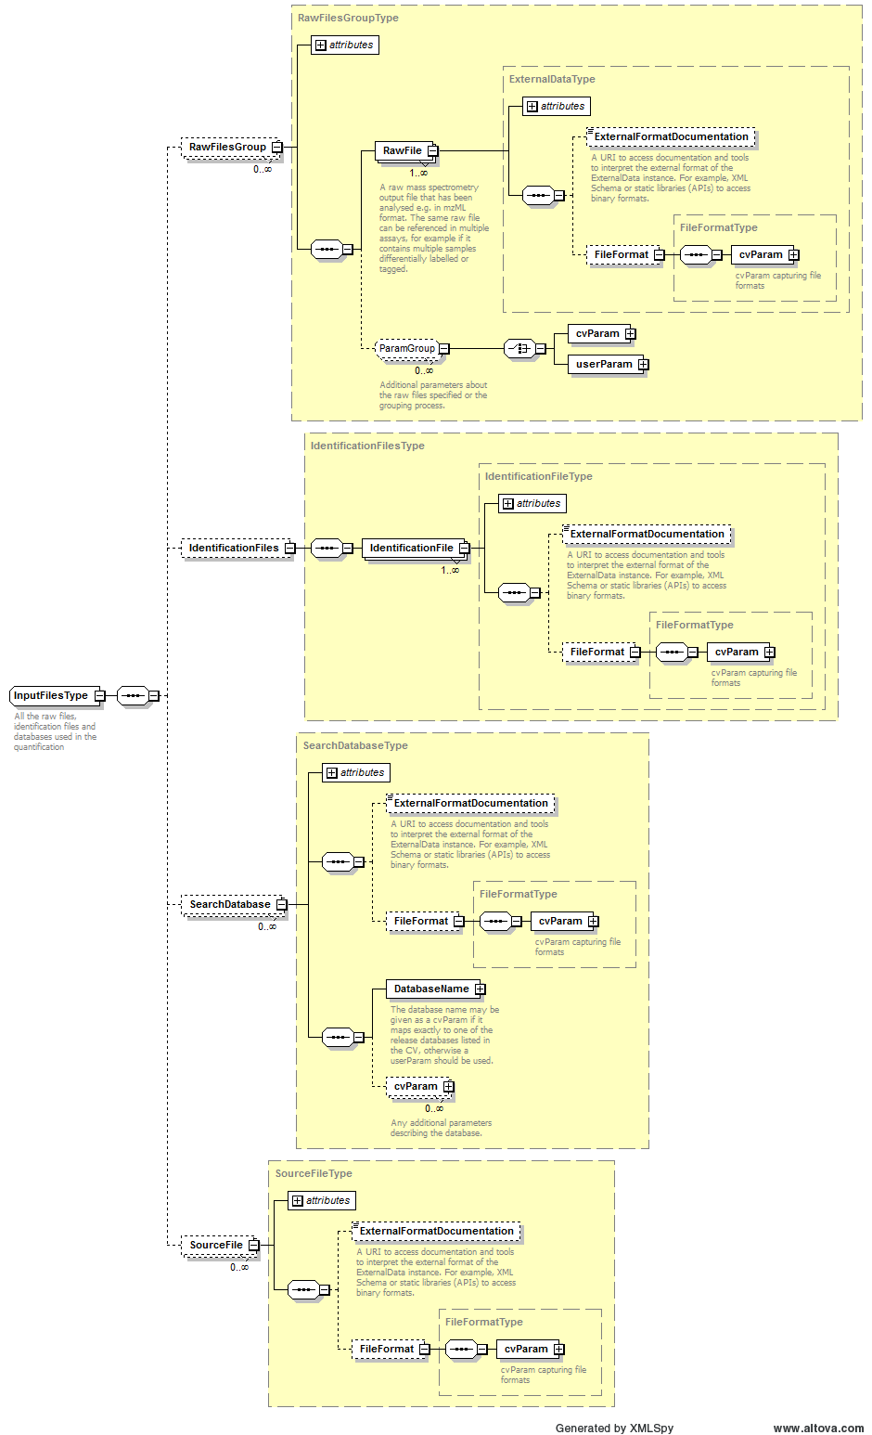
Example Context: | <InputFiles>  <IdentificationFiles>  <IdentificationFile id="IF_healthy1" location="C:\ms\mzIdent\healthy1.mzid"/>  <IdentificationFile id="IF_healthy3" location="C:\ms\mzIdent\healthy3.mzid"/>  <IdentificationFile id="IF_disease2" location="C:\ms\mzIdent\disease2.mzid"/>  <IdentificationFile id="IF_disease4" location="C:\ms\mzIdent\disease4.mzid"/>  </IdentificationFiles>  ...  </InputFiles>

Element <InputObject_refs>
Definition: | References to raw file groups, FeatureList, PeptideConsensusList, ProteinList or ProteinGroupList or QuantLayers that were inputs to the data processing step.
Type: | xsd:IDREFS
Attributes: | none
Subelements: | none
Example Context: | <InputObject_refs>QL_raw_protein_value_layer</InputObject_refs>

Element <Label>
Definition: | A specification of labels or tags used to define the assay within the raw file, such as heavy labelling or iTRAQ tag mass.
Type: | LabelType
Attributes: | none
Subelements:
  Subelement Name | minOccurs | maxOccurs | Definition
  cvParam | 0 | 1 | A single entry from an ontology or a controlled vocabulary.
  Modification | 1 | unbounded | The modification searched for, sourced from e.g. UniMod and the mass delta
Example Context: | <Label>  <Modification>  <cvParam accession="UNIMOD:994" name="Label:15N(1)" cvRef="UNIMOD"/> <!-- not really from ammonium sulfate -->  <!-- cvParam accession="MS:1001XXXX" name="metabolic labelling: heavy N (mainly 15N)" cvRef="PSI-MS"/ -->  <!-- cvParam accession="MS:1001XXXX" name="incorporation rate" cvRef="PSI_MS" value="98" unitAccession="" unitCvRef="" unitName="percent"/ -->  </Modification>  </Label>

Element <Masstrace>
Definition: | The coordinates defining the feature in RT and MZ space, given as boundary points or a series of rectangles, as encoded by the MassTraceEncoding cvParam on the FeatureList.
Type: | psi-mzq:listOfDoubles
Attributes: | none
Subelements: | none
Example Context:

Element <Modification>
Definition: | The modification searched for, sourced from e.g. UniMod and the mass delta
Type: | ModParamType
Attributes:
  Attribute Name | Data Type | Use | Definition
  massDelta | xsd:float | optional | The mass delta of the searched modification in Daltons
  residues | listOfChars | optional | The residue(s) searched with the specified modification
Subelements:
  Subelement Name | minOccurs | maxOccurs | Definition
  cvParam | 1 | 1 | A single entry from an ontology or a controlled vocabulary.
Example Context: | <Modification>  <cvParam accession="UNIMOD:994" name="Label:15N(1)" cvRef="UNIMOD"/> <!-- not really from ammonium sulfate -->  <!-- cvParam accession="MS:1001XXXX" name="metabolic labelling: heavy N (mainly 15N)" cvRef="PSI-MS"/ -->  <!-- cvParam accession="MS:1001XXXX" name="incorporation rate" cvRef="PSI_MS" value="98" unitAccession="" unitCvRef="" unitName="percent"/ -->  </Modification>
cvParam Mapping Rules: | Path /MzQuantML/PeptideConsensusList/PeptideConsensus/Modification  MAY supply a *child* term of UNIMOD:0 (unimod root node) only once  MAY supply a *child* term of MS:1001471 (peptide modification details) only once  e.g.: MS:1001460 (unknown modification)  e.g.: MS:1001524 (fragment neutral loss)  e.g.: MS:1001525 (precursor neutral loss)  MAY supply a *child* term of MOD:00000 (protein modification) only once  Path /MzQuantML/AssayList/Assay/Label/Modification  MUST supply a *child* term of UNIMOD:0 (unimod root node) only once  MUST supply a *child* term of MS:1001471 (peptide modification details) only once  e.g.: MS:1001460 (unknown modification)  e.g.: MS:1001524 (fragment neutral loss)  e.g.: MS:1001525 (precursor neutral loss)  MUST supply a *child* term of MOD:00000 (protein modification) only once
Example cvParams: | <cvParam accession="UNIMOD:994" name="Label:15N(1)" cvRef="UNIMOD"/> <!-- not really from ammonium sulfate -->  <cvParam cvRef="PSI-MOD" accession="MOD:00790" name="Bruker Daltonics SERVA-ICPL(TM) quantification chemistry, light form"/>  <cvParam cvRef="PSI-MOD" accession="MOD:00789" name=" Bruker Daltonics SERVA-ICPL(TM) quantification chemistry, heavy form"/>  <cvParam accession="UNIMOD:35" name="Oxidation" cvRef="UNIMOD"/>  <cvParam accession="UNIMOD:5" name="Carbamyl" cvRef="UNIMOD"/>

Element <MS2AssayQuantLayer>
Definition: | Quant layer for reporting data values about MS2 features (e.g. iTRAQ) related to different assays i.e. the column index MUST refer to Assays defined in the file.
Type: | QuantLayerType
Attributes:
  Attribute Name | Data Type | Use | Definition
  id | xsd:ID | required | The unique identifier for the object within the file.
Subelements:
  Subelement Name | minOccurs | maxOccurs | Definition
  DataType | 1 | 1 | Type of data in the column e.g. cvParam = "Intensity|RawAbundance|NormalisedAbundance"
  ColumnIndex | 1 | 1 | Space separated unique identifiers for each column of data, MUST refer to an object in the file i.e. StudyVariable, Assay or Ratio, depending on the context where the QuantLayer resides.
  DataMatrix | 1 | 1 | A matrix of data stored in rows and columns, as defined in the parent QuantLayer.
Example Context: | <MS2AssayQuantLayer id="QL_iTRAQ">  <DataType>  <cvParam cvRef="PSI-MS" accession="" name="iTRAQ intensities"/>  </DataType>  <ColumnIndex>_114 _115 _116 _117</ColumnIndex>  <DataMatrix>  <Row object_ref="f1_1">45667 4545 350656 36453</Row>  ...  </MS2AssayQuantLayer>

Element <MS2RatioQuantLayer>
Definition: | Quant layer for reporting data values about MS2 features (e.g. iTRAQ) related to different ratios i.e. the column index MUST refer to Ratio elements defined in the file.
Type: | QuantLayerType
Attributes:
  Attribute Name | Data Type | Use | Definition
  id | xsd:ID | required | The unique identifier for the object within the file.
Subelements:
  Subelement Name | minOccurs | maxOccurs | Definition
  DataType | 1 | 1 | Type of data in the column e.g. cvParam = "Intensity|RawAbundance|NormalisedAbundance"
  ColumnIndex | 1 | 1 | Space separated unique identifiers for each column of data, MUST refer to an object in the file i.e. StudyVariable, Assay or Ratio, depending on the context where the QuantLayer resides.
  DataMatrix | 1 | 1 | A matrix of data stored in rows and columns, as defined in the parent QuantLayer.
Example Context:

Element <MS2StudyVariableQuantLayer>
Definition: | Quant layer for reporting data values about MS2 features (e.g. iTRAQ) related to different study variables i.e. the column index MUST refer to StudyVariables defined in the file.
Type: | QuantLayerType
Attributes:
  Attribute Name | Data Type | Use | Definition
  id | xsd:ID | required | The unique identifier for the object within the file.
Subelements:
  Subelement Name | minOccurs | maxOccurs | Definition
  DataType | 1 | 1 | Type of data in the column e.g. cvParam = "Intensity|RawAbundance|NormalisedAbundance"
  ColumnIndex | 1 | 1 | Space separated unique identifiers for each column of data, MUST refer to an object in the file i.e. StudyVariable, Assay or Ratio, depending on the context where the QuantLayer resides.
  DataMatrix | 1 | 1 | A matrix of data stored in rows and columns, as defined in the parent QuantLayer.
Example Context: | <MS2StudyVariableQuantLayer id="QL_SV_iTRAQ">  <DataType>  <cvParam cvRef="PSI-MS" accession="" name="iTRAQ mean intensities"/>  </DataType>  <ColumnIndex>SV_group_B SV_group_E</ColumnIndex>  <DataMatrix>  <Row object_ref="f1_1">34400 565700</Row>  ...  </MS2StudyVariableQuantLayer>

Element <Organization>
Definition: | Organizations are entities like companies, universities, government agencies. Any additional information such as the address, email etc. should be supplied either as CV parameters or as user parameters.
Type: | OrganizationType
Attributes:
  Attribute Name | Data Type | Use | Definition
  id | xsd:ID | required | An identifier is an unambiguous string that is unique within the scope (i.e. a document, a set of related documents, or a repository) of its use.
  name | xsd:string | optional | The potentially ambiguous common identifier, such as a human-readable name for the instance.
Subelements:
  Subelement Name | minOccurs | maxOccurs | Definition
  cvParam | 0 | unbounded | Attributes of this contact such as address, email, telephone etc.
  userParam | 0 | unbounded | Attributes of this contact such as address, email, telephone etc.
  Parent | 0 | 1 | The containing organization (the university or business which a lab belongs to, etc.)
Example Context: | <Organization id="ULiv" name="University of Liverpool"></Organization>

Element <OutputObject_refs>
Definition: | References to raw file groups, FeatureList, PeptideConsensusList, ProteinList or ProteinGroupList or QuantLayers that were the outputs of the data processing step.
Type: | xsd:IDREFS
Attributes: | none
Subelements: | none
Example Context: | <OutputObject_refs>QL_normalized_protein_value_layer</OutputObject_refs>

Element <Parent>
Definition: | The containing organization (the university or business which a lab belongs to, etc.)
Type: | ParentOrganizationType
Attributes:
  Attribute Name | Data Type | Use | Definition
  organization_ref | xsd:IDREF | required | A reference to the organization this contact belongs to.
Subelements: | none
Example Context:

Element <PeptideConsensus>
Definition: | An element representing a peptide in different assay that may or may not have been identified. If it has been identified, the sequence and modification(s) should be reported. Within the parent list, it is allowed for there to be multiple instances of the same peptide sequence, for example capturing different charge states or different modifications, if they are differentially quantified. If peptides with different modifications or charge states are aggregated, they should be represented by a single PeptideConsensus element.
Type: | PeptideConsensusType
Attributes:
  Attribute Name | Data Type | Use | Definition
  charge | listOfIntegers | required | The charge of this instance of Peptide. If more than one value is provided, it is assumed that this Peptide element is summarising multiple charge states of the Peptide.
  id | xsd:ID | required | The unique identifier for the object within the file.
Subelements:
  Subelement Name | minOccurs | maxOccurs | Definition
  PeptideSequence | 0 | 1 | The amino acid sequence of the (poly)peptide. If a substitution modification has been found, the original sequence should be reported. The peptide sequence is mandatory unless this is a PeptideConsensus that has not been assigned to a peptide sequence.
  Modification | 0 | unbounded | A molecule modification specification. If n modifications have been found on a peptide, there should be n instances of Modification. If multiple modifications are provided as cvParams, it is assumed that the modification is ambiguous i.e. one modification or another. A cvParam MUST be provided with the identification of the modification sourced from a suitable CV e.g. UNIMOD. If the modification is not present in the CV (and this will be checked by the semantic validator within a given tolerance window), there is an _unknown modification_CVerm that MUST be used instead. A neutral loss should be defined as an additional CVParam within Modification. If the Peptide element is intended to represent a summary of both modified and unmodified instances of the peptide, then the Feature_refs qualifier MUST be used on Peptide.
  IdentificationRef | 0 | unbounded | Reference for the identification evidence for peptides from the referenced external file and unique identifier e.g. a link to an mzIdentML file and ID for the SpectrumIdentificationItem.
  Feature_refs | 0 | 1 | If the Peptide entity is intended as a summary of both modified and unmodified instances of the peptide, then the Feature_refs element MUST be completed to document those peptides only that are modified. If this element is excluded, it is assumed that all features have the modification.
  Assay_refs | 0 | 1 | Reference to the assay that is part of this study variable
  cvParam | 0 | unbounded | A single entry from an ontology or a controlled vocabulary.
  userParam | 0 | unbounded | A single user-defined parameter.
Example Context: | <PeptideConsensus charge="3 2" id="pep_SDLSADINEHLIVELYSK">  <PeptideSequence>SDLSADINEHLIVELYSK</PeptideSequence>  <Feature_refs>ft_60773 ft_60772 ft_60775 ft_60774 ft_60777 ft_60776 ft_60779 ft_60778 ft_60771 ft_60770 ft_60769 ft_60786 ft_60785 ft_60784 ft_60783 ft_60789 ft_60788 ft_60787 ft_60782 ft_60781 ft_60780 ft_60768 ft_60767 ft_60766 ft_60765 ft_60764 ft_60763 ft_60762 ft_60761 ft_60790 ft_60791 ft_60792 ft_60793 ft_60798 ft_60799 ft_60794 ft_60795 ft_60796 ft_60797 ft_60817 ft_60818 ft_60819 ft_60813 ft_60814 ft_60815 ft_60816 ft_60821 ft_60820 ft_60823 ft_60822 ft_60808 ft_60809 ft_60806 ft_60807 ft_60804 ft_60805 ft_60802 ft_60803 ft_60812 ft_60811 ft_60810 ft_60801 ft_60800 ft_60858 ft_60857 ft_60859 ft_60864 ft_60865 ft_60866 ft_60867 ft_60860 ft_60861 ft_60862 ft_60863 ft_60849 ft_60848 ft_60847 ft_60846 ft_60855 ft_60856 ft_60853 ft_60854 ft_60851 ft_60852 ft_60850 ft_60836 ft_60835 ft_60838 ft_60837 ft_60839 ft_60840 ft_60841 ft_60842 ft_60843 ft_60844 ft_60845 ft_60827 ft_60826 ft_60825 ft_60824 ft_60829 ft_60828 ft_60830 ft_60833 ft_60834 ft_60831 ft_60832 ft_60879 ft_60880 ft_60881 ft_60882 ft_60883 ft_60884 ft_60885 ft_60869 ft_60868 ft_60870 ft_60877 ft_60878 ft_60875 ft_60876 ft_60873 ft_60874 ft_60871 ft_60872</Feature_refs>  <Assay_refs>ass_2 ass_1 ass_3 ass_4 ass_5 ass_0 ass_6 ass_7 ass_9 ass_8</Assay_refs>  </PeptideConsensus>

Element <PeptideConsensusList>
Definition: | The list of all peptides objects for which quantitation values are reported.
Type: | PeptideConsensusListType
Attributes:
  Attribute Name | Data Type | Use | Definition
  finalResult | xsd:boolean | required | Multiple peptide lists are allowed for reporting the evidence trail to create a final peptide list, but the final result e.g. to be loaded into a database, should be flagged with finalResult=true
  id | xsd:ID | required | The unique identifier for the object within the file.
Subelements:
  Subelement Name | minOccurs | maxOccurs | Definition
  PeptideConsensus | 1 | unbounded | An element representing a peptide in different assay that may or may not have been identified. If it has been identified, the sequence and modification(s) should be reported. Within the parent list, it is allowed for there to be multiple instances of the same peptide sequence, for example capturing different charge states or different modifications, if they are differentially quantified. If peptides with different modifications or charge states are aggregated, they should be represented by a single PeptideConsensus element.
  GlobalQuantLayer | 0 | unbounded | Global values corresponding to the small moleculee such as the total intensity of peptide in all assays, Anova in a quantitative peptidome experiment etc.
  AssayQuantLayer | 0 | unbounded | Quant layer for reporting data values about small molecules related to different assays i.e. the column index MUST refer to Assays defined in the file.
  StudyVariableQuantLayer | 0 | unbounded | Quant layer for reporting data values about small molecules related to different study variables i.e. the column index MUST refer to StudyVariables defined in the file.
  RatioQuantLayer | 0 | unbounded | Quant layer for reporting data values about small molecules related to different ratios i.e. the column index MUST refer to Ratio elements defined in the file.
  cvParam | 0 | unbounded | Attributes of this contact such as address, email, telephone etc.
  userParam | 0 | unbounded | Attributes of this contact such as address, email, telephone etc.
Graphical Context: | 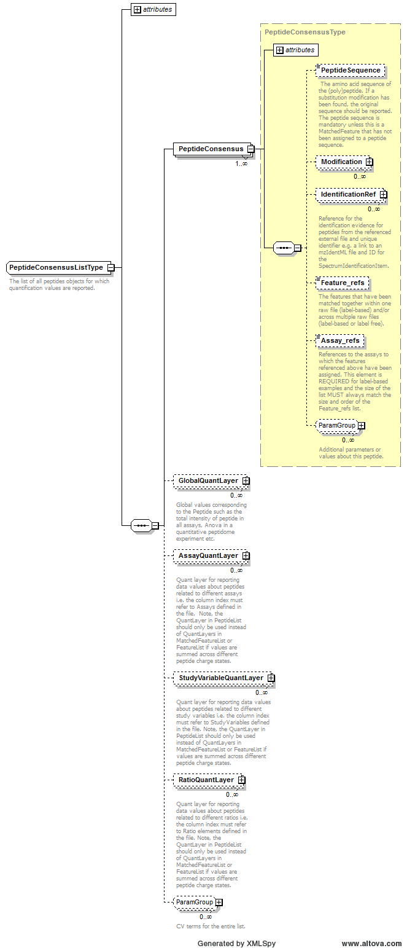
Example Context: | <PeptideConsensusList finalResult="true" id="PepList1">  <PeptideConsensus charge="2" id="pep_DPAATSVAAAR">  <PeptideSequence>DPAATSVAAAR</PeptideSequence>  <Feature_refs>ft_850608 ft_850609 ft_850610 ft_850611 ft_850612 ft_850613 ft_850614 ft_850615 ft_850616 ft_850617 ft_850618 ft_850619</Feature_refs>  <Assay_refs>ass_0 ass_1 ass_2 ass_3 ass_4 ass_5 ass_6 ass_7 ass_8 ass_9 ass_10 ass_11</Assay_refs>  </PeptideConsensus>  <PeptideConsensus charge="3" id="pep_LNRLPAASLGDMVMATVK">  ...  </PeptideConsensusList>

Element <PeptideConsensus_refs>
Definition: | The peptides on which the quantitative protein values in the QuantLayer(s) are based. Note this should not be used to report all peptides that can support the protein identification, only quantitation.
Type: | xsd:IDREFS
Attributes: | none
Subelements: | none
Example Context: | <PeptideConsensus_refs>pep_GVTYSAPLR pep_LIEVPVEYIAGK pep_IETLFTNDLDHGPYISETLR pep_DQVDYMDVSTQQVVSVGASLIPFLEHDDANR pep_LGPEEITADIPNVGEAALSK pep_AYDLGADVR pep_LGDLPTSGQIR pep_ALMGANMQR pep_RPQVLDVPYLLSIQLDSFQK pep_LNHLVDDK pep_LPATIILR pep_HGNKGVISK pep_ADKPLVGTGMER pep_DLSEELQILEAGLFSR pep_INPIEDMPYDENGTPVDIVLNPLGVPSR pep_ERAGFEVR pep_ASDVKDSSLR pep_GDVLADGPSTDLGELALGQNMR pep_VGLVRVER pep_DNLFVR pep_LNHLVDDKMHAR pep_RISALGPGGLTR pep_EFFGSSQLSQFMDQNNPLSEITHK pep_RIQPGDK pep_TGEQFERPVTVGYMYMLK pep_VTPKGETQLTPEEK pep_LSLGDLDTLMPQDMINAKPISAAVK pep_SVGEMAENQFR pep_LGEPVFDVQECQIR pep_NIVDGNHQMEPGMPESFNVLLK pep_LAENLR pep_VIFEIR pep_AVAVDSGVTAVAKR pep_AGFEVR pep_SKGESSLFSR pep_RGGVVQYVDASR pep_GSWLDFEFDPK pep_ISALGPGGLTR pep_SPGVFFDSDKGK pep_KLIDIR pep_ALEIEEMQLK pep_IVIKVNEDEMYPGEAGIDIYNLTK pep_FGEMEVWALEAYGAAYTLQEMLTVK pep_EAAESLFENLFFSEDRYDLSAVGR pep_LSQSGHKR pep_LAENLRK pep_GSWLDFEFDPKDNLFVR pep_LGPEEITADIPNVGEAALSKLDESGIVYIGAEVTGGDILVGK pep_RIETLFTNDLDHGPYISETLR pep_ALNYTTEQILDLFFEK pep_KDLSEELQILEAGLFSR pep_MVYSYTEK pep_GETQLTPEEK pep_EAEIKELLK pep_GGVVQYVDASR pep_SVFPIQSYSGNSELQYVSYR pep_ITQGDDLAPGVLK pep_QLEKDDVK pep_VAFMPWNGYNFEDSILVSER pep_VVQEDRFTTIHIQELACVSR pep_DVHPTHYGR pep_STGSYSLVTQQPLGGK pep_VTDGVVTDEIHYLSAIEEGNYVIAQANSNLDEEGHFVEDLVTCR pep_VIVSQLHR pep_FIEQDPEGQYGLEAAFR pep_AVAVDSGVTAVAK pep_AQFGGQR</PeptideConsensus_refs>

Element <PeptideSequence>
Definition: | The amino acid sequence of the (poly)peptide. If a substitution modification has been found, the original sequence should be reported. The peptide sequence is mandatory unless this is a PeptideConsensus that has not been assigned to a peptide sequence.
Type: | sequence
Attributes: | none
Subelements: | none
Example Context: | <PeptideSequence>MLEPTIDER</PeptideSequence> <!-- peptideB[3+] in both raw files -->

Element <Person>
Definition: | A person's name and contact details. Any additional information such as the address, contact email etc. should be supplied using CV parameters or user parameters.
Type: | PersonType
Attributes:
  Attribute Name | Data Type | Use | Definition
  firstName | xsd:string | optional | The Person's first name.
  id | xsd:ID | required | An identifier is an unambiguous string that is unique within the scope (i.e. a document, a set of related documents, or a repository) of its use.
  lastName | xsd:string | optional | The Person's last/family name.
  midInitials | xsd:string | optional | The Person's middle initial.
  name | xsd:string | optional | The potentially ambiguous common identifier, such as a human-readable name for the instance.
Subelements:
  Subelement Name | minOccurs | maxOccurs | Definition
  cvParam | 0 | unbounded | Attributes of this contact such as address, email, telephone etc.
  userParam | 0 | unbounded | Attributes of this contact such as address, email, telephone etc.
  Affiliation | 0 | unbounded | The organization a person belongs to.
Example Context: | <Person id="person1" firstName="Andy" lastName="Jones">  <Affiliation organization_ref="ULiv"/>  </Person>

Element <ProcessingMethod>
Definition: | Description of one step within the data processing pipeline.
Type: | ProcessingMethodType
Attributes:
  Attribute Name | Data Type | Use | Definition
  order | xsd:nonNegativeInteger | required | This attributes allows a series of consecutive steps to be placed in the correct order.
Subelements:
  Subelement Name | minOccurs | maxOccurs | Definition
  cvParam | 0 | unbounded | A single entry from an ontology or a controlled vocabulary.
  userParam | 0 | unbounded | A single user-defined parameter.
Example Context: | <ProcessingMethod order="1" >  <userParam name="Params for this step to go in here, e.g. which is the tolerance for matching the monoisotopic 14N and 15N peaks..." value=""/>  </ProcessingMethod>
cvParam Mapping Rules: | Path /MzQuantML/DataProcessingList/DataProcessing/ProcessingMethod  MUST supply a *child* term of MS:1001861 (quantification data processing) one or more times  e.g.: MS:1001862 (normalization to mean of sum of all proteins)  e.g.: MS:1001863 (quantile normalization, proteins)  e.g.: MS:1001864 (quantile normalization, peptides)  e.g.: MS:1001865 (Progenesis automatic alignment)  e.g.: MS:1001866 (Progenesis manual alignment)  e.g.: MS:1001867 (Progenesis normalization)
Example cvParams: | <cvParam cvRef="PSI-MS" accession="MS:1000035" name="peak picking"/>  <cvParam accession="MS:1001862" name="normalization to mean of sum of all proteins" cvRef="PSI-MS"/>
Example userParams: | <userParam name="Params for this step to go in here, e.g. which tolerance is used for merging" value=""/>  <userParam name="Params for this step to go in here, e.g. which is the tolerance for matching the monoisotopic 14N and 15N peaks..." value=""/>  <userParam name="Params for this step to go in here, e.g. how many and which isotopic peaks are considered..." value=""/>  <userParam name="Params for this step to go in here..." value=""/>  <ProcessingMethod order="2"><userParam name="Quantification"/></ProcessingMethod>  <userParam name="peak_matching"/>

Element <Protein>
Definition: | -
Type: | ProteinType
Attributes:
  Attribute Name | Data Type | Use | Definition
  accession | xsd:string | required | The accession of the protein in the source database. In most use cases it is expected that accession will be unique within the ProteinList, although in rare cases there may be different entries for the same protein for example if quantifying different PTMs on the same protein.
  id | xsd:ID | required | The unique identifier for the object within the file.
Subelements:
  Subelement Name | minOccurs | maxOccurs | Definition
  IdentificationRef | 0 | unbounded | Reference for the identification evidence for peptides from the referenced external file and unique identifier e.g. a link to an mzIdentML file and ID for the SpectrumIdentificationItem.
  PeptideConsensus_refs | 0 | 1 | The peptides on which the quantitative protein values in the QuantLayer(s) are based. Note this should not be used to report all peptides that can support the protein identification, only quantitation.
  cvParam | 0 | unbounded | A single entry from an ontology or a controlled vocabulary.
  userParam | 0 | unbounded | A single user-defined parameter.
Example Context: | <Protein accession="P0A8V2" id="prot_166">  <PeptideConsensus_refs>pep_GVTYSAPLR pep_LIEVPVEYIAGK pep_IETLFTNDLDHGPYISETLR pep_DQVDYMDVSTQQVVSVGASLIPFLEHDDANR pep_LGPEEITADIPNVGEAALSK pep_AYDLGADVR pep_LGDLPTSGQIR pep_ALMGANMQR pep_RPQVLDVPYLLSIQLDSFQK pep_LNHLVDDK pep_LPATIILR pep_HGNKGVISK pep_ADKPLVGTGMER pep_DLSEELQILEAGLFSR pep_INPIEDMPYDENGTPVDIVLNPLGVPSR pep_ERAGFEVR pep_ASDVKDSSLR pep_GDVLADGPSTDLGELALGQNMR pep_VGLVRVER pep_DNLFVR pep_LNHLVDDKMHAR pep_RISALGPGGLTR pep_EFFGSSQLSQFMDQNNPLSEITHK pep_RIQPGDK pep_TGEQFERPVTVGYMYMLK pep_VTPKGETQLTPEEK pep_LSLGDLDTLMPQDMINAKPISAAVK pep_SVGEMAENQFR pep_LGEPVFDVQECQIR pep_NIVDGNHQMEPGMPESFNVLLK pep_LAENLR pep_VIFEIR pep_AVAVDSGVTAVAKR pep_AGFEVR pep_SKGESSLFSR pep_RGGVVQYVDASR pep_GSWLDFEFDPK pep_ISALGPGGLTR pep_SPGVFFDSDKGK pep_KLIDIR pep_ALEIEEMQLK pep_IVIKVNEDEMYPGEAGIDIYNLTK pep_FGEMEVWALEAYGAAYTLQEMLTVK pep_EAAESLFENLFFSEDRYDLSAVGR pep_LSQSGHKR pep_LAENLRK pep_GSWLDFEFDPKDNLFVR pep_LGPEEITADIPNVGEAALSKLDESGIVYIGAEVTGGDILVGK pep_RIETLFTNDLDHGPYISETLR pep_ALNYTTEQILDLFFEK pep_KDLSEELQILEAGLFSR pep_MVYSYTEK pep_GETQLTPEEK pep_EAEIKELLK pep_GGVVQYVDASR pep_SVFPIQSYSGNSELQYVSYR pep_ITQGDDLAPGVLK pep_QLEKDDVK pep_VAFMPWNGYNFEDSILVSER pep_VVQEDRFTTIHIQELACVSR pep_DVHPTHYGR pep_STGSYSLVTQQPLGGK pep_VTDGVVTDEIHYLSAIEEGNYVIAQANSNLDEEGHFVEDLVTCR pep_VIVSQLHR pep_FIEQDPEGQYGLEAAFR pep_AVAVDSGVTAVAK pep_AQFGGQR</PeptideConsensus_refs>  </Protein>

Element <ProteinGroup>
Definition: | A grouping of quantified proteins based on ambiguous assignment of peptide evidence to protein identification. The semantics of elements within the group, such as a leading protein or those sharing equal evidence can be reported using cvParams.
Type: | ProteinGroupType
Attributes:
  Attribute Name | Data Type | Use | Definition
  id | xsd:ID | required | The unique identifier for the object within the file.
Subelements:
  Subelement Name | minOccurs | maxOccurs | Definition
  IdentificationRef | 0 | unbounded | Reference for the identification evidence for peptides from the referenced external file and unique identifier e.g. a link to an mzIdentML file and ID for the SpectrumIdentificationItem.
  Protein_refs | 1 | 1 | The proteins contributing to this protein group on which quantitative values are based.
  cvParam | 0 | unbounded | A single entry from an ontology or a controlled vocabulary.
  userParam | 0 | unbounded | A single user-defined parameter.
Example Context: | <ProteinGroup id="HSP70_HSP80">  <Protein_refs>HSP70 HSP80</Protein_refs>  <!-- Probably want to allow CV params to specify leading protein etc -->  </ProteinGroup>

Element <ProteinGroupList>
Definition: | The list of all groups of proteins with conflicting evidence for which quantitation values are being reported along with quantitative values about those protein groups. If quantitation is done on individual proteins only, ProteinGroupsList should not be included.
Type: | ProteinGroupListType
Attributes:
  Attribute Name | Data Type | Use | Definition
  id | xsd:ID | required | The unique identifier for the object within the file.
Subelements:
  Subelement Name | minOccurs | maxOccurs | Definition
  ProteinGroup | 0 | unbounded | A grouping of quantified proteins based on ambiguous assignment of peptide evidence to protein identification. The semantics of elements within the group, such as a leading protein or those sharing equal evidence can be reported using cvParams.
  GlobalQuantLayer | 0 | unbounded | Global values corresponding to the small moleculee such as the total intensity of peptide in all assays, Anova in a quantitative peptidome experiment etc.
  AssayQuantLayer | 0 | unbounded | Quant layer for reporting data values about small molecules related to different assays i.e. the column index MUST refer to Assays defined in the file.
  StudyVariableQuantLayer | 0 | unbounded | Quant layer for reporting data values about small molecules related to different study variables i.e. the column index MUST refer to StudyVariables defined in the file.
  RatioQuantLayer | 0 | unbounded | Quant layer for reporting data values about small molecules related to different ratios i.e. the column index MUST refer to Ratio elements defined in the file.
  cvParam | 0 | unbounded | Attributes of this contact such as address, email, telephone etc.
  userParam | 0 | unbounded | Attributes of this contact such as address, email, telephone etc.
Graphical Context: | 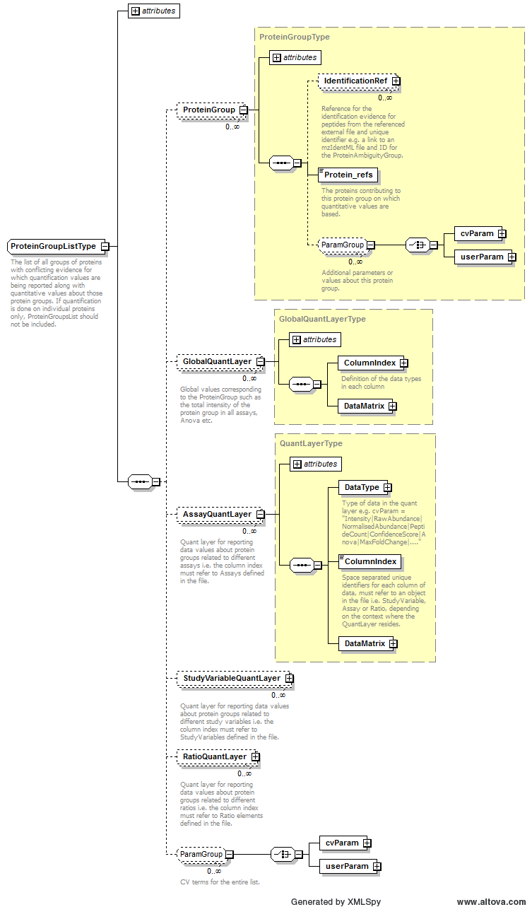
Example Context: | <ProteinGroupList id="PGList">  <ProteinGroup id="HSP70_HSP80">  <Protein_refs>HSP70 HSP80</Protein_refs>  <!-- Probably want to allow CV params to specify leading protein etc -->  </ProteinGroup>  <AssayQuantLayer id="Protein_group_assay_quant_layer">  <DataType>  ...  </ProteinGroupList>

Element <ProteinList>
Definition: | The list of all individual proteins (i.e. ungrouped) for which quantitation values are being reported. If quantitation is done on protein groups, the constituent proteins should be listed here with no QuantLayers.
Type: | ProteinListType
Attributes:
  Attribute Name | Data Type | Use | Definition
  id | xsd:ID | required | The unique identifier for the object within the file.
Subelements:
  Subelement Name | minOccurs | maxOccurs | Definition
  Protein | 0 | unbounded | -
  GlobalQuantLayer | 0 | unbounded | Global values corresponding to the small moleculee such as the total intensity of peptide in all assays, Anova in a quantitative peptidome experiment etc.
  AssayQuantLayer | 0 | unbounded | Quant layer for reporting data values about small molecules related to different assays i.e. the column index MUST refer to Assays defined in the file.
  StudyVariableQuantLayer | 0 | unbounded | Quant layer for reporting data values about small molecules related to different study variables i.e. the column index MUST refer to StudyVariables defined in the file.
  RatioQuantLayer | 0 | unbounded | Quant layer for reporting data values about small molecules related to different ratios i.e. the column index MUST refer to Ratio elements defined in the file.
  cvParam | 0 | unbounded | Attributes of this contact such as address, email, telephone etc.
  userParam | 0 | unbounded | Attributes of this contact such as address, email, telephone etc.
Graphical Context: | 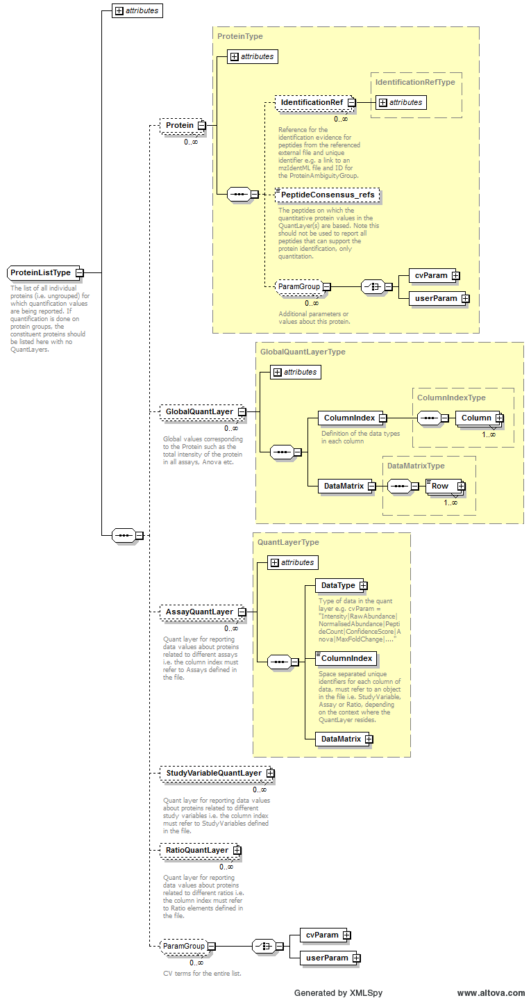
Example Context: | <ProteinList id="ProtL1">  <Protein accession="YDR447C" id="prot_0">  <PeptideConsensus_refs>pep_SNGVLNVDNQTSDLVK pep_KDQYVPEVSALDLSR pep_LCDEIATIQSK pep_LTLDFQTNKR pep_SLGLKLPLSVINVSAQR pep_LTLDFQTNK pep_LPLSVINVSAQR pep_IAGYTTHLMK pep_DQYVPEVSALDLSR</PeptideConsensus_refs>  </Protein>  <Protein accession="YPL220W" id="prot_1">  <PeptideConsensus_refs>pep_NWQNVGSLVVK pep_AGKFPTPVSHNDDLYGK pep_SCGVDAMSVDDLK pep_FPTPVSHNDDLYGK pep_LLGPQLSK pep_SCGVDAMSVDDLKK pep_ITSSQVR pep_LPNCPR pep_SSMGPAFR</PeptideConsensus_refs>  </Protein>  ...  </ProteinList>

Element <Protein_refs>
Definition: | The proteins contributing to this protein group on which quantitative values are based.
Type: | xsd:IDREFS
Attributes: | none
Subelements: | none
Example Context: | <Protein_refs>HSP70 HSP80</Protein_refs>

Element <Provider>
Definition: | The provider of the document in terms of the Contact and the software the produced the document instance.
Type: | ProviderType
Attributes:
  Attribute Name | Data Type | Use | Definition
  analysisSoftware_ref | xsd:IDREF | optional | The Software that produced the document instance.
  id | xsd:ID | required | An identifier is an unambiguous string that is unique within the scope (i.e. a document, a set of related documents, or a repository) of its use.
  name | xsd:string | optional | The potentially ambiguous common identifier, such as a human-readable name for the instance.
Subelements:
  Subelement Name | minOccurs | maxOccurs | Definition
  ContactRole | 0 | 1 | The Contact that provided the document instance.
Graphical Context: | 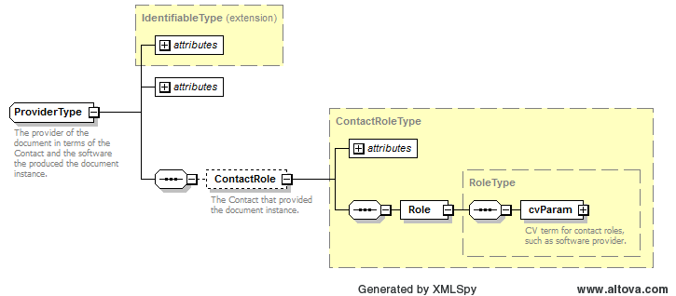
Example Context: | <Provider id="Provider1">  <ContactRole contact_ref="person1">  <Role>  <cvParam accession="MS:1001271" name="researcher" cvRef="PSI-MS"/>  </Role>  </ContactRole>  </Provider>

Element <Ratio>
Definition: | The setup of a ratio of study variables or assays that is referenced elsewhere in the file.
Type: | RatioType
Attributes:
  Attribute Name | Data Type | Use | Definition
  denominator_ref | xsd:IDREF | required | Reference to a StudyVariable or an Assay
  id | xsd:ID | required | The unique identifier for the object within the file.
  name | xsd:string | optional | Optional name for the ratio.
  numerator_ref | xsd:IDREF | required | Reference to a StudyVariable or an Assay
Subelements:
  Subelement Name | minOccurs | maxOccurs | Definition
  RatioCalculation | 0 | 1 | Information should be provided about how ratios are calculated if they differ from simple division of numerator by denominator
Example Context: | <Ratio id="ratio_MUT_VS_WT_1" numerator_ref="assay_MUT1" denominator_ref="assay_WT1" >  <RatioCalculation>  <cvParam accession="MS:1001848" name="simple ratio of two value" cvRef="PSI-MS"/>  </RatioCalculation>  </Ratio>

Element <RatioCalculation>
Definition: | Information should be provided about how ratios are calculated if they differ from simple division of numerator by denominator
Type: | ParamListType
Attributes: | none
Subelements:
  Subelement Name | minOccurs | maxOccurs | Definition
  cvParam | 1 | unbounded | A single entry from an ontology or a controlled vocabulary.
  userParam | 1 | unbounded | A single user-defined parameter.
Example Context: | <RatioCalculation>  <cvParam accession="MS:1001848" name="simple ratio of two value" cvRef="PSI-MS"/>  </RatioCalculation>
cvParam Mapping Rules: | Path /MzQuantML/RatioList/Ratio/RatioCalculation  MUST supply term MS:1001848 (simple ratio of two value) only once
Example cvParams: | <cvParam accession="MS:1001848" name="simple ratio of two value" cvRef="PSI-MS"/>
Example userParams: | <userParam name="Simple ratio calc"/>

Element <RatioList>
Definition: | The definition of ratios of study variables or assays, referenced elsewhere in the document.
Type: | RatioListType
Attributes: | none
Subelements:
  Subelement Name | minOccurs | maxOccurs | Definition
  Ratio | 1 | unbounded | The setup of a ratio of study variables or assays that is referenced elsewhere in the file.
Graphical Context: | 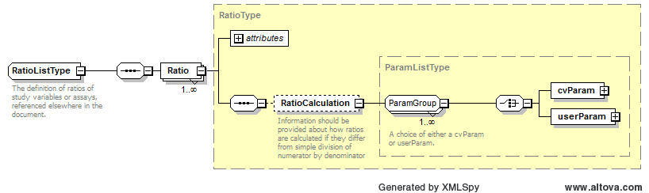
Example Context: | <RatioList>  <Ratio id="ratio_MUT_VS_WT_1" numerator_ref="assay_MUT1" denominator_ref="assay_WT1" >  <RatioCalculation>  <cvParam accession="MS:1001848" name="simple ratio of two value" cvRef="PSI-MS"/>  </RatioCalculation>  </Ratio>  <Ratio id="ratio_MUT_VS_WT_2" numerator_ref="assay_MUT2" denominator_ref="assay_WT2" >  ...  </RatioList>

Element <RatioQuantLayer>
Definition: | Quant layer for reporting data values about small molecules related to different ratios i.e. the column index MUST refer to Ratio elements defined in the file.
Type: | QuantLayerType
Attributes:
  Attribute Name | Data Type | Use | Definition
  id | xsd:ID | required | The unique identifier for the object within the file.
Subelements:
  Subelement Name | minOccurs | maxOccurs | Definition
  DataType | 1 | 1 | Type of data in the column e.g. cvParam = "Intensity|RawAbundance|NormalisedAbundance"
  ColumnIndex | 1 | 1 | Space separated unique identifiers for each column of data, MUST refer to an object in the file i.e. StudyVariable, Assay or Ratio, depending on the context where the QuantLayer resides.
  DataMatrix | 1 | 1 | A matrix of data stored in rows and columns, as defined in the parent QuantLayer.
Example Context: | <RatioQuantLayer id="QL_protein_ratio_disease_vs_healthy">  <DataType>  <cvParam accession="MS:1001848" name="simple ratio of two value" cvRef="PSI-MS"/>  </DataType>  <ColumnIndex>DISEASE_VS_HEALTHY</ColumnIndex>  <DataMatrix>  <Row object_ref="prot1">2.171</Row>  ...  </RatioQuantLayer>

Element <RawFile>
Definition: | A raw mass spectrometry output file that has been analysed e.g. in mzML format. The same raw file can be referenced in multiple assays, for example if it contains multiple samples differentially labelled or tagged. Note, the name raw file does not necessarily imply that the file has not been processed, since in some quant methods, processed peak list formats such as MGF or dta can be used, which could be referenced here.
Type: | RawFileType
Attributes:
  Attribute Name | Data Type | Use | Definition
  id | xsd:ID | required | An identifier is an unambiguous string that is unique within the scope (i.e. a document, a set of related documents, or a repository) of its use.
  location | xsd:anyURI | required | The location of the data file.
  name | xsd:string | optional | The potentially ambiguous common identifier, such as a human-readable name for the instance.
Subelements:
  Subelement Name | minOccurs | maxOccurs | Definition
  ExternalFormatDocumentation | 0 | 1 | A URI to access documentation and tools to interpret the external format of the ExternalData instance. For example, XML Schema or static libraries (APIs) to access binary formats.
  FileFormat | 0 | 1 | The format of the ExternalData file, for example "tiff" for image files.
  cvParam | 0 | unbounded | A single entry from an ontology or a controlled vocabulary.
  userParam | 0 | unbounded | A single user-defined parameter.
Example Context: | <RawFile location="../msmsdata/mam_050108o_CPTAC_study6_6E004_080505133441.raw" name="mam_050108o_CPTAC_study6_6E004_080505133441.raw" id="raw_11"/>

Element <RawFilesGroup>
Definition: | The raw file or collection of raw files that together form one unit of analysis. This is mandatory unless raw files were not used for quantitation e.g. spectral counting. Multiple raw files should only be provided within a group if they have been used for sample pre-fractionation which are later summed together.
Type: | RawFilesGroupType
Attributes:
  Attribute Name | Data Type | Use | Definition
  id | xsd:ID | required | Unique identifier for the group of raw files that constitute one analysis unit.
Subelements:
  Subelement Name | minOccurs | maxOccurs | Definition
  RawFile | 1 | unbounded | A raw mass spectrometry output file that has been analysed e.g. in mzML format. The same raw file can be referenced in multiple assays, for example if it contains multiple samples differentially labelled or tagged. Note, the name raw file does not necessarily imply that the file has not been processed, since in some quant methods, processed peak list formats such as MGF or dta can be used, which could be referenced here.
  cvParam | 0 | unbounded | Attributes of this contact such as address, email, telephone etc.
  userParam | 0 | unbounded | Attributes of this contact such as address, email, telephone etc.
Example Context: | <RawFilesGroup id="rg_11">  <RawFile location="../msmsdata/mam_050108o_CPTAC_study6_6E004_080505133441.raw" name="mam_050108o_CPTAC_study6_6E004_080505133441.raw" id="raw_11"/>  </RawFilesGroup>

Element <RawFilesGroup_refs>
Definition: | The raw file or group of raw files that constitute this assay.
Type: | xsd:IDREFS
Attributes: | none
Subelements: | none
Example Context: | <RawFilesGroup_refs>TECHREPRAW1</RawFilesGroup_refs>

Element <Role>
Definition: | The roles (lab equipment sales, contractor, etc.) the Contact fills.
Type: | RoleType
Attributes: | none
Subelements:
  Subelement Name | minOccurs | maxOccurs | Definition
  cvParam | 1 | 1 | A single entry from an ontology or a controlled vocabulary.
Example Context: | <Role>  <cvParam accession="MS:1001271" name="researcher" cvRef="PSI-MS"/>  </Role>
Example cvParams: | <cvParam accession="MS:1001271" name="researcher" cvRef="PSI-MS"/>

Element <Row>
Definition: | One row of data in a data matrix.
Type: | RowType
Attributes:
  Attribute Name | Data Type | Use | Definition
  object_ref | xsd:IDREF | required | Reference to the data type represented in this row e.g. Feature, Peptide, Protein.
Subelements: | none
Example Context: | <Row object_ref="pep_EATADESKAEETPASSNESTPSASSSSSANK">19378.1864106964 2388.67127101391 9686.73070559988 23668.3522905208 5643.82480910753 6324.71712798637 14398.6737507368 3723.88919448758 15144.6804108271 12080.3687959497 6840.29299876126 5751.39317386369</Row>

Element <SearchDatabase>
Definition: | A database used for searching mass spectra. Examples include a set of amino acid sequence entries, or annotated spectra libraries.
Type: | SearchDatabaseType
Attributes:
  Attribute Name | Data Type | Use | Definition
  id | xsd:ID | required | An identifier is an unambiguous string that is unique within the scope (i.e. a document, a set of related documents, or a repository) of its use.
  location | xsd:anyURI | required | The location of the data file.
  name | xsd:string | optional | The potentially ambiguous common identifier, such as a human-readable name for the instance.
  numDatabaseEntries | xsd:long | optional | The total number of entries in the database.
  releaseDate | xsd:dateTime | optional | The date and time the database was released to the public; omit this attribute when the date and time are unknown or not applicable (e.g. custom databases).
  version | xsd:string | optional | The version of the database.
Subelements:
  Subelement Name | minOccurs | maxOccurs | Definition
  ExternalFormatDocumentation | 0 | 1 | A URI to access documentation and tools to interpret the external format of the ExternalData instance. For example, XML Schema or static libraries (APIs) to access binary formats.
  FileFormat | 0 | 1 | The format of the ExternalData file, for example "tiff" for image files.
  DatabaseName | 1 | 1 | The database name may be given as a cvParam if it maps exactly to one of the release databases listed in the CV, otherwise a userParam should be used.
  cvParam | 0 | unbounded | A single entry from an ontology or a controlled vocabulary.
Example Context: | <SearchDatabase id="SD1" location="C:\DBs\uniprot_sprot_decoy.fasta" version="2010_09" numDatabaseEntries="1038696" releaseDate="2010-08-10T00:00:00">  <DatabaseName>  <cvParam accession="MS:1001104" name="database SwissProt" cvRef="PSI-MS"/>  </DatabaseName>  <cvParam accession="MS:1001348" name="FASTA format" cvRef="PSI-MS"/>  <cvParam accession="MS:1001252" name="DB source EBI" cvRef="PSI-MS"/>  <cvParam accession="MS:1001073" name="database type amino acid" cvRef="PSI-MS"/>  ...  </SearchDatabase>
Example userParams: | <DatabaseName><userParam name="mydb.fasta"/></DatabaseName>  <DatabaseName><userParam name="KEGG"/></DatabaseName>

Element <SmallMolecule>
Definition: | An element to represent a unique identifier of a small molecule for which quantitative values are reported.
Type: | SmallMoleculeType
Attributes:
  Attribute Name | Data Type | Use | Definition
  id | xsd:ID | required | The unique identifier for the object within the file.
Subelements:
  Subelement Name | minOccurs | maxOccurs | Definition
  Modification | 0 | unbounded | A small molecule modification specification, given by cvParams.
  DBIdentificationRef | 0 | unbounded | External database references for the small molecule identification
  Feature_refs | 0 | 1 | If the Peptide entity is intended as a summary of both modified and unmodified instances of the peptide, then the Feature_refs element MUST be completed to document those peptides only that are modified. If this element is excluded, it is assumed that all features have the modification.
  cvParam | 0 | unbounded | A single entry from an ontology or a controlled vocabulary.
  userParam | 0 | unbounded | A single user-defined parameter.
Example Context: | <SmallMolecule id="SM1">  <Modification>  <cvParam cvRef="PSI-MS" accession="" name=""/>  </Modification>  <DBIdentificationRef id_ref="C000017" SearchDatabase_ref="KEGG"/>  <Feature_refs>featureB_1 featureE_1</Feature_refs>  <cvParam cvRef="PSI-MS" accession="MS:1001467" name="taxonomy: NCBI TaxID" value="1456"/>  ...  </SmallMolecule>

Element <SmallMoleculeList>
Definition: | List of small molecules and associated data values.
Type: | SmallMoleculeListType
Attributes:
  Attribute Name | Data Type | Use | Definition
  id | xsd:ID | required | The unique identifier for the object within the file.
Subelements:
  Subelement Name | minOccurs | maxOccurs | Definition
  SmallMolecule | 1 | unbounded | An element to represent a unique identifier of a small molecule for which quantitative values are reported.
  GlobalQuantLayer | 0 | unbounded | Global values corresponding to the small moleculee such as the total intensity of peptide in all assays, Anova in a quantitative peptidome experiment etc.
  AssayQuantLayer | 0 | unbounded | Quant layer for reporting data values about small molecules related to different assays i.e. the column index MUST refer to Assays defined in the file.
  StudyVariableQuantLayer | 0 | unbounded | Quant layer for reporting data values about small molecules related to different study variables i.e. the column index MUST refer to StudyVariables defined in the file.
  RatioQuantLayer | 0 | unbounded | Quant layer for reporting data values about small molecules related to different ratios i.e. the column index MUST refer to Ratio elements defined in the file.
  cvParam | 0 | unbounded | Attributes of this contact such as address, email, telephone etc.
  userParam | 0 | unbounded | Attributes of this contact such as address, email, telephone etc.
Graphical Context: | 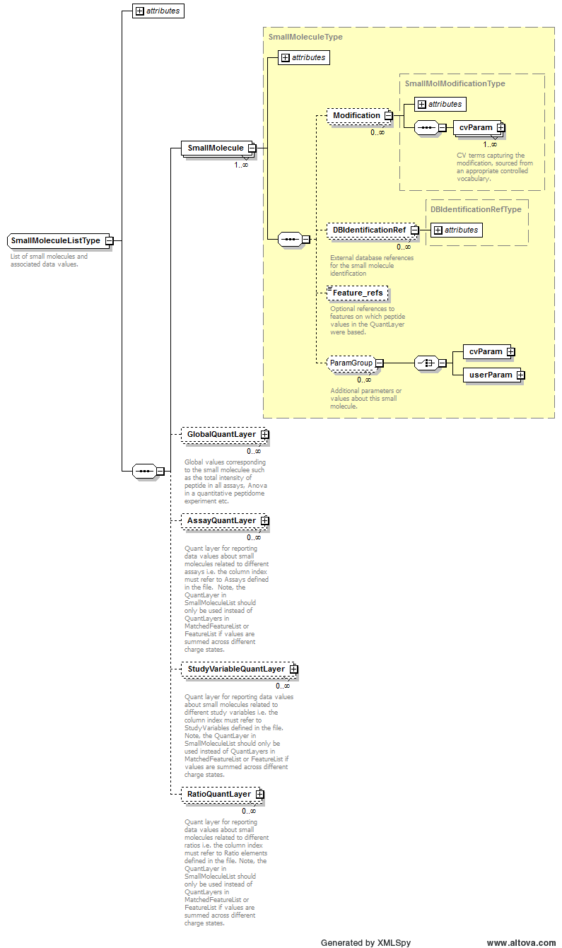
Example Context: | <SmallMoleculeList id="SMList1">  <SmallMolecule id="SM1">  <Modification>  <cvParam cvRef="PSI-MS" accession="" name=""/>  </Modification>  <DBIdentificationRef id_ref="C000017" SearchDatabase_ref="KEGG"/>  <Feature_refs>featureB_1 featureE_1</Feature_refs>  ...  </SmallMoleculeList>

Element <Software>
Definition: | A software package used in the analysis.
Type: | SoftwareType
Attributes:
  Attribute Name | Data Type | Use | Definition
  id | xsd:ID | required | The unique identifier for the object within the file.
  version | xsd:string | required | The software version.
Subelements:
  Subelement Name | minOccurs | maxOccurs | Definition
  cvParam | 0 | unbounded | A single entry from an ontology or a controlled vocabulary.
  userParam | 0 | unbounded | A single user-defined parameter.
Example Context: | <Software id="MS_EXCEL" version="2007">  <cvParam accession="MS:1001139" name="quantitation software name" value="Microsoft Excel" cvRef="PSI-MS"/>  </Software>
cvParam Mapping Rules: | Path /MzQuantML/SoftwareList/Software  MUST supply a *child* term of MS:1001139 (quantitation software name) only once  e.g.: MS:1000739 (WARP-LC)  e.g.: MS:1001488 (Mascot Distiller)  e.g.: MS:1001583 (MaxQuant)  e.g.: MS:1001830 (Progenesis LC-MS)  e.g.: MS:1001831 (SILACAnalyzer)  MUST supply term MS:1001832 (quantitation software comment / customizations) or any of its children one or more times
Example cvParams: | <cvParam accession="MS:1001583" cvRef="PSI-MS" value="1" name="MaxQuant"/>  <cvParam accession="MS:1001830" cvRef="PSI-MS" value="1" name="Progenesis LC-MS"/>  <cvParam accession="MS:1001139" name="quantitation software name" value="Microsoft Excel" cvRef="PSI-MS"/>

Element <SoftwareList>
Definition: | List and descriptions of software used to acquire and/or process the data in this file.
Type: | SoftwareListType
Attributes: | none
Subelements:
  Subelement Name | minOccurs | maxOccurs | Definition
  Software | 1 | unbounded | A software package used in the analysis.
Graphical Context: | 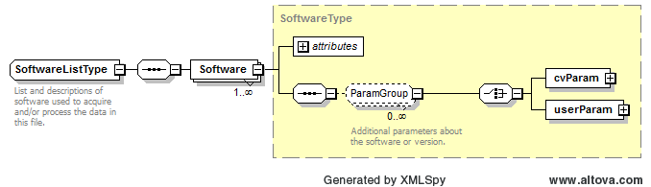
Example Context: | <SoftwareList>  <Software id="MS_EXCEL" version="2007">  <cvParam accession="MS:1001139" name="quantitation software name" value="Microsoft Excel" cvRef="PSI-MS"/>  </Software>  </SoftwareList>

Element <SourceFile>
Definition: | A file from which this MzQuantML instance was created, including potentially MzQuantML files for earlier stages in a workflow.
Type: | SourceFileType
Attributes:
  Attribute Name | Data Type | Use | Definition
  id | xsd:ID | required | An identifier is an unambiguous string that is unique within the scope (i.e. a document, a set of related documents, or a repository) of its use.
  location | xsd:anyURI | required | The location of the data file.
  name | xsd:string | optional | The potentially ambiguous common identifier, such as a human-readable name for the instance.
Subelements:
  Subelement Name | minOccurs | maxOccurs | Definition
  ExternalFormatDocumentation | 0 | 1 | A URI to access documentation and tools to interpret the external format of the ExternalData instance. For example, XML Schema or static libraries (APIs) to access binary formats.
  FileFormat | 0 | 1 | The format of the ExternalData file, for example "tiff" for image files.
Example Context:

Element <StudyVariable>
Definition: | A logical grouping of assays into conditions or user-defined study variables such as wild-type versus disease or time points in a time course.
Type: | StudyVariableType
Attributes:
  Attribute Name | Data Type | Use | Definition
  id | xsd:ID | required | The unique identifier for the object within the file.
  name | xsd:string | optional | A human readable name for the study variable.
Subelements:
  Subelement Name | minOccurs | maxOccurs | Definition
  cvParam | 1 | 1 | A single entry from an ontology or a controlled vocabulary.
  Assay_refs | 1 | 1 | Reference to the assay that is part of this study variable
Example Context: | <StudyVariable id="SV_group_B" name="Group B">  <cvParam accession="MS:1001807" cvRef="PSI-MS" value="1" name="StudyVariable attribute"/>  <Assay_refs>assay_L1 assay_L2</Assay_refs>  </StudyVariable>
cvParam Mapping Rules: | Path /MzQuantML/StudyVariableList/StudyVariable  SHOULD supply a *child* term of MS:1001807 (StudyVariable attribute) one or more times  e.g.: MS:1001808 (technical replicate)  e.g.: MS:1001809 (biological replicate)  e.g.: MS:1001810 (experimental condition 'case')  e.g.: MS:1001811 (experimental condition 'control')  e.g.: MS:1001812 (experimental condition 'disease')  e.g.: MS:1001813 (experimental condition 'healthy')  e.g.: MS:1001814 (generic experimental condition)  e.g.: MS:1001815 (time series, time point X)  e.g.: MS:1001816 (dilution series, concentration X)
Example cvParams: | <cvParam accession="MS:1001807" cvRef="PSI-MS" value="1" name="StudyVariable attribute"/>  <cvParam accession="MS:1001808" name="technical replicate" cvRef="PSI-MS" value="1"/>  <cvParam accession="MS:1001813" name="experimental condition 'healthy'" cvRef="PSI-MS"/>  <cvParam accession="MS:1001812" name="experimental condition 'disease'" cvRef="PSI-MS"/>

Element <StudyVariableList>
Definition: | The list of experimental conditions used to group results.
Type: | StudyVariableListType
Attributes: | none
Subelements:
  Subelement Name | minOccurs | maxOccurs | Definition
  StudyVariable | 1 | unbounded | A logical grouping of assays into conditions or user-defined study variables such as wild-type versus disease or time points in a time course.
Graphical Context: | 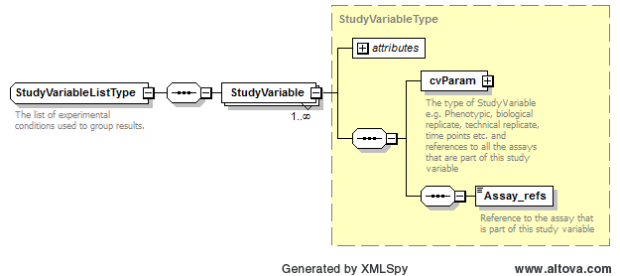
Example Context: | <StudyVariableList>  <StudyVariable id="SV_group_B" name="Group B">  <cvParam accession="MS:1001807" cvRef="PSI-MS" value="1" name="StudyVariable attribute"/>  <Assay_refs>assay_L1 assay_L2</Assay_refs>  </StudyVariable>  <StudyVariable id="SV_group_E" name="Group E">  <cvParam accession="MS:1001807" cvRef="PSI-MS" value="1" name="StudyVariable attribute"/>  ...  </StudyVariableList>

Element <StudyVariableQuantLayer>
Definition: | Quant layer for reporting data values about small molecules related to different study variables i.e. the column index MUST refer to StudyVariables defined in the file.
Type: | QuantLayerType
Attributes:
  Attribute Name | Data Type | Use | Definition
  id | xsd:ID | required | The unique identifier for the object within the file.
Subelements:
  Subelement Name | minOccurs | maxOccurs | Definition
  DataType | 1 | 1 | Type of data in the column e.g. cvParam = "Intensity|RawAbundance|NormalisedAbundance"
  ColumnIndex | 1 | 1 | Space separated unique identifiers for each column of data, MUST refer to an object in the file i.e. StudyVariable, Assay or Ratio, depending on the context where the QuantLayer resides.
  DataMatrix | 1 | 1 | A matrix of data stored in rows and columns, as defined in the parent QuantLayer.
Example Context: | <StudyVariableQuantLayer id="QL_protein_means_of_groups">  <DataType>  <cvParam accession="MS:1001860" name="mean of peptide ratios" cvRef="PSI-MS"/>  </DataType>  <ColumnIndex>SV1_HEALTHY SV2_DISEASE</ColumnIndex>  <DataMatrix>  <Row object_ref="prot1">0.1935 0.420</Row>  ...  </StudyVariableQuantLayer>

Element <userParam>
Definition: | A single user-defined parameter.
Type: | UserParamType
Attributes:
  Attribute Name | Data Type | Use | Definition
  name | xsd:string | required | The name of the parameter.
  type | xsd:string | optional | The datatype of the parameter, where appropriate (e.g.: xsd:float).
  unitAccession | xsd:string | optional | An accession number identifying the unit within the OBO foundry Unit CV.
  unitCvRef | xsd:string | optional | If a unit term is referenced, this attribute MUST refer to the CV 'id' attribute defined in the cvList in this file.
  unitName | xsd:string | optional | The name of the unit.
  value | xsd:string | optional | The user-entered value of the parameter.
Subelements: | none
Example Context: | <userParam name="Params for this step to go in here, e.g. which is the tolerance for matching the monoisotopic 14N and 15N peaks..." value=""/>

Specific Comments on schema
In this section, several points of documentation are elaborated beyond the core specification in Section 6.

File extension and compression
It is noted that standard file compression algorithms greatly reduce the mzQuantML file sizes, speeding up file transfers and uploads / downloads. It is also noted that software implementing mzQuantML import or export will be expected to benefit in performance from working with compressed mzQuantML, since the compression and decompression algorithms are expected to give significant performance gains over disk access times for non-compressed files. As such, it is RECOMMENDED that mzQuantML files are compressed using gzip from all software that exports mzQuantML and software that imports SHOULD be expected to read gzipped files, as well as native (non-compressed) mzQuantML files. The file extension for native mzQuantML files SHOULD be “.mzid” and for compressed files SHOULD be “mzq.gz”.

Referencing elements within the document
A number of elements within the schema have an attribute which is used to reference an element elsewhere in the file using the unique identifier of the referenced element. These attributes are named following the convention: “[elementName]_ref”. The uniqueness of the value in the “id” attribute of elements is validated using xsd:ID, and the integrity of the reference is validated using xsd:IDREF, defined within the schema. As such, using XML Schema validation alone, it would be possible to reference an incorrect type of element (since IDREF does not enforce the type of element). However, we expect that for a file to be semantically valid, references to the correct type of element must be provided and it can be expected that future iterations of semantic validation software will check these rules.

Unknown modifications
In version 1.0.0, only cvParam elements can be given on Peptide and a term “unknown modification” has been added to the PSI-MS CV. This term MUST only be used if the identified modification is not present in UNIMOD (or other allowed CV), according to the identity of the residue modified and the delta mass, within the parent tolerance specified in the search. The semantic validator will check any uses of the “unknown modification” term (MS:1001460) and reject files if the modification is present in UNIMOD.

Conclusions
This document contains the specifications for using the mzQuantML format to represent results from peptide and protein identification pipelines, in the context of a proteomics investigation. This specification, in conjunction with the XML Schema, mapping file and CV constitute a proposal for a standard from the Proteomics Standards Initiative. These artefacts are currently undergoing the PSI document process standardization process, which will result in a standard officially sanctioned by PSI.

Authors and Contributors

Authors of this specification:

- Mathias Walzer, Center for Bioinformatics/Dept. of Computer Science, University of Tübingen, Sand 14, 72076 Tübingen, Germany
- Oliver Kohlbacher, Center for Bioinformatics/Dept. of Computer Science, University of Tübingen, Sand 14, 72076 Tübingen, Germany
- Florian Reisinger, European Bioinformatics Institute, Wellcome Trust Genome Campus, Hinxton, Cambridge, UK
- J. Alberto Medina-Aunon, Proteomics Facility, Centro Nacional de Biotecnología - CSIC, Madrid, Spain
- Julian Uszkoreit, Medizinisches Proteom-Center, Ruhr-Universität Bochum, Germany
- Gerhard Mayer, Medizinisches Proteom-Center, Ruhr-Universität Bochum, Germany
- Martin Eisenacher, Medizinisches Proteom-Center, Ruhr-Universität Bochum, Germany
- Andrew R Jones, Institute of Integrative Biology, University of Liverpool, UK

Correspondence - andrew.jones@liv.ac.uk

In addition to the authors, numerous people contributed to the model development, gave feedback or tested mzQuantML. A complete list will populate these specifications once the format has completed the PSI document process.

References
- [RFC2119] Bradner, S. (1997). "Key words for use in RFCs to Indicate Requirement Levels, Internet Engineering Task Force, RFC 2119, http://www.ietf.org/rfc/rfc2119.txt.
- [Jones 07] Jones AR, Miller M, Spellman P and Pizarro A. Specification documentation for the Functional Genomics Experiment (FuGE) model: user guide. Version 1 (final): http://fuge.sourceforge.net/dev/V1Final/FuGE-v1-SpecDoc.doc.
- [Martens11] Martens L, Chambers M, Sturm M, Kessner D, Levander F, Shofstahl J, Tang W, Rompp A, Neumann S, Pizarro A, Montecchi-Palazzi L, Tasman N, Coleman M, Reisinger F, Souda P, Hermjakob H, Binz P, Deutsch E. mzML--a Community Standard for Mass Spectrometry Data MOLECULAR & CELLULAR PROTEOMICS, 10, R110 000133, 2011

Intellectual Property Statement
The PSI takes no position regarding the validity or scope of any intellectual property or other rights that might be claimed to pertain to the implementation or use of the technology described in this document or the extent to which any license under such rights might or might not be available; neither does it represent that it has made any effort to identify any such rights. Copies of claims of rights made available for publication and any assurances of licenses to be made available, or the result of an attempt made to obtain a general license or permission for the use of such proprietary rights by implementers or users of this specification can be obtained from the PSI Chair.

The PSI invites any interested party to bring to its attention any copyrights, patents or patent applications, or other proprietary rights that may cover technology that may be required to practice this recommendation. Please address the information to the PSI Chair (see contacts information at PSI website).

Copyright Notice
Copyright (C) Proteomics Standards Initiative (2011). All Rights Reserved.

This document and translations of it may be copied and furnished to others, and derivative works that comment on or otherwise explain it or assist in its implementation may be prepared, copied, published and distributed, in whole or in part, without restriction of any kind, provided that the above copyright notice and this paragraph are included on all such copies and derivative works. However, this document itself may not be modified in any way, such as by removing the copyright notice or references to the PSI or other organizations, except as needed for the purpose of developing Proteomics Recommendations in which case the procedures for copyrights defined in the PSI Document process must be followed, or as required to translate it into languages other than English.

The limited permissions granted above are perpetual and will not be revoked by the PSI or its successors or assigns.

This document and the information contained herein is provided on an "AS IS" basis and THE PROTEOMICS STANDARDS INITIATIVE DISCLAIMS ALL WARRANTIES, EXPRESS OR IMPLIED, INCLUDING BUT NOT LIMITED TO ANY WARRANTY THAT THE USE OF THE INFORMATION HEREIN WILL NOT INFRINGE ANY RIGHTS OR ANY IMPLIED WARRANTIES OF MERCHANTABILITY OR FITNESS FOR A PARTICULAR PURPOSE."

