In particular, note the use of the inner product trick (as explained in the lecture notes) to avoid an “Out of memory” error.

Use inner product trick to calculate Av as the eigenvector of AAT.

Use PCA feature, LDA feature, fused feature, and perform the classiﬁcation respectively. Answer folloing question.

1. Print the confusion matrix and overall accuracy for classiﬁers with three features.

PCA:

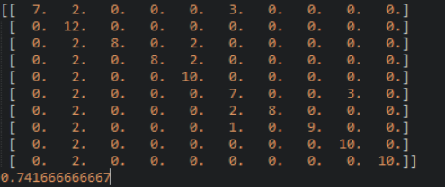

Lda:

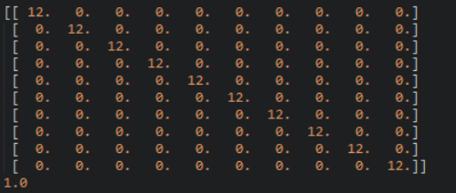

FUSION:alpha=0.5

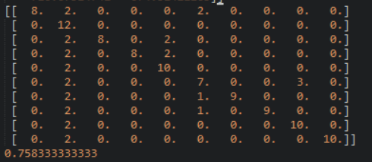

1. Compare the results for PCA feature and LDA feature, which feature is better? Why?

In this lab,lda is better.the accuracy is high,the confusion matrix is better. I think pca is better for dimensionality reduction and compression,from pca we can get some tipical features to represent the original database.but LDA is better for discrimination. It can divided the date into some classes in a [low-dimensional](C:/Users/xuechengxi/AppData/Local/Youdao/Dict/Application/6.3.69.5012/resultui/frame/javascript:void(0);) [space](C:/Users/xuechengxi/AppData/Local/Youdao/Dict/Application/6.3.69.5012/resultui/frame/javascript:void(0);).two methods have their own characters.

3. Let α = 0.1,0.2,...,0.9. Retrain your classiﬁer for fused feature and re-calculate its accuracy for each α. Plot accuracy versus α for diﬀerent α. Submit this plot. What do you observe?

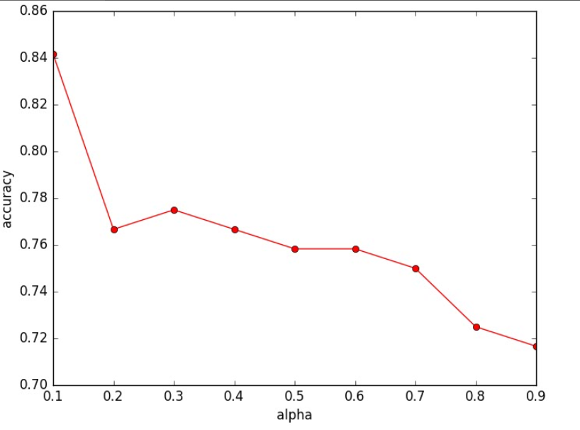

Because lda is better so if we use more lda features, we will get a better result. And the result is not linear, it has some fluctuation. It will not lower then the bad one’s accuracy in the fusion.and will also not higher than the better one.

4. Does the fused feature outperform both PCA feature and LDA feature? Why?

No, the result is between two method. Because fusion will preserve it’s components’ properties.so i think it can not be better than the good one.

Improve:

If we choose the K in PCA except the largest one or two value, the result will get better.because maybe the light is a extensive features but it can not help us recognize a special face, so we can drop some largest value, and by some test,i prove it.

去掉前三个的K

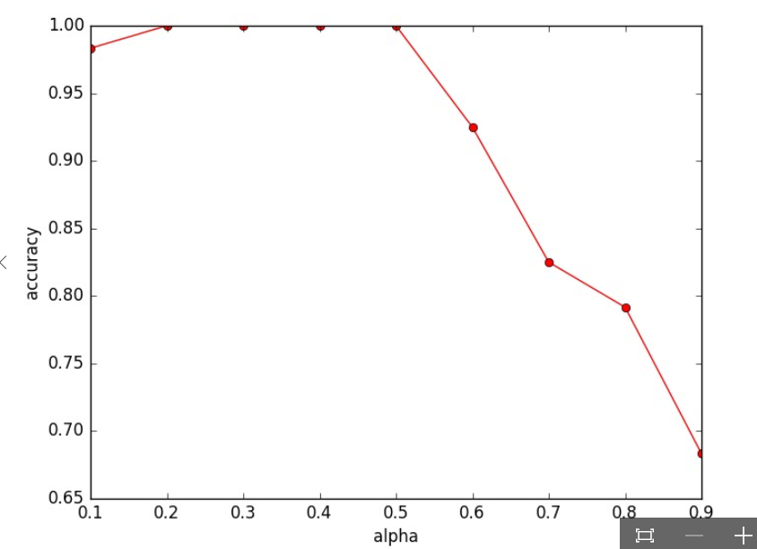

去掉前两个

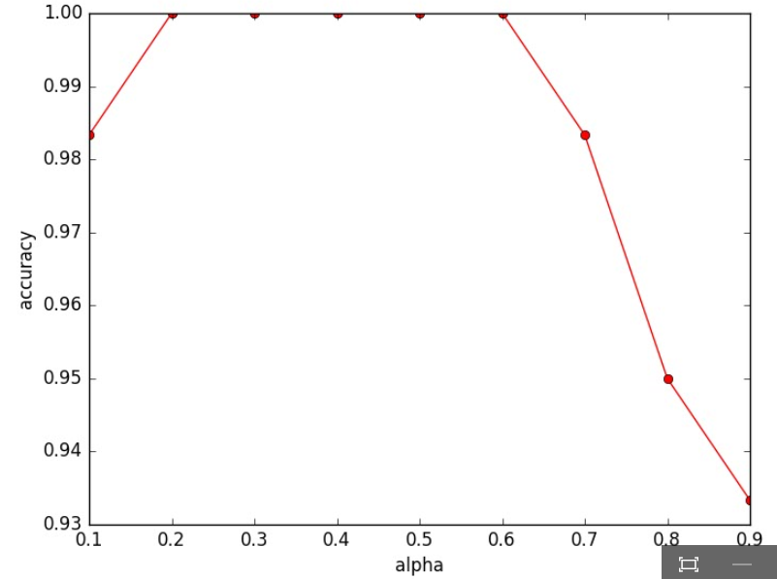

效果提升很多。