Higher, faster, stronger - Together! For a long time, countless athletes and sports researchers have used scientific analysis to push the world record to the limit of human beings, conveying the spirit and value of sports to the world. In this paper, we predict the performance of riders in road cycling competitions and analyze various factors that affect the results of individual time trials and team competitions, from the perspective of power curves, together with environmental factors, so as to help athletes continue to surpass themselves.

We build a power curve model based on the COGGAN model and a mechanics model for cyclists. We define a quantitative concept of fatigue, derive a Logistic-like differential equation system, and establish our power curve model, which describes the relationship between the rider's power output and time under the condition that the rider's physical condition is determined. The data from STRAVA provides important help for us to perfect the power curve model. The mechanical model for cyclists is base on Newtonian mechanics. The effects of environmental factors such as wind speed, wind direction, slope and ground friction, are fully considered.

Firstly, according to the power curve model, the riders are divided into three types: Time Trail Specialist, Climber, and Sprinter according to the maximum oxygen uptake, lactate threshold and muscle fiber type. Finally, we discuss male and female separately and obtain the corresponding power curve. Curves are roughly same to the statistics-based curves of COGGAN et al., thus this model has a high plausibility.

Secondly, with the rider's mechanical model, we construct a numerical calculation algorithm for predicting rider performance, and apply it to the Tokyo Olympics and UCI's individual time trial events. Taking various factors into account, we design a race track. We conduct a qualitative analysis of the characteristics of different types of players, then analyze the performance of different types of players in the three games.

Thirdly, we use the method of controlled variable to explore the effect of weather, especially wind speed and direction, on the outcomes of the race. The results show that the smaller wind speed may have a positive effect on the results, and the larger wind hinders the athletes' moving. Wind direction also played a role in the outcome of the race.

Fourthly, with the concept of overtaking action, we explore the effect of the rider's behavior over the power curve on the results, which is a strictly linear negative correlation, because the rider will experience a "fatigue period". We have also clarified that the game results are sensitive to this behavior, which provides theoretical help for improving performance.

Fifthly, we delve into drafting strategies with the help of Kyle's Law in team competitions. We rationally arranged everyone's role. The results show that scientifically using drafting strategies has an important impact on improving the team competition.

After modeling, we also perform a sensitivity analysis of the model, and evaluate our model’s strengths and weaknesses. And by use of our model, we provides recommendations for players who are underperforming in the Tokyo Olympics.

Key words: road cycling, power curve, mechanical model, logistic model.

**1 Introduction**

## Background

2021 marks the centenary of the Road Bike World Championships. At the same time, more and more people are taking part in cycling. The road cycling individual time trial is one of the most talked about races. Different types of players will achieve different results on different tracks.

In response to this phenomenon, scientists put forward the concept of power curve. That is, the maximum power a rider can maintain in a given amount of time. We will determine the rider's power curve based on the rider's physiological characteristics. At the same time, rational use of the power curve can also help the rider to achieve better results.

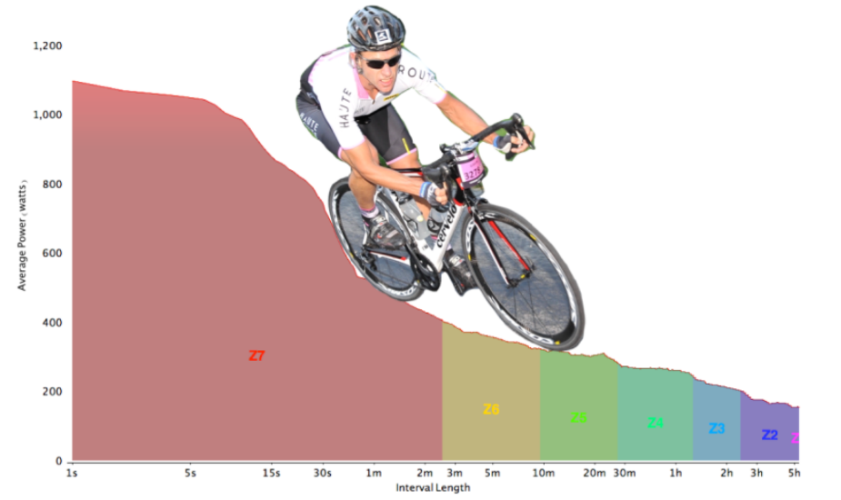

Figure 1:The Power Profile

## Restatement of the Problem

## Our work

This problem requires us to build the rider's power curve model and use the power curve model to help the rider pursue better performance. Our work mainly includes the following:

* Find data related to the physical fitness of riders of different types and genders, and build a rider's power curve model. Analyze the force of the rider during the race and build the rider's mechanical model.
* Apply the constructed model to different races, study the performance of different types of athletes on different tracks, analyze the reasons, and study the impact of wind and overtaking on rider power output.
* Conduct sensitivity analysis on the model, and analyze the advantages and improvements of the model, and finally draw a conclusion.

In order to avoid complicated descriptions and intuitively reflect our workflow, the flow chart is shown in Figure 2

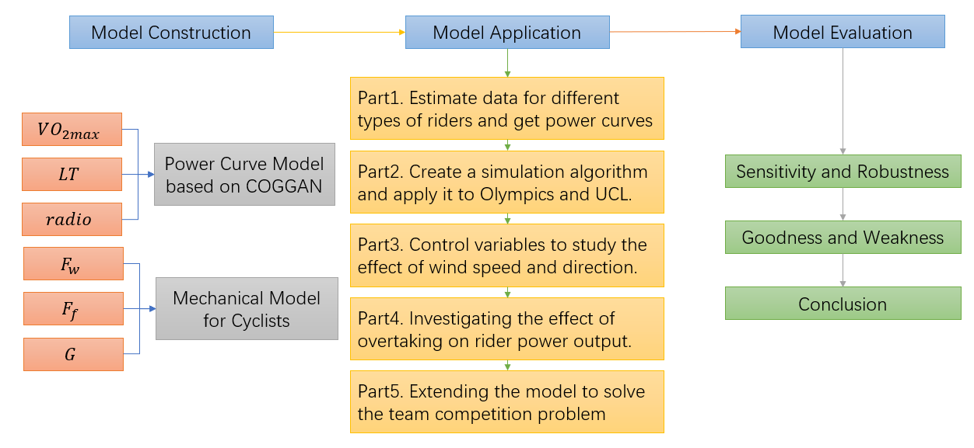

**Figure 2：Flow Chart of Our Work**

# Assumptions and Explanations

To simplify the problem, we make the following basic assumptions, each of which is reasonable.

* Assumption 1: The influence of the athlete's equipment on the power curve is not considered, and the power curve is only related to the athlete's physical factors.

→Justification: Most of the equipment of athletes belongs to the top level, and the difference between the equipment used by different athletes is relatively small and can be ignored.

* Assumption 2: The athlete's performance in the game is ideal.

→ Justification: Player mistakes in the game are very rare, and small mistakes are difficult to avoid and control, so the impact of mistakes on the game can be ignored.

* Assumption 3: The race is played in good weather, regardless of extreme weather effects such as rainy days.

→ Justification: Most races are not played in bad weather such as rain, and this facilitates modeling.

* Assumption 4: No fouls, no drafts in individual time trials.

→ Justification: Make sure each rider do his or her best, ignoring the interference of other riders in the individual time trial.

* Assumption 5: No resistance exists inside the rider's bike.

→ Justification: Professional riders' bicycles are made with top-notch manufacturing technology and have less internal friction, which has a negligible impact on the rider’s performance.

# Notations

Some important mathematical notations used in this paper are listed below

|  |  |  |
| --- | --- | --- |
| Symbol | Definition | Unit |
| FTPi | Functional threshold power, the maximum average power that can be generated in the current hour | W/Kg |
| VO2max | maximum oxygen uptake | ml/(Kgmin) |
| LT | Lactate Threshold |  |
| radio | muscle fiber ratio | / |
| Tr | Fatigue | W/s |
| Pi（t） | 理想状态下运动员做功的功率 | W |
| Pci | Sprint power | W |
| Vw | wind speed | m/s |
| g | Rolling resistance coefficient | / |
|  | Air drag coefficient | / |
|  | The inclination of the ground to the horizontal | rad |
|  | Vector angle of wind and traction | rad |
| FN | 支持力 | N |
| F | 牵引力 | N |
| mg | 重力 | N |
|  | 自行车摩擦力 | N |
|  | 风阻 | N |

# Model Preparation

# Solutions to Probleams

## Solutions to problem1: Estimate data and get power curves

### Calculate constants for power curve model

Table 1:Physiological characteristics of professional bike racing champions[5]

|  |  |  |  |
| --- | --- | --- | --- |
| Rider | Thibaut Pinot | Chris Froome | Miguel Indurain |
| VO2max  (ml*kg-1*min-1) | 85 | 84 | 88 |
| Power Output at 4mM Lactate  (watts) | 402 | 505 | 505 |
| Peak Power Output (watts) | - | 525 | 572 |
| Body Fat (%) | - | 9.5 | - |
| Body Weight (kg) | 65 | 67 | 76 |
| Maximal HR (bpm) | - | 170 | 191 |
| Study Authors | Pinot et. al | Bell et. al | Mujika et. al |

Table 2:Power characteristics of some professional Cyclists(means ± SD in W/kg)[5]

|  |  |  |
| --- | --- | --- |
|  | Women(n=8) | Men(n=23) |
| Peak 5-second | 15.22 ± 2.13 | 18.09 ± 2.25 |
| Peak 1-minute | 7.23 ± 0.79 | 9.48 ± 1.14 |
| Peak 5-minute | 4.83 ± 0.32 | 6.10 ± 0.60 |
| Coggan FTP-estimate  (95% of peak 20-min) | 4.04 ± 0.36 | 4.86 ± 0.42 |
| Peak 1-hour | 3.50 ± 0.38 | 4.49 ± 0.44 |
| 20-minute | 4.26 ± 0.38 | 5.11 ± 0.45 |

Note: Coggan suggests a 5-minute all-out effort prior to obtaining 20-minute value for FTP-estimate

Table 3:Coggan’s Power Profile Table.(Only shows data of professional Cyclists)[6]

|  |  |  |  |  |  |  |  |
| --- | --- | --- | --- | --- | --- | --- | --- |
| Men | | | | Women | | | |
| **5s** | 1 min | 5 min | FT | 5s | 1 min | 5 min | FT |
| **24.04** | 11.50 | 7.60 | 6.40 | 19.42 | 9.29 | 6.61 | 5.69 |
| **23.77** | 11.39 | 7.50 | 6.31 | 19.20 | 9.20 | 6.52 | 5.61 |
| **23.50** | 11.27 | 7.39 | 6.22 | 18.99 | 9.11 | 6.42 | 5.53 |
| **23.22** | 11.16 | 7.29 | 6.13 | 18.77 | 9.02 | 6.33 | 5.44 |
| **22.95** | 11.04 | 7.19 | 6.04 | 18.56 | 8.93 | 6.24 | 5.36 |
| **22.68** | 10.93 | 7.08 | 5.96 | 18.34 | 8.84 | 6.15 | 5.28 |
| **22.41** | 10.81 | 6.98 | 5.87 | 18.13 | 8.75 | 6.05 | 5.20 |
| **22.14** | 10.70 | 6.88 | 5.78 | 17.91 | 8.66 | 5.96 | 5.12 |
| **21.86** | 10.58 | 6.77 | 5.69 | 17.70 | 8.56 | 5.87 | 5.03 |
| **22.95** | 11.04 | 7.19 | 6.04 | 18.56 | 8.93 | 6.24 | 5.36 |

Table 4:Numbering of different types of professional riders.

|  |  |
| --- | --- |
|  | Types |
| 1 | Male Time Trail Specialist |
| 2 | Male Climber |
| 3 | Male Sprinter |
| 4 | Female Time Trail Specialist |
| 5 | Female Climber |
| 6 | Female Sprinter |

We use a part of Robert Sroka data which comes from the STRAVA exercise tool manufacturer in Table 2 to fit our Power curve model. We bring it into the equation system, and use the bisection method to find the equation to obtain the male Time Trail Specialist constants as follows:

.

According to Martin JC 's law: in the anaerobic sprint process, professional male road cyclists can often output more than 1000W in about 10-15s[7].So we can estimate that .

Female Time Trail Specialist constants are listed below:

.

Then we can get

### Power Curve of different types of Cyclists

According to the parameters obtained in the previous section, the following images can be obtained:



Figure 3: STRAVA and COGGAN Data and Power Curve of Average Men Time Trial Specialist

It is clear (also shown by calculation) that our equation fits the STRAVA data well. The COGGAN data is larger than the STRAVA data at each time. The reasons may be: 1. The STRAVA statistics comes from the usual training data so do not show the best level of the cyclists. 2. There may be a gap between COGGAN data and STRAVA data measurement standards and instruments. But the gap is less than 15%, which can be ignored in the forecast. It is more important that the trend of the model is completely consistent with it. Compared with the David Johnstone statistics [6], our model is perfect. (please note the t-axis scale)

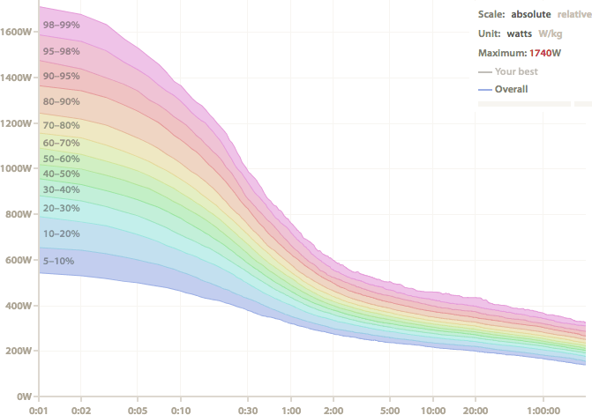

Figure 4：David Johnstone’s Power curve

According to the analysis of Robert Sroka[5], the maximum oxygen uptake() plays a decisive role in the capability of athletes. And for the different advantages of different riders, the influencing factors include a variety of internal factors, external factors. And internal factors have the greatest impact, such as, the maximum oxygen uptake(), lactate threshold(, muscle fiber type(, pedaling rhythm, human mechanical efficiency, crank length, saddle height, body fat ratio. Many of them are related to innate talent but can be improved through acquired training, and our model only take some factors into consideration.

represents the turning point from aerobic respiration to anaerobic respiration. The larger is, the stronger the aerobic respiration ability and the stronger the ability to maintain a high level of exercise a cyclist can have. In many cases, elite athletes can maintain a long-term power output (80-90% of FTP). Muscle fiber type I is known as aerobic muscle, whose percentage in the human body can be increased through aerobic training, such as jogging. Muscle fiber type I is conducive to slow, aerobic, anti-fatigue exercise. Muscle fiber type II is also known as anaerobic Muscle, whose percentage can be increased by endurance training, such as weightlifting. It is important for fast, anaerobic sprinting sessions. The ratio of muscle fiber type I to type II() is also an important indicator to measure an athlete. The of an average person is 50/50.

Sprinter has strong short-range sprint ability, strong anaerobic exercise ability, because of a high level and low .

Climber requires sufficient energy supply, with high and high , which can maintain a high level of exercise for a long time.

Time Trail Specialist needs all-around and balanced abilities.

We solve the power curves for different types of riders according to analysis above.

Table 5:Estimation of rider data for different models

|  |  |  |  |  |  |  |  |
| --- | --- | --- | --- | --- | --- | --- | --- |
|  | | 1 | 2 | 3 | 4 | 5 | 6 |
|  | 85.667 | | 90 | 87 | 29.439 | 30.928 | 29.897 |
|  | 4 | | 4.3 | 4 | 4 | 4.3 | 4 |
|  | 1.5 | | 2 | 1 | 1.5 | 2 | 1 |
|  | 4.7893802 | | 5.0316246 | 4.86390378 | 1.645844407 | 1.729090509 | 1.671454158 |
|  | -0.1746259 | | -0.1218321 | -0.2619389 | -0.17462595 | -0.12183206 | -0.261938925 |
|  | 18.75 | | 15.12 | 28.13 | 18.75 | 15.12 | 28.13 |



Figure 5: Power Curve of Different Riders

## Solution to Problem2: Create a simulation algorithm and Apply it to races.

### Proposition of a Numerical Simulation Algorithm

Taking both power curve model and mechanical model into consideration, we assume that riders’ power output strictly follows the power curve. And we simulate different types of cyclists’ performance in various competitions and compare it with reality, which confirm the correctness of our model. It can help players find problems and achieve better results.

The rider can choose to briefly exceed the limit on the power curve, but an extra time is needed to recover at lower power levels for a longer period, and then cyclist wastes more time. So we can clarify that the rider achieve his best performance when riders’ power output strictly follows the power curve. According to Assumption 2, the rider's mistakes during the race can be ignored, so we can assume that pro riders’ power output strictly follows his power curve.

According to Assumption 5, the energy loss of mechanical structures is negligible, and the wind direction and speed remain unchanged during the race. We can create an algorithm to simulate the speed and arrival time of the time-trial cyclists. This simulation algorithm’s pseudo-code is as followed.

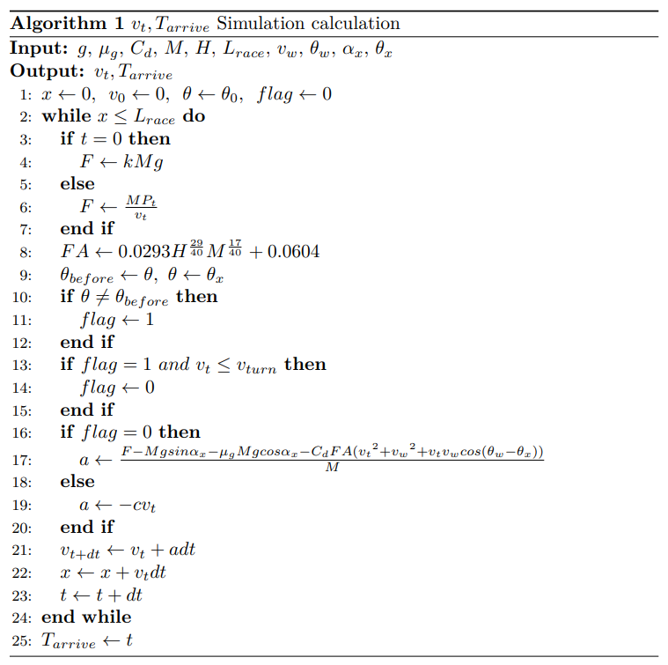

Figure 6:Algorithm Pseudocode for Simulation Computing

### Apply our model to three races

By watching the games and searching on the Internet, we obtain the Tokyo 2021 Olympic Road Individual Time Trial and Belgium Flanders UCI World Championship Time Trial’s route data[8].We get the relationship between the slope angle(, the road direction angle(), and x. We also get the wind speed and direction data on that day. On the day of the 2021 Olympic Road Individual Time Trial in Tokyo, Japan, , and the wind direction is south. On the day of the individual time trial of the UCI Belgium Flanders World Championships,, and the wind direction is east. We run simulation calculations for different types of riders. The results are shown in the following figures and table.



Figure 7:Some Professional Cyclists’speed time simulation curve at the Tokyo Olympics



Figure 8: Some Professional Cyclists’speed time simulation curve at the UCI

It is analyzed that due to the large number of mountains in the Tokyo Olympics, Climber can play better. In reality, the gold medalist is famous for mountain biking, while the Sprinter plays less well because it does not have the endurance of long-distance mountaineering. UCI Belgium's competition venue is flat, which is more favorable for comprehensive players, while Climber plays poorly, and Sprinter plays the worst. Because Sprinter has disadvantage in longer road races. Due to the complex terrain of the Tokyo Olympics venue and the high wind speed at that time, everyone's arrival time was long. The gold medal winner's record was 3300s, which differs from the predicted value by 19.4%. It can be said that the simulation effect is good. The UCI competition is more standard, the wind resistance is lower. The game is extremely frustrating. The gold medalist's record is 2867s, which differs from the predicted value by only 6%. However, the short-term power peak of Sprinter during the sprint is extremely strong, much higher than other competitors. It is observed that during the prediction process, the athletes' level is always higher than the predicted level, indicating that there may be more systematic factors such as skills and equipment that have not been considered, and the athlete's level may not be limited to the power curve. And there is an obvious gap in physical strength between men and women. Due to the lack of physical strength of women, it is impossible to accelerate in the late stage of the hillside road. And female cyclists played better in the UCI because of the flat terrain. And we can find that simulated results in the process are appropriate. When encountering a turn, cyclists needs to decelerate rapidly, and then rapidly increase his speed.

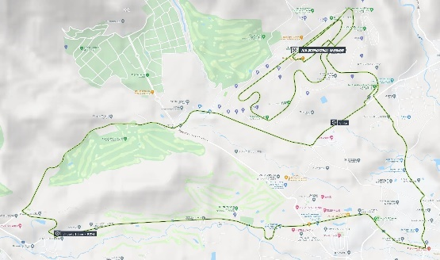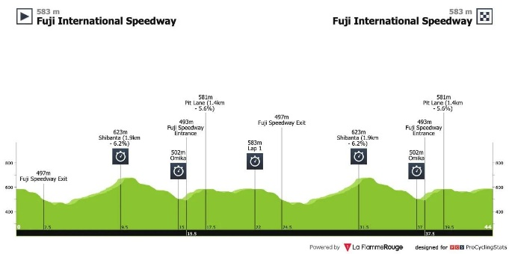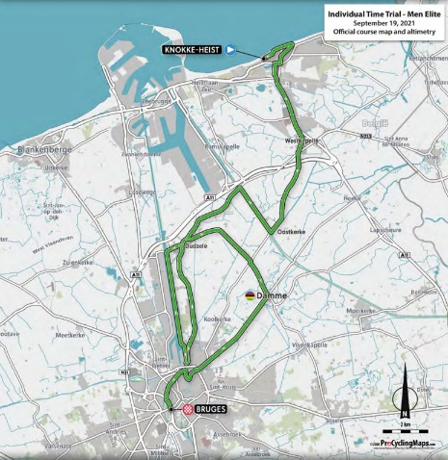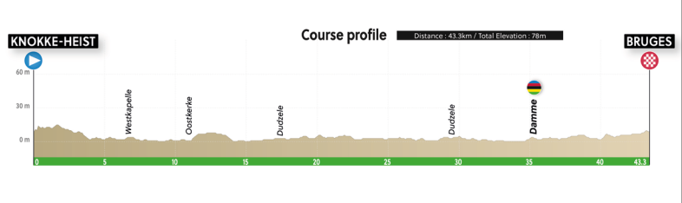

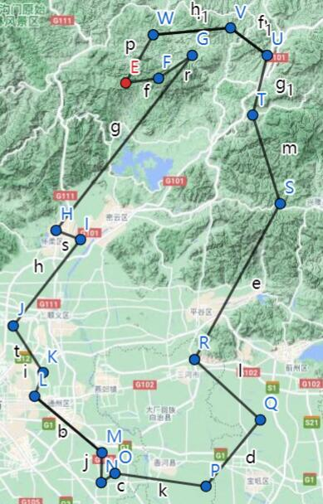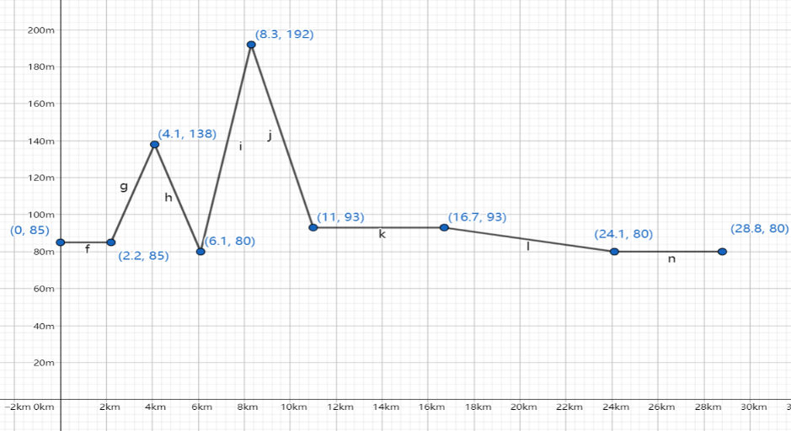

Figure 9: Data of Tokyo Olympics, UCI and our race[9][10]

We comprehensively considered the terrain and weather effects, and design our competition. Our competition took place in Wuhan, Hubei Province. At the start of this competition, there were two key slopes. The overall race track is relatively smooth, and the total distance is short, only 28.8km. The track is slightly favorable for the Sprinter, and conclusions can also be drawn from the results. Sprinter starts quickly and performs well on the first ramp, but falls behind the rest of the bikers on the second key ramp for physical reasons. In the end, Sprinter performs well in the sprints. Climber is weak in sprints so lags behind others, so its performance is worse than Time Trail Specialist. Results are in line with common sense.



Figure 10:Some Professional Cyclists’speed time simulation curve at Our Race

To sum up, this model is based on the power curve of the athlete, and fully takes into terrain, wind speed, and turning account. This model conforms to common sense and kinematic laws, and the predicted results are in line with reality.