导入电子表格中的数据
用于从以下电子表格导入数据的脚本:
工作簿: C:\Users\hp\Desktop\MATLAB数学建模方法与实践（第3版）程序及数据\程序_MATLAB数学建模方法与实践_卓金武等\程序_MATLAB数学建模方法与实践_卓金武等\Cha2\sz000004.xls
工作表: Sheet1
由 MATLAB 于 2022-02-04 10:10:29 自动生成
设置导入选项并导入数据 1
转换为输出类型 1
清除临时变量 2

设置导入选项并导入数据
opts = spreadsheetImportOptions("NumVariables", 8);
% 指定工作表和范围
opts.Sheet = "Sheet1";
opts.DataRange = "A2:H99";
% 指定列名称和类型
opts.VariableNames = ["Date", "DateNum", "Popen", "Phigh", "Plow", "Pclose", "Volum", "Turn"];
opts.VariableTypes = ["double", "double", "double", "double", "double", "double", "double", "double"];
% 导入数据
tbl = readtable("C:\Users\hp\Desktop\MATLAB数学建模方法与实践（第3版）程序及数据\程序_MATLAB数学建模方法与实践_卓金武等\程序_MATLAB数学建模方法与实践_卓金武等\Cha2\sz000004.xls", opts, "UseExcel", false);

转换为输出类型
Date = tbl.Date;
DateNum = tbl.DateNum;
Popen = tbl.Popen;
Phigh = tbl.Phigh;
Plow = tbl.Plow;
Pclose = tbl.Pclose;
Volum = tbl.Volum;
Turn = tbl.Turn;

清除临时变量
clear opts tbl
figure
plot(DateNum, Pclose, 'k')
datetick('x', 'mm')
xlabel('Date')
ylabel('Money')
figure
bar(Pclose)
p = polyfit(DateNum, Pclose, 1);
P1 = polyval(p, DateNum)
figure
plot(DateNum, P1, DateNum, Pclose, '*g')
value = p(1)
MaxDD = maxdrawdown(Pclose)
risk = MaxDD
P1 =
13.7628
13.8840
14.0052
14.1264
14.2476
14.6112
14.7324
14.8535
14.9747
15.0959
15.4595
15.5807
15.7019
15.8231
15.9443
16.3079
16.4291
16.5503
16.6715
16.7927
17.1563
17.2775
17.3987
17.5199
17.6411
18.0047
18.1259
18.2470
18.3682
18.4894
18.8530
18.9742
19.9438
20.0650
20.1862
20.5498
20.6710
20.7922
20.9134
21.0346
21.3982
21.5194
21.6405
21.7617
21.8829
22.2465
22.3677
22.4889
22.6101
22.7313
23.0949
23.2161
23.3373
23.4585
23.5797
23.9433
24.0645
24.1857
24.3069
24.4281
24.9129
25.0341
25.1552
25.2764
25.6400
25.7612
25.8824
26.0036
26.1248
26.4884
26.6096
26.7308
26.8520
26.9732
27.3368
27.4580
27.5792
27.7004
28.1852
28.3064
28.4276
28.5487
28.6699
29.0335
29.1547
29.2759
29.3971
29.5183
29.8819
30.0031
30.1243
30.2455
30.3667
30.7303
30.8515
30.9727
31.0939
31.2151
value =
0.1212
MaxDD =
0.1155
risk =
0.1155
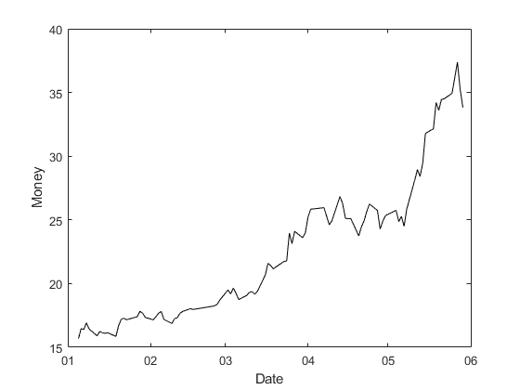
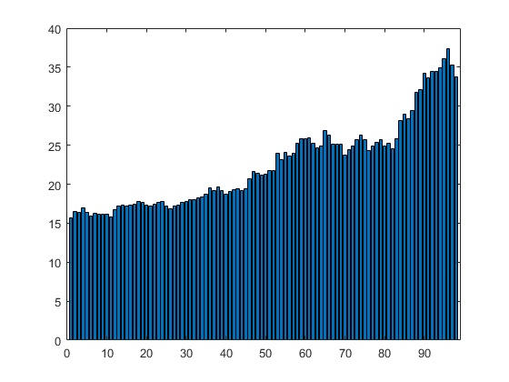
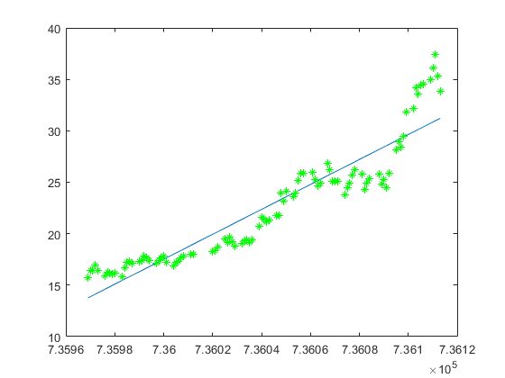
Published with MATLAB® R2021b

