重庆大学 数据库系统 课程试卷
命题人： 罗军 组题人： 朱征宇 审题人： 熊忠阳 命题时间：2007/11/28
学院 专业 年级 学号 姓名
封
线
密
2007 ~2008 学年 第一学期
开课学院： 计算机学院 |  |  |  |  |  |  |  | 考试日期： 2007-12-14
 |  |  |  |  |  |  |  | 考试时间： 90 分钟
题 号 | 一 | 二 | 三 | 四 | 五 | 六 | 七 |  | 八 | 九 | 十 |  | 总 分
得 分
注：1.大标题用四号宋体、小标题及正文用小四号宋体；2.按A4纸缩小打印
NOTES:The exam is closed book and closed notes. Please write your solutions in the spaces provided on the exam. Make sure your solutions are neat and clearly marked. You may use the blank areas and backs of the exam pages for scratch work. Please do not use any additional scratch paper.
Problem 1: (15 points)
The first question is based on the following information:
1. Manufacturers have a name, which we may assume is unique, an address, and a phone number.
2. Products have a model number and a type (e.g., "television set"). Each product is made by one manufacturer, and different manufacturers may have different products with the same model number. However, you may assume that no manufacturer would have two products with the same model number.(弱实体集)
3. Customers are identified by their unique social security number. They have email addresses, physical addresses. Several customers may live at the same (physical) address, but we assume that no two customers have the same email.
4. An order has a unique order number, and a date. An order is placed by one customer. For each order, there are one or more products ordered, and there is a quantity for each product on the order.
Do the following:
In the space below, draw an entity/relationship diagram that represents the above information. Indicate keys by underlining, as usual.
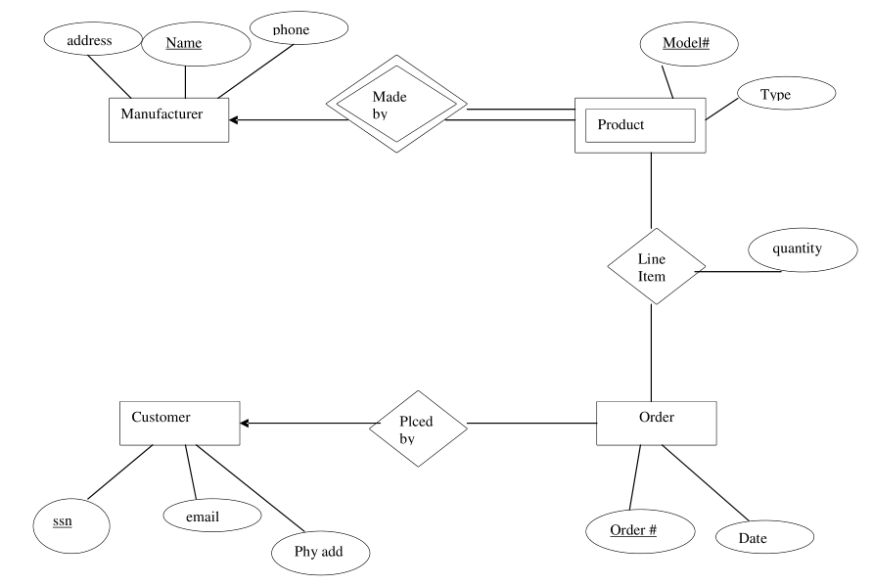

Problem 2: (10 points)
The next question is based on the following E/R diagram representing cities and the states they are in.
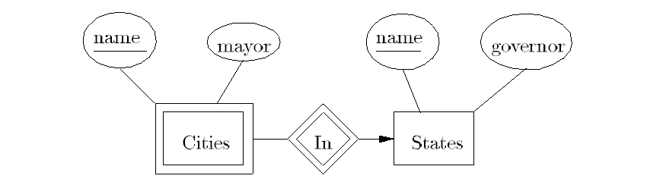

A city's name is unique within a state, but there are often cities with the same name in different states. Thus, Cities is a weak entity set taking its key from its own name and the name of the state it is in.
If we follow the rules given in the text for converting this E/R diagram to relations, we get the followings,which one is correct:
(a) Cities(name, mayor, stateName) and States(name, governor)
(b) Cities(name, mayor, governor) and States(name, governor)
(c) Cities(name, mayor, stateName, governor)
(d) Cities(name, mayor) and States(name, governor)
Problem 3: (10 points)
Consider the following database schema:
Paintings(artist, work, date, museumname)
Museums(museumname, city, curator)
Intuitively, Paintings contains tuples (a,w,d,m) such that artist a painted work w on date d, and the work is hanging in museum m. Museums contains tuple (n,c,x) if n is the name of a museum in city c, and the curator of museumm is x. Write the following queries in Relational Algebra.
1. On what date did Leonardo paint the Mona Lisa?
2. In what city is the Mona Lisa?
1. 投影date(选择artist=”Leonardo”合取work=”Mona Lisa”(Paintings))
2. 投影city(选择work=”Mona Lisa”(Paintings自然连接Museums))

Problem 4: (10 points)
Suppose we have the following table declarations:
CREATE TABLE A(w INT PRIMARY KEY);
CREATE TABLE B(x INT PRIMARY KEY
REFERENCES A(w) ON DELETE SET NULL）;
CREATE TABLE C(y INT REFERENCES A(w));
CREATE TABLE D(z1 INT REFERENCES B(x) ON DELETE SET NULL,
z2 INT REFERENCES A(w) ON UPDATE CASCADE);
Consider the following scripts:
1. DELETE FROM C; DELETE FROM B; DELETE FROM A; DELETE FROM D;
2. DELETE FROM C; DELETE FROM D; DELETE FROM A; DELETE FROM B;
3. DELETE FROM B; DELETE FROM C; DELETE FROM D; DELETE FROM A;
Which of the above scripts will empty all four tables, without error?
(a) 3 only (b) 1 only (c) 2 and 3 only (d) 1 and 3 only

Problem 5: (5 points)
In the following question, assume the schemas of the relations are R(a; b)
and S(b; c).
Q1:
SELECT a
FROM R, S
WHERE R.b = S.b;
Q2:
SELECT a
FROM R
WHERE b IN (
SELECT b
FROM S );
Which of the following answer is correct?
(a) Q1 and Q2 produce the same answer.
(b) The answer to Q1 is always contained in the answer to Q2.
(c) The answer to Q2 is always contained in the answer to Q1.
(d) Q1 and Q2 produce different answers.

Problem 6: (10 points)
Initially, user A is the owner of relation R, and no other user holds privileges on R. The following are executed:
by A: GRANT INSERT ON R TO B WITH GRANT OPTION;
by B: GRANT INSERT ON R TO C WITH GRANT OPTION;
by C: GRANT INSERT ON R TO D WITH GRANT OPTION;
by D: GRANT INSERT ON R TO B WITH GRANT OPTION;
by B: REVOKE INSERT ON R FROM C CASCADE;
As a result, which is the exact set of users that have the privilege INSERT ON R:
(a) A only
(b) A and B only
(c) A, B, and D only
(d) A, B, C, and D

Problem 7: (15 points)
Relation R(a, b, c) currently has the following instance:
{(1; 2; 3), (3; 4; 2), (2; 6; 1)}
We make the following view definitions:
CREATE VIEW V AS
SELECT a*b AS d, c FROM R;
CREATE VIEW W AS
SELECT d, SUM(c) AS e FROM V GROUP BY d;
What is the sum of all the components of all the tuples of the following query?
SELECT AVG(d), e FROM W GROUP BY e;
(a) 10
(b) 17
(c) 23
(d) 28
R
a b c
1 2 3
3 4 2
2 6 1

V(view)
d(a*b) c
2 3
12 2
12 1

W(view)
d e(SUM(c))
2 3
12 3

SELECT AVG(d), e FROM W GROUP BY e;
(2+12)/2=7 3
7+3=10

Problem 8. (10 points)
Suppose we have a relation R(A,B,C,D) and the FD's
A-> B, B-> C,A->D
1.(5 points) What is true about the key(s) for R?
(a) Only A is a key
(b) Only AB is a key
(c) Only AB and AC are keys.
(d) Only AB, AC, and BC are keys
2.(5 points) To decompose R into 3NF
{ A->B, A->D }
{ B->C }

Problem 9. (15 points)
Consider the following table containing enrollment information for students in courses:
Took(studentID,year,dept,course,units)
Assume the following two queries are asked frequently over this data:
Q1: select year,dept,sum(units)
from Took from Took
group by year, dept

Q2: select dept,course,sum(units)
from Took from Took
group by dept, course
You are allowed to create views V1 and V2 over table Took to help answer both queries. Define the views using regular SQL view syntax
create view V1 as
select year,dept,sum(units)
from Took
group by year, dept;

create view V2 as
select dept,course,sum(units)
from Took
group by dept, course;

Let R(A, B, C) satisfy the following functional dependencies (FDs): AB -> C, BC -> A, and AC -> B. The closure of A (i.e., A+) is
a) A
b) AB
c) AC
d) ABC

