重庆大学 数据库系统 课程试卷
命题人： 曾令秋 杨广超 组题人： 朱征宇 审题人： 罗军 命题时间：2008-11-27
学院 专业 年级 学号 姓名
封
线
密
2008 ~2009 学年 第一学期
开课学院： 计算机学院 |  |  |  |  |  |  |  | 考试日期： 2008-12-22
 |  |  |  |  |  |  |  | 考试时间： 120 分钟
题 号 | 一 | 二 | 三 | 四 | 五 | 六 | 七 |  | 八 | 九 |  | 总 分
得 分
注：1.大标题用四号宋体、小标题及正文用小四号宋体；2.按A4纸缩小打印
NOTES:The exam is closed book and closed notes. Please write your solutions in the spaces provided on the exam. Make sure your solutions are neat and clearly marked. You may use the blank areas and backs of the exam pages for scratch work. Please do not use any additional scratch paper.
Problem 1: (10 points)
As is well known, A DBMS suppots concurrent access to data. It can be accessed simultaneously by many distinct processes which are called transactions. Please descript the four properties (ACID) of Transaction
略

Problem 2: (10 points)
One way to represent students and the grades they get in courses is to use the entity sets corresponding to students, to courses, and to “enrollments.”(注册) Enrollments entities form a “connecting” entity set between students and courses and can be used to represent not only the fact that a student is taking a certain course, but the grade of the student in the course. Every student has a different id, and there is a unique number for each course. Draw an E/R diagram for this situation, indicating weak entity sets and the keys for the entity sets. Is the grade part of the key for enrollments? NO (key for enrollments: id, number；grade不是分辨符)
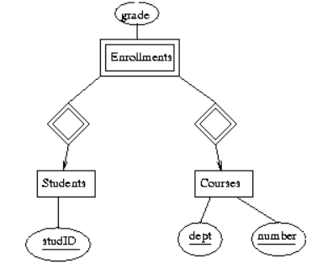
(没有dept，studID为id)

Problem 3: (15 points)
Convert the following E/R Diagram to a relational database schema.
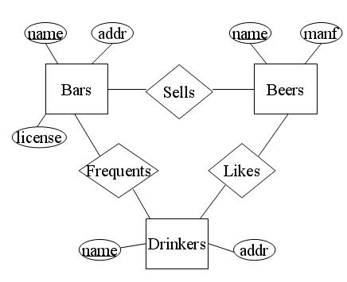
1
m
n
n
m
n
Bars(name,addr,licence)
Beers(name,manf)
Drinkers(name,addr,beersname)
Sells(barsname,beersname)
Frequents(barsname,drinkersname)
只有多对多联系集转化关系模式里面区分不了的再对属性名进行修改，实体集转化关系模式不用对属性名进行修改。
多对一联系集转化关系模式只有一个主码，就去掉不作为关系模式，而作为“多”的一方的属性(beersname)

Problem 4: (15 points)
Consider the relation schema R(A,B,C,D,E) with functional dependencies {AB->C, C->D, C ->E, D->A, E->B}.
a) Find all the keys for R. AB, AE,BD,C,DE
b) Which of the given dependencies violate 3NF?
{AB->C, C->D, C ->E, D->A, E->B}
没有破坏成为3NF的？所以直接就能分解成3NF？
F1{AB->C} F2{ C->D, C ->E } F3{ D->A} F4{ E->B}

Problem 5: (10 points)
Here is a relation R:
A | B | C | D | E
1 | 2 | 3 | 4 | 8
1 | 4 | 5 | 7 | 6
6 | 7 | 10 | 9 | 8
9 | 6 | 3 | 5 | 9

and there is an expression of relational algebra on R:
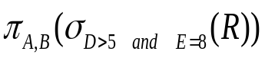.
i) Descript the meaning of the expression
找出关系R中D大于5并且E等于8的所有元组的A属性和B属性的集合？
ii) Write the result of the expression when it is used on R
A | B
6 | 7

Problem 6: (8 points)
Suppose we have two relations R1 and R2, the two schemas are as following:
R1(A,B,C) and R2(C,D,E).
Two general query expressions of relational algebra are
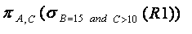
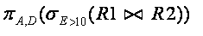
Please, show how to express the two queries in SQL.
select A,C from R1 where B=15 and C>10;
select A,D from R1 natural join R2 where E>10;

Problem 7: (10 points)
Using the two base tables:
Dept(deptid, deptname, deptdescription)
Employee(empid, empname, job, hiredate, deptid)
i) Define a view CountEmp that gives for each department its deptname and the number of its employees
create view CountEmp(deptname,num) as
select deptname,count(*)
from Dept natural join Employee
group by (deptname);
ii) Write a query using your view from i) asking for “deptname” of the department , in which the number of employees is more than 10.
select deptname
from CountEmp
where num>10;

Problem 8. (12 points)
Consider the relation schema:
Student(sno,sname,gender, speciality)
with the following integrity constraints for its attributes:
i) sno is the primary key,
ii) sname is not allowed to have a NULL value,
iii) gender must be “F”or “M”,
iv) the first four characters of sno must be ‘2006’.
Write out the declaration of the relation schema(you can use any appropriate types for the attributes of the relation).
原：
create table Student(
sno char(8) primary key,
sname varchar(20) not null,
gender char(1) check(gender in (‘F’,’M’)),
check(sno like ‘2006%’));

?
create table Student
( sno char(8),
sname varchar(20) not null,
gender char(1) check(gender in (‘F’,’M’)),
speciality varchar(32),
check(sno like ‘2006%’),
primary key(sno)
);

Problem 9. (10 points)
Suppoesed a relational schema is:
Book(bookid, bookcategory, bookname, bookauthor, booksalenum, booklefnum),
and a part of a PSM procedure for a given book category to find the best-selling book has been written as below.
Please choose the right word for each blank from the list of a)-g) to finish the PSM.
a) FUNCTION b) CLOSE c) GET FROM d) FETCH FROM
e) BookCursor f) PROCEDURE g) CURSOR

---------------------------------Begin of the SPM-------------------------------
- CREATE GetBestTwoBook(
- IN gbookcategory char(20)
- OUT bestbookname char(20)
- OUT bestbookauthor char(20)
)
- DECLARE Not_found CONDITION FOR SQLSTATE ‘02000’;
- DECLARE BookCursor FOR
- SELECT bookname, bookauthor, booksalenum
FROM Book where bookcategory=gbookcategory ;
- DECLARE tmpbookname char(20);
- DECLARE tmpbookauthor char(20) ;
- DECLARE tmpbooksalenum INTEGER;
- DECLARE getbookname char(20);
- DECLARE getbookauthor char(20) ;
- DECLARE getbooksalenum INTEGER;

BEGIN
- SET tmpbooksalenum=0;
- OPEN ;
- bookLoop:LOOP
- BookCursor INTO getbookname, getbookauthor, getbooksalenum;
- IF Not_found THEN LEAVE bookLoop END IF;
- IF getbooksalenum> tmpbooksalenum THEN
- BEGIN
- SET tmpbookname= getbookname;
- SET tmpbookauthor=getbookauthor;
- SET tmpbooksalenum=getbooksalenum;
- END
- END IF
- END LOOP;
- SET bestbookname= tmpbookname;
- SET bestbookauthor= tmpbookauthor;
- BookCursor;
END
--------------------------------End of the SPM-------------------------------

