重庆大学 数据库系统 课程试卷
命题人： 杨广超 组题人： 曾令秋 审题人： 罗军 命题时间：2011/12/7 教务处制
学院 专业、班 年级 学号 姓名
封
线
密
公平竞争、诚实守信、严肃考纪、拒绝作弊
2011 ~2012 学年 第一学期
开课学院： 计算机学院 |  |  |  |  |  |  |  | 考试日期： 2011-12-28
 |  |  |  |  |  |  |  | 考试时间： 120 分钟
题 号 | 一 | 二 | 三 | 四 | 五 | 六 | 七 |  | 八 | 九 | 十 |  | 总 分
得 分
NOTES:The exam is closed book and closed notes. Please write your solutions in the spaces provided on the exam. Make sure your solutions are neat and clearly marked. You may use the blank areas and backs of the exam pages for scratch work. Please do not use any additional scratch paper.

Problem 1: (20 points)
Consider the following three database schemas:
employee(person_name, street, city)
work(person_name, company_name, salary)
company(company_name, city)
1）Please write the queries in relational algebra(关系代数) according to the description：(15 points)
a. find out the name of all employees in city cq;

b. find out the name and salary of all employees in corporation A;

c. find out the name and city of all employees in corporation B.

2）Optimize the relational algebra expression c in 1), draw the optimized relational algebra expression tree. (5 points)

Problem 2: (20 points)
Consider the following three database schemas:
Customers（cust_id, cust_name, cust_address, cust_phone）
Products(prod_id, prod_name, prod_type, prod_price, prod_number)
Orders(order_id, cust_id, prid_id, number)
1) Please write the following queries in SQL
a. Find out the name of product whose price is higher than ¥100.

b. Find out the order number of customer Tom.

2) Create a view to complete the following function: statistics the quantity of each type (prod_type) inventory(库存) Products.

3) Create a product table which defines the primary key , and make sure that Prod_ type must be one of “television”, “refrigerator” and “washing machine”.

Problem 3: (15 points)
Design an E/R diagram for Bar. Both red wine and beer are supplied in Bar. Customers drink in the Bar. And then translate the E/R mode into relational model. Bar has name and address, customer has name and birthday, and all wines have manufacturer and brand.

Problem 4: (10 points)
The functional dependency set F for relation R (A, B, C, D, E, F) is shown as follows:
F={ A->E,B->D,CE->F,F->BC}
Calculate the closure(闭包) for attribute set AF.

Problem 5: (15 points)
A B+ tree structure is shown in Figure 1.
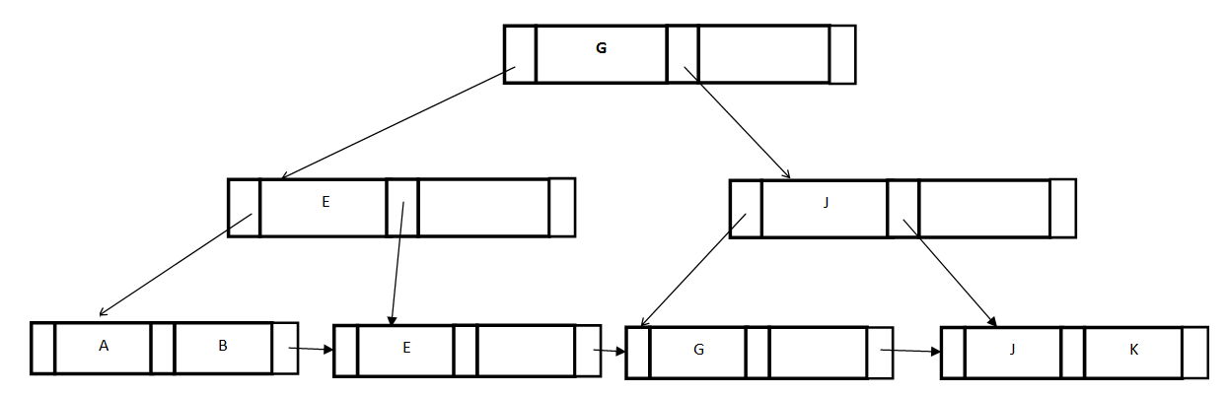
Figure 1

- Write the nodes from querying path between the root and the key value “K”

- Draw B+ Tree after insert key value “H” based on Figure 1 ;

(3) Draw B+ Tree after insert key value “D” based on Figure 1;

Problem 6: (10 points)
Describe explicitly the ACID properties of Transactions.

Problem 7: (10 points)
You can select one of the following questions to answer.
1) Set five transactions, T1, T2, T3, T4, T5 whose timestamps are 1,2,3,4,5 respectively. Fill in the blank of table 1 according to Timestamp-Based Protocols. “abort” is filled when operation is rejected.(Initial R-timestamp and W-timestamp is set to 0)
Table 1

A partial schedule |  |  |  |  | R-timestamp、W-timestamp  Or abort
T1 | T2 | T3 | T4 | T5 | R-timestamp、W-timestamp  Or abort
Read(y) |  |  |  |  | R-timestamp(y)=1
 | Write(y) |  |  |  | W-timestamp(y)=2
 |  | Read(y) |  |  | （ ）
 |  |  | Write(z) |  | W-timestamp(z)=4
Read(x) |  |  |  |  | R-timestamp(x)=1
 |  |  |  | Read(z) | （ ）
 | Write(z) |  |  |  | （ ）
 |  | Read(z) |  |  | （ ）
 |  |  |  | Write(x) | （ ）

2)Please answer the following two questions:
(1)Consider the following query on the relation R (A, B, C, D)
SELECT [ ]
FROM R
GROUP BY A, B
Assume A,B,C,D take integer values

Which can appear in the position marked as [... ] in following
I. MIN(C+D)
II. A,B
III. C,D

a) II only.
b) I and II only.
c) I, II, and III.
d) None.

The answer is ( )

(2)Please describe the main procedure in database system design

