重庆大学 数据库系统 课程试卷
命题人： 罗军 组题人： 罗军 审题人：朱征宇 命题时间：2012-06-06
学院 专业 年级 学号 姓名
封
线
密
2011 ~2012 学年 第二学期
开课学院： 计算机学院 |  |  |  |  |  |  |  | 考试日期： 2012-06-15
 |  |  |  |  |  |  |  | 考试时间： 120 分钟
题 号 | 一 | 二 | 三 | 四 | 五 | 六 | 七 |  | 八 | 九 |  | 总 分
得 分
注：1.大标题用四号宋体、小标题及正文用小四号宋体；2.按A4纸缩小打印
NOTES:The exam is open book and notes. Please write your solutions in the spaces provided on the exam. Make sure your solutions are neat and clearly marked. You may use the blank areas and backs of the exam pages for scratch work. Please do not use any additional scratch paper.
Problem 1: (5 points)
As is well known, A DBMS suppots concurrent access to data. It can be accessed simultaneously by many distinct processes which are called transactions. Please descript the four properties (ACID) of Transaction
略

Problem 2: (5 points)
Initially, user A is the owner of relation R, and no other user holds privileges on R. The following are executed:
by A: GRANT SELECT ON R TO B WITH GRANT OPTION;
by B: GRANT SELECT ON R TO C WITH GRANT OPTION;
by C: GRANT SELECT ON R TO D WITH GRANT OPTION;
by D: GRANT SELECT ON R TO B WITH GRANT OPTION;
by B: REVOKE SELECT ON R FROM C CASCADE;
As a result, which is the exact set of users that have the privilege INSERT ON R:
(a) A only
(b) A and B only
(c) A, B, and D only
(d) A, B, C, and D
answer is ( B )

Problem 3: (5 points).
Consider the table Xbox_Games(name, price) and assume that these values already exist in the database: ('ok_game', 40), ('good_game', 50), ('AWESOME_game', 60). We have the following two transactions:

T1: BEGIN TRANSACTION
S1: UPDATE Xbox_Games SET price=22 WHERE name='ok_game'
S2: INSERT INTO Xbox_Games VALUES ('BAD_Game', 0)
S3: UPDATE Xbox_Games SET price=38 WHERE name='ok_game'
COMMIT;

T2: BEGIN TRANSACTION
S4: SELECT AVG(price) AS average_price FROM Xbox_Games
COMMIT;

Above two transactions are hitting the DBMS roughly at the same time.
Suppose T2 must appear to be executed either completely before or completely after T1 , What are the possible values for average_price?
I. 50
II. 44
III. 37

a) I only.
b) II only.
c) I or II.
d) I or III.

answer is ( D)

Problem 4. (5 points)
Consider the relation schema:
Student(sno,sname,gender, speciality)
with the following integrity constraints for its attributes:
i) sno is the primary key,
ii) sname is not allowed to have a NULL value,
iii) gender must be “F”or “M”,
iv) the first four characters of sno must be ‘2006’.
Write out the declaration of the relation schema(you can use any appropriate types for the attributes of the relation).
Create table Student(
Sno char(8) primary key,
Sname varchar(20) not null,
Gender char(1) check(gender in (‘F’,’M’)),
Check(Sno like ‘2006%’)
);

Problem 5. (5 points)
Consider the following database schema:
S(SNO,SNAME,GENDER)
C(CNO,CNAME)
SC(SNO,CNO,GRADE)
We have the statement:
SELECT SNAME
FROM S,C,SC
WHERE S.SNO=SC.SNO AND
C.CNO=SC.CNO AND
S.GENDER=’MALE’ AND
C.CNAME=’DATABASE’
Please give the process of the query optimization for the statement above
略。SQL→关系代数表达式→语法树→最优语法树→最优关系代数表达式→最优SQL

Problem 6. (5 points)
Suppose we have the following:
CREATE TABLE Beers (
name CHAR(20) PRIMARY KEY,
origin CHAR(120)
);
CREATE TABLE Sells (
bar CHAR(20),
beer CHAR(20),
price REAL,
FOREIGN KEY(beer)
REFERENCES Beers(name)
ON DELETE SET NULL,
ON UPDATE CASCADE
);
Assume the following data already exists in our database:
Beers Table:
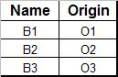
Sells Table:
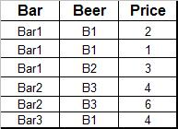
We execute the following two queries:

DELETE FROM Beers where name='B1';
UPDATE Beers set Name='B4' Where Name='B3';

Now, what does the following query return?
SELECT SUM(Price) FROM Sells WHERE Sells.Beer IS NOT NULL;

NULL
NULL
B2
B4
B4
NULL

a) 3
b) 10
c) 13
d) 20
answer is ( C )

Problem 7: (10 points)
A B+ tree structure is shown in Figure 1.
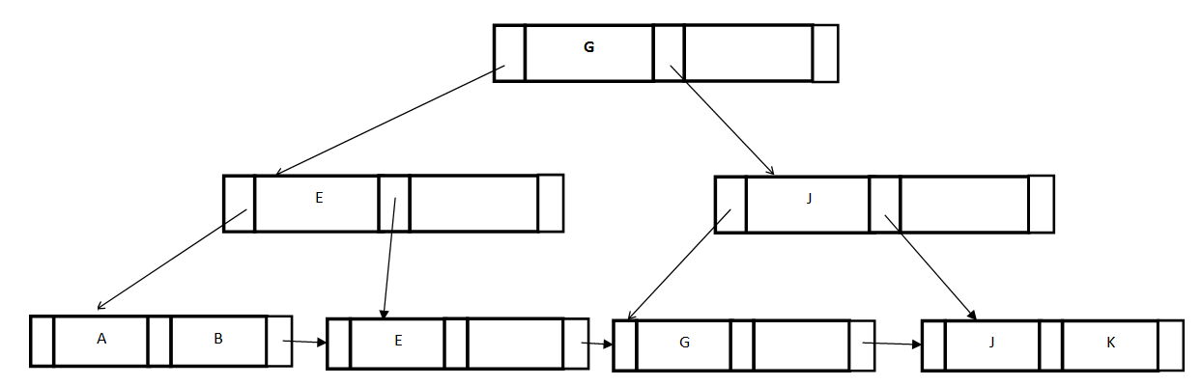
Figure 1.

- Draw B+ Tree after insert key value “I” based on Figure 1 ;

(2) Draw B+ Tree after insert key value “C” based on Figure 1;

