C/C++ COMPUTER STATION LOGIN LAB REPORT

1) Enter your name, student ID, platform (Mac or PC) and date
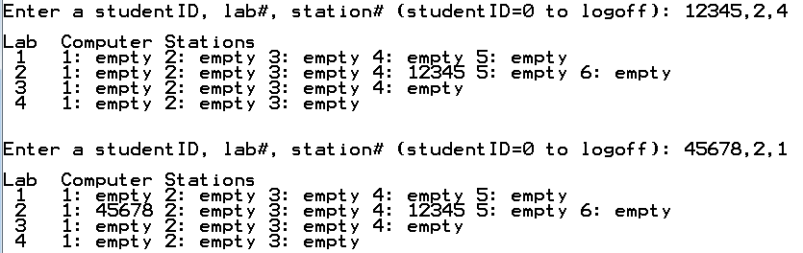
Name: HUY NGUYEN
Class: CIS054 C/C++ ProgrammingC++
Platform (Mac or PC): PC
Date: Nov/17/2019

DESCRIPTION:
This project contains fairly advanced topics using pointers to create an array of dynamic arrays. It uses a multi-dimensional jagged array. It is called jagged because the rows in the array are not necessarily the same size.

Refer to the textbook, end of chapter problems for Chapter 9
- Eight Edition – Chapter 9 problem 5, pages 520-521
- Ninth Edition – Chapter 9 problem 5, pages 535-536

LAB REPORT:
2) Fill in the HIPO chart using English or pseudo-code. Do NOT paste your program or any part of it in the PROCESSING section.
INPUTS | PROCESSING | OUTPUTS
Input choice form option menu  Input Student ID, #lab, # station | -Create and array with colume are 1-4( lab) and slot each lab  -Create an array of pointers which will represent 4 labs.  while loop to let user enter choice mulitple time.  -Give the user the choice to select the slot out of all the slots  -Take the 5-digit ID number from the user  -Log on the user by inserting the ID in the respective lab and slot.  -The user is already logged of if Lab[i][j] cointeins the ID entetered by the user.  -Searches through the arrays for the input user ID and if found outputs the station number | Display menu to let user choose log in log off or exit lab station.  Display table of Lab: Id student on lab column and row station.

DISCUSSION:
3) Complete the DISCUSSION section. It does not need to be long, but it needs to be complete.
3a) What did you do to develop the program? ("Followed the Directions" is not a complete description)
Determine variable student ID, #lab , # station
Create array:
-The first array is the array of labs,
-The second array contains the size (or number of computers)
If user choose 1 for log in .We will put in lab ID student which user select lab and station.
If user choose 2 for log of , asking user student ID for log off. If user enter not correct ID, display message let user know it is invalid ID
Choosing 0 for exit program and 3 for looking up ID student

3b) What problems did you have and how did you overcome the problems?
First of all , I don’t know how to display row with different size . It took me a lot of time to find solution. I had to watch lecture from Professor Dan and youtube . Finally, I understand to set up it by using pointer . First I determine array lab _ slot ={ 5, 6 , 4 , 3 };
And then I use pointer to loop number in to array by int* Lab[4];
An other problem I got to determine condition of student ID. When user enter student id , the lab table not show up ID of student. Reading note and lecture , and testing program I found out I have to use double ‘for’ loop and make conditional for user enter student ID ; for (int i = 0; i < 4; i++) {
cout << i + 1;
//inner loop to iterate through the lab slots
for (int j = 0; j < Lab_slot[i]; j++)
{
if (Lab[i][j] != 0) {
cout << " " << j + 1 << ": " << Lab[i][j];

}
else {
cout << " " << j + 1 << " : empty";
}
}

Testing and running program until I got compute match with my result. I think it is really good assignment and I learned many thing from that.
PROGRAM OUTPUT:
4) Show screen shots for at least TWO sample purchases of the program execution.
Refer to previous lab assignments for instructions on how to capture a screen or portions of a screen for either the PC or a Mac

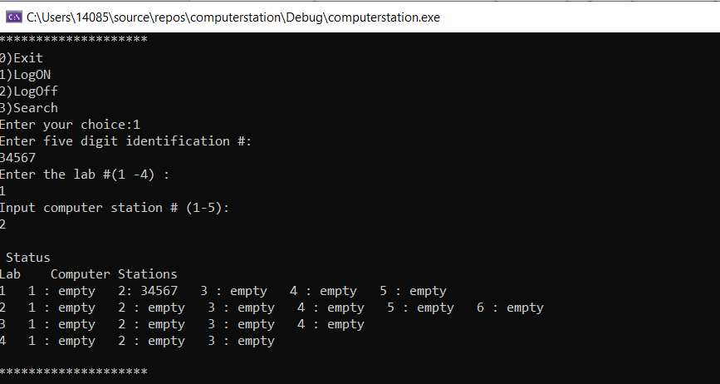
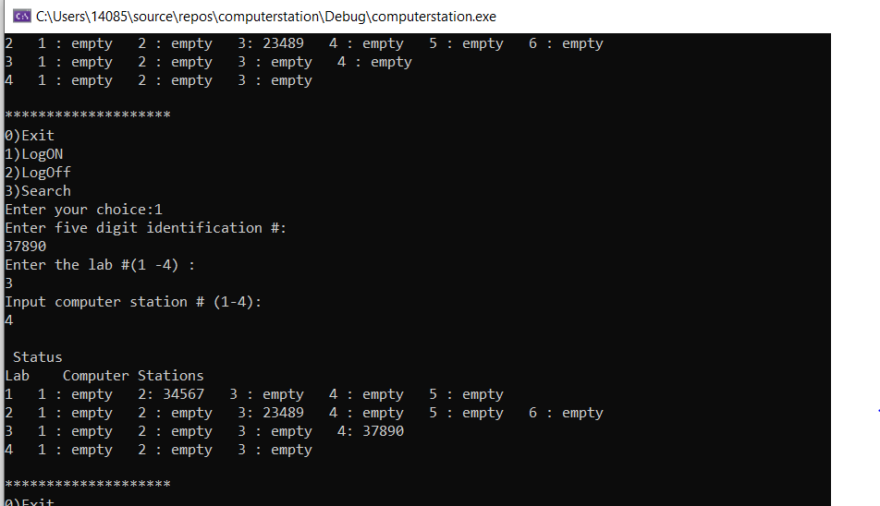

PROGRAM LISTING:
5) Copy and paste the code that YOU typed to make the program work. Your program should include a comment block at the top that shows the name of the program, date, version and your name.

/*
Name: HUY NGUYEN
Class: Cis54
Date: Nov/17/2019

*/
#include <iostream> // used by cin and cout
#include <iomanip> // useb by setios, precision, etc.
#include <cstring> // used for toupper()
//#include <cmath> // math function and constants
#include<cctype>
using namespace std;
void Generate(int* Lab[], int Lab_slot[]);
void Release(int* Lab[]);
void Logon(int* Lab[], int Lab_slot[]);
void Sub_lab(int* Lab[], int Lab_slot[]);
void Logoff(int* Lab[], int Lab_slot[]);
void look(int* Lab[], int Lab_slot[]);
int main(int arg, char* argv[])
{// create and array with colume are 1-4( lab) and slot each lab
int Lab_slot[] = { 5, 6 , 4 , 3 };

// create an array of pointers which will represent 4 labs.
int* Lab[4];
// allocate space to each of the labs using GenerateA().
// It will initialize each lab slot to 0.
Generate(Lab, Lab_slot);
int choice;
// while loop to let user enter choice mulitple time
while (true) {
// let user pick up choice
cout << "********************\n" << "0)Exit\n" << "1)LogON \n" << "2)LogOff\n" << "3)Search\n" << "Enter your choice:";
cin >> choice;
switch (choice)
{case 0: // Exting from program
Release(Lab);
cout << "\n Exting!!";
return 1;
case 1: // log on from user
Logon(Lab, Lab_slot);
cout << endl;
break;
case 2: // log off from user
;
cout << endl;
break;
case 3:
// Searching using student ID with the help look
look(Lab, Lab_slot);
cout << endl;
break;
default:
cout << "\n Enter the correct choice";
break;

}

}
return 1;
}
void Generate(int* Lab[], int Lab_slot[])
{
//out look to interate throught the lab
for (int i = 0; i < 4; i++)
{

Lab[i] = new int[Lab_slot[i]];

for (int j = 0; j < Lab_slot[i]; j++)

Lab[i][j] = 0;
}

}

void Release(int* Lab[]) {
for (int i = 0; i < 4; i++) {
// delete every lab first
delete[] Lab[i];

}
}

void Logon(int* Lab[], int Lab_slot[]) {
// input ID number from use
cout << "Enter five digit identification #: \n";
int idNo;
cin >> idNo;
// Input the lab number (1-4)
cout << "Enter the lab #(1 -4) : \n";
int labNo;
cin >> labNo;

// Get available lab number enter from user by lab slot
int slots = Lab_slot[labNo - 1];

// Give the user the choice to select the slot out of all the slots.
cout << "Input computer station # (1-" << slots << "): \n";
int slot;
cin >> slot;

// clearly, the slot is already occupied if Lab[labNo-1][slot-1] != 0
if (Lab[labNo - 1][slot - 1] != 0) {
cout << "\n This lab slot already occupied!!";
}
else {
//Log on the user by inserting the ID in the respective lab and slot.
Lab[labNo - 1][slot - 1] = idNo;
//Display the status of each lab using sub lab function
Sub_lab(Lab, Lab_slot);
}
}
//Display the status of all labs(show ID who logged into which computer
void Sub_lab(int* Lab[], int Lab_slot[]) {
cout << "\n Status \n";
cout << "Lab Computer Stations\n";
//outer loop to iterate through the labs
for (int i = 0; i < 4; i++) {
cout << i + 1;
//inner loop to iterate through the lab slots
for (int j = 0; j < Lab_slot[i]; j++)
{
if (Lab[i][j] != 0) {
cout << " " << j + 1 << ": " << Lab[i][j];

}
else {
cout << " " << j + 1 << " : empty";
}
}
cout << endl;
}

}

void Logoff(int* Lab[], int Lab_slot[])
{
// Take the 5-digit ID number from the user
cout << "Input the 5 digit #: \n";
int id;
cin >> id;
// outer loop to iterate through the labs
for (int i = 0; i < 4; i++) {
//outer lopp to iterate through the labs slot
for (int j = 0; j < Lab_slot[i]; j++) {
// The user is already logged of if Lab[i][j] cointeins the ID entetered by the user.
if (Lab[i][j] = id) {
// If found , log out the user.
cout << " \n Logging out!!";
// make the lab slot tempty by setting it to 0
Lab[i][j] = 0;
//display the lab status using sub lab()
Sub_lab(Lab, Lab_slot);
return;
}
else {
cout << "\n No such ID found!!";
}
}
}

}

//Searches through the arrays for the input user ID and if found outputs the station number
void look(int* Lab[], int Lab_slot[]) {
// Take the 5-digit ID number from the user.
cout << "Input 5 digit #:\n";
int id;
cin >> id;
//outer loop to iterate through the labs
for (int i = 0; i < 4; i++) {
//inner loop to iterate through the lab slots
for (int j = 0; j < Lab_slot[i]; j++) {
//The user is already looged of if Lab[i][j] contains the ID enetered by user
if (Lab[i][j] == id) {
//If found , display tan appropriate message
cout << "\n ID foud at lab: " << i + 1 << ", Slot: " << j + 1;
return;
}
else {
cout << "\n No such ID found";
}
}
}
}

