C++ DERIVED CLASS LAB REPORT

1) Enter your name, student ID, platform (Mac or PC) and date
Name and Student ID: HUY NGUYEN
Class: CIS054 C/C++ Programming; C++
Platform (Mac or PC): PC
Date: DEC/9/2019

DESCRIPTION:
Using the Derived-Class.cpp file, create an additional derived class (sub class) of type Employee. The Employee class must be derived from the Person class and include the following data items:
int EmpNo; // Employee number
double Hours;
double PayRate;

The print method for Employee needs to compute the pay based on Hours and PayRate and then display the Name, and Pay.

Update the main program to include at least two employees.

LAB REPORT:
2) Determine the Inputs, Processing and Outputs before creating the program
INPUTS | PROCESSING | OUTPUTS
Assign values to objects | Create:  personal class : has name of person  Student class : has name data from personal class and unit from each student  Teacher class: has name data from personal class and number of student in class and classes.  Employ: has name data from personal class, ID number, hours working , pay rate | Display  Student’s Name and Units  Teacher’s Name, numberOfStudents and numberOfClasses  Employee’s Name and PayCheck

3) Fill in the EXPECTED & ACTUAL RESULTS
TEST DATA VALUES  Provide several different examples of menu selections | EXPECTED RESULT  Computed values before the program is run | ACTUAL RESULT  Fill in the output displayed  by the program
Student s3("Tam Nguyen ", 10);  Student s4("Jose Chavez ", 11);  Teacher t1("Dan McElroy ", 28, 3);  Teacher t3("Fred Jones ", 18, 2);  Employ n1(" Cong Pham", 1, 25, 33);  Employ n2(" Hong Vu", 2, 45, 30);  Employ n3(" Linh Vuong", 3, 50, 28); | Student: Jose Chavez Units: 11  Student: Mary Smith Units: 9  Teacher: Fred Jones Stduents: 2 Classes: 18  Employ: ID 1 Name: Cong Pham Pay: $825  Employ: ID 2 Name: Hong Vu Pay: $1425  Employ: ID 3 Name: Linh Vuong Pay: $1540 | Student: Jose Chavez Units: 11  Student: Mary Smith Units: 9  Teacher: Fred Jones Stduents: 2 Classes: 18  Employ: ID 1 Name: Cong Pham Pay: $825  Employ: ID 2 Name: Hong Vu Pay: $1425  Employ: ID 3 Name: Linh Vuong Pay: $1540

DISCUSSION:
4) Complete the DISCUSSION section. It does not need to be long, but it needs to be complete.
4a) What did you do to develop the program? ("Followed the Directions" is not a complete description)
I make diagram and follow it to expand my code.
Main
- Create Student, Teacher, Employee objects using Student’s constructor
- Create array of pointers to objects
- Find out size of the array
- Invoke print method of every object in the array

Person class
- Variables: Name
- Person constructor - assigs passed string to Name
- Print () – print Name

Student class – derived from Person
- Variables: Units
- Student constructor – assigns passed string and integer to Name and Units
- Print () – print Name and Units

Teacher class – derived from Person
- Variables: numberOfStudents, numberOfClasses
- Teacher constructor – assigns passed string, first integer and second integer to Name, numberOfStudents and numberOfClasses
- Print() – print Name, numberOfStudents and numberOfClasses

4b) What problems did you have and how did you overcome the problems?
I have struggle to calculate over time of employ. Firstly, I forget how to calculate over time of employer when they over 40 hours. However, I fix it when I looked back assignment I did before and fix my problem. Finally, I run and test program to make sure my expect result correct with compute result.

PROGRAM OUTPUT:
5) Show a screenshots that has at least two Teachers, two Students and two Employees
Refer to previous lab assignments for instructions on how to capture a screen or portions of a screen for either the PC or a Mac

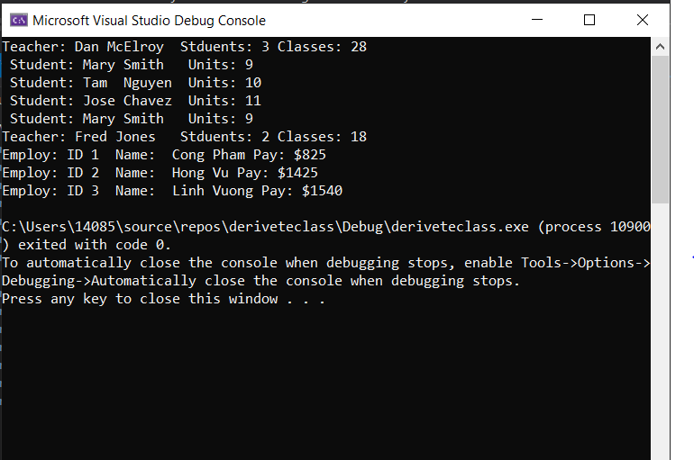

PROGRAM LISTING:
6) Copy and paste the code that YOU typed to make the program work. Your program should include a comment block at the top that shows the name of the program, date, version and your name.
/*
Name: HUY NGUYEN
Class: CIS 54
Date: DEC/9/2019
*/

#include <iostream>
#include<cstring>
using namespace std;

// person class definition
class Person {
protected : // a derived class can access protected data
char Name[20];
public:
Person(const char* n)
{
strcpy_s(Name, n); // for Microsoft

}
virtual void print() const
{
cout << " Person: " << Name << endl;
}
};

// Student class definition
class Student : public Person { //access all data and function from person
private :
int units;
public:
// student constructor gets name from person class
Student(const char* n, int u) : Person(n)
{
units = u;

}
virtual void print()const
{
cout << " Student: " << Name << " Units: " << units << endl;
}
};

// teacher class definition
class Teacher : public Person {
// access all data and function from person
private :
int numberOfStudents;
int numberOfClasses;
public:
// Teacher constructor gets ' name ' from the Person class
Teacher(const char* n, int s, int c) : Person(n)
{
numberOfClasses = s;
numberOfStudents = c;
}
virtual void print()const
{
cout << "Teacher: " << Name << " Stduents: " << numberOfStudents << " Classes: " << numberOfClasses << endl;
}

};
class Employ : public Person {
private:
int EmpNo;
double Hours;
double Payrate;
public:
Employ(const char* n, int employerNumber, double hours, double pay_rate) : Person(n)
{
EmpNo = employerNumber;
Hours = hours;
Payrate = pay_rate;
}
double pay()const
{
double regularHrs, overtime;
if (Hours <= 40) {
regularHrs = Hours;
overtime = 0;
}
else {
regularHrs = 40;
overtime = Hours - 40;
}
double paycheck = regularHrs * Payrate + overtime * Payrate * 1.5;
return paycheck;
}
virtual void print()const {
cout << "Employ: " <<"ID "<<EmpNo<<" Name: " << Name << " Pay: $"<<pay()<<endl;
}
};
int main(int* argc, char*argv[])

{
// create object from several different types of classes
Student s1("Joe Williams", 12);
Student s2("Mary Smith ", 9);
Student s3("Tam Nguyen ", 10);
Student s4("Jose Chavez ", 11);
Teacher t1("Dan McElroy ", 28, 3);
Teacher t3("Fred Jones ", 18, 2);
Employ n1(" Cong Pham", 1, 25, 33);
Employ n2(" Hong Vu", 2, 45, 30);
Employ n3(" Linh Vuong", 3, 50, 28);

// create an array of pointers to different people
Person*List[] = { &t1, &s2, &s3, &s4, &s2, &t3 ,&n1, &n2,&n3};
int SizeOfList = sizeof(List) / sizeof(Person*);
for (int i = 0; i < SizeOfList; i++) {
List[i]->print();
}
return 0;
}

