Final Exam Project
1) Enter your name, student ID, platform and date
Name: HUY NGUYEN
Class: CIS054 C/C++ Programming: CIS 054
Platform (Mac or PC): PC
Date: Dec/15/2019

2) PROJECT DESCRIPTION
Create an application that searches a file of male and female first names. A link to the file is provided on the class webpage. "FirstNames.txt" is a list of the most popular baby names in the United States and was provided by the Social Security Administration.
Each line in the file contains a boy's name and a girl's name. The file is space-delimited, meaning that the space character is used to separate the boy name from the girl name. The file begins with:
C:/Users/14085/Desktop/phony/phony.422
Noah Emma
Liam Olivia
Mason Sophia
Jacob Ava
William Isabella
Ethan Mia
James Abigail
Write a program that asks the user to enter a name. The program then searches the file for the name and displays the position of the name in the file if it matches either a boy name or a girl name. The program also displays a message if the name could not be found. Sample outputs:
Enter a name to search: Daniel
Daniel is ranked 12 for boy names
Daniel was not found for girls

Enter a name to search: Cassandra
Cassandra is ranked 511 for girl names
Cassandra was not found for boys

Enter a name to search: Taylor
Taylor is ranked 76 for girl names
Taylor is ranked 462 for boy names

NOTE: You can use any method you wish to match the name input on the keyboard with the names in the file. You can compare two strings ignoring upper/lower case by using #include<cstring> in C++ or #include<string.h> in C and the following comparison if ( stricmp(string1,string2) == 0)
If your compiler does not have stricmp, you may need to use _stricmp or strcasecmp.
3) DISCUSSION
a) What did you do to develop the program? ("Followed the Directions" is not a complete description

First of all , I need to count rank for boy and girl in note file by set up int rank = 0. After that, I use Boolean to determine name of boy and girl in file. If user enter name is equal name in file, it will display name of user enter and the rank of name. If name not in file, it will display message let user to know name is not in rank or it means in file .
b) What problems did you have and how did you overcome the problems?
I got problem to display message to let user know that name is not found in file. First, I don’t know how to do it but after looking it back binary searching assignment. I found out the way to coding and fix my problem. And then, I run problem make sure compute result match with my expect result.

4) PROGRAM OUTPUT
Submit seven screen shots:
1) search result for your first name
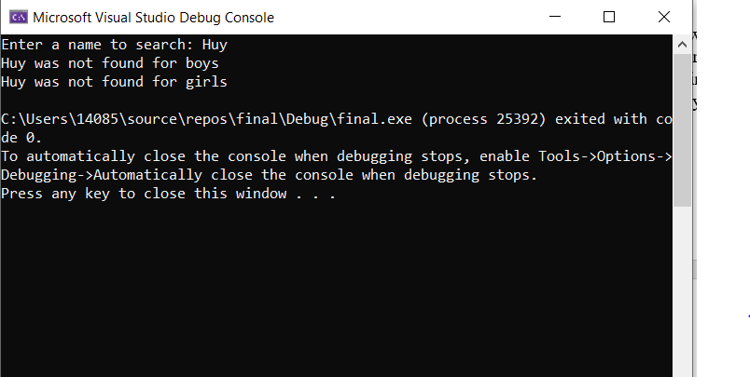
2) search result for a name used for both boys and girls, such as Taylor, Ryan or Dylan
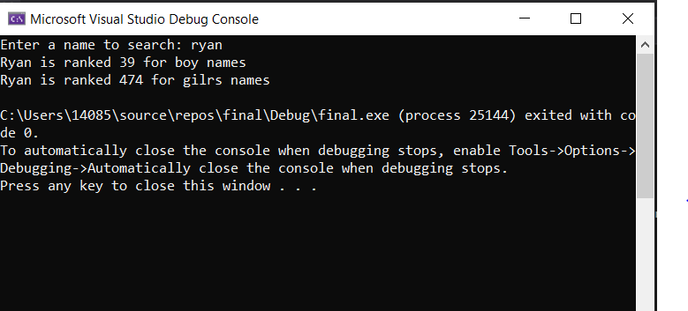
3) search result for a name used only for boys
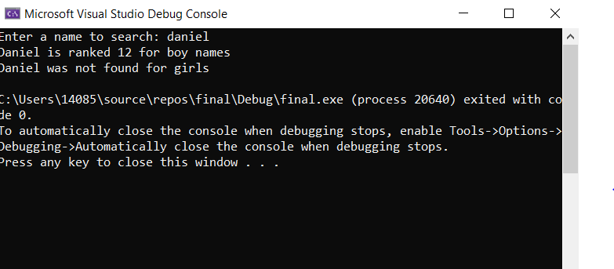
4) search result for a name used only for girls
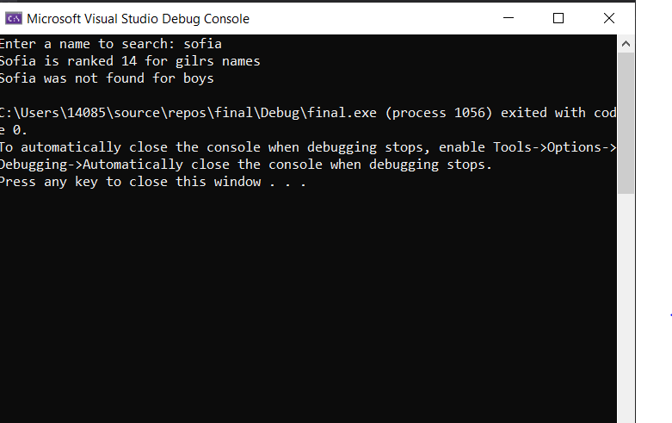
5) search result for a name that at the first record in the file
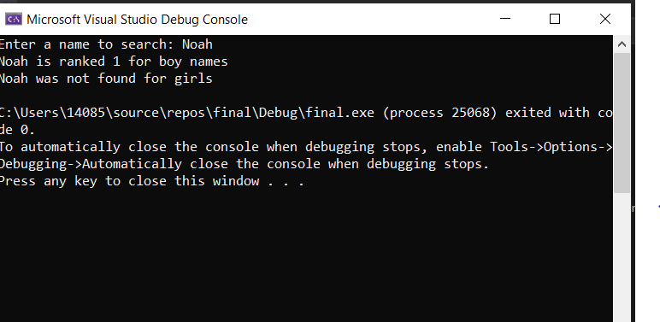
6) search result for a name that is at the last record in the file
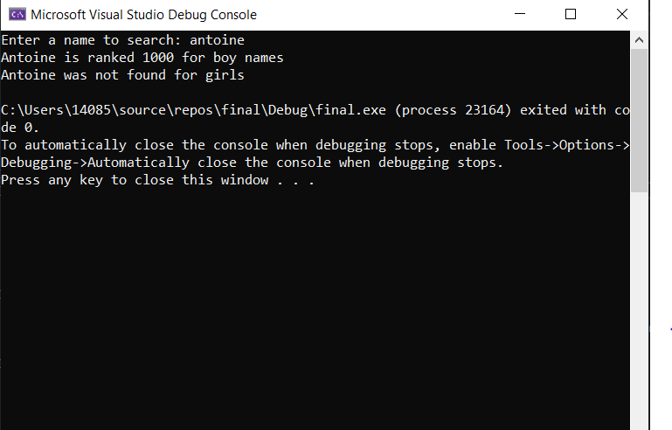
7) search result for a name that is not in the file
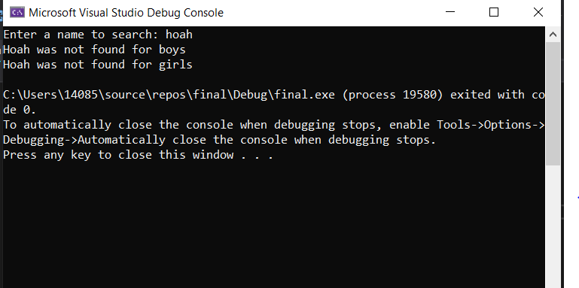
5) PROGRAM LISTING
Copy and paste YOUR code.
/*
Name: HUY NGUYEN
CLass: CIs054
Date : DEC/15/2019
*/
#include<iostream>
#include<string>
#include<fstream>
using namespace std;
int main() {
int rank = 0;
bool BoyDone = false; // if a boy name is encountered or not
bool GirlDone = false; // if a girl name is encountered or not
string Namesearch;
string boyname, girlname;
ifstream ifile;
char filename[] = "C:/Users/14085/Desktop/phony/phony.422";
ifile.open(filename);
cout << "Enter a name to search: ";
cin >> Namesearch;
Namesearch[0] = toupper(Namesearch[0]);
if (ifile.is_open()) {
while (!ifile.eof() && rank<1000) {

rank++;
ifile >> boyname >> girlname;

if (Namesearch == boyname) {
BoyDone = true;
cout << Namesearch << " is ranked " << rank << " for boy names" << endl;
}
if (Namesearch == girlname) {
GirlDone = true;
cout << Namesearch << " is ranked " << rank << " for gilrs names" << endl;
}

}
}
// If boy or girl name is not found
if (!BoyDone) {
cout << Namesearch << " was not found for boys" << endl;
}
if (!GirlDone) {
cout << Namesearch << " was not found for girls" << endl;
}
ifile.close();
return 0;
}

