C++ LENGTH OF LINE PROGRAM LAB REPORT

1) Enter your name, student ID, platform (Mac or PC) and date
Name and Student ID: HUY NGUYEN - 0864168
Class: CIS054 C/C++ Programming: C++
Platform (Mac or PC): PC
Date: Oct/18/2019

DESCRIPTION:
Create a program that uses a function to determine the length of a line by inputting the X,Y coordinates of the line endpoints. Show the result with a precision of four decimal places. The function prototype is to be specified as follows:

double LengthOfLine (double X1, double Y1, double X2, double Y2); // returns length of line

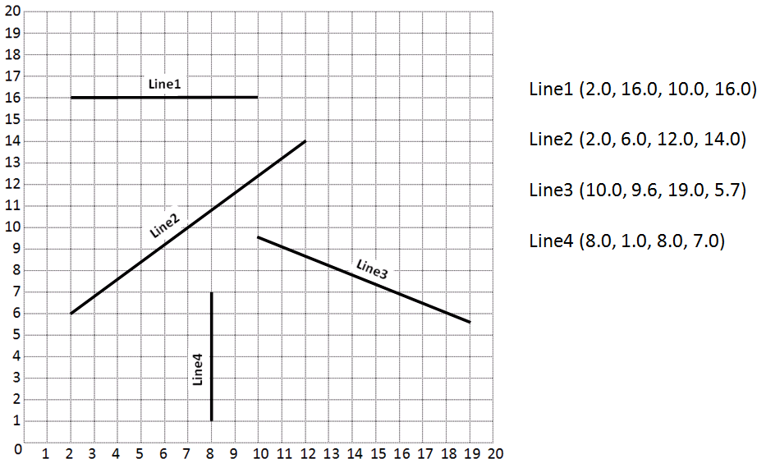

INPUTS | PROCESSING | OUTPUTS
Coordinates of the line: (X1 , X2) , (Y1,Y2) | Set up point of line (x1,x2) and (y1,y2)  Using formula to find length of two line:  x = x2 – x1 , y = y2-y1  Finding hypotenuse by using formula:  H = sqrt ( x² + y²) | Displayed the length of the line.
2) Determine the Inputs, Processing and Outputs before creating the program
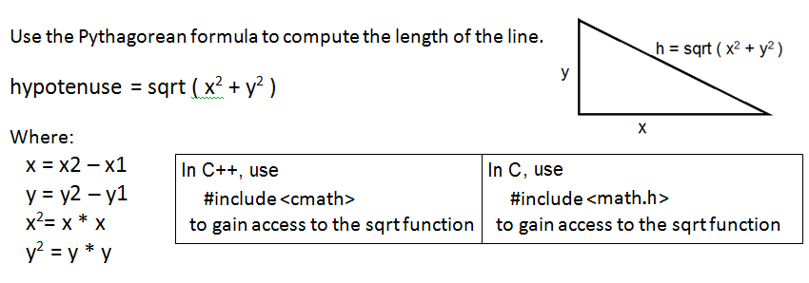

3) Fill in the EXPECTED & ACTUAL RESULTS
TEST DATA VALUES | EXPECTED RESULT  Computed values before the program is run | ACTUAL RESULT  Fill in the output displayed  by the program
2.0 16.0 10.0 16.0 | 8.000 | The length of the line is : 8.0000
2.0 6.0 12.0 14.0 | 12.8062 | The length of the line is : 12.8062
10.0 9.6 19.0 5.7 | 9.8087 | The length of the line is : 9.8087
8.0 1.0 8.0 7.0 | 6.0000 | The length of the line is : 6.0000

DISCUSSION:
4) Complete the DISCUSSION section. It does not need to be long, but it needs to be complete.
4a) What did you do to develop the program? (“Followed the Directions” is not a complete description)

First of all, I need to set up point of two line (x1, x2) and (y1,y2). After that using formula x = x2 – x1 , y = y2-y1 to find length of two line. And then , finding hypotenuse by using Pythagorean formula :
H = sqrt ( x² + y²). Finally , running program and make sure to get compute result correct with expected result.

4b) What problems did you have and how did you overcome the problems?
I got problem to determine wrong point of two lines. Instead using x = x2 – x1 and y = y2 – y1 , I use x = x1 – y1 . Therefore, I did not get correct result after running program on two time of first run test. After looking it back coding, I changed formula and got correct result after running and test program.

PROGRAM OUTPUT:
5) Show four screen shots, one for each of the TEST DATA VALUES in the above table.
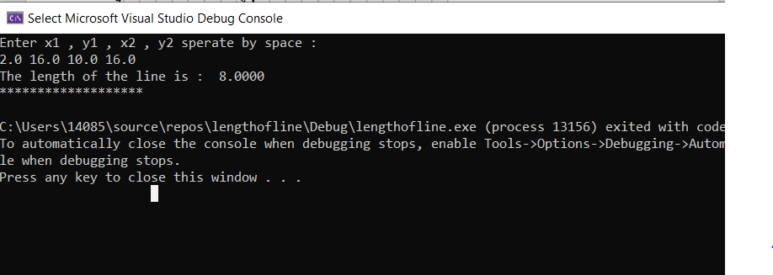

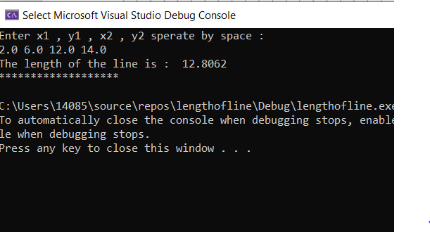

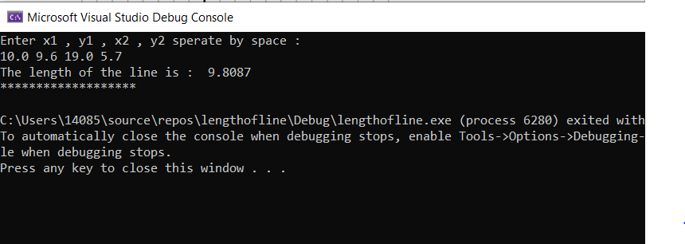

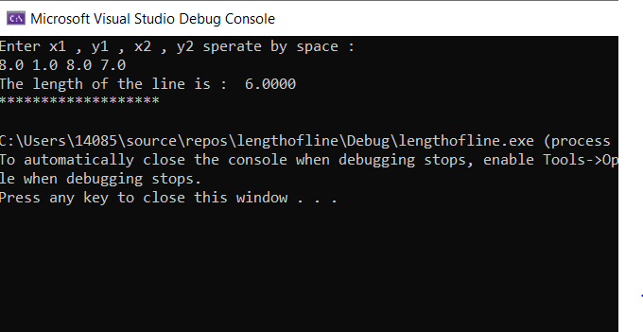
Refer to previous lab assignments for instructions on how to capture a screen or portions of a screen for either the PC or a Mac
PROGRAM LISTING:
6) Copy and paste the code that YOU typed to make the program work. Your program should include a comment block at the top that shows the name of the program, date, version and your name.

// lengthofline.cpp : This file contains the 'main' function. Program execution begins and ends there.
/*The length of a line on a grid can be solved by the Pythagorean Theorem
where the square of the hypotenuse is equal to the sum of the square of the sides.*/
//
/*Name:HUY NGUYEN
Version : C++
Date : Oct / 18 / 2019
program : RollDice
*/
#include <iostream>
#include<cmath>
#include<iomanip>
using namespace std;
double LengthOfLine(double x1, double y1, double x2, double y2);
int main(int argc, char* argv[])
{
cout << setiosflags(ios::fixed | ios::showpoint);
double x1, y1, x2, y2; // Declare the variables
cout << "Enter x1 , y1 , x2 , y2 sperate by space : " << endl;
cin >> x1 >> y1 >> x2 >> y2 ;
double length = LengthOfLine(x1, y1, x2, y2);
cout << "The length of the line is : " <<setprecision(4)<< length << endl;
cout << "*******************" << endl;
return 0;
}

double LengthOfLine(double x1, double y1, double x2, double y2)
{
double a, b, c; // c is the computed length of line
a = x2 - x1;
b = y2 - y1;
c = sqrt(a * a + b * b);
return c;
}

