MEAN AND MEDIAN OF A FILE - LAB REPORT

1) Enter your name, student ID, platform (Mac or PC) and date
Name and Student ID: HUY NGUYEN - 0864168
Class: CIS054 C/C++ Programming
Platform (Mac or PC): PC
Date: NOV/3/2019

DESCRIPTION:
In this lab assignment, you are to read a file with an odd number of records, compute the mean and median of the field that has account balances. Repeat the process with a file that has an even number of records. The two files are provided as part of the lab assignment and are named Balances-1.txt and Balances-2.txt. You need to run the program for each file and compute the median value for each file.

NOTE: The code for processing a disk file is very different between the C and C++ languages. There are separate code examples for C and C++. The code samples show how to read a disk file and skip records until you reach the location of the records that will contain the values to be used when computing the median value. You can verify that you have the correct results by opening the files with a spreadsheet program (Microsoft Excel, Apple Numbers or OpenOffice Calc), select the column with the balances and compute the median value with one of the statistical functions.

Sample code is given at the end of this lab assignment. Insert code in the while loop with code to compute the total of all balances. After the while loop completes, display the total of all balances.

To open a file, you must specify the full pathname and filename. This is called the fully-qualified filename. For example, when in C or C++, to open a file named Balances.txt that is located on the desktop, the fully-qualified filename on my system would be:
/Users/Dan/Desktop/Balances.txt
For this lab, you will need to process the Balances-1.txt and Balances-2.txt.
Run the program twice, once for each file.

The pathname consists of your HOME directory and /Desktop which is a folder on the operating system that refers to the desktop. For example, my HOME directory is located at /Users/Dan
My desktop is located at /Users/Dan/Desktop This is true for either a Mac or PC.

Mac - To display the location of the HOME directory on a Mac running OS/X
1) Go to Launchpad and launch Terminal
2) At the Terminal prompt, type echo $HOME
3) Use this information followed by /Desktop/Balances.txt as the fully-qualified filename. Don’t forget the / at the beginning of the path and filename.

Windows - To display the location of the HOME directory on a PC running Windows
1) Click the START button on Windows located at the lower-left side of the screen
2) When the box pops up at the bottom that says, "Search programs and files", type cmd and press [Enter]
3) At the command prompt, type: echo %UserProfile%
4) Use this information followed by /Desktop/Balances.txt as the fully-qualified filename. Don’t forget the / at the beginning of the path and filename.

SPECIAL NOTE FOR PROGRAMMERS ON WINDOWS SYSTEMS
Windows uses the backslash character \ to separate parts of the pathname and filename. The C programming language was created to create the Unix operating system which uses the forward slash character / to separate the parts of the pathname and filename.

C and C++ use the backslash \ in character strings as an escape to give a new meaning to the next character. For example, \n is new line, \b is backspace, \t is tab, etc. It is necessary to type two backslashes \\ inside of a quoted string to get one backslash \ in memory. For example to get this:
\Users\Dan\Desktop
The quoted string in a C or C++ program must be written as:
"\\Users\\Dan\\Desktop"

Since web servers were originally developed on Unix systems, the forward slash / is used in web addresses. To make Windows compatible with the rest of the world, Windows now accepts forward slashes / as well as backslashes \ as part of a filename and they can be used interchangeable. In C or C++ you can now use
"/Users/Dan/Desktop"
as well as
"\\Users\\Dan\\Desktop"
to get the same result when referring to a file.

LAB REPORT:
2) Determine the Inputs, Processing and Outputs before creating the program.
INPUTS | PROCESSING | OUTPUTS
Input file name test:  Balances-1.txt  Balances-2.txt | Open file name and see how many variables need to determine. In file, they will have AccName for name of item, AccNo, Accbal.  Determine total, mean, median  Using formula to calculate  Open file name and reject if file name is incorrect or don’t have file name | Numeric record; Record skip; mean; median.

3) Fill in the EXPECTED & ACTUAL RESULTS.
TEST DATA VALUES | EXPECTED RESULT  Use a spreadsheet program to determine the expected median values | ACTUAL RESULT  Fill in the output displayed  by the program
Balances-1.txt  Mean  Median  Balances-2.txt  Mean  Median | 1)Total : 117  Mean :1136.13  Median: 1151.03  2) Total :118  Mean: 1132.46  Median 1150.22 | 1)There are 117records  The mean value of the balances is : 1136.13  Records skip =58  The median : 1151.03  2) There are 118records  The mean value of the balances is : 1132.46  Records skip =58  The median : 1150.22

DISCUSSION:
4) Complete the DISCUSSION section. It does not need to be long, but it needs to be complete.
4a) What did you do to develop the program? ("Followed the Directions" is not a complete description)

Fist of all , I open file and determine how many variable I have to count. There are total , mean, median for out put. They also have recordscout, recourdskip. In file, they have Accname, Accnumber, AccBal. Using formula to calculate mean= total / recordscout, medan = accBal if recordcout % 2 ==1 or else if median = (median + acctbal)/2. Calculate recordskip =recordcout /2 if record cout is odd and record skip = ( record count/2) -1 if record count is even. Using if (infile.fail()) if file opens incorrect. Running and testing program make sure expected result match with actual result.

4b) What problems did you have and how did you overcome the problems?

I got problems to calculate median. First , I got 1149 for median from balances-1.txt. However, the execution of program is 1151 . Therefore, I got mistake coding some where in my programs. Even thought I tried anyway I still did not find my mistake. Finally , I watched video lecture of professor Dan and I found out I missed on code infile >> acctNo >> acctName >> acctBal; between while and if loop in part 3. After fixing my program, I got compute result match with expected result.
PROGRAM OUTPUT:
5) Display a total of four screenshots. Show two screen shots for each data file. Show a screenshot displaying
5a) result of using a spreadsheet program to calculate the median and mean, and
5b) screenshots showing the execution of the program for the two data files.
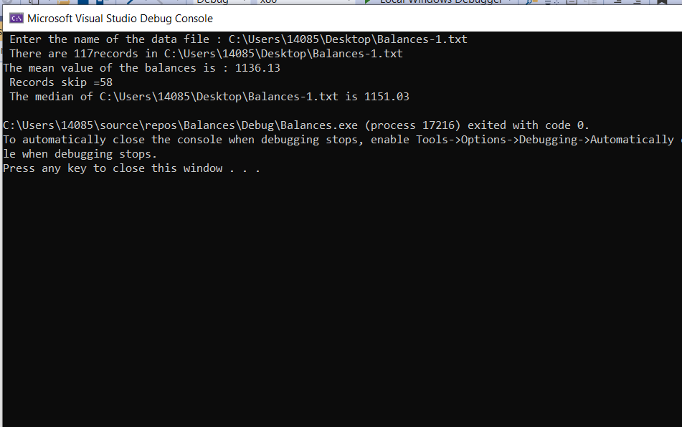

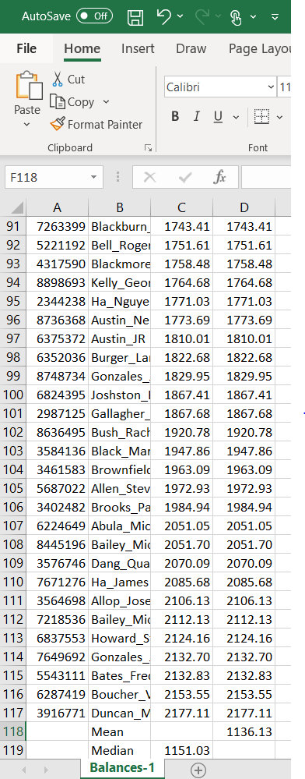
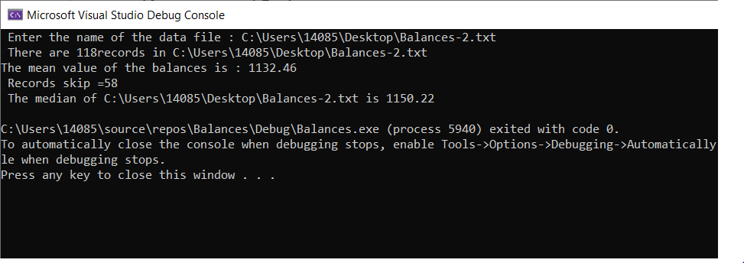
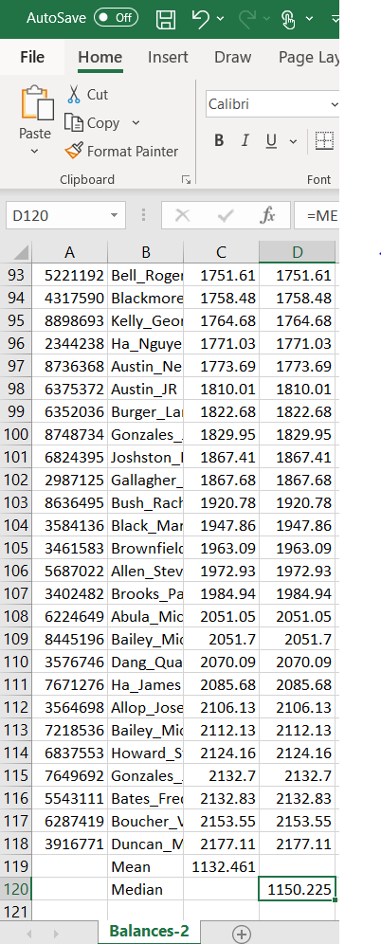
Refer to previous lab assignments for instructions on how to capture a screen or portions of a screen for either the PC or a Mac

PROGRAM LISTING:
6) Copy and paste the code that YOU typed to make the program work. Your program should include a comment block at the top that shows the name of the program, date, version and your name.
// Balances.cpp : This file contains the 'main' function. Program execution begins and ends there.
//
/*
Name : HUY NGUYEN
Class CIS 54
Date : Nov/3/2019
*/

#include <iostream>
#include<fstream>
#include <cstdlib> // using by exit funciton
using namespace std;

int main(int argc , char* argv[])
{
// variable control to disk file
ifstream infile;
char filename[200];
int recordCount = 0;
int recordSkip = 0;

// variables for fields of each record in the file
int acctNo = 0;
char acctName[100] = " ";
double acctBal = 0.0;
// variable used to determine the median
double total = 0.0;
double mean = 0.0;
double median = 0.0;
cout << " Enter the name of the data file : ";
cin >> filename;

// Part 1 , Cout the number of records in the file
// Determine the mean when you know the reocrd count and the total of all balances;
infile.open(filename);
if (infile.fail())
{
cerr << "Unable to open file " << filename << " , first pass" << endl;
exit(1);

}
infile >> acctNo >> acctName >> acctBal;
while (!infile.eof()) //while loop not end of ile
{

if (acctName[0] != 0) // ignore empty records
{
total += acctBal;
recordCount++;
}
acctName[0] = 0; // initialize to 0 to test for empty records
infile >> acctNo >> acctName >> acctBal;

}

infile.close();
cout << " There are " << recordCount << "records in " << filename << endl;
mean = total / recordCount;
cout << "The mean value of the balances is : " << mean << endl;
// Part 2 , Determine the number of records to skip

if (recordCount % 2 == 1)
{
recordSkip = recordCount / 2; // Odd number of record
cout << " Records skip =" << recordSkip << endl;
}
else
{
recordSkip = recordCount /2 - 1; // Even number of records

cout << " Records skip =" << recordSkip << endl;
}

// Part 3 , open the file skip leading records , determine the median
infile.open(filename);
if (infile.fail()) {
cerr << " Unable to open" << filename;
exit(1);
}
while (recordSkip != 0) {
infile >> acctNo >> acctName >> acctBal;
recordSkip--; // count down to zero
}
infile >> acctNo >> acctName >> acctBal;
if (recordCount % 2 == 1) {
median = acctBal;
}
else {
median = acctBal;
infile >> acctNo >> acctName >> acctBal;
median = (median + acctBal) / 2;
}
infile.close();

// Display the results
cout << " The median of " << filename << " is " << median << endl;
return 0;

}

