C/C++ "Random Sentences" Lab Report

1) Enter your name, your student ID and date
Name:HUY NGUYEN
Student ID: 0864168
Date: NOV/11/2019

PROJECT DESCRIPTION:
Write an application that uses random-number generation to create sentences. Use only five arrays of strings called article, noun, verb and preposition. All words in each array should use only lower-case letters. The length of each array should not be the same, and should be determined by the program when the program runs. Create a sentence by selecting a word at random from each array in the following order: article, adjective, noun, verb, preposition, article, adjective and noun. As each word is randomly picked, concatenate it to the previous words in the sentence. It is the program that needs to capitalize the first word and end each sentence with a period. The application must generate and display 20 sentences each time the program is run.
The article* array should contain at least the words "the", "a", "one", "some" and "any".
The adjective array could contain words like "brave", "orange", "fast", "slow", “smart”, etc.
The noun array could contain words like "boy", "girl", "dog", "town", "car", “truck”, “cat”, “bird”, “house”, etc.
The verb array could contain words like "drove", "jumped", "ran", "walked", "skipped", etc.
The preposition array should contain at least "to", "from", "over", "under" and "on".
*NOTE: Articles the, a and an are only used with singular nouns. Do not worry about selecting either 'a' or 'an' based on whether the next word starts with a vowel. The words some and any are actually classified as 'determiners' in the English language and can be used with plural nouns.
You can change or add additional nouns, adjectives, verbs and prepositions to the arrays. Make sure that your random picker looks at the array size for each type of part of speech.
Examples:
The brave dog skipped to a fast town.
The orange car jumped over a slow dog.
A fast girl walked to a brave girl.
LAB REPORT:
2) Fill in the INPUT/PROCESSING/OUTPUT table (HIPO chart). Use either English or pseudo-code in the PROCESSING column. Do not paste code from your Visual Basic program.
INPUT | PROCESSING | OUTPUT
Randoom 5 sentence | Make a group constant char noun , adjective, verb, article..  Use coding rand to make random word on list of constant.  Add each word in sentence and running. | Display 5 sentences

DISCUSSION:
3) Complete the DISCUSSION section in English. It does not need to be long, but it needs to be complete.
3a) What did you do to develop the program?
First of all , I need determine a sentence need noun , verb , adjective, article. Hence I make a list of group and organize word to become a sentence, Random words in a sentence using rand . For example :
Adjective1 = ADJECTIVE[rand() % adjective];
Running and testing program to make sure each of word will be correct in place of sentence.

3b) What problems did you have and how did you overcome the problems?
I got problem how to add word to become a sentence. First test , I run it just one word for 5 sentences. After checking coding , I found out I did not type + to add sentences for example :Verb= VERB[rand() % verb];
sentence = Verb;
sentence += " ";
, so the result only got one word. Correct coding will be : sentence += Verb. And then . testing couple times I got result match with expect result.

PROGRAM OUTPUT:
4) Show two screenshots showing correct operation of the program. Refer to previous lab assignments to review how to save a screen shot to the lab report.
Sample program output #1

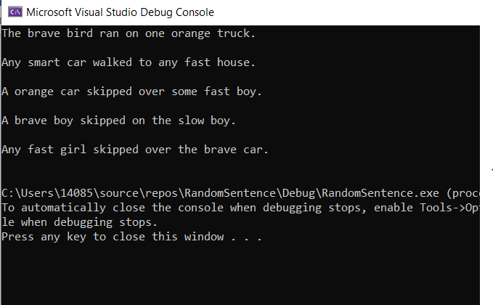
Sample program output #2
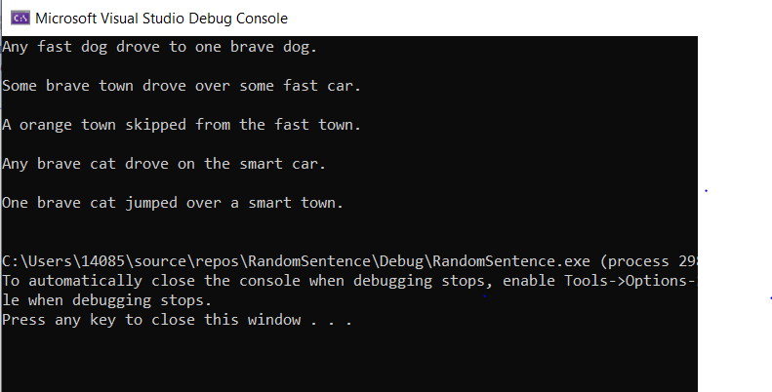

PROGRAM LISTING:
5) Copy and paste the code for the entire program.
// RandomSentence.cpp : This file contains the 'main' function. Program execution begins and ends there.
//
/*
Name: HUY NGUYEN
Date : Nov /8 /2019
Class: CIS 54
*/

#include <iostream>
#include<cctype> // need for upperletter
#include<string>
#include<cstdlib> // need for random number generation
#include<ctime> // need to seed the random generator
const char* NOUN[] = { "boy", "girl", "dog", "town", "car", "truck", "cat", "bird", "house" };
const char* ARTICLE[] = { "the", "a", "one", "some" , "any"};
const char* ADJECTIVE[] = { "brave", "orange", "fast", "slow", "smart" };
const char* VERB[] = { "drove", "jumped", "ran", "walked", "skipped" };
const char* PERPOSITION[] = { "to", "from", "over", "under", "on" };
int nouncount = sizeof(NOUN) / sizeof(char*);
int article = sizeof(ARTICLE) / sizeof(char*);
int adjective = sizeof(ADJECTIVE) / sizeof(char*);
int verb = sizeof(VERB) / sizeof(char*);
int perposition = sizeof(PERPOSITION) / sizeof(char*);

using namespace std;
int main(int argc, char*argv[])

{
// declacre the variable
string sentence; //string++ object
string Article1, Article2, Adjective1, Adjective2, Noun1,Noun2, Verb , Perposition;
int selection;

srand((unsigned int)time(0)); // seed the random number generator

for (int i = 0; i < 5; i++) // create and display 5 sentence
{

//put in a sentence

Article1 = ARTICLE[rand() % article]; // Random the first word with array
Article1[0] = toupper(Article1[0]); // capital first letter of sentence
sentence = Article1; // add word in sentence
// use += to add a space after each word
sentence += " "; // add space between two word
Adjective1 = ADJECTIVE[rand() % adjective];
sentence += Adjective1;
sentence += " ";
Noun1 = NOUN[rand() % nouncount];
sentence += Noun1;
sentence += " ";
Verb= VERB[rand() % verb];
sentence += Verb;
sentence += " ";
Perposition = PERPOSITION[rand() % perposition];
sentence += Perposition;
sentence += " ";
Article2 = ARTICLE[rand() % article];
sentence += Article2;
sentence += " ";
Adjective2 = ADJECTIVE[rand() % adjective];
sentence += Adjective2;
sentence += " ";
Noun2= NOUN[rand() % nouncount];
sentence += Noun2;
sentence += ".";
cout << sentence << endl<<endl;

}
return 0;
}

