C++ RATIONAL NUMBERS LAB REPORT

1) Enter your name, student ID, platform (Mac or PC) and date
Name and Student ID: HUY NGUYEN-0864168
Class: CIS054 C/C++ Programming: C++
Platform (Mac or PC): PC
Date: DEC/3/2019

DESCRIPTION:
1) Make sure that you can get the Sample Code that is provided on Canvas to work. It shows how to implement the + and += operators for the Rational class.
2) Create the code to implement and test the – –= * *= / /= and == operators.
3) The == operator should return a bool that is true if the numerators and denominators are the same for both objects. Otherwise return false. Use an if statement to test the result.

LAB REPORT:
2) Fill in the EXPECTED & ACTUAL RESULTS
TEST DATA VALUES  Provide examples showing implementation of the – –= * *= / /= and == operators | EXPECTED RESULT  Computed values before the program is run. Addition and subtraction are provided. You need to compute the others. | ACTUAL RESULT  Fill in the output displayed  by the program after the function is executed.
Addition  n1 = n2 + n3;  // show n1, n2, n3, before, after | n1 n2 n3  BEFORE 0/1 3/4 2/3  AFTER 17/12 3/4 2/3 | n1 n2 n3  before: 0/1 3/4 2/3  Addition: 17/12 3/4 2/3
Addition Assignment  n1 = n2 += n3;  // show n1, n2, n3, before, after | n1 n2 n3  BEFORE 0/1 3/4 2/3  AFTER 17/12 17/12 2/3 | n1 n2 n3  before: 0/1 3/4 2/3  Add Assignment:17/12 17/12 2/3
Subtraction  n1 = n2 – n3;  // show n1, n2, n3, before, after | n1 n2 n3  BEFORE 0/1 3/4 2/3  AFTER 1/12 3/4 2/3 | n1 n2 n3  before: 0/1 3/4 2/3  Subtract: 1/12 3/4 2/3
Subtraction Assignment  n1 = n2 –= n3;  // show n1, n2, n3, before, after | n1 n2 n3  BEFORE 0/1 3/4 2/3  AFTER 1/12 1/12 2/3 | n1 n2 n3  before: 0/1 3/4 2/3  Sub Assignment:1/12 1/12 2/3
Multiplication  n1 = n2 * n3;  // show n1, n2, n3, before, after | n1 n2 n3  BEFORE 0/1 3/4 2/3  AFTER 1/2 3/4 2/3 | n1 n2 n3  before: 0/1 3/4 2/3  Multiply : 1/2 3/4 2/3
Multiplication Assignment  n1 = n2 *= n3;  // show n1, n2, n3, before, after | n1 n2 n3  BEFORE 0/1 3/4 2/3  AFTER 1/2 1/2 2/3 | n1 n2 n3  before: 0/1 3/4 2/3  Mul Assignment:1/2 1/2 2/3
Division  n1 = n2 / n3;  // show n1, n2, n3, before, after | n1 n2 n3  BEFORE 0/1 3/4 2/3  AFTER 9/8 3/4 2/3 | n1 n2 n3  before: 0/1 3/4 2/3  Devide: 9/8 3/4 2/3
Division Assignment  n1 = n2 /= n3;  // show n1, n2, n3, before, after | n1 n2 n3  BEFORE 0/1 3/4 2/3  AFTER 9/8 9/8 2/3 | n1 n2 n3  before: 0/1 3/4 2/3  Devi Assignment:9/8 9/8 2/3
Comparison when NOT equal  if (n2 == n3)  // display "n2 equals n3"  else  // display "n2 not equal n3" | n1 n2 n3  BEFORE 0/1 3/4 2/3  RETURNS FALSE | before: 0/1 3/4 2/3  Return value =: False  n2 not Equal n3
Comparison when equal  if (n2 == n3)  // display "n2 equals n3"  else  // display "n2 not equal n3" | n1 n2 n3  BEFORE 0/1 3/4 3/4  RETURNS TRUE | Return value =True  N2 equal n3

DISCUSSION:
3) Complete the DISCUSSION section. It does not need to be long, but it needs to be complete.
3a) What did you do to develop the program? (“Followed the Directions” is not a complete description)
I have set up a program in Visual Studio that will use operation between fractions. I have written a basic code example that does all the resources that I need to follow.
This program will allow basic operations between fractions, for example, addition, subtraction, multiplication, division and other basic functions that can be performed in fractions. To achieve a seamless integration of the struct fraction into the C++ type system its operations need to be overloaded and required to provide such implementation.
My task is to implement code that:
- Create a fraction // (implemented)
- Implement rational::reduce, which will be used to reduce fractions.
- Implement the Add two fractions //(implemented)
- Implement support for division operations for the new fraction type
- Implement Multiply fractions
- Implement Subtract fraction
3b) What problems did you have and how did you overcome the problems?
I had struggle to determine comparison between n2 and n3. First , my result always return true and n2 equal n3 even though n2 = 3/4 and n3 = 4/5 . When I look back and check my code I saw even thought numerator and denominator of n2 and n3 are different but when they divide my result is 0 . I think because I set it up int for both numerator and denominator. Therefore, I fix my coding by comparison numerator and denominator after GCD of n2 and n3 to get Boolean result. After that, I run program and test to make sure my compute match with my expected result.

PROGRAM OUTPUT:
4) Show one or more screen shots showing implementation of – –= * *= / /= and ==
Refer to previous lab assignments for instructions on how to capture a screen or portions of a screen for either the PC or a Mac
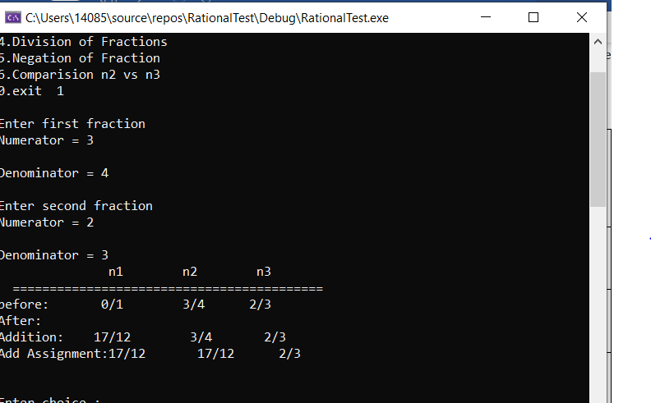
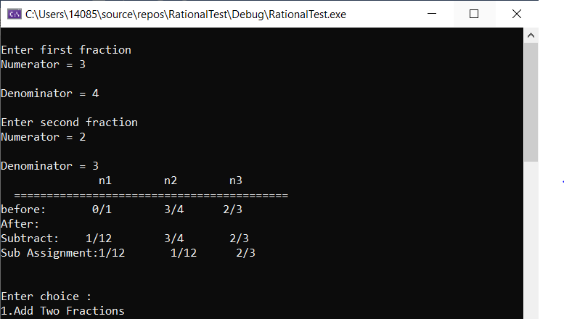
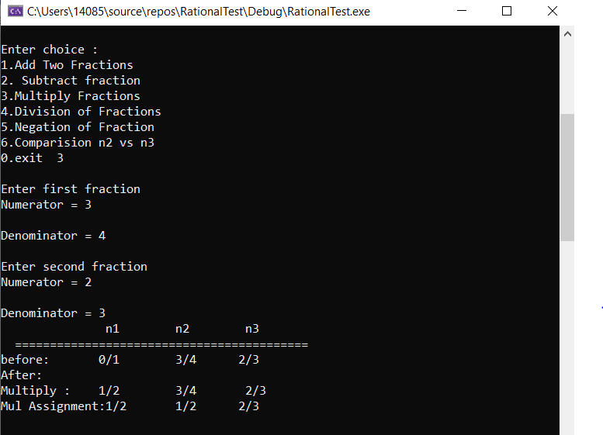
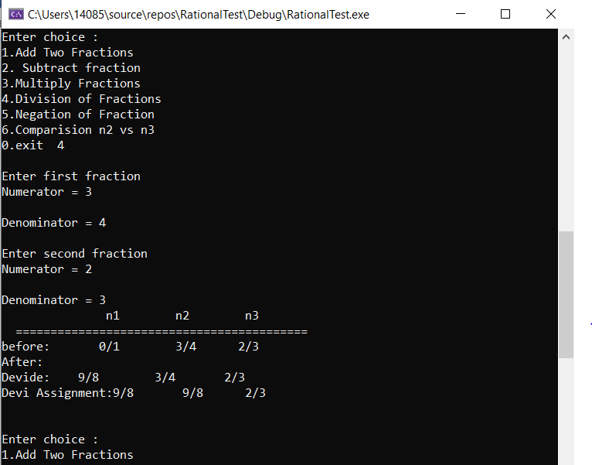

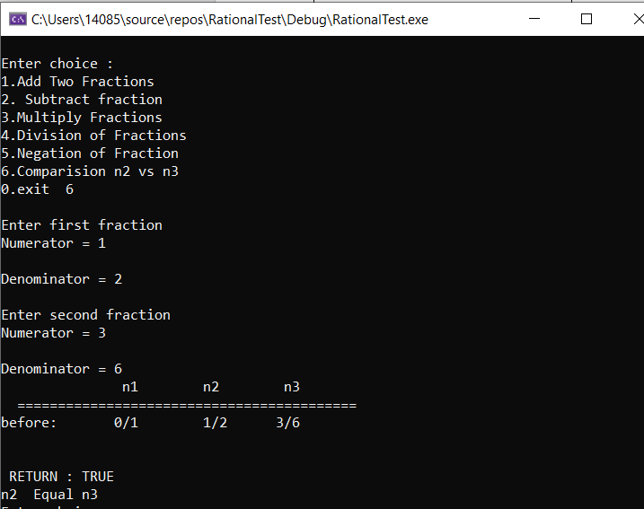
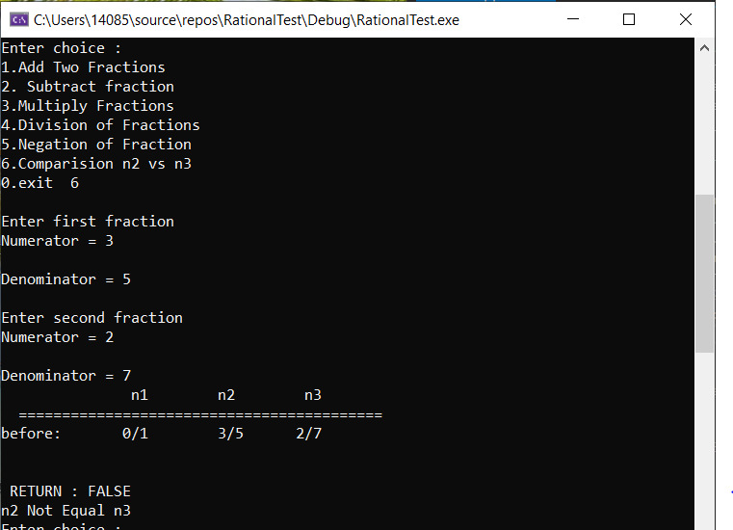
PROGRAM LISTING:
5) Copy and paste the code that YOU typed to make the program work. Your program should include a comment block at the top that shows the name of the program, date, version and your name.
/// the function and method definitions (in a source file = rationals.cpp)

/*
Name: HUY NGUYEN
Class: CIS 054
Date: Dec/3/2019
*/

#include <iostream>
#include "Rational.h"
using namespace std;

Fraction newFraction() {

Fraction f;

f.numerator_ = 0;

f.denominator_ = 1;

return f;

}

Fraction newFraction(int num, int den) {

Fraction f;

f.numerator_ = num;

f.denominator_ = den;

return f;

}

//Examples input and output

//Input -> (1\2)+(1/2)

//Output -> (4/4)

void addToFraction(Fraction& f1, const Fraction& f2) {

int denominador = f1.denominator_ * f2.denominator_;

Fraction tmp_lhs = newFraction(f1.numerator_ * f2.denominator_, denominador);

Fraction tmp_rhs = newFraction(f2.numerator_ * f1.denominator_, denominador);

f1.numerator_ = tmp_lhs.numerator_ + tmp_rhs.numerator_;

f1.denominator_ = denominador;

}

//Examples input and output

//Input -> (1\2)+2

//Output -> (5/2)

///Implement the negation operator for fractions.
///input : 4/3
/// output -4/3
///input : 5/4
///output :-5/4
void negationFraction(Fraction& f) {
f.numerator_ = -(f.numerator_);
}
///Implement the negation operator for fractions. by OVERLOADING - (minus) operator
void operator-(Fraction& f) {
f.numerator_ = -(f.numerator_);
}

///In multiply of two fractions, simply multiply the two numerators && multiply the two denominators
///input : (4/3) * (5/2)
///output:(20/6)
void multiplyFraction(Fraction& f1, const Fraction& f2) {
f1.numerator_ = f1.numerator_ * f2.numerator_;
f1.denominator_ = f1.denominator_ * f2.denominator_;
}

///In division of two fractions, the first fraction must
/// be multiplied by the reciprocal of the second fraction.
void divideFraction(Fraction& f1, const Fraction& f2) {
f1.numerator_ = f1.numerator_ * f2.denominator_;
f1.denominator_ = f1.denominator_ * f2.numerator_;
}
///input = (2/3)-(1/2)
///output =1/6
void substractFraction(Fraction& f1, const Fraction& f2) {
int denominador = f1.denominator_ * f2.denominator_;

Fraction tmp_lhs = newFraction(f1.numerator_ * f2.denominator_, denominador);

Fraction tmp_rhs = newFraction(f2.numerator_ * f1.denominator_, denominador);

f1.numerator_ = tmp_lhs.numerator_ - tmp_rhs.numerator_;

f1.denominator_ = denominador;
}
///function to find GCD common divisor
int GCD(int num1, int num2)
{
if (num1 == 0)
return num2;
return GCD(num2 % num1, num1);
}

///input : 20/5 GCD(20,5)=5 output=4/1
///input : 22/5 GCD (22, 5) =

void printFraction(Fraction& f) {
///If both numerator and denominator of fraction
/// is divisible by their greatest common divisor then fraction can be reduce
///hence we divide numerator and denominator by gcd
int gcd = GCD(f.numerator_, f.denominator_);
f.numerator_ = f.numerator_ / gcd;
f.denominator_ = f.denominator_ / gcd;
cout << f.numerator_ << '/' << f.denominator_ ;
}
void comparision(Fraction& f1, Fraction& f2)
{
int gcd1 = GCD(f1.numerator_, f1.denominator_);
f1.numerator_ = f1.numerator_ / gcd1;
f1.denominator_ = f1.denominator_ / gcd1;
int gcd2 = GCD(f2.numerator_, f2.denominator_);
f2.numerator_ = f2.numerator_ / gcd2;
f2.denominator_ = f2.denominator_ / gcd2;
cout << "\n RETURN : " << ((f1.numerator_ == f2.numerator_) && (f1.denominator_ == f2.denominator_) ? "TRUE" : "FALSE");
cout << endl;
if ((f1.numerator_== f2.numerator_)&&(f1.denominator_== f2.denominator_))
{
cout << "n2 Equal n3";
}
else
cout << "n2 Not Equal n3";
}

// Rational.h
struct Fraction {
int numerator_;
int denominator_;
};

Fraction newFraction();
Fraction newFraction(int num, int den);
void addToFraction(Fraction& f1, const Fraction& f2);
void printFraction(Fraction& f);
void negationFraction(Fraction& f);///f=-f
void operator-(Fraction& f); /// f1=-f1
void multiplyFraction(Fraction& f1, const Fraction& f2); /// f1=f1*f2
void divideFraction(Fraction& f1, const Fraction& f2); /// f1=f1/f2
void substractFraction(Fraction& f1, const Fraction& f2); ///f1=f1-f2
void comparision(Fraction& f1, Fraction& f2);

//Rational test, Main class

#include <iostream>
#include<iomanip>
#include "Rational.h"
using namespace std;
using namespace std;

int main() {
/*
//Creating fraction a and b

Fraction a = newFraction(3,2);

Fraction b = newFraction(4,2);

//Adding fraction to number

int num=15;
addToFraction(a, num);
cin.get();
*/

int choice = 0;
do {

cout << "\nEnter choice :";
cout << "\n1.Add Two Fractions\n2. Subtract fraction";
cout << "\n3.Multiply Fractions\n4.Division of Fractions\n5.Negation of Fraction\n6.Comparision n2 vs n3";
cout << "\n0.exit \t";
cin >> choice;

switch (choice) {

case 1:
{
int num1, den1;
cout << "\nEnter first fraction";
cout << "\nNumerator = ";
cin >> num1;
cout << "\nDenominator = ";
cin >> den1;
Fraction f1 = newFraction(num1, den1);
int num2, den2;
cout << "\nEnter second fraction";
cout << "\nNumerator = ";
cin >> num2;
cout << "\nDenominator = ";
cin >> den2;
Fraction f2 = newFraction(num2, den2);

addToFraction(f1, f2);
cout << left << setw(15)<<""<<left << setw(10)<< "n1" << left << setw(10)<<"n2" << left << setw(10)<<"n3" << left << setw(10)<<"\n ==========================================\n";

cout << "before: 0/1" << left << setw(8) <<""<<num1 <<"/"<< left << setw(7)<<den1 <<num2<<"/"<<den2 <<endl ;
cout << "After:";
cout<<" \nAddition: " ;
printFraction(f1);
cout<< left << setw(8) << "" << num1 << "/" << left << setw(8) << den1 << num2 << "/" << den2 ;
cout << "\nAdd Assignment:";
printFraction(f1);
cout << "" << left << setw(7)<<""; printFraction(f1);
cout<< "" << left << setw(6)<< ""<<num2 << "/" << den2 << endl;

cout << endl;

break;
}

case 2:
{
int num1, den1;
cout << "\nEnter first fraction";
cout << "\nNumerator = ";
cin >> num1;
cout << "\nDenominator = ";
cin >> den1;
Fraction f1 = newFraction(num1, den1);
int num2, den2;
cout << "\nEnter second fraction";
cout << "\nNumerator = ";
cin >> num2;
cout << "\nDenominator = ";
cin >> den2;
Fraction f2 = newFraction(num2, den2);

substractFraction(f1, f2);

cout << left << setw(15) << "" << left << setw(10) << "n1" << left << setw(10) << "n2" << left << setw(10) << "n3" << left << setw(10) << "\n ==========================================\n";

cout << "before: 0/1" << left << setw(8) << "" << num1 << "/" << left << setw(7) << den1 << num2 << "/" << den2 << endl;
cout << "After:";
cout << " \nSubtract: ";
printFraction(f1);
cout << left << setw(8) << "" << num1 << "/" << left << setw(8) << den1 << num2 << "/" << den2;
cout << "\nSub Assignment:";
printFraction(f1);
cout << "" << left << setw(7) << ""; printFraction(f1);
cout << "" << left << setw(6) << "" << num2 << "/" << den2 << endl;
cout << endl;

break;
}

case 3:
{
int num1, den1;
cout << "\nEnter first fraction";
cout << "\nNumerator = ";
cin >> num1;
cout << "\nDenominator = ";
cin >> den1;
Fraction f1 = newFraction(num1, den1);
int num2, den2;
cout << "\nEnter second fraction";
cout << "\nNumerator = ";
cin >> num2;
cout << "\nDenominator = ";
cin >> den2;
Fraction f2 = newFraction(num2, den2);

multiplyFraction(f1, f2);

cout << left << setw(15) << "" << left << setw(10) << "n1" << left << setw(10) << "n2" << left << setw(10) << "n3" << left << setw(10) << "\n ==========================================\n";

cout << "before: 0/1" << left << setw(8) << "" << num1 << "/" << left << setw(7) << den1 << num2 << "/" << den2 << endl;
cout << "After:";
cout << " \nMultiply : ";
printFraction(f1);
cout << left << setw(8) << "" << num1 << "/" << left << setw(8) << den1 << num2 << "/" << den2;
cout << "\nMul Assignment:";
printFraction(f1);
cout << "" << left << setw(7) << ""; printFraction(f1);
cout << "" << left << setw(6) << "" << num2 << "/" << den2 << endl;
cout << endl;

break;
}

case 4:
{
int num1, den1;
cout << "\nEnter first fraction";
cout << "\nNumerator = ";
cin >> num1;
cout << "\nDenominator = ";
cin >> den1;
Fraction f1 = newFraction(num1, den1);
int num2, den2;
cout << "\nEnter second fraction";
cout << "\nNumerator = ";
cin >> num2;
cout << "\nDenominator = ";
cin >> den2;
Fraction f2 = newFraction(num2, den2);

divideFraction(f1, f2);

cout << left << setw(15) << "" << left << setw(10) << "n1" << left << setw(10) << "n2" << left << setw(10) << "n3" << left << setw(10) << "\n ==========================================\n";

cout << "before: 0/1" << left << setw(8) << "" << num1 << "/" << left << setw(7) << den1 << num2 << "/" << den2 << endl;
cout << "After:";
cout << " \nDevide: ";
printFraction(f1);
cout << left << setw(8) << "" << num1 << "/" << left << setw(8) << den1 << num2 << "/" << den2;
cout << "\nDevi Assignment:";
printFraction(f1);
cout << "" << left << setw(7) << ""; printFraction(f1);
cout << "" << left << setw(6) << "" << num2 << "/" << den2 << endl;

cout << endl;

break;
}

case 5:
{
int num, den;
cout << "\nEnter first fraction";
cout << "\nNumerator = ";
cin >> num;
cout << "\nDenominator = ";
cin >> den;
Fraction f1 = newFraction(num, den);
-f1;
cout << "\nAfter negation = ";
printFraction(f1);
negationFraction(f1);
cout << "\nAgain another After negation = ";
printFraction(f1);

cout << endl;

break;
}
case 6:
{
int num1, den1;
cout << "\nEnter first fraction";
cout << "\nNumerator = ";
cin >> num1;
cout << "\nDenominator = ";
cin >> den1;
Fraction f1 = newFraction(num1, den1);
int num2, den2;
cout << "\nEnter second fraction";
cout << "\nNumerator = ";
cin >> num2;
cout << "\nDenominator = ";
cin >> den2;
Fraction f2 = newFraction(num2, den2);
cout << left << setw(15) << "" << left << setw(10) << "n1" << left << setw(10) << "n2" << left << setw(10) << "n3" << left << setw(10) << "\n ==========================================\n";

cout << "before: 0/1" << left << setw(8) << "" << num1 << "/" << left << setw(7) << den1 << num2 << "/" << den2 << endl;

cout << endl;
comparision(f1, f2);
}

}

} while (choice != 0);

return 0;

}

