C/C++ RESERVATION SYSTEM LAB REPORT

1) Enter your name, student ID, platform (Mac or PC) and date
Name: HUY NGUYEN-0864168
Class: CIS054 C/C++ Programming C++
Platform (Mac or PC): PC
Date: NOV/17/2019

DESCRIPTION:
Write a program that reserves seats for a theater, airline, etc. using a two-dimensional array. The program should start by asking for the number of rows and seats on each row and display the available seats. The rows are to be identified by a number starting at '1'. The seats on each row are to be identified by a letter, 'A', 'B', 'C', etc. For example, 3C, 4A and 2D are sample seat identifiers.

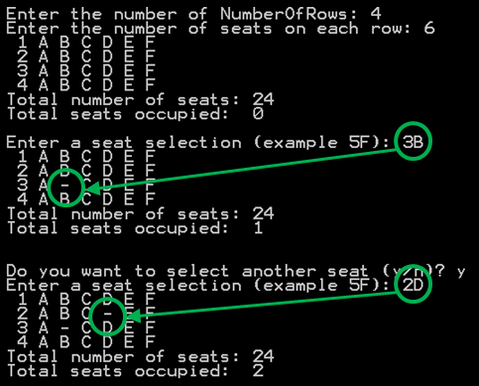
Because the total number of rows and seats is unknown when the program first starts, it will be necessary for the program to dynamically allocate memory for the seating array and then release that memory when the program ends.

The program should ask the user to select row and seat. The program needs to verify and process only legal row and seat requests. If the seat is already reserved, the program should notify the user that the seat is taken. If the seat is available, the program should replace the seat identifier with a dash character '-'. The program should contain a loop to ask if additional seats are to be reserved. The program should also give a message when all the seats are taken. A counter must be used to keep track of and display the total number of seats purchased.

When running the program, you must use a minimum of 3 rows and 4 seats. The lab report must show these minimums. The program output must also show:
a) a sample display of when more than one seat is taken, and
b) another display showing a message when all seats are taken. You can use 2 rows by 2 seats for this.

LAB REPORT:
2) Fill in the HIPO chart using English or pseudo-code. Do NOT paste your program or any part of it in the PROCESSING section.
INPUTS | PROCESSING | OUTPUTS
Input row and seat of each row  Input seat selection | Determine variables : Number of rows, number of seat, row selection and seat selection.  If user enter wrong valid for variables display warning message : “Illegal entry”.  If user enter same row and seat let user know that seat already took.  When user take full seat display message let user know plane already full. | Display table total of seat , total number of seat, number seat occupied.
DISCUSSION:
3) Complete the DISCUSSION section. It does not need to be long, but it needs to be complete.
3a) What did you do to develop the program? ("Followed the Directions" is not a complete description)

First of all , I need to determine what variable user will enter. There are Number of rows, number of seat, row selection and seat selection. For seat selection, using seatSelection = toupper(seatSelection); convert up case. After that, setting up condition for variables. Display total of seat = number of row * number of seat. Using count ++ to count how many seat occupied. If user enter wrong valid , display message let user know and try again for correct value. If user take all seat, display message let user know seats are full.

3b) What problems did you have and how did you overcome the problems?

I got problem to set up condition when user input wrong value. First I did not know how to determine when user enter row over number user set up or enter wrong letter for number of seat. It took me many hours to test and debugged . After that I found out solution to set up condition for invalid value.:
while (cin.fail() || row < 0 || seat < 0 || ((row + 1) > NumberOfRows || (seat + 1) > NumberOfSeats)) //reject non integer and negative answers or row and seat do not have in array.

Testing and running program again I got result match with my expect result. If user enter wrong value, it will show message for user know.

PROGRAM OUTPUT:
4) Show a screen shot for purchases of at least TWO seats and another screen shot with a message that shows what happens when ALL seats have been purchased..
Refer to previous lab assignments for instructions on how to capture a screen or portions of a screen for either the PC or a Mac
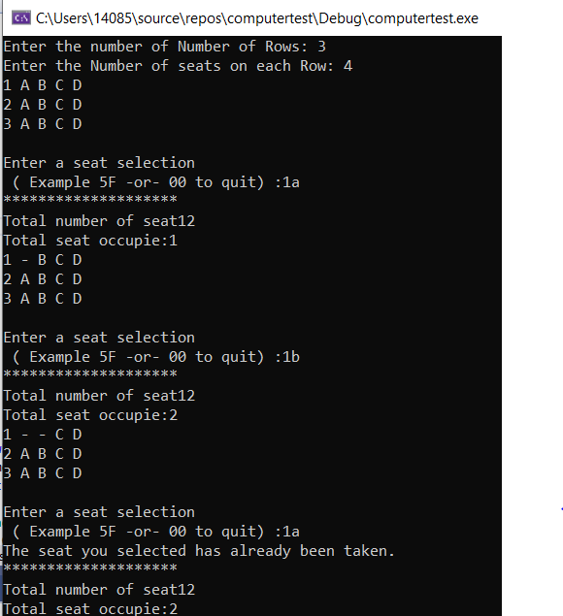

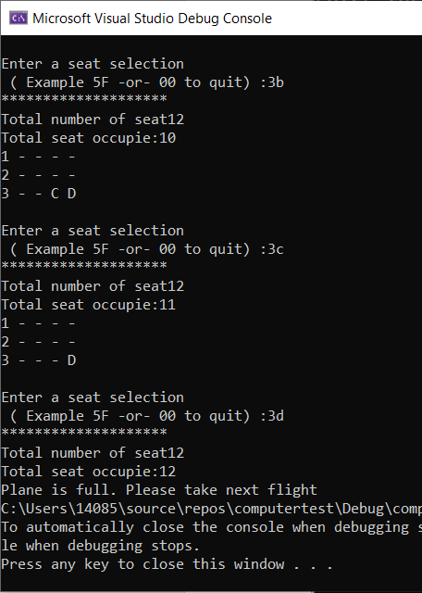

PROGRAM LISTING:
5) Copy and paste the code for your program. Your program should include a comment block at the top that shows the name of the program, date, version and your name.

/*
Name : HUY NGUYEN
Class : CIS 54
Date : Nov/17/2019
*/
#include<limits>
#include <iostream> // used by cin and cout
#include <iomanip> // useb by setios, precision, etc.
#include <cstring> // used for toupper()
//#include <cmath> // math function and constants
#include<cctype>
using namespace std;
char** CreateArrayOfSeats(int NumberOfRows, int seats);
void InitializeSeats(char** ArrayOfSeats, int NumberOfRows, int seats);
void DisplayArrayOfSeats(char** ArrayOfSeats, int NumberOfRows, int NumberOfSeats);
void MemoryCleanup(char** ArrayofSeats, int NumberOfRows, int NumberOfSeats);
int main(int argc, char* argv[])
{
char** ArrayofSeats;
int NumberOfRows;
int NumberOfSeats;
char rowSelection;
char seatSelection;
int row;
int seat;
int total;
int countSeat=0;
// Get the number of NumberofRows and seats from the user
cout << "Enter the number of Number of Rows: ";
cin >> NumberOfRows;
cout << "Enter the Number of seats on each Row: ";
cin >> NumberOfSeats;

ArrayofSeats = CreateArrayOfSeats(NumberOfRows, NumberOfSeats);
InitializeSeats(ArrayofSeats, NumberOfRows, NumberOfSeats);
DisplayArrayOfSeats(ArrayofSeats, NumberOfRows, NumberOfSeats);

do {

cout << endl << "Enter a seat selection" << endl << " ( Example 5F -or- 00 to quit) :";

cin >> rowSelection; // get the row from the user

cin >> seatSelection; // get the seat from the user

if (rowSelection == '0')
continue; // skip the rest of the loop
seatSelection = toupper(seatSelection); //Convert to upper case
row = rowSelection - '1'; // Count from zero to work with the array
seat = seatSelection - 'A'; // Convert 'A' to 0 , 'B' to 1 ....

while (cin.fail() || row < 0 ||seat<0 || ((row +1)> NumberOfRows || (seat +1) > NumberOfSeats) ) //reject non integer and negative answers or row and seat do not have in array.
{
cout << "Illegal entry" << endl;
cout << "Enter a seat again correctly ( Example 5F -or- 00 to quit) : ";
cin.clear(); // clear the input buffer
cin.ignore(1000, '\n'); // and ignore anything else before a new cin
cin >> rowSelection;
cin >> seatSelection;
seatSelection = toupper(seatSelection); //Convert to upper case
row = rowSelection - '1'; // Count from zero to work with the array
seat = seatSelection - 'A';

}

if (ArrayofSeats[row][seat] == '-')
cout << "The seat you selected has already been taken." << endl;
else
{
ArrayofSeats[row][seat] = '-';
countSeat++;
}
int total = NumberOfRows * NumberOfSeats;
cout << "Total number of seat" << (total) << endl;
cout << "Total seat occupie:" << countSeat << endl;
if (total == countSeat) {
cout << "Plane is full. Please take next flight";
exit(0);
}

DisplayArrayOfSeats(ArrayofSeats, NumberOfRows, NumberOfSeats);
} while (rowSelection != '0');
MemoryCleanup(ArrayofSeats, NumberOfRows, NumberOfSeats); // Return the memory
return 0;

} // end of main
char** CreateArrayOfSeats(int NumberOfRows,int seats) // means pointer to pointers
{
char** ArrayOfSeats;
ArrayOfSeats = new char* [NumberOfRows]; // create array of pointers for number of rows
for (int r = 0; r < NumberOfRows; r++)
ArrayOfSeats[r] = new char[seats]; // Create an array of seats for each row
return ArrayOfSeats;
}
void InitializeSeats(char** ArrayOfSeats, int NumberOfRows, int seats) {
for (int r = 0; r < NumberOfRows; r++)// initialize the data for each row
{
for (int s = 0; s < seats; s++)
ArrayOfSeats[r][s] = 'A' + s; // put 'A' 'B' 'C'etc in each row
}
}
void DisplayArrayOfSeats(char** ArrayOfSeats, int NumberOfRows, int NumberOfSeats)
{
for (int r = 0; r < NumberOfRows; r++) {
cout.widen(2);
cout << r + 1 << ' '; //Display row numbers starting from 1
for (int s = 0; s < NumberOfSeats; s++)
cout << ArrayOfSeats[r][s] << ' '; // Display info for each seat
cout << endl; // New line after each row
}
}
void MemoryCleanup(char** ArrayofSeats, int NumberOfRows, int NumberOfSeats)
{
for (int r = 0; r < NumberOfRows; r++)
delete[]ArrayofSeats[r];
delete[]ArrayofSeats;

}

