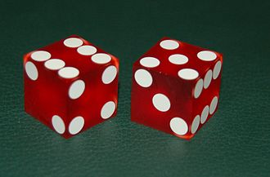
C/C++ ROLL DICE HISTOGRAM ASSIGNMENT AND LAB REPORT

1) Enter your name, student ID, platform (Mac or PC) and date
Name and Student ID: HUY NGUYEN - 086418
Platform (Mac, PC, Linux, etc.): PC
Development System (Visual Studio, Xcode, etc.) Visual Studio
Date: Oct/18/2019
Sample Output
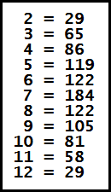
OBJECTIVES:
Enter and run a C or C++ program that uses a function

DESCRIPTION:
Design a C or C++ program that does the following:
1) Use a loop to simulate the rolling of a pair of dice 1000 times.
2) Use the function provided named roll to simulate the rolling of a single die.
3) Write a function named rollDice to simulate the rolling of two dice by calling
the roll function twice
4) Count the number of times each value from 2 to 12 occurred. You will need a separate counter for each value. If the value is 2, then increment its counter. If the value is 3, then increment its counter, etc.
5) Display the result of each of the counters.

LAB REPORT:
2) Complete the HIPO table below – Since this table is not already filled out, you need to complete it yourself.
INPUTS | PROCESSING | OUTPUTS
Random two dices ( each dice has face number from 1 to 6) | Random two dices.  Sum of two dice = dice1 + dice2  Frequency each sum of two dice  Using switch loop to count sum of two dice (with 1000 times) | Sum of two dices from 2 to 12 and displayed frequency each sum of two dices (from 2 to 12)

DISCUSSION:
3) Complete the DISCUSSION section. It does not need to be long, but it needs to be complete.
3a) What did you do to develop the program? ("Followed the Directions" is not a complete description. The value of 7 should occur most often when two dice are rolled, and the values 2 and 12 should occur the least often. How does your program correspond to these expectations?

First of all, I need to determine each dice would have 6 sides (from 1 to 6). Therefore, I used random method to input side of dice(int dice = 1 + rand() % 6). After that, I set up sum of two dice = dice1 + dice 2. Ranger sum of two dice would be from 2 to 12. Set up count for each value of sum and using switch for increments its count. Run program with rolling dice 1000 times and test value.

3b) What problems did you have and how did you overcome the problems?
I got wrong result problems. Correct result would be high frequency for 4 , 5 , 6 ,7 ,8 and low for 2 ,3 ,11 ,12 but I got only one value for sum of two dice like sum two dice 7 = 1000 times or 5 = 1000 times. I found out a reason because I put( unsigned int sumOfDice = rollDice() ) out of for loop. Therefor, when I ran program , it got one value and ran 1000 times. After put (unsigned int sumOfDice = rollDice(); ) inside for loop. I got correct result which same expect result.

PROGRAM OUTPUT:
4) Show four screen shots of the program running four different times.
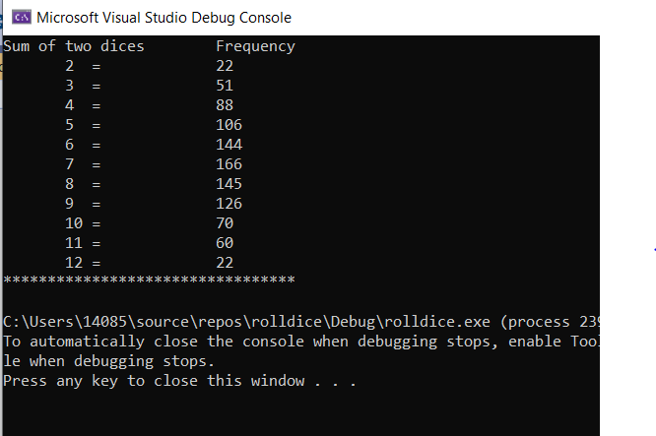

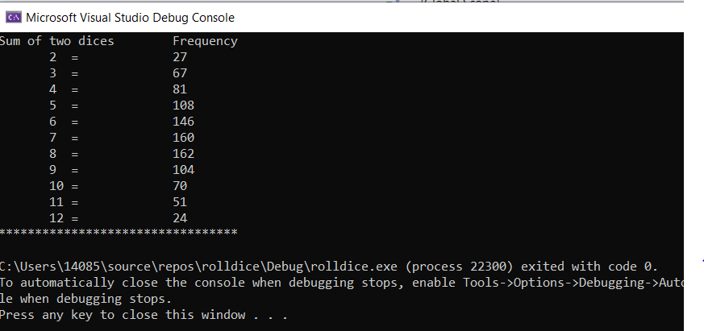
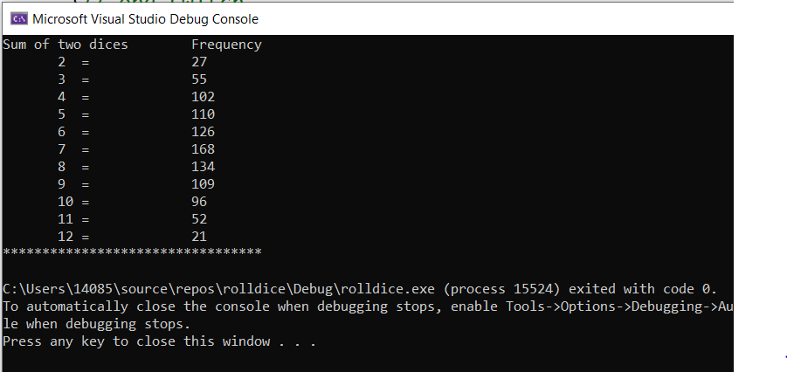

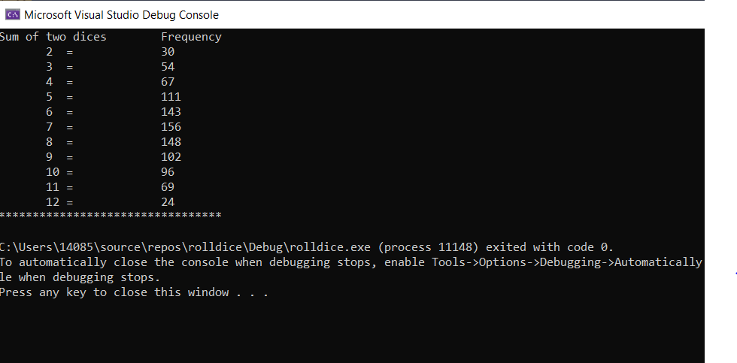
Place only the section of the screen that shows the output of the program. Refer to the Paycheck lab report if you instructions on capturing only a portion of the screen to place in the lab report.

PROGRAM LISTING:
5) Copy and paste the code that YOU typed to make the program work. Your program should include a comment block at the top that shows the name of the program, date and your name.
/* rolldice.cpp : This file contains the 'main' function. Program execution begins and ends there.
Write a function name rollDice to count the number of times each value from 2 to 12 occurred.
Use a loop to simulate the rolling of a pair of dice 1000 times.
*/

/*
Name:HUY NGUYEN
Version : C++
Date : Oct / 18 / 2019
program : RollDice
*/

#include <iostream>
#include <cstdlib>
#include<ctime>
using namespace std;
unsigned int rollDice();

int main()
{
unsigned int frequency2 = 0; // count of 2number
unsigned int frequency3 = 0; // count of 3number
unsigned int frequency4 = 0; // count of 4number
unsigned int frequency5 = 0; // count of 5number
unsigned int frequency6 = 0; // count of 6number
unsigned int frequency7 = 0; // count of 7number
unsigned int frequency8 = 0; // count of 8number
unsigned int frequency9 = 0; // count of 9number
unsigned int frequency10 = 0; // count of 10number
unsigned int frequency11 = 0; // count of 11number
unsigned int frequency12 = 0; // count of 12number

// randomize random number generator using current time

srand(static_cast<unsigned int>(time(0)));

for ( int roll = 1; roll <= 1000; roll++)
{
unsigned int sumOfDice = rollDice();
switch (sumOfDice)
{

case 2: ++frequency2; break;
case 3: ++frequency3; break;
case 4: ++frequency4; break;
case 5: ++frequency5; break;
case 6: ++frequency6; break;
case 7: ++frequency7; break;
case 8: ++frequency8; break;
case 9: ++frequency9; break;
case 10: ++frequency10; break;
case 11: ++frequency11; break;
case 12: ++frequency12; break;
default: break;
}// end switch

}//end for
cout << "Sum of two dices" << "\tFrequency" << endl;
cout << " 2 = \t" << frequency2 << endl;
cout << " 3 = \t" << frequency3 << endl;
cout << " 4 = \t" << frequency4 << endl;
cout << " 5 = \t" << frequency5 << endl;
cout << " 6 = \t" << frequency6 << endl;
cout << " 7 = \t" << frequency7 << endl;
cout << " 8 = \t" << frequency8 << endl;
cout << " 9 = \t" << frequency9 << endl;
cout << " 10 = \t" << frequency10 << endl;
cout << " 11 = \t" << frequency11<< endl;
cout << " 12 = \t" << frequency12 << endl;
cout << "*********************************" << endl;

}
unsigned int rollDice() {
// pick random dive values
unsigned int die1 = 1 + rand() % 6; // first die roll;
unsigned int die2 = 1 + rand() % 6; // second die roll
unsigned int sum = die1 + die2 ; // compute sum of die value
return sum;

}

