C/C++ SENTENCE FORMATTING LAB REPORT

1) Enter your name, student ID, platform (Mac or PC) and date
Name and Student ID: HUY NGUYEN - 0864168
Class: CIS054 C/C++ Programming C++
Platform (Mac or PC): PC
Date: NOV/10/2019

DESCRIPTION:
1) Input a sentence from the keyboard ending in a period
2) Change all whitespace characters to a space
3) Remove multiple spaces
4) Capitalize the first character of the sentence
5) Make all other characters lower-case

Example:
input --> this Is A tEst.
output -> This is a test.

LAB REPORT:
2) Determine the Inputs, Processing and Outputs before creating the program
INPUTS | PROCESSING | OUTPUTS
Typing sentence to test | Determine char sentence[200]  If between two word has more than one space , using for loop to remove space.  Capital first letter of sentence and then all of word will be low letter. | Correct sentence with capital first letter

3) Fill in the EXPECTED & ACTUAL RESULTS
TEST DATA VALUES  Provide at least two different examples strings to format | EXPECTED RESULT  Computed values before the program is run | ACTUAL RESULT  Fill in the output displayed  by the program
- i went To shoPPing with My friend YESTERDAY.  - i have a good day. | - I went to shopping with my friend yesterday.  - I have a good day. | 1) The correct sentence is : I went to shopping with my friend yesterday.  2) The correct sentence is : I have a good day.

DISCUSSION:
4) Complete the DISCUSSION section. It does not need to be long, but it needs to be complete.
4a) What did you do to develop the program? ("Followed the Directions" is not a complete description)
First of all, I have to determine char sentence which enters a sentence. And then using if -statement remove space when between two words have more than one space available. Setting up first letter of sentence will be capital and then all of word after will be lower case.

4b) What problems did you have and how did you overcome the problems?

I got problem when I enter space begin of first sentence and then enter words. The letter was not capital. I checked my code again and added conditional sentence[0] == ' ' , and my if statement becomes if (sentence[0] == ' '||sentence[i] == ' ' && sentence[i + 1] == ' '). Now no matter where space if between two word or first of sentence has space it will remove and correct sentence. Running and testing program , I made sure I got correct result match with compute result.

PROGRAM OUTPUT:
5) Show screen shots for at least TWO strings that were formatted.
Refer to previous lab assignments for instructions on how to capture a screen or portions of a screen for either the PC or a Mac

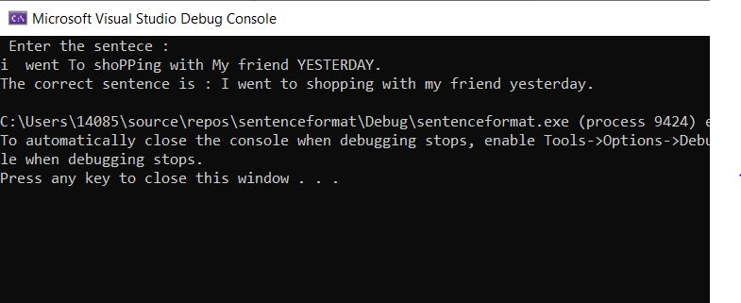
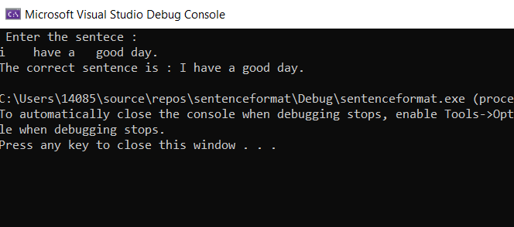

PROGRAM LISTING:
6) Copy and paste the code that YOU typed to make the program work. Your program should include a comment block at the top that shows the name of the program, date, version and your name.

// sentenceformat.cpp : This file contains the 'main' function. Program execution begins and ends there.
//
/*
Name: HUY NGUYEN
Date : Nov /8 /2019
Class: CIS 54
*/
#include <iostream>
#include<cctype>
using namespace std;
int main(int argc, char*[] )
{
char sentence[200];
int i = 0;
cout << " Enter the sentece : "<<endl;
cin.getline(sentence, 200);
// change all whitespace character to a space
while (sentence[i] != '0')
{
if (sentence[0] == ' '||sentence[i] == ' ' && sentence[i + 1] == ' ') for (int j = i; sentence[j]; j++)
{
sentence[j] = sentence[j + 1];

}
else
i++;
}
// Capital the first character of sentence
sentence[0] = toupper(sentence[0]);
// make all character lower case
for (i = 1; sentence[i]; i++)
{
sentence[i] = tolower(sentence[i]);
}
cout <<"The correct sentence is : "<< sentence << endl;

}

