C/C++ STUDENT 'CLASS' LAB REPORT

1) Enter your name, student ID, platform (Mac or PC) and date
Name and Student ID: HUY NGUYEN -0864168
Class: CIS054 C/C++ Programming C++
Platform (Mac or PC): PC
Date: NOV/24/2019

DESCRIPTION:
Modify the Student 'class' files as follows:
1) Add a Major field to the Student class definition. Update the student.h and student.cpp files to include the additional field. Be sure to include a get and set method for the Major field.
2) Add several majors such as CIS, Math, English, etc. to the students in the array of students located in the main program.
3) When displaying the list of student ID numbers and student names, also display their major. For C++ use the setw( ) function to set the widths of each column so that the columns line up on the screen when displayed. For the C-language, set the parameters for %s in the format string.
4) Change some of the ID numbers and GPAs to illegal values. Have the program detect and display an error message when the illegal values are present.

EXTRA CREDIT: 3 points – must be submitted at the same time as the original lab report
Display a header at the top of the table similar to:
ID # NAME MAJOR
============================================

LAB REPORT:
2) Determine the Inputs, Processing and Outputs before creating the program
INPUTS | PROCESSING | OUTPUTS
Student name ,  Student ID  GPA,  Major | Set up each student has Name of student , student Id and major  If student ID input is over 4 number display 0  If student name begin with number display bad name ,  Count total GPA by add GPA each student  Average Gpa = total GPA/ number of student | #ID  Student name  Major  GPa average of students

3) Fill in the EXPECTED & ACTUAL RESULTS
TEST DATA VALUES  Provide different examples including an illegal Student ID | EXPECTED RESULT  Computed values before the program is run | ACTUAL RESULT  Fill in the output displayed  by the program
Student("Joe Williams", 44536, 3.4, "CIS"),  Student("Sally Washington", 55458, 3.7, "Maths"),  Student("Fred MacIntosh", 665, 2.9, "History"),  Student("Jose De La Cruz", 67892, 3.5, "English"),  Student("777 Dan McElroy", 777, 4.0, "CIS"),  Student("Thinh Nguyen h", 7367,3.6, "Physis") | 0 Joe Williams CIS  - Sally Washington Maths  665 Fred MacIntosh History  - Jose De La Cruz English  777 --Bad name entered CIS  7367 Thinh Nguyen h Physis | 0 Joe Williams CIS  - Sally Washington Maths  665 Fred MacIntosh History  - Jose De La Cruz English  777 --Bad name entered CIS  7367 Thinh Nguyen h Physis
DISCUSSION:
4) Complete the DISCUSSION section. It does not need to be long, but it needs to be complete.
4a) What did you do to develop the program? ("Followed the Directions" is not a complete description)

First of all , I will determine variable of each student will have student name, student Id , GPA and major . After that , I create array student. And then I create sub class of student class. In sub class , I set up int student ID, string student name, double GPA and string major. After setup variable from sub student, I create an other student.cpp and get variable form sub class. Making condition for student Id by Id number between 1 and 10000( student ID will have 4 number) if not student Id will become 0.

4b) What problems did you have and how did you overcome the problems?

I have problem to set up new major field. Frist I thought it will be char their for I set up but it not running. After that I look it back I found out major need to set up like name student “ string”. Therefore, I changed set up for major and coding same like name student but different name and object. Student will begin will char and capital , if not it will display bad name create. Gpa of student will be between 1 and 4. Major will be set up string. After that , I will run and test program make sure compute result match with expect result.

PROGRAM OUTPUT:
5) Show a screen of the program execution that includes an illegal selection for name. The columns of data need to be left justified.

For extra credit, display a header row and a ==== separator line.
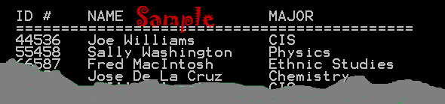
Refer to previous lab assignments for instructions on how to capture a screen or portions of a screen for either the PC or a Mac
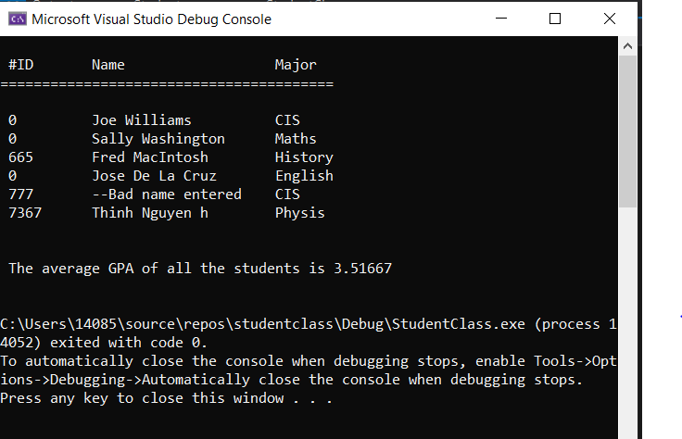

PROGRAM LISTING:
6) Copy and paste the code for the program work. Your program should include a comment block at the top that shows the name of the program, date, version and your name.
/*
Name : HUY NGUYEN
CLass: CIS054
Date: NOV/24/2019
*/

// Student_Class.cpp : Defines the entry point for the console application.
//

#include <iostream>
#include "Student.h"
#include <iomanip>
using namespace std;

// define an array of students
Student CIS054[] =
{
Student("Joe Williams", 44536, 3.4, "CIS"),
Student("Sally Washington", 55458, 3.7, "Maths"),
Student("Fred MacIntosh", 665, 2.9, "History"),
Student("Jose De La Cruz", 67892, 3.5, "English"),
Student("777 Dan McElroy", 777, 4.0, "CIS"),
Student("Thinh Nguyen h", 7367,3.6, "Physis")
};

int main(int argc, char* argv[])
{
int NumberOfStudents = sizeof(CIS054) / sizeof(Student);

//Display the header line
//List all the students in the course

//Printing header
cout << "\n " << left << setw(10) << "#ID" << left << setw(22) << "Name" << left << setw(22) << "Major" << " \n";
cout << "========================================\n";
//Iterating over students array
for (int i = 0; i < NumberOfStudents; i++)
{
cout << "\n " << left << setw(10) << CIS054[i].getIdNumber() << left << setw(22) << CIS054[i].getName() << left << setw(22) << CIS054[i].getMajor();
}

cout << endl; // blank line after displaying the student names

//compute the average gpa of all the students
double total = 0;
for (int i = 0; i < NumberOfStudents; i++)
total += CIS054[i].getGpa();
double average = total / NumberOfStudents;
cout << "\n\n " << "The average GPA of all the students is " << average << endl << endl;

return 0;
}

// Student.cpp - contains the code for the Student class member methods

// only for Microsoft Visual Studio C++ programs
#include "Student.h"
// used by isalpha (test for a character)
#include <cctype> //used by isalpha (test for a character)

using namespace std;

//default Student Constructor
Student::Student()
{
name = ""; //set name to an empty string
IdNumber = 0;
gpa = 0.0;
major = "";
}
//Fully qualified Student Constructor
Student::Student(string n, int id, double g, string m)
{
setName(n); //use setName to validate data
setIdNumber(id); //use setIdNumber to validate data
setGpa(g); //use setGpa to validate data
setMajor(m); //Adding major
}

//mutators and accessors
void Student::setName(string n)
{
if (isupper(n[0])) //1st character of name must be A-Z
name = n;
else
name = "--Bad name entered";
}

string Student::getName()
{
return name;
}

void Student::setIdNumber(int id)
{
if (id > 1 && id < 10000) //must be from 0 to 10000
IdNumber = id;
else
IdNumber = 0; //indicate an illegal selection
}

int Student::getIdNumber()
{
return IdNumber;
}

void Student::setGpa(double g)
{
if (g >= 0.0 && g <= 4.0)
gpa = g;
else
gpa = 0;
}

double Student::getGpa()
{
return gpa;
}

//Setter method for major
void Student::setMajor(string m)
{
major = m;
}

//Getter method for major
string Student::getMajor()
{
return major;
}

// Student.h
#include <string>
using namespace std;

class Student
{

private:
string name;
int IdNumber;
double gpa;

/* Extra Field */
string major;

public:
//constructors
Student(); //default constructor
Student(string n, int id, double g, string m);
//mutattors and accessors
void setName(string n);
string getName();
void setIdNumber(int id);
int getIdNumber();
void setGpa(double g);
double getGpa();

/* Getter and setter methods for variable Major */
void setMajor(string m);
string getMajor();
};

