C/C++ TIC-TAC-TOE LAB REPORT

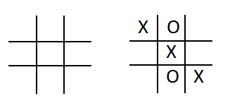
1) Enter your name, student ID, platform (Mac or PC) and date
Name and Student ID: HUY NGUYEN - 0864168
Class: CIS054 C/C++ Programming
Platform (Mac or PC): PC
Date: Oct /16/2019

DESCRIPTION
Create a program using a two dimension array and functions that lets two players play the tic-tac-toe game. The program is to read a number from 1 to 9 from the keyboard alternating between the X and the O. Ask which square the X player wants, and then ask which square the O player wants. Continue until the game is won by either player, or all the squares have been filled. (Called a Cat's Game or a Tie Game)

A function must be used to display the tic-tac-toe game board, and a function must be used that determines if the game has been won. You can create the program on your own, or start with the sample code provided.

EXTRA CREDIT (up to 3 points)
Modify the DisplayTicTacToe( ) function using the | and – characters to draw lines for the tic-tac-toe display.
Extra credit work must be submitted when the lab report is submitted. Not at a later date.

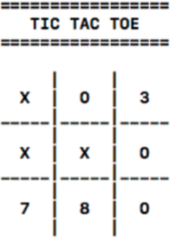
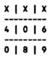
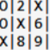
3 points
extra credit
2 points
extra credit
1 point
extra credit

LAB REPORT
2) Determine the Inputs, Processing and Outputs before creating the program
INPUTS | PROCESSING | OUTPUTS
Player choose number from 1 to 9 to fill ‘x’ and ‘o’ on board [3]x[3] | Radom ‘x’ or ‘o’ for player play game;  Create board [3]x[3]  Let player select number from 1 to 9 equivalent with place on board.  Fill in ‘x’ and ‘o’ on each square  If player have same symbol on cross, down or diagonal that player is winner. Else it will tie game. | Print board fill by ‘x’ and ‘o’. Let player know who won or tie game.

DISCUSSION
3) Complete the DISCUSSION section. It does not need to be long, but it needs to be complete.
3a) What did you do to develop the program? ("Followed the Directions" is not a complete description)

Use a double dimension character array (3x3) for the tic-tac-toe game board. After that I set up a while loop to play the game until there is a winner or all the squares have been filled Ask the 'X' or 'O' player for a number 1-9 and then convert the number into array coordinates. We will check for illegal input or the square already used. If is not fill in, we should fill in an 'X' or 'O' for the selected square. Select the next player and check to see if there is winner. Finally, Display a message to show the winner or a tie game

3b) What problems did you have and how did you overcome the problems?
I got problem to create board, I did not know how to create board with small line ( | ). First running line got multiply (|) on one raw like | | | | |.I found solution by reading definition of array. After that, I try to code them by create each line and add space and then will be number “|” << board [0][0]<<”|” . Running and testing program couple times to make sure I created board correctly. PROGRAM OUTPUT
4) Show screen shots for at least FOUR sample games: 1) a win going across, 2) a win going down, 3) a win going at a diagonal, 4) a tie game in which there was no winner.
Refer to previous lab assignments for instructions on how to capture a screen or portions of a screen for either the PC or a Mac
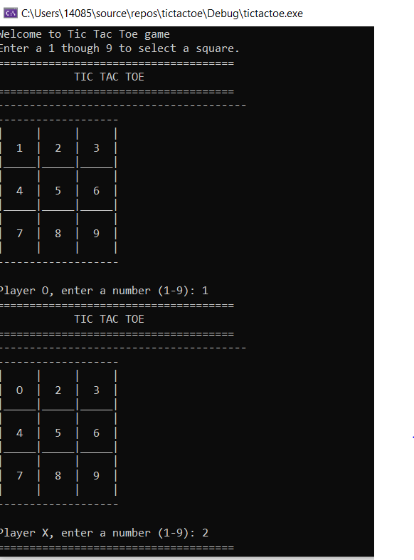
1) a win going across
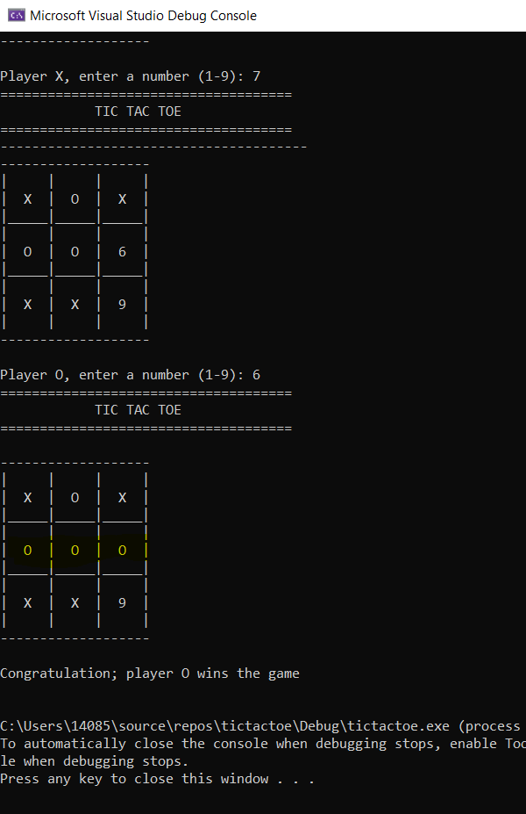
2) a win going down,
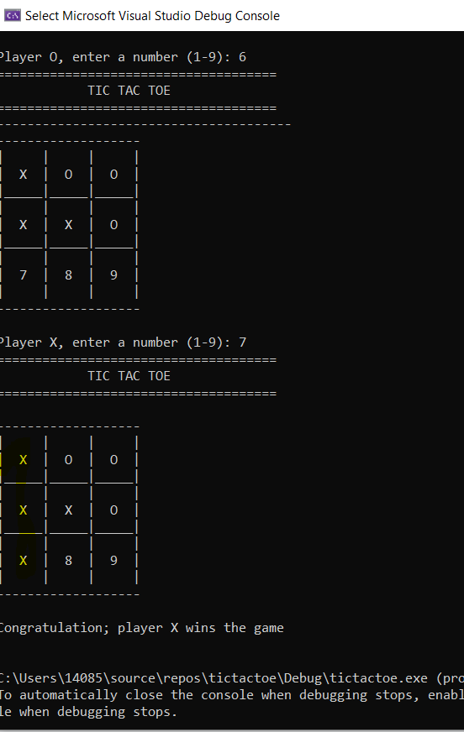
3) a win going at a diagonal,
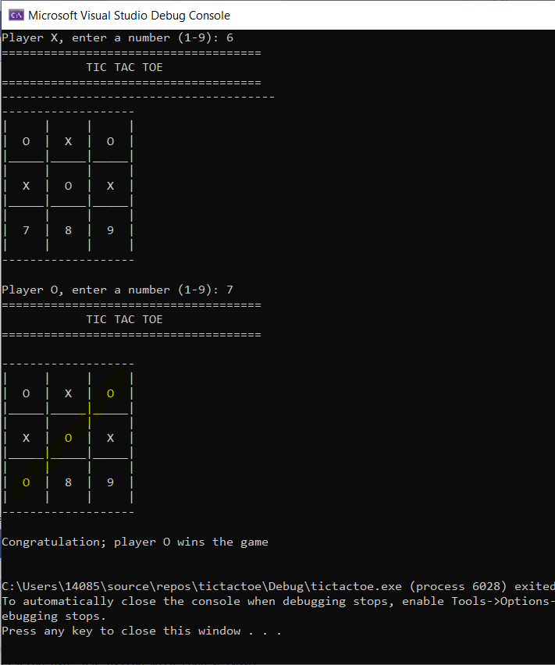

4) a tie game in which there was no winner.
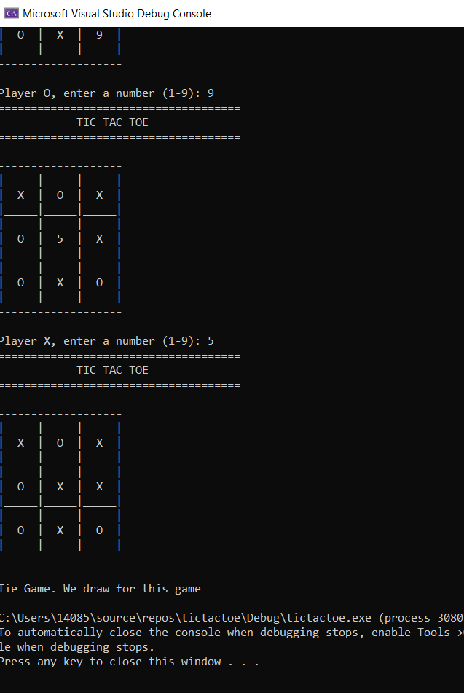

PROGRAM LISTING
6) Copy and paste the code that YOU typed to make the program work. Your program should include a comment block at the top that shows the name of the program, date, version and your name.

// tictactoe.cpp : This file contains the 'main' function. Program execution begins and ends there.
/*
Create a program using a two dimension array and functions that lets two players play the tic-tac-toe game.
The program is to read a number from 1 to 9 from the keyboard alternating between the X and the O.
Ask which square the X player wants, and then ask which square the O player wants.
Continue until the game is won by either player, or all the squares have been filled.
*/

/*
Name:HUY NGUYEN
Class: CIS 054
Date: Oct/26/2019
*/
//
#include<ctime>
#include <iostream>
#include<ctime>
using namespace std;
// fuction prototypes
char symbol, player1;
void DisplayTicTacToe(char board[3][3] );
char CheckForWinnningGame(char board[3][3]);
void displayLine();

int function();
char board[3][3] = {// create board index for position in the array
{'1','2','3'}, // first row
{'4','5','6'}, // second row
{'7','8','9'} //third row

};
int squareCounter = 0; // count how many square are used
char gameWinner = '-'; //winner of the game ('X' or 'O')
char inputCharacter; // input from the user ( should be '1' to '9')
int choice; // input converted to interger 0 to 8 (start from 0)
char player; // current player , set player choose 'x' or '0'
int main(int argc, char* argv[])
{

cout << "Welcome to Tic Tac Toe game" << endl;

function();

}

int function()
{

// select the starting player
srand((unsigned int)time(NULL)); // seed the random number generator
if (rand() % 2 == 1)
player = 'X';
else
player = 'O';
// starting instructions

cout << "Enter a 1 though 9 to select a square." << endl;

//Ask for a 1-9 until all squares are filled or the game has been won
while (squareCounter < 9 && gameWinner != 'X' && gameWinner != 'O')
{
cout << "=====================================" << endl;
cout << " TIC TAC TOE " << endl;
cout << "=====================================" << endl;

cout << "---------------------------------------" ;

DisplayTicTacToe(board);
cout << "\nPlayer " << player << ", enter a number (1-9): ";
cin >> inputCharacter;

// Arrays start couting from index 0
// convert input Character from ASCII ( '1' to '9') to interger ( 0 to 8)
// to select the row and column index for the 3x3 array
choice = inputCharacter - '1'; // now the inputs are 0 to 8
int row = choice / 3; // row will be 0 ( for 0,1,2) ,1 ( for 3 ,4 ,5 ) ,2( for 6 , 7 ,8)
int column = choice % 3; // col will be 0 (for 0, 3, 6) , 1( for 1,4 ,7), 2 ( for 2, 5 ,8)

if (choice < 0 || choice >8)// reject the input if it is not in domain (0,8)
cout << " Illegal value, try again" << endl;
else if (board[row][column] == 'X' || board[row][column] == 'O')
cout << "This space has already been used , try again" << endl;
else
{
board[row][column] = player;// put in an 'X' or 'O'
squareCounter++; // count the number of squares completed
// select the next player
if (player == 'X')
player = 'O'; //switch from 'x' to 'O' for next move
else
player = 'X'; // switch from 'O' to 'X' for next move

}
gameWinner = CheckForWinnningGame(board);// returns 'x' or 'o' if the game is won
}

//The game is over . Either the game has been won or no more squares
cout << "=====================================" << endl;
cout << " TIC TAC TOE " << endl;
cout << "=====================================" << endl;
DisplayTicTacToe(board);
cout << endl; //blank line
if (gameWinner == 'X' || gameWinner == 'O')
{

cout << "Congratulation; player " << gameWinner << " wins the game" << endl << endl;
}
else
{

cout << "Tie Game. We draw for this game" << endl;
}
return 0;
}
// Display the Tic Tac Toe board

void DisplayTicTacToe(char board[3][3])
{
cout << "\n-------------------" ;
cout << "\n| | | |" << endl;
cout << "| " << board[0][0] << " | " << board[0][1] << " | " << board[0][2] << " | "<< endl;
cout << "|_____|_____|_____|" << endl;
cout << "| | | | "<< endl;
cout << "| " << board[1][0] << " | " << board[1][1] << " | " << board[1][2] << " | " << endl;
cout << "|_____|_____|_____|" << endl;
cout << "| | | | " << endl;
cout << "| " << board[2][0] << " | " << board[2][1] << " | " << board[2][2] << " | " << endl;
cout << "| | | | ";
cout << "\n-------------------" << endl;
}

// Check all eight possible combinations for a win
// returns the player ('X' or 'O') if the game has been won
// returns '-' if there is currently no winner

char CheckForWinnningGame(char board[3][3])
{
char player;
//check going across the top row to see if all squares are the same
player = board[0][0];
if (board[0][1] == player && board[0][2] == player)return player;
// check going across the middle row to see if all squares are the same
player = board[1][0];
if (board[1][1] == player && board[1][2] == player) return player;
//check third row
player = board[2][0];
if (board[2][1] == player && board[2][2] == player) return player;
//Check going down the first column
player = board[0][0];
if (board[1][0] == player && board[2][0] == player) return player;
// Check going down the second column
player = board[0][1];
if (board[1][1] == player && board[2][1] == player) return player;
//Check going down third column
player = board[0][2];
if (board[1][2] == player && board[2][2] == player) return player;
// Check going across the left diagonal
player = board[0][0];
if (board[1][1] == player && board[2][2] == player)return player;
//check going across the right diagonal
player = board[0][2];
if (board[1][1] == player && board[2][0] == player) return player;
return '-'; // if there is no winner

}

