C/C++ BINARY SEARCH OF STRUCTURED RECORDS LAB REPORT

1) Enter your name, student ID, platform (Mac or PC) and date
Name and Student ID: HUY NGUYEN- 0864168
Class: CIS054 C/C++ Programming: C++
Platform (Mac or PC): PC
Date: NOV/25/2019

DESCRIPTION:
- Get a copy of structSearch program and the phony.422 data file from the class website.
- Modify the program to permit the user to enter a customer name or a customer phone number
for the search. Ignore case when doing the search for the customer name. Use the stricmp function to compare the customer name entered at the keyboard with the customer name from the file.
- a. search for a record near the beginning of the list,
b. search for a record anywhere in the middle of the list,
c. search for the record near the end of the list.

NOTE: If your compiler does not have strcmp, you may need to use strcmp or _strcmp . If your compiler does not have stricmp, you may need to use stricmp or _stricmp or strcasecmp.

DISCUSSION:
2) Complete the DISCUSSION section. It does not need to be long, but it needs to be complete.
2a) What did you do to develop the program? ("Followed the Directions" is not a complete description)

First of all , I define the max number of records in the file and the lengths of each character array. In main class, I use do-while to setup menu and condition. In menu, I set up user can choose to search customer by using phone number or by using name. If user entered invalid phone number or name not in list , the display message will show “not found”. If user want to exit program, enter “0”.
2b) What problems did you have and how did you overcome the problems?
My problem is put wrong direction of file pony in file name. When I direct pony file I forget to type 422 at the end of file. Therefore, when I run file , it got error. Looking back discussion note and lecture from Professor Dan, I found out my problem and fix it. After that , I run program and test to make sure my result correctly.

2c) Compare the number of searches when looking for a data record near the beginning, the middle or near the end of the list. Which search method would give the best results when the search could be anywhere in the list?
From result of search, I think the best results is search in middle of list when I compare it. From data , 8 tries is number near first list and 6 tries is phone number near the end, but 5 tries is number around middle. Pay on result , I think middle of list is best results.

PROGRAM OUTPUT:
3) Show screen shots for at least THREE searches:
a. search for a record near the beginning of the list,
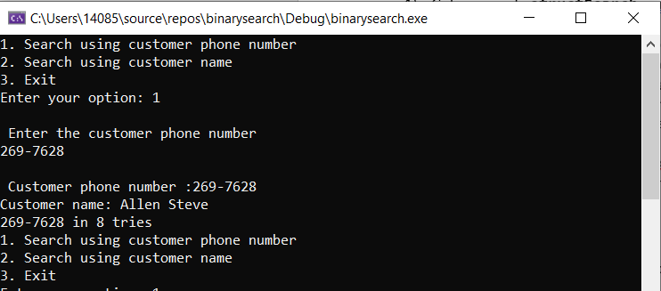
b. search for a record anywhere in the middle of the list,
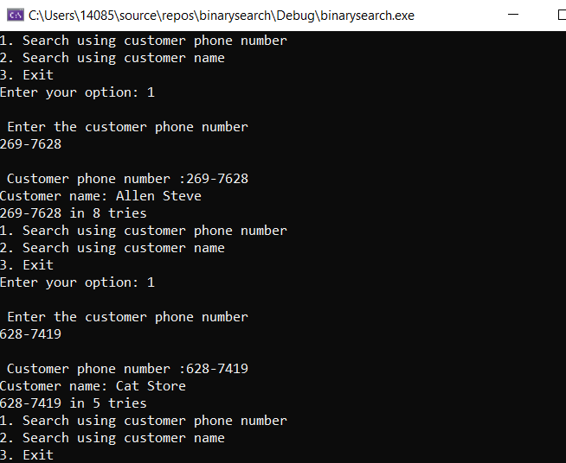
c. search for the record near the end of the list.
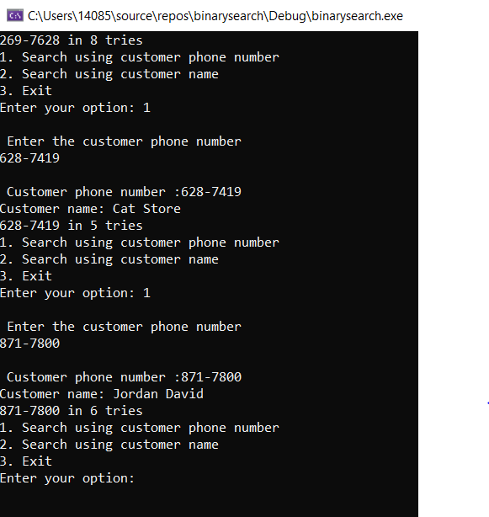
Refer to previous lab assignments for instructions on how to capture a screen or portions of a screen for either the PC or a Mac

PROGRAM LISTING:
4) Copy and paste the code that YOU typed to make the program work. Your program should include a comment block at the top that shows the name of the program, date, version and your name.
/*
Name: HUY NGUYEN
Class : CIS 054
Date; Nov/25/2019
*/
#include<iostream>
#include<fstream>
#include<cstdlib>
#include<string.h>
using namespace std;

//define the max number of records in the file
const int LIST_LENGTH = 256;

// define the lengths of each character array
const int NAME_SIZE = 40;
const int NUMBER_SIZE = 13;
const int LINE_SIZE = 80;

typedef struct S_REC {
char name[NAME_SIZE];
char number[NUMBER_SIZE];
}PhoneRec;

int main(int argc, char* argv[])
{
PhoneRec List[LIST_LENGTH]; // [length][width]
char line[LINE_SIZE]; // line of text from the disk
char filename[] = "C:/Users/14085/Desktop/phony/phony.422";
char* ptr;

ifstream PhoneFile(filename);
if (!PhoneFile) {
cerr << "Unable to open " << filename << endl;
return 1;
}
int listsize = 0;
while (!PhoneFile.eof() && listsize < LIST_LENGTH) {
line[0] = 0; // clear the line
PhoneFile.getline(line, LINE_SIZE); // read a line from the disk
if (strlen(line) > 1) {
//Version -1

char* nextToken = NULL; // used only by strtok_s
ptr = strtok_s(line, ".", &nextToken); // find name, separated by '.' character
strcpy_s(List[listsize].name, NAME_SIZE, ptr); // copy name to array, position listsize
ptr = strtok_s(NULL, ".\r\n", &nextToken); // find phone number
strcpy_s(List[listsize].number, NUMBER_SIZE, ptr); // copy to array, position listsize
listsize++;
}
}
bool found;
int option = 0;
int tries;
do
{
cout << "1. Search using customer phone number" << endl;
cout << "2. Search using customer name" << endl;
cout << "3. Exit" << endl;
cout << "Enter your option: ";
cin >> option;
if (option == 1)
{
char phoneNumber[10];
cout << "\n Enter the customer phone number" << endl;
cin >> phoneNumber;

// Binary Search
int min = 0; // star index for current search
int max = listsize - 1; //end index for current search
int mid;
tries = 0; // couter to see
found = false;
while (max >= min && !found) {
tries++;
mid = (min + max) / 2;
if (_stricmp(phoneNumber, List[mid].number) == 0)
found = true;
else if (_stricmp(phoneNumber, List[mid].number) < 0)
max = mid - 1;
else
min = mid + 1;

}
if (found)
{
cout << "\n Customer phone number :" << List[mid].number << endl;
cout << "Customer name: " << List[mid].name << endl;
cout << List[mid].number << " in " << tries << " tries " << endl;

}
else
cout << "Not Found" << endl;

}
if (option == 2)
{
// sequential search
int index;
char searchString[50];
cout << "\nEnter a customer name: ";
cin.ignore();
cin.getline(searchString, 50, '\n');

tries = 0; // couter to see efficency
found = false;
for (index = 0 ; index <listsize;index++)
{
tries++;
if (_stricmp(searchString, List[index].name) == 0)
{
found = true;
break;
}

}
if (found) {
cout << "\n Customer phone number :" << List[index].number << endl;
cout << "Customer name: " << List[index].name << endl;
cout << List[index].number << " in " << tries << " tries " << endl;

}
else
cout << "Not found" << endl;

}
} while (option != 3);
return 0;

}

