Electromagnetic Waveguide Simulator
A full-stack software platform that automates microwave waveguide simulation
Summer research · Space Materials Lab, Khalifa University
Huzaifa Taha Rangwala — UC Berkeley (Math + CS) · Space Materials Lab, Khalifa University
To download or for more information, contact huzaifataha54@berkeley.edu
Version 3.6

New in Version 3.5
Version 3.6 expands the radar-cross-section tab into a four-tab instrument suite (grouped under an “RCS ▾” menu): the RCS solver gains a down-range scattering-center profile, a full 2×2 polarimetric matrix with Pauli bounce classification, an interactive 3-D scattering lobe, and probability-of-detection curves; plus three new tabs — Inverse RAM design (searches absorber materials/thickness/layers for the lightest coating meeting a reduction target, with the Pareto frontier and the Rozanov thickness bound, one-click validated full-wave), Run comparison (pin and overlay runs), and Batch sweeps (unattended one-parameter sweeps + a documented headless Python API).
Version 3.6 turns the radar-cross-section tab into a full materials-testing instrument: extra target shapes (cylinder, dihedral, and imported STEP/STL CAD), bare-metal / coated / solid constructions, custom materials, polarization and custom-band control, standard RCS benchmarks (conducting-sphere-vs-Mie as the headline, plus plate, dihedral and the NASA-almond literature target), a radar-range detectability calculator, live openEMS progress streaming, a run-manifest button on every openEMS tab, and a citeable CITATION.cff. The RCS results now mirror the Full-wave and Horn layout, with all formulas moved to the physics section.
- Interactive 3-D geometry inline — the horn results embed a zoomable WebGL model (drag / rotate / zoom), matching the pre-run Preview view.
- Streamlined openEMS controls — Band, Ports and Field view are segmented toggles in a grouped, aligned configuration panel, with clearer guidance when the local bridge is not running.
- One-click exports — Horn Excel workbook plus PNG/CSV/text bundle; Full-wave and Compare ZIP/CSV; automated validation and trade-space reports.
- Refreshed UI — animated hero, at-a-glance metrics, per-tab icons, unified charts, print-ready Physics derivation, and full Arabic info pop-ups on every tab.
- Interactive 3-D simulated field — after a horn run, explore the actual solved openEMS |E| in 3-D (rotate / zoom), CST-style: a rainbow dB colour map with a colour bar, a translucent model, and switchable Volume / Cut-plane views.
- Extra polish — a branded loading splash and an animated results headline with count-up metrics on the Simulator tab.

Introduction
My summer research at Khalifa University's Space Materials Lab is focused on finding better materials for satellite waveguides — the channels that route microwave signals across a spacecraft. Solid copper and aluminum work well but are heavy, and launch mass is expensive, so I'm investigating whether lightweight, coated alternatives (such as MXene-coated wood) can do the same job for a fraction of the weight.
Testing that question by hand — for many materials, coatings and frequencies — would be enormously time-consuming. So I designed and built a software simulator that does it for me: it predicts how any candidate material performs as a waveguide (its signal loss, weight and cost) and backs those predictions with real full-wave 3-D electromagnetic simulations.

Why it matters
Full-wave electromagnetic simulation is normally slow and hands-on: an engineer builds each 3-D model by hand — geometry, mesh, ports, excitation — runs the solver, then post-processes the output, on the order of 30 minutes of setup for a single case. Across many materials and frequencies, that becomes days of repetitive work.
My platform automates the entire chain into a single click that finishes in about three minutes, and pairs it with an instant in-browser analytical engine so “what-if” questions answer in real time. A dozen materials can be benchmarked unattended from one screen — all running locally on a laptop. The figure below shows one such run: a click produces the 3-D field render and S-parameters automatically.
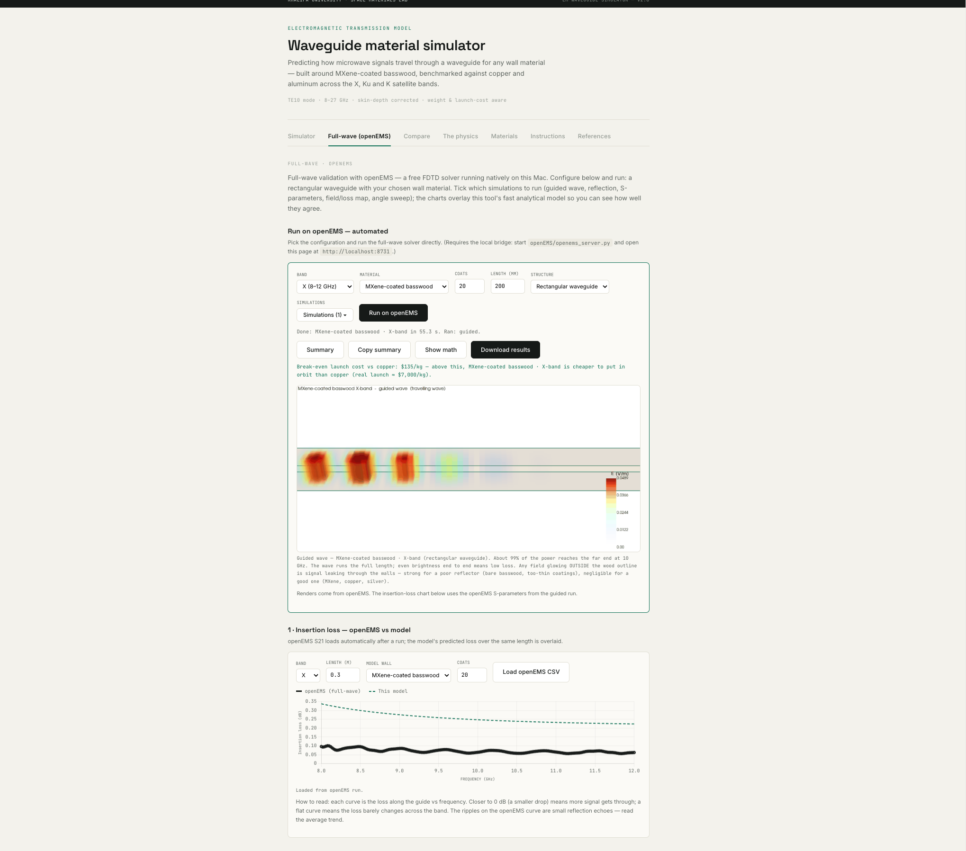
Figure 1 — A single click runs a full-wave simulation end-to-end: the platform builds the 3-D model, solves it with the FDTD engine in the background, and streams back a coloured field render and S-parameters, overlaid on the analytical model.

What it does
It also predicts radar cross section (RCS): how strongly a shape or coated material scatters radar, validated against the exact Mie series and physical optics, with a detectability (radar-range) read-out and STEP/STL import.
- One-click full-wave simulation. Configure a run in the browser and the platform automatically builds the 3-D model, runs the FDTD solver, renders coloured field animations, extracts S-parameters, and streams everything back — no manual solver setup.
- Import any CAD shape / 3-D geometry. Not limited to standard rectangular guides — arbitrary geometry can be brought in and simulated from the same one-click flow.
- Instant analytical engine. A closed-form physics model runs live in the browser, so loss, weight and cost update in real time as you change any parameter.
- Selectable analyses. Tick which simulations to run — guided-wave propagation, reflection, S-parameters, field & wall-loss maps, angle-of-incidence sweep, and far-field radiation pattern (openEMS near-field-to-far-field) — each with its own output and CSV data.
- Automated benchmarking. A comparison view runs and ranks many materials side-by-side on loss, weight, cost and footprint, with radar charts and one-click export of all images, graphs and CSV data.
- Full transparency. Every governing equation is rendered on-screen, every input is cited, and every solver run is logged so results can be audited.
- Inverse design (automatic optimization). Set a target — band and maximum acceptable loss — and what to minimize (mass, delivered-to-orbit cost, or embodied carbon); the platform searches the entire space of coatings, substrates, coat counts and solid metals and returns the Pareto-optimal designs plus a single ranked recommendation.
- Measurement-to-simulation bridge. Upload a measured transmission curve (CSV or Touchstone .s2p) from a vector network analyser and the platform fits the effective conductivity of your fabricated coating — extracting a real RF material property from a bench measurement and overlaying measured against simulated.
- Multilayer coatings. Stack up to three different coating layers (for example MXene then graphene) with independent thicknesses and ordering; the transfer-matrix engine returns the exact reflection, transmission and an effective wall impedance for the full-wave solver.
- Built-in guidance. A per-page and per-chart information system explains every simulation, graph and field animation in plain language, with an English / Emirati-Arabic toggle.
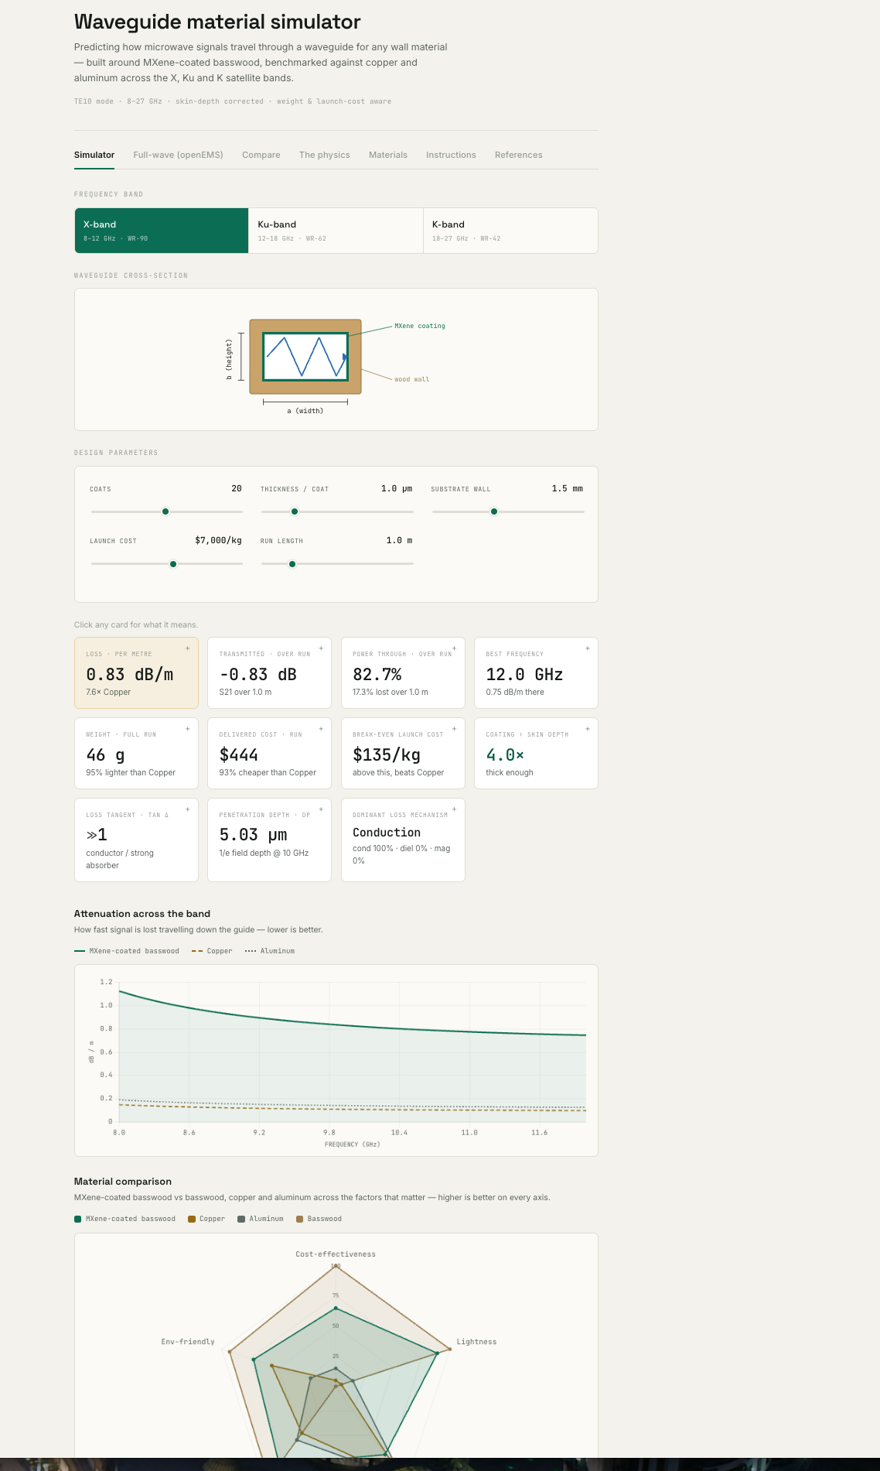
Figure 2 — The Simulator: instant, in-browser results (loss, weight, delivered cost, penetration depth, dominant loss mechanism) and a live material-comparison radar that update as any parameter changes.

Technology & software engineering
The platform is a full-stack system spanning an interactive front-end, a hand-written numerical engine, and an automated back-end that drives a professional-grade solver:
Layer | Technologies | What I built
Front-end / UI + visualization | HTML, CSS, JavaScript, Chart.js, MathJax, JSZip | Interactive single-page app; real-time line/radar/multi-series charts; rendered equations; client-side state, saved libraries and ZIP/CSV export
Numerical engine | JavaScript (complex-number math) | Electromagnetic physics implemented from scratch — ABCD transfer-matrix method, skin-depth & surface-impedance models, TE10 attenuation, complex permittivity/permeability
Automation bridge | Python, Flask, subprocess | A local server that orchestrates the whole pipeline browser ⇄ solver ⇄ renderer: generates solver input, launches jobs headlessly, parses output, logs every run
Full-wave solver | openEMS (FDTD), Octave, CSXCAD | Scripted 3-D model build, ports, field dumps and S-parameter extraction
3-D rendering | Python, PyVista, NumPy, imageio | Off-screen volume rendering of the field into coloured stills and animations
Validation & reproducibility | Automated test suite, CSV/ZIP export, run-history log | A comprehensive automated check suite against textbook values (analytical anchors, math harness, script and markup checks); auditable, exportable, cross-validated results
How the automation works: clicking Run in the Compare or Full-wave tab sends the configuration from the browser to a local Python/Flask server. That server drives openEMS entirely in the background — no solver GUI — generating the model script, launching the FDTD run as a subprocess, rendering the 3-D fields with PyVista, then handing the images, S-parameters and CSV data straight back to the page. A workflow that normally demands a specialist and a commercial GUI is reduced to one button.
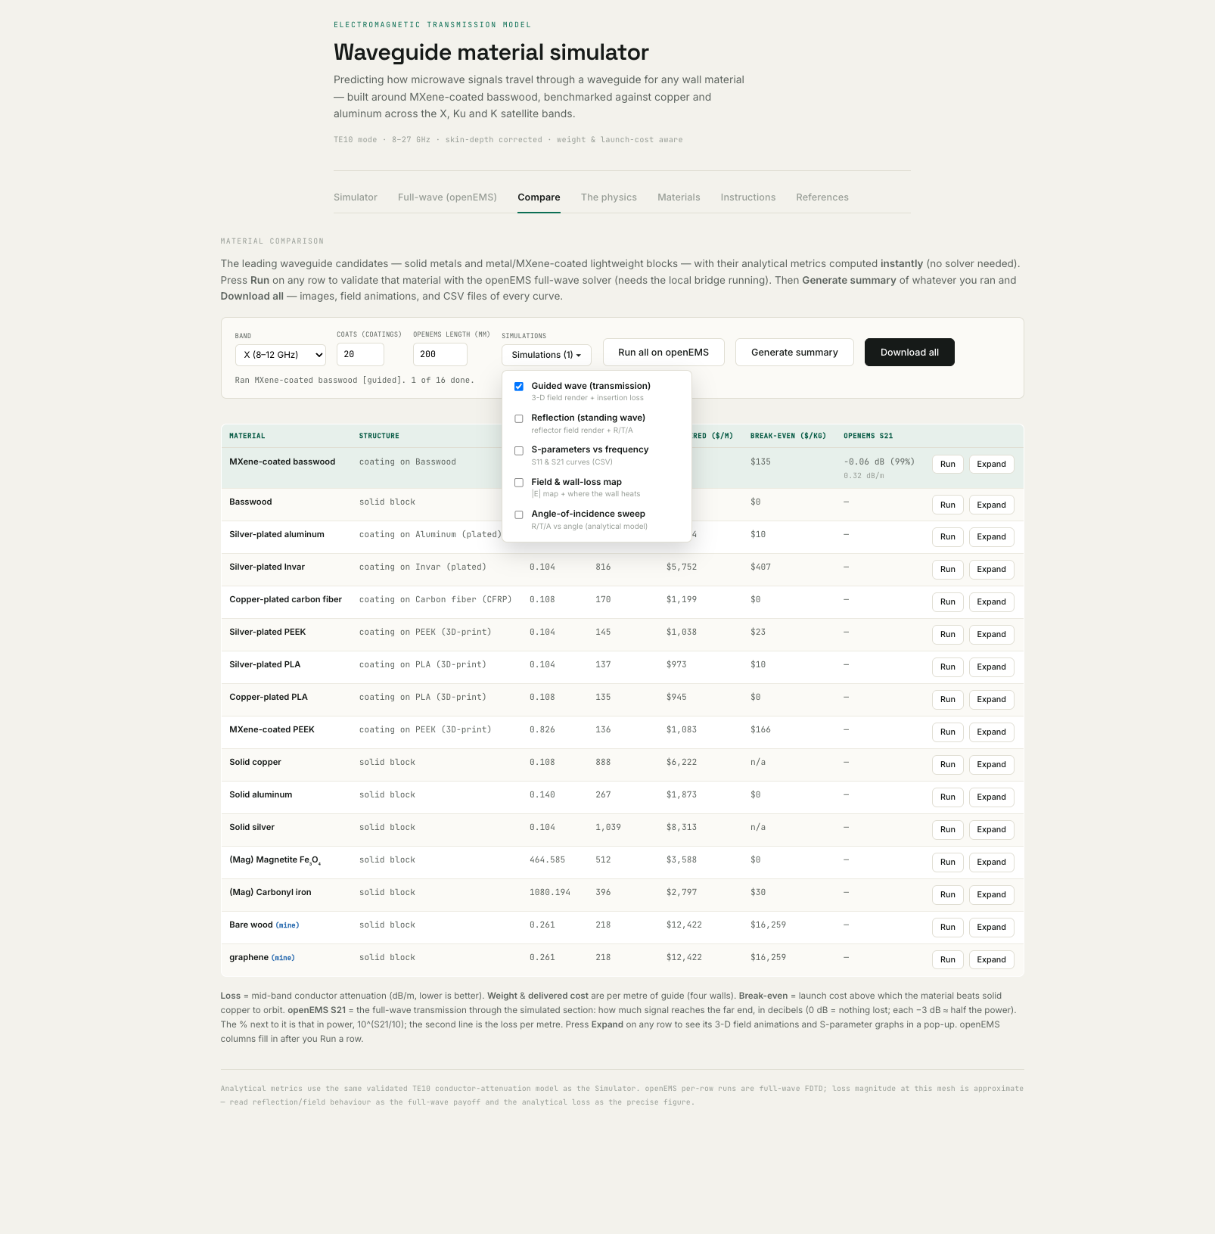
Figure 3 — The Compare view: leading candidate materials benchmarked side-by-side, with selectable openEMS simulations and one-click export of all data and images.
Software skills demonstrated: full-stack web development, scientific / numerical programming, workflow automation, inter-process orchestration and API design, data visualization, computational electromagnetics, multi-objective optimization, inverse modeling / parameter extraction, uncertainty quantification, and a validation-and-testing discipline.

The physics engine
The simulator is built on real electromagnetic theory, implemented directly in code. It uses the rectangular-waveguide TE10 mode, with conductor attenuation from the skin-depth / surface-impedance formulation and a finite-coating correction. Materials enter through a complex permittivity ε = ε₀(εr′ − jεr″) and permeability μ = μ₀(μr′ − jμr″), which yield the loss tangent, penetration depth, and the three microwave-absorption channels (conduction, dielectric and magnetic loss), alongside weight and launch-cost models. The transmission and reflection of a coated wall are solved with the ABCD transfer-matrix method. The open-ended guide's radiation pattern is obtained by a near-field-to-far-field transform, and the same loss model is inverted to extract effective conductivity from measured data. The full-wave solver is time-domain FDTD; the frequency-domain results (S-parameters, far-field) are Fourier-derived from one run, and a Field-view control shows the field as a time-domain animation or a frequency-domain steady |E| map at the centre frequency. A one-click geometry preview — an interactive in-browser 3-D model (three.js) — shows the structure, ports and feed before any run.

From simulator to design tool
The platform does more than evaluate a material you choose — it can choose the material for you. The inverse-design view runs the analytical engine across thousands of candidate walls (every coating on every substrate, over a range of coat counts, plus every solid metal) and returns the Pareto-optimal frontier: the set of designs where signal loss cannot be reduced without adding mass, cost or carbon. For a stated loss budget it names the single best design. This turns a calculator into a design tool, and answers the research question directly — what is the lightest wall that still meets an X-band loss target?
It also closes the loop with the laboratory. Given a measured S-parameter file from a fabricated guide, the platform inverts its own loss model to extract the effective conductivity the coating actually achieved — a characterization capability, not just a predictor. The model that predicts performance is run in reverse to read a material property off the bench and to check whether a real coating is good enough for the intended band.
Finally, the platform is honest about uncertainty. MXene's reported conductivity spans two orders of magnitude, so a single loss figure would be false precision; the physics documentation sets out how a Monte-Carlo pass over the input ranges turns each result into a distribution with a confidence interval, and how a sensitivity analysis identifies which property most deserves to be measured. Every new formula — Pareto dominance, the least-squares conductivity fit and the Monte-Carlo method — is cited in the References tab.

How the results are trusted
The fast analytical engine is validated against textbook physics — for example it reproduces the loss of a copper WR-90 waveguide at 10 GHz (≈ 0.11 dB/m) exactly, along with skin depths and cutoff frequencies. The full-wave solver (openEMS, a free, academically-published FDTD engine) then independently confirms the field behaviour, and every run is written to a history log so accuracy and convergence can be audited after the fact.
Built during a summer research internship at Khalifa University. Precise loss figures come from the validated analytical engine; the full-wave solver provides independent field behaviour and cross-checks. The entire system runs on a laptop with no commercial software or cloud services.
Version 3.6 adds a Reflection Loss (RL) tab in the RCS menu: upload a measured material's dispersion file — CSV, text or Excel, column layout auto-detected (ε′, ε″, μ′, μ″ vs frequency) to get metal-backed reflection loss for every thickness, a thickness–frequency absorption map, effective absorption bandwidth, and a coated flat-plate RCS reduction (bare PEC vs absorber; defaults 180×180 mm, 3 mm, 9 GHz, θ = −90…+90°), with a one-click handoff to the full-wave openEMS RCS solver. Validated against the supplied reference spreadsheet to ~0.01 dB.
Version 3.6 adds a Reflection Loss (RL) tab in the RCS menu: upload a measured material's dispersion file — CSV, text or Excel, column layout auto-detected (ε′, ε″, μ′, μ″ vs frequency) to get metal-backed reflection loss for every thickness, a thickness–frequency absorption map, effective absorption bandwidth, and a coated flat-plate RCS reduction (bare PEC vs absorber; defaults 180×180 mm, 3 mm, 9 GHz, θ = −90…+90°), with a one-click handoff to the full-wave openEMS RCS solver. Validated against the supplied reference spreadsheet to ~0.01 dB.
The Parametric sweep tab runs thousands of analytical reflection-loss calculations across ε/μ and thickness (or a measured material's thickness), ranks every combination by absorption (deepest RL / widest −10 dB bandwidth / best at a target frequency), and exports the full set as CSV — the fast, instant complement to the slower openEMS Batch sweeps.
The Parametric sweep tab runs thousands of analytical reflection-loss calculations across ε/μ and thickness (or a measured material's thickness), ranks every combination by absorption (deepest RL / widest −10 dB bandwidth / best at a target frequency), and exports the full set as CSV — the fast, instant complement to the slower openEMS Batch sweeps.
Version 3.6 brings the Horn antenna tab to parity with the RCS and waveguide tabs: an instant analytical engine (pyramidal + conical, Balanis aperture integration with flare phase error) giving gain, beamwidth, sidelobes and the radiation pattern in real time, plus inverse design, a parametric sweep, design comparison, and a lightweight-coating gain-penalty-vs-mass trade with a Monte-Carlo band — validated against the 15 dBi standard-gain horn, with the openEMS solve as the full-wave check.
Version 3.6 brings the Horn antenna tab to parity with the RCS and waveguide tabs: an instant analytical engine (pyramidal + conical, Balanis aperture integration with flare phase error) giving gain, beamwidth, sidelobes and the radiation pattern in real time, plus inverse design, a parametric sweep, design comparison, and a lightweight-coating gain-penalty-vs-mass trade with a Monte-Carlo band — validated against the 15 dBi standard-gain horn, with the openEMS solve as the full-wave check.

