Waveguide Material Simulator
Complete User Guide — Version 4.0
Space Materials Lab, Khalifa University
Huzaifa Taha Rangwala — UC Berkeley (Math + CS); Visiting Researcher / SWE, Khalifa University, Abu Dhabi
2026 / 1448H
To download or for more information, contact huzaifataha54@berkeley.edu
This guide explains the whole tool in plain language: what it is for, the background you need, and then every tab — what it does, exactly what you see, how to use it click by click, how to read the results with worked examples, common questions, and the honest limits. It assumes no prior expertise; a reader new to microwaves can follow it, and a specialist can use it as a precise reference.

What's new in Version 4.0
Version 4.0 widens the tool from waveguides alone to four domains in one workflow, and hardens what was already there. The physics is unchanged and every value is still cited on the References tab. Highlights:
- Four domains across 21 pages — waveguides, horn antennas, reflection loss from measured permittivity and permeability, and the radar cross section of a 3-D model you upload — grouped under the Waveguide, Horn, RCS + RL and Learn menus.
- Reflection loss from your own laboratory file — upload a raw vector-network-analyser export (CSV, text or Excel) and get reflection loss per thickness, the optimal thickness, the thickness-frequency map and the full table, with Excel and ZIP exports that reproduce the reference spreadsheet to a median of 0.006 dB.
- Radar signature of a real 3-D model (CAD-RCS) — upload a STEP or STL file and get monostatic radar cross section against look-angle, part by part, with a per-facet heatmap and an independent coating for each part drawn from a shared material library.
- Shape improvement — search real deformations of your own geometry for a lower signature in the threat sector you choose. Every candidate is audited for geometric validity before it is allowed to score, and overall length is held by construction so nothing wins by quietly shrinking the object.
- How small does it look to radar? — the same reduction expressed three standard ways — echo power removed, equivalent metal-sphere diameter, and detection range — plus the scale factor solved numerically against your own mesh.
- Analytical horn design — instant gain, beamwidth, sidelobe level and efficiency for pyramidal and conical horns, with inverse design, parametric sweeps, design comparison and a coating-mass trade.
- Six openEMS full-wave analyses behind one shared lock — one solve at a time, enforced on the server as well as in the browser, so a shared link cannot corrupt a run in progress.
- Rotating exports — a GIF of a full turn of the coloured model, and a self-contained interactive page that spins and scrubs offline.
- Installable on a phone or iPad — a progressive web app with native mobile navigation — a top app bar, a bottom tab bar, a drawer and an edge swipe.
- Honest about range — any reflection loss, optimal thickness or comparison outside the frequencies your material was actually measured over is labelled extrapolation instead of being reported as data.
- Everything still labelled and cited — every figure says whether it is analytical, full-wave or measured, and every constant, equation and claim carries a numbered reference on the References page.

0. How to read this guide
You do not have to read cover to cover. Three suggested paths:
- New to the subject? Read Section 1 (Background primer) first, then Section 2, then skim the tab you care about in Section 3.
- Just want to use a specific tab? Jump to its part of Section 3 — each is self-contained and includes step-by-step instructions.
- Want to see it in action? Read Section 5 (Worked examples), which walks through complete real tasks end to end.
Anything in the software also explains itself: every page has an "ⓘ Info" button, and every chart on the simulation tabs has its own small ⓘ, each opening a plain-language popup (with an English / Arabic language toggle).

1. Background primer — the ideas in plain language
If you already know microwave engineering, skip to Section 2. Otherwise, this is everything you need to understand what the tool is doing.

What is a waveguide?
A waveguide is a hollow metal pipe that carries a microwave signal from one place to another — much as a water pipe carries water. On a satellite, waveguides route radio signals between the electronics and the antennas. A horn antenna is simply a waveguide whose end is flared open so the signal radiates out as a beam.

What are microwaves, GHz, and "bands"?
Microwaves are high-frequency radio waves. Frequency is measured in gigahertz (GHz, billions of cycles per second). Satellites use standard frequency ranges called bands; this tool covers three of them — X (8–12 GHz), Ku (12–18 GHz) and K (18–27 GHz). Each band uses a slightly different pipe size, which is why you choose a band before anything else.

Why does the wall material matter?
Inside the pipe the wave repeatedly glances off the inner walls as it travels. If the wall is a perfect mirror (a perfect conductor) almost none of the signal is lost. Real walls are not perfect: a little of the signal leaks through or is absorbed as heat on every bounce. That lost fraction is called insertion loss. Solid metals (copper, aluminium) are excellent mirrors — but they are heavy.

Why does weight matter so much?
Launching anything to orbit costs thousands of dollars per kilogram. So a heavy metal part can cost far more to fly than a light one, even if the light one is more expensive to manufacture. A large part of what this tool computes is exactly this trade-off: performance versus mass versus cost-to-orbit versus environmental footprint.

What is "MXene-coated basswood", the flagship idea?
Basswood is a very light wood. MXene (chemically, titanium carbide, Ti3C2Tx) is a modern two-dimensional material that conducts electricity well and can be applied as a thin coating. The idea: take a light wooden pipe and line its inside with a thin MXene coating. If that thin coating reflects the microwave signal nearly as well as solid metal, you get metal-like performance at a small fraction of the weight. The central research question of this whole tool is: does that actually work, across the satellite bands, once you account for real physics, cost and survivability?

How performance is measured (decibels)
Loss is quoted in decibels per metre (dB/m). Decibels are a compressed scale: every 3 dB lost is roughly half the power gone. Lower dB/m is better. For scale, a good solid-copper X-band guide loses about 0.11 dB/m; a well-coated MXene-basswood guide is in the same neighbourhood, while weighing perhaps a twentieth as much.

The two engines inside the tool
Two independent methods compute everything, and it helps to know which is which:
- The analytical model — textbook equations solved instantly in your browser. It is exact for an idealised smooth pipe and is the source of the precise loss/weight/cost numbers. It needs no installation.
- The full-wave solver (openEMS) — a real 3-D simulation that steps the electromagnetic fields through space and time. It is slower and needs a one-time setup, but it produces the actual field pictures, animations and antenna behaviour, and it independently checks the fast model.

2. What the tool is, at a glance
The tool answers one question rigorously: can a lightweight coated material replace solid metal for satellite waveguides and horn antennas, keeping the radio performance while cutting the mass? It does so three ways — an instant analytical model, a full-wave simulator, and a set of design and characterization tools that pick the best material for you, read a real conductivity back from a lab measurement, and check whether a part can survive in orbit.

The tabs at a glance
Page | What it does | Needs the openEMS server?
Waveguide ▾
Analytical Simulator | Headline loss, weight and delivered-cost result for a material, with the attenuation and material-comparison charts. | No
Full-wave (openEMS) | Real 3-D field renders, S-parameters, wall-loss map and far-field pattern, with the analytical model overlaid on each. | Yes
Inverse design | Searches coating count and wall thickness for the lightest design that still meets a loss budget. | No
Measurement fit | Extracts effective conductivity from a measured .s2p file and feeds it back into the design. | No
Space survival | First-order multipaction and vacuum-thermal screens. | No
Compare | Side-by-side league table of candidate materials. | Analytical: No / Run: Yes
Materials | Define any material — conductor, substrate or multilayer stack. Also reachable from the Horn menu. | No
Horn ▾
Horn design (analytical) | Instant gain, beamwidth, sidelobe level and aperture efficiency for pyramidal and conical horns. | No
Inverse & sweep | Sizes a horn to a target gain, and sweeps aperture against flare length. | No
Compare & trade | Overlays saved horn designs, and trades coating loss against mass saved. | No
Full-wave (openEMS) | FDTD horn: gain vs frequency, radiation patterns, S11, per-coating wall loss, and the interactive 3-D field. | Yes
RCS + RL ▾
RCS (openEMS) | Full-wave radar cross section of canonical targets — sphere, plate, cylinder, dihedral or an imported mesh — bare or coated. | Yes
Reflection loss (RL) | Absorber performance from your own measured permittivity and permeability, with the thickness-frequency map. | No
Fast material search (analytical) | Thousands of closed-form absorber evaluations in seconds; ranks a whole design space. | No
Inverse RAM design | Searches absorber recipes — Dallenbach, Salisbury, Jaumann — against a target, with a Pareto front and the Rozanov bound. | No
Material library | The shelf of materials pinned from the RL tab, compared side by side and shared with the CAD-RCS part list. | No
Full-wave batch (openEMS) | Runs one full-wave solve per point across a swept parameter. | Yes
CAD-RCS (STEP/STL) | Radar signature of an uploaded 3-D model, part by part, plus the shape-improvement search. | No (the optional cross-check: Yes)
Learn ▾
The physics | Every equation, derived and cited, with a contents index and a Print / Save as PDF button. | No
Instructions | In-app quick start, all 21 pages, and how to set the solver up. | No
References | Every value and formula with its source, plus the self-validation report. | No
Note: "Needs the server" means the full-wave "Run on openEMS" buttons. Everything else works by simply opening the file in a browser.

3. Getting started
Just open the link https://desktop-dbcfmfa.tail53b2e4.ts.net/

4. The tabs, one by one
Each tab uses the same layout: in plain terms · what you see · how to use it (step by step) · reading the results (with an example) · common questions · honest limits.

4.1 Simulator

In plain terms
The headline dashboard. Pick a band and it shows, instantly, how well the current wall material carries a signal, plus its weight, cost to orbit and environmental footprint, and a radar chart placing it against copper, aluminium and bare basswood. This is the first screen to show someone.

What you see
- Band selector (X, Ku, K), which also sets the pipe size.
- A row of summary cards: insertion loss; the coating-to-skin-depth ratio (a check that the coating is thick enough); penetration depth; loss tangent; the dominant loss mechanism; weight per metre; delivered cost to orbit; and the break-even launch cost versus copper. Click any card to expand a plain-language explanation.
- An attenuation-versus-frequency chart across the band, and a five-axis radar chart (cost, weight, performance, sustainability, environmental friendliness).
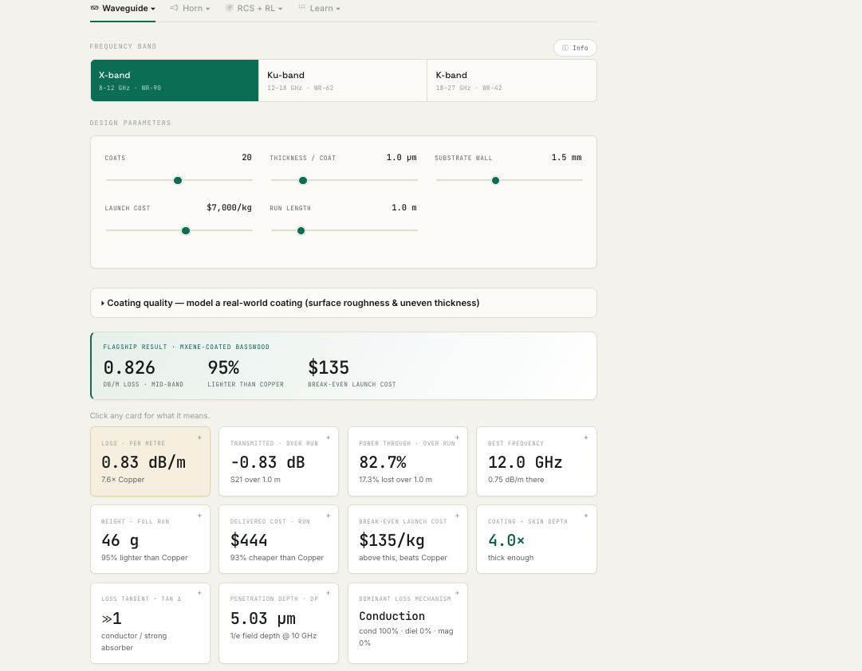
The Simulator tab, upper half: the band selector, the design sliders, the flagship headline and the twelve derived cards. Every number recomputes as a slider moves — nothing has to be pressed.
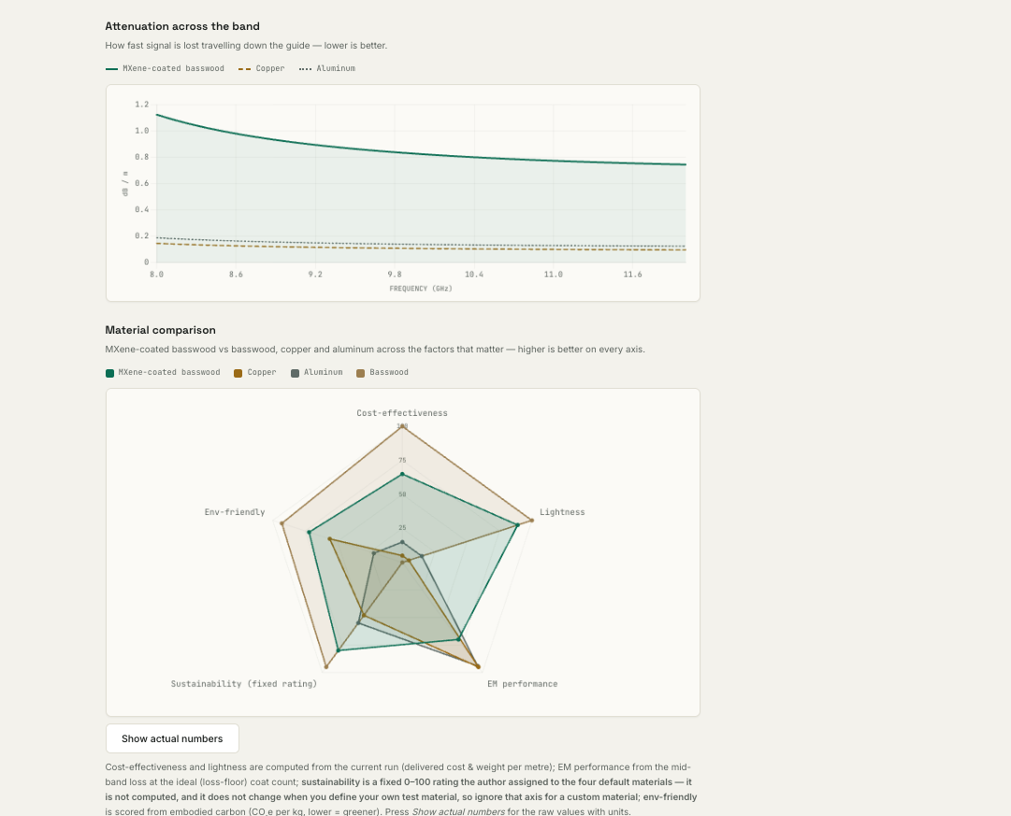
The Simulator tab, lower half: attenuation across the band against solid copper and aluminium, and the material-comparison chart. Four of its five axes come from the current run; the sustainability axis is a fixed rating and is labelled as one.

How to use it — step by step
- Choose a band with the buttons at the top.
- The results use the "test material" defined on the Materials tab (default: MXene-coated basswood). To try another material, change it on the Materials tab and press Apply; this tab updates instantly.
- Click any summary card to read exactly what that number means.

Reading the results (with an example)
Lower insertion loss is better. On the radar chart a larger enclosed shape is better overall. Example: with the default MXene-coated basswood at X-band you will see a loss on the order of a fraction of a dB per metre, a weight around 45–50 grams per metre (versus roughly 890 for solid copper), and a break-even launch cost telling you above what price-per-kg the light material wins on total cost to orbit.

Common questions
Q: The break-even says "$135/kg" — what does that mean? A: Above that launch price, the light material is cheaper to deliver to orbit than copper. Real launch is thousands of dollars per kg, far above break-even, so the light material wins comfortably.
Q: Why is the coating-to-skin-depth ratio flagged? A: The signal only "feels" a thin surface layer (the skin depth). If the coating is thinner than a few skin depths, the wave leaks through and loss rises. The card warns you when to add coats.

Honest limits
These are exact results for an idealised, smooth-walled, single-mode pipe — the right numbers for screening and comparison. The Full-wave tab adds the real 3-D behaviour.

4.2 Full-wave (openEMS)

In plain terms
The real electromagnetic simulator for a straight waveguide. Instead of formulas it builds a 3-D model, runs the openEMS solver, and shows you the wave actually moving, the scattering parameters, the radiated beam, and where the wall heats. It is how you see the physics and confirm the fast model. openEMS is a time-domain (FDTD) solver, so the frequency-domain results (S-parameters, far-field, R/T/A) are Fourier-derived from one run. A "Field view" control lets you show the field as a time-domain animation or as a frequency-domain steady |E| map at the band-centre frequency.

What you see
- Controls for band, material, number of coats, and guide length.
- Ports: 1-port (reflection / S11 only) or 2-port (through; S11 and S21).
- Mesh density: how finely space is divided (finer = more accurate, more memory/time); the estimated cell count and RAM are shown live.
- A Simulations tick-box with six analyses you mix and match: guided wave (travelling-wave animation), reflection (standing-wave animation), S-parameters (S11/S21 vs frequency), field & wall-loss map (where the wall heats), angle-of-incidence sweep, and far-field radiation pattern (the beam from the open end, via the openEMS NF2FF transform).
- A multi-layer coating stack option: substrate plus up to three stacked coatings (Layer 1 = innermost, facing the wave).
- Result charts, each with its own ⓘ button, plus field animations and stills.
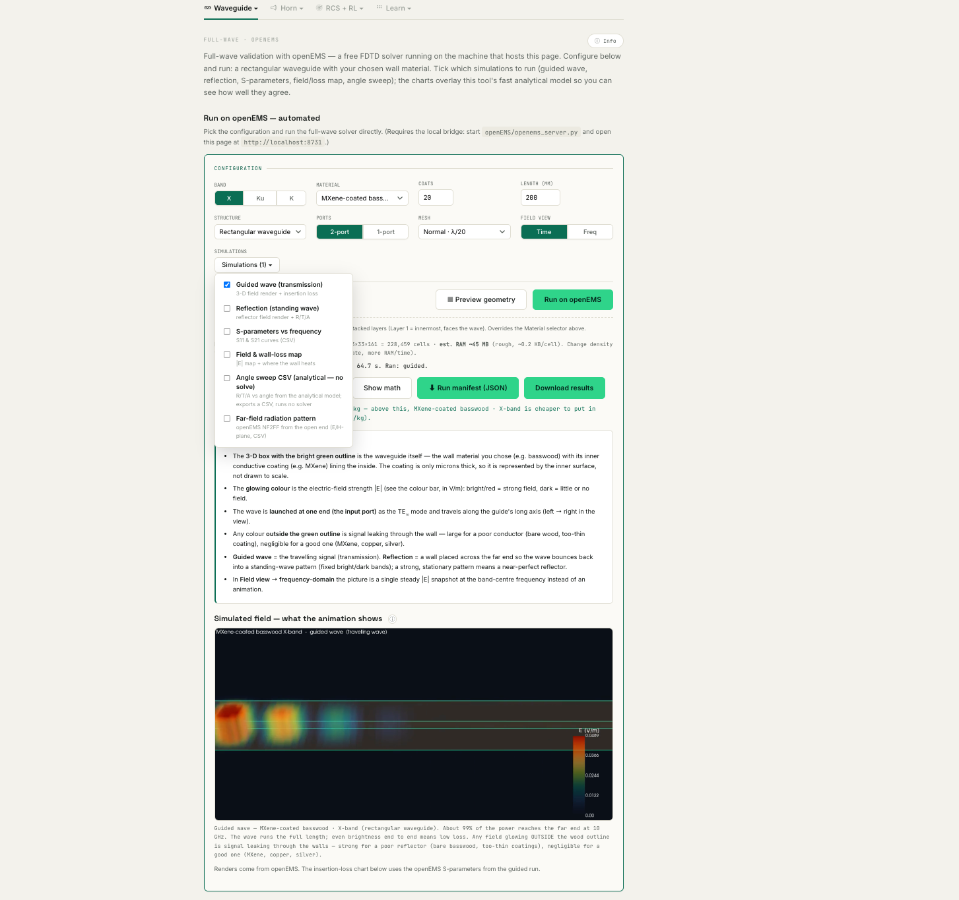
The Full-wave tab: the Configuration panel, the Simulations chooser with all six openEMS analyses, and the field render from the finished solve. Mesh size and estimated memory are reported before you press Run.
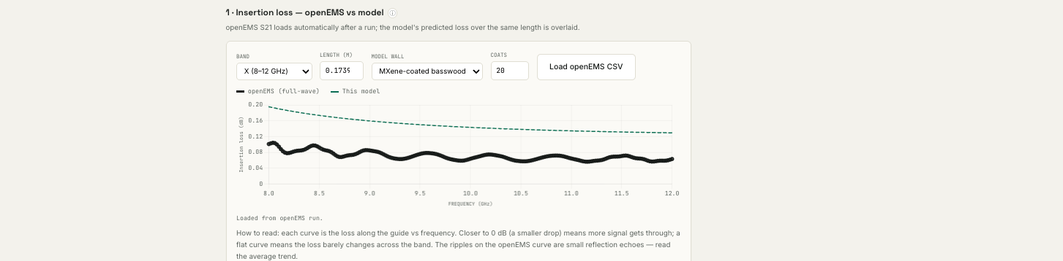
Insertion loss after a full-wave run. The dashed curve is this tool's fast model; the solid curve is the openEMS S-parameters, loaded automatically from the solve. They are always drawn together, so the agreement is something you can see rather than something you are told.

How to use it — step by step
- Make sure the bridge server is running and you opened the page at http://localhost:8731.
- Set band, material, coats and length; choose 1- or 2-port and a mesh density.
- Tick only the analyses you want this time (you need not run all six).
- Press Run on openEMS and wait a couple of minutes per full-wave analysis; results load into the charts automatically.

Reading the results (with an example)
Insertion loss / S21 closer to 0 dB = less lost (dashed = fast model, solid = openEMS). S11 more negative = better input match. In the field animation, bright = strong field; on a good wall the wave stays inside the outline, on a leaky wall you see it escaping — that escaping field is lost signal. Example: run "guided wave" + "S-parameters" for MXene-coated basswood at X-band and you should see a bright wave running the full length with most of the power reaching the far end, and an S21 close to 0 dB.

Common questions
Q: I ran it but saw no field animation. A: A field GIF is produced only by the guided or reflection simulations. If you ticked only S-parameters, there is no animation to show — tick "guided wave" too.
Q: The far-field openEMS curve did not appear. A: Tick the sixth simulation, "Far-field radiation pattern", and Run; it is a separate solve that overlays on the analytical pattern.
Q: S11 dips oddly near the low band edge. A: That is a known numerical artifact of waveguide ports close to cutoff, not a material effect; the analytical model gives the true low reflection.

Honest limits
At practical mesh sizes the openEMS loss magnitude is approximate — quote the analytical model for the precise loss, and read the full-wave results for field behaviour, reflection and radiation. Coatings are modelled by their surface impedance because a micron-thin layer cannot be meshed directly (this is the physically correct method).

Geometry preview — the pre-simulation 3-D model
Both the Full-wave and Horn tabs have a "▦ Preview geometry" button that opens a large pop-up showing the structure that will be simulated — its shape, wall material and where the wave is fed — before you run anything. It is the equivalent of the 3-D model view in commercial tools such as CST.
Interactive 3-D model. Drawn live in your browser with WebGL (three.js) from the exact settings you have chosen — band (which sets the guide cross-section), length, number of coats and port count. Drag to rotate, scroll to zoom; it appears instantly and needs no server. It is a faithful schematic: the dimensions and the input/output port positions are correct, but it is a drawn representation rather than the solver’s mesh, and because the conductive coating is only microns thick it is shown as a highlighted inner lining, exaggerated so you can see it. It does not compute any fields — it only shows the model. A colour key and the exact dimensions are printed beneath the model.
To use it: choose your band / length / coats / ports on the tab, press "Preview geometry", then rotate and zoom the model; press Esc or Close to exit (nothing is lost). Colour key:
- Sand/tan box = the wall (substrate, e.g. basswood).
- Teal inner lining = the conductive coating (e.g. MXene) on the inside surface (not to scale).
- Green plane = the input port, where the TE10 wave is launched; the green arrow is the feed direction; yellow arrows show the E-field orientation.
- Blue plane = the output port (2-port mode; in 1-port mode the far end is an absorbing termination).
- For the horn: the flared walls, the feed port at the narrow end, and the aperture outline are shown.

4.3 Horn antenna (openEMS)

In plain terms
The full-wave model for a horn antenna — a flared open waveguide that radiates a beam. It shows how well a coated horn radiates versus a solid-metal one, and reproduces the full set of antenna measurements a reviewer expects. A "Field view" control switches the horn field between the frequency-domain steady |E| (default, with the dB/linear scale) and a time-domain animation.

What you see
- Gain versus frequency across the band.
- Input match versus frequency: S11, its phase, VSWR, and input impedance.
- The radiation pattern at band centre in both principal planes (E-plane and H-plane), with co- and cross-polarization.
- The interior field (with a decibel/linear scale toggle), the an interactive 3-D geometry model, and a coating-comparison table.
- An Excel export of everything, and a "run all materials" batch.

How to use it — step by step
- With the server running, choose the band; optionally upload a CAD .step file of your own horn, otherwise the validated WR-90 standard-gain horn is used.
- Press Run (or "run all materials" to compare every coating in one pass).
- Download the Excel workbook for the full numeric results.

Reading the results (with an example)
Gain (dBi): higher = a more focused, stronger beam, and it rises with frequency for a fixed horn. In the radiation pattern the peak at 0 degrees is the main beam (its height is the directivity), the width where it drops 3 dB is the beamwidth, and the small side bumps are sidelobes. Example: the default WR-90 horn should give a directivity around 14–15 dBi near 10 GHz, which is exactly the rated figure for that standard-gain horn — a built-in sanity check.

Common questions
Q: Why does the interior field get dimmer toward the mouth? A: That is real physics — the wave spreads out as it radiates, so the amplitude falls. The dB scale toggle keeps the pattern visible all the way out.
Q: How can every coating be compared from one run? A: Wall loss is obtained by the surface-impedance method from a single full-wave solve; a separate lossy solve per coating could not resolve the micron skin depth.

Honest limits
Gain, pattern and reflection are the trustworthy full-wave outputs; the absolute loss magnitude is approximate. Directivity is validated against the rated ~15 dBi horn.

4.4 Inverse design

In plain terms
The tool that designs for you. Rather than you guessing a material and reading its performance, you state the goal and it searches the whole catalogue for the best design. It turns a calculator into a design tool.

What you see
- Controls: band; what to minimize (mass, delivered-to-orbit cost, or embodied CO2); the maximum acceptable loss; and the launch cost per kilogram.
- A recommended-design card; a "design space" chart plotting every candidate as loss versus your objective, with the Pareto-optimal frontier highlighted and the recommendation marked; and a ranked table.
- A "Send to Full-wave (openEMS)" button on the recommendation, and a "Trade-space report (X/Ku/K)" button.

How to use it — step by step
- Choose the band, the objective to minimize, and your maximum loss.
- Press Optimize. It evaluates thousands of designs (every coating on every substrate, over a range of coat counts, plus every solid metal) in an instant.
- Read the recommendation and the frontier; scan the ranked table for alternatives.
- Press "Send to Full-wave (openEMS)" to load that exact design into the Full-wave tab, ready to simulate; or "Trade-space report" to run it across all three bands and export the result.

Reading the results (with an example)
On the design-space chart both axes are logarithmic and lower-left is best (low loss AND low mass/cost/carbon). The green line is the Pareto frontier — designs where you cannot improve one axis without worsening the other; anything up-and-right of it is beaten by a better design. The orange marker is the recommendation for your target. Example: ask for the lightest X-band guide under 0.5 dB/m and it may recommend a graphene- or MXene-coated basswood at a specific coat count, showing its loss, grams per metre, and cost — with solid copper sitting far to the heavy side of the frontier.

Common questions
Q: It says "no design meets your target". A: Your maximum loss is too strict for the catalogue; it then shows the lowest-loss design instead. Relax the loss limit and re-optimize.
Q: Can I trust the recommendation directly? A: Treat it as a screening shortlist. Press "Send to Full-wave" and confirm the winner with a real openEMS run before quoting it.

Honest limits
This is a screening optimizer over the fast analytical model, evaluated at band centre. It is excellent for narrowing thousands of options; confirm a chosen design in full-wave.

4.5 Measurement fit

In plain terms
The bridge between the laboratory bench and the model. Every other tab predicts performance from an assumed conductivity; this one works backwards — give it a real measured curve and it tells you the conductivity your fabricated coating actually achieved. That is a characterization capability, and it is the feature most specific to a materials lab. The tab has its own "Instructions" popup too.

What you see
- A file upload for your measurement.
- Controls: band, the guide length you measured over, the fit mode (effective solid-wall conductivity, or coating-on-substrate), and — in coating mode — the substrate permittivity and coat count.
- Outputs: the extracted conductivity with a confidence range, an overlay of measured versus modelled, a plain-language interpretation, and a "Save as lab-calibration sample" button (see Section 6).

How to use it — step by step
- Measure a coated waveguide section of known length on a Vector Network Analyser (VNA) and save its transmission (S21) as a Touchstone .s2p file — or a CSV with two columns: frequency in GHz and S21 in dB.
- Press Upload S21 and choose the file.
- Set the band and the guide length; choose the fit mode.
- Press Fit. Read the extracted conductivity, the confidence range, and the measured-versus-modelled overlay.

Reading the results (with an example)
A close overlay of the measured points and the fitted curve means the extracted conductivity genuinely explains your measurement. Example: measure a 20-coat MXene guide over 200 mm; the tool might report an effective conductivity around 10^6 S/m — squarely in the published MXene-film range — telling you your process is performing as expected. Where do you get a .s2p? It is the standard export of any VNA (Keysight, Rohde & Schwarz, Anritsu, Copper Mountain, even a NanoVNA): connect the coated guide between the two VNA ports through waveguide-to-coax adapters, calibrate, sweep the band, and Save as Touchstone.

Common questions
Q: I do not have a measurement yet — can I still try it? A: Yes. Upload a CSV (frequency, S21 in dB) to see how the tab behaves; you can even export a simulated curve from elsewhere to test it.
Q: The fit looks offset from my data by a constant. A: That usually means connector or mismatch loss that is not wall loss; calibrate and de-embed the adapters first.

Honest limits
It assumes the loss is wall-dominated (a well-matched guide); large connector/mismatch losses bias the conductivity low. The value returned is an RF-effective conductivity — it folds true conductivity, surface roughness and thickness non-uniformity into the one number that reproduces the observed loss, which is exactly the figure you want for RF design.

4.6 Space survival

In plain terms
Two go/no-go screens for whether a part can physically survive in orbit — questions a general electromagnetic tool never asks. Low loss is necessary but not enough; two vacuum-specific failure modes decide flight-readiness.

What you see
- Multipaction screen: set band and peak power; it reports the frequency-times-gap product and the peak voltage across the gap, with a low / watch / high flag.
- Vacuum power-handling screen: set the wall, coats, length, input power, surface emissivity and the temperature of the surroundings; it reports the steady-state wall temperature and the maximum safe power.

How to use it — step by step
- For multipaction, choose a band and enter the peak power your system will carry.
- For heating, choose the wall and set input power, length, emissivity and the surrounding temperature.
- Read the flags; adjust power or design if you are in a risky region.

Reading the results (with an example)
Multipaction is a vacuum electron avalanche that can destroy the signal at high power; the tool flags whether your peak gap voltage is near the risky range for metals (roughly hundreds to a thousand volts). Heating: in vacuum the wall can only radiate away the power it absorbs, so it can get hot; the tool gives the steady-state temperature and the maximum power before the coating degrades. Example: MXene-coated basswood carrying 100 W over 1 m at X-band might sit only tens of degrees above its surroundings — comfortably safe — while telling you it could handle on the order of a kilowatt before reaching the MXene temperature limit.

Common questions
Q: Emissivity — what should I use? A: It is how readily the surface radiates heat. A bare shiny metal is low (~0.1) and runs hotter; a coated or oxidised surface is higher (~0.5–0.9). Use a value representative of your finish; it matters a lot.
Q: Are these final verdicts? A: No — they are first-order screens. Use them to catch obvious problems early, then verify by test.

Honest limits
A quantitative multipaction verdict needs the wall's secondary-electron-yield curve and a full ECSS analysis — and MXene's yield is essentially unmeasured, which is itself an open research question. The thermal model is a lumped radiative balance; real hardware also conducts heat to its mounts, which helps.

4.7 Compare

In plain terms
A side-by-side league table of the leading candidates — solid metals and metal/MXene-coated lightweight blocks — ranked on the factors that matter, with the option to validate any row in openEMS.

How to use it
The analytical loss, weight, cost and break-even load instantly for every candidate. Press Run on any row (server required) to validate it in full-wave; use "run all" to batch, "generate summary" to summarise whatever you ran, and "download all" to export every image, animation and CSV organised by material.

Reading the results
Lower loss, weight and delivered cost are better; the break-even column is the launch price above which a material beats solid copper to orbit. Expand any row to see its field animations and S-parameter graphs.

4.8 The physics

In plain terms
The complete derivation behind every number, with a literature citation on every equation. It is a reference, not a control panel — the place a reviewer checks the science.

What it covers
- The waveguide chain: TE10 mode, cutoff frequency, skin depth, surface resistance (with the thin-coating correction), and the attenuation that becomes the loss curve.
- Material response: complex permittivity/permeability, loss tangent, the three absorption channels (conduction, dielectric, magnetic), penetration depth and heating rate.
- The multilayer transfer-matrix method for stacked coatings.
- Horn-antenna figures of merit: directivity, gain, aperture efficiency, beamwidth, sidelobe level, front-to-back ratio, input match (S11, VSWR, impedance), radiation efficiency and realized gain.
- The open-ended waveguide far-field pattern and the near-field-to-far-field transform.
- Inverse design and Pareto optimality; the measurement inverse-fit; and uncertainty quantification (why one number is false precision, and how a Monte-Carlo pass turns each result into a distribution with a confidence interval).
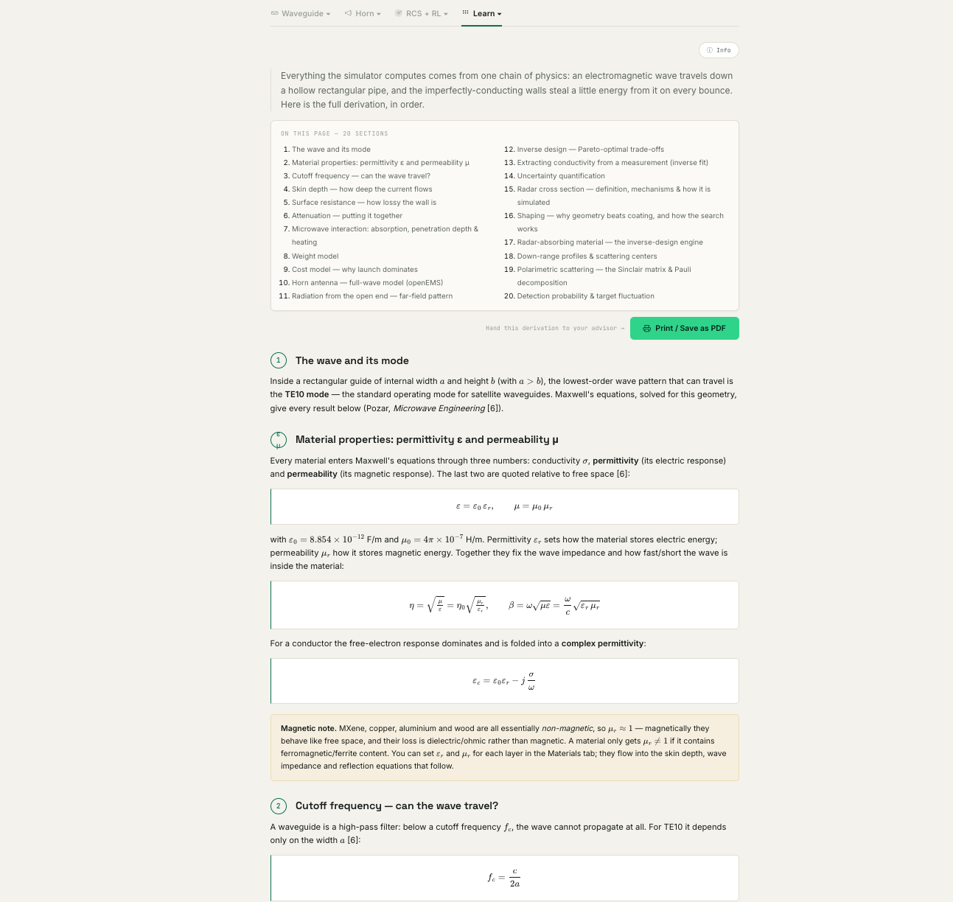
The physics tab: twenty sections of derivation, each equation carrying the numbered reference it comes from, with a contents index at the top and a Print / Save as PDF button.

4.9 Materials

In plain terms
Where you define materials. Edit the test material (a coating on a substrate, or a solid block) and the two baselines, press Apply, and the whole tool recomputes for your material.

How to use it
Set conductivity, density, price and embodied carbon; for a coating, set the coating and the substrate separately. A "quick pick" dropdown loads any preset candidate, and a per-field selector lets you enter loss either as an imaginary permittivity or as a loss tangent. The file material_properties.txt in the project folder lists ready values for copper, aluminium, silver, gold, MXene, graphene and several substrates.

4.10 Instructions

In plain terms
The in-app quick start and full setup guide. It explains what a simulator is, what each tab does, how to make your own material, and — in two collapsible sub-sections — exactly how to run the whole folder on macOS and on Windows (what to install, the terminal commands, and the machine paths to edit if you were handed the folder).

4.11 References

In plain terms
Every value and every formula the tool uses, each with its source — conductivities, densities, prices, embodied carbon, the electromagnetic and antenna formulas, the optimization and measurement methods, and the space-survivability standards.

The self-validation report
Press "Run validation report" and the tool recomputes textbook benchmarks live (for example copper WR-90 loss at 10 GHz, the cutoff frequency, the copper skin depth, and the reference masses) and shows expected versus computed with a pass/fail result. "Save as PDF" produces a clean printable report — the tool demonstrating on demand that its engine reproduces known physics.

5. Worked examples (complete walkthroughs)

Example 1 — Is MXene-coated basswood good enough at X-band?
- Open the Simulator tab and select the X band.
- Read the insertion-loss card (a fraction of a dB/m), the weight card (~45–50 g/m vs ~890 for copper), and the break-even card.
- Open the Full-wave tab, keep the default material, tick "guided wave" and "S-parameters", and Run.
- Confirm the wave runs bright the full length and S21 sits near 0 dB. Conclusion: near-metal RF performance at a fraction of the mass.

Example 2 — Find the lightest Ku-band guide under 0.3 dB/m
- Open Inverse design; set band = Ku, minimize = Mass, max loss = 0.3 dB/m.
- Press Optimize. Read the recommended design and where it sits on the Pareto frontier.
- Scan the ranked table for close alternatives (maybe a different coating or coat count).
- Press "Send to Full-wave (openEMS)" and Run to confirm the winner in full-wave.

Example 3 — Extract the real conductivity of a coating and design from it
- Measure a coated guide of known length on a VNA; save S21 as .s2p.
- Open Measurement fit, upload the file, set band and length, choose the fit mode, and press Fit.
- Press "Save as lab-calibration sample". Tick "Use my calibrated conductivity across the tool".
- Go to Inverse design and Optimize — it now uses your measured conductivity (a badge confirms it), and any design you Send to openEMS carries it too.

Example 4 — Will it survive 200 W in orbit?
- Open Space survival. In the multipaction screen set the band and peak power = 200 W; read the flag.
- In the heating screen set the wall, length, input power = 200 W, a representative emissivity and the surroundings temperature.
- Read the steady-state wall temperature and the maximum safe power. If over the limit, reduce power or improve cooling and re-check.

6. Features that span several tabs

The self-calibrating loop (measure → learn → design → simulate)
This is the tool's most distinctive workflow, connecting three tabs. On Measurement fit, after fitting a measured sample, press "Save as lab-calibration sample." As you save samples, the tool learns your process's real coating conductivity and shows it in a calibration panel. Tick "Use my calibrated conductivity across the tool", and from then on the Inverse design optimizer uses your measured number instead of the literature value (a badge appears on the recommendation), and any design you Send to the Full-wave openEMS tab carries your measured conductivity too. In short: measure your real material, and the tool designs and simulates from what your lab actually achieves. The calibration persists across sessions.

Send an optimized design to openEMS
On the Inverse design recommendation, "Send to Full-wave (openEMS)" jumps to the Full-wave tab pre-loaded with that exact design — material, substrate, coat count and band — so you can verify the screening result in full-wave with one click.

The validation report (References tab)
A one-click report recomputes textbook benchmarks and shows the engine reproduces them, exportable as a PDF. It is the credibility exhibit.

The trade-space report ("produce a result")
On Inverse design, "Trade-space report (X/Ku/K)" runs the optimizer across all three bands for your objective and loss target, tables the best design per band, and exports both a CSV of every Pareto-optimal design and a printable PDF. This turns the tool into a finding you can put directly into a paper — for example, the lightest wall that meets each band's loss budget, and where MXene beats metal.

7. How the numbers are trusted
- The fast analytical engine is validated against textbook physics — for example it reproduces the loss of a copper WR-90 waveguide at 10 GHz (about 0.11 dB/m) exactly, along with skin depths, cutoff frequencies and reference masses. The References tab can demonstrate this live.
- The full-wave solver (openEMS) is a free, peer-reviewed, publication-grade FDTD engine; published benchmarks put it within a few percent of commercial solvers. It independently confirms field behaviour and is checked against the analytical loss and the rated 15 dBi standard-gain horn.
- Every run is logged, and every input value and formula is cited in the References tab.
- Honest caveats are stated throughout: openEMS loss magnitude at practical mesh sizes is approximate; the analytical model is exact for the idealised 1-D layered problem; the survivability screens are first-order; and the sustainability and embodied-carbon figures are ballpark.

8. Troubleshooting
The browser says it cannot connect at localhost:8731. The bridge server is not running. Start it (Instructions tab, Option B) and keep that terminal window open.
"Run on openEMS" gives an error about openEMS or Octave. The full-wave toolchain is not installed yet, or a machine path needs editing. See the Instructions tab setup for your operating system.
No field animation appeared after a run. Field animations come only from the guided or reflection simulations. Tick "guided wave" and run again.
The openEMS far-field curve is missing. Tick the sixth simulation, "Far-field radiation pattern", then Run.
The analytical and openEMS loss numbers differ. Expected. Quote the analytical model for the precise loss; read openEMS for field behaviour, reflection and radiation.
A run is slow. Full-wave runs take minutes, and a finer mesh takes longer. Use a coarser mesh for quick looks and a finer one to confirm.
Equations or charts do not render. The page needs an internet connection the first time to load fonts, charts and the equation renderer.
The Save-as-PDF report did not open. Allow pop-ups for the page; the printable report opens in a new tab, then use your browser's "Save as PDF".

9. Glossary of key terms
Term | Plain-language meaning
Waveguide | A hollow metal pipe that carries a microwave signal.
Horn antenna | A waveguide with a flared open end that radiates a beam.
TE10 mode | The standard single pattern in which a wave travels down a rectangular waveguide.
Insertion loss | How much signal is lost travelling down the guide, in dB per metre. Lower is better.
Decibel (dB) | A compressed ratio scale; roughly, every 3 dB is a factor of two in power.
S11 | Fraction of power reflected back at the input; more negative (dB) is a better match.
S21 | Fraction of power that gets through; closer to 0 dB is lower loss.
Cutoff frequency | The lowest frequency a given guide can carry; below it nothing propagates.
Skin depth | The very thin surface layer the current flows in; a coating must be several skin depths thick to act like metal.
Surface resistance | How lossy the wall is per unit area; sets the insertion loss.
Conductivity (sigma) | How well a material carries current; MXene is far below copper but far above a plastic.
Permittivity / permeability | How a material stores electric / magnetic energy; inputs to the physics.
Loss tangent | How lossy a dielectric is; ratio of energy dissipated to stored.
VSWR | A match measure from S11; near 1 is well matched.
Directivity / Gain (dBi) | How focused and strong an antenna beam is.
Beamwidth (HPBW) | The angular width of the main beam at half power (-3 dB).
NF2FF | Near-field-to-far-field transform: how the solver turns nearby fields into the far beam.
FDTD | Finite-difference time-domain: the full-wave method openEMS uses.
Pareto frontier | The set of best trade-off designs; you cannot improve one goal without worsening another.
Multipaction | A vacuum electron-avalanche failure mode at high RF power.
Emissivity | How readily a surface radiates heat; affects how hot a wall gets in vacuum.
Embodied carbon (CO2e) | The greenhouse-gas cost of making a kilogram of the material.
.s2p (Touchstone) | A standard file, exported by a VNA, holding measured S-parameters.
VNA | Vector Network Analyser: the instrument that measures S-parameters.

10. Radar cross section (openEMS) — the RCS instrument (new in v3.4)
Radar cross section (RCS) measures how strongly a target scatters a radar wave back toward the receiver. This tab is a full materials-testing instrument for RCS built on the same openEMS full-wave engine as the Full-wave and Horn tabs, and it is laid out the same way: a configuration panel, a black button row on top of the results (Download all, Summary, Show math, Run manifest), the field animations shown above the graphs, and the analytical reference drawn dashed against the solid openEMS curve. All of the RCS formulas live on the “The physics” tab, cited.

In plain terms
You pick a target (a sphere, plate, cylinder, dihedral corner, or your own imported CAD mesh), choose whether it is bare metal, metal + a coating, or a solid material, set the radar band and viewing angle, and press Run. openEMS launches a plane wave at the target and measures the echo. The headline number is the backscatter RCS in dBsm (decibels relative to one square metre); lower means harder to detect. If you add a radar-absorbing coating, the tab reports the RCS reduction in dB versus bare metal — the core of the stealth-materials use case.

What you see
- A configuration panel: target shape, construction (bare metal / coating / solid), material (catalog or a custom σ, εr, μr entry), polarization (V or H), incidence angle, radar band (X/Ku/K or a custom range), mesh density, solver accuracy and frequency points.
- A “Simulations” dropdown to pick what to produce from a single solve: monostatic RCS vs frequency, bistatic H-plane and E-plane cuts, a scattered-field animation, a rotating 3-D scattering lobe, and an aspect-angle turntable sweep.
- Results: a headline (RCS at band centre, reduction vs bare metal, size regime ka), the field GIFs on top, then the charts, each with the dashed analytical reference where one exists (exact Mie for a sphere; physical optics for plate/cylinder/dihedral).

How to use it — step by step
- 1) Pick a target shape and its size, or click a preset in “Standard RCS benchmarks” at the top of the tab (sphere, plate, dihedral).
- 2) Choose the construction: bare metal (PEC) for a pure scatterer, or a coating/solid material to test a radar-absorbing material.
- 3) Set the band, polarization and incidence angle; tick the simulations you want in the dropdown.
- 4) Press “Run RCS on openEMS”. A live progress bar shows the real openEMS energy-decay percentage during the solve (1–3 minutes).
- 5) Read the headline, compare the solid openEMS curve to the dashed analytical reference, and use the black buttons on top to download everything, copy the run summary, show the per-run math, or save the run manifest.

Reading the results (with an example)
A 15 mm conducting sphere at 10 GHz sits at ka ≈ 3 (the optical regime), where the exact backscatter tends to π·a² ≈ −31.5 dBsm. The openEMS solve returns about −31 dBsm — within ~1 dB of the exact Mie value, which is the expected full-wave accuracy. Read the shape of the curve as exact and the last decibel of magnitude as mesh-limited.

Standard RCS benchmarks
Near the top of the tab — just under the configuration — is a “Standard RCS benchmarks” panel with one-click presets. The conducting sphere versus the exact Mie series is the headline validation (closed-form, no measurement uncertainty). The flat plate and 90° dihedral corner validate against physical optics. The NASA almond (Woo et al., 1993) is offered as a named literature benchmark — honestly flagged as a hard target for a Cartesian-grid FDTD (a smooth curved body staircases), so expect a qualitative match at 1.19 GHz and only approximate levels at 7 GHz.

Radar range & detectability
A radar-range calculator turns an RCS into a detection range using the radar range equation R = [Pt·Gt·Gr·λ²·σ / ((4π)³·Pmin·L)]^(1/4). Because range scales as σ^(1/4), a coating that cuts RCS by Δ dB shrinks the detection range by 10^(−Δ/40) — the number that makes radar-absorbing material worth its mass. The target RCS auto-fills from your last solve; every radar parameter is editable. It is a first-order free-space estimate, not a specific-radar prediction.

Importing your own geometry (STEP / STL)
Choose the “Imported CAD (STL/STEP)” target shape and upload an .stl, .step or .stp file. The bridge converts STEP to STL, recentres it at the origin and reports its size and half-extent, and openEMS solves it as a perfect conductor. Imported meshes are staircased by the Cartesian grid, so results are approximate — validate against a canonical shape first, and keep the target inside the electrical-size limit (half-extent ≤ 5·λ). The import was validated by importing a 15 mm sphere mesh and recovering the same ≈ −31 dBsm as the analytical sphere.

Live progress and the run manifest
During any openEMS solve (this tab, Full-wave, or Horn) the progress bar now shows the true solver state streamed from openEMS — the FDTD energy-decay percentage — instead of only a time estimate. Every one of the three openEMS tabs also has a “Run manifest” button that saves a JSON record of the solver version, the full configuration, the mesh, the results and the honest caveats; the same manifest is baked into each tab’s downloaded report so any figure can be traced back to the exact run that produced it.

Honest limits
- FDTD-only: valid for small canonical targets (a few wavelengths), not whole vehicles — those are physical-optics / SBR territory, as the tab states.
- The full-wave magnitude is mesh-limited to a few dB; the dashed analytical curve is the exact reference.
- Imported meshes and coatings: imports are solved as PEC only, and a smooth CAD surface is staircased — treat imported RCS as approximate.
- The flagship MXene-coated basswood remains hardware-unvalidated for RCS; the coating comparison is model-only until a measured sample is fit on the Measurement-fit tab.

11. RCS instrument suite (new in v3.4)
Version 3.4 turns the single RCS tab into a four-tab instrument for testing radar-absorbing materials, grouped under the “RCS ▾” menu in the top bar (the waveguide tabs are likewise grouped under “Waveguide ▾”). The four RCS tabs are: RCS (openEMS), Inverse RAM design, Run comparison, and Batch sweeps. The RCS tab itself also gained three new outputs.

New outputs on the RCS (openEMS) tab
Tick these in the “Simulations ▾” picker alongside the existing ones:
- Down-range profile — the inverse Fourier transform of the complex backscatter across the band, turning the frequency sweep into an echo-vs-range plot. Each peak is a scattering center: the front-face specular return near range 0, and delayed peaks from edges or a creeping wave. Range resolution ≈ c/(2·bandwidth), so a wider (Custom) band separates the peaks more clearly. It reuses the Monostatic solve’s data — no extra solve.
- Polarimetric matrix — runs a second, flipped-polarization solve to fill the full 2×2 Sinclair matrix (S_VV, S_HH, S_HV, S_VH), then does a Pauli decomposition that classifies the dominant mechanism: odd-bounce (sphere, plate), even-bounce (dihedral corner, which flips polarization), or volume/diffuse. A sphere reads odd-bounce with near-zero cross-pol; a 45° dihedral reads even-bounce — a clean physics check.
- Interactive 3-D scattering lobe — the rotating lobe is now also a drag-to-rotate, scroll-to-zoom WebGL surface (toggle “Interactive 3-D” / “Rendered GIF”). Radius and colour both track RCS in dBsm.
- Detection-probability curves — the Radar range panel now plots probability of detection vs range (with a false-alarm setting and a Swerling-0/1 target-fluctuation model), for the bare target vs the coated one. The gap is how much closer a radar must come once the coating is applied.

Inverse RAM design
Instead of testing one coating, you set the target (“≥ X dB reduction across the band”) and the tool searches absorber materials, thicknesses and layer counts for the lightest coating that hits it. Each candidate is scored by its metal-backed reflection loss (the exact transmission-line transfer matrix), seeding the classic Salisbury screen, Dallenbach and Jaumann archetypes. You get the Pareto frontier of reduction vs areal mass, the Rozanov thickness bound (the hard physical limit), and a one-click “Send winner to RCS” that loads the design as a coated plate to validate full-wave. Reflection loss is a flat-reflector proxy; the RCS tab confirms it on a real 3-D target.

Run comparison (replaced in Version 3.8 by the Material library)
This tab is no longer in the software: pinning moved to the Reflection loss tab and the pinned materials are now compared on the Material library tab, described further below, which also supplies the per-part coatings on CAD-RCS. What it used to do: Click “📌 Pin this run” on the RCS results and every pinned run’s backscatter curve is overlaid here, with a table of RCS at band centre and coating reduction. It is the fastest way to A/B/C different materials, thicknesses or shapes on one chart. Pins are saved in the browser between sessions; export as CSV or clear any time.

Batch sweeps (and scripting)
Vary one parameter — coating thickness, conductivity, dielectric or magnetic loss, target size, or incidence — across a range, and the tool runs a full openEMS RCS solve at each value in sequence, plotting how the RCS and the coating reduction respond (“how thick does the absorber need to be?”). Each step is a real solve (~20–60 s), one at a time; the chart fills in live, “Stop after current” halts cleanly, and results download as CSV. The tab also documents the headless JSON API (a Python/requests example) so the same sweeps can run unattended overnight.

Honest limits (unchanged)
Everything still rides on the FDTD engine, valid for small canonical targets; the full-wave magnitude is mesh-limited to a few dB, and the dashed analytical curve is the exact reference. Inverse-RAM reflection loss and the radar/detection numbers are first-order screens, not qualification. All formulas are on The physics tab and cited on References ([44] Rozanov/Salisbury, [45] detection, [46] polarimetry/range profiling).

Version 3.5 update — Reflection Loss (RL) tab
A new Reflection Loss (RL) tab lives in the RCS menu. Upload a measured material's dispersion straight from your lab (CSV, text or Excel; the columns are auto-detected — raw VNA files with frequency in MHz and ε/μ in columns 6–9 work directly), then use Download-all for a ZIP of every chart plus the RL table as Excel and CSV — complex permittivity and permeability (ε′, ε″, μ′, μ″) versus frequency, i.e. the columns your VNA or Excel already produce — and the tool computes the reflection loss of a metal-backed absorber for every thickness at once.
It draws one reflection-loss curve per thickness, a thickness-versus-frequency absorption map (with the quarter-wave matching line overlaid), the impedance match and attenuation, and reports the deepest reflection loss, the frequency it occurs at, and the effective absorption bandwidth (the width where reflection loss stays below −10 dB, i.e. at least 90% of the power absorbed). The whole table exports to CSV in one click, reproducing the reference spreadsheet.
The same material is then turned into a coated flat-plate radar cross section: bare metal versus absorber-coated, together with the RCS reduction. The defaults reproduce the requested case — a 180 × 180 mm plate, 3 mm coating, at 9 GHz, swept over θ = −90° to +90°. A bare 180 mm plate reads +10.75 dBsm at 9 GHz (and +14.1 dBsm at 13.2 GHz, matching the published full-wave value). A 'Send to openEMS' button hands the material to the full-wave RCS tab for a rigorous angle-dependent check.
The reflection-loss formula is the standard metal-backed transmission-line result, RL = 20·log10|(Zin−1)/(Zin+1)| with Zin = √(μr/εr)·tanh(j·2πfd/c·√(μr·εr)); it is identical to the Inverse-RAM engine and to all five reference papers, and was validated against the supplied reference spreadsheet to about 0.01 dB away from the deep nulls.
Parametric sweep tab (RCS menu). For running many calculations at once — the workhorse for a paper. Choose a design space (give ε′, ε″, μ′, μ″ and thickness each a min, max and number of steps) or a measured material (sweep only its thickness), pick a frequency band, and the tool evaluates the reflection loss for every combination — thousands in a few seconds, because it is the closed-form formula, not a full-wave solve. It then ranks all combinations by how strongly they absorb (deepest reflection loss, widest −10 dB bandwidth, or best reflection loss at a target frequency), shows the best design and a top-50 table, and exports the entire result set as a CSV. This is distinct from the openEMS Batch sweeps tab, which runs one slow full-wave solve per point and is only for validating a shortlist.
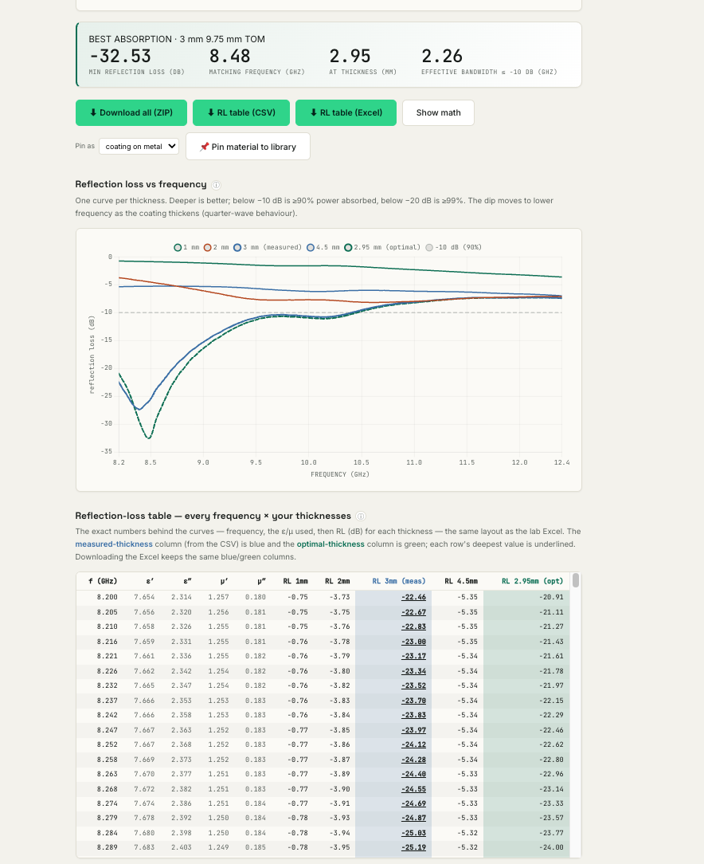
The Reflection loss tab after loading a laboratory file: the headline (deepest absorption, matching frequency, thickness, effective bandwidth), one curve per thickness, and the full frequency-by-thickness table — measured thickness in blue, computed optimum in green.
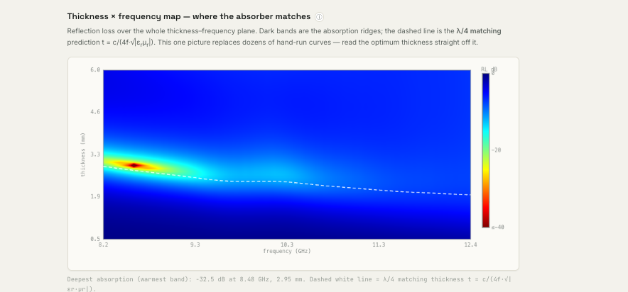
The thickness-against-frequency map. Colour is reflection loss and the warm ridge is the absorption band; the dashed white line is the independent quarter-wave prediction, which lands on the ridge without being fitted to it. The best thickness can be read straight off the picture.

Version 3.6 update — analytical horn design
The Horn antenna tab now designs a horn instantly from its dimensions, alongside the full-wave openEMS solve. Choose pyramidal or conical, type the feed and aperture sizes and the flare length, and it reports gain, aperture efficiency, E- and H-plane half-power beamwidths, the first sidelobe level and the full radiation pattern in real time — using Balanis aperture integration including the flare's quadratic phase error. It is validated against the rated 15 dBi standard-gain horn (it returns 15.6 dBi for that geometry) and reproduces the textbook optimal-horn efficiency.
On top of the instant engine: an inverse-design box sizes the shortest optimal-gain horn that meets a target gain; a parametric sweep ranks many aperture/flare combinations by gain; pinned designs overlay for comparison; and a lightweight-coating panel shows the core trade — the gain penalty of a thin conductive coating on a light basswood shell versus the mass saved against a solid-metal horn (about six times lighter for a few tenths of a dB), with a Monte-Carlo band over MXene's conductivity range. Everything is analytical and instant; the openEMS solve remains the full-wave check.

Version 3.8 update — CAD-RCS tab (radar signature of an uploaded 3-D model)
New in v3.8, in the RCS ▾ group: upload a 3-D model of a real object — a STEP or STL file (a rocket, drone, satellite fitting…) — and get its monostatic radar cross section versus viewing angle, instantly and analytically, plus how a radar-absorbing coating on each part reduces it.
How it works: the model’s surface is thousands of tiny triangles. Physical Optics treats each lit triangle as a small mirror and sums their reflections with the correct phases (the coherent sum is the radar echo); Ufimtsev’s Physical Theory of Diffraction (PTD) adds the scattering from sharp edges, so the estimate stays realistic at the wide and edge-on angles where Physical Optics alone collapses. A coating multiplies each part’s surface return by the reflection coefficient from the same reflection-loss physics as the RL tab — so a coating suppresses the specular flash but not edge diffraction (edges stay conductive).
What you do: open the tab, upload your model (STL is read in the browser and works offline; STEP is tessellated on the bridge and arrives split into its solid parts — export a multi-body assembly for a per-part breakdown). Pick a coating for each part, then press Compute. You get a radar-brightness-versus-angle chart (bare metal vs coated), a per-part table of contribution and reduction, and a 3-D view colour-coded so the parts that scatter most glow — with a slider to sweep the angle and a toggle to watch the coating dim them. Everything exports as CSV, a manifest, and a ZIP.
Honest limits: this is the standard asymptotic method for electrically-large targets that a full-wave solver cannot fit (a whole vehicle would need over a billion FDTD cells). It captures specular and first-order edge scattering and was validated against textbook closed forms (flat plate, sphere, cylinder) and against openEMS full-wave on a plate — broadside within 0.15 dB and wide-angle within about 3.5 dB, while Physical Optics alone is up to 70 dB wrong at grazing. It does NOT model multiple bounces or cavities (corner reflectors, nozzles), creeping or travelling waves, tip diffraction, or one part shadowing another. For a small part, press “Verify a part on openEMS” to overlay a rigorous full-wave check.
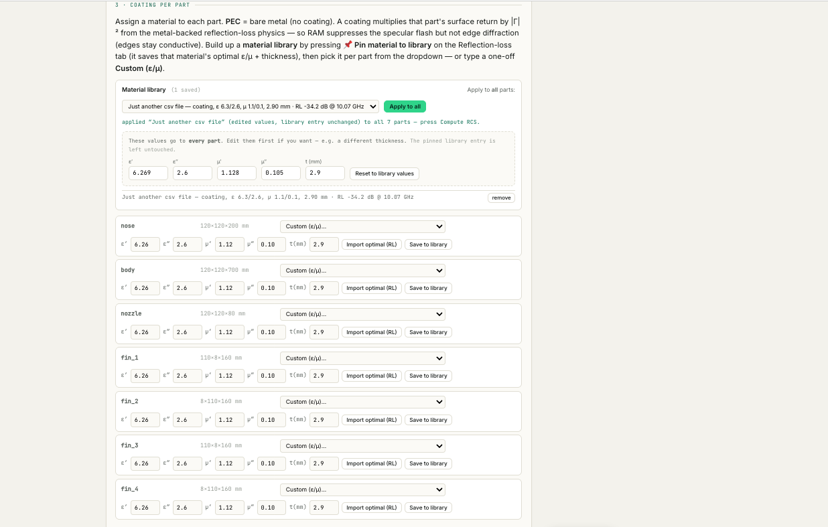
CAD-RCS, section 3: every part of the uploaded model listed with its own dimensions, and a material assigned to each — bare metal, a coating pinned from the material library, or one-off values you type.
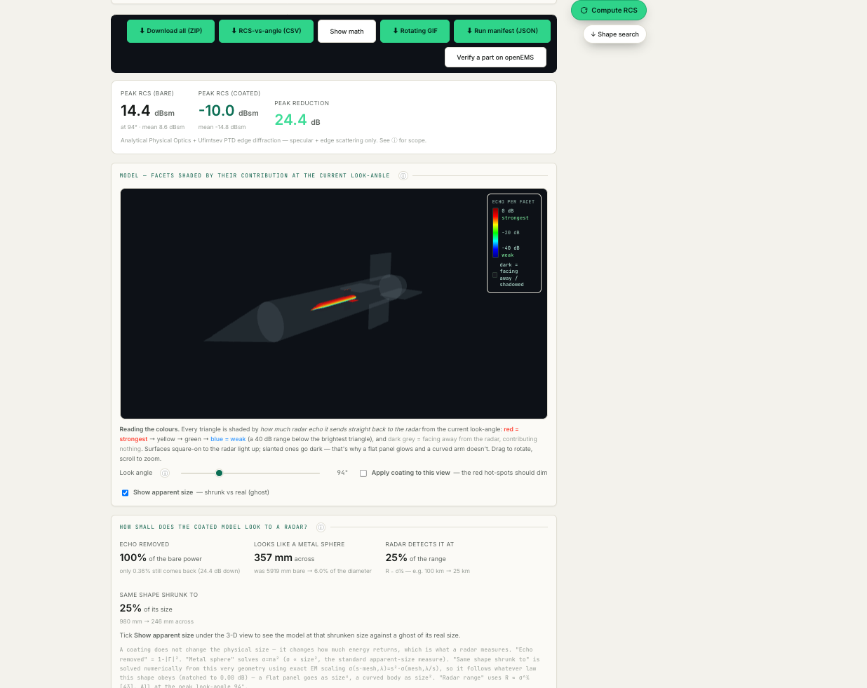
The CAD-RCS result: peak return bare and coated, the reduction between them, the per-facet heatmap at the current look-angle (bright means that triangle is sending echo back), and the apparent-size panel beneath it.

Version 3.8 update — Material library (replaces the old Run comparison tab)
The RCS ▾ group's old “Run comparison” tab (which overlaid pinned openEMS runs) has been replaced by a Material library tab, because comparing candidate absorber materials is the question that actually comes up.
How to use it: on the Reflection-loss (RL) tab, load or type a material, press Compute reflection loss, then press 📌 Pin material to library. That saves the material's optimal point — the ε/μ at its deepest-RL frequency and the thickness that achieved it — plus the full measured ε/μ dispersion if you uploaded a lab file. Repeat for each candidate.
The Material library tab then overlays every saved material's reflection-loss curve on one chart with the −10 dB threshold marked, and reports which is the deepest absorber and which has the widest bandwidth. The table lists ε/μ, thickness (editable — it re-evaluates instantly), the deepest RL and where it occurs, the EAB (contiguous width where RL ≤ −10 dB, i.e. at least 90 % of the power absorbed), the RL at a target frequency you choose, and the resulting RCS reduction on a flat metal surface (equal to |RL|, since the coated return scales as |Γ|²). You can edit, delete, export two CSVs, or clear the library.
The same library feeds the per-part coating dropdowns on the CAD-RCS tab, so any material you pin can be painted onto a specific part of an imported 3-D model, with an Apply-to-all option for the whole airframe.
Honest note: the Data column says how each curve was produced. “measured” means the material carries its real ε/μ dispersion from your uploaded file, so the curve is exact; “const ε/μ” means it was pinned from constant values, which are then held across the band — fine near the pinned frequency, increasingly approximate away from it, because real materials disperse.

Version 3.8 update — “how small does it look to radar?” and phone/iPad install
How small does it look to radar? Both the Reflection-loss tab and the CAD-RCS tab now translate a coating's reflection loss into sizes you can picture. A coating does not shrink the object; it reduces the power that comes back, which is the only thing a radar measures — so “smaller” means “as faint as a smaller piece of bare metal”.
Three figures are given, all from the same reflection coefficient. Echo left = 10^(−R/10) is the fraction of the bare power still returning. Equivalent-sphere diameter = 10^(−R/20) is the metal sphere that would give the same echo (a sphere's RCS goes as size squared) — the standard, shape-independent way to state apparent size. Detection range = 10^(−R/40) follows from the radar equation, since maximum range varies as the fourth root of RCS; it is usually the most meaningful figure in practice.
On the RL tab you also get, per material, how small the same flat plate would have to be to echo as weakly (a plate's RCS goes as size to the fourth, so that ratio is the fourth root), plus a diagram of the real plate outline against that smaller equivalent plate.
On the CAD-RCS tab the same three figures appear for your uploaded model, plus “same shape shrunk to”, which is solved numerically against your own mesh using exact electromagnetic scaling rather than an assumed formula — so it follows whatever law your geometry actually obeys. Tick “Show apparent size” under the 3-D view to see the model drawn at that reduced size against a translucent ghost of its true size. If the equivalent object works out smaller than about two wavelengths the panel flags that figure as indicative, because the asymptotic model is then outside its comfortable range; the echo, sphere and range numbers are closed-form and unaffected.
Install on a phone or iPad. The tool is now a progressive web app. Open the shared HTTPS link on the device and choose Add to Home Screen (iPhone/iPad, in the Share menu) or Install app (Android Chrome). It then launches full-screen with its own icon. Every analytical tab works on mobile, and the openEMS Run buttons still execute on the host PC. The app shell is cached so it starts fast and the analytical tabs keep working with a poor connection, but solver requests are never cached — a solve launched from a phone is always a fresh one.
Native mobile navigation. On a phone or tablet (any screen up to 820 px wide, installed or in the browser) the desktop row of dropdown menus is replaced by the two bars a native app would use: a sticky top bar showing the hamburger and the name of the page you are on, and a fixed bottom tab bar for the four sections — Waveguide, Horn, RCS, More. Tapping a section slides up a sheet of the pages inside it. In addition, swiping right from the left edge of the screen — or tapping the hamburger — opens a side drawer listing every page in the tool, grouped, with the current one ticked. The drawer follows your finger and snaps open or shut, and a swipe that turns out to be a vertical scroll, or that starts on a chart, a 3-D view or a slider, is left alone. The desktop layout is completely unchanged.
If the home-screen icon does not appear. iOS caches the icon at the moment you add the app, per icon address. After the host PC has pulled the latest version and the bridge has been restarted, delete the old home-screen icon, open the link again in Safari, let the page finish loading, and then add it once more from the Share menu.
Reliability pass. A systematic hunt found and fixed a family of bugs where the tool could show you one run's numbers under a later run's name. The clearest one you may have seen: the field animations did not appear to update after a second solve. They are now published in a second, far smaller format as well (about nineteen times smaller for the same frames), a figure is blanked the moment you press Run, and it only ever shows media that actually loaded — with a plain message if it could not. Elsewhere: the Full-wave tab no longer keeps a chart or a summary from a run that did not produce it; the horn tab no longer replays an old time-domain animation when you ask for the frequency-domain view; the Run manifest records the mesh and frequency settings the run actually used rather than whatever the controls say when you press the button; the batch sweep reports which points failed and why instead of a cheerful “done”; and the progress bar no longer starts at the previous run's percentage.
Honesty about frequency range. If you ask for a reflection loss, an optimal thickness or a comparison outside the frequencies your material was actually measured over, the tool now says so. Previously it held the permittivity and permeability at the nearest measured edge — reasonable in itself — but presented the answer as measured data, and in two places it also used the edge frequency while labelling the result with the frequency you asked for. Out-of-band answers are now marked extrapolated, lose any “absorbs 90 %” verdict, and on the Material library tab the extrapolated part of a curve is drawn dashed and excluded from the headline, the bandwidth and the target-frequency column. Materials entered as constant values legitimately apply across the whole band and are unaffected.
Mobile fixes. The Simulations chooser was clipped so that only one of its eight options was visible, and it could not be scrolled to reach the rest — it now sizes itself to the space above the tab bar. The bottom sheet was drawn over the tab bar, so a tap aimed at a section landed on the wrong page. iPad portrait width was missing the large slider and text-size rules, so sliders were a hairline thick and focusing a field zoomed the page. The Compare detail panel could sit over an unrelated tab and its title could fall under the notch. All fixed; the desktop layout is unchanged.
Shape improvement (new). The CAD-RCS tab can now search the geometry itself for a lower radar signature, not just the coating. Pick the radar direction you care about and it applies real deformations to your uploaded model — sharpening the nose, tapering the body, flattening the cross-section, sweeping the planform, canting or tilting the appendages — re-solves each candidate with the same physics used everywhere else, and reports what each one actually buys in decibels. It then stacks the best few and gives you the recipe with the reason for each step. Every candidate keeps the overall length, and the volume and diameter cost is reported, so nothing wins by quietly shrinking the vehicle. You can apply the winner to the model, revert it, or download it as an STL to take back into CAD. On the shipped rocket example it finds 14.5 dB in a 60-degree nose sector from tapering the body and canting the fins; on the stealth flying wing it finds 34.5 dB from sweeping the planform and boat-tailing the aft end.
One shelf of materials. Materials you pin on the Reflection-loss tab are now the only list the RCS (openEMS) coating selector offers, and each coated-material box on the Reflection-loss tab can load any of them directly. When you pin, you say whether it is a coating on metal or a solid block, and that is shown wherever the material is named. Apply-to-all on the CAD tab shows the material's values for editing before writing them to every part — change the thickness once instead of on every row — and your edits do not alter the saved library entry.
Easier to use. Every Run, Compute and Download button is bright green. The CAD Compute button also floats at the edge of the screen so it stays reachable on a long results page. On a phone the long introduction now collapses to the title after your first navigation, with a chip to bring it back, so the controls are not pushed a screen and a half down. The RCS menu is called RCS + RL, the two sweep tabs are named for what they do, and Materials now sits in both the Waveguide and Horn menus. Three defence-oriented example models were added, including a 90-degree corner that this tool deliberately under-reports — it is there so the no-multiple-bounce limitation is something you can see.
Shape suggestions are now checked for viability (new in 4.0). Every candidate shape the search tries is audited before it is scored, and thrown out if it is not a real object: if it folds the surface through itself, squashes triangles flat, loses more internal volume than you allow, balloons in size, changes the outside area beyond reason, flattens a part to under a third of one of its dimensions, or pushes a fin or wing into the fuselage. Rejections appear under the results table, each one naming the change, the setting and the part involved — click “show why” to read them. The status line tells you how many were rejected, so you can see whether your constraints are too tight. The volume budget you set is measured against your ORIGINAL model, not the previous stage, so a change that was allowed on its own can be refused once an earlier one is already in the recipe. Raise “Volume you can afford to lose” if you want the search to range further.
What that check does not cover. It is a check on the geometry only. It cannot tell you whether the shape will fly, carry its loads, fit its contents, stay controllable, survive the heat, or be manufacturable. Treat a winning shape as a direction worth taking to your aerodynamics and structures colleagues, not as a finished design. The panel says so as well.
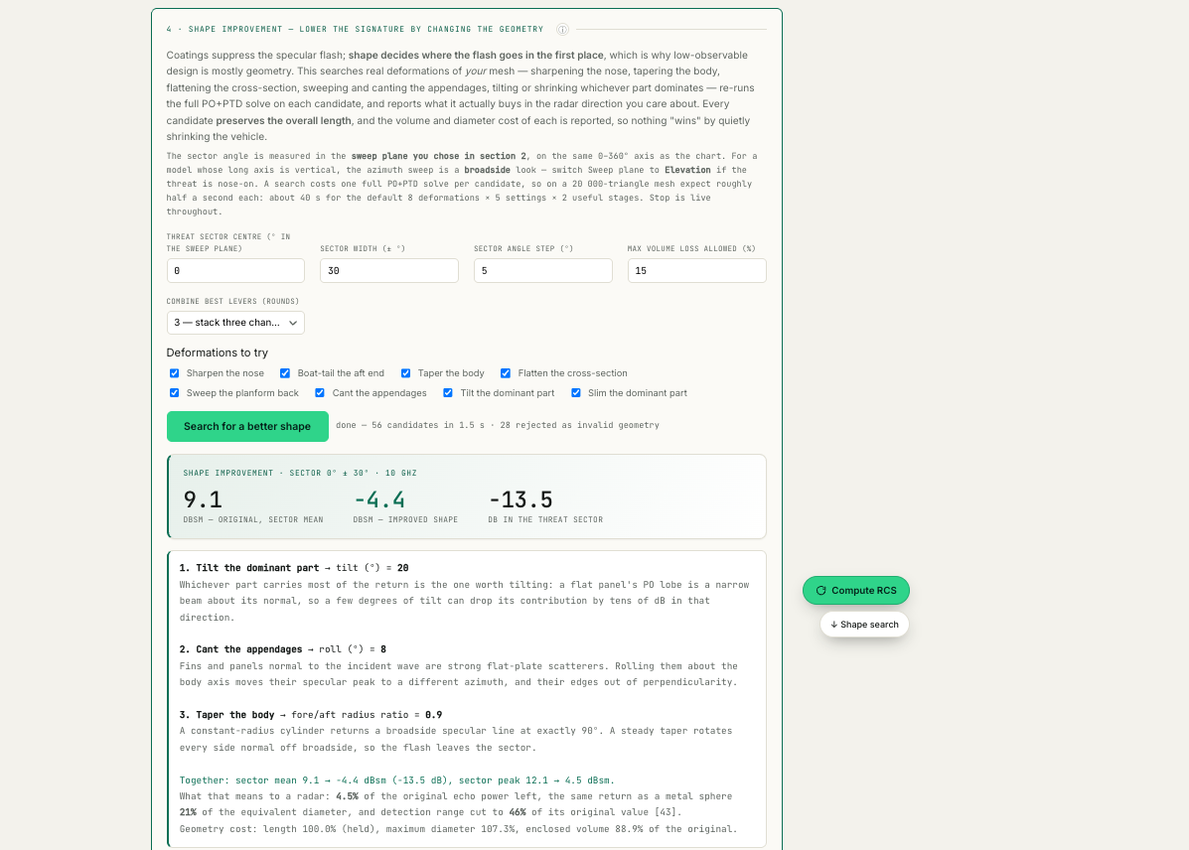
Shape improvement after a search: the recipe it found, the sector mean before and after, and — in the status line — how many candidates were rejected as invalid geometry. The geometry cost is reported with the result: length held, maximum diameter, enclosed volume.
Rotating GIF and interactive 3-D view (new in 4.0). The green “Rotating GIF” button on the CAD-RCS tab records a full turn of the coloured model as an animated GIF you can drop straight into a slide or a report; it plays anywhere with nothing to install. The Download-all archive also contains model_3D_rotating.html, a single file that spins by itself and lets you drag left and right to turn the model by hand, or pause it with the button. Everything is embedded in that file, so it works with no internet connection.
Solid bodies no longer offer coatings (new in 4.0). On the RCS (openEMS) tab, the material list now matches the construction you picked. “Metal + coating” offers only materials you pinned as coatings; “Solid material” offers only those you pinned as solid bodies; “Bare metal (PEC)” needs no material at all. That is a physics distinction, not tidiness: a coating’s reflection loss is measured with metal behind it, which is why the absorber works, so using a thin film as a solid block would be asking a different question. If a list looks empty, nothing has been pinned for that construction yet — pin one on the Reflection-loss tab and choose the right kind there, or type the values under “Custom material”.
Rotating exports, corrected (4.0). The rotating GIF and the interactive page were showing a stationary object: the capture recoloured the model at each look angle but never turned it. Both now rotate the geometry itself through a full circle. The model is laid out along its longest dimension so nothing is cut off at the edges, the framing is computed from the camera's field of view rather than estimated, every export is rendered at the same frame size so it looks identical on any machine, and surfaces facing away from the radar are shaded light enough to stay visible for the whole turn. The colours are the echo contribution at the worst-case look angle and belong to the surface, so they turn with the model.
Clearer wording throughout. Two reviews went over every message the tool shows you. Messages that used to say “see console” now name what failed and where the real log is — the browser console cannot be opened at all when the tool is installed as an app on a phone or tablet. Two pages that told you to start the solver while the solver was already serving the page now check and report what is actually true. “Exact” has been removed from five descriptions of a method that is approximate at grazing angles. Naming a material no longer opens a pop-up asking for something you already typed. And the written instructions now cover all twenty-one pages rather than ten, with the correct setup procedure.
What the full-wave solver produces. The three figures below are unedited output from real solves, at the size the tool saves them.
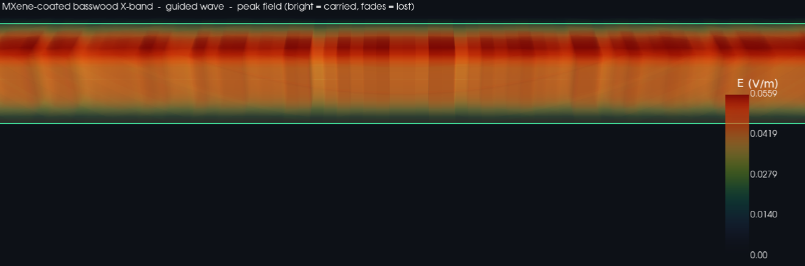
A guided wave inside a lightweight coated waveguide (X-band). Bright is signal being carried; the fading toward the walls is power being lost into them.
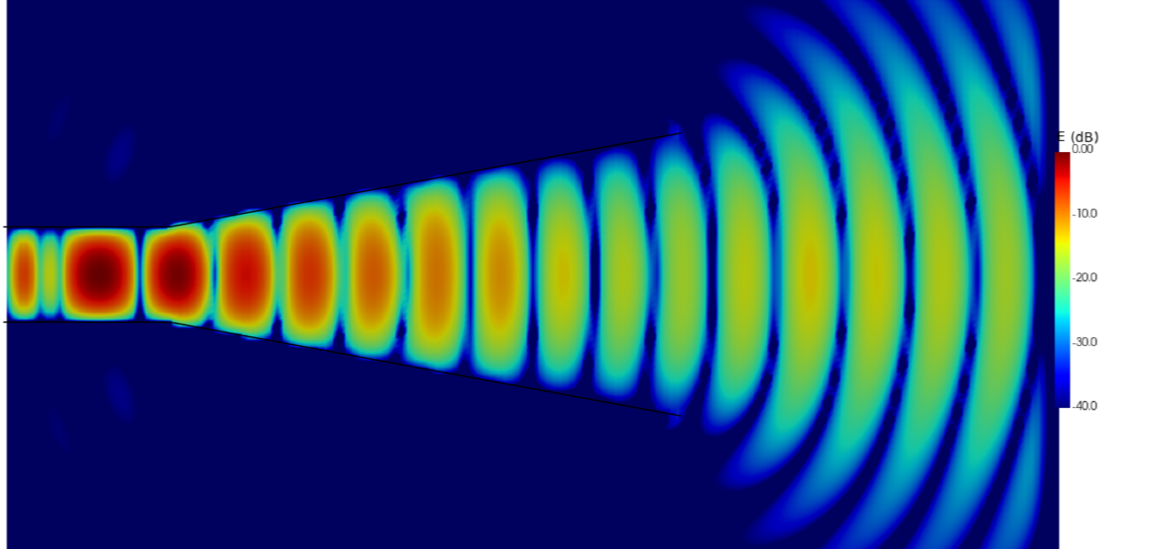
A horn antenna on a decibel scale. The signal enters the narrow feed at left, widens through the flare, and leaves the mouth as curved wavefronts — that is the beam.
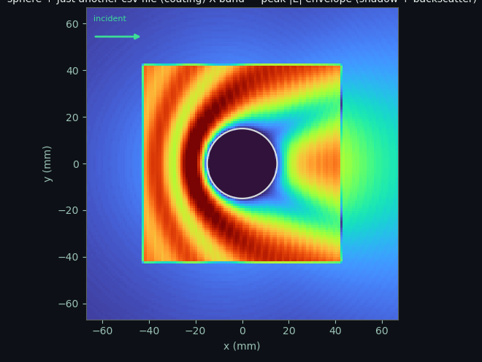
Radar hitting a coated sphere. You can see the wave piling up in front of it, the quiet shadow behind, and the lobe bouncing back toward the radar — that returning lobe is what a coating is trying to remove.

Document maintenance
This guide matches software version 4.0. It is kept in step with the software: whenever a feature is added or changed, this document is updated to match. Current major feature set: instant analytical Simulator; full-wave waveguide and horn (openEMS) with six selectable waveguide simulations including far-field; multilayer coating stacks; Inverse design with Pareto optimization and Send-to-openEMS; Measurement fit with conductivity extraction; the self-calibrating lab loop; the Space-survival screens (multipaction and vacuum heating); the Compare league table; a fully cited Physics tab; the Materials editor; per-page and per-chart info popups with English/Arabic; the self-validation report; and the multi-band trade-space report. The Full-wave and Horn tabs now include a Field-view time/frequency toggle (openEMS is a time-domain FDTD solver; spectra are Fourier-derived — Taflove & Hagness, 2005), and the tab bar groups The physics / Materials / Instructions / References under a "More" menu.

