AI Project: Chess Engine
1. Project Details:
- Project Title: Chess Engine: AI vs Human Chess with Move Probability Analysis using Minimax & Alpha-Beta in C++
- Project Type (Application / Prototype / Research): Prototype
- Team Members : Shuvam Bhatt (230457), Kushagra (230442), Anirudh (230466), Rohit Singh (230782)
2. Abstract:
This project is a one-on-one chess game between AI and a human player, built in C++. The AI uses minimax algorithm with alpha-beta pruning to choose strong moves. After the full game ends, the system runs a post-game analysis that shows how likely the AI would have played each human move at that exact moment. Instead of saying “this is the best move”, it gives a probability percentage e.g., “Your move e5 was 72% likely for the AI”. This is calculated by running a deeper search (depth 7) and counting how many top-scoring moves include the one played. High % means the human thought like the engine; low % means a weak or creative move. Everything is coded from scratch in C++ using bitboards for speed. The game runs in console: human types moves (like “e2e4”), AI replies instantly. After checkmate or draw, full analysis prints with move-by-move AI agreement. This helps students learn AI thinking and improve chess.
3. Problem Statement:
We aim to develop a chess game where a human player competes against an AI opponent, providing an interactive platform to learn from AI decision-making. Unlike standard chess applications that simply label moves as "blunder" or "best move," our system will show the probability of each human move, quantifying how correct it is based on the AI's perspective. This is achieved by calculating the likelihood (as a percentage) that the AI would have selected the same move in that exact position during a deeper search, offering insights into the move's alignment with optimal play—high probability indicates a correct, strong move, while low probability highlights potential weaknesses or creative deviations.
Two primary goals:
- Enable the AI to play smart and fast chess using adversarial search techniques.
- After the game, display the probability for each human move to demonstrate its correctness relative to the AI's deeper thinking.
4. AI Components & Data Source:
AI Components:
- Search: Minimax + Alpha-Beta Pruning (depth 5 during play, depth 7 in analysis).
- Evaluation: Material + piece-square tables (center, king safety).
- Analysis: At each human move, run deep search → count how many top moves match the played one → correctness probability.

Data Source:
- No dataset used.
- Game saved as PGN in memory.
- Reference: Lichess opening book to check early move correctness.
5. Methodology:
Language: C++17 Board Representation: Bitboards (64-bit integers) – one for each piece type (e.g., white pawns, black knights, etc.) for efficient move generation and board updates. Move Input: Human enters moves in Standard Algebraic Notation (SAN) like “e2e4”, “Nf3”, “O-O”, or “e8=Q” – parsed into from/to squares using coordinate mapping.
Game Flow:
- Human (White) starts → inputs move via console.
- AI (Black) runs Minimax with Alpha-Beta Pruning at depth 5 (~1–2 seconds per move on standard laptop).
- AI selects and makes the best move.
- Board is updated; game state checked for checkmate, stalemate, or draw.
- Loop continues until game ends.
Analysis Mode (Post-Game):
- Replay each board position just before a human move.
- Run deeper Minimax search (depth 7) to evaluate all legal moves.
- Compute probability of the human’s move using the following formula:
Let S = best score from depth 7 search
Let G = set of all legal moves with score ≥ S – 50 centipawns
Probability = (1 / |G|) × 100% if human move ∈ G, else 0%
6. Progress So Far:
The project has successfully reached the first working milestone: a modular AI game engine framework written in C++.
The current version includes:
- Minimax search with Alpha-Beta pruning integrated in a generic manner.
- A Tic-Tac-Toe implementation demonstrating the engine architecture.
- CMake build system with cross-platform support.
- Clean separation between:
  - Engine logic (search & evaluation)
  - Game logic (rules, state, and moves)
The Tic-Tac-Toe module validates the engine design, proving that the codebase can support multiple strategy-based games through a unified interface.
This phase establishes the foundation to extend the same system to Chess next.
7. Planned Next Steps:
The next phase focuses on evolving the prototype into a full Chess Engine with GUI support. Planned tasks are:
- Core Chess Engine Development
  - Implement chess board state using bitboards
  - Add legal move generation (pawn structure, castling, en passant, promotions)
  - Integrate chess-specific evaluation function (material, piece-square tables)
  - Depth-based search for AI with Alpha-Beta pruning
  - Move input parser (UCI / algebraic notation)
8. Screenshots:
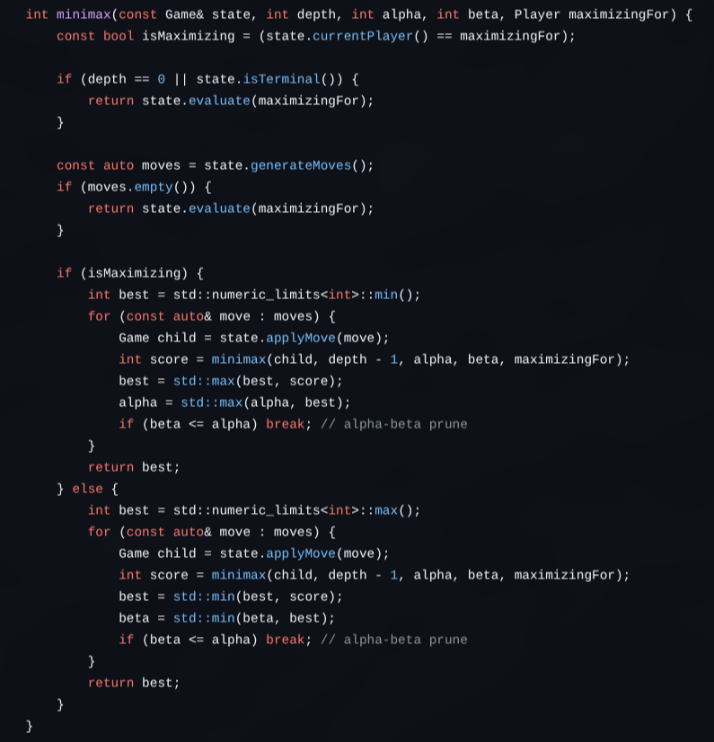

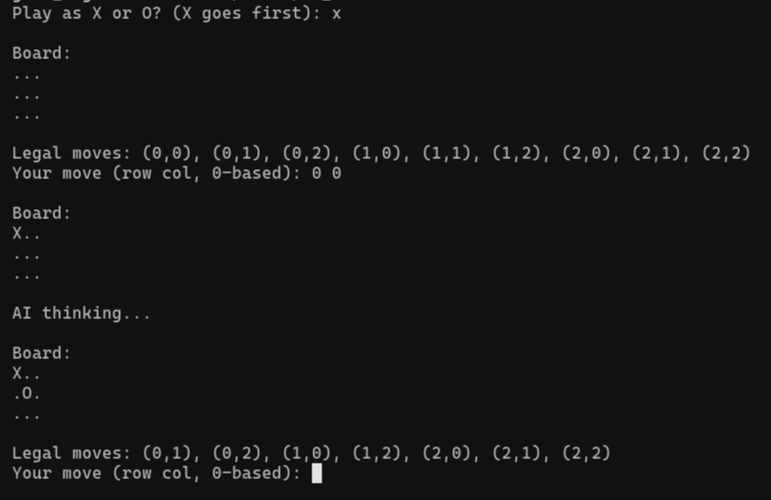
9. References:
- ChessProgramming Wiki – Minimax: https://www.chessprogramming.org/Minimax chessprogramming.org
- ChessProgramming Wiki – Alpha-Beta Pruning: https://www.chessprogramming.org/Alpha-Beta chessprogramming.org
- C++17 Standard Documentation (cppreference.com): https://en.cppreference.com/w/cpp/17.html Cppreference+1
- Stockfish (open-source chess engine) Documentation: https://official-stockfish.github.io/docs/stockfish-wiki/Home.html official-stockfish.github.io+2official-stockfish.github.io+2
- CMake Official Documentation: https://cmake.org/documentation/ cmake.org+1

