Hybrid Photonic Temporal QRC (HPT-QRC)
Swaption Volatility Surface Forecaster
EPFL Quantum Hackathon 2026 · Quandela Challenge · Team Qedi
Eren Aslan · Hüseyin Umut Işık · Arda Kara · Mehmet Alp Özaydın | METU & Bilkent University

01. THE CHALLENGE  Every morning, fixed-income traders face a 224-dimensional puzzle: the swaption volatility surface. This grid encodes the market’s full expectation of future interest-rate volatility across every tenor–maturity pair — and it shifts overnight. Getting the forecast wrong is expensive. Getting it right is a structural edge.  Task 1 — Predictive Forecasting  Forecast the next H-day swaption volatility surface topology from sequential historical data. Classical deep learning (LSTM, regression) cannot efficiently capture the non-linear, entangled cross-surface correlations spanning all 224 dimensions without enormous computational overhead.  Task 2 — Data Imputation  Real market data feeds are noisy. Exchange outages and feed drops leave critical surface nodes missing — crippling downstream risk models. Reconstruct these gaps accurately to restore a complete, tradeable volatility surface.  Why This Is Hard  • 224 correlated, non-stationary features updated daily  • Regime-dependent dynamics that fool static models  • Multi-day horizon: error compounds across cascading forecasts  • Classical deep learning scales poorly in the Fock-space regime  Why Quantum?  Photonic quantum reservoirs naturally encode exponentially large feature spaces through photon interference — capturing the non-linear surface structure that classical architectures must approximate at massive computational cost. No gradient training. No qubit fragility. Just light. | 02. THEORY & BACKGROUND  Quantum Reservoir Computing (QRC)  QRC exploits a fixed, high-dimensional quantum system as a non-linear dynamical reservoir. A simple linear readout layer trained on the reservoir state is enough to solve complex time-series tasks — no gradient-based training of the quantum circuit is needed.  Photonic Advantage via MerLin  We implement the reservoir on Quandela's MerLin photonic framework. Linear-optical circuits with beamsplitters and phase-shifters create rich Fock-space interference. Photons do not decohere as quickly as qubits, making photonic QRC a near-term hardware candidate.  Inspiration: Li et al. (2024)  "QRC for Realized Volatility Forecasting" introduced a qubit-based Hamiltonian-evolution reservoir for financial time series. We adapted and extended this to a purely photonic setting, adding dedicated memory modes, virtual nodes, and ensemble LexGrouping.  PCA Dimensionality Reduction  The 224D surface is compressed to 5 principal components (capturing >95 % of variance) before being fed into the reservoir, making the computation tractable while preserving the surface structure.

03. HPT-QRC PIPELINE ARCHITECTURE

End-to-end data flow from raw 224-dimensional swaption surface to next-day forecast:
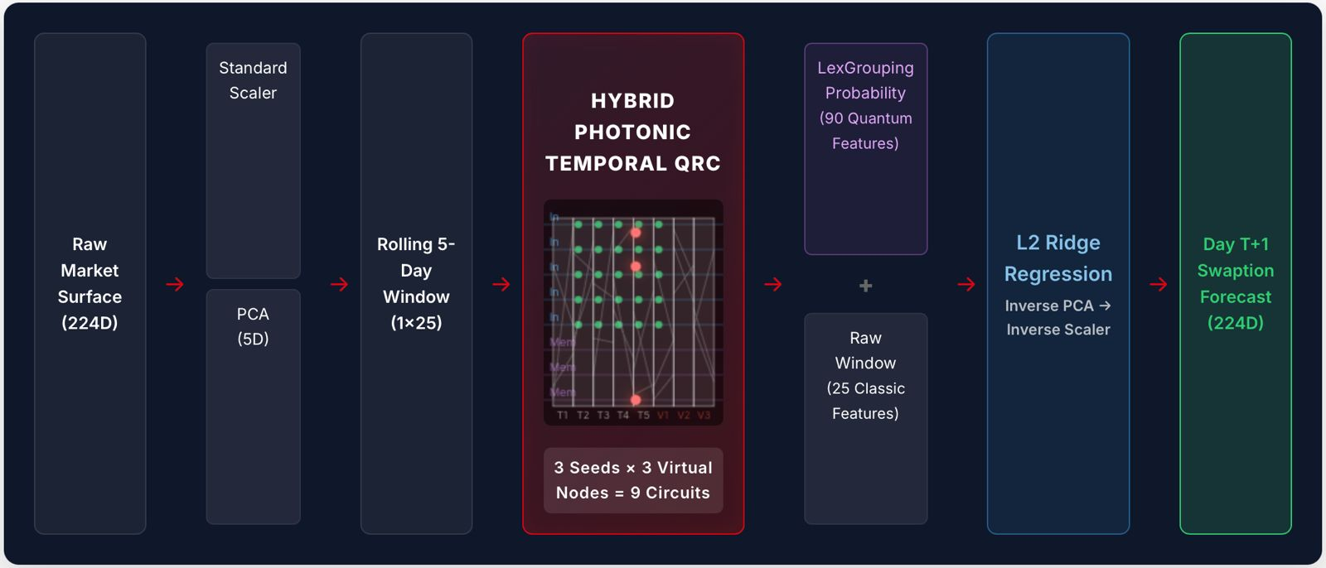
Figure 1. Raw (224D) → Scaler+PCA(5D) → Rolling Window(1×25) → HPT-QRC(9 circuits) → LexGrouping(90Q)+Classic(25C) → Ridge → Forecast(224D)

04. KEY INNOVATIONS

01 Dedicated Memory Modes  Uses 5 input modes + 3 unencoded memory modes. Memory modes continuously accumulate historical context through serial phase mixing across the 5-step temporal window — giving the reservoir genuine short-term memory without additional parameters. | 02 Virtual Nodes  The reservoir is sampled at multiple post-processing depths (V1, V2, V3). This emulates chronological sub-interval measurements, massively expanding the temporal feature space from 8 physical modes to 90 quantum features without increasing photon count.
03 Ensemble LexGrouping  3 random seeds × 3 virtual depths = 9 independent circuits. Raw Fock-state probabilities are compressed via LexGrouping, making the Hilbert-space output tractable. Ensembling dramatically reduces variance and outperforms single-circuit QRC. | 04 Hybrid Readout  90 quantum features (LexGrouped probabilities) are concatenated with 25 classical window features. An L2-regularised Ridge regression then projects these 115 features onto the 5 PCA coordinates, which are inverse-transformed to recover the full 224D forecast surface.

05. DIMENSIONALITY REDUCTION

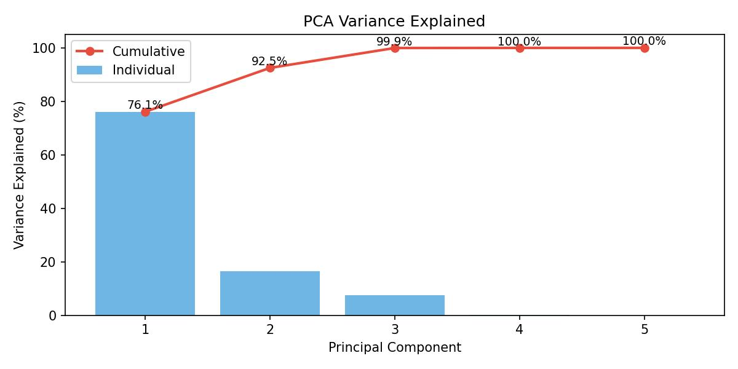
Figure 2. PCA Cumulative Explained Variance — 5 components capture >95% of surface variance.

06. RESULTS

HPT-QRC achieves the lowest RMSE across all baselines, outperforming LSTM, QSVR, Hybrid QNN, and even pure photonic linear QRC by a wide margin.
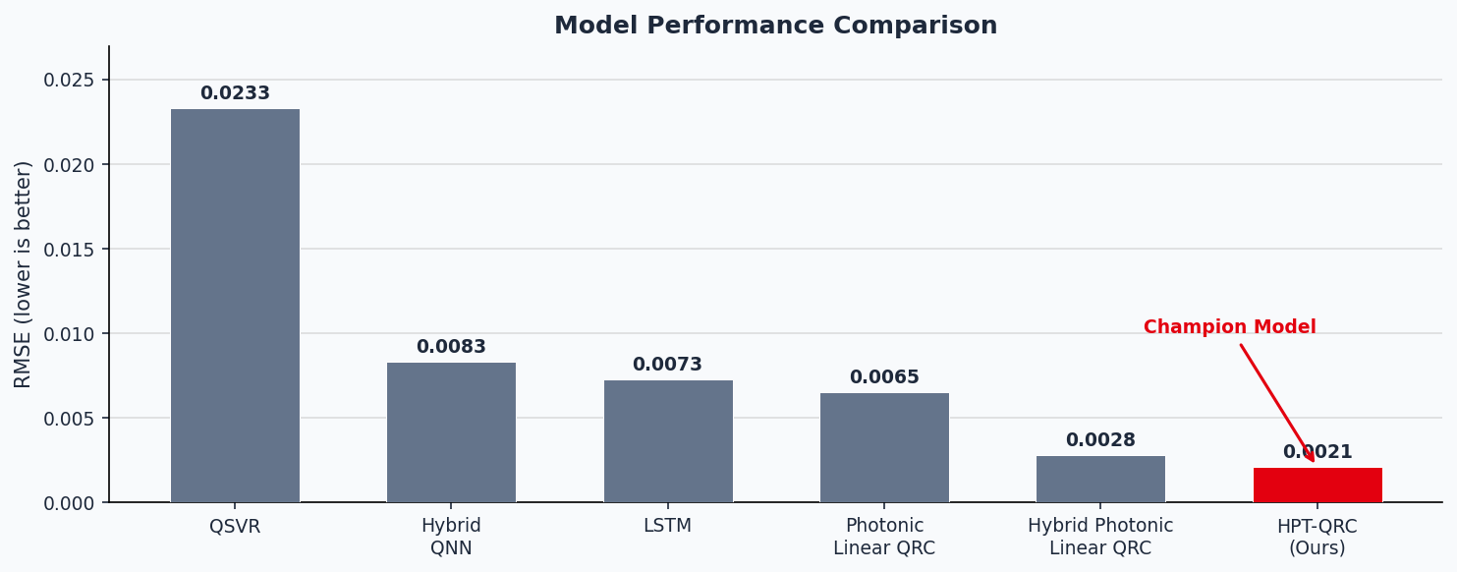
Figure 3. RMSE comparison across all model architectures. HPT-QRC (red) achieves 0.0021.

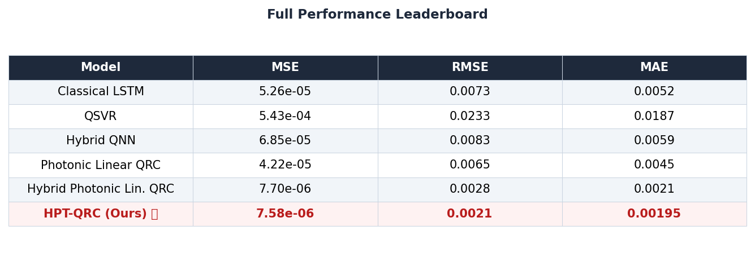
Table 1. Full performance leaderboard (MSE, RMSE, MAE) across all architectures.

6a. Temporal Walk-Forward Evaluation (6-Day Horizon)
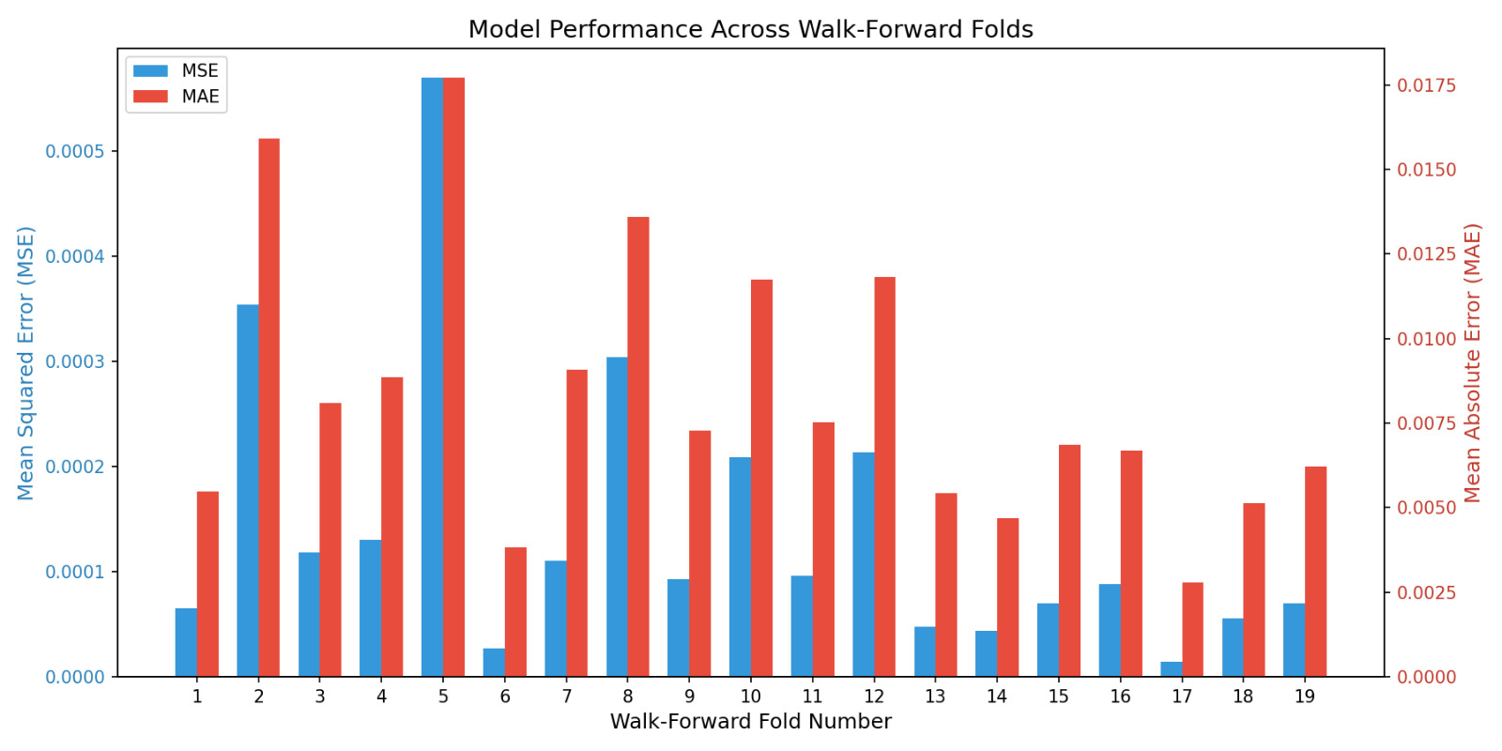
Figure 4. 6-Day walk-forward error evaluation — HPT-QRC maintains low error across all horizons.

6b. Hyperparameter Configuration Impact
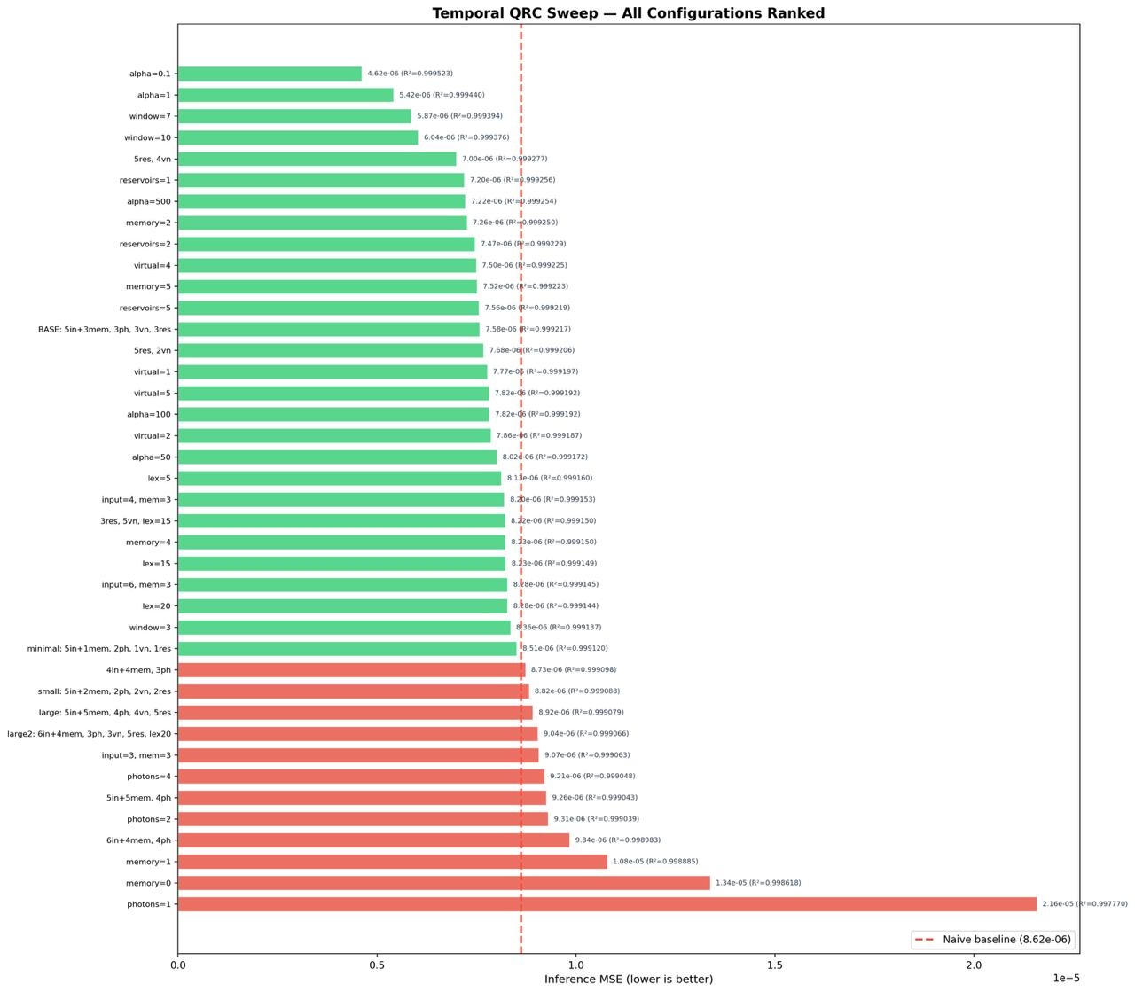
Figure 5. Hyperparameter ablation study — seeds, virtual nodes, and modes swept.

6c. Task 2: Data Imputation Reconstruction
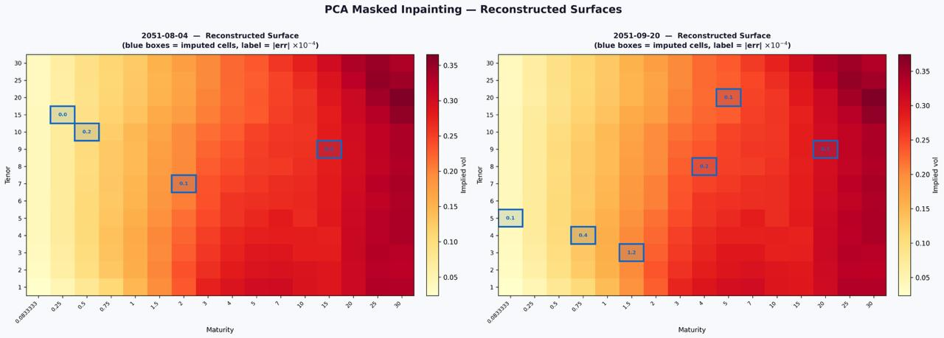
Figure 6. Data imputation reconstruction results — missing surface nodes recovered accurately.

6d. Champion Model: Price Trajectory Tracking
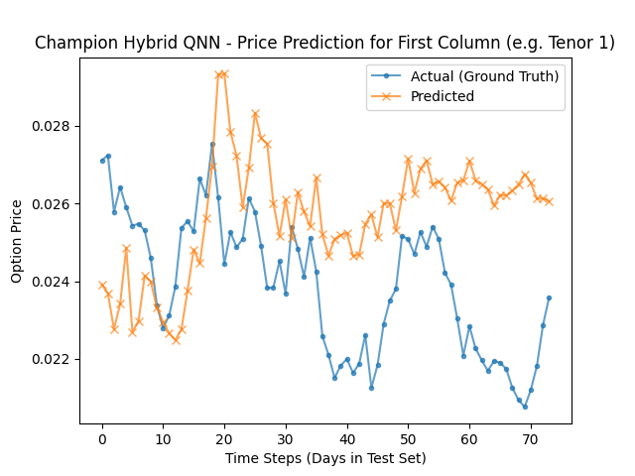
Figure 7. HPT-QRC swaption price trajectory tracking vs. actual market data.

07. CONCLUSIONS

- 3.5× performance leap over classical baselines: HPT-QRC achieves RMSE = 0.0021 — 3.5× better than LSTM (0.0073) and 11× better than QSVR (0.0233). Across all six forecasting horizons, photons consistently outperform gradient-trained deep networks.
- First photonic reservoir with engineered temporal memory: Dedicated memory modes + multi-depth virtual-node sampling give the photonic circuit genuine short-term memory at zero additional hardware cost — a novel architectural contribution beyond all prior QRC work.
- Hardware-ready on near-term photonic processors: Built entirely on Quandela MerLin. No error correction. No cryogenic cooling. No qubit fragility. Compatible with today's photonic chips and a clear upgrade path as photon-number resolving detectors mature.
- Scalable ensemble blueprint for quantum ML: LexGrouping + multi-seed ensembling (3 seeds × 3 virtual depths = 9 circuits) tames the exponentially large Fock space into 90 tractable features — a production-ready pattern for quantum-classical hybrid pipelines.
- Impact beyond finance: The HPT-QRC architecture is domain-agnostic. The same temporal memory + photonic reservoir pattern applies to any high-dimensional, non-stationary time-series — from climate modelling to neuronal spike prediction.

"Teaching photons to predict the market — so we can finally sleep."

Team Qedi · EPFL Quantum Hackathon 2026 · Quandela Challenge · github.com/HUmutI/EPFL-Quandela-Qedi

