Hybrid Photonic Temporal QRC (HPT-QRC)
Swaption Volatility Surface Forecaster
EPFL Quantum Hackathon 2026 · Quandela Challenge · Team Qedi
Eren Aslan · Hüseyin Umut Işık · Arda Kara · Mehmet Alp Özaydın | METU & Bilkent University

01. THE CHALLENGE  Swaption volatility surfaces encode the market's expectation of interest-rate volatility across all tenor–maturity combinations. Each surface is a 224-dimensional snapshot that changes daily.  Task 1 — Predictive Forecasting  Predict the next H-day swaption volatility surface topology from historical market data. Classical models (LSTM, regression) struggle with the high-dimensional, non-linear structure of these surfaces.  Task 2 — Data Imputation  Reconstruct missing option price nodes in the 2-D surface grid. Real market feeds often contain gaps, making robust imputation critical for downstream risk models.  Why Quantum?  Quantum reservoirs naturally encode high-dimensional, non-linear feature spaces through interference and entanglement — properties that classical architectures must approximate at great computational cost. | 02. THEORY & BACKGROUND  Quantum Reservoir Computing (QRC)  QRC exploits a fixed, high-dimensional quantum system as a non-linear dynamical reservoir. A simple linear readout layer trained on the reservoir state is enough to solve complex time-series tasks — no gradient-based training of the quantum circuit is needed.  Photonic Advantage via MerLin  We implement the reservoir on Quandela's MerLin photonic framework. Linear-optical circuits with beamsplitters and phase-shifters create rich Fock-space interference. Photons do not decohere as quickly as qubits, making photonic QRC a near-term hardware candidate.  Inspiration: Li et al. (2024)  "QRC for Realized Volatility Forecasting" introduced a qubit-based Hamiltonian-evolution reservoir for financial time series. We adapted and extended this to a purely photonic setting, adding dedicated memory modes, virtual nodes, and ensemble LexGrouping.  PCA Dimensionality Reduction  The 224D surface is compressed to 5 principal components (capturing >95 % of variance) before being fed into the reservoir, making the computation tractable while preserving the surface structure.

03. HPT-QRC PIPELINE ARCHITECTURE

End-to-end data flow from raw 224-dimensional swaption surface to next-day forecast:
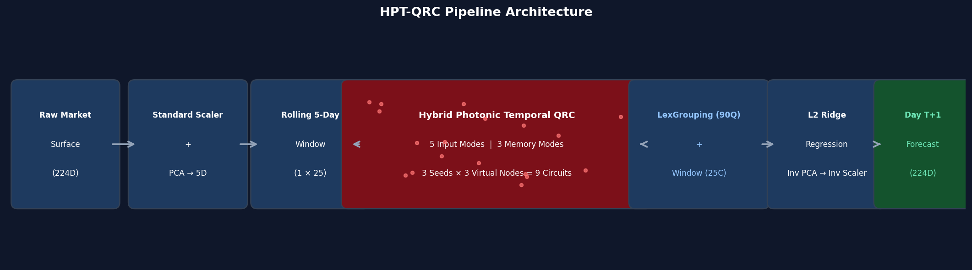
Figure 1. Raw (224D) → Scaler+PCA(5D) → Rolling Window(1×25) → HPT-QRC(9 circuits) → LexGrouping(90Q)+Classic(25C) → Ridge → Forecast(224D)

04. KEY INNOVATIONS

01 Dedicated Memory Modes  Uses 5 input modes + 3 unencoded memory modes. Memory modes continuously accumulate historical context through serial phase mixing across the 5-step temporal window — giving the reservoir genuine short-term memory without additional parameters. | 02 Virtual Nodes  The reservoir is sampled at multiple post-processing depths (V1, V2, V3). This emulates chronological sub-interval measurements, massively expanding the temporal feature space from 8 physical modes to 90 quantum features without increasing photon count.
03 Ensemble LexGrouping  3 random seeds × 3 virtual depths = 9 independent circuits. Raw Fock-state probabilities are compressed via LexGrouping, making the Hilbert-space output tractable. Ensembling dramatically reduces variance and outperforms single-circuit QRC. | 04 Hybrid Readout  90 quantum features (LexGrouped probabilities) are concatenated with 25 classical window features. An L2-regularised Ridge regression then projects these 115 features onto the 5 PCA coordinates, which are inverse-transformed to recover the full 224D forecast surface.

05. DIMENSIONALITY REDUCTION

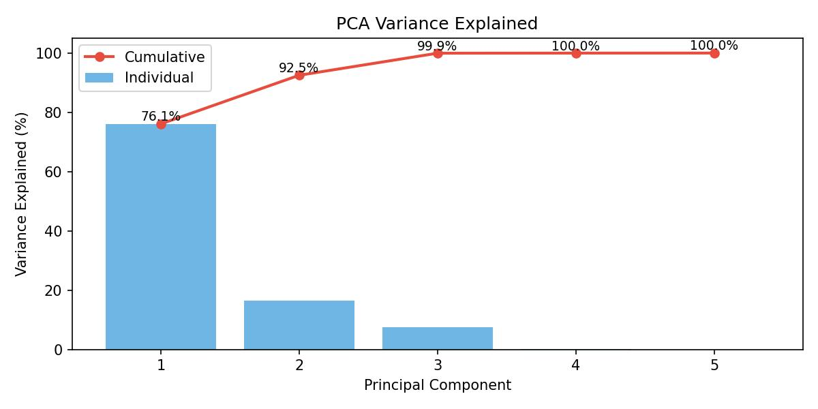
Figure 2. PCA Cumulative Explained Variance — 5 components capture >95% of surface variance.

06. RESULTS

HPT-QRC achieves the lowest RMSE across all baselines, outperforming LSTM, QSVR, Hybrid QNN, and even pure photonic linear QRC by a wide margin.
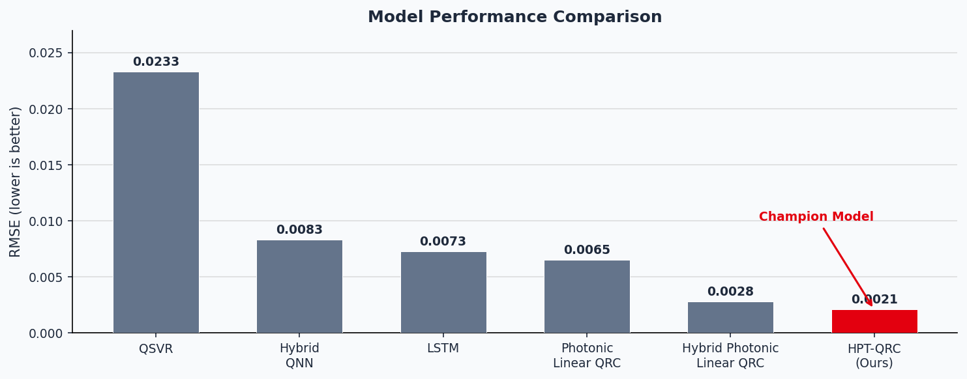
Figure 3. RMSE comparison across all model architectures. HPT-QRC (red) achieves 0.0021.

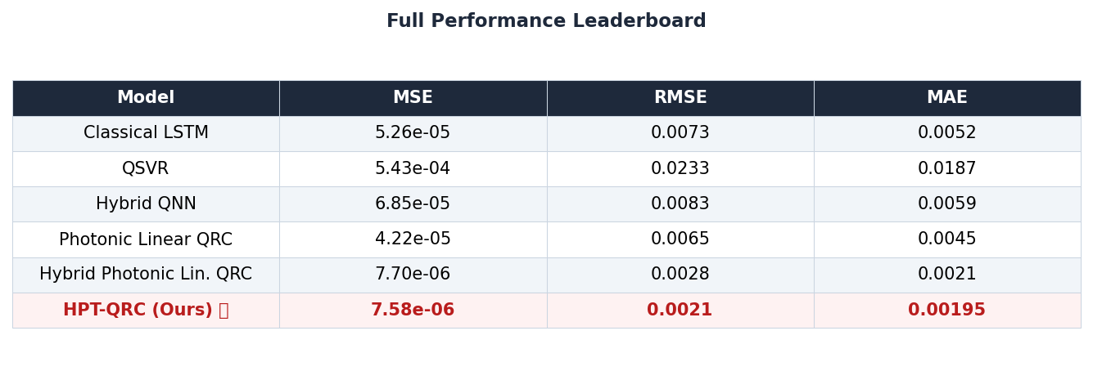
Table 1. Full performance leaderboard (MSE, RMSE, MAE) across all architectures.

6a. Temporal Walk-Forward Evaluation (6-Day Horizon)
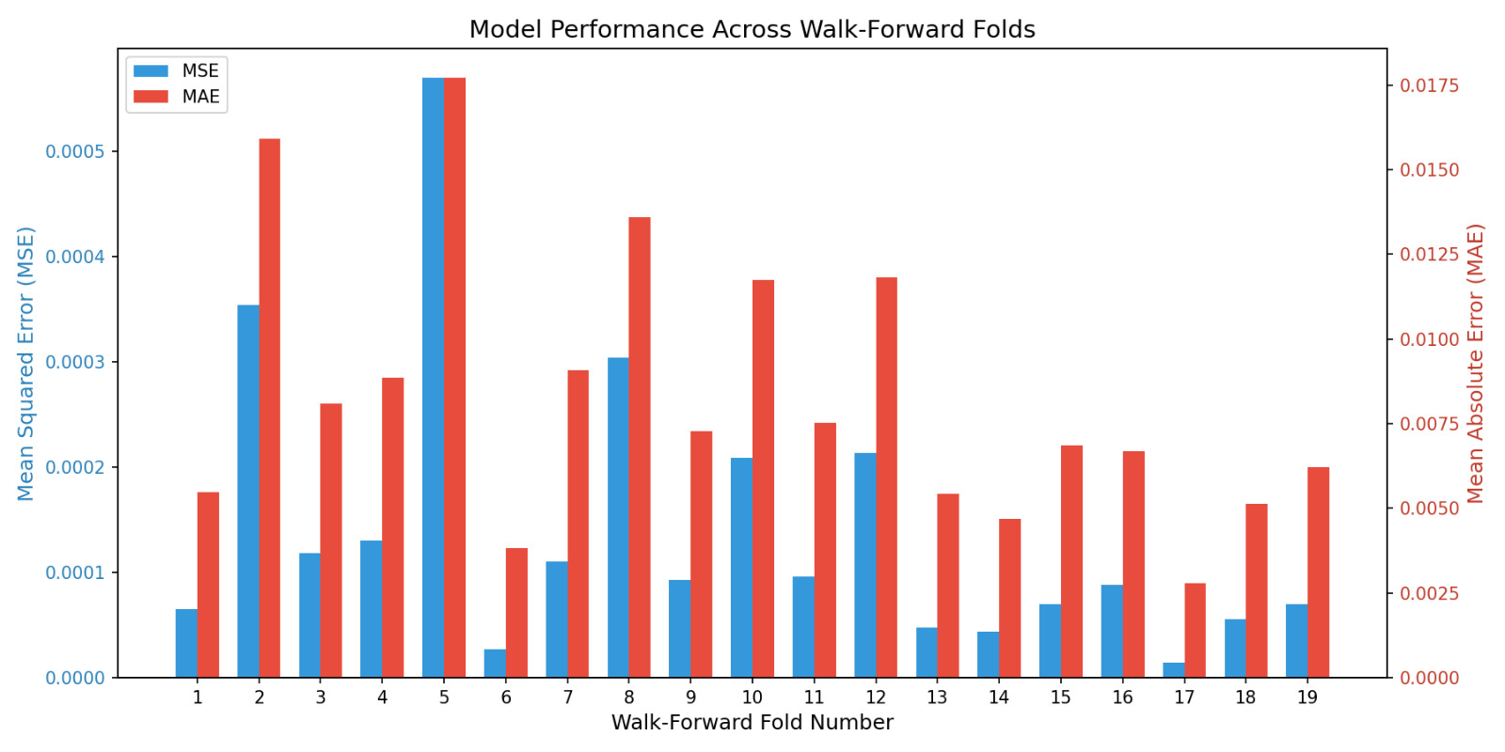
Figure 4. 6-Day walk-forward error evaluation — HPT-QRC maintains low error across all horizons.

6b. Hyperparameter Configuration Impact
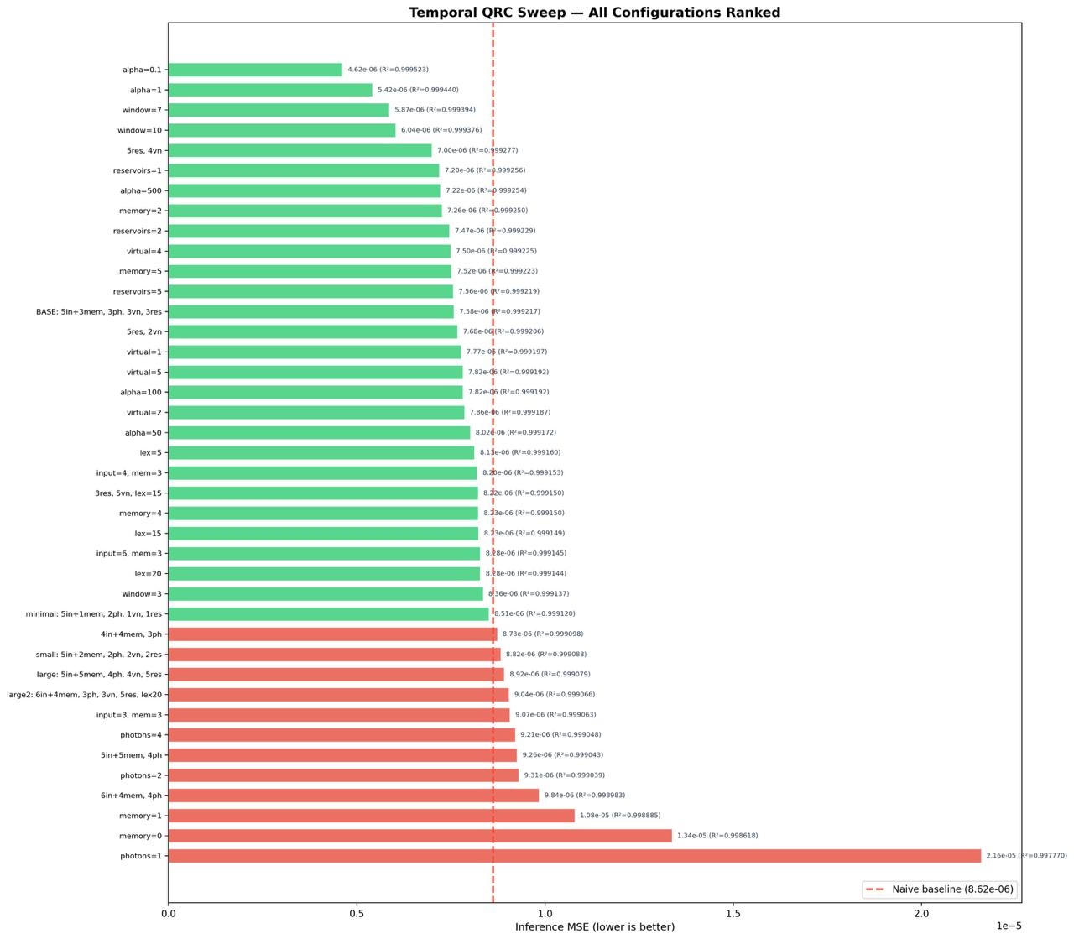
Figure 5. Hyperparameter ablation study — seeds, virtual nodes, and modes swept.

6c. Task 2: Data Imputation Reconstruction
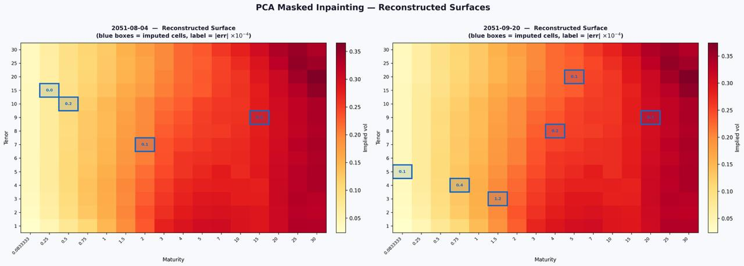
Figure 6. Data imputation reconstruction results — missing surface nodes recovered accurately.

6d. Champion Model: Price Trajectory Tracking
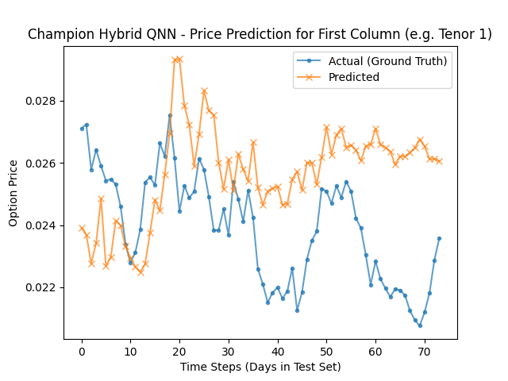
Figure 7. HPT-QRC swaption price trajectory tracking vs. actual market data.

07. CONCLUSIONS

- State-of-the-art accuracy: HPT-QRC achieves RMSE = 0.0021, beating LSTM (0.0073), QSVR (0.0233), and all intermediate photonic variants.
- Novel temporal memory architecture: Dedicated memory modes + virtual-node sampling give the photonic reservoir genuine short-term memory at zero extra hardware cost.
- Scalable ensemble approach: LexGrouping + multi-seed ensembling compress the exponentially large Fock space into tractable 90-feature vectors.
- Near-term hardware ready: Implemented on Quandela MerLin — compatible with current photonic quantum processors without error correction.

Team Qedi · EPFL Quantum Hackathon 2026 · Quandela Challenge · github.com/HUmutI/EPFL-Quandela-Qedi

