Harshvardhan V Doyal

M00953762

**CST2120 Web Applications and Databases**

Coursework 1: Game Website

Website with Navigation

Contents

Table of Figures 2

Introduction 3

Home Page 3

Login And Sign-Up Pop-ups 4

Leaderboards Page 5

Game Window 6

Conclusion 7

# Table of Figures

Figure 1 : Home Page and Header………………………………………………………………………………………………………3

Figure 2: Home Page and Footer……………..…………………………………………………………………………………………3

Figure 3: Sign Up Form……………..………………………………………………………………………………………….……………4

Figure 4: Log in Form……………..…………………………………………………………………………………………….……………4

Figure 5: Leaderboard page with header……………..………………………………………………………….…………………5

Figure 6: Leaderboard page with footer……………..……………………………………………………………………………5

Figure 7: Game Window……………..……………………………………………………………………………………………………6

Figure 8: Gameplay……………..……………………………………………………………………………………………………………6

# Introduction

This report offers a comprehensive overview of our web application, covering key pages such as the homepage, game page, scoreboard, login, and signup. Each section details the normal behavior, functionalities, and includes relevant screenshots without revealing code. Emphasis is placed on robust error handling, input validation, and data storage methods. The report concludes with insights into unique features and technologies integrated for a thorough understanding of our development process. Please refer to the report alongside the tested web browser for the best experience.

# Home Page

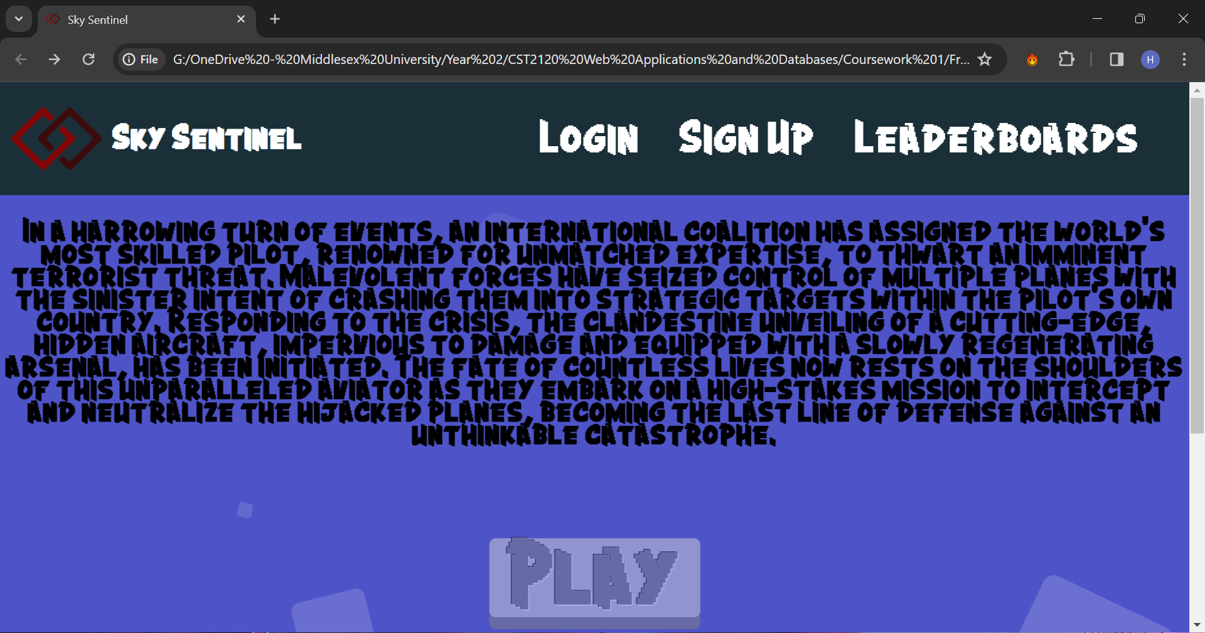

Figure 1: Home Page and Header

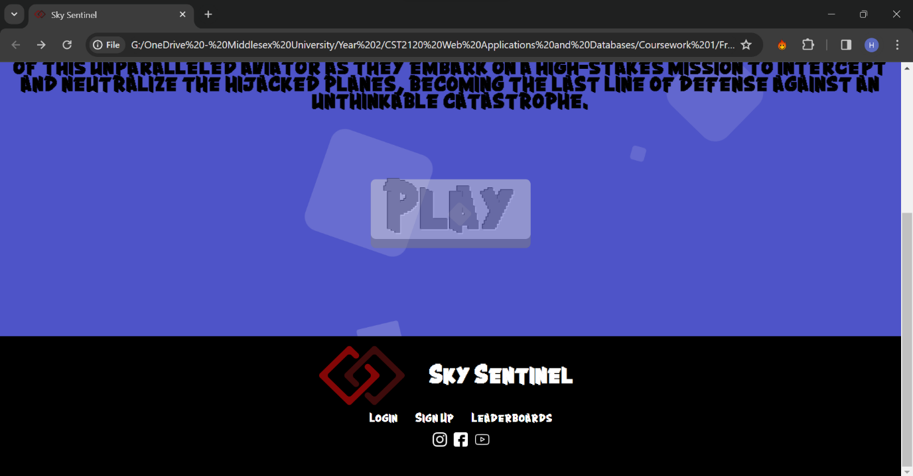

Figure 2: Home Page and Footer

The play button is greyed out if the user is not logged into the page. The background is animated using a list. The icons lead to the respective websites and so do the text buttons.

# Login And Sign-Up Pop-ups

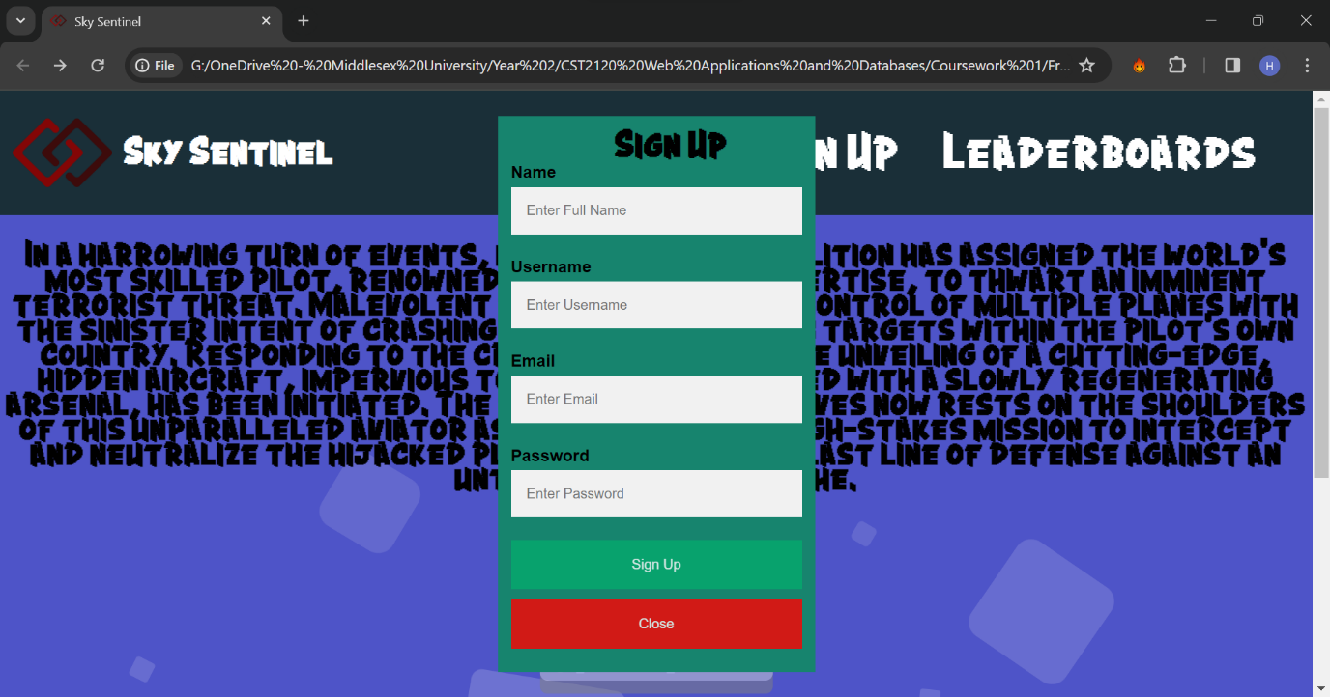

Figure 3: Sign Up Form

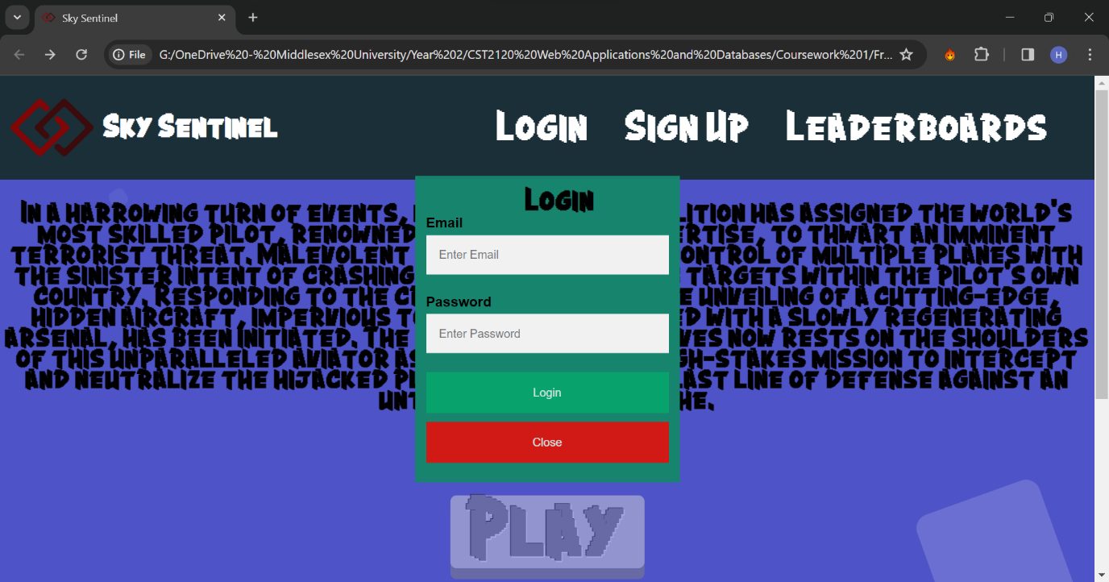

Figure 4: Login Form

If the is no account that match login details, a pop up will appear. The data is store in local storage.

The password should be 8 letter long. The email should have a specific format. The pop up is done using javascript and the design using html forms and CSS.

# Leaderboards Page

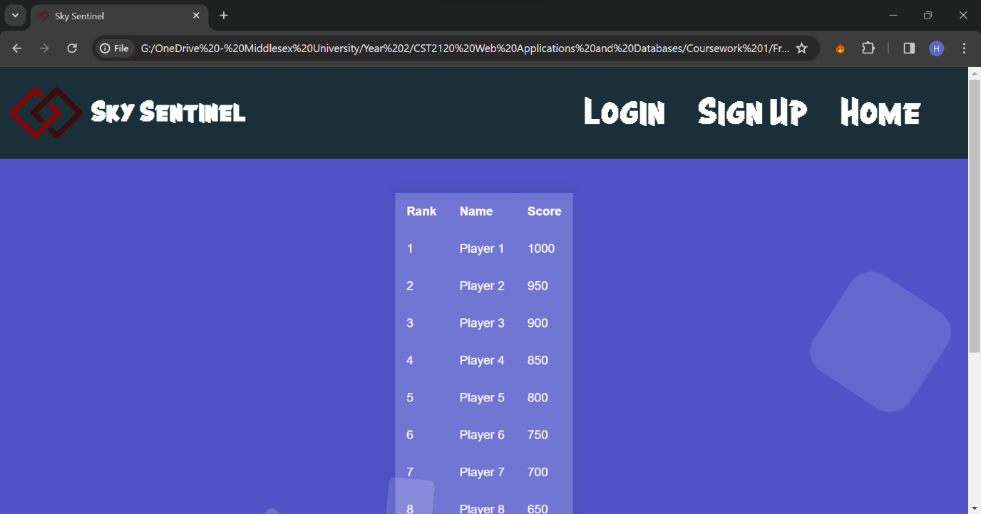

Figure 5: Leaderboard page with header

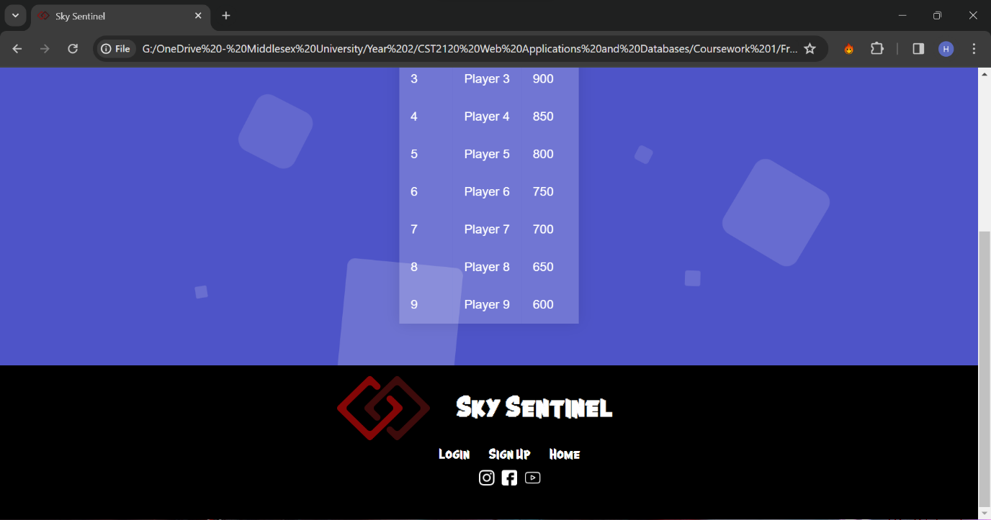

Figure 6: Leaderboard page with footer

The leaderboard used a table that has been customised with CSS.

# Game Window

Figure 7: Game Window

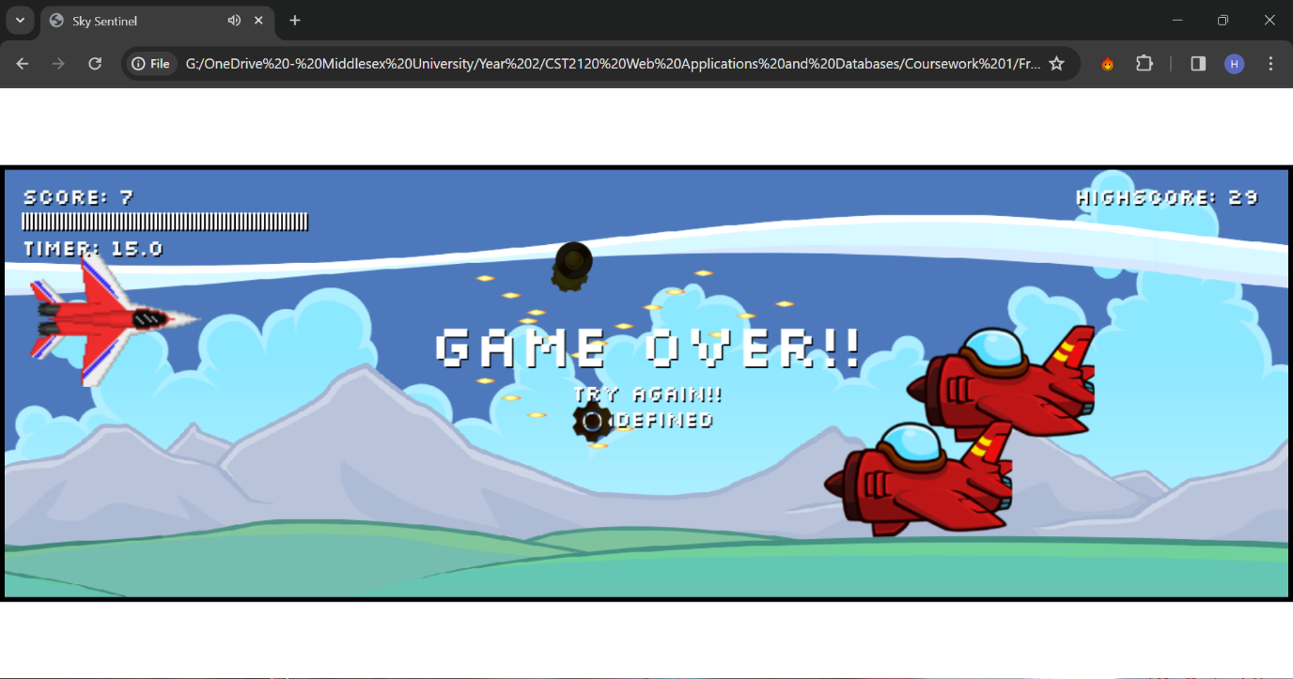

Figure 8: Gameplay

The game window is a canvas.

The player moves using arrow up and arrow down and shoots with space bar.

The aim is to get the highest score possible in the limited time frame.

Score is generated based on the point each enemy provide.

There is a sound when shooting. The highscore is saved.

# Conclusion

The browser used to test was Google Chrome and the ide used was webstorm. The game is developed using pure javascript and OOP. TO implement different types of enemies a super class enemy has been used. The game properties is also done by classes and rendering the map. There is an infinite loop to animate the game.