Harshvardhan V Doyal

M00953762

**CST2120 Web Applications and Databases**

Coursework 2: Social Networking

Final Website

Table of Contents

Table of Figures 2

1.Login Page 3

2.Signup Page 3

3.Home Page 4

4.Post in Postman 5

5.Get in Postman 6

6.Get in the StudentID Page 6

7.The data in MongoDB 7

# Description

This project is a special online space where gamers can hang out, share cool clips and pictures, and make new friends who love gaming as much as they do.

Think of it like a big virtual clubhouse for gamers. You can show off your best moments, like that time you won a tough battle or pulled off an amazing move. Plus, you can connect with old buddies and meet new ones who enjoy the same kinds of games you do.

This platform makes it easy to find people who are into the same games you are, whether it's action-packed shooters, immersive role-playing games, or intense esports competitions.

# Login Page

Figure 1: Login screen

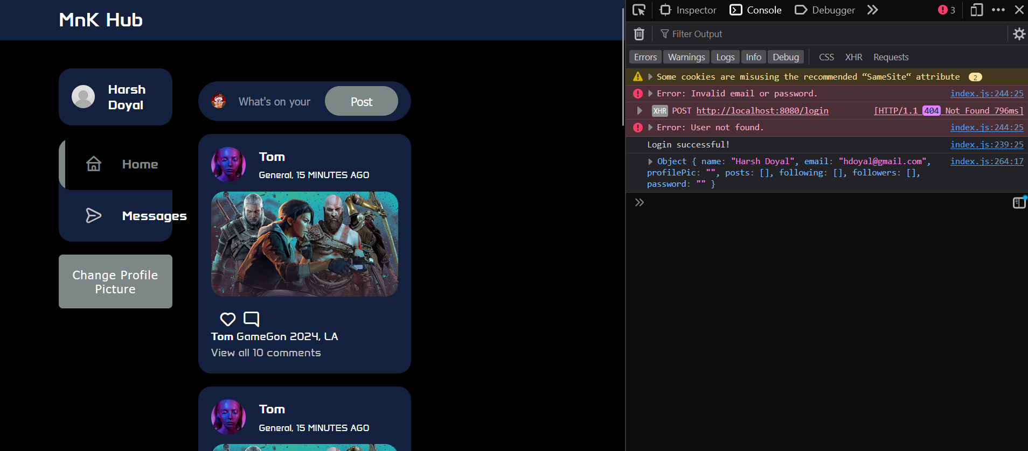

Figure 2: Successful Login

Figure 3: Incorrect Password

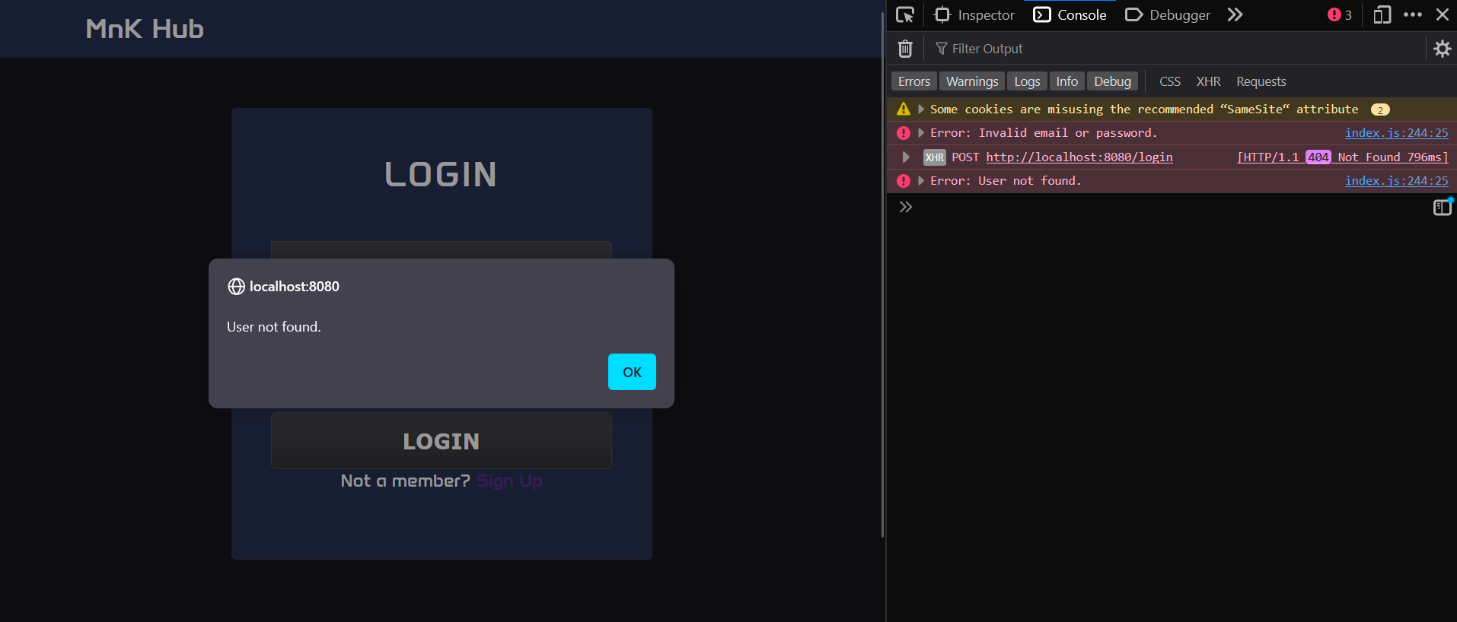

Figure 4: User did not sign up.

User must enter email and password to login. Email and password will be checked if present in the database. If email is present and password matched. User will be logged in. If email is present, user will get a pop-up saying invalid email or password. If both does not exist user will get a pop-up saying invalid user. Up successful logging data from database about the user will be retrieve and stored in global variables.

# Signup Page

Figure 5: Sign Up

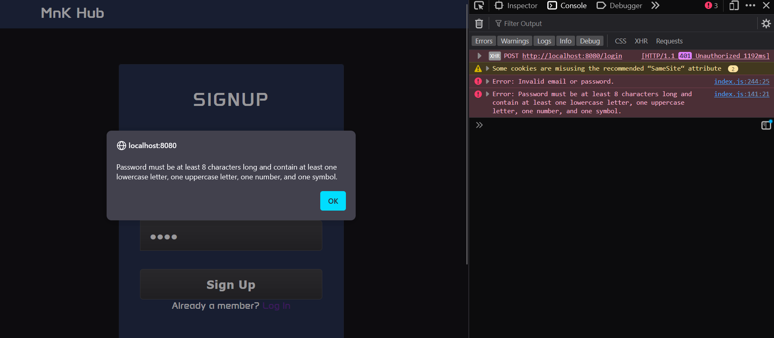

Figure 6: Sign Up with simple password

Figure 7: Leaving all fields blank.

User must enter Name, email, and password to sign up. If password is not strong enough and pop-up will say Password must be at least 8 characters long and contain at least one lowercase letter, one uppercase letter, one number, and one symbol. If one or more fields are blank a pop-up will notify the user.

# Testing

## HTML Validator

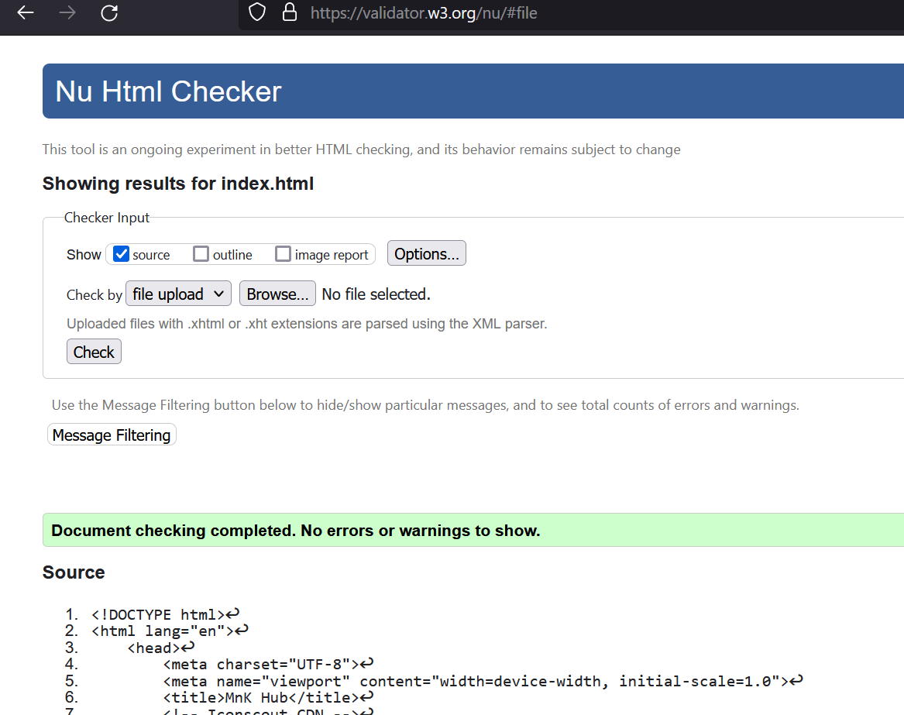

## CSS Validator

# Security, Privacy Legal Issues.

Security, privacy, and legal issues are paramount considerations for any website, especially for a social media platform, which involves users sharing personal content such as photos and videos of their gaming experiences.

Security Issues:

Ensuring the security of user data is crucial to maintaining trust and protecting against malicious activities.

1. Two-Factor Authentication (2FA): Implementing 2FA adds an extra layer of security by requiring users to verify their identity through a second method, such as a code sent to their mobile device. This mitigates the risk of unauthorized access even if passwords are compromised.

2. Regular Security Audits: Conducting routine security audits can help identify vulnerabilities and weaknesses in your website's infrastructure. Penetration testing and code reviews can uncover potential exploits that hackers might leverage.

3. Data Encryption: Password must be at least 8 characters long and contain at least one lowercase letter, one uppercase letter, one number, and one symbol. Password encrypted using a had algorithm when stored in database.

4. Secure File Uploads: Implement strict validation and filtering mechanisms to prevent malicious files from being uploaded. This helps mitigate the risk of malware infections and protects users from potential security threats.

Privacy Issues:

Privacy concerns are paramount when users share personal content online. Users must feel confident that their data is being handled responsibly and that their privacy is respected.

1. Privacy Settings: Provide users with granular privacy controls to determine who can view their content. Allow users to customize visibility settings for individual posts, ensuring they have full control over their privacy preferences.

2. Data Access Controls: Limit access to user data to only authorized personnel and processes. Implement strict access controls and data minimization techniques to ensure that only necessary information is collected and retained.

3. Anonymization: Implementing anonymization techniques to protect user identities when analysing or sharing aggregated data. This helps preserve user privacy while still allowing for valuable insights to be gleaned from user interactions.

Legal Issues:

Compliance with relevant laws and regulations is essential to avoid legal repercussions and maintain the trust of your users. Some key legal considerations include:

1. GDPR Compliance: Ensure compliance with the General Data Protection Regulation (GDPR) if the website caters to users in the European Union. This includes obtaining explicit consent for data processing, providing data subjects with access to their information, and implementing mechanisms for data portability and erasure.

2. Terms of Service and User Agreements: Draft comprehensive terms of service and user agreements that govern the relationship between your website and its users. Clearly outline user rights and responsibilities, as well as the consequences of violating the terms of service.

3. Intellectual Property Rights: Implement measures to protect intellectual property rights, both for your website's content and user-generated content. Enforce copyright policies to prevent unauthorized use or distribution of copyrighted material.