CONTENTS

CONTENTS 2

FOREWORD 4

INTRODUCTION 4

1 Scope 5

2 Normative references 5

3 Terms and definitions 5

4 Top package ExtHVDCwise 5

4.1 General 5

4.2 Package ExtDCEquipment 5

4.2.1 General 5

4.2.2 (HVDCwise) DCStorage 6

4.2.3 (HVDCwise) DCStorageBranchKind enumeration 7

4.2.4 (HVDCwise) DCSuperCapacitorStorageSubModule 7

4.2.5 (HVDCwise) DCBatteryStorageSubModule 8

4.2.6 (HVDCwise) DCStorageController root class 9

4.2.7 (HVDCwise) DCStorageControlModeKind enumeration 10

4.3 Package ExtDCTerminal 10

4.3.1 General 10

4.3.2 (HVDCwise) ExtDCTerminal root class 10

4.3.3 (HVDCwise) DCTerminalPolarityKind enumeration 11

4.4 Package ExtDCStateVariables 11

4.4.1 General 11

4.4.2 (HVDCwise) SvDCVoltage 11

4.4.3 (HVDCwise) SvDCPowerFlow 12

4.4.4 (HVDCwise) SvDCStorage 12

4.4.5 (HVDCwise) SvDCBattery 12

4.4.6 (HVDCwise) SvDCSuperCapacitor 13

Annex A (informative) xxx 14

Bibliography 14

Figure 1 – Class diagram ExtDCEquipment::DCStorage 5

Figure 2 – Class diagram ExtDCTerminal::ExtDCTerminal 10

Figure 3 – Class diagram ExtDCStateVariables::ExtDCStateVariables 11

Table 1 – Attributes of ExtDCEquipment::DCStorage 6

Table 2 – Association ends of ExtDCEquipment::DCStorage with other classes 6

Table 3 – Literals of ExtDCEquipment::DCStorageBranchKind 7

Table 4 – Attributes of ExtDCEquipment::DCSuperCapacitorStorageSubModule 7

Table 5 – Association ends of ExtDCEquipment::DCSuperCapacitorStorageSubModule with other classes 8

Table 6 – Attributes of ExtDCEquipment::DCBatteryStorageSubModule 8

Table 7 – Association ends of ExtDCEquipment::DCBatteryStorageSubModule with other classes 9

Table 8 – Attributes of ExtDCEquipment::DCStorageController 9

Table 9 – Association ends of ExtDCEquipment::DCStorageController with other classes 10

Table 10 – Literals of ExtDCEquipment::DCStorageControlModeKind 10

Table 11 – Attributes of ExtDCTerminal::ExtDCTerminal 11

Table 12 – Literals of ExtDCTerminal::DCTerminalPolarityKind 11

Table 13 – Attributes of ExtDCStateVariables::SvDCVoltage 12

Table 14 – Association ends of ExtDCStateVariables::SvDCVoltage with other classes 12

Table 15 – Attributes of ExtDCStateVariables::SvDCPowerFlow 12

Table 16 – Association ends of ExtDCStateVariables::SvDCPowerFlow with other classes 12

Table 17 – Association ends of ExtDCStateVariables::SvDCStorage with other classes 12

Table 18 – Attributes of ExtDCStateVariables::SvDCBattery 12

Table 19 – Association ends of ExtDCStateVariables::SvDCBattery with other classes 13

Table 20 – Attributes of ExtDCStateVariables::SvDCSuperCapacitor 13

Table 21 – Association ends of ExtDCStateVariables::SvDCSuperCapacitor with other classes 13

HVDC WISE

____________

CIM Extensions

HVDC WISE

CIM Extensions

# Top package ExtHVDCwise

## General

This section provides detailed information on extensions related to DC modelling proposed by HVDC WISE project.

## Package ExtDCEquipment

### General

The section contains extensions related to the DC equipment.

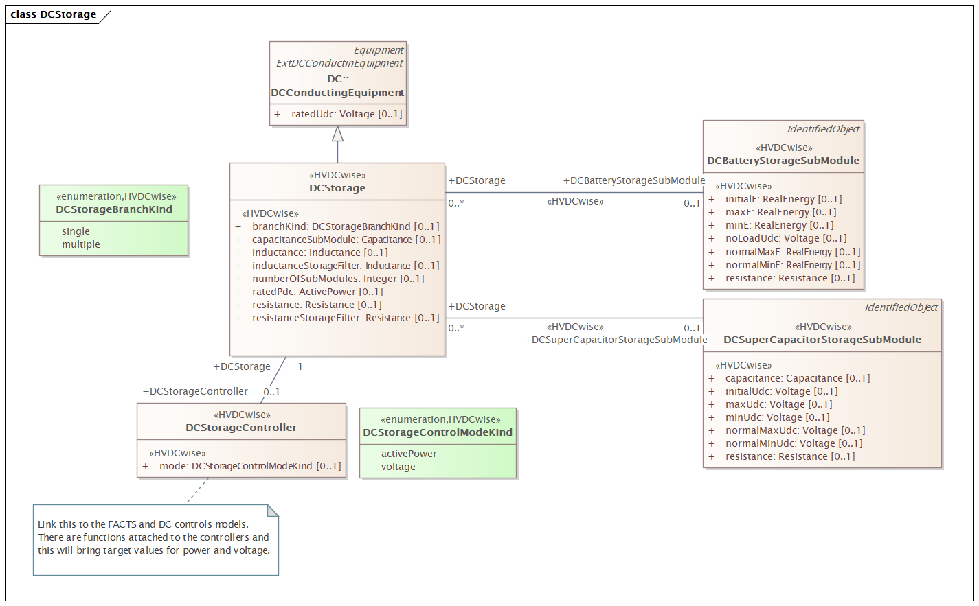

Figure 1 – Class diagram ExtDCEquipment::DCStorage

Figure 1: The diagram shows extensions related to the DC storage.

### (HVDCwise) DCStorage

Inheritance path = DCConductingEquipment : Equipment : PowerSystemResource : IdentifiedObject : ExtEuIdentifiedObject : ExtDCConductinEquipment

Direct current storage. It is a two terminal device.

The DC storage has been primarily defined for DC-connected single branch of series-connected submodules with energy storage but can be used for models with several branches in parallel.

Table 1 shows all attributes of DCStorage.

Table 1 – Attributes of ExtDCEquipment::DCStorage

| name | mult | type | description |
| --- | --- | --- | --- |
| ratedPdc | 0..1 | ActivePower | (HVDCwise) Rated DC power of the converter. The attribute shall be positive value. |
| inductance | 0..1 | Inductance | (HVDCwise) Inductance of the branch inductor. The attribute shall be positive value. |
| resistance | 0..1 | Resistance | (HVDCwise) Resistance of the branch inductor. The attribute shall be positive value. |
| capacitanceSubModule | 0..1 | Capacitance | (HVDCwise) Capacitance of the sub-module capacitor. The attribute shall be positive value. |
| numberOfSubModules | 0..1 | Integer | (HVDCwise) Number of submodules. |
| inductanceStorageFilter | 0..1 | Inductance | (HVDCwise) Storage filter inductance for each sub-module (Lsm). Used for calculation of the inductance of the equivalent circuit. The attribute shall be positive value. |
| resistanceStorageFilter | 0..1 | Resistance | (HVDCwise) Storage filter inductor resistance for each sub-module (Rsm). Used for calculation of the resistance of the equivalent circuit. The attribute shall be positive value. |
| branchKind | 0..1 | DCStorageBranchKind | (HVDCwise) Kind of DC storage in terms of number of branches. |
| ratedUdc | 0..1 | Voltage | inherited from: DCConductingEquipment |
| aggregate | 0..1 | Boolean | inherited from: Equipment |
| inService | 0..1 | Boolean | inherited from: Equipment |
| networkAnalysisEnabled | 0..1 | Boolean | inherited from: Equipment |
| normallyInService | 0..1 | Boolean | inherited from: Equipment |
| aliasName | 0..1 | String | inherited from: IdentifiedObject |
| description | 0..1 | String | inherited from: IdentifiedObject |
| mRID | 0..1 | String | inherited from: IdentifiedObject |
| name | 0..1 | String | inherited from: IdentifiedObject |
| energyIdentCodeEic | 0..1 | String | (European) inherited from: ExtEuIdentifiedObject |
| shortName | 0..1 | String | (European) inherited from: ExtEuIdentifiedObject |
| ratedCurrent | 0..1 | CurrentFlow | inherited from: ExtDCConductinEquipment |

Table 2 shows all association ends of DCStorage with other classes.

Table 2 – Association ends of ExtDCEquipment::DCStorage with other classes

| mult from | name | mult to | type | description |
| --- | --- | --- | --- | --- |
| 0..* | DCBatteryStorageSubModule | 0..1 | DCBatteryStorageSubModule | (HVDCwise) The DC battery storage submodule for this DC storage. |
| 0..* | DCSuperCapacitorStorageSubModule | 0..1 | DCSuperCapacitorStorageSubModule | (HVDCwise) The DC super capacitor submodule for this DC storage. |
| 1..1 | DCStorageController | 0..1 | DCStorageController | The DC storage controller for this DC storage device. |
| 1..1 | SvDCStorage | 0..* | SvDCStorage | (HVDCwise) The state variables of a DC storage. |
| 1..1 | DCTerminals | 0..* | DCTerminal | inherited from: DCConductingEquipment |
| 0..* | AggregatedEquipment | 0..1 | Equipment | (NC) inherited from: Equipment |
| 0..1 | OperationalLimitSet | 0..* | OperationalLimitSet | inherited from: Equipment |
| 1..1 | ContingencyEquipment | 0..* | ContingencyEquipment | inherited from: Equipment |
| 0..* | EquipmentContainer | 0..1 | EquipmentContainer | inherited from: Equipment |
| 0..1 | Faults | 0..* | Fault | inherited from: Equipment |
| 0..* | AdditionalEquipmentContainer | 0..* | EquipmentContainer | inherited from: Equipment |
| 0..1 | DetailedModelDynamics | 0..* | DetailedModelDynamics | inherited from: Equipment |
| 0..1 | DetailedEquipment | 0..* | Equipment | (NC) inherited from: Equipment |
| 0..* | PSRType | 0..1 | PSRType | inherited from: PowerSystemResource |
| 0..1 | Controls | 0..* | Control | inherited from: PowerSystemResource |
| 0..1 | Measurements | 0..* | Measurement | inherited from: PowerSystemResource |
| 1..1 | OperatingShare | 0..* | OperatingShare | inherited from: PowerSystemResource |
| 0..* | ReportingGroup | 0..* | ReportingGroup | inherited from: PowerSystemResource |
| 0..1 | DiagramObjects | 0..* | DiagramObject | inherited from: IdentifiedObject |
| 1..1 | Names | 0..* | Name | inherited from: IdentifiedObject |
| 0..1 | ParameterEvent | 0..* | ParameterEvent | inherited from: IdentifiedObject |
| 0..1 | AlternativeIdentifier | 0..* | Name | (NC) inherited from: IdentifiedObject |
| 0..1 | Name | 0..* | Name | (NC) inherited from: IdentifiedObject |

### (HVDCwise) DCStorageBranchKind enumeration

Kind of DC storage in terms of number of branches.

Table 3 shows all literals of DCStorageBranchKind.

Table 3 – Literals of ExtDCEquipment::DCStorageBranchKind

| literal | value | description |
| --- | --- | --- |
| single |  | DC storage is a single branch of series-connected submodules with energy storage. |
| multiple |  | DC storage is made of multiple branches of series-connected submodules with energy storage. |

### (HVDCwise) DCSuperCapacitorStorageSubModule

Inheritance path = IdentifiedObject : ExtEuIdentifiedObject

Super capacitor storage submodule of the DC storage device.

Table 4 shows all attributes of DCSuperCapacitorStorageSubModule.

Table 4 – Attributes of ExtDCEquipment::DCSuperCapacitorStorageSubModule

| name | mult | type | description |
| --- | --- | --- | --- |
| capacitance | 0..1 | Capacitance | (HVDCwise) Capacitance of supercapacitor per sub-module (Csc). Used for calculation of the capacitance of the equivalent circuit. The attribute shall be positive value. |
| resistance | 0..1 | Resistance | (HVDCwise) Resistance of supercapacitor per sub-module (Rsc). Used for calculation of the resistance of the equivalent circuit. The attribute shall be positive value. |
| normalMaxUdc | 0..1 | Voltage | (HVDCwise) Normal maximum permissible supercapacitor voltage. When the supercapacitor voltage is superior to this value, the power that the device can absorb is reduced. The attribute shall be positive value. |
| maxUdc | 0..1 | Voltage | (HVDCwise) Maximum permissible supercapacitor voltage. When the supercapacitor voltage is superior to this value, the power that the device can absorb is set to zero. The attribute shall be positive value. |
| normalMinUdc | 0..1 | Voltage | (HVDCwise) Normal minimum permissible supercapacitor voltage. When the supercapacitor voltage is inferior to this value, the power that the device can provide is reduced. The attribute shall be positive value. |
| minUdc | 0..1 | Voltage | (HVDCwise) Minimum permissible supercapacitor voltage. When the supercapacitor voltage is inferior to this value, the power that the device can provide is set to zero. The attribute shall be positive or zero value. |
| initialUdc | 0..1 | Voltage | (HVDCwise) Initial voltage of the capacitance of the super capacitor (Csc). The attribute shall be positive or zero value. |
| aliasName | 0..1 | String | inherited from: IdentifiedObject |
| description | 0..1 | String | inherited from: IdentifiedObject |
| mRID | 0..1 | String | inherited from: IdentifiedObject |
| name | 0..1 | String | inherited from: IdentifiedObject |
| energyIdentCodeEic | 0..1 | String | (European) inherited from: ExtEuIdentifiedObject |
| shortName | 0..1 | String | (European) inherited from: ExtEuIdentifiedObject |

Table 5 shows all association ends of DCSuperCapacitorStorageSubModule with other classes.

Table 5 – Association ends of ExtDCEquipment::DCSuperCapacitorStorageSubModule with other classes

| mult from | name | mult to | type | description |
| --- | --- | --- | --- | --- |
| 0..1 | DCStorage | 0..* | DCStorage | (HVDCwise) The DC storage that has this DC super capacitor submodule. |
| 1..1 | SvDCSuperCapacitor | 0..* | SvDCSuperCapacitor | (HVDCwise) The state variavles for this DC super capacitor. |
| 0..1 | DiagramObjects | 0..* | DiagramObject | inherited from: IdentifiedObject |
| 1..1 | Names | 0..* | Name | inherited from: IdentifiedObject |
| 0..1 | ParameterEvent | 0..* | ParameterEvent | inherited from: IdentifiedObject |
| 0..1 | AlternativeIdentifier | 0..* | Name | (NC) inherited from: IdentifiedObject |
| 0..1 | Name | 0..* | Name | (NC) inherited from: IdentifiedObject |

### (HVDCwise) DCBatteryStorageSubModule

Inheritance path = IdentifiedObject : ExtEuIdentifiedObject

Battery storage submodule of the DC storage device.

Table 6 shows all attributes of DCBatteryStorageSubModule.

Table 6 – Attributes of ExtDCEquipment::DCBatteryStorageSubModule

| name | mult | type | description |
| --- | --- | --- | --- |
| resistance | 0..1 | Resistance | (HVDCwise) Internal battery resistance per sub-module (Rbat). Used for calculation of the resistance of the equivalent circuit. The attribute shall be positive value. |
| noLoadUdc | 0..1 | Voltage | (HVDCwise) No load battery voltage per sub-module (Vbat). Used for calculation of the equivalent battery voltage. The attribute shall be positive value. |
| normalMaxE | 0..1 | RealEnergy | (HVDCwise) Normal maximum battery energy. When the battery energy is superior to this value, the power that the device can absorb is reduced. The attribute shall be positive value. |
| maxE | 0..1 | RealEnergy | (HVDCwise) Maximum battery energy. When the battery energy is superior to this value, the power that the device can absorb is set to zero. The attribute shall be positive value. |
| normalMinE | 0..1 | RealEnergy | (HVDCwise) Normal minimum battery energy. When the battery energy is inferior to this value, the power that the device can provide is reduced. The attribute shall be positive value. |
| minE | 0..1 | RealEnergy | (HVDCwise) Minimum battery energy. When the battery energy is inferior to this value, the power that the device can provide is set to zero. The attribute shall be positive value. |
| initialE | 0..1 | RealEnergy | (HVDCwise) Initial energy of the battery storage. The attribute shall be positive value. |
| aliasName | 0..1 | String | inherited from: IdentifiedObject |
| description | 0..1 | String | inherited from: IdentifiedObject |
| mRID | 0..1 | String | inherited from: IdentifiedObject |
| name | 0..1 | String | inherited from: IdentifiedObject |
| energyIdentCodeEic | 0..1 | String | (European) inherited from: ExtEuIdentifiedObject |
| shortName | 0..1 | String | (European) inherited from: ExtEuIdentifiedObject |

Table 7 shows all association ends of DCBatteryStorageSubModule with other classes.

Table 7 – Association ends of ExtDCEquipment::DCBatteryStorageSubModule with other classes

| mult from | name | mult to | type | description |
| --- | --- | --- | --- | --- |
| 0..1 | DCStorage | 0..* | DCStorage | (HVDCwise) The DC storage that has this DC battery storage. |
| 1..1 | SvDCBattery | 0..* | SvDCBattery | (HVDCwise) The state variable of the DC battery submodule. |
| 0..1 | DiagramObjects | 0..* | DiagramObject | inherited from: IdentifiedObject |
| 1..1 | Names | 0..* | Name | inherited from: IdentifiedObject |
| 0..1 | ParameterEvent | 0..* | ParameterEvent | inherited from: IdentifiedObject |
| 0..1 | AlternativeIdentifier | 0..* | Name | (NC) inherited from: IdentifiedObject |
| 0..1 | Name | 0..* | Name | (NC) inherited from: IdentifiedObject |

### (HVDCwise) DCStorageController root class

Controller of the DC storage.

Table 8 shows all attributes of DCStorageController.

Table 8 – Attributes of ExtDCEquipment::DCStorageController

| name | mult | type | description |
| --- | --- | --- | --- |
| mode | 0..1 | DCStorageControlModeKind | (HVDCwise) Direct current storage control mode. |

Table 9 shows all association ends of DCStorageController with other classes.

Table 9 – Association ends of ExtDCEquipment::DCStorageController with other classes

| mult from | name | mult to | type | description |
| --- | --- | --- | --- | --- |
| 0..1 | DCStorage | 1..1 | DCStorage | The DC storage device that has this controller. |

### (HVDCwise) DCStorageControlModeKind enumeration

Kinds of control modes of the DC storage.

Table 10 shows all literals of DCStorageControlModeKind.

Table 10 – Literals of ExtDCEquipment::DCStorageControlModeKind

| literal | value | description |
| --- | --- | --- |
| activePower |  | In this control mode, the reference value is an active power to be provided or absorbed by the device. |
| voltage |  | In this control mode, the reference value corresponds to the dc voltage at the device terminals. |

## Package ExtDCTerminal

### General

This section contains extensions related to the DCTerminal.

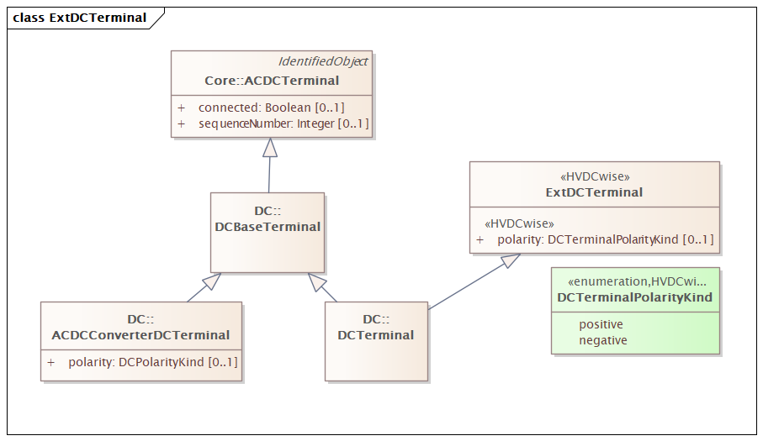

Figure 2 – Class diagram ExtDCTerminal::ExtDCTerminal

Figure 2: The diagram shows extensions related to the DCTerminal.

### (HVDCwise) ExtDCTerminal root class

Extended class.

Table 11 shows all attributes of ExtDCTerminal.

Table 11 – Attributes of ExtDCTerminal::ExtDCTerminal

| name | mult | type | description |
| --- | --- | --- | --- |
| polarity | 0..1 | DCTerminalPolarityKind | (HVDCwise) Represents the normal network polarity condition. Used in DC system configurations that have explicit polarity of the terminals, e.g., voltage source converter (VSC) technology. |

### (HVDCwise) DCTerminalPolarityKind enumeration

Polarity for DC terminal. Used in DC system configurations that have explicit polarity of the terminals, e.g., voltage source converter (VSC) technology.

Table 12 shows all literals of DCTerminalPolarityKind.

Table 12 – Literals of ExtDCTerminal::DCTerminalPolarityKind

| literal | value | description |
| --- | --- | --- |
| positive |  | Positive terminal. |
| negative |  | Negative terminal. |

## Package ExtDCStateVariables

### General

This section contains extensions to the state variables.

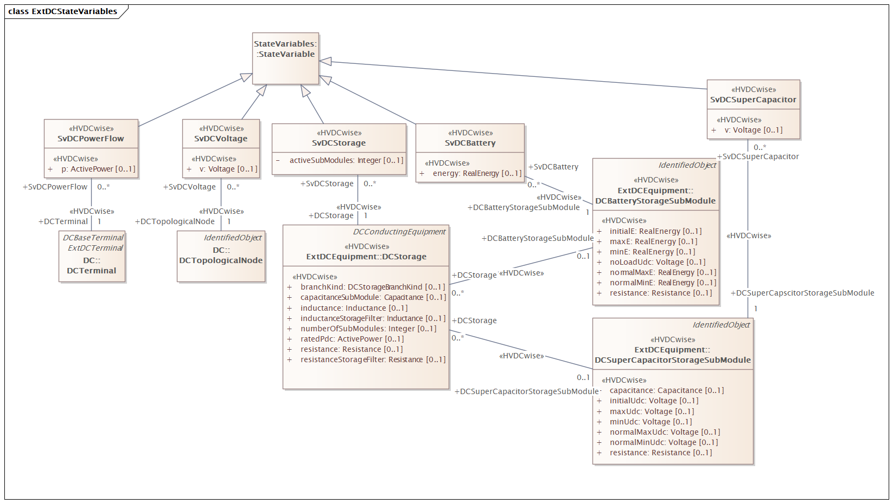

Figure 3 – Class diagram ExtDCStateVariables::ExtDCStateVariables

Figure 3: The diagram shows extensions to the state variables.

### (HVDCwise) SvDCVoltage

Inheritance path = StateVariable

State variable for direct current voltage.

Table 13 shows all attributes of SvDCVoltage.

Table 13 – Attributes of ExtDCStateVariables::SvDCVoltage

| name | mult | type | description |
| --- | --- | --- | --- |
| v | 0..1 | Voltage | (HVDCwise) State variable for direct current voltage. |

Table 14 shows all association ends of SvDCVoltage with other classes.

Table 14 – Association ends of ExtDCStateVariables::SvDCVoltage with other classes

| mult from | name | mult to | type | description |
| --- | --- | --- | --- | --- |
| 0..* | DCTopologicalNode | 1..1 | DCTopologicalNode | (HVDCwise) The DC topological node associated with the DC voltage state. |

### (HVDCwise) SvDCPowerFlow

Inheritance path = StateVariable

State variable for power flow. Load convention is used for flow direction. This means flow out from the DCTopologicalNode into the equipment is positive.

Table 15 shows all attributes of SvDCPowerFlow.

Table 15 – Attributes of ExtDCStateVariables::SvDCPowerFlow

| name | mult | type | description |
| --- | --- | --- | --- |
| p | 0..1 | ActivePower | (HVDCwise) The active power flow. Load sign convention is used, i.e. positive sign means flow out from a DCTopologicalNode (bus) into the conducting equipment. |

Table 16 shows all association ends of SvDCPowerFlow with other classes.

Table 16 – Association ends of ExtDCStateVariables::SvDCPowerFlow with other classes

| mult from | name | mult to | type | description |
| --- | --- | --- | --- | --- |
| 0..* | DCTerminal | 1..1 | DCTerminal | (HVDCwise) The DC power flow state variable associated with the DC terminal. |

### (HVDCwise) SvDCStorage

Inheritance path = StateVariable

State variable for direct current storage.

Table 17 shows all association ends of SvDCStorage with other classes.

Table 17 – Association ends of ExtDCStateVariables::SvDCStorage with other classes

| mult from | name | mult to | type | description |
| --- | --- | --- | --- | --- |
| 0..* | DCStorage | 1..1 | DCStorage | (HVDCwise) The DC storage that has this state variables. |

### (HVDCwise) SvDCBattery

Inheritance path = StateVariable

State variable for direct current battery.

Table 18 shows all attributes of SvDCBattery.

Table 18 – Attributes of ExtDCStateVariables::SvDCBattery

| name | mult | type | description |
| --- | --- | --- | --- |
| energy | 0..1 | RealEnergy | (HVDCwise) Battery energy. The attribute shall be positive value or zero. |

Table 19 shows all association ends of SvDCBattery with other classes.

Table 19 – Association ends of ExtDCStateVariables::SvDCBattery with other classes

| mult from | name | mult to | type | description |
| --- | --- | --- | --- | --- |
| 0..* | DCBatteryStorageSubModule | 1..1 | DCBatteryStorageSubModule | (HVDCwise) The DC battery submodule that has this state variables. |

### (HVDCwise) SvDCSuperCapacitor

Inheritance path = StateVariable

State variable for direct current super capacitor.

Table 20 shows all attributes of SvDCSuperCapacitor.

Table 20 – Attributes of ExtDCStateVariables::SvDCSuperCapacitor

| name | mult | type | description |
| --- | --- | --- | --- |
| v | 0..1 | Voltage | (HVDCwise) State variable for direct current voltage of the super capacitor. |

Table 21 shows all association ends of SvDCSuperCapacitor with other classes.

Table 21 – Association ends of ExtDCStateVariables::SvDCSuperCapacitor with other classes

| mult from | name | mult to | type | description |
| --- | --- | --- | --- | --- |
| 0..* | DCSuperCapscitorStorageSubModule | 1..1 | DCSuperCapacitorStorageSubModule | (HVDCwise) The DC super capacitor submodule that has this state variables. |