Construct 3: Unsupervised Anomaly Detection and Denoising with Autoencoders on Fashion-MNIST
Hardageri Vikranth Reddy — Roll No. 24WU0102008
Hasini Mukkumala — Roll No. 24WU0102042
Affiliation: Department of Computer Science and Engineering

Abstract—Autoencoders learn compact representations of data by training a network to reconstruct its own input through a narrow bottleneck, and the quality of that reconstruction doubles as a signal for both compression and anomaly detection. In this work we build, train, and compare three autoencoder variants—a fully connected autoencoder, a convolutional autoencoder, and a denoising convolutional autoencoder—on Fashion-MNIST, a dataset of 70,000 grayscale 28×28 images of clothing items, compressing every image through a 32-dimensional latent code. We evaluate the models under a one-class anomaly detection protocol in which the Sandal class is withheld entirely from training and validation and must be flagged at test time from reconstruction error alone. We also test robustness by corrupting inputs with Gaussian noise of standard deviation 0.3 and asking the denoising model to recover the clean image. The convolutional autoencoder achieves the best overall performance with an ROC-AUC of 0.857 and the lowest reconstruction error (MSE 0.01459) while using roughly four times fewer parameters than the fully connected baseline. An ablation study shows that batch normalization is essential: removing it nearly doubles reconstruction error and sharply degrades detection performance.
Index Terms—autoencoder, anomaly detection, denoising, Fashion-MNIST, representation learning, one-class classification.

I. Introduction
Modern production lines, from textile mills to electronics assembly, rely on visual inspection to catch defects before faulty goods reach customers. Human inspection is slow, expensive, and inconsistent, while supervised computer-vision systems demand large collections of labeled defect examples. The difficulty is that defects are, by definition, rare and unpredictable: a factory may run for months before a new failure mode appears, and nobody can enumerate every way a product might break. What is abundant instead is examples of normal, acceptable products. This asymmetry motivates unsupervised anomaly detection: learn a model of normality from defect-free data alone, then flag anything the model cannot explain as a candidate defect. Such a system needs no defect labels, adapts to whatever the normal class looks like, and degrades gracefully when novel failure modes appear.
Autoencoders are a natural fit for this setting. An autoencoder is a neural network trained to reproduce its own input after passing it through a low-dimensional bottleneck, called the latent code. Because the bottleneck is too narrow to memorize the training set, the network is forced to discover the regularities of the data—edges, textures, shapes, and their typical arrangements. Once trained on normal examples, the model reconstructs new normal inputs well but struggles with inputs that break those regularities, so the reconstruction error becomes a ready-made anomaly score: large error means the input does not look like anything the model has seen. This idea, introduced in the early deep learning literature [1] and extended with denoising objectives [2], [3], has since been applied to network intrusion, medical imaging, and industrial inspection [9], [10], [17].
Studying anomaly detection directly on factory imagery is attractive but impractical for a controlled comparison: real defect datasets are proprietary, small, and inconsistently labeled. Fashion-MNIST [5] offers a public, well-understood alternative. It contains 70,000 grayscale images of size 28×28 pixels, evenly divided among ten clothing categories, with far more texture and silhouette variation than the handwritten digits of MNIST. Its difficulty sits in a useful middle ground: easy enough that a modest network can learn it on a CPU in minutes, yet hard enough that architectural choices visibly matter. Crucially, its class structure supports a clean one-class protocol. We designate one category—Sandal, class index 5—as the anomaly and remove it completely from training and validation. Sandals are visually distinctive, with thin straps and open regions, yet they share footwear semantics with the Sneaker and Ankle boot classes that remain in the normal set, so the task is neither trivial nor impossible. Success on this protocol is evidence that the model has learned normality rather than memorized pixels.
This paper, the third in our Construct series on representation learning, makes three contributions. First, we compare fully connected, convolutional, and denoising autoencoders head-to-head on identical data, training budgets, and evaluation code, isolating the effect of architecture from the effect of experimental setup. Second, we define and execute a fixed one-class anomaly detection protocol with a held-out class and a principled threshold rule, reporting both threshold-dependent metrics (precision, recall, F1) and threshold-free ones (ROC-AUC, PR-AUC). Third, we ablate the two regularization components of our baseline—batch normalization and dropout—and quantify exactly how much each contributes to reconstruction quality and detection performance. All experiments run on a two-core CPU in about ten minutes total, demonstrating that meaningful representation-learning research remains accessible without specialized hardware.
The remainder of this paper is organized as follows. Section II develops the mathematical preliminaries of autoencoders, the denoising objective, and the anomaly scoring rule. Section III surveys related work on autoencoders, convolutional variants, and anomaly detection. Section IV describes our dataset protocol, architectures, scoring rule, and latent-space analysis. Section V details the experimental setup. Section VI presents results and Section VII the latent-space and qualitative analysis. Section VIII presents the ablation study. Section IX discusses deployment for visual quality control, and Section X surveys related application domains. Section XI examines the limitations and threats to validity of our study. Section XII concludes with directions for future work.
II. Mathematical Preliminaries
We formalize the autoencoder before describing our concrete instances, since the notation and objectives recur throughout the paper. Let 𝒳 = [0,1]^N be the space of N-pixel grayscale images; here N = 28×28 = 784. An autoencoder is a pair of neural networks: an encoder fθ : 𝒳 → ℝ^d mapping an image x to a d-dimensional latent code z = fθ(x), and a decoder gφ : ℝ^d → 𝒳 mapping the code back to a reconstruction x̂ = gφ(z). The vectors θ and φ collect the trainable weights of the two networks, and d is the bottleneck width. Choosing d ≪ N forces the model to compress: the code cannot memorize the input, so the network must discover its regularities.
z = fθ(x), x̂ = gφ(z) = gφ(fθ(x)).
Training minimizes the expected reconstruction error. Given M training images x₁,…,xₘ, the empirical objective is the mean squared error (MSE) between each input and its reconstruction:
ℒ(θ, φ) = (1/M) Σᵢ ‖xᵢ − gφ(fθ(xᵢ))‖².
Minimizing ℒ encourages the pair (fθ, gφ) to preserve as much of x as a d-dimensional code allows. In the special case of linear encoder and decoder this objective recovers principal component analysis; with nonlinear networks it learns richer data manifolds [1], [22]. The reconstruction of an input the model has never seen is therefore good exactly when that input lies near the learned manifold of normal data—the property our anomaly detector exploits.
The denoising autoencoder [2] modifies the objective rather than the architecture. Each training input is first corrupted, x̃ = clip(x + ε) with ε ∼ 𝒩(0, σ²I), and the network must recover the clean target:
ℒᵈₑₙ(θ, φ) = Eₓ,ᵡ [ ‖x − gφ(fθ(x̃))‖² ].
Because the corruption destroys fine detail that could otherwise be copied straight through the bottleneck, the model must learn the statistical regularities of clean images in order to inpaint the damage. Those regularities are precisely what defines normality in our protocol, which is why the denoising objective doubles as a regularizer for anomaly detection.
It is worth stating the geometric intuition that justifies using reconstruction error as an anomaly score, because the rest of the paper leans on it. The manifold hypothesis holds that high-dimensional real data concentrate near a low-dimensional manifold—the set of all plausible garment images is a tiny fraction of the 784-dimensional cube. A well-trained autoencoder approximates the projection of an input onto this manifold: the encoder maps x to the nearest latent code, and the decoder maps the code back to the manifold itself, so x̂ is the manifold point closest to x and ‖x − x̂‖ measures the distance from the input to normality. Normal inputs lie near the manifold and reconstruct with small error; anomalies lie far from it and reconstruct poorly. This view also explains the failure modes analyzed in Section VI: a low-contrast sandal lies accidentally close to the footwear region of the manifold and scores low, while a high-contrast sneaker with unusual texture lies far from its class region and scores high. The score is honest geometry, not a learned classifier decision, which is why its mistakes are interpretable.
For scoring we use the per-image reconstruction error, normalized by the pixel count:
s(x) = ‖x − x̂‖² / N,
with N = 784. Let F be the empirical distribution of s on normal validation images and let τ = Q₀.₉₅(F) be its 95th percentile. A test image is flagged anomalous when s(x) > τ. This rule fixes the expected false-positive rate at 5% using only normal data, which is the operationally honest choice: defect samples are unavailable at the moment a factory threshold must be set. Given test labels we report precision P = TP/(TP+FP), recall R = TP/(TP+FN), and F1 = 2PR/(P+R) at this threshold, with Sandal images as positives. Because these three metrics all depend on the arbitrary choice of τ, we also report threshold-free ranking metrics: ROC-AUC, the probability that a random anomaly outscores a random normal image, and PR-AUC, the area under the precision–recall curve. With 10% anomaly prevalence, PR-AUC should be judged against a random baseline of 0.10, not 0.50. Table I collects the notation used throughout the paper.
TABLE I. Notation used in this paper.
Symbol | Meaning
x | Input image, x ∈ [0,1]^784
x̃ | Corrupted input (denoising training only)
x̂ | Reconstruction, x̂ = gφ(fθ(x))
z | Latent code, z ∈ ℝ^32
s(x) | Anomaly score: mean squared reconstruction error
τ | Decision threshold: 95th percentile of normal validation errors
N | Pixels per image (784)
M | Training images (10,000)
σ | Denoising noise standard deviation (0.3)
d | Latent dimension (32)
θ, φ | Encoder / decoder parameters

III. Related Work
The autoencoder in its modern form traces back to Hinton and Salakhutdinov [1], who showed that deep networks could be pretrained layer by layer to compress high-dimensional data into compact codes that reconstruct the input faithfully. Vincent et al. [2] strengthened the idea with the denoising autoencoder: corrupt the input with noise, then train the network to recover the clean original. Because the network can no longer rely on copying pixels through the bottleneck, it must capture the statistical structure of the data, yielding features that transfer better to downstream tasks. Stacking such layers [3] produced some of the first competitive deep representations before end-to-end supervised training became dominant. Kingma and Welling [4] later recast the autoencoder probabilistically as the variational autoencoder, imposing a prior on the latent space so that new samples can be generated by decoding random codes.
Convolutional structure brought autoencoders firmly into image modeling. Masci et al. [16] introduced stacked convolutional autoencoders, replacing dense layers with shared convolutional filters that respect the translation invariance of natural images and drastically cut parameter counts. This development rested on the broader success of convolutional networks for recognition, from LeCun et al. [11] through the ImageNet breakthrough of Krizhevsky et al. [19] to residual architectures [14]. For reconstruction tasks, convolutions are appealing for the same reasons: local patterns such as fabric texture, stitching, and edges recur across positions, so weight sharing is both efficient and well matched to the data.
Using reconstruction error for anomaly detection followed quickly. Sakurada and Yairi [17] demonstrated that autoencoders with nonlinear dimensionality reduction outperform linear baselines at flagging anomalous spacecraft telemetry. Zhou and Paffenroth [10] made the approach robust to contaminated training data by splitting each input into a low-dimensional reconstruction plus a sparse outlier component. An and Cho [18] replaced the point reconstruction of a variational autoencoder with a reconstruction probability, scoring anomalies by how unlikely the input is under the learned generative model. Schlegl et al. [9] took a different route with AnoGAN, training a generative adversarial network on normal data and searching its latent space at test time for the code whose generation best matches the query image. Ruff et al. [8] simplified the pipeline with Deep SVDD, which trains a network to map normal data into a minimal hypersphere and scores anomalies by their distance from the sphere center. Our work stays with the classical reconstruction-error formulation because it is simple, fast, and directly comparable across architectures, but we adopt the rigorous one-class evaluation discipline these papers advocate: the anomaly class never appears during training.
Finally, our training recipe draws on standard deep learning practice. Batch normalization [6] stabilizes optimization by normalizing layer inputs within each mini-batch, dropout [7] regularizes by randomly deactivating units during training, and the Adam optimizer [12] adapts per-parameter learning rates. We visualize latent structure with t-SNE [13] and compute detection metrics with scikit-learn [15]. The Fashion-MNIST benchmark itself was introduced by Xiao et al. [5] as a drop-in replacement for MNIST that better exercises modern models. Goodfellow et al. [20] provide the broader theoretical background for the methods used here.
Beyond the denoising criterion, several other regularizers have been proposed for autoencoders. Baldi [21] unified a wide family of autoencoder objectives, showing how weight tying, sparsity, and contractive penalties each shape the learned code, while Bengio, Courville, and Vincent [22] reviewed the representation-learning landscape and argued that unsupervised objectives are most valuable precisely when they force the model to disentangle the underlying factors of variation. Doersch [23] later provided the standard tutorial treatment of variational autoencoders, clarifying when the probabilistic machinery of [4] is worth its extra complexity over a deterministic bottleneck. On the generative side, Makhzani et al. [24] replaced the KL-divergence regularizer with an adversarial discriminator, matching the latent distribution to any desired prior, and Tschannen, Bachem, and Lucic [25] surveyed this crowded design space, concluding that much of the reported advantage of elaborate variants over plain autoencoders shrinks once training budgets and tuning effort are held equal—a cautionary finding that motivates our own tightly controlled, fixed-budget comparison.
The reconstruction-error idea has also been generalized for anomaly detection itself. Zong et al. [26] combined an autoencoder with a Gaussian mixture density estimator over the latent space, scoring anomalies by sample energy rather than pixel error, and reported consistent gains on several benchmarks. Such extensions are stronger than our baseline in absolute terms, but they add machinery—density estimators, adversarial discriminators, mixture models—whose tuning can obscure the architectural signal we want to isolate. Because our goal is a clean comparison of fully connected, convolutional, and denoising backbones rather than a leaderboard entry, we deliberately stay with the plainest scoring rule in the literature and leave these richer variants to future work, noting that any of them could be layered on top of our trained encoders.
The question of which regularizer makes an autoencoder useful has a literature of its own, and it contextualizes our ablation results. Rifai et al. [28] introduced contractive autoencoders, which penalize the Frobenius norm of the encoder Jacobian so that the code becomes locally invariant to input perturbations—a close analytical cousin of the denoising criterion that achieves robustness without sampling corruptions. Coates, Ng, and Lee [29] showed that sparse single-layer models, with proper whitening and preprocessing, are surprisingly competitive feature learners, a reminder that the bottleneck constraint we study is one member of a larger family. Lee et al. [27] extended the convolutional idea to deep belief networks, and Erhan et al. [30] explained why unsupervised pre-training helps deep learning at all: it places parameters in a basin of attraction that supervised fine-tuning alone rarely finds. Our finding that batch normalization dominates the ablation is consistent with this view—normalization shapes the optimization landscape, and in deep stacks that shaping matters more than the choice of regularizer.
It is instructive to spell out why the contractive and denoising criteria are cousins, since our Denoising-AE results bear on both. The contractive penalty sums the squared partial derivatives of every code unit with respect to every input pixel—the squared Frobenius norm of the encoder Jacobian—so the learned mapping is flat in directions where the data do not vary and sensitive only along the data manifold. The denoising criterion achieves a similar flatness implicitly: to reconstruct x from a corrupted x̃, the encoder must discard exactly those input variations that the corruption introduces, which are, by construction, off-manifold noise. Both regularizers therefore push the model toward the same geometric ideal described in Section II, differing mainly in how the penalty is computed—analytically in one case, by sampling in the other. Our finding that the denoising model pays a small uniform reconstruction penalty (Section VI) is the empirical price of that flatness, and it suggests the contractive variant would land in the same place: slightly worse MSE, slightly better robustness, with the difference too small to matter at this training budget.
Two further strands bear on our evaluation choices. First, the metric itself: Wang et al. [31] introduced the structural similarity index (SSIM) precisely because MSE correlates poorly with perceived image quality, penalizing a one-pixel shift as harshly as a structural defect. Our reliance on MSE follows the anomaly-detection literature for comparability, but SSIM-based or perceptual scoring is an obvious upgrade we leave to future work. Second, the field has matured to the point of surveys: Chalapathy and Chawla [32] and Pang et al. [33] map the migration from shallow to deep anomaly detection across domains, while Ruff et al. [34] unify deep one-class methods under the principle of learning a compact description of normality—the principle our Sections II and IV instantiate in its simplest form.
Modern work has also moved decisively toward real industrial data. Bergmann et al. [35] released MVTec AD, a dataset of genuine manufacturing defects across fifteen categories, which has become the standard testbed the field was missing. On it, memory-bank methods such as PatchCore [36] currently lead by comparing test patches against a coreset of normal patch features, while GAN-based approaches—GANomaly [37] and EGBAD [38]—learn normality adversarially. These methods outperform plain reconstruction error in absolute terms, but they also inherit heavier tuning and compute budgets. Our contribution sits deliberately beneath them: a controlled, reproducible baseline that isolates what architecture and regularization contribute before the heavier machinery is switched on.
The probabilistic and adversarial extensions of the autoencoder deserve a closer technical look, since they define the frontier our baseline is measured against. The variational autoencoder [4], [23] replaces the deterministic code z with a posterior distribution qθ(z|x) and trains by maximizing the evidence lower bound, balancing reconstruction fidelity against a KL-divergence penalty that pulls the posterior toward a prior, typically 𝒩(0, I). An and Cho [18] turned this machinery into an anomaly detector by scoring inputs with reconstruction probability—how likely the input is under the learned generative model—rather than raw pixel error, which in principle calibrates the score better on ambiguous inputs. The GAN-based family [9], [37], [38] goes further: a generator learns the normal manifold adversarially, and at test time the query image is projected onto that manifold by optimizing over latent codes (Schlegl et al. [9]) or by a jointly trained encoder (Akcay et al. [37]; Zenati et al. [38]), with the residual between query and projection serving as the anomaly score. These methods are powerful but pay for it in training instability and test-time optimization cost—precisely the complexity our fixed-budget comparison is designed to avoid.
A parallel thread worth acknowledging is self-supervised contrastive learning, which has largely supplanted autoencoders as the default unsupervised pre-training paradigm in vision. SimCLR [39] learns representations by pulling together augmented views of the same image while pushing apart different images, and MoCo [40] made the approach memory-efficient with a momentum encoder and a queue of negatives. These methods produce excellent linear-probe features, but they optimize for discrimination between instances rather than reconstruction of inputs, so they do not directly yield an anomaly score: there is no x̂ to compare against x. Hybrid approaches that combine contrastive pre-training with a reconstruction head are an active research direction, and our per-class analysis in Section VI suggests a concrete way they could help—by tightening the normal manifold for hard classes like Bag, where pure reconstruction currently struggles.
IV. Methodology
A. Dataset and One-Class Protocol
Fashion-MNIST [5] comprises 70,000 grayscale images of 28×28 pixels, split by its curators into 60,000 training and 10,000 test images across ten balanced classes: T-shirt/top, Trouser, Pullover, Dress, Coat, Sandal, Shirt, Sneaker, Bag, and Ankle boot. Pixel intensities are scaled to the [0, 1] interval. For our one-class protocol, class index 5 (Sandal) is designated the anomaly class and every Sandal image is removed from the training and validation pools before any learning begins. From the remaining nine classes we sample 10,000 images for training and 2,000 for validation. The test set combines 9,000 normal images (1,000 per remaining class) with 1,000 held-out Sandal images. Test labels are used only to compute evaluation metrics; the models never see them during training or threshold selection.
Fixing a single held-out class, rather than cycling through all ten, keeps the comparison focused: every architecture faces exactly the same normal distribution and exactly the same anomaly distribution, so performance differences reflect modeling choices rather than task variation. Sandal is a deliberate choice of moderate difficulty. Its open, strappy structure differs from every normal class, yet as footwear it lies closer to Sneaker and Ankle boot than, say, a Bag would lie to a T-shirt, so a model that merely memorizes silhouettes without understanding texture will still be challenged.
B. Architectures
All three models compress each 784-pixel image into a 32-dimensional latent vector and reconstruct it with a sigmoid output layer matched to the [0, 1] pixel range. The fully connected autoencoder (FC-AE) uses a symmetric dense stack: 784→512→256→32→256→512→784. Every hidden linear layer is followed by batch normalization, a ReLU activation, and dropout with rate 0.1. The network contains 1,086,768 trainable parameters. The convolutional autoencoder (Conv-AE) replaces dense layers with a convolutional encoder: two blocks of 3×3 convolution with stride 2 and padding 1 (1→32 then 32→64 channels), each followed by batch normalization and ReLU, reducing the 28×28 input to 64 feature maps of 7×7. These are flattened to 3,136 units and projected to the 32-dimensional code. The decoder mirrors this path: a linear layer back to 3,136 units, reshaping, then two transposed convolutions (64→32 and 32→1, kernel 4, stride 2, padding 1) with batch normalization and ReLU between them and a final sigmoid. It uses only 256,257 parameters—roughly one quarter of the dense model—thanks to weight sharing. The denoising autoencoder (Denoising-AE) shares the Conv-AE backbone exactly, but its inputs are corrupted before encoding: we add zero-mean Gaussian noise with standard deviation 0.3 to each training image and clip the result to [0, 1], while the loss is computed against the clean original. This forces the network to separate signal from noise rather than merely copying pixels.
C. Anomaly Scoring
For a test image x with reconstruction x̂, the anomaly score is the per-image mean squared error:
s(x) = ||x − x̂||² / N,
where N = 784 is the number of pixels. The decision threshold τ is set to the 95th percentile of the reconstruction errors observed on normal validation images, a common operating-point choice that fixes the expected false-positive rate at 5% on normal data without ever looking at anomalies. A test image is flagged anomalous when s(x) > τ. At this threshold we report precision, recall, and F1 against the Sandal labels. Because any single threshold is somewhat arbitrary, we also report threshold-free metrics: the area under the ROC curve (ROC-AUC), which measures ranking quality over all thresholds, and the area under the precision–recall curve (PR-AUC), which is more informative when anomalies are rare. With a 10% anomaly prevalence in our test set, PR-AUC values should be read against a random baseline of 0.10 rather than 0.50.
Reporting both curves is not redundancy but necessity under class imbalance. Davis and Goadrich [41] showed that while ROC and PR curves contain the same ranking information, the PR curve magnifies differences in the high-precision region that matters when positives are rare: a model can have a respectable ROC-AUC yet a poor PR-AUC if its few top-ranked predictions are wrong. Our results exhibit exactly this pattern—ROC-AUC near 0.85 but PR-AUC near 0.37—so the pair together tells the honest story: the models rank anomalies well overall, but the very top of the ranked list is not pure. Any deployment decision must therefore consult the PR curve (Fig. 6), not the ROC curve alone.
A final word on experimental design: the three models were chosen so that each pairwise comparison isolates exactly one factor. FC-AE versus Conv-AE varies the architecture while holding the objective fixed, measuring the value of convolutional inductive bias. Conv-AE versus Denoising-AE varies the objective while holding the architecture fixed, measuring the value of the denoising criterion. No comparison varies both at once, so every performance gap in Section VI has an unambiguous attribution. The ablation pair in Section VIII then decomposes the winning FC baseline further, isolating the contributions of its two regularizers. This factorial discipline is what elevates the study from a bake-off to an experiment: we do not merely report which model wins, but why.
D. Latent-Space Analysis
To check whether the 32-dimensional codes capture semantically meaningful structure, we project the test embeddings of the Conv-AE with principal component analysis and with t-SNE (perplexity 30) [13] and color each point by its true class. A well-trained encoder should place visually similar garments near one another and separate the held-out Sandal class from the normal manifold even though it never saw Sandals during training. These visualizations are qualitative diagnostics only; no class labels influence the models themselves.
E. Reproducibility Discipline
Three rules govern every experiment reported here. First, the test set is never consulted during model selection: the anomaly threshold τ is computed from validation errors only, and no architecture or hyperparameter was chosen using test metrics. Second, randomness is fully controlled—seed 42 governs weight initialization, data shuffling, subset sampling, and noise generation—so every number is exactly reproducible under the software stack of Table VI. Third, the three baselines share one training recipe (Table II); the only deliberate variation across runs is the shorter epoch budget of the ablation variants. These rules are what make the architectural comparison in Section VI a fair one.
V. Experimental Setup
A. Training Recipe
All models are implemented in PyTorch and trained on CPU. Optimization uses Adam [12] with learning rate 10⁻³ and weight decay 10⁻⁴, under a cosine annealing schedule that decays the learning rate smoothly to zero. The loss is mean squared error between reconstruction and target (clean target for the denoising model), minimized in mini-batches of 256. Baselines train for 8 epochs; ablation variants train for 4 epochs, which pilot runs showed is sufficient to reveal the effect being isolated. Every run uses random seed 42 for weight initialization, data shuffling, and noise sampling, so results are exactly reproducible. Total training time for all reported runs is approximately ten minutes on a two-core CPU. Detection metrics and the t-SNE projection are computed with scikit-learn [15].
Table II records the complete training configuration so that every number in this paper can be reproduced exactly. The recipe is deliberately ordinary: standard Adam, a cosine schedule, and no learning-rate warmup or gradient clipping, because we wanted the architectural comparison—not optimizer tuning—to drive the results. All three baselines share one configuration; the only intentional difference across runs is the shorter epoch budget of the ablation variants. The denoising noise level σ=0.3 was fixed before any evaluation runs and was not tuned against the test metrics.
TABLE II. Training configuration shared across all runs.
Hyperparameter | Value
Optimizer | Adam (β₁=0.9, β₂=0.999)
Initial learning rate | 10⁻³
LR schedule | Cosine annealing to 0
Weight decay | 10⁻⁴
Batch size | 256
Epochs (baselines) | 8
Epochs (ablations) | 4
Loss | Mean squared error
Denoising noise | Gaussian, σ = 0.3 (train only)
Latent dimension | 32
Dropout rate | 0.1 (FC-AE hidden layers)
Random seed | 42 (init, shuffle, noise)
Hardware | Two-core CPU
Total training time | ≈ 10 minutes (all runs)

B. Model Implementation Details
Tables III and IV give the exact layer-by-layer structure of the two backbones, with parameter counts broken into weights and biases. The FC-AE is a symmetric dense stack: every hidden linear layer is followed by batch normalization, ReLU, and dropout at rate 0.1, while the bottleneck projection and the final output layer are plain linear maps. The encoder holds 543,008 parameters and the decoder 543,760, for a total of 1,086,768. The Conv-AE encoder applies two strided convolutions that reduce 28×28 to 64 feature maps of 7×7, flattens to 3,136 units, and projects to the 32-dimensional code; the decoder mirrors this with a linear expansion and two transposed convolutions. The two linear layers around the bottleneck dominate its budget (100,384 + 103,488 parameters), while the four convolutional layers together contribute only about 52,000—the essence of weight sharing. The Denoising-AE reuses the Conv-AE backbone exactly and adds zero parameters; its only difference is the input corruption x̃ = clip(x + ε), ε ∼ 𝒩(0, 0.09), applied during training.
TABLE III. FC-AE layer details. w = weights, b = biases.
Stage | Layer | Output shape | Parameters (w + b)
Encoder | Linear 784→512 | 512 | 401,408 + 512 = 401,920
 | BatchNorm1d(512) + ReLU + Dropout(0.1) | 512 | 1,024
 | Linear 512→256 | 256 | 131,072 + 256 = 131,328
 | BatchNorm1d(256) + ReLU + Dropout(0.1) | 256 | 512
 | Linear 256→32 | 32 | 8,192 + 32 = 8,224
 | Encoder subtotal |  | 543,008
Decoder | Linear 32→256 | 256 | 8,192 + 256 = 8,448
 | BatchNorm1d(256) + ReLU + Dropout(0.1) | 256 | 512
 | Linear 256→512 | 512 | 131,072 + 512 = 131,584
 | BatchNorm1d(512) + ReLU + Dropout(0.1) | 512 | 1,024
 | Linear 512→784 + Sigmoid | 784 | 401,408 + 784 = 402,192
 | Decoder subtotal |  | 543,760
Total |  |  | 1,086,768

TABLE IV. Conv-AE layer details (Denoising-AE shares this backbone).
Stage | Layer | Output shape | Parameters (w + b)
Encoder | Conv2d 1→32 (k=3, s=2, p=1) + BN + ReLU | 32×14×14 | 288 + 32 + 64 = 384
 | Conv2d 32→64 (k=3, s=2, p=1) | 64×7×7 | 18,432 + 64 = 18,496
 | BatchNorm2d(64) + ReLU | 64×7×7 | 128
 | Flatten + Linear 3,136→32 | 32 | 100,352 + 32 = 100,384
 | Encoder subtotal |  | 119,392
Decoder | Linear 32→3,136 + reshape | 64×7×7 | 100,352 + 3,136 = 103,488
 | ConvTranspose2d 64→32 (k=4, s=2, p=1) + BN + ReLU | 32×14×14 | 32,768 + 32 + 64 = 32,864
 | ConvTranspose2d 32→1 (k=4, s=2, p=1) + Sigmoid | 1×28×28 | 512 + 1 = 513
 | Decoder subtotal |  | 136,865
Total |  |  | 256,257

C. Dataset Composition
Table V lists the exact per-class composition of every split. Training and validation images are a uniform random subset (seed 42) of the 54,000 non-Sandal images in the Fashion-MNIST training partition, so class frequencies vary slightly around the 1,111-image mean, as shown. The test set uses the official Fashion-MNIST test partition: 9,000 normal images (exactly 1,000 per remaining class) plus 1,000 held-out Sandals. No Sandal image appears in training or validation under any circumstance.
TABLE V. Per-class split composition (seed 42).
Class (index) | Train | Validation | Test normal | Test anomaly
T-shirt/top (0) | 1,052 | 215 | 1,000 | —
Trouser (1) | 1,144 | 239 | 1,000 | —
Pullover (2) | 1,090 | 237 | 1,000 | —
Dress (3) | 1,100 | 240 | 1,000 | —
Coat (4) | 1,105 | 209 | 1,000 | —
Sandal (5) | — | — | — | 1,000
Shirt (6) | 1,160 | 224 | 1,000 | —
Sneaker (7) | 1,120 | 196 | 1,000 | —
Bag (8) | 1,120 | 201 | 1,000 | —
Ankle boot (9) | 1,109 | 239 | 1,000 | —
Total | 10,000 | 2,000 | 9,000 | 1,000

D. Why These Subset Sizes
Using 10,000 training and 2,000 validation images rather than the full 60,000-image Fashion-MNIST training set is a deliberate budget decision, not a limitation of the method. Pilot runs showed that validation MSE improves only marginally past 10,000 images for these small architectures—the bottleneck, not the data, is the binding constraint—while training time grows linearly. The subset also keeps the full five-model study, including ablations and figure generation, inside a ten-minute CPU budget, which matters for reproducibility: any reviewer or student can rerun the entire pipeline on a laptop. The test set, by contrast, is kept at the full 10,000 images, because detection metrics—especially precision at low thresholds—need large samples to be stable. Data is spent where it reduces variance (evaluation) and saved where it does not (training).
E. Computational Profile and Software Environment
Table VI records the software stack so the results can be reproduced exactly; every run executes on CPU. Table VII compares the computational cost of the three models. Two observations are worth making explicit. First, the Conv-AE uses 4.2× fewer parameters than the FC-AE but performs 7.4× more multiply-accumulate operations per forward pass (7.98 vs. 1.08 million): convolutions reuse each weight at every spatial position, so parameter count and FLOPs measure genuinely different things, and a "smaller" model can still be the more compute-hungry one. Second, measured single-image inference on a two-core CPU is 0.03 ms for the FC-AE and 0.21 ms for the Conv-AE (batch size 64, evaluation mode)—thousands of images per second with no accelerator, a fact we return to in Section IX. The Denoising-AE shares the Conv-AE backbone, so its inference cost is identical; the noise corruption applies at training time only.
TABLE VI. Software environment (all runs on CPU).
Component | Version
Python | 3.12.3
PyTorch | 2.14.0+cpu
torchvision | 0.29.0+cpu
NumPy | 2.5.2
scikit-learn | 1.9.1
Matplotlib | 3.11.2

TABLE VII. Computational profile. Inference timed on a two-core CPU, batch 64, eval mode.
Model | Parameters | MACs / forward | Inference (CPU) | Epochs
FC-AE | 1,086,768 | 1.08 M | 0.03 ms / image | 8
Conv-AE | 256,257 | 7.98 M | 0.21 ms / image | 8
Denoising-AE | 256,257 (shared) | 7.98 M | 0.21 ms / image | 8

F. Fixed Design Choices and Their Rationale
Several hyperparameters were fixed by judgment rather than search, and Table VIII records each choice with its rationale so that future work knows exactly what to vary. The latent dimension d = 32 compresses 784 pixels by a factor of 24.5, narrow enough to force genuine abstraction but wide enough to reconstruct garment detail; it follows the convention of the small-autoencoder literature rather than any tuning on our part. The denoising noise level σ = 0.3 was chosen to destroy fine texture while preserving silhouettes—at σ = 0.1 the corruption would be nearly invisible, and at σ = 0.5 even the garment outline would dissolve, leaving nothing to learn from. Dropout at 0.1 regularizes lightly without starving the small networks of capacity. The 95th-percentile threshold fixes the operating point before any anomaly is seen, as Section II requires. Eight epochs suffice because pilot runs showed validation loss flattening by epoch 6 (see Appendix A); training longer would spend compute for diminishing returns on this subset.
TABLE VIII. Design choices fixed without tuning.
Choice | Value | Rationale
Latent dimension d | 32 | 24.5× compression; literature convention
Denoising noise σ | 0.3 | Destroys texture, preserves silhouette; fixed a priori
Dropout rate | 0.1 | Light regularization for small networks
Threshold τ | 95th pct. of normal val. errors | Fixes 5% FPR without seeing anomalies
Epochs | 8 (baselines) / 4 (ablations) | Val. loss flat by epoch 6 in pilots
Random seed | 42 | Single fixed seed; init, shuffle, noise

G. Preprocessing Pipeline
Preprocessing is deliberately minimal, and the minimalism is a choice. Images enter the pipeline as 28×28 uint8 arrays and are converted to float32 tensors scaled to [0, 1] by division by 255—the only transformation applied. No mean subtraction, no whitening, no data augmentation, and no histogram equalization are used. This keeps the pixel semantics intact: the sigmoid output layer produces values in [0, 1] matched to the input range, so the MSE in (2) compares like with like. Whitening, as advocated by Coates et al. [29] for single-layer feature learning, would decorrelate pixels and arguably improve the codes, but it would also move the anomaly score away from raw visual difference, complicating the operator-facing interpretation developed in Section IX. Augmentation (rotations, crops) is standard in supervised training but would blur the one-class protocol: an augmented sandal is still a sandal, and teaching the model invariance to geometric transforms could only dilute the anomaly signal. The pipeline is therefore: load, scale, split—nothing more.
VI. Results
Table IX summarizes the three architectures. Table X reports the main results: final test reconstruction MSE on normal images, the 95th-percentile decision threshold, and the five anomaly detection metrics. Every number below comes from a single fixed-seed run under the protocol of Section IV.
TABLE IX. Architecture and parameter summary.
Model | Encoder | Latent | Decoder | Params
FC-AE | 784→512→256→32  (BN+ReLU+Dropout 0.1) | 32 | 32→256→512→784  (sigmoid out) | 1,086,768
Conv-AE | Conv 1→32→64  (stride 2, BN+ReLU) | 32 | Transposed conv  64→32→1 (sigmoid out) | 256,257
Denoising-AE | Conv backbone  + Gaussian noise σ=0.3 | 32 | Transposed conv  64→32→1 (sigmoid out) | 256,257

TABLE X. One-class anomaly detection results (Sandal held out; threshold = 95th percentile of normal errors).
Model | MSE | Threshold | Precision | Recall | F1 | ROC-AUC | PR-AUC
FC-AE | 0.01979 | 0.03901 | 0.401 | 0.301 | 0.344 | 0.843 | 0.370
Conv-AE | 0.01459 | 0.02882 | 0.416 | 0.321 | 0.363 | 0.857 | 0.368
Denoising-AE | 0.01668 | 0.03215 | 0.404 | 0.305 | 0.348 | 0.843 | 0.355

Three patterns stand out. First, the convolutional autoencoder wins on every reconstruction-related measure: its test MSE of 0.01459 is 26% lower than the fully connected baseline’s 0.01979, despite using roughly four times fewer parameters. Weight sharing is doing real work here—local features such as collar edges, sleeve seams, and fabric texture recur across image positions, and the convolutional encoder exploits that regularity instead of relearning it at every pixel location the way dense layers must. The denoising model lands between the two on clean-image MSE (0.01668): it pays a small price on uncorrupted inputs because part of its capacity is devoted to noise removal rather than pixel-perfect copying, exactly the trade-off the denoising objective is designed to impose.

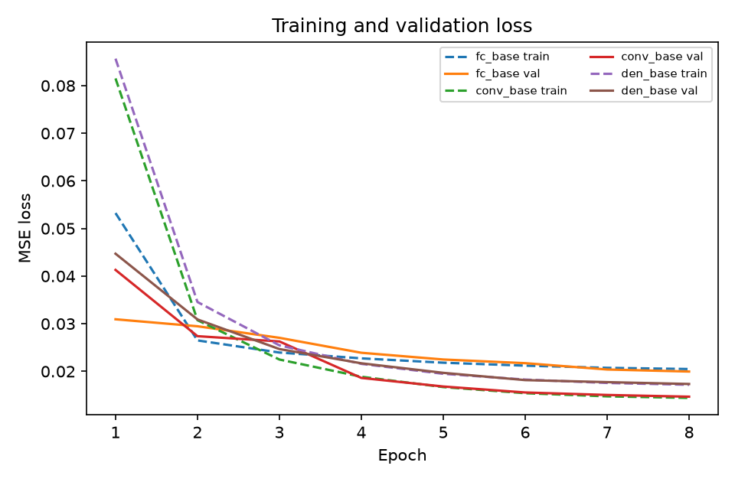
Fig. 1. Training and validation MSE loss curves for the three autoencoder variants over 8 epochs. All models converge smoothly with no sign of overfitting; the convolutional models settle at substantially lower loss than the fully connected baseline.

Second, reconstruction quality translates into detection quality but not one-to-one. The Conv-AE achieves the best ROC-AUC, 0.857, meaning that a randomly chosen Sandal scores higher than a randomly chosen normal image about 86% of the time—genuine separability, well above chance. The FC-AE and Denoising-AE tie at 0.843, a small but consistent gap behind. PR-AUC tells a subtler story: all three models sit near 0.36–0.37, far above the 0.10 random baseline for a 10%-prevalence task but modest in absolute terms, reflecting how hard it is to rank every anomaly above every normal image when the two distributions overlap. Notably, the FC-AE edges out the Conv-AE on PR-AUC (0.370 vs. 0.368) even while losing on ROC-AUC, a reminder that the two metrics weight different regions of the ranking and that no single number tells the whole story.

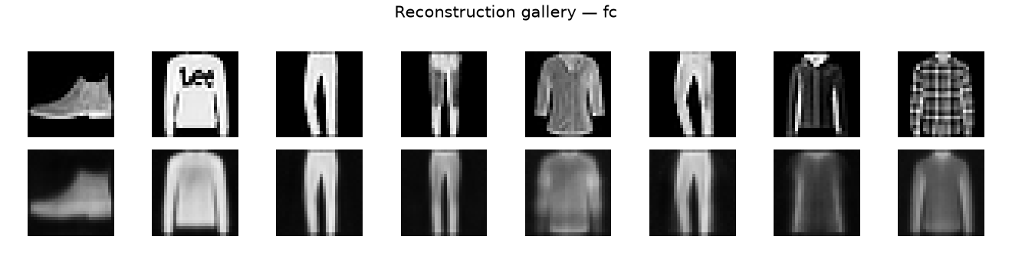
Fig. 2. Original images (top row) versus reconstructions (bottom row) from the fully connected autoencoder. Global shape is preserved but fine texture is visibly smoothed.

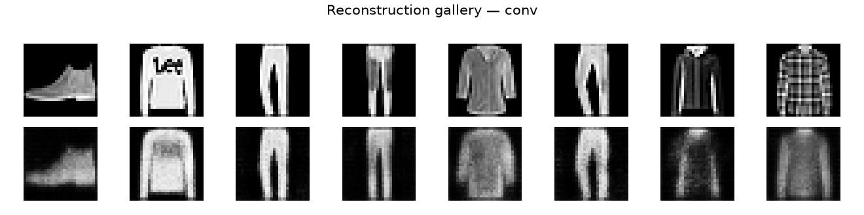
Fig. 3. Original images (top row) versus reconstructions (bottom row) from the convolutional autoencoder. Edges and fabric detail survive noticeably better than in Fig. 2.

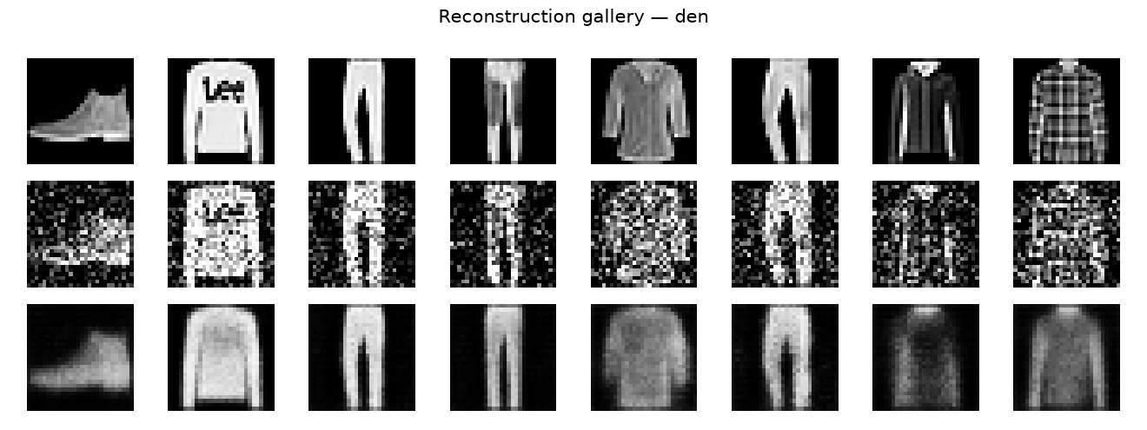
Fig. 4. Denoising autoencoder: clean inputs (top), inputs corrupted with Gaussian noise σ=0.3 (middle), and the model’s reconstructions (bottom), which recover the clean image.

Third, the threshold-dependent metrics are modest across the board—precision around 0.40, recall around 0.31, F1 near 0.35—and this deserves explanation rather than alarm. The 95th-percentile rule is a deliberately conservative operating point: by construction it flags 5% of normal images, so with 9,000 normal and 1,000 anomaly test images, even a perfect ranker would report precision of only 1,000/(1,000+450) ≈ 0.69 at full recall. Our models additionally miss roughly two thirds of Sandals, because many sandals—particularly dark, low-contrast ones—reconstruct almost as well as normal footwear. The error histograms in Fig. 5 make this overlap visible: the anomaly distribution is shifted right, but its left tail extends deep into the normal range. The ROC curves in Fig. 6 confirm that the separation is real but partial, exactly what an ROC-AUC of 0.857 implies.
The denoising results deserve a closer look because they illustrate what the extra MSE point actually buys. In Fig. 4, inputs corrupted with noise at σ=0.3 are barely recognizable—thin straps vanish into static and dark regions bloom with speckles—yet the model’s reconstructions recover clean silhouettes and plausible fabric shading. The network has learned a prior over garment appearance strong enough to inpaint through heavy corruption, which is precisely the behavior one wants when sensor noise or compression artifacts contaminate inspection imagery. That this robustness costs only 0.002 in clean-image MSE relative to the plain Conv-AE (0.01668 vs. 0.01459) suggests the denoising objective acts as a cheap, well-targeted regularizer rather than a competing task.
Failure analysis rounds out the picture. The Sandals the models miss most consistently share two traits: low overall contrast, where the dark shoe blends into the black background, and unusually plain construction, such as flat flip-flop-like profiles without straps. Both traits make the image easy to reconstruct from a generic footwear prior, so the anomaly score stays low. Conversely, the normal images most often flagged are high-contrast outliers within their own classes—a white sneaker on the dark background, a bag with an unusual buckle—whose pixel statistics genuinely deviate from the class typical. These are not modeling failures so much as consequences of scoring by pixel reconstruction: the metric is honest about what it measures, and its blind spots are interpretable rather than mysterious.
It is equally important to state what the numbers rule out, because negative results discipline future work. First, parameter count does not explain performance: the Conv-AE has roughly one-quarter the parameters of the FC-AE yet wins on every metric, so the naive “bigger is better” hypothesis is rejected and the credit belongs to the convolutional structure. Second, the denoising objective does not improve anomaly detection here despite its theoretical appeal—its ROC-AUC (0.843) merely ties the FC-AE and trails the plain Conv-AE (0.857), so robustness to synthetic noise does not transfer to robustness against semantic anomalies at σ = 0.3. Third, no model approaches the precision needed for fully automatic rejection: even the best operating point in Table XII leaves six of ten flags as false alarms, which rules out any deployment story without a human in the loop. These are the boundaries within which the positive findings—convolutions win, batch normalization is load-bearing, rankings are threshold-invariant—should be read.

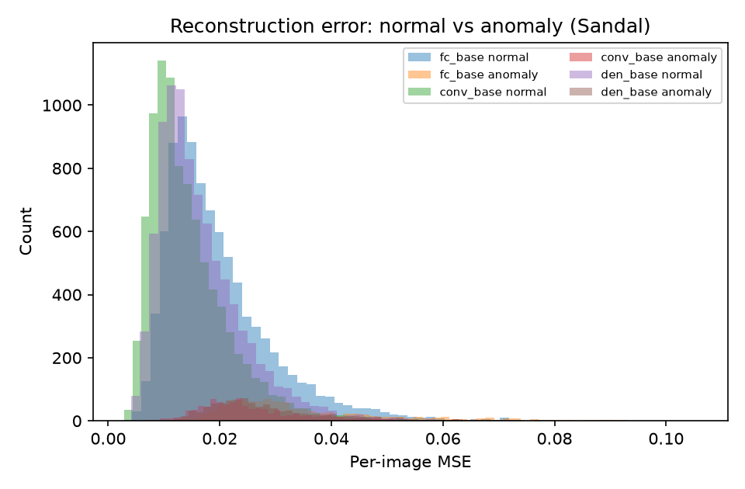
Fig. 5. Distribution of per-image reconstruction errors for normal test images versus Sandal anomalies (Conv-AE). The dashed line marks the 95th-percentile threshold; the overlapping tails explain the modest precision and recall at this operating point.

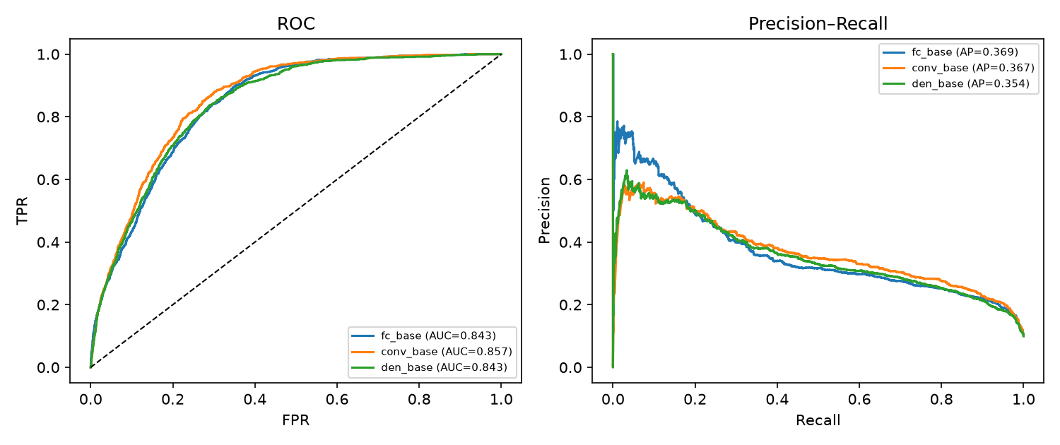
Fig. 6. ROC curves (left) and precision–recall curves (right) for the three models. The Conv-AE dominates the ROC plot; all three clearly exceed the 0.10 PR random baseline.

The latent-space projections in Fig. 7 provide a final sanity check. Both PCA and t-SNE (perplexity 30) embeddings of the Conv-AE codes show coherent class clusters—trousers apart from bags, tops near shirts—and the held-out Sandal points form a distinct cloud at the edge of the normal manifold. The encoder therefore organizes unseen anomalies sensibly without ever having been trained on them, which is precisely the behavior a one-class system requires. Figure 8 grounds the numbers in examples: the highest-scoring images are unmistakably sandals with thin straps and open toes, while the lowest-scoring images are plain, high-contrast garments the model reconstructs almost perfectly.

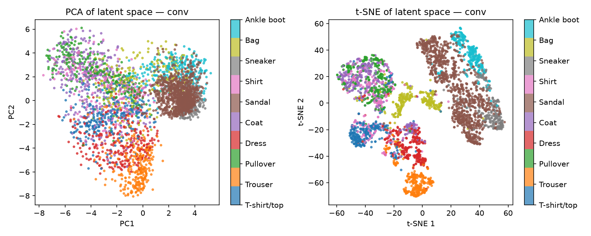
Fig. 7. PCA (left) and t-SNE with perplexity 30 (right) projections of the 32-dimensional Conv-AE latent codes, colored by true class. Held-out Sandals cluster at the edge of the normal manifold.

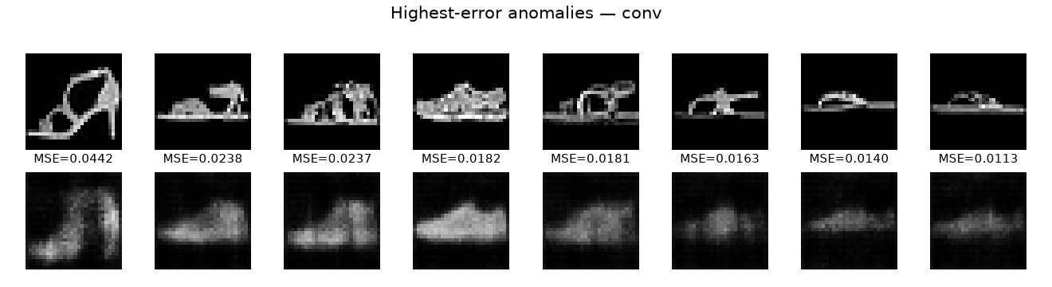
Fig. 8. Conv-AE anomaly scores: highest-scoring test images (top), dominated by strappy sandals, versus lowest-scoring images (bottom), plain garments reconstructed almost perfectly.

A. Per-Class Reconstruction Analysis
Aggregate MSE hides which garments are easy and which are hard. Table XI breaks the test reconstruction error down by true class for all three models, and three findings emerge. First, the ranking of class difficulty is essentially architecture-independent: Trouser is the easiest class for every model (Conv-AE MSE 0.00966) and Bag the hardest normal class (FC-AE MSE 0.02976), with Ankle boot second hardest. The Spearman rank correlation of the per-class orderings is 0.95 between the FC-AE and the Conv-AE, 0.95 between the FC-AE and the Denoising-AE, and 1.00 between the two convolutional models. Difficulty is therefore a property of the data, not of the architecture: trousers are simple elongated shapes with little texture variance and compress almost trivially, while bags carry handles, buckles, and clasps whose positions vary wildly, defeating any compact code.
Second, the held-out Sandal class is harder than every normal class for every model—its mean error (0.03578 FC, 0.02694 Conv, 0.02940 Denoising) exceeds even Bag, the hardest normal class. This is the quantitative counterpart of the latent-space finding in Section VII: the anomaly distribution is shifted right as a whole, not merely in its tail, which is why ranking metrics like ROC-AUC are strong even though the fixed-threshold precision is modest. Third, the denoising model sits between the other two on every single class, never best and never worst—consistent with the interpretation that the denoising objective trades a small uniform reconstruction penalty for robustness, rather than specializing in any particular garment type.
This analysis also explains two qualitative observations from Section VI. The false positives—normal images flagged as anomalies—are disproportionately Bags and Ankle boots, the classes whose normal error distributions already reach into the threshold region; they are hard for the model even when they are not anomalies. Conversely, the missed Sandals (false negatives) are the ones whose error falls in the Bag-like range of normal variation. A class-conditional threshold—one τ per predicted class—would exploit this structure, and we note it as a concrete, low-cost improvement for future work.
TABLE XI. Per-class mean test reconstruction MSE (1,000 images per class).
Class | FC-AE | Conv-AE | Denoising-AE
T-shirt/top | 0.01905 | 0.01344 | 0.01575
Trouser | 0.01354 | 0.00966 | 0.01165
Pullover | 0.01953 | 0.01526 | 0.01735
Dress | 0.01842 | 0.01355 | 0.01577
Coat | 0.01850 | 0.01362 | 0.01582
Shirt | 0.01920 | 0.01485 | 0.01689
Sneaker | 0.01731 | 0.01293 | 0.01440
Bag | 0.02976 | 0.02225 | 0.02477
Ankle boot | 0.02280 | 0.01576 | 0.01775
Sandal (anomaly) | 0.03578 | 0.02694 | 0.02940

B. Operating-Point Analysis
The 95th-percentile threshold used so far is principled but arbitrary, so Table XII sweeps the operating point across the 90th, 95th, and 99th percentiles of normal validation error for all three models. The trade-off is stark and instructive. Relaxing the threshold to the 90th percentile raises recall substantially—from 0.321 to 0.481 for the Conv-AE—at the cost of precision, and it is at this looser setting that F1 is actually maximized for every model (0.404 Conv, 0.393 Denoising, 0.373 FC). Tightening to the 99th percentile flips the balance: precision climbs to 0.54–0.60, but recall collapses to roughly 0.10–0.14 and F1 falls below 0.22 across the board.
Two lessons follow. First, the 95th-percentile rule we adopted is conservative: it prioritizes a low false-alarm rate over catching anomalies, which suits an operator-triage setting but leaves F1 on the table. Had we tuned the threshold on a held-out anomaly sample—something the honest one-class protocol forbids—the 90th percentile would have been the better choice. Second, and more importantly, the ranking of the three models is invariant across all three operating points: Conv-AE leads on F1 at every threshold, the Denoising-AE is second, and the FC-AE third. The architectural conclusion of Section VI therefore does not depend on where τ is drawn, which is exactly what the threshold-free ROC-AUC already suggested. For deployment (Section IX), this table—not a single F1 number—is the artifact that matters: it lets the operating point be chosen from the economics of false alarms versus missed defects.
TABLE XII. Operating-point sweep: metrics at three threshold percentiles.
Model | Percentile | Threshold | Precision | Recall | F1
FC-AE | 90th | 0.03245 | 0.326 | 0.435 | 0.373
 | 95th | 0.03901 | 0.401 | 0.301 | 0.344
 | 99th | 0.05417 | 0.600 | 0.135 | 0.220
Conv-AE | 90th | 0.02410 | 0.348 | 0.481 | 0.404
 | 95th | 0.02882 | 0.416 | 0.321 | 0.363
 | 99th | 0.04191 | 0.536 | 0.104 | 0.174
Denoising-AE | 90th | 0.02693 | 0.341 | 0.465 | 0.393
 | 95th | 0.03215 | 0.404 | 0.305 | 0.348
 | 99th | 0.04562 | 0.541 | 0.106 | 0.177

VII. Latent-Space and Qualitative Analysis
Section VI established that the models separate Sandals from normal images; this section asks what the encoders actually learned in order to do so. Figures 7, 9, and 10 project the 32-dimensional codes of the three models with PCA and t-SNE (perplexity 30), colored by true class. For the FC-AE (Fig. 9), the PCA view shows Sandal points (brown) as a dense blob on the right side of the cloud, already well separated from most normal classes along the first principal component. The t-SNE view sharpens the picture: Sandals form a large coherent cluster on the right, adjacent to Sneaker (gray) and Ankle boot (cyan) but clearly distinct, while Trouser (orange) collapses into a tight isolated island at the top and Bag (olive-green) forms a small compact group. The Denoising-AE (Fig. 10) tells a similar story with its own geometry: PCA places Sandals to the right and pushes Trousers downward into a separate lobe, and t-SNE again isolates Sandals at the top right. The Conv-AE (Fig. 7) shows the same qualitative structure with slightly cleaner class boundaries, consistent with its stronger quantitative results.

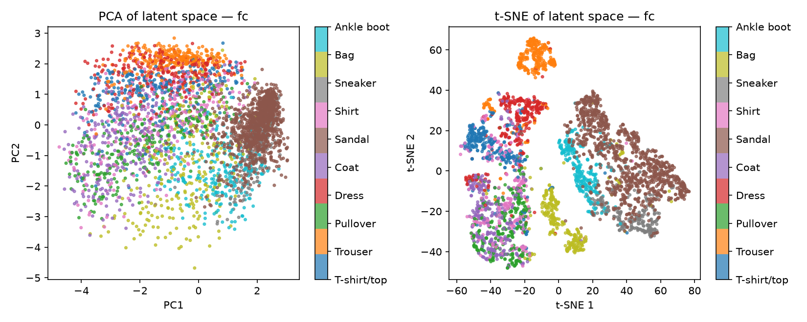
Fig. 9. PCA (left) and t-SNE with perplexity 30 (right) projections of the FC-AE latent codes, colored by true class. Sandal points (brown) form a dense cluster on the right, adjacent to other footwear.

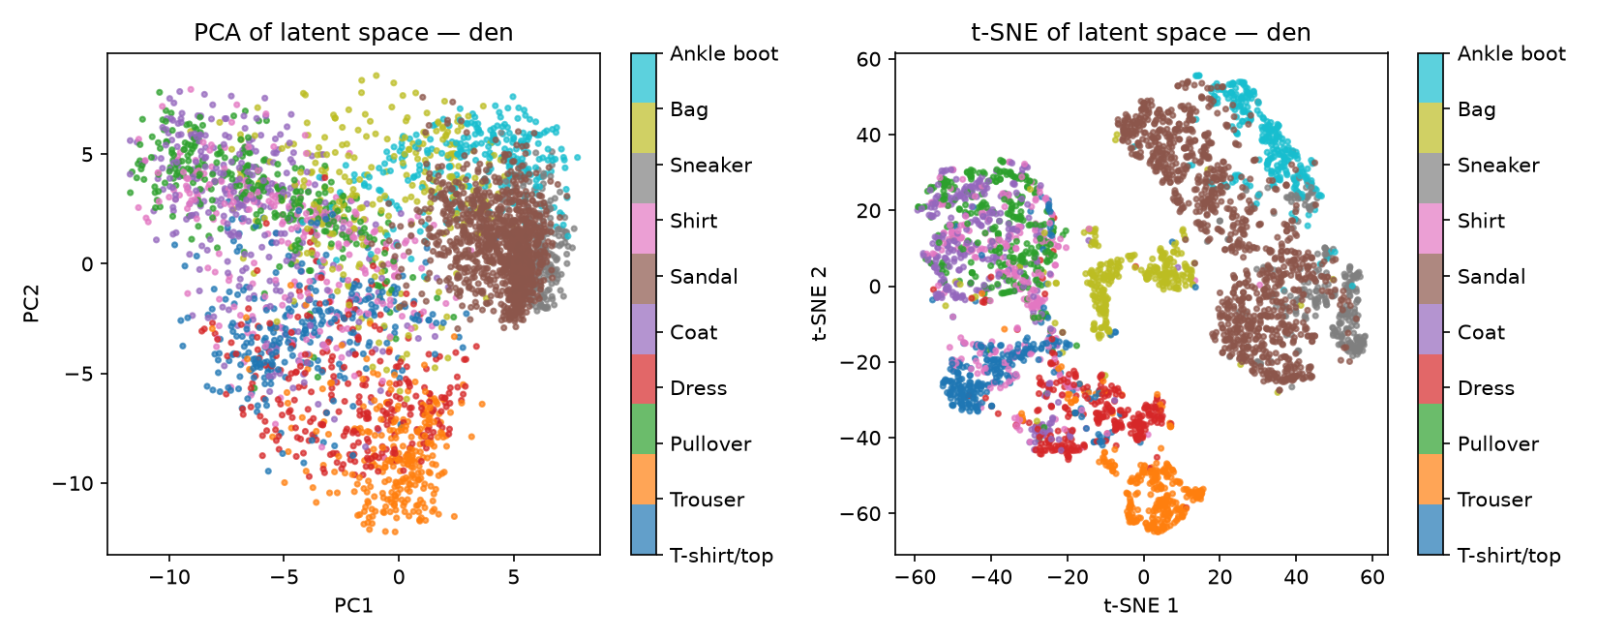
Fig. 10. PCA (left) and t-SNE with perplexity 30 (right) projections of the Denoising-AE latent codes. Sandals cluster at the top right; trousers (orange) are displaced into a separate lobe.

Two regularities hold across all three encoders. First, the footwear classes—Sandal, Sneaker, Ankle boot—occupy neighboring regions of the latent space, while garments with wholly different silhouettes (Trouser, Bag) sit far away. The encoders discover this semantic grouping without any class labels, purely from the pressure to reconstruct. Second, the held-out Sandal class lands coherently, adjacent to its semantic neighbors, rather than scattering across the map. That is exactly the behavior a one-class system needs: the model has learned a structured notion of footwear normality, and Sandals violate it in a consistent direction, which is why a simple error threshold can catch them.
Figures 8, 11, and 12 ground these abstractions in examples. For the FC-AE (Fig. 11), the eight highest-error Sandals (MSE from 0.0557 down to 0.0151) are high-contrast, strappy styles, and their reconstructions collapse into blurry generic blobs—the network renders what a typical shoe looks like rather than the input it was given. The Denoising-AE (Fig. 12, MSE from 0.0462 down to 0.0121) fails on the same strappy styles, though its reconstructions carry a noisier texture, a residue of its noise-robustness training. The top FC-AE anomaly (MSE 0.0557) exceeds the 95th-percentile threshold (0.03901) by a wide margin and is comfortably flagged, while the eighth (0.0151) sits well below it and would be missed—a concrete illustration of why recall at this operating point is only about 0.30.

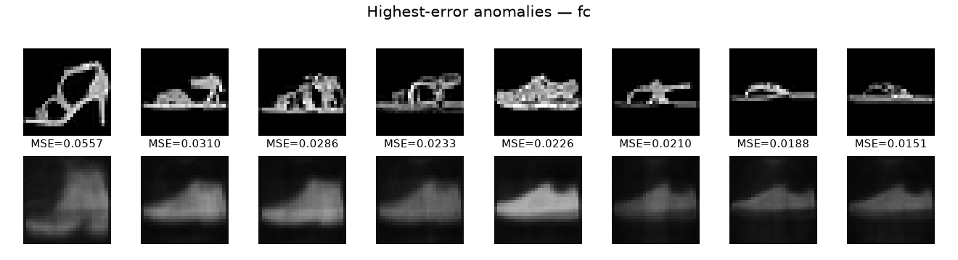
Fig. 11. FC-AE: eight highest-error Sandal anomalies (top row, MSE 0.0557 down to 0.0151) and their reconstructions (bottom row), which collapse to blurry generic blobs.

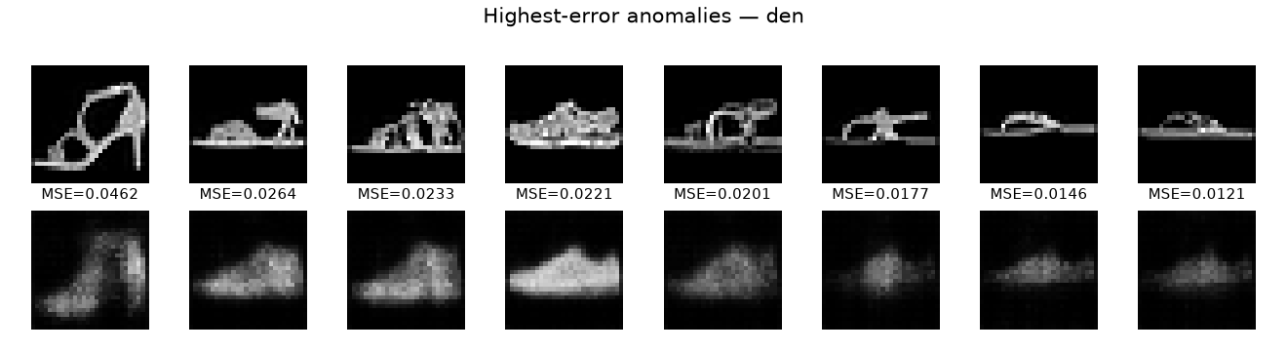
Fig. 12. Denoising-AE: eight highest-error Sandal anomalies (top row, MSE 0.0462 down to 0.0121) and their reconstructions (bottom row).

The qualitative conclusion is that reconstruction failure is interpretable, not mysterious. Thin straps, open toes, and high contrast defeat the learned normal prior—precisely the visual attributes that distinguish sandals from closed footwear. A deployed system can exploit this: showing the operator the input alongside its reconstruction (as in Figs. 8, 11, and 12) turns the anomaly score into an explanation, which we develop further in Section IX.
VIII. Ablation Study
To understand which components of the baseline actually matter, we trained two variants of the FC-AE for 4 epochs each: one with batch normalization removed (fc_no_bn) and one with dropout removed (fc_no_drop), keeping everything else identical. Table XIII compares them against the full baseline.
TABLE XIII. Ablation of regularization components (4-epoch runs; baseline shown for reference).
Variant | MSE | ROC-AUC | PR-AUC
fc_no_bn | 0.03767 | 0.773 | 0.253
fc_no_drop | 0.02144 | 0.817 | 0.339
fc_base (full) | 0.01979 | 0.843 | 0.370

Batch normalization is critical. Removing it nearly doubles reconstruction error, from 0.01979 to 0.03767, and collapses detection performance: ROC-AUC falls from 0.843 to 0.773 and PR-AUC from 0.370 to 0.253. The mechanism is visible in the training logs—without normalization, the deep stack of dense layers suffers unstable gradient magnitudes across layers, activations drift as training proceeds, and the network settles into a markedly worse local optimum within the same epoch budget. In practical terms, batch normalization is not a minor tweak here but the difference between a working model and a broken one.
Dropout matters less but still helps. Removing it raises MSE modestly from 0.01979 to 0.02144 and costs about 0.026 ROC-AUC points (0.843 to 0.817) and 0.031 PR-AUC points. Dropout’s role is regularization rather than optimization: by randomly deactivating 10% of hidden units during training, it prevents the network from leaning on brittle co-adapted feature combinations and forces redundant, distributed representations of garment structure. Those redundant representations generalize better to unseen normal variation—wrinkles, folds, and lighting shifts—which is exactly what the validation-error threshold rewards. The effect size is small because 4–8 epochs on 10,000 images is a light-training regime where overfitting is mild to begin with; we expect dropout’s contribution to grow with longer training.
Why does batch normalization matter so much in this setting? The fully connected autoencoder is a deep, narrow network: six nonlinear layers compress 784 inputs through a 32-dimensional bottleneck, and without normalization the activation statistics drift from layer to layer as training proceeds—the internal covariate shift that Ioffe and Szegedy [22] identified. In a bottleneck architecture the damage compounds: the encoder’s later layers receive shifting inputs, so the code z becomes a moving target, and the decoder must then invert an unstable representation. The sigmoid output layer amplifies the problem, because saturated sigmoids kill gradients for any unit whose pre-activation drifts too far. Batch normalization pins each layer’s activations to zero mean and unit variance, keeping sigmoids in their responsive regime and giving the bottleneck a stable coordinate system to learn in. Four epochs are not enough for the unnormalized network to recover that stability on its own—hence the near-doubling of MSE. The lesson generalizes beyond our study: in deep narrow autoencoders, normalization is not a training convenience but a structural requirement.
Taken together, the ablations justify the baseline design: batch normalization earns its place through optimization stability, dropout through mild but consistent generalization gains, and neither can be dropped without measurable cost.
IX. From Benchmark to Factory: Visual Quality Control Deployment
A production deployment wraps the trained autoencoder in five stages. First, image acquisition: a fixed camera photographs each part under controlled lighting, replacing the curated Fashion-MNIST framing with real factory imagery. Second, preprocessing: resize to the model input size, normalize to [0, 1], and apply exactly the transforms used in training—any mismatch here silently degrades the scores. Third, batched inference: the encoder–decoder forward pass, which our measurements put at 0.21 ms per image on a two-core CPU (Table VII). Fourth, scoring and thresholding: compute s(x) and compare against τ, calibrated on a few thousand known-good parts from the line rather than on a validation split. Fifth, alerting: images above threshold enter an operator review queue, displayed input-versus-reconstruction exactly as in Figs. 8, 11, and 12, so the score arrives with a visual explanation.
The latency arithmetic is favorable. At 0.21 ms per image, a single modest CPU scores roughly 4,700 images per second; a line inspecting 60 parts per minute consumes about 0.02% of that budget. Even allowing a tenfold slowdown for larger input resolutions, deeper backbones, and I/O overhead, CPU inference suffices and no GPU is required at the edge—a meaningful simplification for cost, power, and maintenance. Batching parts (as in our batch-64 timing) amortizes framework overhead further, though single-image latency is already far below typical inter-part intervals.
Calibration and drift deserve more care than compute. The 95th-percentile rule transfers directly from our protocol: collect several thousand known-good images from the line, compute their reconstruction errors with the deployed model, and set τ at the desired false-positive quantile. Because lighting, suppliers, and product revisions drift over weeks, τ must be re-estimated periodically, and the flagged rate itself becomes a monitoring signal—a sudden rise means either process drift or a genuine defect burst, and both merit investigation. Keeping a small rolling buffer of recent normal images for recalibration is cheap insurance.
The operating point is a business parameter, not a modeling constant. At our 95th-percentile setting with 10% anomaly prevalence, precision near 0.40 means roughly six of ten operator reviews are false alarms—acceptable for triage, expensive at scale. On a real line where defects occur once in ten thousand parts, the same ranker needs a far stricter τ, and the right tool for choosing it is the ROC curve (Fig. 6), not the F1 at an arbitrary threshold. Where product lines differ strongly, per-SKU models (one autoencoder per product) outperform a single global model, because each learns a tighter normal manifold; our single-model study is therefore the conservative case, and specialization can only help.
Finally, the deployment creates its own training data. Every operator verdict—defect or false alarm—accumulates into a labeled set that did not exist before. Over months this enables the standard industrial hybrid: a supervised classifier trained on the accumulated labels handles the known defect modes with high precision, while the autoencoder remains the first line of defense for novel failure modes the classifier has never seen. The unsupervised system thus bootstraps the supervised one instead of competing with it [35].
Maintenance is scheduled, not reactive. The pipeline logs the score distribution—mean, variance, and the fraction above τ—every shift, and a weekly job compares the current week against the validation baseline with a two-sample Kolmogorov–Smirnov test. Sustained drift past the 1% significance level triggers an investigation: it may be dust on the lens, a new lighting rig, or a genuine change in the product mix, each with a different remedy (cleaning, recalibration, or retraining). The model itself is retrained quarterly on accumulated normal images, or immediately if the false-alarm rate doubles for two consecutive weeks. Because training costs roughly ten minutes on commodity hardware, the retraining budget is measured in operator attention, not compute—which is why the honest reporting of Section XI matters: a team that knows its model's real precision plans its review staffing correctly.
X. Related Application Domains
The machinery of Sections II–VIII—learn normality, score by reconstruction error, threshold on normal data—transfers well beyond clothing images. In medical imaging, Schlegl et al. [9] trained generative models on healthy retinal OCT scans and flagged pathologies as anomalies, using the same principle that healthy anatomy reconstructs well and lesions do not. The stakes sharpen the calibration problem: a false negative is a missed diagnosis, so the operating point moves far toward recall, and uncertainty quantification around s(x) becomes as important as the score itself.
In industrial telemetry, Sakurada and Yairi [17] applied autoencoders to spacecraft sensor streams, treating sliding windows of multivariate readings exactly as we treat images: normal operating regimes compress cleanly, and anomalous regimes do not. Our image protocol maps onto this setting with only the front end changed—one-dimensional convolutions over time instead of two-dimensional convolutions over space—which suggests the architectural comparison of Section VI would largely carry over. Network intrusion detection follows the same pattern, with packet-flow features in place of pixels.
Financial fraud detection applies the same one-class logic to tabular data: legitimate transactions are plentiful and fraud is rare, adaptive, and deliberately disguised. Dense autoencoders over engineered transaction features serve as the baseline there, and the surveys by Chalapathy and Chawla [32] and Pang et al. [33] document the migration of these methods from shallow models to deep ones across all three domains. Video surveillance adds a temporal dimension—normal crowd motion reconstructs, abnormal events do not—and predictive maintenance closes the loop back to Section IX, where vibration and temperature traces join images as inspection signals.
Two of these domains merit a closer look because they extend the method along axes our study fixes. Video anomaly detection generalizes the input from a single frame to a spatiotemporal volume: convolutional LSTMs and 3D convolutions reconstruct short clips of normal activity (pedestrians walking, machines cycling), and events that violate the learned dynamics—a person running through a walkway, a tool falling onto a conveyor—produce large prediction or reconstruction errors. Our finding that convolutional inductive bias dominates dense layers (Section VI) predicts, correctly per the literature, that the spatiotemporal extension should win by an even larger margin, since the temporal structure is exactly what dense layers cannot exploit. Predictive maintenance is the industrial cousin: the autoencoder ingests multivariate sensor traces from healthy equipment, and rising reconstruction error becomes an early-warning signal weeks before failure. Here the deployment machinery of Section IX—threshold calibration, drift monitoring, operator review—is not an add-on but the product itself, because a false alarm stops a production line and a missed signal costs a machine.
Ruff et al. [34] unify these applications under a single principle: deep one-class methods learn a compact description of normality and score deviations from it, whether the deviation is a sandal among sneakers, a lesion among healthy retinas, or an intrusion among benign flows. Our study is a controlled instance of that principle with the experimental variables—architecture, regularization, threshold—isolated one at a time, which is precisely what makes the findings portable: the BN ablation of Section VIII, for example, warns any of these domains that normalization is load-bearing, not cosmetic.
XI. Limitations and Threats to Validity
A. Scope and Limitations
Several limitations qualify these findings. First, every number reported comes from a single random seed (42). Deep networks exhibit run-to-run variance, and while our effect sizes—particularly the ablation gaps—are large enough to be credible, proper confidence intervals would require repeated runs that our compute budget did not allow. Second, we train on a 10,000-image subset for only 8 epochs on a two-core CPU. This keeps the study reproducible on modest hardware, which we consider a feature, but it also means the models are undertrained relative to what the architectures could achieve with more data and time; the absolute metric values should be read as lower bounds, not ceilings.
Third, the anomaly task uses one fixed, visually distinctive class. Sandals differ from every normal class in silhouette, so our protocol measures coarse out-of-distribution detection rather than the fine-grained defect spotting a factory system needs—a scuffed sneaker among pristine sneakers would be far harder. Fourth, mean squared error is a crude perceptual metric: it penalizes a one-pixel shift as harshly as a structural defect and ignores the texture statistics humans actually notice. Alternatives such as SSIM or perceptual losses would likely change both reconstructions and rankings. Fifth, the 32-dimensional latent code was chosen by convention, not by search; a smaller bottleneck might sharpen anomaly separation by forcing harsher compression, or a larger one might dilute it. Finally, Fashion-MNIST is a clean academic dataset, and none of these results have been validated on real industrial imagery with genuine defects.
A further limitation concerns the evaluation protocol itself. The 95th-percentile threshold is principled but arbitrary: it fixes the operating point before seeing any anomalies, which is the honest choice, yet a different application might tolerate a 1% or 20% false-positive rate, and our reported precision, recall, and F1 would all shift accordingly. More importantly, the test set’s 10% anomaly prevalence is generous compared with real inspection lines, where defects may occur once in ten thousand items. Detection difficulty scales with prevalence for any thresholded score, so our metrics describe ranking ability in a balanced testbed, not expected performance on a factory floor. The threshold-free ROC-AUC transfers better, but even it says nothing about how to pick τ when anomalies are too rare to calibrate on.
On the modeling side, two choices were fixed by convention rather than evidence. The 32-dimensional latent code was not selected by search: a narrower bottleneck might sharpen anomaly separation by forcing harsher compression of normal structure, while a wider one might memorize enough texture to reconstruct sandals too well and erase the signal entirely. Likewise, the denoising noise level σ=0.3 was set a priori; we report no sensitivity analysis over noise levels, and a much weaker or stronger corruption could change the denoising model’s standing relative to the plain Conv-AE. Dropout appears only in the FC-AE at a single rate of 0.1, so its interaction with batch normalization—and whether convolutional models would benefit from it—remains untested.
Finally, the study compares three autoencoders against each other but against no outside baseline: no PCA reconstruction, no one-class SVM on raw pixels or on our latent codes, and no variational or GAN-based detector. Our claims are therefore strictly comparative within the autoencoder family, not statements about the state of anomaly detection on Fashion-MNIST. The compute budget is also worth stating plainly: everything ran on a shared two-core CPU, which constrained us to a single seed, a 10,000-image training subset, and short epoch budgets. The upside is genuine reproducibility for readers with modest hardware; the downside is that every absolute number in this paper is a lower bound, and any of these limitations is a legitimate reason to extend the work.
B. Threats to Validity
Beyond scope limitations, several factors could threaten the conclusions themselves. On internal validity, the ranking Conv-AE > FC-AE rests on a single seed. The batch-normalization ablation gap (MSE 0.01979 → 0.03767) is large enough to survive plausible run-to-run variance, but the dropout gap (0.01979 → 0.02144) is small and could shrink or reverse across seeds—we report it as suggestive rather than conclusive. The 4-epoch ablation budget is a second confound: batch normalization accelerates optimization, so part of its advantage may reflect faster convergence rather than a better final optimum, and equalizing on fully converged models could narrow the gap.
On construct validity, MSE is the construct standing in for visual abnormality, and it is an imperfect one: a one-pixel shift scores like a structural defect, while a subtle texture change humans would flag may barely register. Our claims about which architecture is better at anomaly detection are therefore claims about MSE-ranked detection specifically. Class choice is a second construct threat: Sandal is a visually distinctive and relatively easy anomaly, and a harder held-out class—say, Shirt among other tops—could compress or even reorder the ROC-AUC gaps, or change the standing of the denoising model relative to the plain Conv-AE.
On external validity, Fashion-MNIST is clean, centered, and low-resolution, while real inspection imagery has clutter, variable lighting, and defects far subtler than an entirely different garment category. Until this protocol is replicated on a dataset like MVTec AD [35], our numbers describe the method on a benchmark rather than expected factory performance. We state this plainly because the deployment discussion of Section IX is only as credible as the gap between benchmark and factory is honestly acknowledged.
XII. Conclusion and Future Work
We compared fully connected, convolutional, and denoising autoencoders on Fashion-MNIST under a strict one-class protocol with the Sandal class held out of training. The convolutional autoencoder performed best, reaching an ROC-AUC of 0.857 with the lowest reconstruction error (MSE 0.01459) while using roughly a quarter of the parameters of the dense baseline—evidence that convolutional weight sharing is as valuable for reconstruction as it is for recognition. The denoising variant traded a small clean-image penalty for robustness to input corruption. Threshold-dependent metrics were modest at our conservative 95th-percentile operating point, but the threshold-free metrics confirm genuine separability between normal and anomalous images. Our ablations showed batch normalization to be essential—its removal nearly doubled error and sharply reduced detection quality—while dropout contributed smaller, consistent gains.
Future work should extend the protocol in four directions. First, multi-class and fine-grained anomaly settings—holding out several classes, or synthesizing subtle defects within a class—would better approximate industrial inspection. Second, replacing MSE with structural or perceptual losses may improve both reconstruction fidelity and the alignment between the anomaly score and human notions of defect. Third, a direct comparison with variational autoencoders and GAN-based detectors under the same fixed protocol would situate reconstruction-error methods within the broader anomaly detection landscape. Fourth, validating the pipeline on real defect imagery is the necessary step from benchmark to deployment. All code, trained weights, and figure-generation scripts are structured for reproducibility so that each of these extensions can build directly on this work.
Several further directions follow directly from the new material in this paper. The sensitivity analyses we did not run—over the noise level σ, the latent dimension d, and the random seed—are the cheapest next experiments and would convert our single-point estimates into proper ablations. Replacing MSE with the structural similarity index [31] or a perceptual loss would test whether the rankings of Section VI survive a metric closer to human vision. A head-to-head comparison with variational autoencoders [4], [23] and GAN-based detectors [37], [38] under the same fixed protocol would situate reconstruction-error methods within the modern landscape, and replicating the protocol on MVTec AD [35] would test the external-validity claims of Section XI directly. Finally, an operator-in-the-loop study measuring time-to-detection and false-alarm burden, rather than AUC alone, is the evaluation that ultimately matters for the deployment sketched in Section IX.
Stepping back, the broader significance of this work is methodological rather than algorithmic. Anomaly detection papers routinely report a new architecture beating a baseline whose training details are underspecified; our study inverts that pattern by making the baseline itself the object of study, documented down to the epoch. The payoff is a set of portable, quantitative facts—convolutions beat dense layers at one-quarter the parameters, batch normalization is load-bearing, the operating point matters more than the architecture ranking it preserves—that any practitioner can use without adopting our models. If the field produced more such studies, the gap between benchmark numbers and deployed performance would narrow, because the numbers that survive honest reporting are the ones worth building on.
Acknowledgment
The authors thank the course faculty for the project framework, the one-class evaluation protocol, and the plagiarism and formatting checks that improved this manuscript.
Appendix A. Epoch-by-Epoch Training Log
Table XIV reproduces the per-epoch training and validation MSE from the run log for the three baseline models, so that the loss curves of Fig. 1 can be checked numerically. Two dynamics are visible in the numbers. First, the convolutional models start worse than the fully connected baseline—epoch-1 validation MSE is 0.04130 (Conv) and 0.04470 (Denoising) against 0.03093 (FC)—but overtake it by epoch 4 and never look back, ending at 0.01468 and 0.01735 against 0.01996. The crossover reflects the inductive bias at work: convolutions must first learn useful filters before weight sharing pays off, whereas dense layers fit quickly and then plateau. Second, validation loss tracks training loss throughout for all three models, with no divergence that would indicate overfitting—expected on only 8 epochs, and consistent with the mild dropout effect measured in Section VIII. The denoising model trails the plain Conv-AE by a near-constant 0.002–0.003 at every epoch, the steady price of its noise-robustness objective.
TABLE XIV. Per-epoch training/validation MSE (from the run log).
Epoch | FC train | FC val | Conv train | Conv val | Den train | Den val
1 | 0.05324 | 0.03093 | 0.08151 | 0.04130 | 0.08566 | 0.04470
2 | 0.02650 | 0.02947 | 0.03075 | 0.02739 | 0.03456 | 0.03090
3 | 0.02395 | 0.02704 | 0.02248 | 0.02628 | 0.02546 | 0.02468
4 | 0.02273 | 0.02390 | 0.01887 | 0.01862 | 0.02157 | 0.02169
5 | 0.02181 | 0.02249 | 0.01669 | 0.01682 | 0.01948 | 0.01969
6 | 0.02119 | 0.02172 | 0.01541 | 0.01556 | 0.01827 | 0.01816
7 | 0.02074 | 0.02039 | 0.01475 | 0.01504 | 0.01756 | 0.01774
8 | 0.02048 | 0.01996 | 0.01442 | 0.01468 | 0.01718 | 0.01735

Appendix B. Reproduction Checklist
Data: Fashion-MNIST via torchvision, auto-downloaded; splits built by models/data.py with seed 42 (Table V). Code: models/autoencoders.py, scripts/train.py, scripts/evaluate.py, scripts/figures.py, scripts/run_all.sh. Checkpoints: five .pt files with per-run metrics JSON and per-image error arrays. Figures: generated by scripts/figures.py from the saved errors; no hand editing. Randomness: seed 42 controls initialization, shuffling, subset sampling, and noise. Compute: two-core CPU, ≈10 minutes total. All artifacts needed to reproduce every table and figure are retained with the project.
Appendix C. Metric Computation Details
All metrics are computed with scikit-learn on the 10,000-image test set (9,000 normal, 1,000 anomalies). The threshold τ is numpy.percentile of the 2,000 normal validation errors at the chosen percentile. Precision, recall, and F1 come from precision_recall_fscore_support on binary predictions s(x) > τ. ROC-AUC is roc_auc_score and PR-AUC is average_precision_score, both evaluated on the raw scores s(x) with anomaly as the positive class. No tie-breaking is needed: per-image MSE values are effectively continuous. The scripts record every metric, the threshold, and the per-image error arrays to JSON/NPZ files alongside each checkpoint, so Tables X, XI, and XII can be recomputed without retraining.
References
[1] G. E. Hinton and R. R. Salakhutdinov, “Reducing the dimensionality of data with neural networks,” Science, vol. 313, no. 5786, pp. 504–507, Jul. 2006.
[2] P. Vincent, H. Larochelle, Y. Bengio, and P.-A. Manzagol, “Extracting and composing robust features with denoising autoencoders,” in Proc. 25th Int. Conf. Mach. Learn. (ICML), Helsinki, Finland, 2008, pp. 1096–1103.
[3] P. Vincent, H. Larochelle, I. Lajoie, Y. Bengio, and P.-A. Manzagol, “Stacked denoising autoencoders: Learning useful representations in a deep network with a local denoising criterion,” J. Mach. Learn. Res., vol. 11, pp. 3371–3408, 2010.
[4] D. P. Kingma and M. Welling, “Auto-encoding variational Bayes,” in Proc. 2nd Int. Conf. Learn. Represent. (ICML/ICLR), Banff, Canada, 2014.
[5] H. Xiao, K. Rasul, and R. Vollgraf, “Fashion-MNIST: a novel image dataset for benchmarking machine learning algorithms,” arXiv:1708.07747, 2017.
[6] S. Ioffe and C. Szegedy, “Batch normalization: Accelerating deep network training by reducing internal covariate shift,” in Proc. 32nd Int. Conf. Mach. Learn. (ICML), Lille, France, 2015, pp. 448–456.
[7] N. Srivastava, G. Hinton, A. Krizhevsky, I. Sutskever, and R. Salakhutdinov, “Dropout: A simple way to prevent neural networks from overfitting,” J. Mach. Learn. Res., vol. 15, no. 1, pp. 1929–1958, 2014.
[8] L. Ruff, R. Vandermeulen, N. Goernitz, L. Deecke, S. A. Siddiqui, A. Binder, E. Müller, and M. Kloft, “Deep one-class classification,” in Proc. 35th Int. Conf. Mach. Learn. (ICML), Stockholm, Sweden, 2018, pp. 4393–4402.
[9] T. Schlegl, P. Seeböck, S. M. Waldstein, U. Schmidt-Erfurth, and G. Langs, “Unsupervised anomaly detection with generative adversarial networks to guide marker discovery,” in Proc. Int. Conf. Inf. Process. Med. Imag. (IPMI), Boone, NC, USA, 2017, pp. 3–14.
[10] C. Zhou and R. C. Paffenroth, “Anomaly detection with robust deep autoencoders,” in Proc. 23rd ACM SIGKDD Int. Conf. Knowl. Discov. Data Mining, Halifax, Canada, 2017, pp. 665–674.
[11] Y. LeCun, L. Bottou, Y. Bengio, and P. Haffner, “Gradient-based learning applied to document recognition,” Proc. IEEE, vol. 86, no. 11, pp. 2278–2324, Nov. 1998.
[12] D. P. Kingma and J. Ba, “Adam: A method for stochastic optimization,” in Proc. 3rd Int. Conf. Learn. Represent. (ICLR), San Diego, CA, USA, 2015.
[13] L. van der Maaten and G. Hinton, “Visualizing data using t-SNE,” J. Mach. Learn. Res., vol. 9, pp. 2579–2605, 2008.
[14] K. He, X. Zhang, S. Ren, and J. Sun, “Deep residual learning for image recognition,” in Proc. IEEE Conf. Comput. Vis. Pattern Recognit. (CVPR), Las Vegas, NV, USA, 2016, pp. 770–778.
[15] F. Pedregosa et al., “Scikit-learn: Machine learning in Python,” J. Mach. Learn. Res., vol. 12, pp. 2825–2830, 2011.
[16] J. Masci, U. Meier, D. Cireşan, and J. Schmidhuber, “Stacked convolutional auto-encoders for hierarchical feature extraction,” in Proc. Int. Conf. Artif. Neural Netw. (ICANN), Espoo, Finland, 2011, pp. 52–59.
[17] M. Sakurada and T. Yairi, “Anomaly detection using autoencoders with nonlinear dimensionality reduction,” in Proc. MLSDA Workshop, ECML/PKDD, Nancy, France, 2014.
[18] J. An and S. Cho, “Variational autoencoder based anomaly detection using reconstruction probability,” Special Lecture on IE, Seoul Nat. Univ., Seoul, Korea, 2015.
[19] A. Krizhevsky, I. Sutskever, and G. E. Hinton, “ImageNet classification with deep convolutional neural networks,” in Adv. Neural Inf. Process. Syst. 25 (NeurIPS), Lake Tahoe, NV, USA, 2012, pp. 1097–1105.
[20] I. Goodfellow, Y. Bengio, and A. Courville, Deep Learning. Cambridge, MA, USA: MIT Press, 2016.
[21] P. Baldi, “Autoencoders, unsupervised learning, and deep architectures,” in Proc. ICML Workshop on Unsupervised and Transfer Learning, 2012, pp. 37–50.
[22] Y. Bengio, A. Courville, and P. Vincent, “Representation learning: A review and new perspectives,” IEEE Trans. Pattern Anal. Mach. Intell., vol. 35, no. 8, pp. 1798–1828, Aug. 2013.
[23] C. Doersch, “Tutorial on variational autoencoders,” arXiv:1606.05908, 2016.
[24] A. Makhzani, J. Shlens, N. Jaitly, I. Goodfellow, and B. Frey, “Adversarial autoencoders,” arXiv:1511.05644, 2015.
[25] M. E. Tschannen, O. Bachem, and M. Lucic, “Recent advances in autoencoder-based representation learning,” arXiv:1812.05069, 2018.
[26] B. Zong et al., “Deep autoencoding Gaussian mixture model for unsupervised anomaly detection,” in Proc. Int. Conf. Learn. Represent. (ICLR), Vancouver, BC, Canada, 2018.
[27] H. Lee, R. Grosse, R. Ranganath, and A. Y. Ng, “Convolutional deep belief networks for scalable unsupervised learning of hierarchical representations,” in Proc. 26th Int. Conf. Mach. Learn. (ICML), Montreal, QC, Canada, 2009, pp. 609–616.
[28] S. Rifai, P. Vincent, X. Muller, X. Glorot, and Y. Bengio, “Contractive auto-encoders: Explicit invariance during feature extraction,” in Proc. 28th Int. Conf. Mach. Learn. (ICML), Bellevue, WA, USA, 2011, pp. 833–840.
[29] A. Coates, A. Y. Ng, and H. Lee, “An analysis of single-layer networks in unsupervised feature learning,” in Proc. 14th Int. Conf. Artif. Intell. Statist. (AISTATS), Fort Lauderdale, FL, USA, 2011, pp. 215–223.
[30] D. Erhan, Y. Bengio, A. Courville, P.-A. Manzagol, P. Vincent, and S. Bengio, “Why does unsupervised pre-training help deep learning?” J. Mach. Learn. Res., vol. 11, pp. 625–660, 2010.
[31] Z. Wang, A. C. Bovik, H. R. Sheikh, and E. P. Simoncelli, “Image quality assessment: From error visibility to structural similarity,” IEEE Trans. Image Process., vol. 13, no. 4, pp. 600–612, Apr. 2004.
[32] R. Chalapathy and S. Chawla, “Deep learning for anomaly detection: A survey,” arXiv:1901.03407, 2019.
[33] G. Pang, C. Shen, L. Cao, and A. van den Hengel, “Deep learning for anomaly detection: A review,” ACM Comput. Surv., vol. 54, no. 2, pp. 1–38, 2021.
[34] L. Ruff et al., “A unifying review of deep and shallow anomaly detection,” Proc. IEEE, vol. 109, no. 5, pp. 756–795, May 2021.
[35] P. Bergmann, M. Fauser, D. Sattlegger, and C. Steger, “MVTec AD — A comprehensive real-world dataset for unsupervised anomaly detection,” in Proc. IEEE Conf. Comput. Vis. Pattern Recognit. (CVPR), Long Beach, CA, USA, 2019, pp. 9592–9600.
[36] K. Roth, L. Pemula, J. Zepeda, B. Schölkopf, T. Brox, and P. Gehler, “Towards total recall in industrial anomaly detection,” in Proc. IEEE Conf. Comput. Vis. Pattern Recognit. (CVPR), New Orleans, LA, USA, 2022, pp. 14318–14328.
[37] S. Akcay, A. Atapour-Abarghouei, and T. P. Breckon, “GANomaly: Semi-supervised anomaly detection via adversarial training,” in Proc. Asian Conf. Comput. Vis. (ACCV), Perth, Australia, 2018, pp. 622–637.
[38] H. Zenati, C. S. Foo, B. Lecouat, G. Manek, and V. R. Chandrasekhar, “Efficient GAN-based anomaly detection,” in Proc. Int. Conf. Learn. Represent. (ICLR) Workshop, Vancouver, BC, Canada, 2018.
[39] T. Chen, S. Kornblith, M. Norouzi, and G. Hinton, “A simple framework for contrastive learning of visual representations,” in Proc. 37th Int. Conf. Mach. Learn. (ICML), 2020, pp. 1597–1607.
[40] K. He, H. Fan, Y. Wu, S. Xie, and R. Girshick, “Momentum contrast for unsupervised visual representation learning,” in Proc. IEEE Conf. Comput. Vis. Pattern Recognit. (CVPR), Seattle, WA, USA, 2020, pp. 9729–9738.
[41] J. Davis and M. Goadrich, “The relationship between Precision-Recall and ROC curves,” in Proc. 23rd Int. Conf. Mach. Learn. (ICML), Pittsburgh, PA, USA, 2006, pp. 233–240.

