Assignment:1

Creating sample tables and inserting values.

Create the following tables with the given structures and insert sample data as specified: -

A) SALESPEOPLE

Snum int(4)

Sname varchar(10)

City varchar(10)

Comm float(3,2)

**Ans:**

mysql> create table SALESPEOPLE (Snum int (10), Sname varchar (10), City varchar

(10), Comm float (3,2));

mysql> insert into SALESPEOPLE values ('1001', 'Peel', 'London', '.12' ),('1002'

, 'Serres', ' San Jose', '.13'),('1004', 'Motika', 'London', '.11'),('1007', 'Rifkin', 'Barcelona', '.15'),('1003', 'Axelrod', 'New York', '.10');

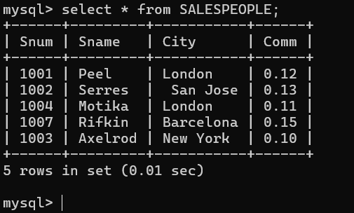

B) CUSTOMERS

Cnum int(4)

Cname varchar(10)

City varchar(10)

Rating int(4)

Snum int(4)

**Ans**:

mysql> create table CUSTOMERS ( Cnum int (4), Cname varchar (10), City varchar(1

0), Rating int(4), Snum int(4) );

mysql> insert into CUSTOMERS values ('2001', 'Hoffman', 'London', '100', '1001')

,('2002', 'Giovanni', 'Rome', '200', '1003'),('2003', 'Liu', 'San jose', '200',

'1002'),('2004', 'Grass', 'Berlin', '300', '1002'),('2006', 'Clemens', 'London',

'100', '1001'),('2008', 'Cisneros', 'San jose', '300', '1007'),('2007', 'Pereira', 'Rome', '100', '1004');

Query OK, 7 rows affected (0.01 sec)

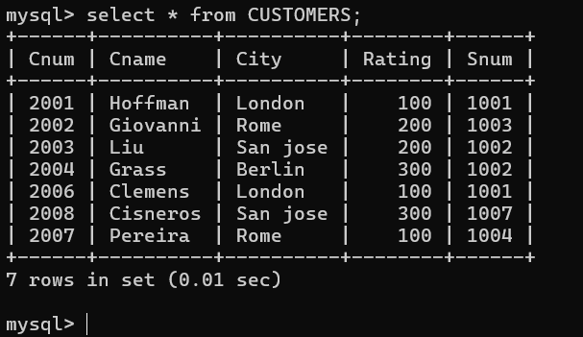

C) ORDERS

Onum int(4)

Amt float(7,2)

Odate date

Cnum int(4)

Snum int(4)

**Ans:**

mysql> create table orders(Onum int(4), Amt float(7,2), Odate date

, Cnum int(4), Snum int(4));

Query OK, 0 rows affected, 4 warnings (0.03 sec)

mysql> insert into orders values('3001','18.69','1990-10-03','2008','1007'),('3003','767.19','1990-10-03','2001','1001'),('3002','1900.10','1990-10-03','2007','1004'),('3005','5160.45','1990-10-03','2003','1002'),('3006','1098.16','1990-10-03','2008','1007'),('3009','1713.23','1990-10-04','2002','1003'),('3007','75.75','1990-10-

04','2004','1002'),('3008','4723.00','1990-10-05','2006','1001'),(

'3010','1309.95','1990-10-06','2004','1002'),('3011','9891.88','19

90-10-06','2006','1001');

Query OK, 10 rows affected (0.01 sec)

Records: 10 Duplicates: 0 Warnings: 0

