**Assignment –4**

**Retrieving Information from Tables.**

1. Write a select command that produces the order number, amount, and date for all rows in the Orders table.

**Ans:**

**select Onum,Amt,Odate from orders;**

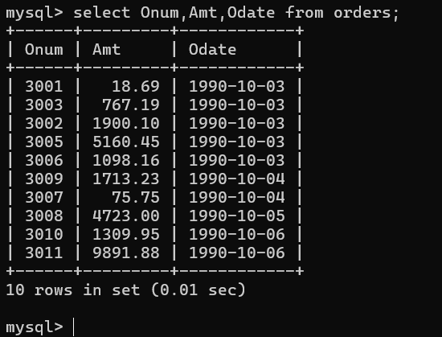

1. Write a query that produces all rows from the Customers table for which the salesperson’s number is 1001.

Ans:

select * from customers where snum=1001;

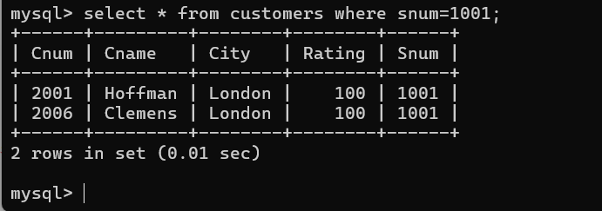

1. Write a query that displays the Salespeople table with the columns in the following order: city, sname, snum, comm.

Ans:

select city,sname,snum,comm from SALESPEOPLE;

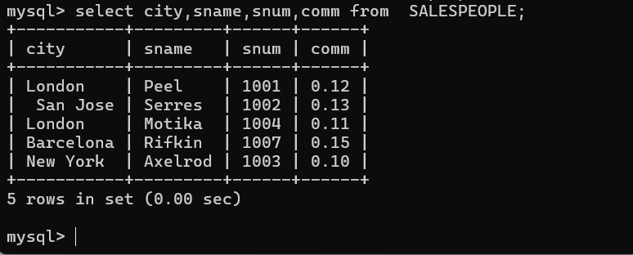

1. Write a select command that produces the rating followed by the name of each customer in San Jose.

Ans: select rating,cname from customers where city='san jose';

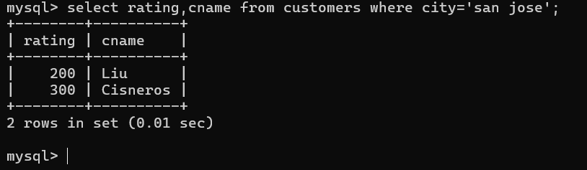

1. Write a query that will produce the snum values of all salespeople (suppress the duplicates) with orders in the Orders table

Ans:

select distinct snum from orders;

