**Assignment –5**

**Relational and Logical Operators.**

1. Write a query that will give you all orders for more than Rs. 1,000.

Ans:

select * from orders where Amt>1000;

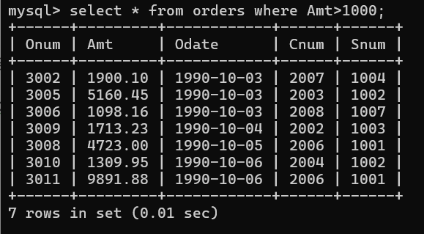

1. Write a query that will give you the names and cities of all salespeople in London with a commission above .10.

Ans:

select sname,city from salespeople where city ='London' and comm>.10;

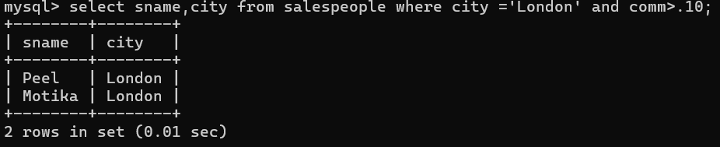

1. Write a query on the Customers table whose output will exclude all customers with a rating <= 100, unless they are located in Rome.

Ans:

select * from customers where rating <=100 And city = 'Rome';

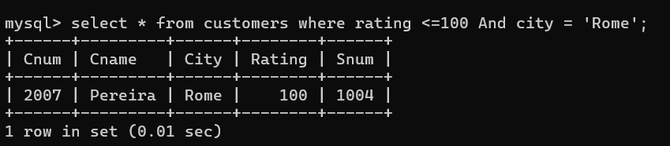

1. What will be the output from the following query? Select * from Orders where (amt < 1000 OR NOT (odate = ‘1990-10-03’ AND cnum > 2003));

Ans:

select * from orders where(amt <1000 OR NOT(odate= '1990-10-03' AND cnum > 2003));

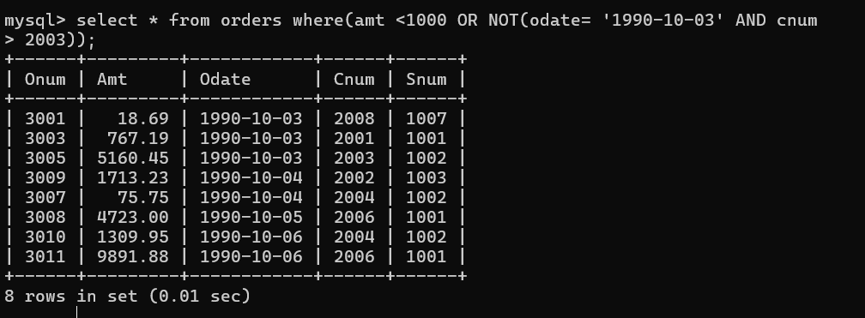

1. What will be the output of the following query? Select * from Orders where NOT ((odate = ‘1990-10-03’ OR snum >1006) AND amt >= 1500);

Ans:

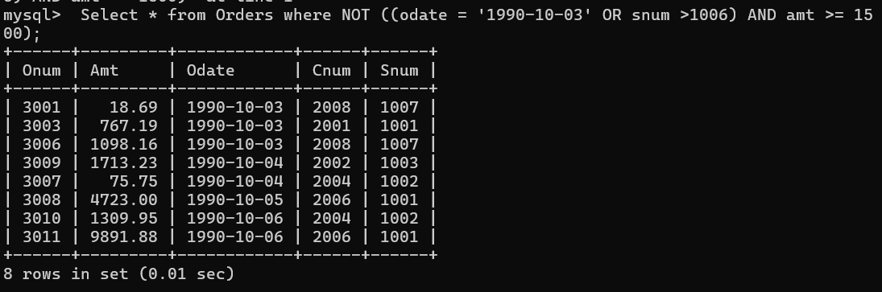

1. What is a simpler way to write this query? Select snum, sname, city, comm From Salespeople where (comm > .12 OR comm <.14);

Ans:

Select snum, sname, city, comm From Salespeople

where (comm > .12 OR comm <.14);

