**Assignment –6**

**Using Special Operators in Conditions.**

1. Write two different queries that would produce all orders taken on October 3rd or 4 th, 1990.

Ans:

select * from orders where odate between '1990-10-03' and '1990-10-04';

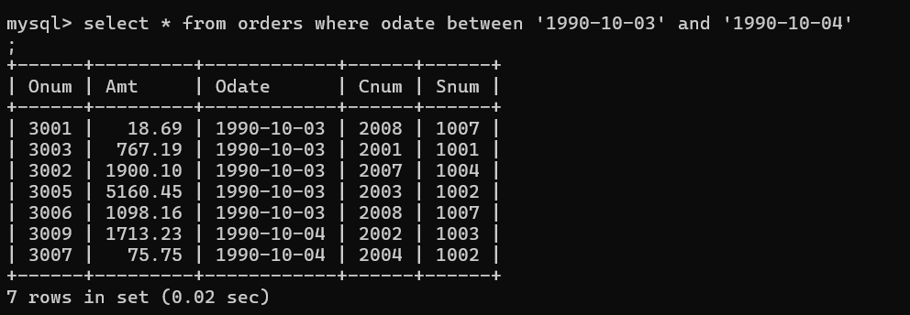

1. Write a query that selects all of the customers serviced by Peel or Motika. (Hint: the snum field relates the two tables to one another).

Ans:

select * from customers where snum=1001 or snum=1004;

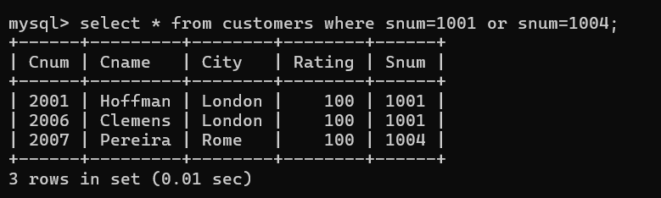

1. Write a query that will produce all the customers whose names begin with a letter from ‘A’ to ‘G’.

Ans:

select * from customers where cname like 'A%' OR cname like 'G%';

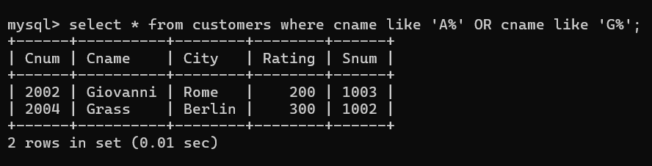

4)Write a query that selects all customers whose names begin with the letter ‘C’.

Ans: select * from customers where cname like 'C%';

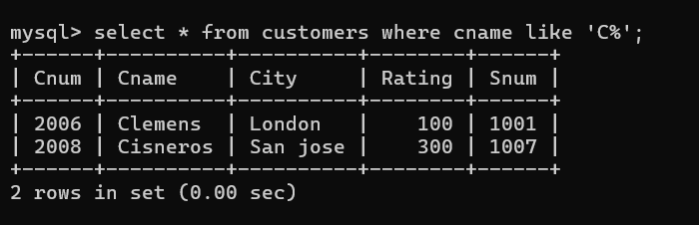

5) Write a query that selects all orders except those with zeroes or NULLs in the amt field?

Ans:

select * from orders where Amt!=0 OR Amt!=null;

