Darlene Warren

Enterprise Network Design with VLAN Segmentation and Inter-VLAN Routing

Overview
This project involved designing and implementing a segmented enterprise network using Cisco Packet Tracer. The goal was to improve network organization, performance, and security by separating departments into different Virtual Local Area Networks (VLANs). Inter-VLAN communication was achieved using a router-on-a-stick configuration, allowing devices in different VLANs to communicate efficiently.
In addition to basic network configuration, security enhancements were implemented using port security on access ports. This ensured that only authorized devices could connect to the network, adding an extra layer of protection against unauthorized access. This project demonstrates both networking and foundational security concepts used in real-world enterprise environments.

Network Design
The network was divided into four VLANs representing different departments within an organization:
- VLAN 10: IT Department (192.168.10.0/24)
- VLAN 20: Human Resources (192.168.20.0/24)
- VLAN 30: Security Operations Center (SOC) (192.168.30.0/24)
- VLAN 40: Guest Network (192.168.40.0/24)
Each VLAN was assigned to a unique subnet to isolate traffic and enhance security. This design ensures that broadcast traffic is limited within each department while still allowing controlled communication across VLANs.

Figure 1: Network Topology

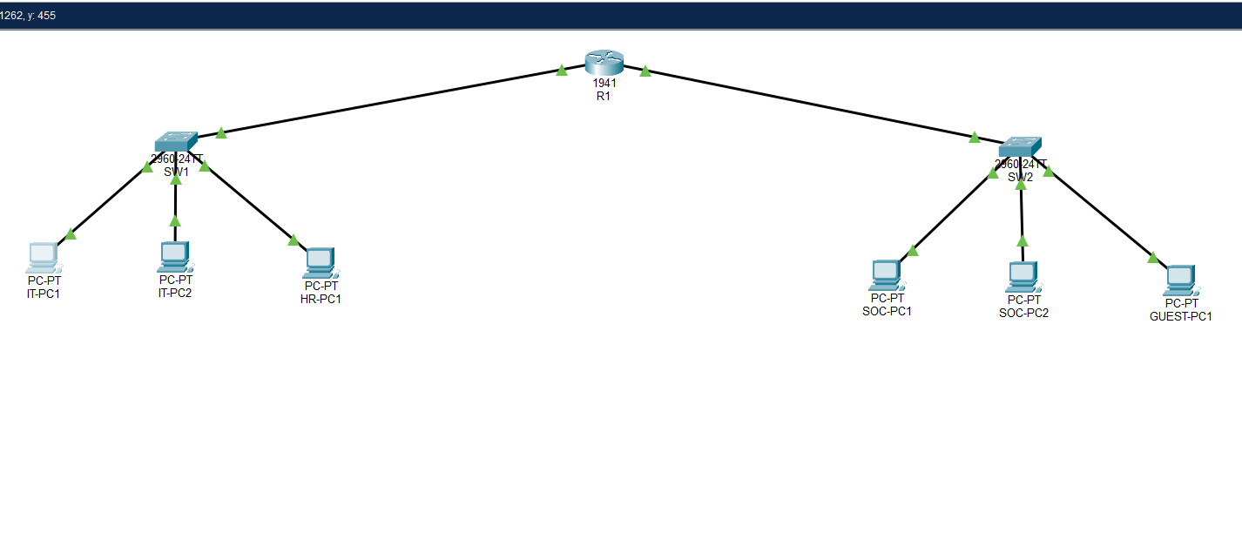Logical segmentation of departments using VLANs.

Configuration Summary
The network was configured using Cisco IOS command-line interface (CLI). VLANs were created on the switch and ports were assigned accordingly to match each department. A trunk link was configured on the switch to allow multiple VLANs to pass through a single connection to the router using 802.1Q encapsulation.
On the router, subinterfaces were created for each VLAN using a router-on-a-stick configuration. Each subinterface was assigned an IP address to serve as the default gateway for its respective VLAN. The following configurations were implemented:
- Creation of VLANs 10, 20, 30, and 40
- Assignments of switch ports to the appropriate VLANs
- Configuration of trunk port using 802.1Q
- Configuration of router subinterfaces
(GigabitEthernet0/0.10, 0/0.20, 0/0.30, 0/0.40)
- Assignments of IP addresses to each subinterface

Testing and Validation
Connectivity was tested using ICMP ping commands from both the router and end devices. Initial pings experienced minor delays due to ARP resolution, which is expected behavior. Subsequent tests showed successful communication with 100 percent packet delivery.
The following tests were successfully completed:
- Router to PC communication with VLAN 10
- PC to router communication using default gateway
- Inter-VLAN communication between VLAN 10, 20, 30, 40
- Restricted access from VLAN 40 (Guest Network) to internal VLANs
- Inter-VLAN communication between VLAN 10, 20, 30 only
These results confirmed that the network was fully operational and properly configured.
Additional testing was performed from the Guest PC to validate network security restrictions. A successful ping to the default gateway (192.168.40.1) confirmed proper connectivity within VLAN 40.
Attempts to ping internal network addresses such as 192.168.10.1 resulted in failed responses. This demonstrates that access control measures are functioning correctly, preventing guest users from accessing internal network resources.

Figure 2: Inter-VLAN Ping Test
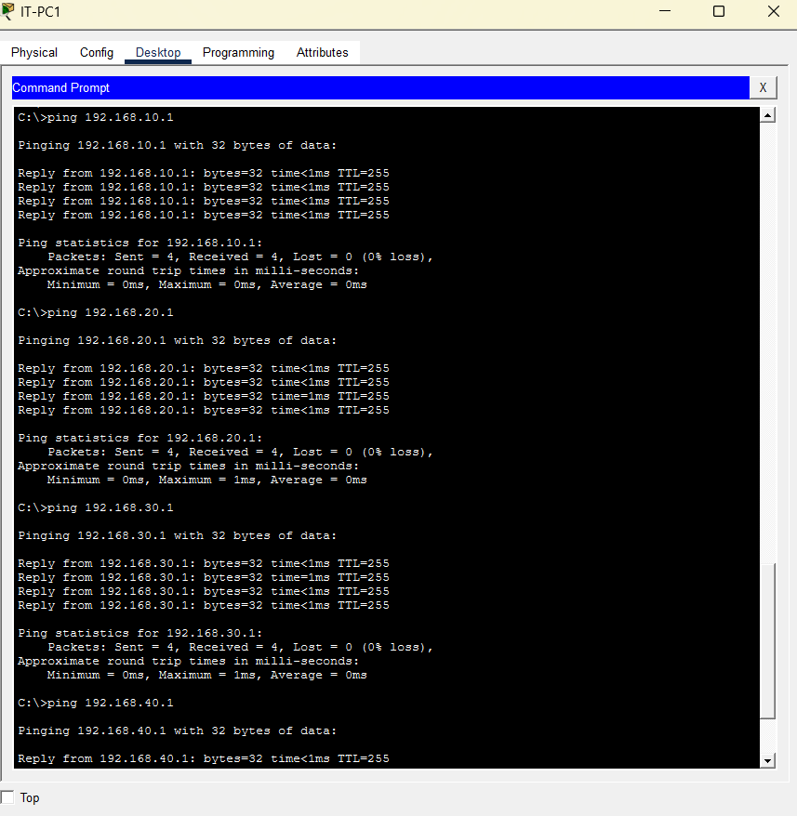
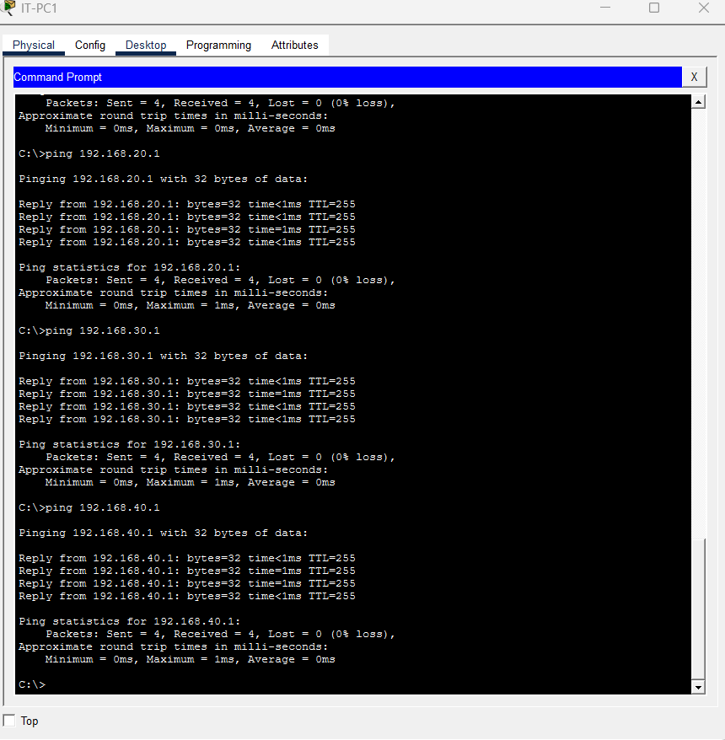
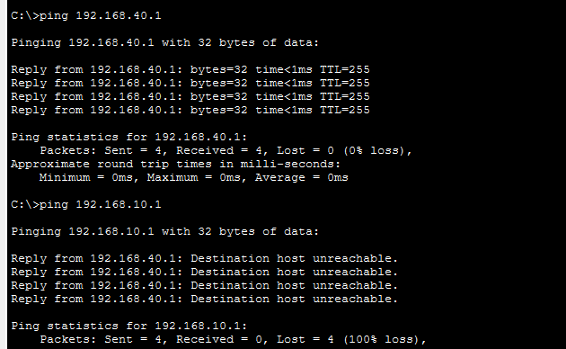
Successful inter-VLAN connectivity with enforced guest network restrictions.

Security Enhancements
Basic port security was implemented on all access ports to prevent unauthorized devices from connecting to the network. Each port was configured to allow a maximum of one MAC address using sticky learning. In the event of violation, the port restricts access rather than shutting down, allowing continued monitoring while preventing unauthorized communication. This enhances network security by limiting access to approved devices only.
Additionally, network segmentation and access control policies were implemented to restrict communication between VLANs, particularly isolating the guest network from internal resources.

Figure 3: Port Security Configuration
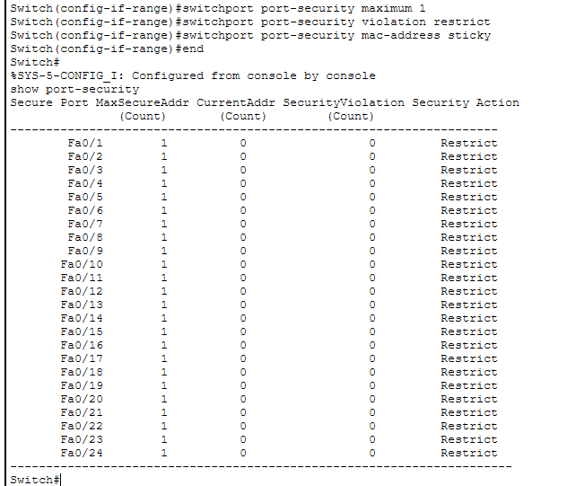
Port security applied with sticky MAC learning.

Figure 4: Access Control List

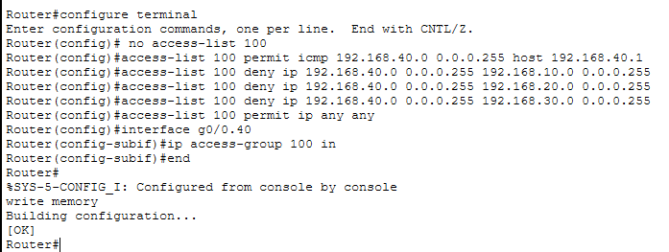
ACL restricting guest VLAN access to internal networks.

Figure 5: Trunk Configuration
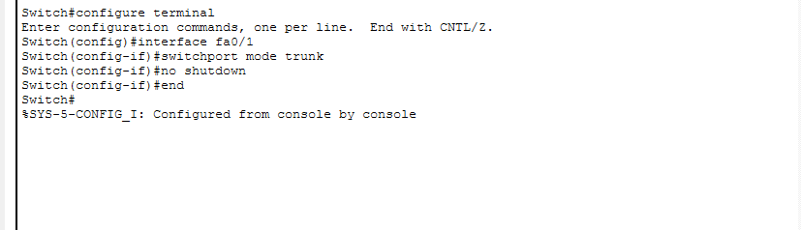
Trunk link configured to carry multiple VLANs using 802.1Q.

Skills Demonstrated
This project demonstrates practical knowledge and hands-on experience in the following areas:
- VLAN configuration and segmentation
- Trunking using IEEE 802.1Q
- Inter-VLAN routing (router-on-a-stick)
- Cisco IOS CLI configuration
- Network troubleshooting and validation
- IP addressing and subnetting
- Port security configuration to restrict unauthorized device access
- MAC address learning using sticky configuration
- Basic network implementation and access control
- Implementation of network security controls using ACLs

Conclusion
This project successfully implemented a scalable and secure network design using VLAN segmentation and inter-VLAN routing. The configuration allows efficient communication between departments while maintaining network organization and security. This hands-on experience reflects real-world networking concepts commonly used in enterprise environments.
The addition of port security enhanced the overall security posture by restricting unauthorized devices from accessing the network. This project demonstrates a strong understanding of both networking fundamentals and basic security practices. The hands-on experience gained reflects real-world enterprise network implementation and prepares for roles in networking and cybersecurity.
The project also highlights the importance of implementing layered security controls, including VLAN segmentation, port security, and access restrictions, to protect enterprise network environments.

