Sesami dEVICE cORE
HWD Mobile App Integration
September 18, 2026
© 2022 Sesami Cash Management Corporation. All Rights Reserved.

Revision History

Version | Date | Author | Description
1.00 | 9/17/2026 | Greg Nichols | Initial Document
1.01 | 9/18/2026 | Greg Nichols | -Add Cash Workflow  -Fix Image Resolutions  -Remove Swagger Notation  -General Formatting

Contents
Initial Connections 4
Certificate 4
Headers 4
HTTPS 4
SignalR 4
Swagger 4
Example: Frontend Startup Sequence 5
Diagram 5
Steps 6
1. Load Environment Config 6
2. Load Icon Library 6
3. Initialize Pinia 6
4. Initialize Kiosk 6
5. Initialize Logger 8
6. Connect SignalR 8
7. Initialize Singletons 8
8. Mount Components 8
9. Mount Application 8
Example: Frontend Application Start 9
Diagram 9
Steps 9
1. Initialize Display Service 9
2. Initialize Timeout Service 9
3. Abandon Orphaned Workflows 10
4. Log Application Start 10
5. Serve Idle Screen 10
WorkFlow: Login 11
Process 11
1. Authentication 11
2. User Data Store 11
3. Start and Complete Workflow 12
4. Set User Timeout 12
5. FTS Check 12
6. Existing Workflow Check 12
WorkFlow - Add Cash 13
Workflow Overview 13
WorkflowStage: Accept Cash 14
Start Acceptance 14
Stop Acceptance 15
Hardware Layer 16
WorkflowStage: Print Receipt 17

Initial Connections

Certificate
All connections require the self-signed certificate for Sesami loaded in the public trust of the computer or mobile device attempting to connect to the API layer. If this is not present, an SSL certificate error will be returned.

Headers
All messages to the backend need to apply the appropriate headers to the payload:
Header | Value
Content-Type | application/json
Authorization | Bearer {token}
UserSession* | JSON.stringify(userSession)
UserPermissions* | JSON.stringify(permissions)
*If a user is logged in and they need to access a non-anonymously mapped endpoint, the header should contain the userSession and userPermission objects returned from the authentication process. Failure to do so will return not-authorized errors.

HTTPS
Connections to the backend can be made against the serverhost/port based on environment variable or environment.json configurations for the local device. In developer mode, vite takes ownership and expects 5173 to proxy to 6174.

SignalR
Connections to SignalR can be made against the serverhost/port based on environment variable or environment.json configurations for the local device.

Swagger
In development mode, swagger is exposed on the serverhost/port based on environment variable or environment.json configurations of the local device. It is under the /swagger path.

Example: Frontend Startup Sequence

Diagram
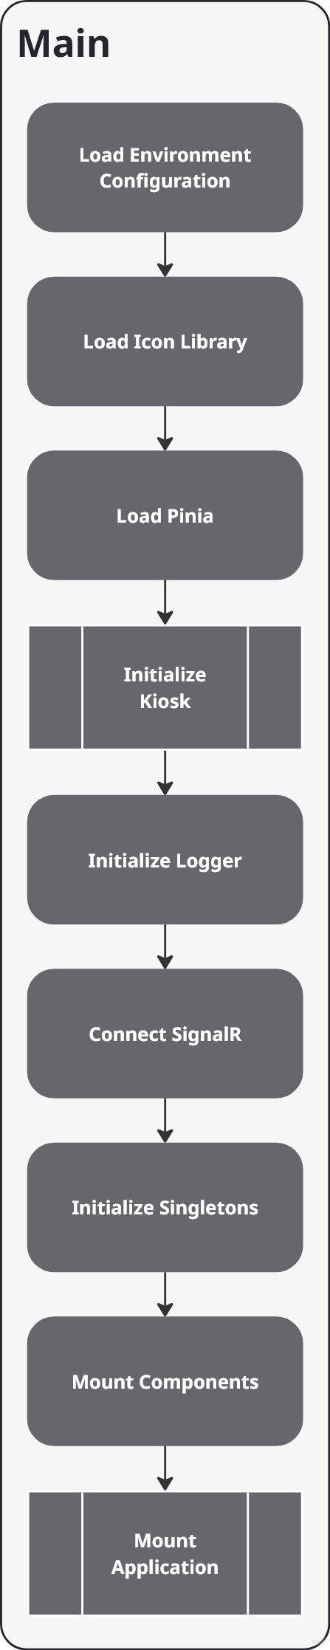

Steps

1. Load Environment Config
The environment configuration is used to indicate the server host and port for the backend. This value can be set given the following hierarchy:
- Operating System Environment Variables
- Environment.json

2. Load Icon Library
Loads all icons either stored locally or from npm packages.

3. Initialize Pinia
Pinia is the official state management library and global store framework for the frontend. It allows the frontend to centralize and share data (state) across different components and pages without manually passing data down through props or custom events. It is the Vue 3 replacement for the legacy vuex stores.

4. Initialize Kiosk
The purpose is call the API endpoints to cache the initial state of the backend metadata. Primarily strapping the application configuration and type configuration stores.
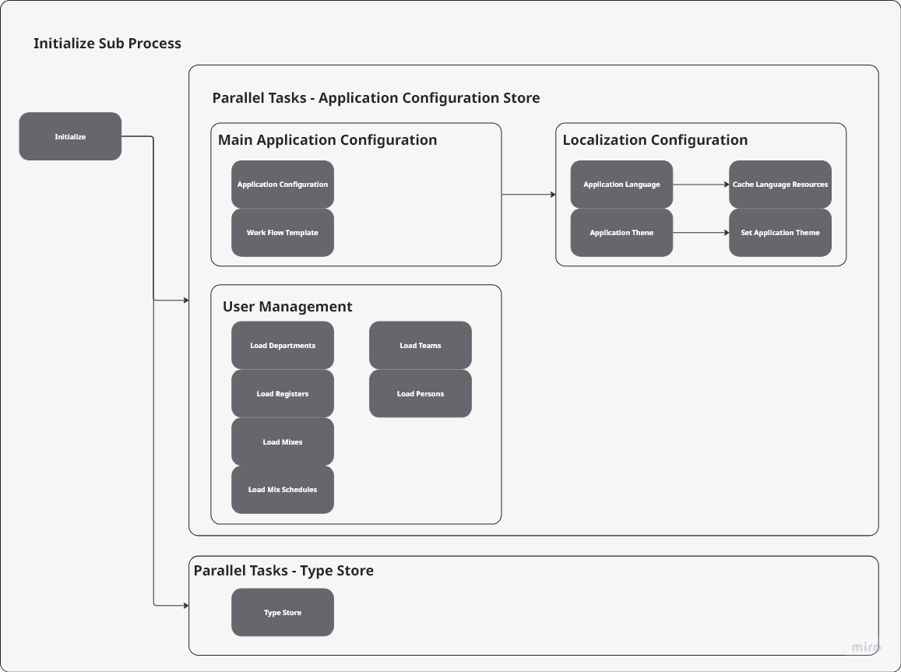

Application Store
The application store holds the application configuration, the current workflow template configured on the backend (there can be more but only one active template), the localization settings, the language resources, the theme, including the router configuration for the theme to workflow mapping, and all the initial user management data. As the application state changes, events drive the refresh of the cache by updating, inserting, or reloading the underlying data.

Type Store
The type store holds all the static type data from the backend. There are 30-40 endpoints in total. The primary endpoints that is encouraged to utilize:
- WorkFlowCodes
- WorkFlowStageCodes
- WorkFlowExecutionCodes
- WorkFlowExecutionStatusCodes
- WorkFlowSpawnCodes
- StorageDoorCodes
- StorageDoorLockCodes
- PermissionCodes
- ComponentCodes
- ProductCodes

5. Initialize Logger
Straps the error handler for vue, unhandled promise rejections, and general javascript errors to the logging service which communicates to the backend to store log information. Eventually, the logging service will take ownership of writing logging data without the backend but it is tied for now.

6. Connect SignalR
Automatically attempts to connect signalr to the backend from the frontend with retry in the case of disconnection. The reconnect event handler in the signalr service is also used to determine whenever the backend application has successfully restarted.

7. Initialize Singletons
Provides a single signalrservice and singletimeout service for injection throughout the application instead of instantiating these each time. Subscriptions to signalr events are handled through setting the events on during mount and off during unmount. Timeoutservice is controlled by setting the timeout directly on the injected singleton.

8. Mount Components
Any shared components (like fontawesome, flowfooters, maskedamounts, etc) can be setup during this to make it easier for use within the application.

9. Mount Application
The final step is to mount app.vue which will continue the application startup sequence.

Example: Frontend Application Start

Diagram
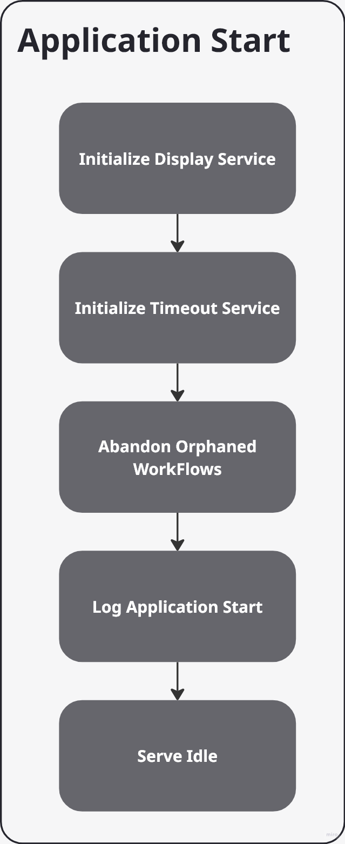

Steps

1. Initialize Display Service
This is required by Vue 3 to bootstrap or configure a display/UI layout layer during the mounting of the main application.

2. Initialize Timeout Service
Starts the timeout service and enables the default setting governed by the global application timeout in general configuration.

3. Abandon Orphaned Workflows
On startup, the application cleans up workflows that have no usersession and personId attached to them. This is to prevent developers from corrupting the underlying data table and cleaning up already corrupted data where users are not present (a requirement for starting a workflow).

4. Log Application Start
Just a general log that the application has started.

5. Serve Idle Screen
Idle gets served automatically if there is no usersession, current workflow, or the application is set to startup. This is done via the router.js for the configured theme and mapping instance.

WorkFlow: Login

Process
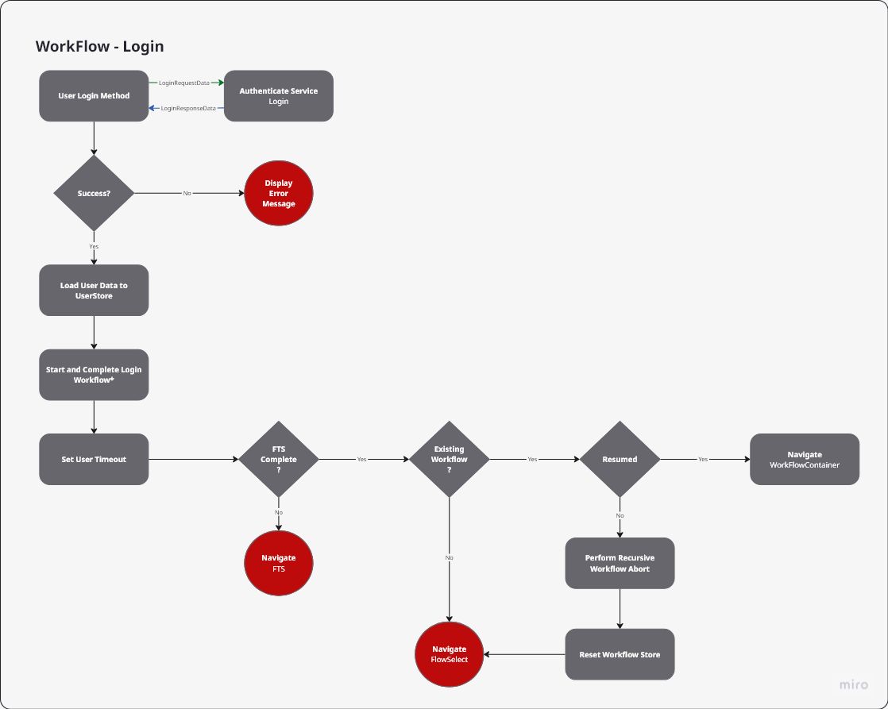

1. Authentication
A call will be made to attempt to authenticate a user. The expectation is the payload should contain the user session type (BT, Remote, Local, etc) and all relevant information captured by the device. If the request is successful, all user meta data will be returned for quick checks against the application configuration cache (registers, departments, perms, etc.). If not, an error dialog should be presented displaying the reason (use translation service against appconfigstore for resources) to the user.

2. User Data Store
Upon a user logging in, all metadata should be stored about that user in the user store. This will reduce the number of API requests needed to make in the backend. If data changes for a user OR for the application overall, events will be triggered and the store will adjust naturally to reflect the changes during runtime.
At the end of the session or a timeout, the user store should be logged out through the authentication service, redirected to idle, and the user data store should be cleared (this is only for active logged in users only).

3. Start and Complete Workflow
- WorkFlowCode: Login, 3001
Sesami does not have a process for a login workflow. Instead, we should immediately start and complete the login workflow to show a historical record that it has been completed. This is relevant for replay and tracking purposes. Other customers may have additional things that may get triggered.

4. Set User Timeout
Always reset the timeout service on login. It will detect the right value (whether set on a group, user, or config) and apply the appropriate value.

5. FTS Check
It is required on login to ensure the first time setup workflow has been completed before allowing access to the machine. If first time setup is not complete, it should be presented in the workflow container for completion. If not, proceed to detect incomplete workflows.

6. Existing Workflow Check
Sesami Device Core has automatic workflow resume enabled by default. When a user logs in, a call for the user will be made to find the most recent incomplete workflow (workflow endpoints, getIncompleteWorkFlow). The user has a choice to resume a workflow (if yes, navigate to the static flowselect container) or abort a workflow. If the user chooses to abort a workflow (not continue), a call will be made to the workflowservice to abort the incomplete workflow. This process must be repeated until there are no active workflows in the returned workflowcontextobject. Failure to do so will leave orphaned opened workflow chains creating data corruption.

WorkFlow - Add Cash

Workflow Overview
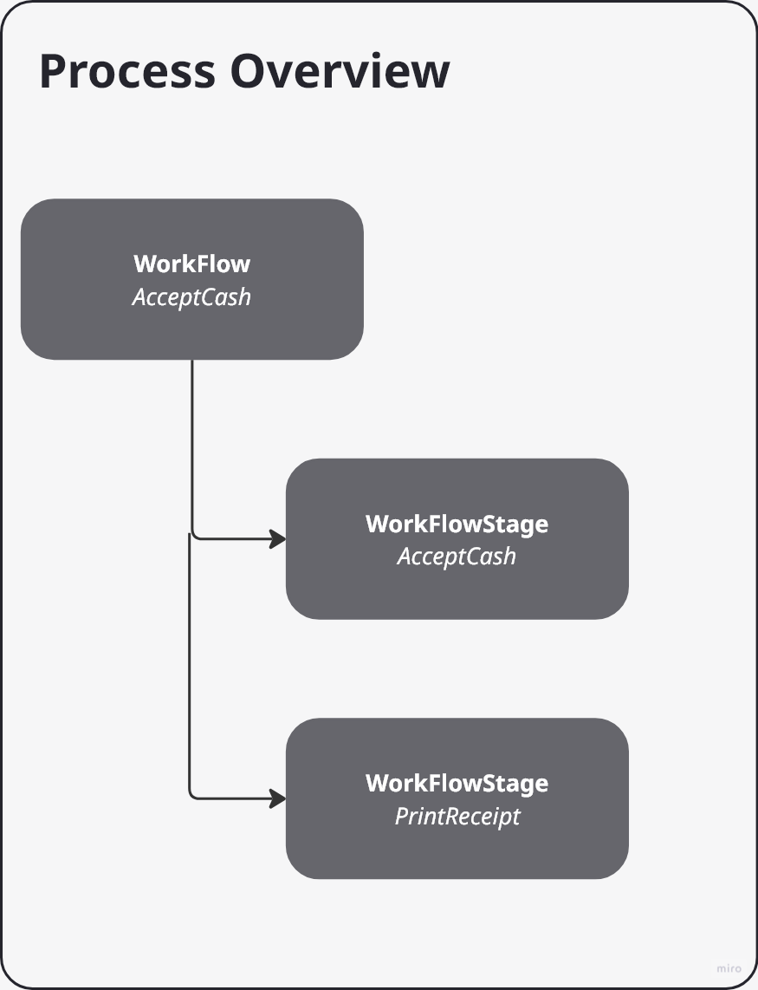
The Accept Cash workflow only consists of 2 stages (currently):
- Accept Cash
  - Creates acceptance transactions for acceptance capable connected assets
  - Start acceptance process on assets with valid acceptance conditions
  - Stop acceptance process on assets that were started
  - Handles error conditions
  - Completes WorkflowStage
- Print Receipt
  - Summary screen detailing complete transaction snapshot
  - Prints receipt if hardware is available
  - Completes WorkflowStage

WorkflowStage: Accept Cash
The accept cash workflowstage begins with the initial determination of assets that can perform acceptance. In some system configurations, there may be multiple different devices (note recyclers, safes, coins, atms, etc.) configured in a peer-to-peer or daisy chain process. In the event that there is more than one device that can perform acceptance, a financial transaction is pre-authorized for each valid device. In addition, the screen must subscribe (if not already subscribed) to the following events that get generated from the hardware layer:
- Running Totals
  - DeviceNoteProcessedEvent
  - DeviceNoteRefusedEvent
  - DeviceNoteRejectedEvent
  - DeviceNoteAcceptanceReadyEvent
- Screen Transition
  - FinancialTransactionCompletedEvent

Start Acceptance
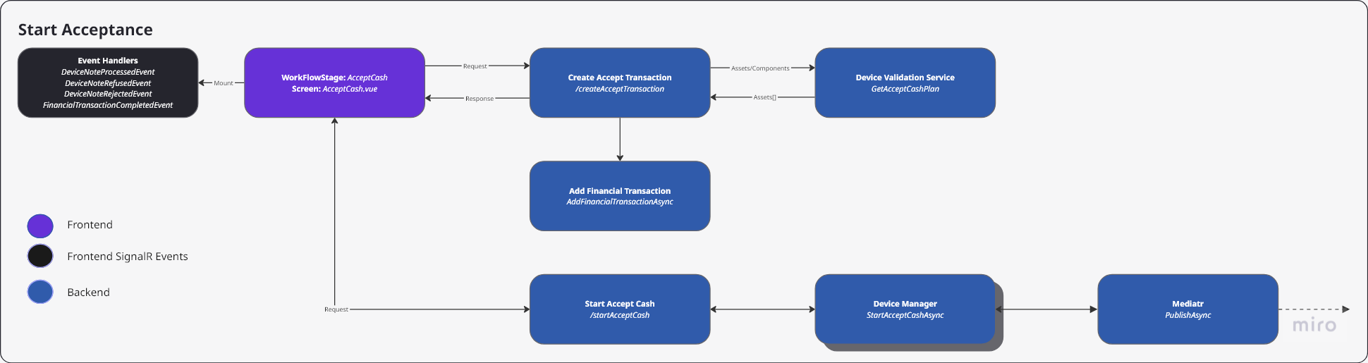
The purpose of start acceptance is to identify the assets that can accept cash and start the physical device for acceptance. As part of this step, the device validation service isolates assets that are not in error, have a full capacity, or are disabled. Once these assets are determined (if any), a response is returned to the UI with a transaction record for each applicable device. These records should be stored as the financialtransactioncompletedevents generated in the future will be used to determine a complete acceptance. The assetId in the generated id should match an assetId within the cache.
In the event there are no devices, a dialog popup should appear indicating there are no devices available to accept cash and the workflow should be aborted, returning either to idle or flowselect based on the customer configuration in the workflowtemplate.
If there are one or many devices, customer may require a selection of what assets need to perform the acceptance. In the Sesami workflow, all assets (coin, note, smart safe) are started simultaneously without the need to select the individual asset.

Stop Acceptance
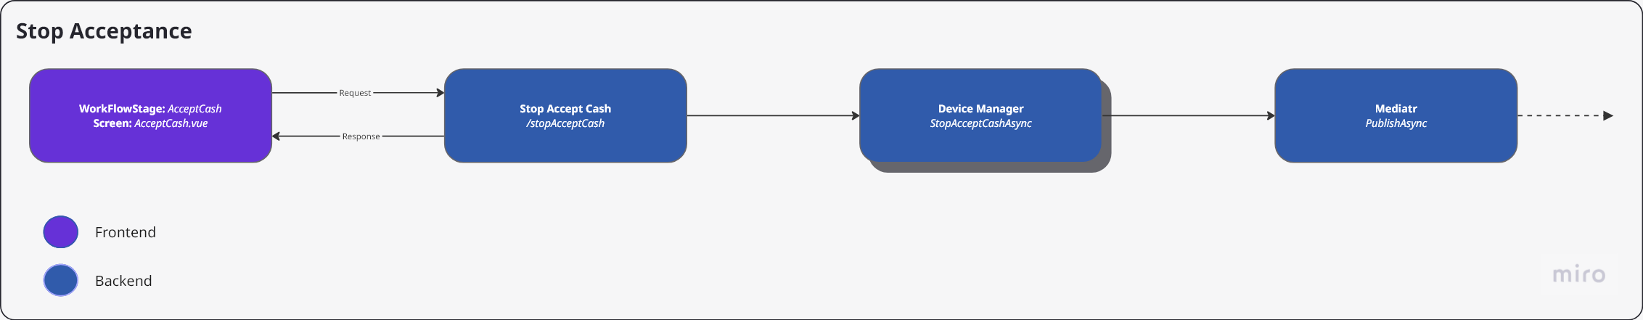
The UI has one manual trigger for stop acceptance, the button. In the event a user clicks stop, a payload will be sent down to /stopacceptcash which will publish an event to the hardware. In order to complete the workflow stage, all financial transaction completed events tied to each asset that was ordered to start acceptance must be accounted forth. Failure to do so will result in hardware in an incomplete state which may cause downstream effects.
The hardware layer can generate a financialtransactioncompletedevent at any time based on timeout, error or other issues. These should be treated equally to someone clicking stop on the acceptance phase.

Hardware Layer
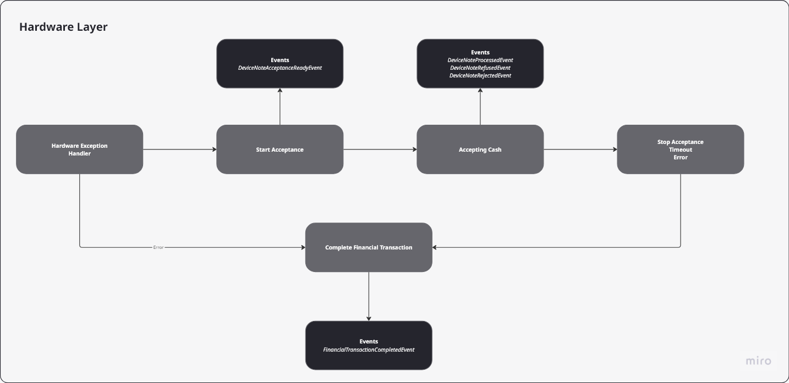
Once an event reaches the hardware layer, it will first determine if there is an error condition prior to starting acceptance. If there is an error condition, a financialtransactioncompletedevent will be generated with an attached error code. The UI can then determine the best course of action to take based on the error code.
Once acceptance starts, the corresponding device will generate an event indicating acceptance has started. This can be utilized to display text or update iconography on the screen.
During the acceptance stage, the corresponding device will continually generate processed, refused, and accepted events through SignalR. The UI can utilize these to increment running counts.
In order to terminate a stop acceptance, it can be done the following ways:
- User clicks continue or stop on the UI which will send down a command to terminate the hardware
- The hardware encounters a breaking error in which it will terminate the acceptance state
- The hardware timeouts in which it will terminate the acceptance state
Regardless of the termination path, the hardware is expected to finalize it’s financial transactions and publish them through Mediatr.

WorkflowStage: Print Receipt
Print receipt is really a wrapped summary screen where the financial transaction completed events from the previous stage are summarized into a total breakdown. In addition, if there are configured assets to perform the printing of a receipt, a call is made to an endpoint to handle this asynchronously. In the event a printer is attached and the printer is in error, an event will be generated and sent through SignalR. The UI may or may not display this error information.

