6DATA007W

Interim Progress Demonstration (IPD)

A Data-Driven Carpooling Application for Sustainable Urban Mobility in London
Student: Syed Hussnain Ali Wasti (w1978727)

Supervisor: Salma Chahed

This report is submitted in partial fulfillment of the requirements for the
BSc (Hons) Data Science and Analytics
at the University of Westminster.

School of Computer Science & Engineering
University of Westminster

05/02/2026

Use of Generative AI

In this assessment, I used ChatGPT to brainstorm ideas and refine the formal academic writing. All project decisions, planned implementation steps, and reflections are my own work. Generative AI was used as an assistive aid and not as a replacement for independent analysis or practical work, in accordance with university guidance.

Table of contents

Contents
Use of Generative AI 2
Table of contents 3
List of figures 4
List of Tables 5
1. Project Overview 6
2. Changes from the PPS 7
3. Work completed to date 7
4. Methodological and other challenges 8
5. Outstanding tasks 9
6. Prototype 9
Appendix A 11

List of figures

Figure 1 Stakeholder Onion Diagram for the Data-Driven Carpooling Application 6
Figure 2 Gantt chart showing the project timeline by month. 9

List of Tables

Table 1 Project Gantt chart presented as table. 10

Project Overview
Urban mobility in London presents ongoing challenges related to congestion, environmental pollution, and inefficient use of private vehicles. Despite a well-developed public transport system, a large proportion of commuters continue to rely on private cars, often travelling alone. This contributes to increased carbon emissions, traffic delays, and pressure on urban infrastructure. Improving vehicle occupancy through carpooling has the potential to reduce these issues while offering commuters cost and efficiency benefits.
The aim of my project is to develop a data-driven carpooling application that supports sustainable urban mobility in London. My project focuses on using open data and analytical techniques to identify feasible carpooling opportunities by matching commuters based on geographic proximity, route similarity, and travel constraints. Unlike simplistic approaches that rely solely on straight-line distance, the proposed solution will consider realistic road networks and commuting behaviour.
The objectives of the project are:
- To investigate existing carpooling and shared mobility solutions and identify their limitations.
- To select and prepare appropriate open datasets related to London’s transport network.
- To design an analytical methodology for matching commuters.
- To implement a prototype carpooling system using data science techniques.
- To evaluate the solution in terms of efficiency, feasibility, and sustainability impact.
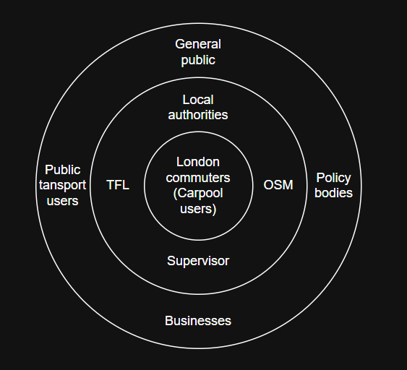
Figure 1 Stakeholder Onion Diagram for the Data-Driven Carpooling Application

Changes from the PPS
Since the submission of the Project Proposal and Specification (PPS), the overall scope and objectives of my project have remained consistent. However, several refinements have been made to improve feasibility and alignment with ethical and practical constraints.
Initially, my project considered the use of real commuter travel data. Following further analysis, this approach was revised in favour of using open datasets combined with synthetic commuting data. This change was made to avoid privacy and ethical concerns associated with personal location data, while still enabling realistic simulation of commuting patterns in London.
In addition, the project methodology has been clarified to emphasise a staged development process. Greater focus has been placed on planning, data understanding, and tool preparation before commencing full implementation. This refinement reduces the risk of poorly structured code and ensures that development can proceed efficiently. These changes strengthen the project and support a more controlled transition into the implementation phase.

Work completed to date
At the Interim Progress Demonstration stage, the project is in a pre-implementation and preparation phase, with substantial progress made in research, planning, and technical setup.
Background Research
Background research has been conducted into carpooling systems, shared mobility, and sustainable urban transport. This research highlighted common challenges such as limited route realism, poor scalability, and insufficient integration of real transport networks. These findings informed the decision to adopt a data-driven, network-aware approach.
Methodological Design:
I have defined a clear methodological framework. The planned approach consists of:
- Acquiring and preparing open road network data for London.
- Generating synthetic origin–destination commuter data.
- Applying clustering techniques to group similar travel patterns.
- Using routing logic to assess route compatibility.
- Evaluating matches using defined efficiency and deviation metrics.
This methodology has been carefully designed to ensure technical feasibility within the available timeframe.
Data and Tools Preparation:
I have identified and reviewed relevant APIs, and appropriate tools and libraries have been selected. The development environment has been set up in advance, and a public GitHub repository has been created with a planned folder structure and documentation strategy. This ensures reproducibility and supports effective version control once coding begins.
Project Planning and Management:
I developed a revised project timeline, identifying milestones for implementation, testing, evaluation, and report writing. Key risks, such as time constraints and computational complexity, have been identified early. Mitigation strategies include incremental development, modular coding, and prioritisation of core functionality.
Current Status:
Although I have not begun full implementation, the project is fully prepared to enter the coding phase immediately. The work completed so far demonstrates structured planning, clear understanding of the problem domain, and readiness for practical development. Although I have not fully started implementation, significant prep work has been completed to ensure a development. My project is now ready to move into the implementation phase.

Methodological and other challenges
A key challenge has been managing the complexity of modelling urban mobility in a city as large and dense as London. To address this, the methodology has been deliberately scoped to balance realism and feasibility.
Another challenge involved ethical considerations around the use of personal travel data. This was resolved through the decision to use synthetic data.
Time management has also been a consideration due to concurrent academic commitments and poor health. Which will be resolved with making a set personal timetable and routine.

Outstanding tasks
The main outstanding tasks relate to the implementation and evaluation phases, which will commence immediately after the IPD submission. These include:
- Implementing data preprocessing pipelines.
- Generating synthetic commuter datasets.
- Developing and testing the matching algorithm.
- Building an interactive prototype for visualisation.
- Evaluating system performance and sustainability impact.

Figure 2 Gantt chart showing the project timeline by month.
Note:
0=Oct, 1=Nov, 2=Dec, 3=Jan, 4=Feb, 5=Mar, 6=Apr, 7=May

Task | Start Month | End Month | Status at IPD
Background research & literature | 0 (Oct) | 2 (Dec) | Completed
Methodology design | 1 (Nov) | 3 (Jan) | Completed
Stakeholder & ethics analysis | 2 (Dec) | 3.5 (Jan) | Completed
Environment & GitHub setup | 2 (Dec) | 3 (Jan) | Completed
Data access & validation | 3 (Jan) | 4 (Feb) | In progress
Synthetic data generation | 3 (Jan) | 5 (Mar) | In progress
Data preprocessing | 3 (Jan) | 5 (Mar) | In progress
Road network modelling | 4 (Feb) | 6 (Apr) | Planned
Carpool matching algorithm | 4 (Feb) | 6 (Apr) | Planned
Prototype development | 5 (Mar) | 7 (May) | Planned
Testing & evaluation | 5 (Mar) | 6.5 (Apr) | Planned
Sustainability analysis | 5 (Mar) | 6.5 (Apr) | Planned
Final report writing | 4.5 (Feb) | 7 (May) | In progress
Viva preparation & submission | 6 (Apr) | 7 (May) | Planned
Table 1 Project Gantt chart presented as table.

Prototype
At this stage, a full prototype has not yet been implemented. However, I have completed prep work, including environment setup, data source identification, and methodological design. The planned prototype will visualise matched carpool routes using open geospatial data and will serve as the basis for evaluating route similarity, journey efficiency, and sustainability impact. I will immediately start the development after the IPD submission.
GitHub repository:

References

Appendix A
