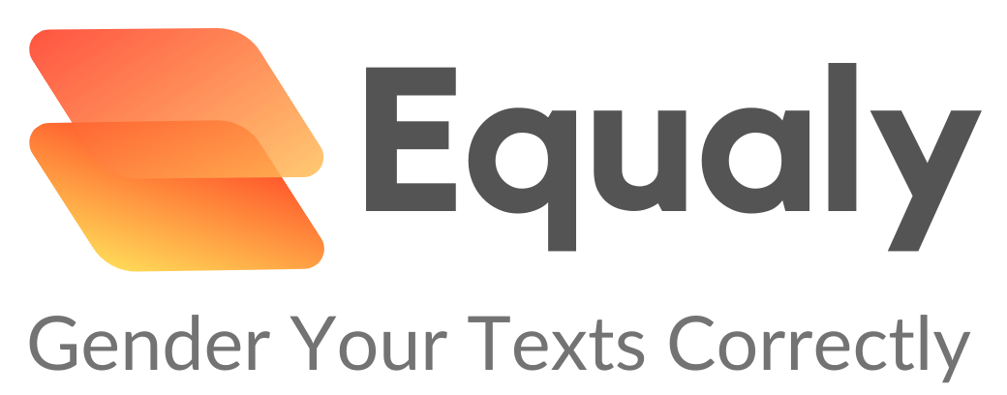

by Dennis Podkolsin, Felix Jacobsen and Marcus Koppelmann

**Project Teaser**

We believe in an inclusive future. A future where gendering happens just intuitively. This belief drove the design of Equaly.

Equaly is a web app that allows you to create correctly gendered text in an instant, simply by pasting the text you want to be gendered, while experiencing the most intuitive user interface we could imagine. Equaly's A.I. detects the text’s language, the relationships and inner workings. Based on this, it then suggests a reworded text with no meaning lost and correct, inclusive gendering achieved.

Equaly is simple and accessible. You just need access to a Browser. It is designed as an aid, but first and foremost as an educator for your own gendering journey.

The technical application itself is designed in a way so that it can be run literally by anyone and any institution or individual. It solely requires Java 8 to be installed. Everything else is handled by Equaly.

Whether it may be a university or a company, ease of use and ease of maintainability combined guarantee for a low barrier of entry and an easy insight into how gendering can be done quickly and applied confidently on a large scale.

We are just at the beginning of a truly inclusive future in education and professional life, where technologies like Equaly can seamlessly and automatically enable you to contribute to this goal.

Link: <https://youtu.be/K94C-gy7rE8>

*Word count: 2**26*